Hotel Placement-Food&Beverage Operations (BMIH4002)
Module Tutor- Laurence Blanke
Student Id: 2123931
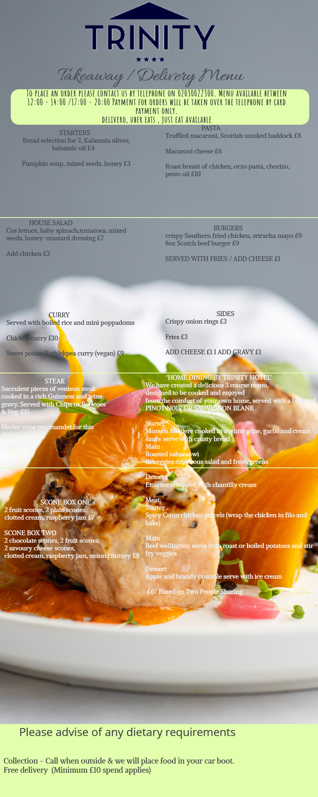
Hotel placement -food beverage operation module tutor laurence blanke student id 2123931

