Schrӧder House - Gerrit Reitveld

Historical Background
The Schӧder House was built between 1923 and 1924 (Nuttgens, 1997) in Utrecht, The Netherlands (Fig. 1) (Kostof, 1995).
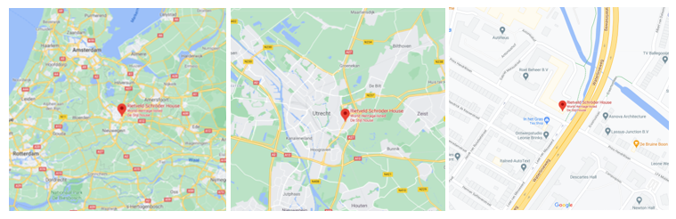
Fig. 1 (Above) – Three maps showing the location of the Schrӧder House within The Netherlands (Maps, 2021)
The House was built on the corner plot of Prins Hendriklaan located next to a row of brick houses (Dietsch, 2002). The house initially looked over an area of grass but since then an overpass has taken its place on the east side of the house.
The architect of the Schrӧder House was Gerrit Rietveld who worked closely alongside Ms Truus Schrӧder to design the house (Nuttgens, 1997). The two are pictured together in the image below (Fig.2).
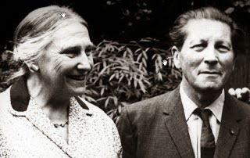
Fig. 2 (Left) – Truus Schrӧder and Gerrit Reitveld (Lane, 2014)
Rietveld started his working life as a carpenter and is widely known for his creation of the ‘Red- Blue (Stevens Curl, 2015). He was also a founding member of CIAM (Congrès International d'Architecture Moderne) which was created by a group of architects including Le Corbusier, Walter Gropius and more. The ideas developed within CIAM strongly influenced how architecture developed all over the world (Joch, 2012).
The purpose of the building was a home for the widowed Truus Schrӧder and her three children to reside in. It remained as a private house for 60 years until it became a museum which it remains (Heritage, 2013). Truus Schrӧder envisioned the house having a connection between the inside and the outside of the house as well as being open space. The house is nothing conventional which is as Schrӧder wanted moving into the creation of this interesting home (Chebaro, 2020).

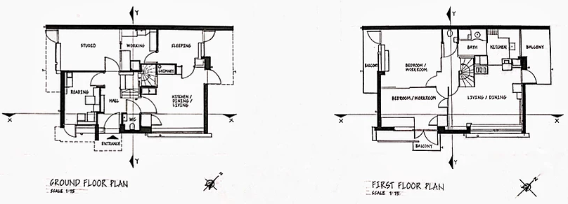
Plan and Section

Fig, 3 (Above) – Ground floor and first floor plans of the Schrӧder House
The plan of the house is 1010 sq. feet (Frampton, 2015/2016) and is almost rectangular in shape following a similar floor plan the terrace houses next to the house. The plan works around the central spiral staircase with rooms coming off in each direction on the ground and first floor. The ground floor follows a more generic layout with a large kitchen space with a service lift, a sleeping area, reading and workspace. A studio is also located on the ground floor this was initially meant to be garage (Overy, et al., 1988) but was changed into a studio during the building process for Rietveld’s work. In contrast to the ground floor the upper floor is an open plan flexible space. The space however can still be separated by sliding doors into multiple separate rooms each with their own sink. The beds on this upper floor can also all be folded back into couches (Overy, et al., 1988) with gives the space more uses when the sliding doors are folded back. Having outside space access in each room was very important to Truus Schrӧder so each space has access to its own balcony.
The principle elements of the two floor plans are the slightly asymmetrical spiral staircase which centres the building and the connection between the interior and the exterior of the house through the balcony spaces, shapes, and colours.
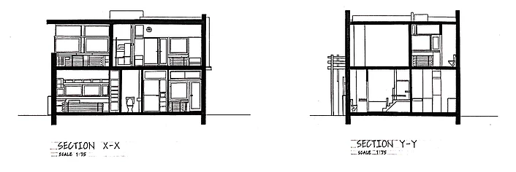
Fig. 4 (Above) – Section views of the Schröder house from two directions
In the two sections views of the house you can see the specially designed radiators and the centrals spiral staircases. The upper floor also has two different ceiling heights, sightly less than 3000mm on the northwest side and almost 4000mm of the southwest side of the building. This building has a very basic shape for a section which massively differs from the shape of the building’s exterior and the unconventional upper floor plan.
Materials and Light
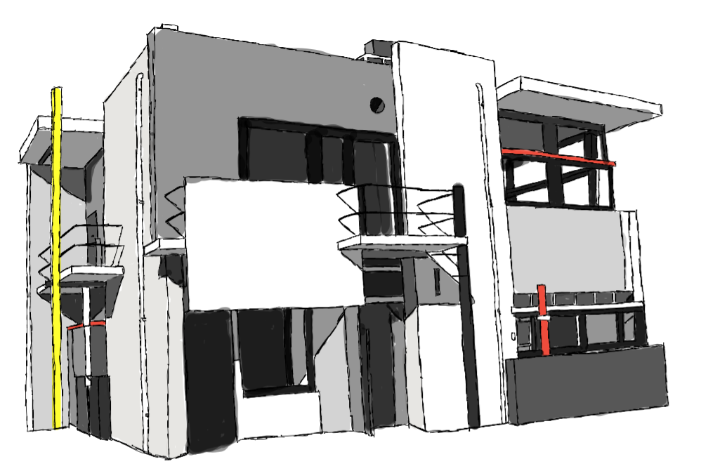
Fig. 5 – My own sketch of the Schrӧder House showing the colours of the cement rendering
The materials used to build the house were brick, timber, steel, and glass most of which are concealed by the cement rendering over the surfaces of the house (Frampton, 2015/2016). The cement rendering is used as a base for the matt paint on the flat planes of the house, Rietveld initially wanted the whole structure to be created using only concrete with no brick or timber however this would have been too expensive. The projecting balconies on three sides of the house and the roof planes are either cantilevered or supported by light steel stanchions (Frampton, 2015/2016).
The aesthetic qualities of the materials are mostly focused around the matt paint used throughout the exterior and the interior of the building. Primary colours with grey black and white paint are used with the brighter colours creating contrast between the duller walls that take up the larger amount of space on the walls. As the colours on the exterior are carried through to the interior this pushes Truus Schrӧder’s idea of a connection between the inside and outside. The blocks of colour influences the visual perception of the house and helps it stand out further in comparison the rest of the terrace houses adjacent.
The light within the house is perceived as a moulding tool in the interior of the house and the large windows allow huge amounts of natural light making the space open and inviting.
Details in the house such as the radiator were a complicated and expensive process to introduce (Zijl, 2010). The decision to design the radiators was made as Truus Schrӧder through the generic style of radiator was ugly and didn’t want to include them in her house.

Ideas and Theories Underpinning the Design
The main idea underpinning the design of the Schrӧder House was the De Stijl movement which Reitveld was heavily involved in. The Schrӧder House is known as the only true work of De Stilj architecture following the geometric forms, straight lines, and primary colours. The ‘Red Blue Chair’ designed in 1923 also by Rietveld was also key to the design of the house and Reitveld used the chair to help him with the design of the Schrӧder House.
The second main idea underpinning the design was the open plan first floor, this was also a social and educational experiment (Padovan, 2002). This was very ahead of its time as open plan designs are now a key idea in houses we build today. The dividing screens were also key as this allowed the space to still be subdivided which was even more important when Truus Schrӧder’s children grew older and needed their own space.
This open plan floor was also an example of a pioneering building design at the time of building as well as the bold use of primary colours. These primary colours stood out massively in contrast to the generic row of terrace houses next to the Schrӧder house. This contrast both made the Schrӧder house appear bolder, brighter, and newer; and the terraced houses appear more generic and duller.
The De Stilj ideas arose at this time largely due to the ending of World War 1 and the wishes to remake and remodel society after the destruction and horrors. The member of De Stijl embraced a utopian vision of art and it potential to develop society.

Conclusion and Summary
The key points I have focused on in the previous sections and was most interested in are the integration between the interior and exterior, the use of the matte paint and the unusual open plan first floor.
The integration between the interior and exterior was something very important to Truus Schrӧder was especially important when there was an open meadow adjacent to the property. The paint used also helps to further this idea with the paint inside continuing on the same plane through the window and onto the outside was giving the idea of a fluid transition between the two spaces. Primary colours were also painted and used throughout the interior on the house further pushing the relationship between the inside and outside and underpinning the ideas of the De Stilj movement.
The open plan first floor is something I was particularly interested in and is very successful in its design. Initially Rietveld wanted to keep the space completely open with no sliding screens however the introduction of these makes it a much more suitable space for a growing family and more a larger range of uses.
Rietveld’s ideas were well met in this building, however due to Truus Schrӧder’s heavy involvement int the design process he could not carry out the design exactly how he wanted. This involves the sliding doors, the full concrete build and how well the house could be lived in. As a product of the De Stilj movement the building is very successful and is known as ‘the only true work of De Stilj architecture’ (Padovan, 2002). Which I believe is true and you can even see the influences of Peit Mondrian’s own work when looking at both the interior and the exterior of the Schrӧder House.

References

Chebaro, S., 2020. Rietveld Schröder House: an iconic masterpiece. [Online]
Available at: https://www.utrechtcentral.com/city-guide/interesting-places/rietveld-schroder-house-an-iconic-masterpiece-54914/
[Accessed 20 February 2021].
Ching, F., 2007. Architecture: Form, Space and Order. New Jersey: John Wiley & Sons, Inc.
Dietsch, K., 2002. Architecture for Dummies. New Jersey: John Wiley & Sons, Inc.
Eerenbeemt, W. Z. a. M. v. d., 2018. Gerrit Rietveld Wealth of Sobriety. 2nd ed. Amsterdam: Lectura Cultura.
Frampton, K., 2015/2016. A Geneology of Modern Architecture - Comparative Critical Analysis of Built Form. Zurich: Lars Muller Publishers.
Heritage, W., 2013. Rietveld Schröderhuis (Rietveld Schröder House).. [Online]
Available at: https://whc.unesco.org/en/list/965/
[Accessed 19 February 2021].
Jie, S., 2018. Project 2: Shcroder House. [Online]
Available at: https://ysjdesign99.wixsite.com/archi/post/2018/07/02/project-2-schroder-house
[Accessed 12 April 2021].
Joch, A., 2012. Congrès International d'Architecture Moderne (CIAM). [Online]
Available at: http://transatlanticperspectives.org/entry.php?rec=57
[Accessed 20 February 2021].
Kostof, S., 1995. A History of Architecture: Settings and Rituals. New York: Oxford University Press, Inc.
Lane, J., 2014. Rietveld-Schroder House.. [Online]
Available at: http://art-now-and-then.blogspot.com/2014/01/rietveld-schroder-house.html
[Accessed 19 February 2021].
Maps, G., 2021. Rietveld Schröder House. [Online]
Available at: https://www.google.co.uk/maps/place/Rietveld+Schr%C3%B6der+House/@52.0918425,4.9849862,9.2z/data=!4m5!3m4!1s0x47c668a5f6c7fbef:0x946051912fa7ee09!8m2!3d52.0853216!4d5.1475553
[Accessed 20 February 2021].
Nuttgens, P., 1997. The Story of Architecture. 2nd ed. London: Phaidon Press Limited.
Overy, P., Buller, L., Oudsten, F. d. & Mulder, B., 1988. The Rietveld Schoder House. Netherlands: Uniboek B.V.
Padovan, R., 2002. Towards Universality Le Cobusier Mies + De Stijl. Oxon: Routledge.
Stevens Curl, J. a. W. S., 2015. A Dictionary of Architecture and Landscape Architecture. 3rd ed. New York: Oxford University Press..
Zijl, I. v., 2010. Gerrit Rietveld. London: Phaidon Press Limited.

