Qualification: PGDip/MA in Strategic People Management

Module Name: Driving Chance and Building a Business Case
Module Code: BMHR7019
Word Count: 3586
Student Name: Alys Owens
Student Number: 2005306
CIPD Membership Number: 56652305
By signing below, I confirm that the work/evidence presented is my own, unaided work. I understand the regulations pertaining to candidate malpractice and the action that may be taken as a result.
Signed: Alys Owens
Dated: 29th September 2025

Executive Summary
This research provides a comprehensive analysis of the return-to-work (RTW) process at Castell Howell Foods, focusing on employee experiences, organisational practices, and operational challenges. The objective was to understand how RTW procedures function in practice and to identify both strengths and areas where the process could be improved.
Methodology
A mixed-methods approach was employed to capture a complete view of the RTW process. This included:
- Literature review: Examining academic and industry research on RTW strategies, challenges, and best practices.
- Secondary data analysis: Reviewing internal HR records, absence data, and organisational policies.
- Primary research: A structured questionnaire distributed to 102 employees across multiple departments and roles, capturing experiences, perceptions, and attitudes towards RTW procedures. Descriptive and comparative statistical analysis was conducted to identify patterns and trends. Ethical standards were maintained, including informed consent, confidentiality, and voluntary participation.
Key Findings
- Employee involvement: Most included in planning; some excluded or hesitant to disclose due to stigma.
- Inconsistencies: Communication and awareness of RTW policies varied across departments. Employees in physically demanding roles reported lower levels of support and preparedness.
- Policy awareness: Nearly half of employees were unaware of formal RTW procedures, limiting clarity and trust in the process.
Overall, the research demonstrates that Castell Howell Foods has a supportive RTW foundation, but inconsistencies in policy communication, departmental practices, and role-specific support limit the effectiveness and equity of reintegration across the workforce.

Contents Page

1. Aims and Objectives………………………………………………………………………………3
2. Introduction of the investigation topic and rationale…………………………………………..3
2.1 Introduction……………………………………………………………………………..3
2.2 Rationale…………………………………………………………………………………3

3. Literature Review………………………………………………………………………………….4
3.1 Theoretical Frameworks and Practical Constraints…………………………………..4
3.2 Mental Health, Managerial Competence and Perceived Support…………………….4
3.3 Measuring Success and the Question of Sustainability…………………………………4
3.4 Organisational Context and Policy Benchmarks……………………………………….5
3.5 Secondary data……………………………………………………………………………5

4. Methodology………………………………………………………………………………………..5
4.1 Research Philosophy……………………………………………………………………..5
4.2 Research Methodology…………………………………………………………………..5
4.3 Primary Research and Participants……………………………………………………..5
4.4 Participant Access and Response Rate………………………………………………….6
4.5 Ethical Considerations……………………………………………………………………6
4.6 Reliability, Validity, and Limitations…………………………………………………….6
4.7 Data Analysis………………………………………………………………………………6

5. Findings and Data Analysis…………………………………………………………………………6
5.1 Participant Demographics and Employment Information……………………………..6

6. Conclusion………………………………………………………………………………………….10

7. Infographic Content……………………………………………………………………………….10

- Aim and Objectives
The primary aim and objective of this research is to critically evaluate the return-to-work (RTW) process at Castell Howell Foods with a view to continuous improvement. To achieve this, the study holds the following:
- To research and analyse existing literature regarding return-to-work strategies, challenges, and best practices across relevant departments.
- To review existing secondary data from within Castell Howell, including absence records, HR policies, and previous employee feedback related to return-to-work experiences.
- To conduct quantitative and/or qualitative research through the use of structured questionnaires distributed to employees within Castell Howell. The purpose is to establish their perceptions, experiences, and attitudes towards the current return-to-work processes.
- To critically evaluate the primary research findings to identify common themes, barriers, and opportunities for enhancing return to work support.
- To make evidence-based recommendations for improvement to Castell Howell’s return to work policies, procedures, and employee support systems.

- Introduction of the investigation topic and rationale
2.1 Introduction
Castell Howell Foods Ltd is one of Wales’s leading independent foodservice wholesalers, built on strong regional roots and a commitment to quality, sustainability, and corporate responsibility. Founded in 1988 by group chairman Brian Jones, the company has grown from a small local supplier into a key player in the UK food distribution sector (FUW, 2024).
Headquartered at Cross Hands Food Park in Carmarthenshire, Castell Howell operates a modern fleet of over 200 vehicles and employs more than 900 staff (FUW, 2024), serving thousands of customers across Wales and parts of England. The company now supplies over 14,000 product lines to more than 5,000 customers on a weekly basis, sourcing over £37 million annually from Welsh producers (FUW, 2024). The business supports customers, colleagues, and communities by embedding social, cultural, environmental, and economic sustainability in its operations, from distributing 16,000 summer food packs to children (The Grocer, 2022) to piloting low-carbon, local supply chains (Cynnal Cymru, 2023).
Effective return-to-work (RTW) processes are essential organisational management, especially in industries where business continuity and employee wellbeing are closely integrated (Black and Frost, 2011) Castell Howell Foods has recently faced an increased number of employee absences arising from illness, injury, and required operations. These instances have highlighted attention to both strengths and weakness in the organisation’s approach to engaging staff, highlighting the necessity for a more systematic and robust RTW strategy.
2.2 Rationale
The need for this research reflects growing recognition that return to work (RTW) practices must balance empathy with operational effectiveness. Quantitative evidence demonstrates that structured approaches such as phased returns, tailored accommodations, and follow up support are associated with measurable reductions in long term absence and improved reintegration outcomes (Hooftman et al., 2014). As organisations face increasing pressure to safeguard employee wellbeing while sustaining productivity, RTW has become a strategic priority (CIPD, 2022). Effective RTW processes can generate quantifiable benefits including higher retention rates, lower absenteeism, and strengthened managerial capability, while inadequate support is linked to increased disengagement and turnover. Lencioni’s framework of the three signs of a miserable job - anonymity, irrelevance, and immeasurability offers further insight into how poor reintegration can negatively influence measurable employee outcomes (Lencioni, 2007).
- Literature Review
3.1 Theoretical Frameworks and Practical Constraints
The return-to-work (RTW) process is shaped by models such as the biopsychosocial framework and Organisational Support Theory (OST). These highlight the interaction of health, workplace structures and perceived organisational support in determining reintegration outcomes (Eisenberger,1986). Whilst conceptually useful, much of the research remains theoretical and insufficiently translated into practice.
For instance, the Health and Evidence Exchange Centre (2025) shows 57 studies and concludes that effective RTW depends on coordinated, individualised and collaborative interventions. Yet such recommendations often assume access to dedicated RTW coordinators or extensive occupational health provision resources unlikely to be available in a medium-sized, labour-intensive organisation such as Castell Howell Foods.
Hanson et al.’s (2024) feasibility study in Ghana illustrates this challenge. While physiotherapist-led education was effective, workforce shortages and cultural norms of presenteeism limited outcomes. Although not directly comparable to the UK food industry, this research demonstrates that context-specific pressures often undermine theoretically sound approaches. Castell Howell faces similar constraints, high physical demands and lean staffing structures reduce flexibility in accommodating phased returns.
3.2 Mental Health, Managerial Competence and Perceived Support
Mental health-related RTW has gained prominence, with (Olsson et al., 2025) showing that communication and support from managers are crucial for young workers recovering from common mental disorders. Although demographic limitations reduce generalisability, the study reinforces OST’s principle that perceived organisational support significantly influences RTW success. However, perceptions of support are subjective, shaped as much by interpersonal skills as by formal policies (Rhoades and Eisenberger, 2002).
This raises practical challenges for firms such as Castell Howell, where line managers must juggle production pressures with HR responsibilities. The literature consistently identifies line managers as pivotal to successful RTW (Tjulin et al., 2011), yet also highlights deficiencies in training and confidence. However, research often treats managers as a homogenous group, overlooking variations across industries. In production-based contexts, the dual responsibility for output and employee welfare may heighten these tensions (James et al., 2018).
3.3 Measuring Success and the Question of Sustainability
Another contested issue is how RTW outcomes should be evaluated. Traditional measures, such as the date of return, neglect the sustainability of reintegration. Beekman (2023) argues that sustainable participation and long term functional outcomes offer more meaningful metrics. This perspective is particularly relevant to physically demanding workforces, where premature return may increase the risk of relapse or disengagement (Institute of Occupational Health, 2025).
Yet sustainability-focused monitoring requires ongoing adjustment and review an approach that is often resource-intensive. For Castell Howell, the feasibility of such monitoring is questionable, given operational and financial constraints. This underscores the recurring gap between academic ideals and workplace realities, although long-term approaches are conceptually superior, they demand capacities that mid-sized firms may not possess.

3.4 Organisational Context and Policy Benchmarks
Cross-national comparisons highlight how context influences return-to-work (RTW) practices. For example, Becker et al. (2024) found that structured RTW procedures are more common in countries with strong social security systems. However, their findings may not fully apply to smaller organisations. In their subsample of small enterprises, RTW processes were often inconsistent, a challenge likely reflected at Castell Howell.
3.5 Secondary data
Its previous and current RTW procedures, phased returns, review meetings and reasonable adjustments do reflect needed recommendations from the Health and Safety Executive (HSE, 2023) and ACAS ( 2023). These mostly include early intervention and people focused flexibility. Furthermore, Black and Frost (2011) stress the importance of communication, a feature present in Castell Howell’s policies but one potentially not embedded from a review of the secondary data. Alignment on paper does not guarantee consistent application in practice, particularly where managerial competence and resource capacity are limited.
- Methodology
4.1 Research Philosophy
This research adopts a pragmatic research philosophy, which prioritises practical outcomes and emphasises the application of knowledge to real world contexts. Pragmatism supports methodological flexibility, enabling researchers to select strategies most suited to addressing the research question (Bryman, 2016). In this case, the use of quantitative methods was considered appropriate because they enable the generation of objective, generalisable insights that can inform organisational policy and practice (Stokes and Wall, 2014). This approach aligns with the applied nature of the study, where the ultimate goal is to develop actionable recommendations for improving RTW processes.
4.2 Research Methodology
A quantitative approach was employed for this study. Quantitative research is particularly effective in capturing measurable variables, identifying patterns, and drawing comparisons across large groups (McNeill and Chapman, 2005). This approach was deemed suitable as it provides clarity and universality, making it possible to detect trends within the workforce that might otherwise remain hidden in smaller, qualitative samples.
4.3 Primary Research and Participants
Primary data refers to information collected directly from participants for the purpose of addressing the research question. In this research, a questionnaire was utilised as the primary data collection tool. Structured questionnaires are widely used in quantitative research as they ensure consistency in responses and allow for systematic statistical analysis (Bryman, 2016).
The questionnaire was designed to capture employee attitudes and experiences related to the RTW process. It consisted predominantly of closed ended questions, using multiple-choice and scaled response options. These focused on key themes such as satisfaction with RTW procedures, perceptions of organisational support, adequacy of workplace adjustments, and effectiveness of communication during the RTW phase. While most items were closed ended, limited open-response options were included to provide additional context. This structured design enhanced reliability by ensuring consistent interpretation across participants, while still allowing space for complex input (Stokes and Wall, 2014).

4.4 Participant Access and Response Rate
The questionnaire was distributed to the entire workforce at Castell Howell Foods, rather than relying on purposive or random sampling. This inclusive strategy minimised the risk of selection bias and ensured equal opportunity for participation across departments and roles (Stokes and Wall, 2014). A total of 102 completed responses were returned, representing a substantial proportion of the organisation’s workforce. This strong response rate enhanced the robustness of the findings and permitted comparative analysis across teams. However, it was recognised that not all employees had direct experience of the RTW process. To mitigate this, data analysis focused specifically on the subset of responses from employees who indicated experience with RTW procedures.
4.5 Ethical Considerations
Prior to data collection, ethical approval was obtained. Participants were fully informed about the purpose and scope of the study and provided assurances regarding confidentiality and anonymity. They were also advised of their right to withdraw at any stage without consequence. Informed consent was secured from all participants, ensuring alignment with recognised ethical standards and promoting honest, open engagement (McNeill and Chapman, 2005).
4.6 Reliability, Validity, and Limitations
Reliability was supported through Survey Monkey, in which the questionnaire was sent to all employees. Feedback from this phase informed refinements to clarify ambiguous items and ensure consistency. The structured design of the questionnaire further supported reliability by standardising participant responses (Bryman, 2016).
Validity was enhanced by basing the survey items on established theoretical frameworks, including the biopsychosocial model and Organisational Support Theory. These frameworks ensured that the measures were conceptually relevant to the RTW experience (Bryman, 2016). Validity was further strengthened through triangulation, comparing survey responses with secondary data such as HR policies and absence records (Stokes and Wall, 2014).
Despite these measures, several limitations must be acknowledged. The study was confined to a single organisation, which restricts the external validity and generalisability of findings. Self-reported data may also have been influenced by social desirability bias or inaccuracies of recall. Moreover, the exclusive reliance on quantitative methods limited the ability to capture rich, in-depth insights into individual employee experiences. Incorporating qualitative methods such as interviews could have provided a deeper understanding of the organisational culture surrounding RTW (McNeill and Chapman, 2005).
4.7 Data Analysis
The data collected were analysed using descriptive statistics to identify trends and patterns across the workforce. Comparative analysis was conducted to explore variations between departments and job roles. Filtering ensured that only responses from employees with RTW experience were included in the final analysis, thereby enhancing the relevance of the findings (Bryman, 2016). The systematic approach to analysis enabled the identification of key areas for organisational improvement and the formulation of practical recommendations.
- Findings & Data Analysis
5.1 Participant Demographics and Employment Information
Participants represented a wide range of roles across the organisation, including warehouse operatives, production staff, distribution workers, office-based employees, night shift staff, and managerial positions. This distribution reflects the company’s workforce composition, where operational roles form the majority.
The demographic range supports the representativeness of the findings, particularly given the inclusion of multiple departments and role levels. Having both short tenured and long-serving employees enriches the data, as perspectives on absence and reintegration can differ depending on experience and familiarity with organisational systems. The high proportion of recent returnees strengthens the reliability of findings, since their reflections are fresh and directly relevant to current RTW practices.
Fink (2017) argues that representative sampling across job types is essential for accurate workforce analysis. Similarly, Black (2008) highlights that length of service can influence employee expectations and experiences of RTW, with newer staff often needing more guidance compared to long-tenured colleagues.
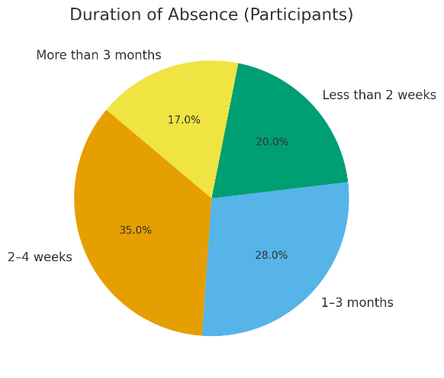
Figure 1:
While short-term absences were most common (as shown in Figure 1), nearly half the sample experienced absences lasting longer than one month (UK Government, 2024). These longer periods are critical because they often require greater support for reintegration (Health and Safety Executive, 2024). Employees absent for over three months, in particular, face physical, psychological, and social challenges upon returning, which necessitates structured planning and tailored interventions (UK Government, 2021).
Waddell and Burton (2006) emphasise that prolonged absence significantly increases barriers to returning, both in terms of physical recovery and confidence. Their research demonstrates that employees with long absences are at higher risk of delayed or unsuccessful reintegration without structured support mechanisms.
Figure 2:
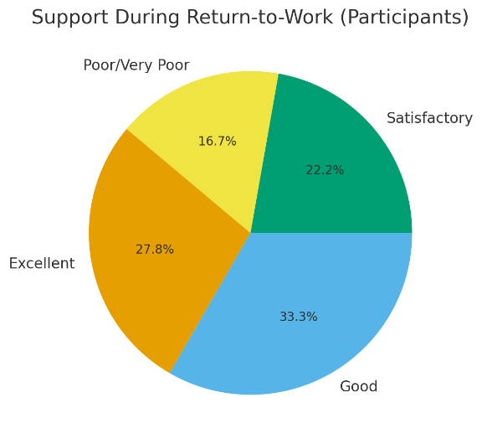
Over half of respondents described their RTW support as good or excellent, indicating positive organisational practices (as shown in Figure 2). However, a sizeable minority reported neutral or poor experiences, suggesting inconsistency across departments. Qualitative comments highlighted phased returns and supportive managers as particularly helpful. Conversely, lack of clarity and communication were frequently cited as barriers to a smooth reintegration.
Shaw et al. (2008) found that structured RTW programme and proactive communication significantly improve employee satisfaction and wellbeing during reintegration. Their research underscores the importance of clarity and ongoing dialogue, echoing employee feedback from this survey.
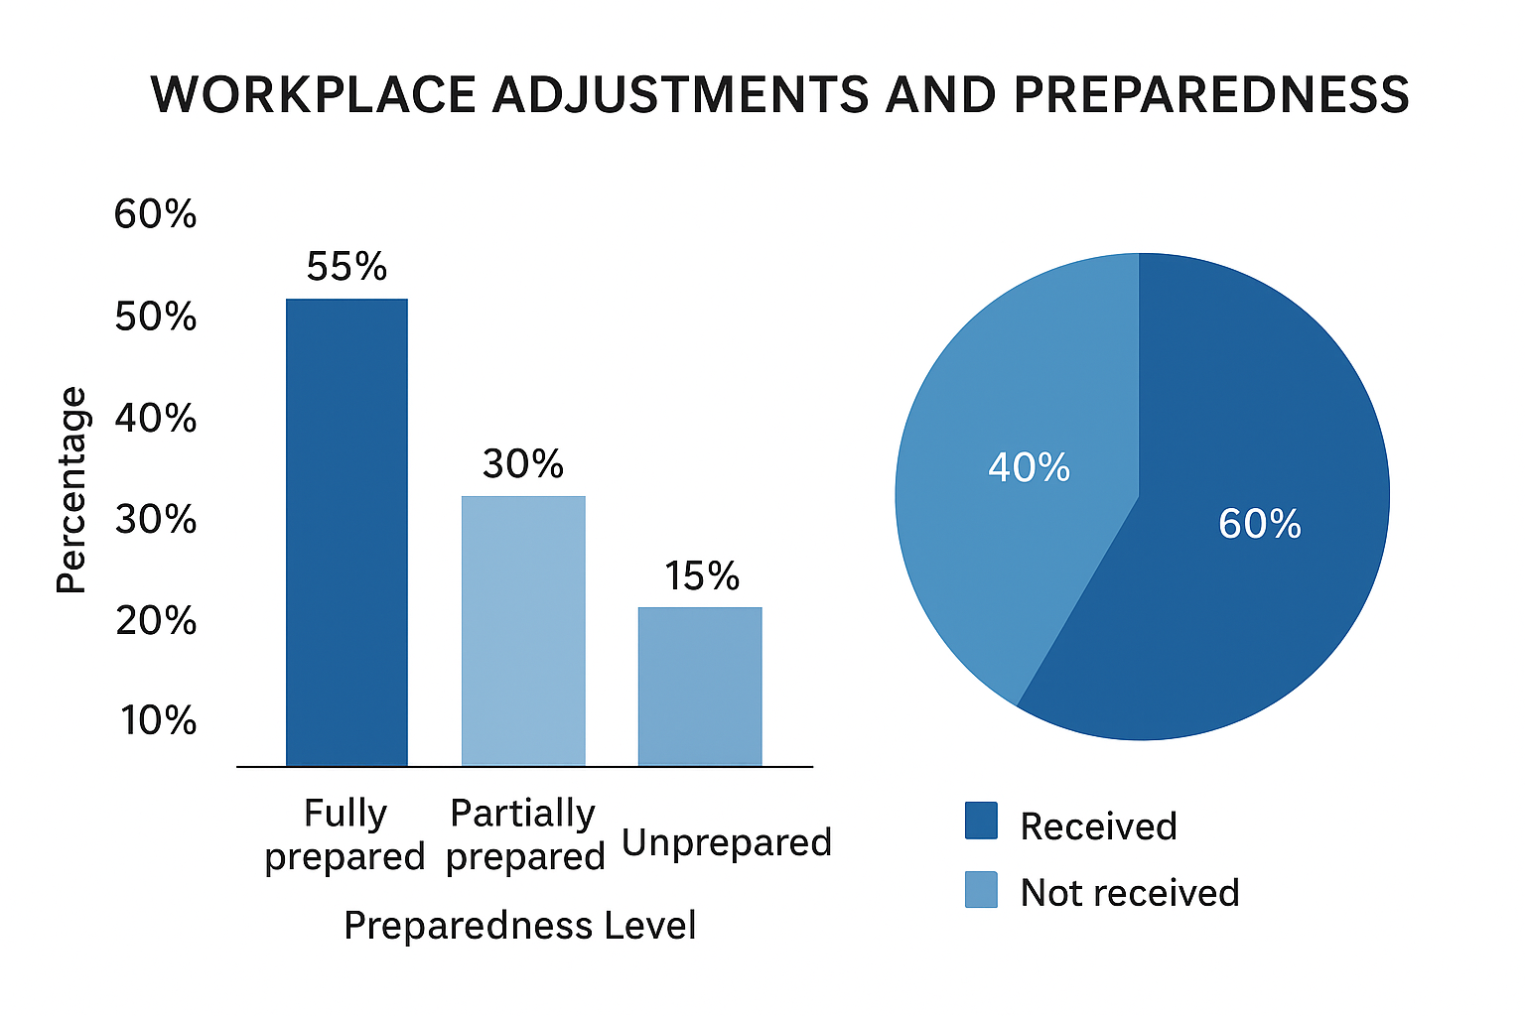
Figure 3:
While most employees received adjustments such as ergonomic support, modified duties, or phased hours, preparedness varied (as shown in Figure 3). Employees in physically demanding roles were more likely to feel partially prepared or unprepared, revealing inequities in how support is applied. These differences point to the need for consistent pre-return assessments and tailored adjustment plans.
Over half of participants described their RTW support as good or excellent, indicating positive organisational practices. However, a sizeable minority reported neutral or poor experiences, suggesting inconsistency across departments. Qualitative comments highlighted phased returns and supportive managers as particularly helpful. Conversely, lack of clarity and communication were frequently cited as barriers to a smooth reintegration.
Nieuwenhuijsen et al. (2013) demonstrate that workplace adjustments are strongly linked with sustained RTW outcomes, particularly for employees with physical limitations, as such adaptations reduce the likelihood of relapse or further absence. Extending this argument, inclusive management styles that recognise neurodiverse needs are increasingly more to effective reintegration, as supportive managers can tailor communication, flexibility, and phased returns to individual requirements (Branicki et al., 2024). By contrast, rigid or inconsistent managerial practices may exacerbate difficulties, highlighting the importance of equipping line managers with both awareness and resources to deliver consistent, equitable support across departments.
Figure 4: Involvement in Planning and Communication

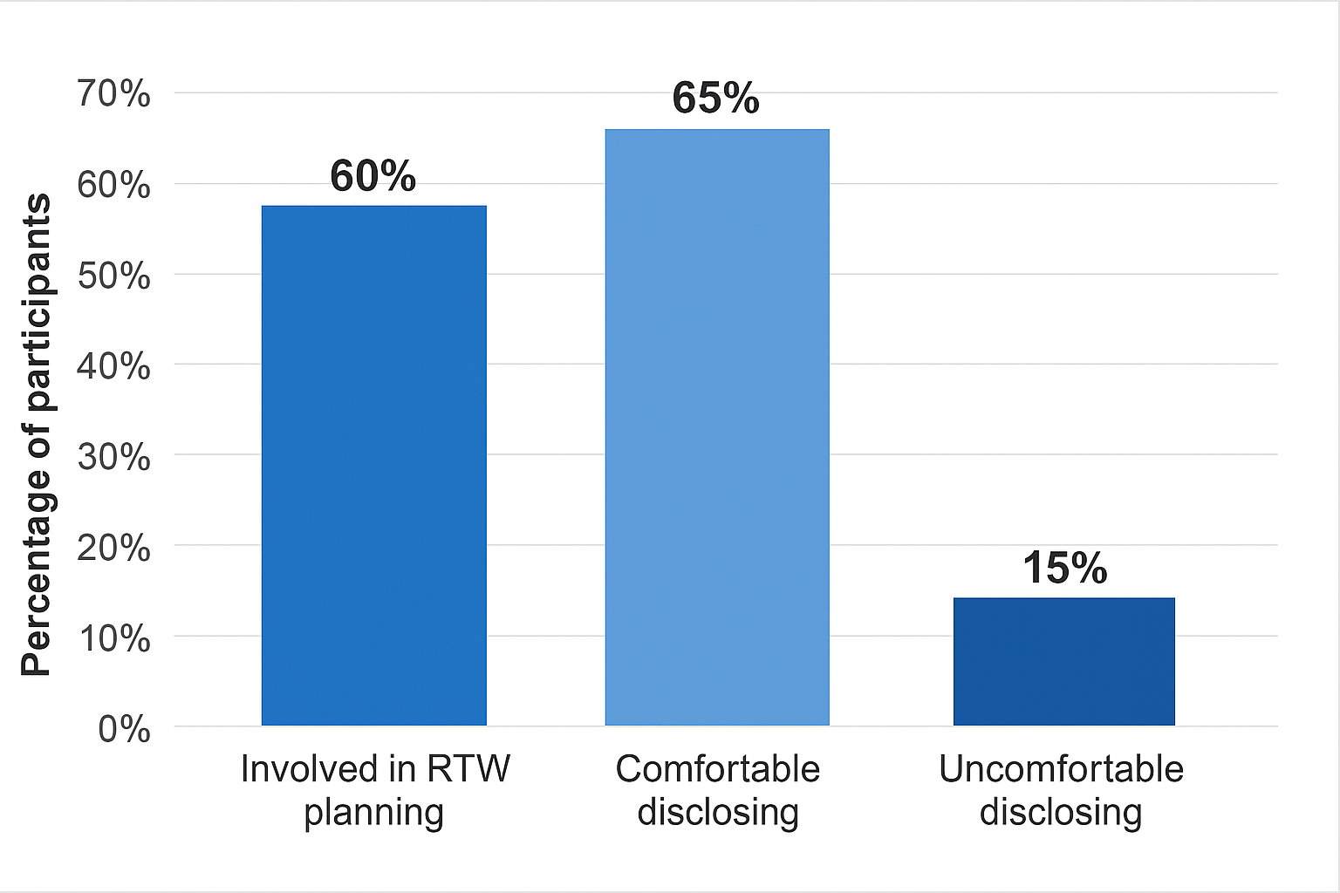
The majority of employees were included in RTW planning discussions, which is positive (as shown in Figure 4). However, a significant minority were excluded, and many reported they would have benefited from clearer communication and structured planning. Concerns around disclosure also surfaced: while most were comfortable sharing limitations, some withheld information due to fears of judgment or negative career impacts.
Carroll et al. (2010) highlight that employee involvement in RTW planning enhances satisfaction, motivation, and reintegration outcomes. Cullen et al. (2018) further demonstrates how stigma can discourage employees from disclosing health limitations, undermining the effectiveness of RTW arrangements.
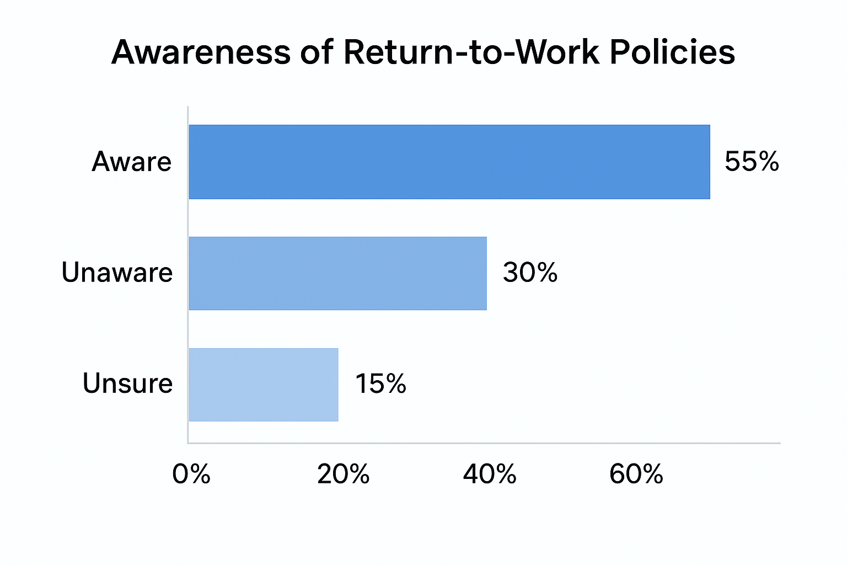
Figure 5:
Nearly half of participants were not clearly aware of RTW policies (as shown in Figure 5). This lack of awareness creates inconsistency in practice, with some employees relying on supportive managers while others navigate the process with limited guidance.
5.2 Research Link: MacEachen et al. (2006) argue that poor communication of RTW policies leads to fragmented practices across organisations. Their findings stress the need for transparent policy dissemination and training to ensure consistent application across departments
5.3 Reflective Feedback
Employees praised supportive managers, phased returns, flexible hours, colleague support, and regular check-ins. These practices reduced stress and aided gradual reintegration. Positive feedback reinforces the importance of interpersonal support and flexibility in the RTW process.
Common issues included heavy workloads, unclear policies, fatigue, and difficulty readjusting. Long-term absentees particularly struggled with stamina and workload management. The findings highlight gaps in structured support, particularly for employees returning after long absences.
5.4 Perceptions of Organisational Commitment to Wellbeing
65% of participants perceived strong organisational commitment to wellbeing, while others highlighted inconsistencies between departments. The majority view is encouraging, but disparities between teams suggest uneven implementation of wellbeing practices, undermining trust and equity.
- Conclusion
Overall, the survey results reveal a workforce with diverse experiences of returning to work. While many employees reported supportive managers, phased returns, and helpful adjustments, challenges such as inconsistent communication, lack of policy awareness, and uneven departmental practices remain. Research consistently shows that structured planning, transparent communication, and equitable implementation of policies are critical for successful reintegration. By addressing these gaps, the organisation can improve employee wellbeing, enhance return-to-work outcomes, and strengthen its reputation as a supportive employer.
- Infographic
Introduction
Castell Howell Foods growth reflects operational expansion and a sustained focus on workforce wellbeing integral to the organisation’s values. It holds a reputation for combining commercial success with ethical business practices, emphasising employee development, community engagement and environmental sustainability. The focus underpins the organisation’s long-term strategic vision and its ability to adapt to evolving foodservice sectors.
Effective return to work (RTW) processes are a critical component of organisational management, enabling employees recovering from illness, injury or medical treatment to reintegrate. Processes safeguard physical and mental health while supporting business continuity, efficiency and staff morale (Black and Frost, 2011). Recently Castell Howell Foods has reported increasing levels of health-related absence, inconsistencies in structure, delivery and communication have been observed, which may reduce the overall effectiveness of the RTW process.
Literature Review
The RTW process is shaped by theoretical models such as the biopsychosocial framework and Organisational Support Theory (OST), which emphasise the interaction between individual health, workplace structures and perceived organisational support (Eisenberger, 1986). Although conceptually robust, frameworks are often insufficiently translated into practical workplace strategies. Research by the Health and Evidence Exchange Centre (2025) highlights the effectiveness of coordinated, individualised and collaborative interventions, yet it assumes access to resources such as dedicated RTW coordinators, which are seldom available in medium-sized, labour-intensive firms like Castell Howell. Similarly, Hanson et al. (2024) illustrate how workforce shortages, pressures and cultures can undermine theory, emphasising the need for tailored context-specific solutions.
Mental health studies highlight the importance of managerial competence, support and organisational backing for successful reintegration (Olsson et al., 2025; Rhoades and Eisenberger, 2002). Communication and proactive engagement by line managers are pivotal, yet production-oriented firms face challenges as operational demands may conflict with employee welfare considerations, a tension often underestimated in the literature. Sustainability warrants attention, as conventional RTW measures, such as return dates, often overlook long-term functional outcomes, including ongoing wellbeing, retention and productivity (Beekman, 2023). While Castell Howell’s policies align with HSE and ACAS guidance, secondary data suggest that implementation can vary due to managerial capacity and operational pressures. Literature reinforces the principles of coordination, individualisation, support and sustainability, highlighting the gap between theory and practice.
Methodology
This research adopts a pragmatic philosophy, prioritising practical outcomes and application of knowledge to real context (Bryman, 2016). Pragmatism allows flexibility around questions and context. Any quantitative strategy measures key variables, identifies trends and generates insights on RTW. (McNeill and Chapman, 2005; Stokes and Wall, 2014).
Primary data were collected via a questionnaire distributed to the workforce, capturing employees’ experiences of RTW. Survey items examined satisfaction with procedures, perceptions of support, adjustment adequacy and communication. Closed-ended questions ensured consistency in responses, while limited open responses provided additional context, enhancing reliability (Bryman, 2016). A total of 102 responses were received, representing a substantial proportion of the workforce. Data were analysed using descriptive and comparative statistics, filtered to include only employees with RTW experience. Ethical approval was secured.
Limitations include the single-organisation focus, reliance on self-reported data and the absence of extensive qualitative insights, which restrict analytical depth and external generalisability. Validity was strengthened through alignment with theoretical frameworks, triangulation with secondary HR data and consistency checks across survey responses.
Key Findings
Respondents reflected diverse roles (Fink, 2017; Black, 2008). Nearly half reported absences greater than one month, highlighting the need for tailored reintegration support (UK Government, 2024; Waddell and Burton, 2006).
Over half of employees rated RTW support as good or excellent, citing phased returns and supportive line managers as key enablers. Nonetheless, inconsistencies were evident, with some respondents reporting unclear communication and ambiguous processes (Shaw et al., 2008). Workplace adjustments were provided to 60% of employees, although preparedness varied, particularly in physically demanding roles, highlighting inequities in support delivery (Branicki et al., 2024). Employee involvement in RTW planning was reported by 60%, stigma led some to withhold disclosure of limitations (Carroll et al., 2010; Cullen et al., 2018). Nearly half of respondents were unclear on RTW policies, emphasising the need for improvement (MacEachen et al., 2006).
Conclusion
Effective RTW at Castell Howell Foods relies on structured policies, competent managerial support and active employee involvement. While many employees experienced phased returns, workplace adjustments and supportive managers, inconsistencies in communication, policy awareness and preparedness were evident. Transparent communication, tailored interventions and equitable implementation are essential. Consistent, people-focused practices can enhance wellbeing, reduce barriers to RTW, improve retention and strengthen organisational trust. Overall, this study demonstrates the importance of combining theory with context to improve reintegration outcomes in medium-sized, labour-intensive workplaces.

Reference List
ACAS (2023) Managing sickness absence. London.
Anderson, V., Fontinha, F. and Robson, F. (2019) Research methods in human resource management: investigating a business issue. 4th edn. London: Kogan Page.
Becker, A., de Rijk, A., Engels, J. and Verbeek, J. (2024) ‘Cross-national perspectives on structured return-to-work procedures: the role of social security systems’, International Journal of Occupational and Environmental Health, 30(2), pp. 145–158.
Beekman, J. (2023) ‘Measuring sustainable return-to-work: beyond time-to-return metrics’, Journal of Occupational Rehabilitation, 33(1), pp. 12–25.
Black, C. (2008) Working for a healthier tomorrow. London.
Black, C. and Frost, D. (2011) Health at work – an independent review of sickness absence. London: The Stationery Office.
Branicki, L., Stebbings, S. and Hughes, B. (2024) ‘Neurodiversity and workplace reintegration: inclusive managerial practices for sustained return-to-work’, Work, Employment and Society, 38(1), pp. 55–74.
Brown, J., Mackay, D., Demou, E., Craig, J., Frank, J. and Macdonald, E.B. (2015) ‘The EASY (Early Access to Support for You) sickness absence service: a four-year evaluation of the impact on absenteeism’, Scandinavian Journal of Work, Environment & Health, 41(3), pp. 204–215.
Bryman, A. (2016) Social research methods. 5th edn. Oxford: Oxford University Press.
Cameron, E. and Green, M. (2020) Making sense of change management: a complete guide to the models, tools and techniques of organizational change. 5th ed. London: Kogan Page.
Carroll, C., Rick, J., Pilgrim, H., Cameron, J. and Hillage, J. (2010) ‘Workplace involvement improves return-to-work outcomes: a systematic review’, Occupational Medicine, 60(7), pp. 499–508.
CIPD (2022) Health and wellbeing at work survey. London: Chartered Institute of Personnel and Development.
CIPD (2023) Managing a return to work after long-term absence: guidance for people professionals. London: Chartered Institute of Personnel and Development.
Cullen, K., Irvin, E., Collie, A., Clay, F., Gensby, U., Jennings, P., Hogg-Johnson, S., Kristman, V., Laberge, M., McKenzie, D., Newnam, S., Palagyi, A., Ruseckaite, R. and Sheppard, D. (2018) ‘Effectiveness of workplace interventions in return-to-work for musculoskeletal and mental health conditions: an updated systematic review’, BMJ Open, 8(7), e019312.
Cynnal Cymru (2023) Sustainable food supply chains in Wales: pilot projects with Castell Howell Foods. Cardiff: Cynnal Cymru.
Eisenberger, R. (1986) ‘Perceived organizational support’, Journal of Applied Psychology, 71(3), pp. 500–507.
Fink, A. (2017) How to conduct surveys: a step-by-step guide. 6th edn. London: SAGE Publications.
Finnes, A., Enebrink, P., Ghaderi, A., Dahl, J., Nager, A. and Öst, L.G. (2019) ‘Psychological treatments for return to work in individuals on sickness absence due to common mental disorders or musculoskeletal disorders: a systematic review and meta-analysis of randomized-controlled trials’, International Archives of Occupational and Environmental Health, 92(3), pp. 273–293.
FUW (2024) Castell Howell Foods celebrates success and growth. Available at: https://fuw.org.uk/ (Accessed: 15 September 2024).
Grant, M., Rees, S., Underwood, M. and Froud, R. (2019) ‘Obstacles to returning to work with chronic pain: in-depth interviews with people who are off work due to chronic pain and employers’, BMC Musculoskeletal Disorders, 20(1), p. 1.
Hanson, C., Kofie, H., Mohammed, A. and Owusu, G. (2024) ‘Feasibility of physiotherapist-led education for return-to-work in Ghana: a pilot study’, International Journal of Rehabilitation Research, 47(2), pp. 101–110.
Health and Safety Executive (2004) Managing sickness absence and return to work: an employers' and managers' guide. London: HSE Books.
Health and Safety Executive (2023) Managing sickness absence and return to work. London: HSE.
Health and Safety Executive (2024) Work-related ill health and sickness absence statistics. London: HSE.
Hesketh, I. and Cooper, C. (2022) Managing workplace health and wellbeing during a crisis: how to support your staff in difficult times. 1st edn. London: Kogan Page.
Hesketh, I. and Cooper, C. (2023) Wellbeing at work: how to design, implement and evaluate an effective strategy. 2nd edn. London: Kogan Page.
Hodges, J. (2021) Managing and leading people through organizational change: the theory and practice of sustaining change through people. London: Kogan Page.
Holbeche, L. (2018) The agile organization: how to build an engaged, innovative and resilient business. 2nd ed. London: CIPD Kogan Page.
Hooftman, W.E., et al (2014) ‘Sustained effectiveness of return-to-work interventions: a systematic review’, Occupational and Environmental Medicine, 71(4), pp. 245–252.
Institute of Occupational Health (2025) Monitoring long-term reintegration in the workplace. London: IOH Press.
James, C., Cunningham, I. and Dibben, P. (2018) ‘Line managers and return-to-work processes: balancing production and employee support’, Human Resource Management Journal, 28(2), pp. 267–282.
Karanika-Murray, M. and Cooper, C.L. (2018) Navigating the return-to-work experience for new parents: maintaining work-family well-being. Abingdon: Routledge.
Lencioni, P. (2007) The three signs of a miserable job: a fable for managers (and their employees). San Francisco: Jossey-Bass.
MacEachen, E., Clarke, J., Franche, R.L. and Irvin, E. (2006) ‘Systematic review of the qualitative literature on return-to-work after injury’, Scandinavian Journal of Work, Environment and Health, 32(4), pp. 257–269.
Marchington, M., Wilkinson, A. and Donnelly, R. (2020) Human resource management at work: the definitive guide. 7th edn. London: Kogan Page. (Chapter 14 in particular but also see chapters 1, 3, 7, 9 and 10 for case studies based on workforce analytics.)
Marr, B. (2018) Data-driven HR: how to use analytics and metrics to drive performance. London: Kogan Page.
McNeill, P. and Chapman, S. (2005) Research methods. 3rd edn. London: Routledge.
Moran, S. (2022) Managing employee burnout: how to develop a happy, healthy and engaged workforce. 1st edn. London: Kogan Page.
Morris, A. (2024) How to manage long term sickness absence. London: DavidsonMorris.
Nieuwenhuijsen, K., Verbeek, J.H., de Boer, A.G., Blonk, R.W. and van Dijk, F.J. (2008) ‘Supervisory behaviour as a predictor of return-to-work in employees absent due to mental health problems’, Occupational and Environmental Medicine, 65(11), pp. 804–809.
Nieuwenhuijsen, K., Verbeek, J.H., de Boer, A.G., Blonk, R.W. and van Dijk, F.J. (2013) ‘Workplace interventions for employees with mental health problems: a systematic review’, Occupational and Environmental Medicine, 70(12), pp. 927–934.
Popa, A.E., Akgüç, M. and Amir, Z. (2022) ‘Return to work following long term sickness absence: a comparative analysis of stakeholders’ views and experiences in six European countries’, Journal of Occupational Rehabilitation, 33(1), pp. 213–225.
Rhoades, L. and Eisenberger, R. (2002) ‘Perceived organizational support: a review of the literature’, Journal of Applied Psychology, 87(4), pp. 698–714.
Robart, R. and Boyle, P. (2021) ‘Supporting workers with lower back injuries to return to work: a meta-ethnography’, British Journal of Occupational Therapy, 84(2), pp. 93–101.
Saunders, M.N.K., Lewis, P. and Thornhill, A. (2019) Research methods for business students. 8th edn. Harlow: Pearson Education.
Shaw, W.S., Robertson, M.M., Pransky, G.S. and McLellan, R.K. (2008) ‘Employee perspectives on the role of supervisors to facilitate return-to-work after injury’, Journal of Occupational Rehabilitation, 18(4), pp. 377–386.
Squires, H., Rick, J., Carroll, C., Hillage, J., Drever, F., Reeves, P. and Dawson, J. (2012) ‘Cost-effectiveness of interventions to return employees to work following long-term sickness absence due to musculoskeletal disorders’, Journal of Public Health (Oxford, England), 34(1), pp. 115–124.
Stallard Kane (2023) Managing long term absence: best practices and responsibilities. London: Stallard Kane.
Stokes, J. and Wall, T. (2014) Research methods in organisational behaviour and work psychology. London: SAGE Publications.
The Grocer (2022) Castell Howell delivers 16,000 food packs to children during summer holidays. Available at: https://www.thegrocer.co.uk/ (Accessed: 15 September 2024).
Timms, P. (2020) The energized workplace: designing organizations where people flourish. London: Kogan Page.
Tjulin, A., MacEachen, E. and Ekberg, K. (2010) ‘Exploring workplace actors’ experiences of the social organization of return-to-work’, Journal of Occupational Rehabilitation, 21(3), pp. 313–321.
UK Government (2021) Managing long-term sickness absence. London.
UK Government (2024) Sickness absence in the UK labour market. London.
Waddell, G. and Burton, A.K. (2006) Is work good for your health and wellbeing? London: The Stationery Office.

