Essential academic and employment skills

Communication is a key skill in an academic and employment environment. It is vitally important because if a team has good communication they can build stronger working/ educational relationships with others and in turn are more likely to work better together. EROZKAN emphasises that “Communication is one of the most basic elements of human functioning, because it is the cornerstone of strong, healthy interpersonal relationships.” [1] The reasoning applies to academic and working situations as both involve working closely with others and in groups.
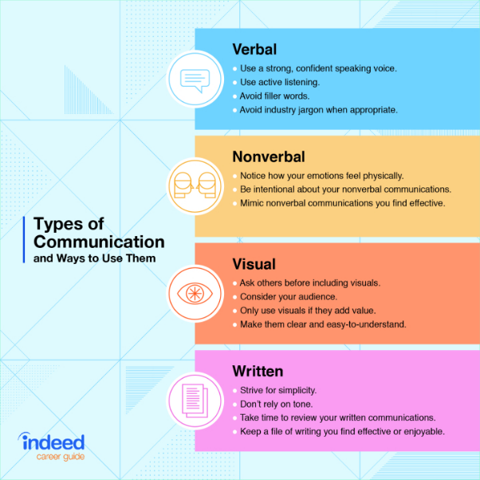
Fig.1. Types of Communication [2]
Fig .1 shows there is multiple types of communication Kumar and Latar also discuss the importance of having multiple communication skills: “It is true that of all the four skills—listening, speaking, reading and writing—reading is probably the most crucial skill.” [3].

Another important academic and employment skill is time management “as good time management helps you to use your time effectively. Prioritise work, and use diaries and charts to plan your time” [4] As mentioned by Smale in How to succeed at university: an essential guide to academic skills and personal development time management is all about making the most out of the time you have at work or in education using various methods to succeed.

Problem solving is equally as important as all other skills needed for academic and employment purposes. It is thought that [5]“An effective problem solver will take the opinions of everyone involved into account” they can then make an informed decision and then decide what steps to take next to complete the work/ project.

References

[1] | A. EROZKAN, "The Effect of Communication Skills and Interpersonal," Educational Sciences: Theory and Practice, vol. 13, no. 2, p. 7, 2013.
[2] | Indeed, "Top 10 Communication Skills for Career Success," 31 August 2018. [Online]. Available: https://www.indeed.com/career-advice/resumes-cover-letters/communication-skills. [Accessed 4 November 2022].
[3] | P. L. Sanjay Kumar, Communication Skills, New Delhi: Oxford Press, 2015.
[4] | B. Smale, How to succeed at university: an essential guide to academic skills and personal development, SAGE PUBLICATIONS, 2009.
[5] | Deakin University, "Problem solving techniques: Steps and methods," Deakin University, 29 May 2019. [Online]. Available: https://credentials.deakin.edu.au/problem-solving-techniques-steps-and-methods/. [Accessed 04 November 2022].

Similarity Score

After submitting my work to turn it in I got a similarity score of 33%. After looking through the feedback studio I can see that the only things that have been flagged as “copied” work are the quotes that I have referenced. None of my work has been flagged so in in this case I don’t think I would be able to improve the similarity score.

