

Ordinance, Munitions and Explosives

Level 4 HNC

Academic Year 2024 - 2025

Jack Burden

Systems Engineering explored using a Microwave design

This thesis is submitted in partial fulfilment of the requirements for the HNC of Ordinance, Munitions and Explosives
(NB. Remove if the degree award is based solely on examination of the thesis)

© UWTSD 2025. All rights reserved. No part of this publication may be reproduced without the written permission of the copyright owner.

Academic integrity declaration
I declare that:
- the thesis submitted has been written by me alone.
- the thesis submitted has not been previously submitted to this university or any other.
- that all content, including primary and/or secondary data, is true to the best of my knowledge.
- that all quotations and references have been duly acknowledged according to the requirements of academic research.
I understand that to knowingly submit work in violation of the above statement will be considered by examiners as academic misconduct.

Abstract
This report explores the design process of Systems Engineering up to Quality Function Deployment 2 (QFD 2). The design discussed is a microwave.

Contents
Academic integrity declaration i
Abstract ii
1 Introduction and Explanation of Systems Engineering 1
2 The Problem the Design Aims to Solve 3
3 Requirements Gathering 5
4 Requirements Analysis 7
5 Functional Importance QFD 1 10
6 Concept Generation 14
7 Concept Evaluation 16
8 Component Criticality QFD 2 20
References 24

Table of Figures
Figure 1 - V-Model diagram [1] 1
Figure 2 - Initial Requirements 5
Figure 3 - Final Requirements list 6
Figure 4 - Pairwise Comparison 7
Figure 5 - Pairwise comparison results 8
Figure 6 - Basic QFD chart structure [3] 10
Figure 7 - QFD 1 11
Figure 8 - Functional Importance Graph 12
Figure 9 - Function Metrics 14
Figure 10 - Function means analysis 16
Figure 11 - System pugh 18
Figure 12 - QFD 2 20
Figure 13 - Feature importance graph 21
Figure 14 - Prime P diagram 22

Introduction and Explanation of Systems Engineering
Systems engineering is a design philosophy with the theory of managing complex systems over their entire life cycle at the heart. From their initial concept to design, testing, mass production (in this case) and inevitable decommission. Systems engineering fathers the project from start to finish however, in this report the focus will be on the beginning of the design process.
The first stage of systems engineering is identifying the requirements from the stakeholders. In this design, there are no stakeholders, instead some microwave users have been surveyed to gauge an idea of what requirements a theoretical stakeholder would propose. It is imperative that this stage is completed accurately as these requirements will be the building blocks for the entire design.
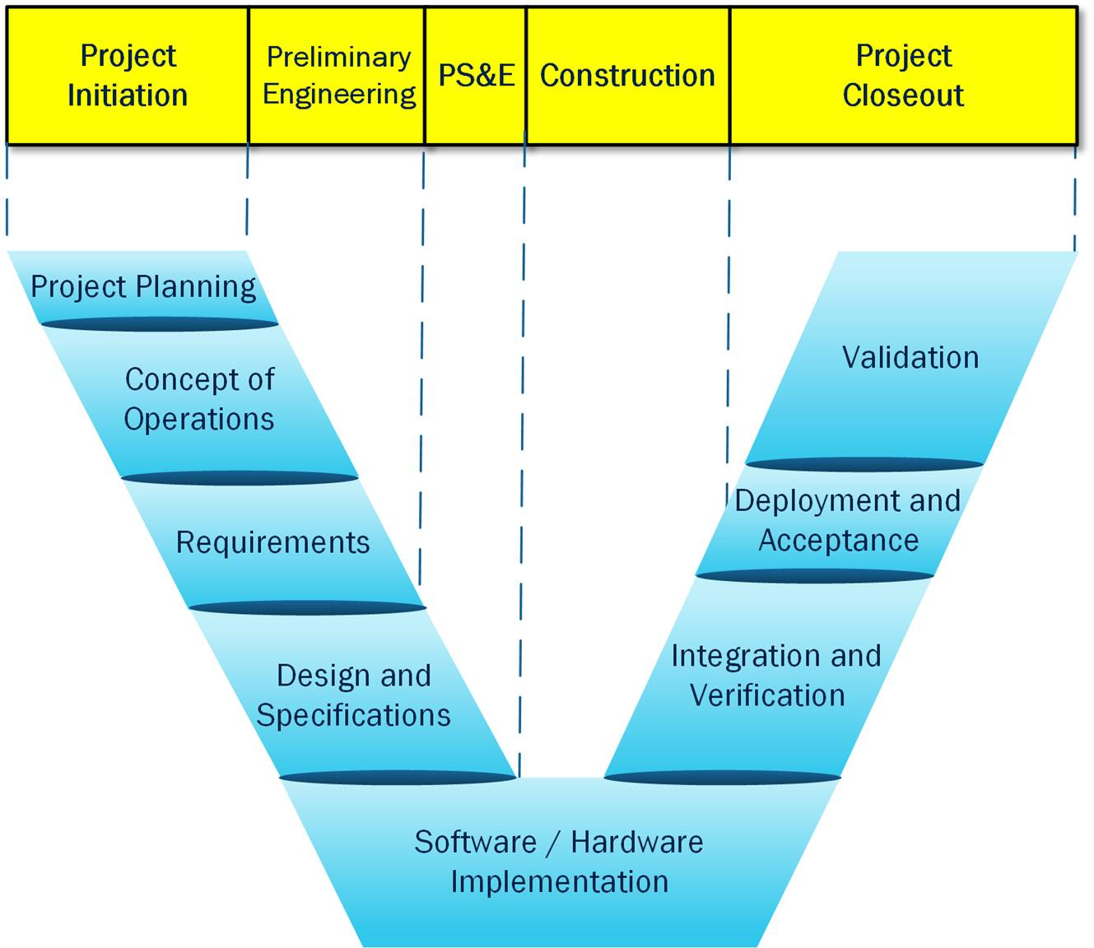
The ideology of systems engineering pioneers the breakdown of complex systems into small, more manageable subsystems. The methodology for achieving this is often visualised using models such as the V-model. This diagram makes the task of dividing complex systems much easier to understand. It also illustrates to the engineer how different components and subsystems work in unison to achieve a system’s overall objective. Please see below an example of a V-model diagram.
Figure 1 - V-Model diagram [1]

Systems engineering is an iterative and cyclical process, requiring constant testing and feedback loops to ensure that the design is at its best. The key to a successful design is to address issues early on in the development process. Systems engineering also forces engineering to compromise on trade-offs and manage risks. Changes to one subsystem can have a knock-on effect on another, it is imperative that this is managed efficiently by the design engineer during the process.

The Problem the Design Aims to Solve

The design put forward aimed to tackle the issues that arise when using a microwave. Despite a microwave having many exceptional attributes, it also has a couple of flaws that can be easily reconciliated in future models. These flaws include: uneven heating of the food, difficulty heating the inside of some food products and some models have difficulty in notifying the user when the food has finished heating. Users are the most important aspect of any design, the engineer must ensure that the users are satisfied with the system they’re designing. “The customer includes all users of the product. Customers are end users (external), manufacturing and assembly operations (internal) and service operations (external).” [2]

Uneven heating is a side effect of the heating method used in microwaves. As the microwaves move across the heating compartment, hot and cold spots develop along the waveform as the microwaves peak and trough. To counter this, current microwave models rotate the food to reduce the amount of cold spots in the food after heating. This solution does not completely remove this flaw. The design put forward aims to solve this issue by investigating other avenues of heating. However, if a different method of heating is used within this new design, is the microwave still a microwave? This question arises as the microwave gets its name from the method of heating. If the design were to use an air frying system to heat the food, would the device then become an airfryer? These questions will be discussed further in the report.
Some microwaves struggle to fully heat the inside of some foods. This stems from the lack of water molecules within certain food products. As microwaves pass through the food, they interact with the water molecules, causing them to vibrate. The action of these molecules vibrating gives off heat which heats the food. There are many ways the new design could counter this issue. The design could have an integrated mist system that releases water mist when the system detects cold spots within the food. Alternatively, the frequency of the microwaves could be tuned in real time. This would cater for the inside of the food by slowing down or speeding up the heating process to ensure all the food has been heated evenly. These potential solutions will be investigated later in the design process.
Some users cannot stay in the same room as their microwave for the entire heating process of the food. Most current microwave models have a sound alert system to notify the user when the food has finished heating. If the user is far away from the microwave, this alert will not always be heard. The new design aims to address this problem by implementing a phone application for the microwave. This would notify the user, wherever they are, that the microwave has finished heating their food. This would be convenient for some users who multi-task whilst waiting for their food to be completely heated.
These are a few examples of major flaws of the microwave that the new design will look to resolve.

Requirements Gathering

Design requirements are crucial directives that should be adhered to. These parameters are often set by the customer or a person (or business) who has a major stake in the design. There are legislations that often automatically apply to the requirements, these are outlined by law. To the best of the designer’s ability, the requirements should be fulfilled. For this design, 5 microwave users have been surveyed to get an idea of what the requirements would be from a customer standpoint.

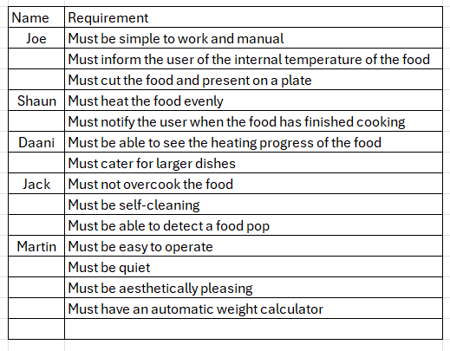
The requirements set for this design has been comprised by asking 5 individual microwave users what they would like in an ideal microwave. The requirements provided by these individuals have then been whittled down to the most impactful requirements that would aid in producing a superior model of the microwave. Please see below the full list of requirements, initially provided by these individuals:
Figure 2 - Initial Requirements

As shown in Figure 1, each of the requirements are personally catered towards individuals and their needs within their households. For example, Martin stated that he would prefer an automatic weight calculator in the microwave. This requirement could be ideal for many users however it is not solving any major problems the current microwave models have and, as a result, has been cut from the final list of requirements. Maybe this idea will be revisited later down the line but the priority at this time is to improve the major flaws discussed in Section 2. Looking into the requirements put forward by Joe, he has stated that he would prefer his microwave to cut up the food and present it on a plate. This requirement is not a priority for the new design of the microwave and will not be used as a reference when designing the improved version. This is a personal preference for Joe and this requirement does not assist in solving any of the other major issues that the new design aims to address.
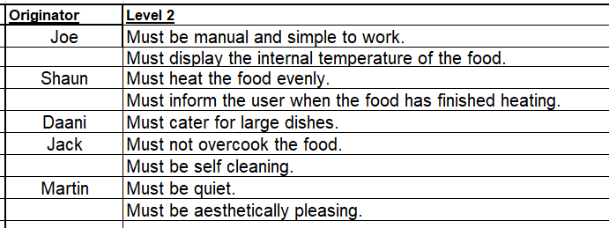
After taking the most impactful requirements from figure 1, the final requirements list that have assisted in the design of the microwave can be found below:
Figure 3 - Final Requirements list
Looking at figure 2, any requirement that involves the heating of the food will be the most impactful to the design.

Requirements Analysis

When analysing the requirements, they are ordered based on priority. This helps the design process by then being able to give precedence to more essential requirements. This priority is determined by comparing each of the requirements against all others. There are various ways to complete this comparison, however, the method used when designing this microwave was the pairwise comparison.
A pairwise comparison is a system of evaluation where each requirement is contrasted against the others. Each contrast is then given a numerical value from 1 (no preference), 2 (slight preference), 5 (preference), 9 (strong preference). These ratings then have reciprocal values that can be inputted when the requirements are compared again. The reciprocal values are 1 (reciprocal to no preference), 0.5 (reciprocal to slight preference), 0.2 (reciprocal to preference), 0.1 (reciprocal to strong preference). The numerical values given to each requirement through each comparison is then taken and used to calculate the ‘overall preference’ of the requirement.
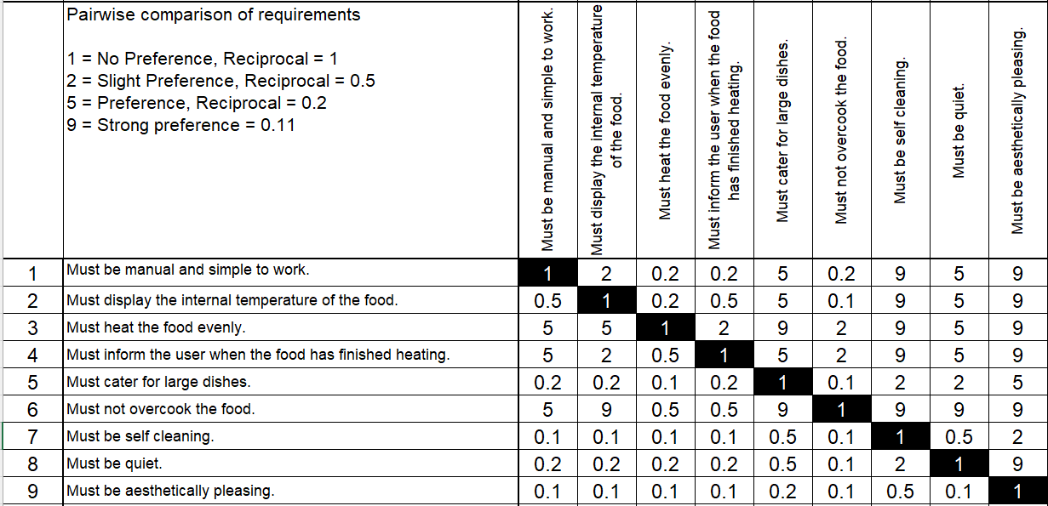
Please see below the pairwise comparison of the requirements used for this microwave design:
Figure 4 - Pairwise Comparison

In figure 3, requirement 9 has little preference against all other requirements. This is due to aesthetics of the design is not a priority over other requirements like requirement 6 or 3. Requirement 7 also has little preference as the microwave being self-cleaning is more of a luxury than a requirement for the functionality of the machine. When comparing both, requirement 7 has a slight preference. This contrast was biased towards the designer that was comparing these requirements. In reality, the preference of these requirements will not have a major impact on the design of the microwave.
Inspecting requirement 3, this requirement has an overall preference over the other requirements. Comparisons where the even heating of the food is only slightly preferred is against requirements 4 and 6. This is because ensuring the user that the food has completed heating and not overcooking the food are important attributes to a microwave almost as much as even heating is. This contrast is, again, biased towards the designer who was comparing the requirements.
In the future, to deplete the biased results of the pairwise comparison, a party of individuals should be involved in the process.
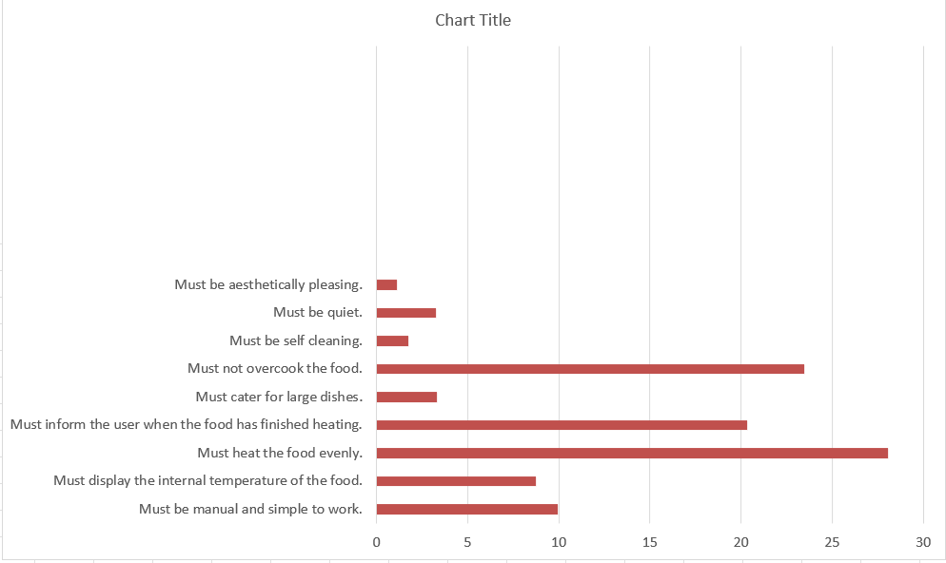
After comparing all the requirements the ‘overall preference’ of each were calculated. Please see below the results from the pairwise comparison:
Figure 5 - Pairwise comparison results
Reviewing figure 4, heating the food evenly, not overcooking the food and informing the user when the food has finished heating are the requirements with the highest preference. As a result of this fact, the design can now use this information to focus on ensuring these parameters are met with sufficient functionality. The other requirements still play a role in assisting the design, however, they are not a priority.

Functional Importance QFD 1

After comparing the requirements and discovering the order of preference, this list is then taken into QFD 1 for a second comparison. QFD 1 places the requirements set against the different functions of the microwave. “Quality Function Deployment (QFD) presents a prima facia case for being a powerful tool to aid the translation of vague, imprecise Customer Requirements into clear measurable Technical Requirements.” [3]

Figure 6 - Basic QFD chart structure [3]

The purpose of this is to uncover which function effects the most requirements. The functions are rated on their impact on each requirement. They are given a numerical value ranging from 9 (very impactful), 3 (slightly impactful) and nil (no impact). These values are then used to calculate the ‘most impactful’ function. Please see below the QFD 1 for the microwave:
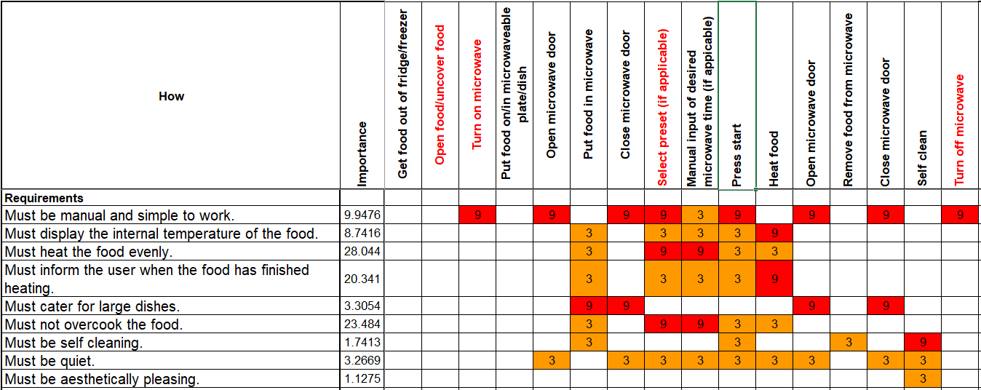
Figure 7 - QFD 1

As illustrated in figure 5, it is evident that requirement 1 (must be manual and simple to work) is impacted the most overall by the different functions of the microwave. Requirement 1 has only been rated as being slightly impacted (3) by the function (manual input of desired microwave time). This is because, despite the requirement stating that the microwave should be manual, the designer believes that the manual input for time of heating is not necessarily as simple to work as it could be. After surveying many different microwave users, it seems that a lot of users struggle to estimate the correct heating time for their food. This results in uneven heating of food and, in some cases, cold food. The designer aims to address this issue in this new design.
Investigating requirement 9 (must be aesthetically pleasing), this requirement is barely impacted by the functions of the microwave. The only slight impact on this requirement is by the ‘self cleaning’ function. The reason for this is that the requirement has impact on the exterior design of the microwave and other functions do not effect this requirement in a significant manor, the exterior design of the microwave is down to user preference. This requirement will not impact the design of the microwave.
Similarly to the pairwise comparison, the requirements that have little preference compared to the others also are minimally impacted by the functions. For example, ‘must be self cleaning’ is impacted by few functions and, referring to figure 4, is one of the least preferred requirements compared to the rest of the set.
After comparing the functions against each requirement, a functional importance graph is generated. This assists in the design of the microwave, illustrating to the designer which function has the most impact on the requirements set. Please see below the functional importance graph:
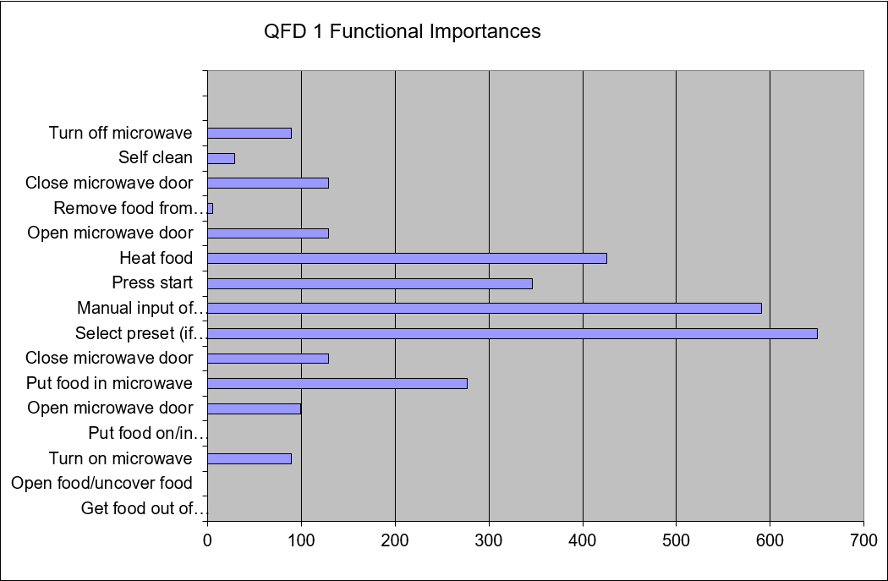
Figure 8 - Functional Importance Graph

Looking at figure 6, the function that has the most impact on the requirements set is ‘select preset’. This function will be the main focus of the design of the microwave moving forwards in the process. This function is essential to ensuring that the microwave is simple and easy to use as well as guaranteeing that the food placed into the machine by the user is evenly and sufficiently heated to the correct temperature for consuming.
The function ‘Manual input of desired heating time’ is the second most impactful function. This is because the function has multiple slight impacts on many of the requirements. As stated above, the designer aims to substitute this function for a more simplistic method.
The functions with no impact on the requirements are functions of the user, such as ‘removing food from the microwave’ and ‘opening/uncovering food’.

Concept Generation

After determining which functions have the most impact on the requirements set, the designer can develop tests that will proof these functions. The tests that have been developed, as a result of the functional importance graph (figure 6), for this requirements set are: Even heating test, Taste test, End of heating alert test, Timer test, Preset test and Start button test.
These tests are placed against the requirements in a functional metrics table. Each test is given a numerical value if the test is applicable to the requirement. To discover whether a test is applicable or not, the QFD 1 table (figure 5) can be used. If a requirement is significantly impacted by a function, the test for that function will be given a high numerical value (9) when compared to the requirement in the functional metrics table. If a requirement is not impacted at all by a function, the test for that function will be given no numerical value when compared to that requirement.
Using figure 6, we can determine that tests that involve the preset function will be applicable to most of the requirements as that function is the most impactful on the requirements set. On the contrary, functions like removing food from the microwave have little to no impact on the requirements set and, due to this, a test has not been developed for these functions. Please see below the functional metrics table for the microwave:
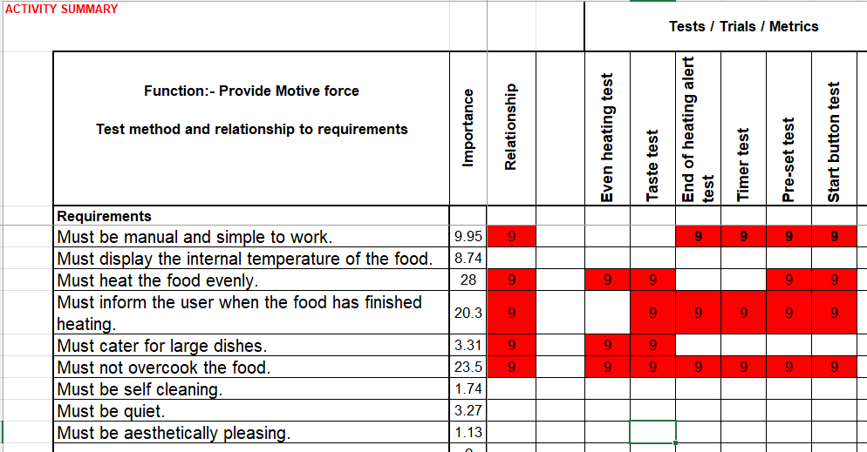
Figure 9 - Function Metrics

Inspecting figure 7, the requirement that has the most applicable tests is requirement 6 (must not overcook the food). Interestingly, this requirement is not the most important requirement, that was determined during the pairwise comparison (see figure 4), however, it is evident that a lot of the functions of the microwave effect this particular requirement. Despite it not being the most important requirement, it is essential that it is not overlooked during the design process as overcooking the food would negate the main purpose of a microwave.
Requirement 3 (must heat the food evenly) is the most important requirement however, the only tests that are applicable to this requirement are the tests that are bread from the heating functions of the microwave. Even though it is important during the heating process to alert the user when the food has completed heating, it does not directly effect the heating of the food (hence why that test is not applied to this requirement). This requirement will still be an essential focus during the design process but it will not influence the evolution of other functions that are not applicable.
The requirements that have no tests applicable to them are the least important requirements, they will not effect the development of the functions by any significant margin. Despite these requirements being set by the users surveyed, they rely heavily on user preference and will not be the focused on by the designer moving forwards in the process.

Concept Evaluation

When developing a design, it is key to investigate many different avenues and solutions to solving problems. With this aspect in mind, the designer can explore variating methods to enable the functions of the microwave. One way of achieving this is to use a function means analysis.
A function means analysis consists of listing all the functions of a design and generating different methods of completing the function. Once all of these different methods are listed in front of the designer, they evaluate each solution and determine which would fit the design the best. Other variables also effect this decision, for example: a solution for heating the food is using a gas system, however, if the microwave is powered by electricity, this increases the risk of accident as a gas leak from the gas system could result in the microwave setting alight and, therefore, if the microwave is powered by electricity, heating the food using a gas system would not be an ideal solution.
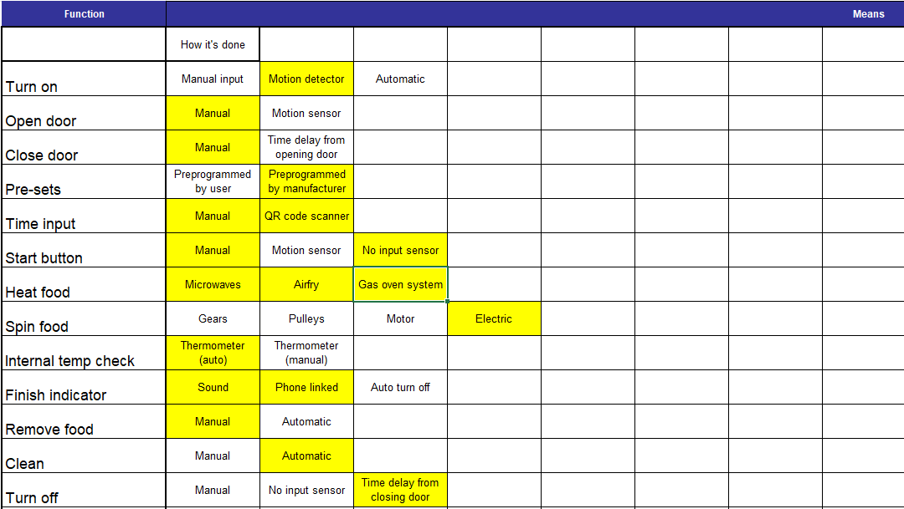
Considering all of the factors that influence the design, please see below the function means analysis for the microwave:
Figure 10 - Function means analysis
As seen in figure 8, a minimum of two solutions to each function have been generated. Many functions can be solved by user input (manual). Some solutions have been derived from existing microwave designs but some have been innovated specifically for this design. For example, a solution for the ‘finish indicator’ is phone linked. This evolved from current microwaves producing an alert when completed. The innovation from this existing solution is that the user would not have to been in the same/adjacent rooms to the microwave withing their homes and they could still be notified that the microwave has finished heating their food. This would ensure that the user can enjoy their food whilst it is still hot.
Inspecting the function of turning on the microwave, three solutions have been proposed: Manual, Motion detector and an automatic system. Each of these solutions have their positives and negatives. For example, the motion detector solution eliminates the action of the user plugging in the microwave and flicking the switch but a negative would be that the microwave could turn on when the user simply walks past it. To counteract this negative, the designer has put forward an input detector timer that will turn off the microwave after 30 seconds if no input from the user is detected.
Some solutions in figure 8 are highlighted in yellow, this detail illustrates that this solution has been chosen for one of the design concepts that will be analysed in the next phase of design: a system pugh.

A system pugh is a method of comparing different design concepts against the requirements set. Each concept is allocated a numerical value ranging from 2 (achieved well), 1 (achieved) and 0 (not achieved). After the comparison, each concept proposed is given an overall score and whichever has the highest total, is the best design for the requirements set.
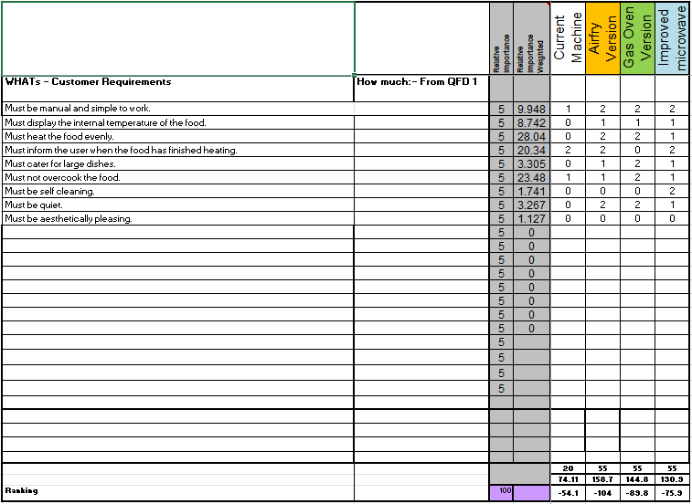
The concepts put forward are differentiated primarily by the method of heating the food. The different design concepts compared are: an air frying system, a gas oven system and an improved microwave system. Please see below the system pugh of these concepts:
Figure 11 - System pugh
Examining figure 9, the current design for microwaves is used as a control variable for the comparison as if the new concepts do not improve the current machine then the solutions for each function need to be redeveloped.
It is evident that the weakest of the concepts is the improved microwave system, scoring the lowest overall and not achieving many of the requirements well. Based on this, this concept will not be taken further.
The air fry and gas oven systems are very similar in achieving the requirements however the air fryer does appear to be the best choice. As stated earlier in the report, there are dangers to the machine and the user when using a gas oven system alongside electricity, this is also a factor as to why this concept has not been chosen.
Using the results from figure 9, the designer will be moving forwards in the design process with the air frying heating system in place of the conventional microwave system.

Component Criticality QFD 2

After comparing the design concepts and discovering the superior version, the design features from this concept are then taken into QFD 2 for another comparison. QFD 2 places the desired design features against the different functions of the microwave. The purpose of this is to unveil which design feature effects the most functions. The design features are rated on their dependence on each function. They are given a numerical value ranging from 9 (very dependant), 3 (slightly dependant) and nil (not dependant). These values are then used to calculate the ‘most dependant’ design feature. Please see below the QFD 2 for the air frying design for the microwave:
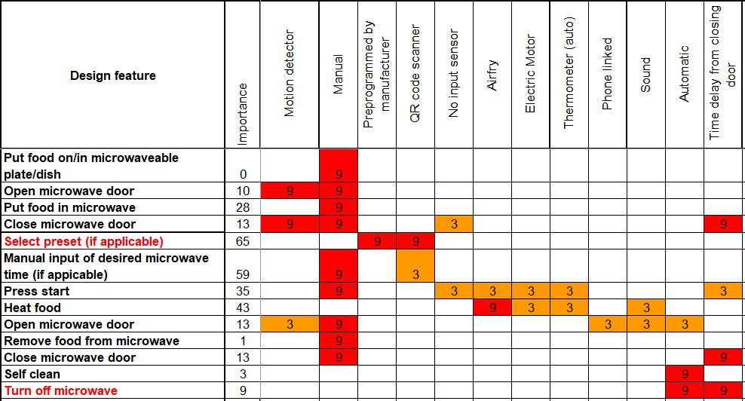
Figure 12 - QFD 2
Looking at figure 10, it is obvious that many of the functions of a microwave still depend heavily on manual user input. Many of these functions cannot be adapted to relieve the user, however, some of them can be. For example, Closing the microwave door could be done by motion sensor or time delay.
A design feature that effects only a couple of functions is the air frying system. Even though this feature only effects a few functions, that does not mean it is not imperative to the design. If the air frying system is eliminated from this design, then the food would not be heated. It was established earlier in the design process that the air frying system is the best heating system for this requirements set (referring to figure 9).
Based on the results of QFD 2, a feature importance graph can be generated to portray to the designer the most important design feature. Please see below the feature importance graph for this design:
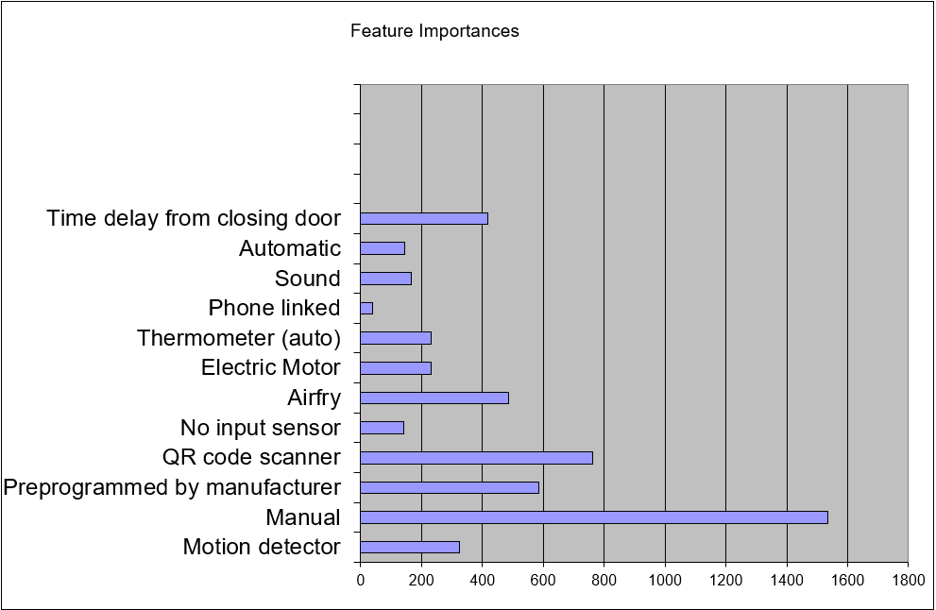
Referring to figure 11, the most important design feature is the manual input from the user. Second to that is the QR code scanner. The QR code scanner would scan the QR code from a store-bought item and would search a database with all of the heating information for the correct heating time to ensure that the specific food item is heated sufficiently for the user.
Figure 13 - Feature importance graph
Design features with a high importance level would be designed to be robust to ensure that fundamental functionality of the machine is not compromised. It is essential to make sure that design features that have many functions dependant on them will not breakdown easily.

Next the designer must produce a Prime P diagram. The purpose of this diagram is to illustrate the different factors that effect the machine. Please see below the Prime P diagram for this microwave design:
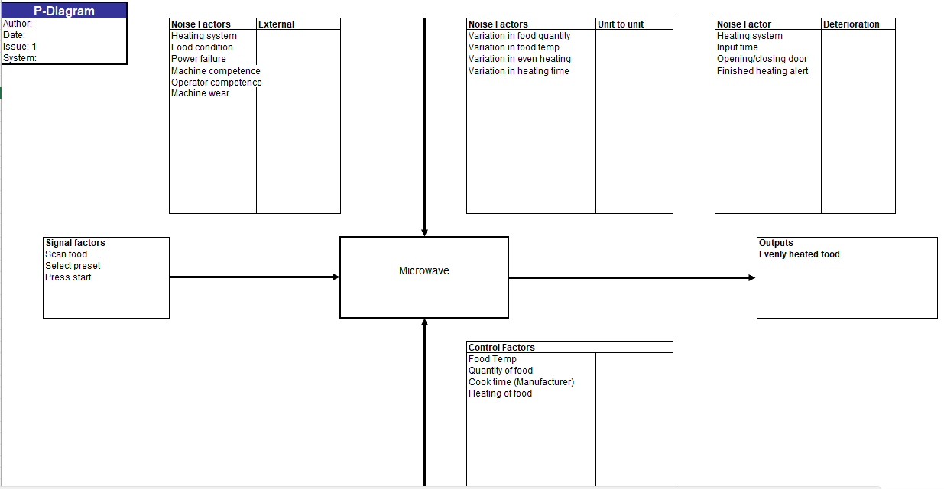
Inspecting figure 12, different factors that are a ramification of the microwave being used are visualised. These factors are: Signal factors, Control factors, Outputs and Noise factors (external, unit to unit, deterioration).
Figure 14 - Prime P diagram
Signal factors are inputs that signal to the microwave that the machine is about to be used, like ‘selecting preset’. Control factors are controlled by the microwave and the user. A control factor that is controlled by the microwave is heating the food, whereas the quantity of food being heated is controlled by the user. Outputs are the outputs of the microwave: evenly cooked food.
Noise factors can affect the microwave in different ways. The majority of noise factors that affect microwaves can be whittled down and distributed in three separate categories. External noise factors are activities outside of the microwave system that directly affect the ability of the machine carrying out its purpose, such as power failure. Unit to unit noise factors are issues that emerge from mass production of the design that indirectly affect the usefulness of a particular machine. An example of this would be variation in even heating of the food. Deterioration noise factors are problems that arise from wear of the internal systems of the microwave over time. For example, the heating system may not heat as quickly as initially designed 5 years after initial use.
The Prime P diagram depicts to the designer the ‘bigger picture’ of the design process. Issues that are not initially thought up during the design process will inevitably haunt the design during mass production. These issues need to be considered by designers to ensure that the affects these factors have on the machine are depleted to have minimal impact on the design.

References
[1] FHWA. Federal Highway Administration. (2007, August), Systems Engineering Life Cycle Models [online]. Available: https://ops.fhwa.dot.gov/seits/sections/section2/2_7.html (accessed on 03/05/2025)
[2] SAEI. Surface Vehicle Standard International. “Potential Failure Mode and Effects Analysis in Design”, Design FMEA, issued 1994-07, page 3, 2009-01.
[3] Dr S. Burge. “A Functional Approach to Quality Function Deployment”, A Functional Approach to QFD, Publisher: Burge Hughes Walsh. January 2007.

