University of Wales Trinity Saint David School of Engineering

Electronic Ignition & Fuel Injection Systems
Electrical Control Systems (ACHA4010)

Maximillian McGowan-Bunting
2104314

12/04/22
Contents
1 Introduction 1
2 Literature Review 2
3 Methodology 4
3.1 Health and Safety 4
3.2 Experimental Procedure 4
3.2.1 Equipment Used: 4
3.2.2 Test Setup 4
3.2.3 Jetronic (LE3) tests 5
3.2.4 Motronic tests 6
4 Analysis 7
5 Conclusions 10
6 References 11
7 Appendices 13
7.1 Motronic data 13
7.1.1 scope patterns 14
7.2 Jetronic data 19
7.2.1 Scope patterns 19

Introduction
This report aims to understand two Bosch engine control systems, the Motronic system and the Jetronic system. The function of these systems is to manage engine performance and emissions; the practical investigation was carried out to apprehend the role of the plethora of sensors used in engine control.
The two primary responsibilities of the electronic control systems are fuel delivery and ignition. The ECU is designed to interpret the data collected by all the sensors and adjust the engine’s running conditions in real-time, both by user input and environmental conditions.
The fuel delivery system’s primary role is to provide an accurately metered amount of fuel at the correct time in the four-stroke cycle. This is achieved by the ECU using the information gathered from the sensors and comparing them to stored data within the ECU, ensuring the best performance and lowest emissions possible for every situation.
The ignition system also uses sensors to determine its method of operation. The ignition system’s role is to ensure that the spark is delivered to the combustion chamber at the correct time in the engine’s cycle.
As well as gaining an understanding of the operation of these systems, this report endeavours to provide an overview of the investigation and testing process, the data gathered from these investigations will be used to compare and contrast the two systems and also suggest possible improvements to the systems, which would improve efficiency, performance and emission control.

Literature Review
Traditionally engines worked like clockwork, entirely mechanical creations, fuel delivery controlled by carburettors, and ignition and timing handled by a mechanical distributor. While engines are still primarily mechanical, the control systems in charge of fuel delivery, timing and ignition are now controlled by an electronic control unit (ECU) (Jia, Guo & Wang, 2018).
With the modern focus on emission control, changes to traditional engine design needed to be made. One main contributor to high engine emissions is non-ideal air to fuel mixture (Milton, 1998). Engines produce many compounds hazardous to health, the majority of which result from incomplete combustion of the charge mixture (Burr and Gregory, 2011). Therefore, a reactive and variable fuel delivery system is required as carburettors cannot make changes based on the amount of load, engine speed or temperature. In contrast, ECUs use many sensors to create a more accurately metered fuel delivery system.
While fuel delivery is a fundamental element in the function of an ICE, it must perform symbiotically with the ignition system to allow the proper operation of the engine. The role of the ignition system is to provide a spark to the fuel mixture to initiate combustion at precisely the right time in the engine’s cycle (Dell, Moseley and Rand, 2014). Again, the ECU uses multiple sensors to ensure that the ignition system is operating correctly and in time.
An extremely high voltage is required to produce a spark, somewhere in the 8-20kV range (Denton, 2006). The system used by both the Jetronic and Motronic systems is the Kettering coil, which acts as a transformer, using a primary winding, which has fewer windings of thicker wire than the secondary, which has many more windings of a much thinner wire. A current flowing through the primary winding causes a magnetic field to be created. When the current is interrupted either by a points and condenser system or by the ECU, this causes the magnetic field to collapse, resulting in a high voltage but low current in the secondary winding; this is then sent to the distributor, which then sends the high voltage to the spark plug (Bosch automotive electrics and electronic handbook, 2005).
In an ideal world, the spark would ignite the fuel and air mixture instantaneously, allowing the ignition to be set at top dead centre (TDC), this is not the case however, and the fuel takes time to burn meaning that the ignition needs to be set before top dead centre, this is known as ignition advance. At idle most engines have about 5-20˚ of ignition advance (Perkins, 2016). As the revs increase, even more, advance is needed to allow for a complete burn of the fuel. There are multiple ways this can be achieved. Early engines had a manual system, where the operator chose the appropriate amount of advance. More recent engines that used a distributor would have either a vacuum system or a centrifugal weight system where the increased revs would advance the ignition automatically. Today, engines used in most road vehicles use a distributor-less system, and the ECU controls the ignition advance.

Methodology

Health and Safety
The workshop can be a dangerous environment if proper procedure is not followed, and risk mitigation is not given due care. A workshop induction needs to be completed before entering; this way, everyone is familiar with the rules and procedures. Safety boots must be worn in the workshop to protect the wearer’s feet from potential injury caused by falling heavy or sharp objects. Dust coats are also recommended; this is primarily to protect the wearer’s clothes and skin from contaminants but has the added benefit of being easily removable in the case of fire or close contact with hazardous materials. COSHH procedures are followed to reduce the risk of contact with hazardous materials, and any oils and fuels are stored securely away from the test site.
When testing the engines, the main risks are carbon monoxide poisoning from the exhaust gasses and injury caused by entanglement with the engine's moving parts. To attenuate these risks, an exhaust extraction system is employed, and the engine is switched off whenever possible. Any moving parts on the engine, such as exposed belts and rotating components, are covered with guards, and a check is performed before starting the engine to ensure that nobody is touching it or too close.
Another risk associated with the testing of engines is due to the electrical systems. They bring a risk of fire, burns, explosions and electrocution. To keep a high safety standard, conductive jewellery should be removed, and any loose connections or exposed wiring should be addressed.

Experimental Procedure

Equipment Used:
- Vauxhall Montronic test engine
- Vauxhall LE3 test engine
- Multimeter
- Bosch universal oscilloscope

Test Setup
For the convenience of testing, the engines are set up on wheeled stands. The test rigs are self-contained and have their own fuel tanks and batteries. The electronic control units (ECUs) are mounted in a convenient location to allow Multimeter access to all the pins. Both engines should be serviced before testing is carried out, and any running issues rectified. During this test, the Jetronic (LE3) engine had some running issues which were unable to be addressed before the test which may cause discrepancies in the collected data. The first stage of testing for both engines is to set up the measuring equipment. The oscilloscope is turned on. The positive and negative leads are connected to their respective terminal of the engine’s cranking battery. The negative lead for the test probes is connected to a quality earth. The dipstick is removed, and the temperature probe’s length is adjusted to suit before being inserted into the dipstick tunnel.

Jetronic (LE3) tests

Static Testing
These tests were performed before starting the engine while the engine was cold.
- All the pins on the ECU were tested for voltage with both the ignition on and off.
- The throttle potentiometer was then resistance tested, between pins 2 & 18 and pins 3 & 18.
- The airflow sensor was also resistance tested, between pins 4 & 3 and pins 2 & 3.
- Finally, the injector’s resistance is tested between the two pins.

Dynamic Testing
- Using the oscilloscope, the injector on time was measured during cold cranking at pin 3 on the ECU.
- The engine temperature was then allowed to reach 20˚C, and the injector on time was rechecked.
- The NTC2 was then resistance tested. Ensuring to resecure the plug to avoid running issues later in the test.
- The NTC2 voltage was then tested at the ECU.
- These tests were repeated in 10˚ increments up to 60˚C where the thermostat opens and starts the fan causing a drop in temperature.
- The injector on time was then checked during snap acceleration and overrun.
- The crank sensor was then tested by using the scope at the ECU
- A scope pattern comparing the primary and secondary signals is required. This is achieved by attaching the oscilloscope to the ignition amplifier and ground.
- The idle speed scope pattern is acquired by attaching the scope probe to pin 5 on the ECU
- Finally, now the engine is at max operating temperature, the NCT and injector on-time tests can be repeated.

Motronic tests

Static Testing
These tests were performed before starting the engine while the engine was cold.
- All the pins on the ECU were tested for voltage with both the ignition on and off.
- The throttle potentiometer was resistance tested, between pins 1 & 2, with the throttle closed and pins 1& 3, with the throttle fully open.
- The throttle potentiometer was then voltage tested, between pin 2 and earth, both with the throttle closed and fully open.
- The airflow sensor was then resistance tested, between pins 4 & 2, 4 & 3 and 4 & 1.
- Then, the injectors, idle speed control valve, HT leads, and Kettering coil were all tested for resistance.
- Finally, the lambda sensor was tested for voltage.

Dynamic Testing
- Firstly, the injector on time was tested using the oscilloscope during cold cranking.
- The engine was then started and allowed to reach a temperature of 20˚C; once this temperature was reached, the injector on time was rechecked.
- The engine is then switched off, and resistance values are measured for NTC2.
- Voltage values were then measured for both the NCT2 and NCT1 at the ECU.
- The rotary idle valve was checked for percentage on time,
- Finally, the lambda and tank vent were checked to see whether they were on or off.
- All these tests were performed at 10˚ increments up to 80˚C.

Analysis
Table 1 shows the data collected during the dynamic tests, and contains the information used by ECU to determine injector on-time, namely the NTC2 resistance and percentage on time of the rotary idle valve. On cold-cranking, the ECU detects the high NTC2 resistance and low cranking speed and pulses the injectors for 20ms; this long on-time provides more fuel to get the engine started, as the choke on a carburettor. As the engine temperature increases up to its normal operating condition, the injector on-time reduces to 2.3ms. The engine needs a less powerful combustion event when at a steady idle (Gable and Gable, 2020). Graph 1 shows this change. The slight increase in injector on-time at 60˚ is likely due to the thermostat opening causing the temperature to drop slightly.
Figure 1 shows the primary coil output for the Motronic system; initially, the Kettering coil is at the system voltage of around 12V; when the coil switch is closed to initiate spark, the voltage drops, and the increased current creates a magnetic field. This is the start of the dwell period. When the distributor’s arm reaches the post for the next HT lead, the circuit is completed, and the magnetic field collapses. This is the end of the dwell period, which causes a voltage spike in the secondary coil, thus causing the spark at the spark plug. This is followed by the coil oscillations caused by the resonance of the magnetic field (Holden, 2013). The same patterns can be seen in the Jetronic system (figure 11).
Figure 2 shows the scope pattern for the idle control valve, also known as an air bypass valve. It takes on the role of the idle speed screw traditionally found in a carburettor (Vidler and Knowles, 2003). The scope pattern shows how the valve opens and closes to allow the correct amount of air to pass; there is slightly more time spent closed than open; this is confirmed by the data found in table 1, where the idle valve has a 43% on-time at operating temperature.
Figures 3 and 16 show the 12V supply and earth patterns and how the ECU controls the injector pulse widths by opening and closing the switch to ground. The drop in supply voltage matches with the slight increase in ground voltage when the switch is opened. The low frequency of the switches shows the engine is running at low RPM.
Figure 4 shows the relationship between the airflow sensor and the throttle potentiometer; these are both variable resistance devices. The airflow sensor operates using a hot wire; the wire cools more with increased airflow; this changes the resistance, allowing the ECU to know how much air has passed through (hot-film air-mass meter, 2022). The throttle potentiometer functions by increasing the resistance the more the throttle plate is rotated; it does this by employing a wiper to move along a wire; the further along the wire the wiper is, the higher the resistance (Teja, 2021). The correlation between these two scope patterns is evident; as the throttle butterfly is opened, increasing the resistance in the potentiometer, there is an increase in airflow, which cools the hot wire reducing the resistance.
Figure 5 illustrates the injector bank’s pulse widths. The two banks fire at the same time and only supply half the fuel required for combustion on each stroke; when the engine reaches the induction stroke, the full amount of fuel enters the cylinder after ‘waiting’ in the intake manifold, this means that there is always fuel available, and there are no dead spots in the induction charge. In the scope pattern, the infrequency of the pulses suggests that the engine is in the pre-start-up phase; this low frequency is to ensure the engine does not get flooded if it is cranking for a more extended period than expected.
The injectors deliver fuel using a solenoid valve to release the pressure built in the fuel system. Figure 6 shows the scope pattern for the Motronic system at idle, and figure 12 shows the Jetronic system. The injector starts at a system voltage of 12V; when the ECU grounds the injector for a specified time, based on the engine temperature and other sensors when the switch is opened again, there is a spike in voltage caused by the back EMF, the injector then returns to system voltage, ready for the next pulse signal (WAVEFORMS - INJECTOR PATTERN TUTORIAL, 1995). When the engine is in an acceleration condition, the injectors pulse more frequently and have a longer on-time (illustrated in figures 7 and 14); more fuel is required for a more powerful combustion event, and the engine performs at a higher RPM. In a deceleration condition, the inverse is true, the pulse widths become smaller, and the frequency decreases with engine RMP; this is shown in figures 8 and 15.
The lambda sensor measures the amount of oxygen present in the exhaust gas. It sends a voltage to the ECU which can then vary the amount of fuel delivered to the cylinder to ensure that the charge is as close to the stoichiometric ratio of 14.7:1. The scope pattern is shown in figure 9 and illustrates how the engine fluctuates between a slightly lean and rich condition to ensure it is always in the ‘sweet spot’. This reduces emissions significantly as the ECU can react to varied conditions such as air temperature and altitude (Regitz and Collings, 2008).
The crank position sensor is essential to the engine’s proper functioning; the ECU can determine engine speed and the exact crank angle at any given point; the scope pattern is shown in figure 10 (Motronic) and figure 13 (Jetronic). The repeating pattern is caused by a steel disk passing through the poles of a magnet; the ‘blip’ in the pattern is where a segment of this disk is missing, the missing section creates a high reluctance path, and this produces a smaller magnetic field (Hillier, Coombes, Rogers and Hillier, 2006). The ECU uses this as a reference to determine the crank angle.

Conclusions
This report followed the investigative process of testing the Motronic and Jetronic engine control systems. Both systems were tested similarly, and some good data was collected. Both systems perform the same function, by and large, but the Motronic system is more modern, so it has some features that help it adjust the engine's operation more accurately.
Both control systems use an extensive array of sensors and components to meter fuel and time the ignition accurately. The crank position sensor is arguably the most important, providing the ECU with crank speed and position information. The ECU can then use this to accurately time injector pulses and ignition. The ECU uses this information and engine temperature and mass air flow to determine the injector pulse width and frequency. A possible improvement that could be made is to employ stratified fuel injection; this is where a small amount of extra fuel is provided to the cylinder next to the spark plug to initiate a burn, allowing the engine to run leaner, thus producing less harmful emissions.
The ignition system used in both the Motronic and Jetronic units is quite outdated by modern standards. Simultaneously, the single Kettering coil can provide a spark at an accurate time; it can be high maintenance. However, the main issue is that as revs increase, the available dwell time is reduced, and the coil does not have enough time to produce a large enough magnetic field. This reduces the power of the spark, thus making combustion more difficult. A modern replacement that is commonly used is capacitor discharge ignition (CDI). This allows a shorter transient response and a faster voltage rise, meaning a quality spark can be produced at a much higher RPM.
To conclude, both systems use an array of sensors. The data collected from these are then used to interpret the conditions within the engine and adjust fuel delivery and ignition timing to ensure optimal engine operation. These electrical control systems are a replacement for outdated technology such as carburettors and points and condenser ignitions. While the Motronic and Jetronic engine control systems are a vast improvement on mechanical control systems, there is now access to modern technology to perform the functions more efficiently and accurately.

References
2005. Bosch automotive electrics and electronic handbook. Cambridge, Massachusetts: Bentley.
Bosch-mobility-solutions.com. 2022. Hot-film air-mass meter. [online] Available at: <https://www.bosch-mobility-solutions.com/en/solutions/sensors/hotfilm-airflow-sensor/> [Accessed 3 May 2022].
Burr, M. and Gregory, C., 2011. Vehicular Exhausts. Encyclopedia of Environmental Health, pp.335-343.
Dell, R., Moseley, P. and Rand, D., 2014. Development of Road Vehicles with Internal-Combustion Engines. Towards Sustainable Road Transport, pp.109-156.
Denton, T., 2006. Advanced automotive fault diagnosis. 2nd ed. London: Elsevier, p.56.
Gable, C. and Gable, S., 2020. What Is Fuel Injector Pulse Width?. [online] LiveAbout. Available at: <https://www.liveabout.com/what-is-fuel-injector-pulse-width-85366> [Accessed 3 May 2022].
Hillier, V., Coombes, P., Rogers, D. and Hillier, V., 2006. Hillier's fundamentals of automotive electronics. Cheltenham: Nelson Thornes.
Holden, H., 2013. Capacitive Discharge Ignition vs Magnetic Discharge Ignition: Ignition System Options for the TR4A.
Jia, Y., Guo, L. and Wang, X., 2018. Real-time control systems. Transportation Cyber-Physical Systems, pp.81-113.
Milton, B., 1998. Control Technologies in Spark-Ignition Engines. Handbook of Air Pollution From Internal Combustion Engines, pp.189-258.
Perkins, E., 2016. Everything You Wanted to Know About Vacuum Advance and Ignition Timing. [online] MotorTrend. Available at: <https://www.motortrend.com/how-to/1601-everything-you-wanted-to-know-about-vacuum-advance-and-ignition-timing/> [Accessed 1 May 2022].
Regitz, S. and Collings, N., 2008. Fast response air-to-fuel ratio measurements using a novel device based on a wide band lambda sensor. Measurement Science and Technology, 19(7).
Teja, R., 2021. How Potentiometer Works? Basics, Symbol, Applications, Taper. [online] electronicshub.org. Available at: <https://www.electronicshub.org/how-potentiometer-works/> [Accessed 3 May 2022].
Vidler, D. and Knowles, D., 2003. Classroom manual for Automotive engine performance. Clifton Park, NY: Thomson/Delmar Learning.
Volvoclub.org.uk. 1995. WAVEFORMS - INJECTOR PATTERN TUTORIAL. [online] Available at: <https://www.volvoclub.org.uk/tech/service/850/Waveforms.pdf> [Accessed 4 May 2022].

Appendices

Motronic data
°C | NTC2  Ω | Factory Resistance  NTC Ω | NTC2  V | NTC1  V | Injector  ms | Rotary idle  % on | Lambda | Tank Vent
20 | 2587 | 2200 to 2800 | 3.7 | 3.76 | 4.6 | 48 | off | off
30 | 1890 |  | 3.1 |  | 3.5 | 46 | on | off
40 | 717 | 1000 to 1400 | 2.1 |  | 2.9 | 45 | on | off
50 | 454 |  | 1.6 |  | 2.5 | 45 | on | on
60 | 327 |  | 1.3 |  | 2.5 | 44 | on | on
70 | 356 |  | 1.4 |  | 2.7 | 45 | on | on
80 | 256 | 270 to 360 | 1 | 3.3 | 2.3 | 43 | on | on
17.8 | Cold Cranking |  |  |  | 20
Table 1 - Motronic dynamic test results

Graph 1 - how injector on-time changes due to engine temperature

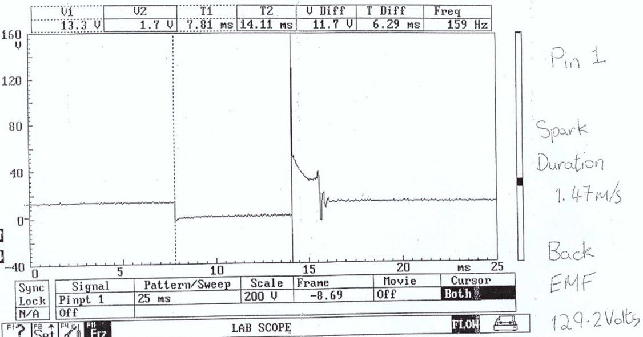
scope patterns
Figure 1 - Motronic primary wave pattern

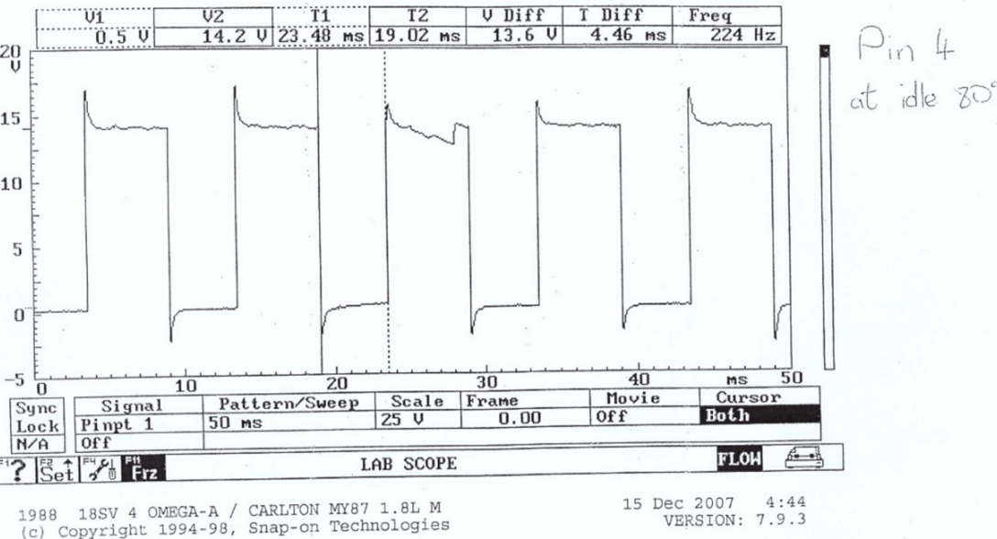
Figure 2 - Motronic rotary idle valve pattern

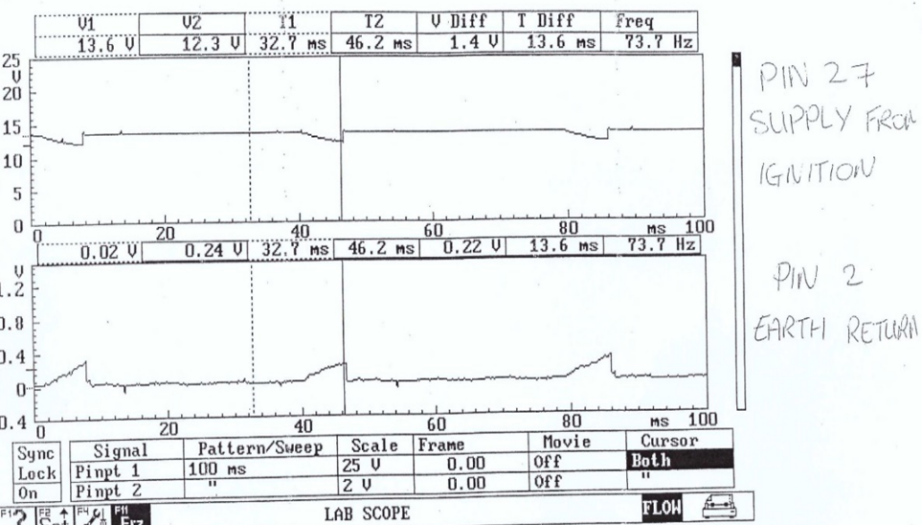
Figure 3 - Motronic 12V supply and earth pattern

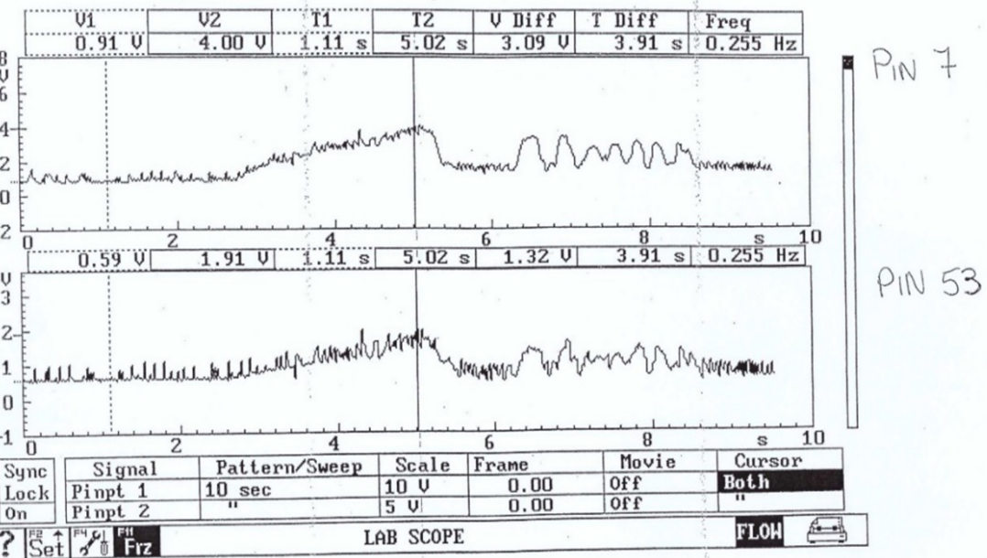
Figure 4 - Motronic air flow sensor (top) and throttle potentiometer (bottom) patterns
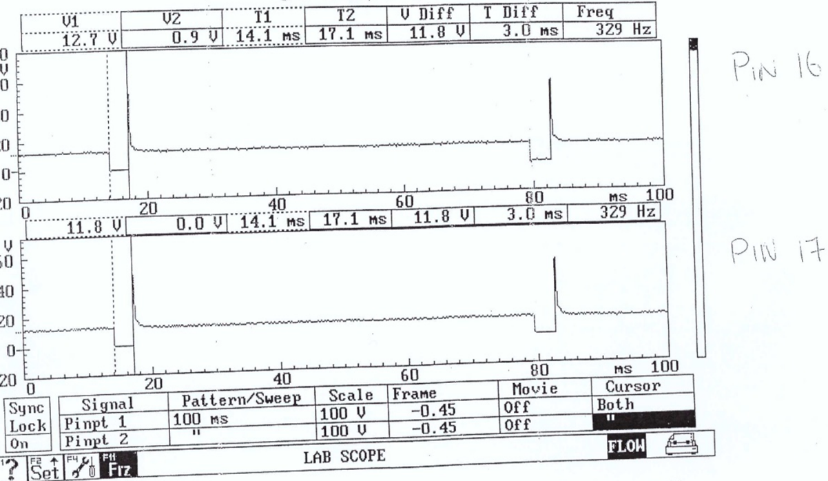
Figure 5 - Motronic injector bank patterns

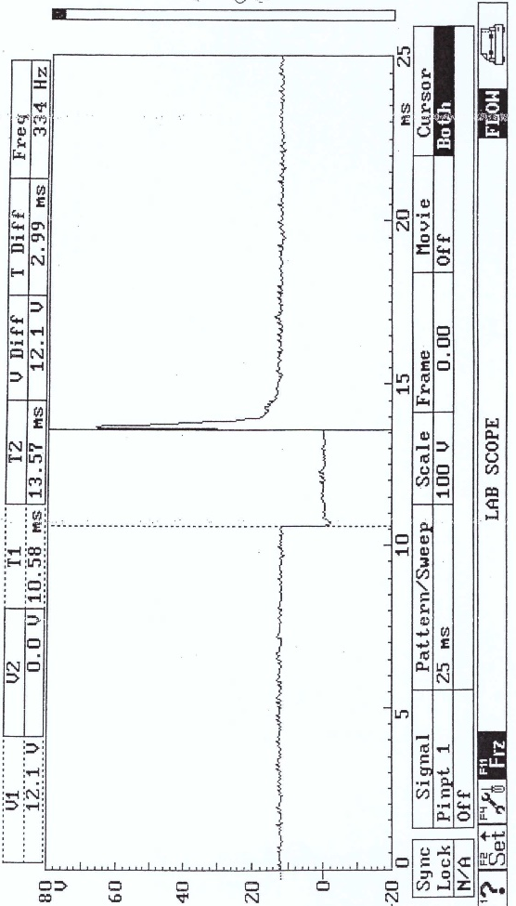
Figure 6 - Motronic injector on-time pattern (idle)

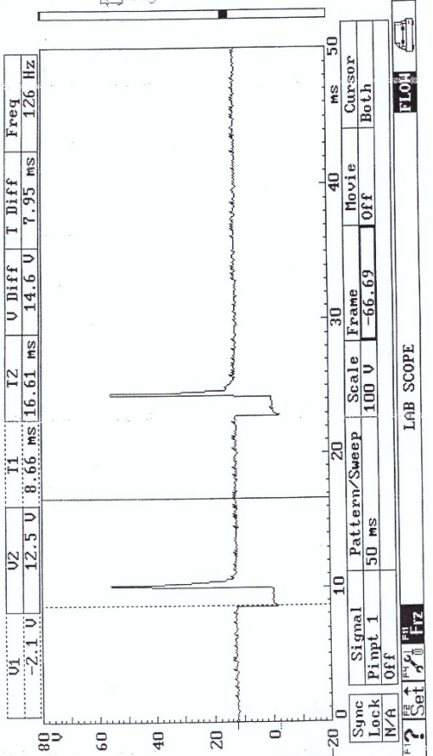
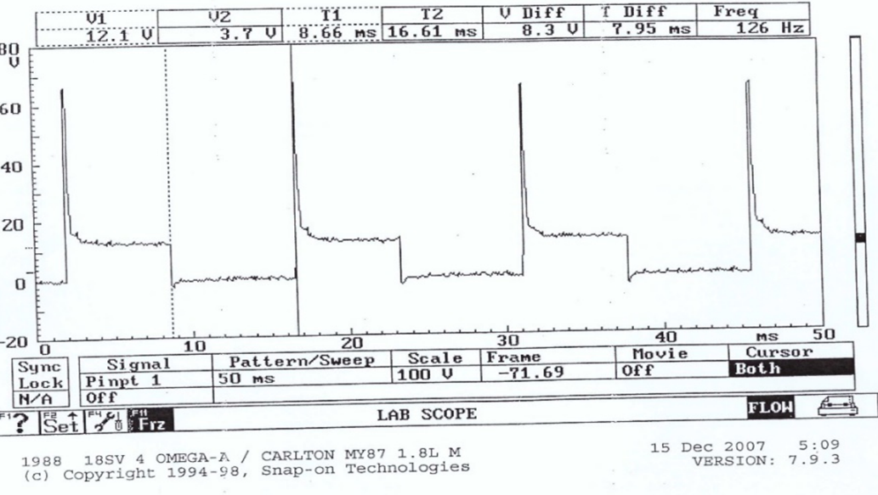
Figure 7 - Motronic injector on-time pattern (accelerating)
Figure 8 - Motronic injector on-time pattern (decelerating)

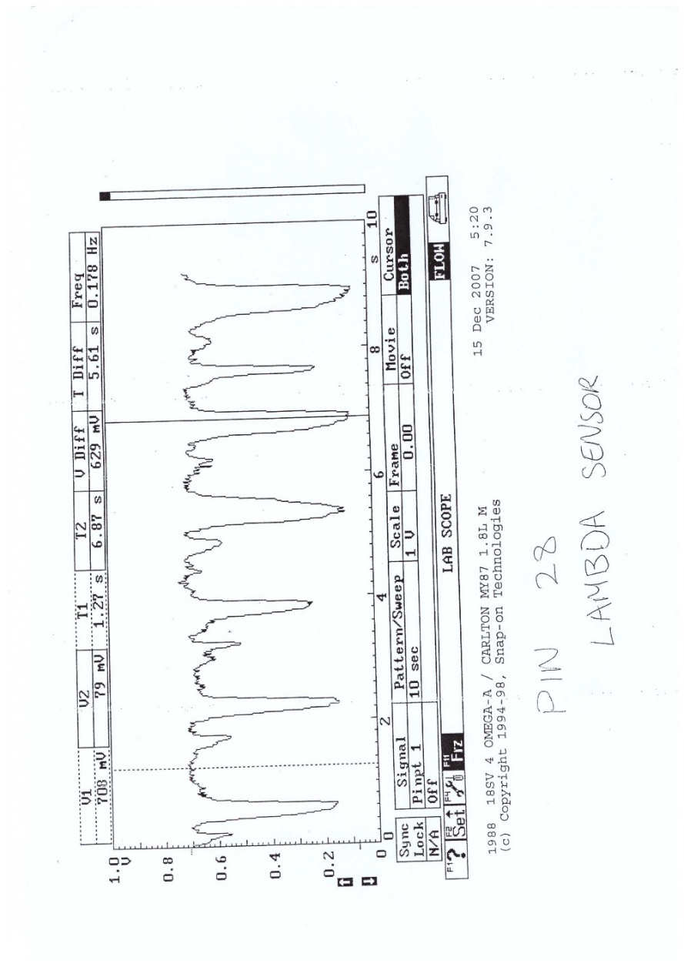
Figure 9 - Motronic lambda sensor pattern
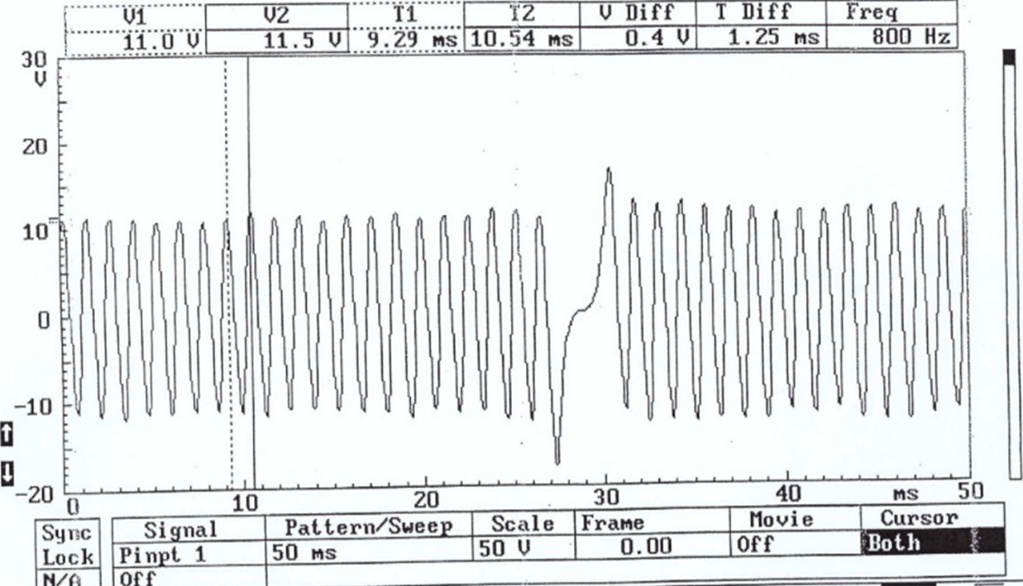
Figure 10 - Motronic crank sensor

Jetronic data

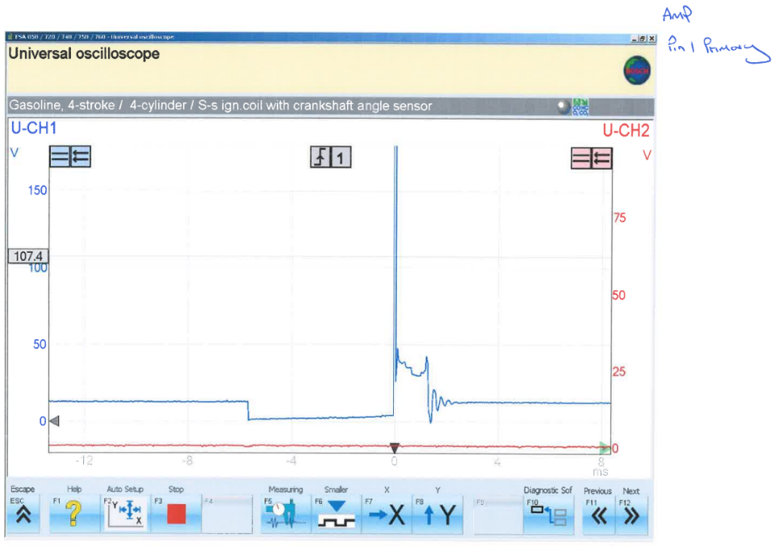
Scope patterns
Figure 11 - Jetronic Kettering coil primary
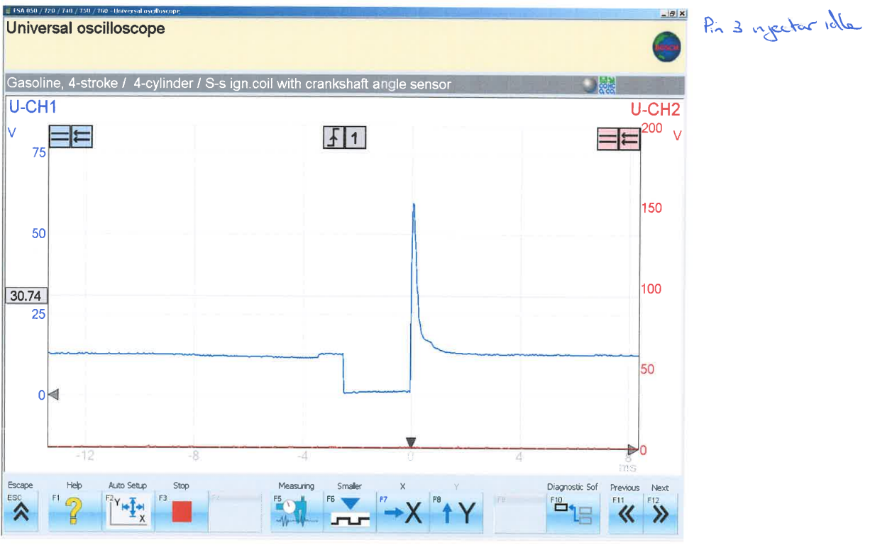
Figure 12 - Jetronic injector on-time (idle)
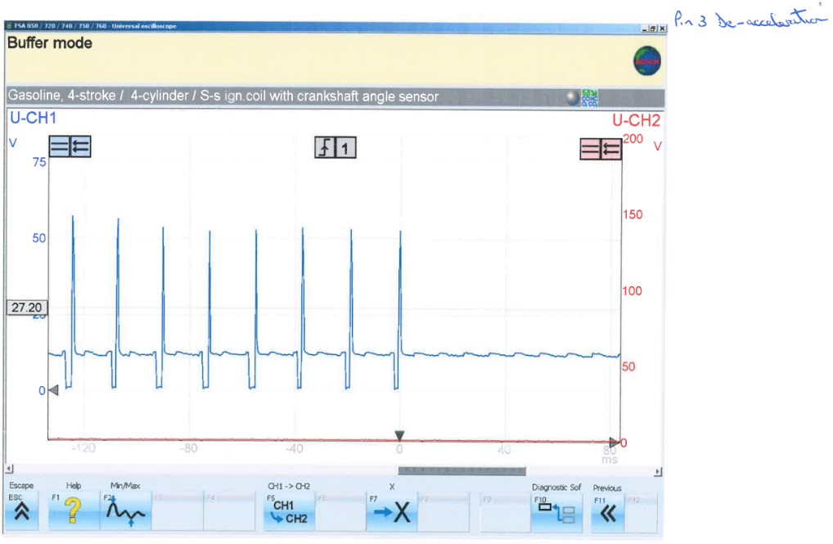
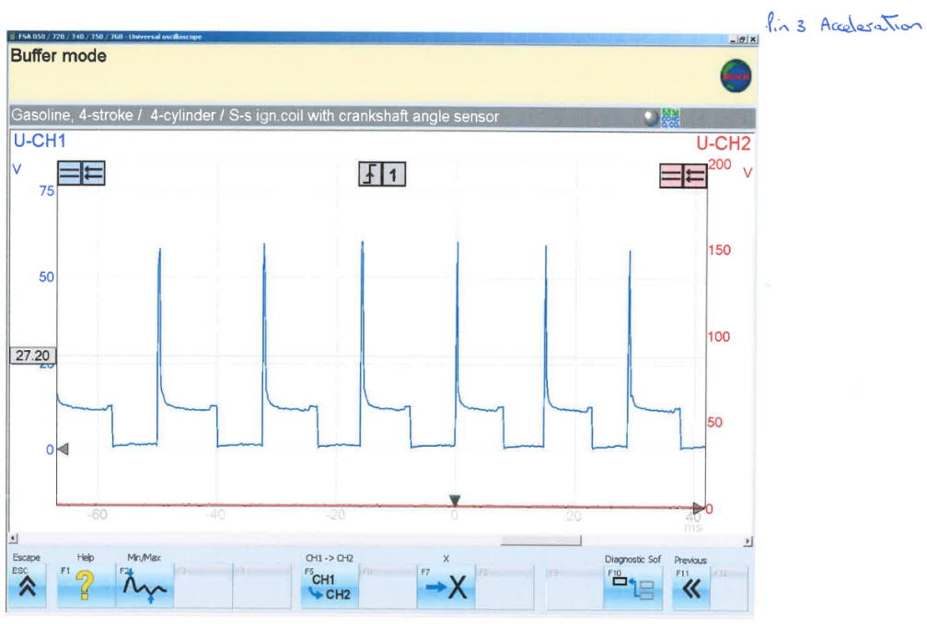
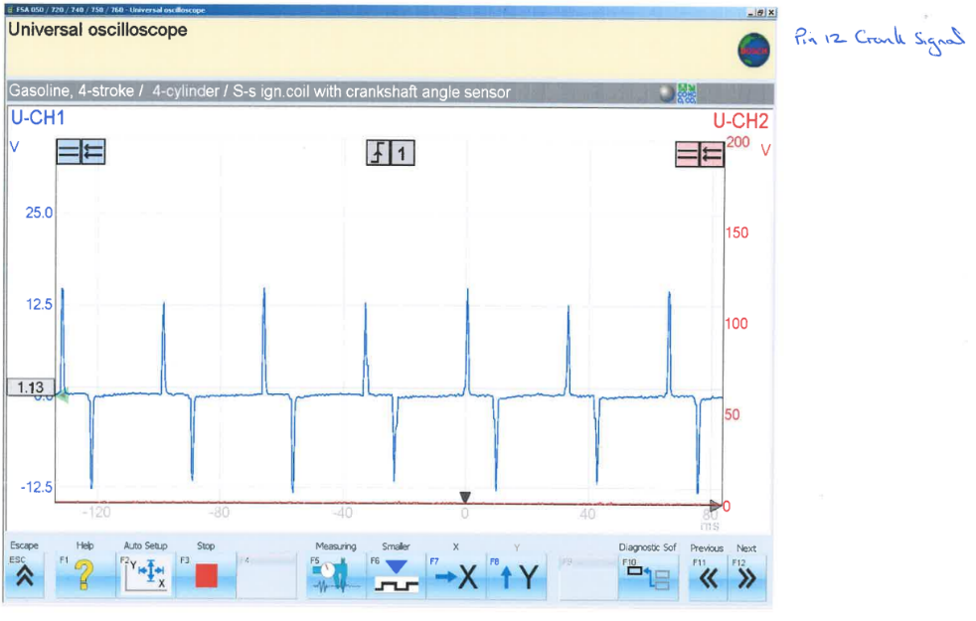
Figure 15 - Jetronic injector on-time (decelerating)
Figure 14 - Jetronic injector on-time (accelerating)
Figure 13 - Jetronic crank position sensor
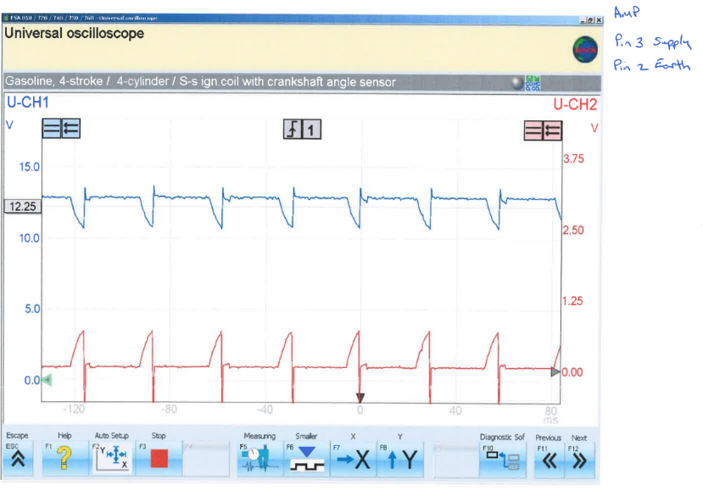
Figure 16 - Jetronic 12V supply and earth

