
Module Name: Quality Assurance and Service Improvements
Module code: LCHS7006
Assignment Title: Component 2- Service Improvement Report

Topic: Improving Patient Safety at Mid Staffordshire NHS Foundation Trust: A Root Cause Analysis and Evidence-Based Service Improvement Strategy

Lecturer: Shepherd Ziko

Student name: Muskan lalani
Student ID: 2430822
Table of Contents
1. Introduction 3
1.1 Background and context 3
1.2 Rationale, aim and objectives 3
1.3 Structure of the report 4
2. Main Body 4
2.1 Case context and problem definition 4
2.2 Conceptual and theoretical framework 5
2.3 Root Cause Analysis using Fishbone & 5 Whys 6
2.3.1 Application of Fishbone Diagram 6
2.3.2 5 Whys 7
2.4 Application of Donabedian Model to Mid Staffordshire 8
2.5 Strategic analysis 9
3. Recommendations: Service Improvement & Implementation Plan 10
3.1 Overall improvement aim and SMART objectives 10
3.2 Short-term interventions: PDSA cycles 11
3.3 Six Sigma Methodologies 12
3.4 Governance, culture change and stakeholder engagement 12
3.5 Measurement, monitoring and sustainability 12
4. Conclusion 12
References 14

1. Introduction

1.1 Background and context
The “Mid Staffordshire NHS Foundation Trust crisis (2005-2009)” referred to as one of the most egregious failures in the recent history of the NHS. Hundreds of patients exposed to unsafe and poor-quality care during this period. The excess deaths and harsh neglect, lack of cleanliness, lengthy waits to attended to and low status of many patients were confirmed by independent inquiries conducted by Francis (2013). Simple needs like nutrition, pain relief, and personal care neglected. The number of staff was significantly less than safe standards, and not all nurses had the support and supervision to deliver safe care. There was a lack of action by the leadership on warnings and complaints raised by patients frequently ignored or downplayed.
The report is devoted to unsafe nurse staffing and poor patient safety monitoring. This is one of the core issues of the broader failures at Mid Staffordshire. Staffing unsafe practices were a direct cause of preventable injury, increased mortality, and patient mistrust. It also affected the overall public health more broadly because low-quality hospital care leads to long-term illness, retards recovery, and health disparities.
Mid Staffordshire currently used as a countrywide case of systems failure. It remains a driver of safety reforms throughout NHS. It brought to light dire need to have robust quality management and efficient service improvement.

1.2 Rationale, aim and objectives
The report is necessary since the identified failures observed in Mid Staffordshire remain evident in other NHS environments. This specifically focuses on the particular area, such as unsafe staffing, ineffective organisational culture, and inefficient response to patient concerns. The recurring nature of these issues demonstrates that blame cannot help in the long run, but a systematic service improvement strategy (as influenced by Rafferty and Leary, 2023). The aim of this report is therefore quality analysis as to why the failure took place and how the failure can be mitigated using evidence-based strategies in future.
The purpose of this report is to examine the underlying causes of the quality failure experienced at Mid Staffordshire NHS Foundation Trust and formulate an evidence-based service improvement plan that will promote patient-centred care.
The objectives of the report are:
- To identify the root-level factors of the failure based on the Fishbone Diagram, 5 Whys, and the Donabedian Model.
- To analyse the broader organisational and strategic environment based on a SWOT analysis.
- To make feasible service improvement recommendations based on PDSA and Six Sigma approaches.
- To draw up a vivid implementation and monitoring strategy to facilitate a quantifiable change.

1.3 Structure of the report
The report structured logically to take the reader through the analysis. The Main Body reviews the case context, the prominent theories, and employs the tools like the “Fishbone Diagram”, “5 Whys”, “Donabedian Model”, and “SWOT” to describe the root causes of the failure. The recommendations section then outlines a detailed service improvement plan based on PDSA and Six Sigma. The Conclusion summarises the key findings and contemplates the implications for the future. The report also continues on Component 1 by shifting the focus of analysis from systems to practical improvement.

2. Main Body

2.1 Case context and problem definition
The Mid Staffordshire case revealed a broad violation of quality and safety. Component 1 has brought a few dark issues in the organisation. Latent conditions were strong, including dramatic financial strain, habitual understaffing, minimal training, and a culture of workers being too scared to voice their concerns (A. Seiji Hayashi et al., 2009). Such circumstances resulted in the conditions in which the negligent care might go on unnoticed and uncontested. In collaboration with this, Balogh et al. (2019) noted that active failures in the form of ignored patient complaints, delayed responses to basic needs, poor clinical decision making, and even incomplete or misleading records were present. These were no single cases of failures. They were indicators of a system that had broken down in an unsafe manner.
In this report, the fundamental problem in quality stated as constant understaffing with a poor safety culture that results in unsafe care and preventable injury. The issue lies in multiple dimensions of quality (Clarke, 2020). It has an impact on safety as patients exposed to danger. It has an impact on effectiveness since important care omitted. It minimises patient-centredness because patients perceived as being overlooked. On the same note, Reichert and Jacobs (2018) observed that it affects timeliness because of the extensive waiting time to obtain simple assistance. It is detrimental to efficiency because inferior care results in increased complications. It also has an impact on equity, as the most vulnerable patients were the most affected.
This issue is systemic. It cannot attributed to personal mistakes only. It demonstrates more profound structural and cultural malfunctions, which need to improve in the future.

2.2 Conceptual and theoretical framework
Donabedian Model
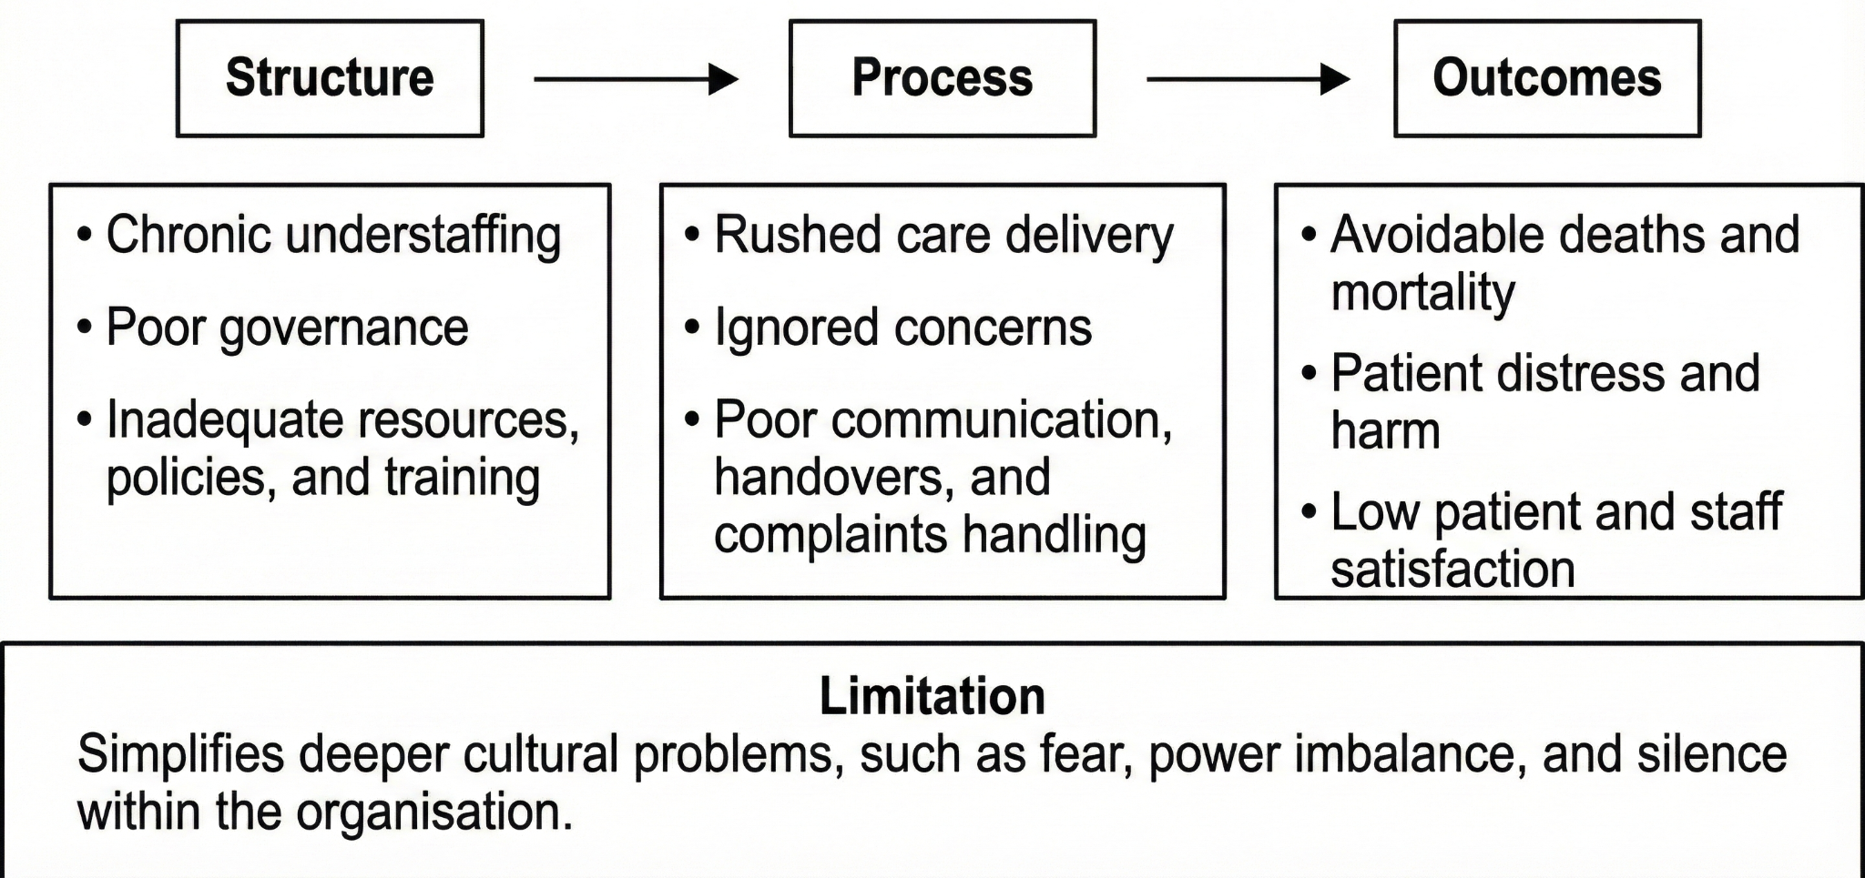
Figure 1: Donabedian Model
(Source: Self-developed)
The “Donabedian Model” describes the quality of healthcare using the structure, process, and outcome (Donabedian, 1988). In the opinion of Ayanian and Markel (2016), structure entails staffing levels, resources, policies, and training. Process is a way of care delivery, including communication, handovers and complaints. Outcomes are associated with patient outcomes, such as mortality, harm, and satisfaction. Mid Staffordshire can examined with the help of this model since poor governance and constant understaffing resulted in poor processes, like hasty care and unaddressed concerns. On the contrary, this resulted in adverse outcomes, like preventable deaths and distress (Francis, 2013). The drawback of the Donabedian Model is that it might streamline more profound cultural issues, which could include fear, power disparity and silence within the organisation.
Lewin change model
Lewin Stage | Meaning | Application to Mid Staffordshire NHS Trust
Unfreeze | Preparing the organisation for change | Staff recognised patient safety failures and unsafe staffing levels. Leadership acknowledged problems and created urgency for change.
Change | Introducing new ways of working | Safe staffing policies, better complaint handling, and safety training were introduced. Staff supported to adopt safer practices (Burnes, 2020).
Refreeze | Making change permanent | New safety practices embedded into daily work. Ongoing monitoring, audits, and governance used to sustain improvements.
Table 1: Lewin change model
(Source: Self-developed)
Systems and Safety Models
The “Swiss Cheese Model” applied in Component 1 demonstrates how several layers of defence can all collapse simultaneously when the gaps in organisations coincide (Wiegmann et al., 2022). Policies were in place in Mid Staffordshire, and staffing, supervision, and communication failures created loopholes that enabled harm to patients (Francis, 2013). This showed that the crisis was a breakdown of the system and not due to individual mistakes.
Root Cause Analysis Tools
Root Cause Analysis builds on this in component 2. The Fishbone Diagram assists in classifying causes under people, processes, equipment, leadership, and environment (Kumah et al., 2024). The 5 Whys goes a notch higher by constantly posing questions as to why a problem occurred, thus assisting in releasing the reasons (Mrayyan et al., 2023).
Comparison
The above-mentioned different kinds of tools provide different opinions. Donabedian describes the chain of structure-process-outcome. On the other hand, Swiss cheese demonstrates a stratified system failure, while RCA tools give particular root causes. However, the combination of all three is a powerful and adequate insight into the Mid Staffordshire failure.

2.3 Root Cause Analysis using Fishbone & 5 Whys

2.3.1 Application of Fishbone Diagram
The Fishbone Diagram used to demonstrate how a number of interconnected factors at Mid Staffordshire caused unsafe staffing and poor safety culture. Many employees under People had low morale and an inappropriate skills mix. Others not experienced and not closely supervised. Employees also bullied, and they would fear standing up to complain about poor care (Francis, 2013). This complicated the ability to appeal against unsafe decisions.
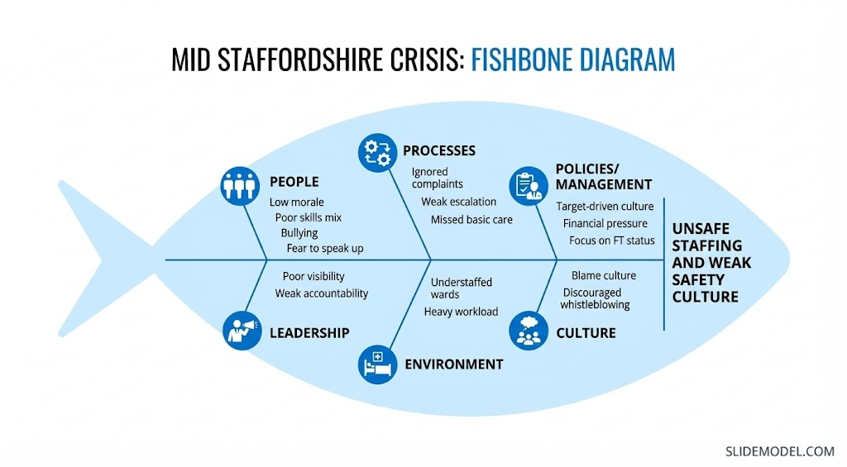
Figure 2: Fishbone Diagram for the Mid Staffordshire crisis with the central problem
(Source: Self-developed)
Complaints disregarded under the Processes. The patients did not have any distinct escalation paths. The absence of processes being organised meant that basic tasks overlooked, like checking on our hydration. On the other hand, in the Policies and Management, the Trust paid much attention to obtaining Foundation Trust status. Patient safety was not as important as financial goals to senior managers (Singh, Patel and Boster, 2024). This implied that safety threats not responded to in a good manner. Now comes to Leadership. In this case, clinical leaders not seen in the wards. Accountability was poor, and poor performance not tackled. Employees were not supported (Sun, 2024). On the other hand, it can see that wards were overstaffed and very busy under the Environment. Nurses were overworked and therefore could not deliver safe and timely care. Within Culture, there was a blame culture. There was no promotion of whistleblowing, and the employees were afraid of repercussions because of blowing. This enabled issues to go uncontrolled (Mrayyan et al., 2023).
As Po-Heng Tsou and Hsin-Yao Hsu (2022) note, the advantage of the Fishbone tool is that it provides an organised and clear image of the causes. Nevertheless, it is descriptive unless it is accompanied by further investigation, which is why such tools as the 5 Whys are also required.

2.3.2 5 Whys
Another noticeable symptom in the Mid Staffordshire case was that the complaints of patients not paid attention to. The 5 Whys can be used to demonstrate why this occurred.
Why 1? The complaints not taken seriously since the staff felt pressured to work on achieving financial targets. Raising concerns deemed to be retarding things.
Why 2? This was a source of pressure to staff since the leadership did not reward performance based on patient safety, but on performance based on finance and Foundation Trust status.
Why 3? Leadership caused these decisions, as national policies influenced the priorities of boards with a focus on financial stability and performance indicators.
Why 4? These national practices adhered to to the latter since the organisation was afraid of being subjected to avoid wrath of regulations, and they wished to seem successful.
Why 5? This was because the broader culture did not embrace openness, and previous warnings raised by the staff had ignored or downplayed.
This discussion demonstrates that unattended complaints did not mean that a single individual had broken down. They were associated with latent conditions as noted in Component 1, including poor culture, weak governance and policy pressures that placed safety on the back burner. It also reveals lapses in leadership and regulation, which enabled these underlying problems to persist without being corrected.

2.4 Application of Donabedian Model to Mid Staffordshire
The Donabedian Model assists in demonstrating how the failures at Mid Staffordshire interconnected on the structural, process, and outcome levels (Cullen et al., 2018). The organisational design was poor. The number of staff was very low, and the skill mix of wards was unsatisfactory. Many employees did not get the right training and encouragement. Physical conditions were also toxic, as there were congested wards and persistent demands to achieve goals (NHS, 2017). There were loose governance arrangements, and regulatory supervision failed to intervene early to stop damage (Francis, 2013).
The result of these structural issues was failed processes. There were hasty admissions and discharges, missing documentation, and missing significant observations (Cam et al., 2023). There was slow, dismissive complaint handling. Communication between teams was low, and clinical decision-making was inconsistent. Employees lacked well-defined channels of escalation in cases of worsening of patients.
These process failures generated grave consequences. The opinion of Panagioti et al. (2019) reveals that the count of patients dying was excessive, most of them suffered unnecessary damage, and satisfaction rates were abysmal. There were more complaints and employee turnover, and burnout was more severe. These consequences well reported in the social investigations and portrayed the underlying problems found in Component 1.
To make improvements effective, the organisation should improve structures by ensuring safe staffing, good governance, and improved training. It will need to redesign processes, including complaints, escalations and handovers. It should also monitor distinct results, such as falls, pressure ulcers, serious incidents, and patient experience. This gives a direct connection to subsequent PDSA and Six Sigma interventions that address every portion of this structure-process-outcome chain.

2.5 Strategic analysis
Strengths | Weaknesses
- Clear NHS quality and safety standards (NHS England, 2019).  - National Patient Safety Strategy and duty of candour (NHS England, 2019).  - Experienced and committed frontline staff.  - Existing incident reporting systems. | - Deeply rooted poor safety culture.  - Chronic understaffing and weak skill mix.  - Poor governance, weak board challenge (Eufemia et al., 2020).  - Limited use of data and damaged reputation.
Opportunities | Threats
- Strong national drive for patient safety and learning culture.  - Better use of digital data and dashboards.  - Integrated Care Systems to support joined-up work.  - Staff engagement in co-designing improvements. | - Ongoing financial pressure and cost controls.  - National workforce shortages and high turnover.  - Intense regulatory and media scrutiny.  - Risk of staff burnout and resistance to change.
Table 1: SWOT Analysis
(Source: Self-developed)
This SWOT analysis indicates that change at Mid Staffordshire can done. The “Patient Safety Strategy” and the national standards provide a clear path to improvement and can employed to tackle poor governance (NHS England, 2019). Conversely, according to Douglas et al. (2014), dedicated frontline employees and established reporting mechanisms are one of the strengths and can used to facilitate cultural change and learning. The long-term issues with monitoring and coordination can addressed by the opportunities for better use of data, digital tools, and integrated care partnerships.
Nevertheless, the lack of money, staffing gaps, and reputational losses restrict the possibilities of fast action. Any improvement plan for the services has to be realistic regarding these obstacles. It must leverage strong points, including staff involvement and national policy advocacy. These strong points assist in addressing weak areas of its culture, staffing, and governance and deal with threats with gradual, carefully designed change (Turner et al., 2018).

3. Recommendations: Service Improvement & Implementation Plan

3.1 Overall improvement aim and SMART objectives
The primary objective of this improvement plan is to decrease the number of serious patient safety incidents associated with nursing care by 50% in 18 months at the Mid Staffordshire NHS Foundation Trust. This objective is a direct reaction to the unsafe staffing and poor safety culture found above.
The plan will have the following SMART objectives
- To achieve a safe staffing escalation policy in all wards within six months, to ensure that unsafe staffing shifts are detected and promptly fixed.
- To enhance the level of incident reporting by 30% in twelve months, become more open and learn.
- To increase patient-reported experience scores in the areas of dignity, communication, and responsiveness by at least 20% in one year.
These goals offer both short-term and long-term goals that can quantified.

3.2 Short-term interventions: PDSA cycles
Small and fast tests are the most suitable in the short term. However, the staff should be able to experiment with new ideas without affecting the entire staff. This is appropriate in the PDSA cycle because it operates by planning a change, testing it on a small scale and then making adjustments (The Deming Institute, 2021). It minimises the chances of failure and makes the staff feel engaged in developing solutions.
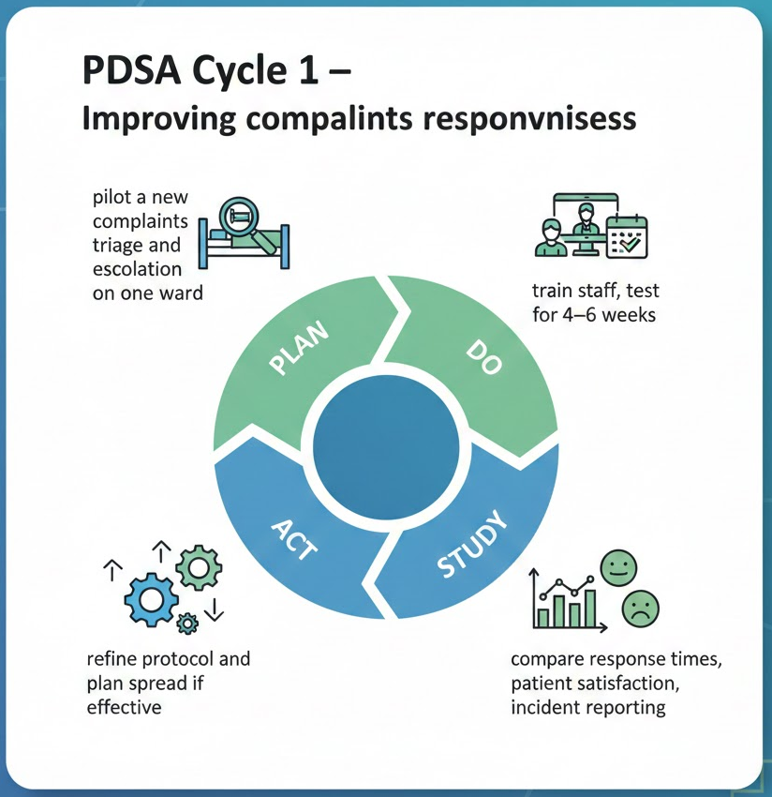
Figure 3: PDSA Cycle
(Source: The Deming Institute, 2021)
This cycle used to pilot a new complaints triage and escalation system on a single ward. It aims at quicker reactions, more explicit, and improved feedback. Pilot findings make minor adjustments and then extend the model throughout the hospital (Cadeddu et al., 2023). This cycle proposes short morning briefings to monitor staffing and identify any threats at hand. The staff in real time redistribute support. The pilot assists in testing what is working, and the changes improve the broader implementation in case the strategy enhances patient safety (Taylor et al., 2014). These cycles promote initial development and establish a learning culture that is capable of equipping the organisation with bigger developments.

3.3 Six Sigma Methodologies
Six Sigma is more accommodating since it eradicates variation and faults in significant clinical procedures. Febriza Imansuri et al. (2024) note that the DMAIC cycle helps overcome such problems as missed observations and intermittent escalation by the Trust. As an illustration, a Six Sigma initiative may standardise schedules of observations and the setting of objective triggers in an attempt to avoid patient deterioration. This supports the process component of the Donabedian Model and leads to safer outcomes and stimulates the organisation to build stronger structures by clarifying the protocols and controls (Rathi, Vakharia and Shadab, 2021).

3.4 Governance, culture change and stakeholder engagement
Good governance and a healthier culture are the other aspects that can enhanced. Bates et al. (2025) suggest that a multi-disciplinary quality and safety committee that will hold it accountable should track progress. The culture of safety may measure through periodic employee surveys and focus groups. On the contrary, as Hughes (2019) contends, openness will enabled through clear-cut whistleblowing policies and active Freedom to Speak up Guardians. They are directly related to these issues of leadership, culture and communication seen in the Fishbone and 5 Whys analysis (Sunder M and Kunnath, 2019).

3.5 Measurement, monitoring and sustainability
Continuous enhancement must measure clearly and regularly. The nurse-to-patient ratios and training completion are the key structural indicators. The process indicators will include incident reporting rates, complaint response time, and observation check compliance (Goldman et al., 2025). The outcome indicators are serious incident levels, mortality, patient satisfaction and staff turnover. Dashboards, periodic audits, and monthly PDCA reviews will ensure that the progress remains visible and aid the continuous improvement.

4. Conclusion
This report analysed the failures at Mid Staffordshire with a fundamental quality problem of unsafe staffing and poor safety culture. The case has been important to the NHS since it highlighted the presence of poor structures, poor processes and harmful cultures that can merge to cause severe and preventable injuries. Applying the Donabedian Model, Fishbone Diagram, and 5 Whys served to demonstrate that the failure was not due to a single error but a number of interconnected issues in staffing, governance, communication, and leadership. The SWOT analysis also served to demystify the internal weaknesses of the organisation and external pressures that determined what was possible and opportunities that facilitate meaningful change.
The service improvement plan put together these findings by integrating the long-term and short-term actions. The PDSA cycles exposed small tests to improve the management of complaints and the safety of employees. Lean and Six Sigma provided additional redesign tools to reduce variation, waste and improve valued clinical processes. The deeper causes in the root cause analysis also required reforms in governance, a change of culture, and enhanced involvement of the staff. In future, leadership encouragement, open communication, and ongoing evaluation shall be imperative in ensuring changes are here to stay. The lessons can applied in this report because the secondary evidence in a previous case used. Real-time data and staff feedback ought to discuss to prevent such a failure in the future.

References
Ayanian, J.Z. and Markel, H. (2016). Donabedian’s Lasting Framework for Health Care Quality. New England Journal of Medicine, 375(3), pp.205–207.
Balogh, E.P., Miller, B.T. and Ball, J.R. (2019). Overview of Diagnostic Error in Health Care. [Online] Nih.gov. Available at: https://www.ncbi.nlm.nih.gov/books/NBK338594/.
Bates, S.M., Lin, J., Allen, L.N., Wright, M. and Kidd, M. (2025). Can multidisciplinary teams improve the quality of primary care? A scoping review. eClinicalMedicine, [online] 88, p.103497. doi:https://doi.org/10.1016/j.eclinm.2025.103497.
Burnes, B. (2020). The Origins of Lewin’s three-step Model of Change. The Journal of Applied Behavioral Science, 56(1), pp.32–59. doi:https://doi.org/10.1177/0021886319892685.
Cadeddu, S.B.M., Dare, L.O. and Denis, J.-L. (2023). Employee-Driven Innovation in Health Organizations: Insights from a Scoping Review. International Journal of Health Policy and Management, [online] 12(1). doi:https://doi.org/10.34172/ijhpm.2023.6734.
Cam, H., Wennlöf, B., Gillespie, U., Franzon, K., Nielsen, E.I., Ling, M.L., Lindner, K., Kempen, T. and Sporrong, S.K. (2023). The Complexities of Communication at Hospital Discharge of Older patients: a Qualitative Study of Healthcare Professionals’ Views. BMC Health Services Research, [online] 23(1). doi:https://doi.org/10.1186/s12913-023-10192-5.
Clarke, S.P. (2020). Nurse Staffing and Patient Care Quality and Safety. [online] Nih.gov. Available at: https://www.ncbi.nlm.nih.gov/books/NBK2676/.
Cullen, W.KL., West, D. and Grant, S.W. (2018). Evaluating quality in clinical care. Surgery (Oxford), 36(9), pp.497–502. doi:https://doi.org/10.1016/j.mpsur.2018.07.002.
Douglas, E., Cromie, S., Chiara Leva, M. and Balfe, N. (2014). Modelling the Reporting Culture within a Modern Organisation. CHEMICAL ENGINEERING TRANSACTIONS, [online] 36. doi:https://doi.org/10.3303/CET1436099.
Eufemia, L., Bonatti, M., Sieber, S., Schröter, B. and Lana, M.A. (2020). Mechanisms of Weak Governance in Grasslands and Wetlands of South America. Sustainability, 12(17), p.7214. doi:https://doi.org/10.3390/su12177214.
Febriza Imansuri, Tasya Chayatunnufus, Safril Safril, Fredy Sumasto, B. Handoko Purwojatmiko and Salati, D. (2024). Reducing Defects Using DMAIC Methodology in an Automotive Industry. Spektrum Industri : Jurnal Ilmiah Pengetahuan dan Penerapan Teknik Industri, 22(1), pp.1–13. doi:https://doi.org/10.12928/si.v22i1.171.
Francis, R. (2013). The Mid Staffordshire NHS Foundation Trust Public Inquiry Report of the Mid Staffordshire NHS Foundation Trust Public Inquiry Executive summary. [online] Available at: https://assets.publishing.service.gov.uk/media/5a7ba0faed915d13110607c8/0947.pdf.
Goldman, J., Kooijman, A., Kuper, A., Coffey, M., Wong, B.M. and Trbovich, P. (2025). Integrating equity into hospital incident reporting and patient concerns systems: study protocol for a mixed methods study. BMJ Open, 15(11), pp.e111054–e111054. doi:https://doi.org/10.1136/bmjopen-2025-111054.
Hughes, H. (2019). Freedom to Speak up – the Role of Freedom to Speak up Guardians and the National Guardian’s Office in England. Future Healthcare Journal, 6(3), pp.186–189. doi:https://doi.org/10.7861/fhj.2019-0031.
Kumah, A., Nwogu, C.N., Issah, A.-R., Obot, E., Kanamitie, D.T., Sifa, J.S. and Aidoo, L.A. (2024). Cause-and-Effect (Fishbone) Diagram: a Tool for Generating and Organizing Quality Improvement Ideas. Innovations Journals, [online] 7(2), pp.85–87. doi:https://doi.org/10.36401/JQSH-23-42.
Mrayyan, M.T., Algunmeeyn, A., Abunab, H.Y., Kutah, O.A., Alfayoumi, I. and Khait, A.A. (2023). Attributes, skills and actions of clinical leadership in nursing as reported by hospital nurses: A cross-sectional study. BMJ Leader, [online] 7(3), pp.203–211. doi:https://doi.org/10.1136/leader-2022-000672.
NHS (2017). Study and training. [online] Health Careers. Available at: https://www.healthcareers.nhs.uk/career-planning/study-and-training.
NHS England (2019). The NHS Patient Safety Strategy Safer culture, Safer systems, Safer Patients NHS England and NHS Improvement. [online] NHS England. Available at: https://www.england.nhs.uk/wp-content/uploads/2020/08/190708_Patient_Safety_Strategy_for_website_v4.pdf.
NHS England (2019). The NHS Patient Safety Strategy. [online] NHS England. Available at: https://www.england.nhs.uk/patient-safety/the-nhs-patient-safety-strategy/ [Accessed 1 Dec. 2025].
Panagioti, M., Khan, K., Keers, R.N., Abuzour, A., Phipps, D., Kontopantelis, E., Bower, P., Campbell, S., Haneef, R., Avery, A.J. and Ashcroft, D.M. (2019). Prevalence, severity, and nature of preventable patient harm across medical care settings: Systematic review and meta-analysis. BMJ, [online] 366(366). doi:https://doi.org/10.1136/bmj.l4185.
Po-Heng Tsou and Hsin-Yao Hsu (2022). Applications of Fishbone Diagram and DEMATEL Technique for Improving Warehouse Operation—A Case Study on YMT Overseas Imported Components. China-USA Business Review, 21(4). doi:https://doi.org/10.17265/1537-1514/2022.04.001.
Rafferty, A.M. and Leary, A. (2023). Nursing notes on a scandal. Future Healthcare Journal, 10(1), pp.3–6.
Rathi, R., Vakharia, A. and Shadab, M. (2021). Lean six sigma in the healthcare sector: A systematic literature review. Materials Today: Proceedings, [online] 50(5), pp.773–781. doi:https://doi.org/10.1016/j.matpr.2021.05.534.
Reichert, A. and Jacobs, R. (2018). The impact of waiting time on patient outcomes: Evidence from early intervention in psychosis services in england. Health Economics, 27(11), pp.1772–1787. doi:https://doi.org/10.1002/hec.3800.
Seiji Hayashi, Emily Selia and Karen McDonnell (2009). Stress and Provider Retention in Underserved Communities. Journal of Health Care for the Poor and Underserved, 20(3), pp.597–604. doi:https://doi.org/10.1353/hpu.0.0163.
Singh, G., Patel, R.H. and Boster, J. (2024). Root cause analysis and medical error prevention. [online] PubMed. Available at: https://www.ncbi.nlm.nih.gov/books/NBK570638/.
Sun, Y. (2024). The study of the effect of performance accountability on performance management. Highlights in Business, Economics and Management, [online] 32, pp.187–198. doi:https://doi.org/10.54097/pvfcd854.
Sunder M, V. and Kunnath, N.R. (2019). Six Sigma to reduce claims processing errors in a healthcare payer firm. Production Planning & Control, 31(6), pp.1–16. doi:https://doi.org/10.1080/09537287.2019.1652857.
Taylor, M.J., McNicholas, C., Nicolay, C., Darzi, A., Bell, D. and Reed, J.E. (2014). Systematic Review of the Application of the Plan–do–study–act Method to Improve Quality in Healthcare. BMJ Quality & Safety, [online] 23(4), pp.290–298. doi:https://doi.org/10.1136/bmjqs-2013-001862.
The Deming Institute (2021). PDSA Cycle . [online] The Deming Institute. Available at: https://deming.org/explore/pdsa/.
Turner, S., Vasilakis, C., Utley, M., Foster, P., Kotecha, A. and Fulop, N.J. (2018). Analysing Barriers to Service Improvement Using a multi-level Theory of innovation: the Case of Glaucoma Outpatient Clinics. Sociology of Health & Illness, [online] 40(4), pp.654–669. doi:https://doi.org/10.1111/1467-9566.12670.
Wiegmann, D.A., J. Wood, L., N. Cohen, T. and Shappell, S.A. (2022). Understanding the ‘Swiss cheese model’ and its application to patient safety. Journal of Patient Safety, [online] 18(2), pp.119–123. Available at: https://www.ncbi.nlm.nih.gov/pmc/articles/PMC8514562/.

