(1:1a)
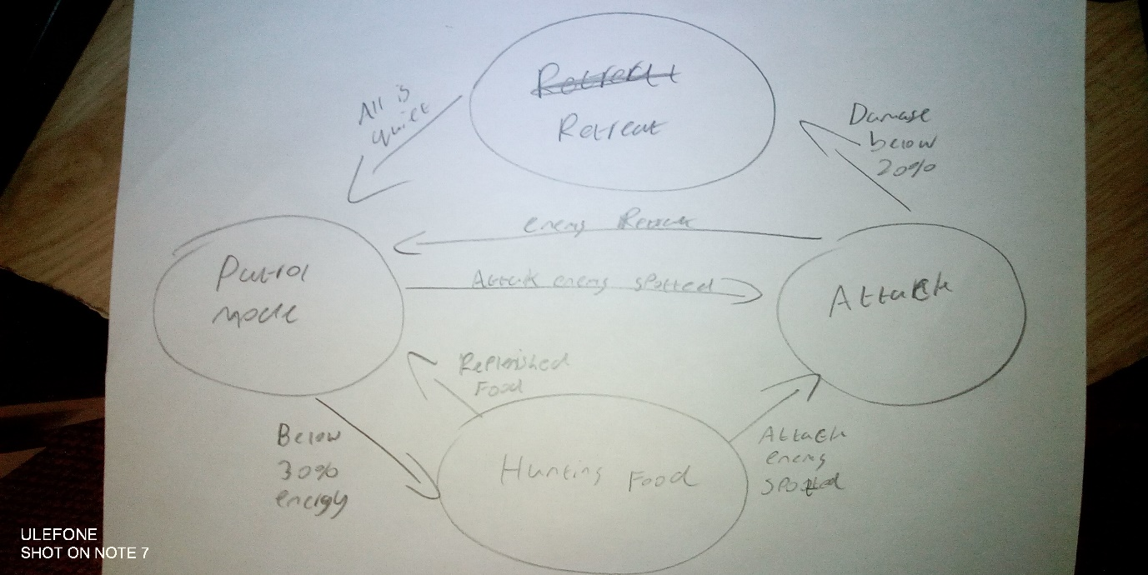
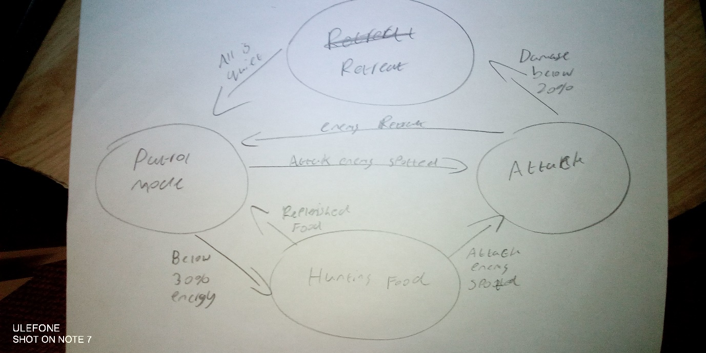

(1:2a)
Attack::Enter(Shark)
{
PrepareForBattle(Shark)
}

Attack::Execute(Shark)
{
If(EnemyInRange(Enemy)) then
{
AttackEnemy(Enemy)
}
}

Attack::Exit(Shark)
{
If(EnemyDead(Enemy)) then
{
ChangeState(Shark, PatrolMode)
}

If(EnemyRetreating(Enemy)) then
{
ChangeState(Shark, PatrolMode)
}

If(BelowMaximumDamage(Shark)) then
{
ChangeState(Shark, Retreat)
}
}

(1b)
Moore Machines
The Moore machines named after Edware Moore the creator who introduced this type of finite state machine in 1956. The Moore machines follow the basic principles of a simple finite-state-machine that uses both transitions and states, states can produce outputs and the result is determined solely by the state and not by any interference with an input.
Mealy Machines
The Mealy Machines were names after George H. Mealy in 1955, The mealy machines were based upon the Moore machines, but outputs are only produced by the transitions of the machine and not in states unlike the Moore Machines. By creating outputs in transitions allows for a much simpler and clean logical chart as more logic can be put on transitions.

