

LCBB4004
Marketing Fundamentals

Assignment 2 – Marketing Fundamentals Analysis & Evaluation

STUDENT NAME:NICOLETA OIAGA
STUDENT NUMBER:1913093
LECTURER’S NAME:TUSHARA BALENDRAN

Table of Contents

Table of Contents 1
Introduction 2
Role of Marketing in Creating Value 3
Viable Diversities to Rivals 5
Product Worth 5
Surprising Service 5
Nestle Customer Shared Value 6
Doing Right Business 6
Value Chain 6
Resolving Issues 7
Communication 7
Collaboration 7
Transparency 7
Stakeholders Engagement 7
Identify Relevant Stakeholders 8
Impact of Stakeholders Engagement on Marketing Activities 9
Stakeholder Engagement Process 11
Nestle Stakeholder Engagement 11
Stakeholder Group of Nestle 12
Conclusion 12
References 13

Introduction
Marketing is a series of activities related to the development, contact, distribution and fulfilment of value-added deals for others. In industry, marketing is structured to reward consumers, who are found, pleased and maintained by the company.

Role of Marketing in Creating Value
According to Theodore Levitt, the prominent economist and professor at Harvard Business School, every company is targeted "to recognize and attract clients." Marketing lets firms accomplish this goal and are not just advertisement, promotion and money gathering. Marketing builds meaning by connecting consumers with goods, consumers and enterprises. Marketing's function is to define, customer loyalty and retention (Haas et al., 2012).
Companies have to first consider a need or and want that they can resolve and the prospective clients who have this want or need before they can produce something of value.
Companies then work to accommodate these requirements by providing a product or service that satisfies these expectations, as the consumer (Sheth and Sisodia, 2012) needs it. It is crucial to ensure consumer loyalty and everybody thinks that the exchange helps them. The service they get for what they spend is satisfied with the client. In return for what companies are getting, they are satisfied with the payment. There is no end to successful campaigns. It also needs to hold clients by the emergence of innovative methods of generating customer satisfaction and company.
The emphasis on processes and structures as well as the mindset and community produce value. Mind and society are much harder to alter and impossible to imitate. Copying goods and processes is better than modifying mentalities and society. Thus, mindset and culture are critical and enduring for long-term growth. This provides better knowledge and performance in tandem with programs (Halliday and Astafyeva, 2014).
Changes in valuation before or after the use of a commodity. During ordering, browsing, actual transactions or deliveries, installation or start-ups, use and even re-sales, value is perceived. Marketers call this the waterfall of essentials sometimes. During the customer journey, you need to adapt.
The development of customer value increases customer satisfaction. Good customer service would add value to a consumer (Zhang et al., 2015). The opposite is also true. The production of consumer satisfaction, which increases loyalty, the share of the market, price, reduces errors and improves productivity (better benefits than price. Greater market share and improved productivity contribute to increased profits.
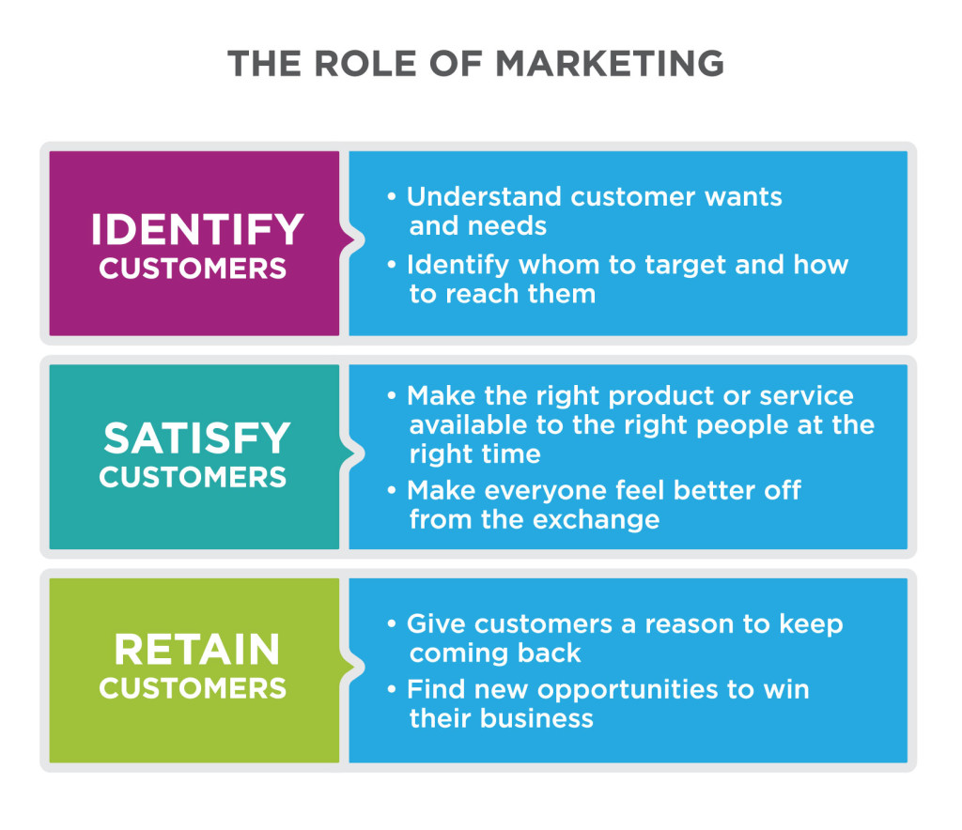
Marketing includes a range of tasks aimed at achieving these goals. The strategy and behaviour of companies in marketing operations regularly vary greatly. Marketing is a significant expense for many large and noticeable businesses, including Disney-ABC, Proctor & Gamble, Sony and Toyota. Their reliance represents their operational strategy, budget and operations on successful marketing for business achievement (Porter and Kramer, 2019). Alternatively, marketing may become much less noticeable for other organizations, particularly those in high or less competitive industries such as transportation, social care, medical care or companies that sell one-of-a-kind goods. It may be as straightforward as a web site or a brochure.
No model assures the effectiveness of marketing. Successful marketing can be very costly or cost very little. In any situation, marketing must enable the company to find, attract and retain customers. Regardless of size or complexity, a marketing campaign is only beneficial if it helps the business achieve its objectives.

Viable Diversities to Rivals
A product or service that everyone wants is an excellent start, but marketers have to build a plan that tells their clients how they are different and better if businesses have a lot of competition. In order to minimize wait times, businesses should increase the number of customer service representatives (Pfitzer et al., 2013). They may sell more goods than rivals sell or create a value-adding relationship. For example, a coffee shop bookstore allows customers to stop and relax when shopping. Whatever the way you distinguish yourself, to ensure it is long-term sustainable, you have to smash the numbers. Otherwise, you can lose the value that you offer to customers and cause damage rather than good.

Product Worth
Many customers are popular buyers of products. Price guarantees have become common in a field where businesses equal or surpass the price of any rival for the same commodity. The timeless technique of providing equivalent goods or services for less offers the items they want and provides customers with reasons for purchasing them from you. Look at the total sales when adopting this plan to make sure that you do not slash your profit margin too far. Again, it is important to ensure that it continues to keep lower rates.

Surprising Service
At any point in the sales process, outstanding customer service not only keeps customers but also offers consumers the incentive to say more to their mates. From the first, "Welcome to our shop," to fix unexpected issues, it's crucial to make customer expectations a great deal in value development (Lüdeke-Freund et al., 2016). Develop both managers and staff to settle conflicts and provide value that consumers do not always expect but genuinely appreciate when going through the door of a company.

Nestle Customer Shared Value
It is important to establish common values for Nestlé’s business activities. They believe that it is only by generating value for both our shareholders and society that we can thrive in the long term. They would make a positive difference for our companies and goods and contribute to the continuous growth of Nestlé.
The development of mutual capital is to ensure that shareholders gain long-term and sustainable capital while also addressing social issues. Companies, which build common value, show that business can be a good force. Nestlé’s work focuses on three interconnected impact fields: individuals and families who put their faith in their goods and brands, our societies and the environment (Goldberg and Fries, 2012). Their mission, today and for the generations to come, is to extend the power of food to improve the quality of life for everyone.
They continue to look for ways to evaluate our collective value and influence more effectively. They aim to invest more confidently and build trust with stakeholders by producing concrete results. They welcome work in this field to educate and promote more dialogue on this critical matter from their methodology.

Doing Right Business
For the way Nestlé operates, ethical values are important. This ensures that fraud, bribery and corruption are zero tolerances, while the data security and transparent disclosure of tax payments are the main concerns.

Value Chain
Based on consistent principles and good governance holds the Nestlé brand trust and reduces value chain risks.

Resolving Issues
Nestle carry out a materiality review every two years to ensure that their sustainability activities are up to date with a changing climate.

Communication
Nestle is still asking for the guidance of the best experts to make mutual trust so durable as possible.

Collaboration
Cooperation is a critical part of the effort to solve global problems such as increasing malnutrition, child slavery, and global warming.

Transparency
The tax they pay comes under the common value of the clients and Nestle agrees that knowledge about the tax policy and donations is a good practice.

Stakeholders Engagement
The presence of stakeholders is the mechanism by which businesses interact and meet their stakeholders. Businesses will understand better what they want if they wish, how committed they are and how intentions and activities of businesses impact their priorities by getting to know them. They also can strengthen contact and represent tactics and activities, with long-term advantages, such as a reputation for the brand or the first mover.
The participation of stakeholders is the mechanism used by a company to engage specific stakeholders to obtain negotiated objectives for a particular reason (Noland and Phillips, 2010). The reporting and explaining and reacting to the stakeholders on decision-masking, intervention and results are now often recognized as a key accountability mechanism because it obliges a company to engage stakeholders in recognizing, acknowledging, and resolving sustainability concerns and problems. Engagement of stakeholders is an organization's mechanism for engaging specific stakeholders.
The participation of stakeholders is recognized as a key to the success of the project and program. Stakeholders include project and program managers, customers and end-user groups, execution teams and contractors to others who have little interest but are not interested in the results such as regulators, media and public groups.
All stakeholders are different, have different views and skills, work in various cultures and environments, and often differ about the outcomes (Ayuso et al., 2011). Not surprisingly, project administration is full of problems relevant to individuals.

Identify Relevant Stakeholders
On the simplest level, businesses that create and adopt a sustainable business model (for a product or brand), first recognize their main stakeholders and then establish and evaluate interactions with each stakeholder community that are constructive, emotional and deliberate. It develops engagement initiatives aimed at and participates in a dialogue with stakeholder groups; tracks the impacts of stakeholder involvement, and experiences a virtuous cycle, or virtuous sequence of favourable results that enable it to achieve its goals more profitably and with less friction.
Stakeholders include, basically, anybody who wishes to make an appraisal of the brand or business. Stakeholder Categories include domestic groups (employees, owners and managers), shareholders, companies (suppliers, retailers, and resellers), influencers (analysts, stakeholders and media) and regulators (governmental authorities, policymakers). Stakeholders today are more mindful of the principles and activities of an organization (Grothmann et al., 2014). They are intelligent, informed and cynical about business contact. Greater openness ensures that businesses are stronger than before. They want a meaningful two-way conversation and communication with businesses. It can refuse (or even punish) permission to companies which, in their view, are inconsistent in their values and behaviour.
The purpose of communication is to encourage participation. Companies must have the acceptability, approval and support of the relevant stakeholders, to carry out their business activities without interference and receive full recognition for their corporate sustainability and citizenship commitments.
Successful engagement with stakeholders means common purpose and shared principles. Stakeholders continue to work with and to build partnerships with businesses with their values.
A conventional structure for "hierarchy of engagement" is useful to discuss precisely the types of relationships businesses need with stakeholders and where sustainable practices and good governance are part of the mission and values of the organization.
They established four levels of interaction with the hierarchy:
Understanding always starts by only seeing and listening to someone speak about business. Confidence and familiarity develop knowledge and experience over time. When a stakeholder knows what the organization stands for, a partnership is formed.
Affinity may happen if an interpretation of what the organization stands for is relevant to the personal values of the stakeholder. The stakeholder can recognise, reliability (commitment) and understand that when these values are shared, the stakeholder will fulfil their promises and commitments.
Participation. Stakeholders associated with the organization are willing to participate in transaction or contact with it (participation), or to "go the extra mile" (conviction) Indeed, without friendship, the companies' positive engagement cannot occur, it implies reciprocity and mutuality.
Advocacy is the ultimate expression of the relationship between stakeholders and the golden age of effective participation of stakeholders (Jonas et al., 2018). A stakeholder may be invested enough in the company to actively support the company, to support it and to promote it.

Impact of Stakeholders Engagement on Marketing Activities
Stakeholder engagement is crucial for any organization's success. A successful strategic planning process requires a clear vision for an organization to achieve success, and only stakeholder participation can result in an effective strategic plan or marketing plan. Successful dedication helps to transform the needs of stakeholders into organizational priorities and provides the foundation for efficient implementation of the strategy. Finding consensus or mutual motivation allows a community to make a decision and guarantees a successful return investment. In reality, you can not establish an effective plan or introduce changes without internal alignment.
Stakeholders can vary depending on the organization or company. They can include staff, clients, vendors, shareholders, regulatory or state agencies, executive boards and company owners. Each one has a specific perspective on the performance of the organization. Interior stakeholders, for example, such as managers, are aware of the strengths and limitations of the company and have a strong understanding of what it takes to deliver (Hoffmann, and Lutz, 2015). Externally, the company and its practices would have a distinct but equally important view.
In today's digitally connected world the connections between stakeholders and businesses (as well as between brands and consumers) are continually evolving. Stakeholders continually accept that businesses feel that they understand them profoundly and humanly communicate with them. In addition, they expect access, particularly. Companies respond by providing an opportunity for individual interesting activities across a wide variety of contact points. The resulting partnerships involving elements of co-creation, co-ownership and mutual interest allow for several desired outcomes including greater loyalty, satisfaction and advocacy, increased profitability, social licenses (authorisation and acceptance), risk reduction and enhanced attracting and retention of talent.
However, most communication techniques focus on only one direction: the dedication of the organization to the player. They can neglect the shared aspect of the experience or relationship of the stakeholder with the company. Since expertise in designing a communication plan too often is ignored, it can be a source of competitive advantage more important than expected – as well as informative for the message and sound of marketing communications. The reactions of stakeholders to a business can be subjective, unconscious and highly affected by others' attitudes and behaviour. Involving stakeholders to carry out organizational strategies that provide benefits and the least tension possible means that they perceive interaction as emotional and that summarize all views, opinions and desires of the stakeholders concerning their own goals.

Stakeholder Engagement Process
It creates a constructive two-way mechanism between the company (business managers, internal technical experts, and CR and business) and stakeholders, where dialogue, views and ideas go both ways and where, through interaction, the company can change its actions. The method is not linear; it is rather an iterative process in which an entity develops and enhances its capacity, instead of one-off meetings, to carry out meaningfully participatory practices while establishing relationships of mutual respect (Dawkins, 2015).
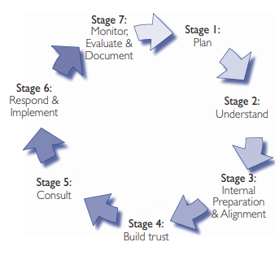

Nestle Stakeholder Engagement
The global network of partners includes those with whom we interact daily and those in public offices who influence the activities. These include workers, customers, vendors, societies, states, NGOs, shareholders, trade organizations and academies.
Their stakeholder meetings, seminars and other activities give us opportunities to deepen this discussion and build on the understanding of key social problems. This engagement assists our teams in building our people's abilities, promotes collaborative efforts and encourages mutual respect and trust. The Nestlé Society Board to senior management (Patrizia and Gianluca, 2013) gives the outcomes of this dialogue.
They also carry out a collective survey of Nestlé Stakeholder. The goal is to understand the changing opinions regarding market concerns and reputations management. This is an annual enquiry with global leader opinion.

Stakeholder Group of Nestle
As the key to our continued market growth, Nestlé recognizes the following groups:

- Training Academy
- Community Group
- Consumers and the public at large
- Clients
- Employees and their leaders
- State Government
- Industry and labour unions
- Government departments
- Non Governmental Organizations
- Agencies to report
- The financial and shareholders
- Farmers and smallholder suppliers included)

Conclusion
Every company, according to All Business, must "acquire, sustain and extend" ties with its target customer. This need does not matter how much the business may sell a product or service. Customer value strategies display goods and services in such a way those customers understand that they save money instantly or save money for the long term by collaborating with your company. Stakeholders' interest has recently risen on the agenda of public relations primarily because of the advent of social media and modern hybrid ways of marketing, public relations and direct marketing. New technologies have allowed direct access of stakeholders to organizational communications only if they are correctly used. The participation of stakeholders in an interactive setting is not an easy task and can be likened to a flip ball match; organizational messages now have immediate access, but often scatter spontaneously in the online world.

References
Ayuso, S., Rodríguez, M.Á., García‐Castro, R. and Ariño, M.Á., 2011. Does stakeholder engagement promote sustainable innovation orientation?. Industrial Management & Data Systems.
Dawkins, C., 2015. Agonistic pluralism and stakeholder engagement. Business Ethics Quarterly, 25(1), pp.1-28.
Goldberg, R.A. and Fries, L.A., 2012. Nestlé: Agricultural Material Sourcing Within the Concept of Creating Shared Value (CSV).
Grothmann, T., Prutsch, A., Schauser, I., McCallum, S. and Rob, S., 2014. Identify and cooperate with relevant stakeholders. CC adaptation manual: Lessons learned from European and other industrialised countries, pp.119-152.
Haas, A., Snehota, I. and Corsaro, D., 2012. Creating value in business relationships: The role of sales. Industrial Marketing Management, 41(1), pp.94-105.
Halliday, S. and Astafyeva, A., 2014. Millennial cultural consumers: co-creating value through brand communities. Arts Marketing.
Hoffmann, C.P. and Lutz, C., 2015. The impact of online media on stakeholder engagement and the governance of corporations. Journal of Public Affairs, 15(2), pp.163-174.
Jonas, J.M., Boha, J., Sörhammar, D. and Moeslein, K.M., 2018. Stakeholder engagement in intra-and inter-organizational innovation. Journal of Service Management.
Lüdeke-Freund, F., Massa, L., Bocken, N., Brent, A. and Musango, J., 2016. Business models for shared value. Network for Business Sustainability: South Africa.
Noland, J. and Phillips, R., 2010. Stakeholder engagement, discourse ethics and strategic management. International Journal of Management Reviews, 12(1), pp.39-49.
Patrizia, G. and Gianluca, C., 2013. Stakeholder engagement between managerial action and communication. Annals of the University of Oradea, Economic Science Series, 22(2), pp.97-105.
Pfitzer, M., Bockstette, V. and Stamp, M., 2013. Innovating for shared value. Harvard Business Review, 91(9), pp.100-107.
Porter, M.E. and Kramer, M.R., 2019. Creating shared value. In Managing sustainable business (pp. 323-346). Springer, Dordrecht.
Sheth, J. and Sisodia, R., 2012. The 4 A's of marketing: Creating value for customer, company and society. Routledge.
Zhang, J., Jiang, Y., Shabbir, R. and Du, M., 2015. Building industrial brand equity by leveraging firm capabilities and co-creating value with customers. Industrial marketing management, 51, pp.47-58.

