

LEVEL 5

SEMESTER 1 and 2

MODULE CODE: SHSS5085
Personal Skills
aSSESSMENT TYPE: project
Assessment/Component: 2

COMPONENT WEIGHTING: 75 %

WORD COUNT: 4,500 WORDS

MODULE TUTOR: Graham Harvey

SUBMISSION DETAILS:

There are two parts to this assessment you must complete both:
a.) Skills development portfolio: a weekly record of planning considerations for each session (including risk assessments and controls, weather forecasts, resource lists, proposed venues, bad weather alternatives).
b.) Reflective account: this should be based on the above portfolio. In this section you should reflect upon and evaluate each session and the overall module and how they relate to each other and your personal objectives. You should identify areas of success and failure and explore key issues that have led to different outcomes and any emergent themes or patterns. You must relate these personal reflections to relevant literature and theories from within the field of experiential learning and outdoor education.

SUBMISSION DETAILS:

Deadline: 3.00pm 5th May 2017
Portal: Turnitin

School of Sport, Health & Outdoor Education

Assessment Feedback Sheet

Student No./Name: Emlyn Price , 1501848

Personal Evaluation – to support your academic progress please complete the section below BEFORE submitting your work.
What do you consider to be the best aspects of this work? |  |  | The section where I have used the brick wall model to evaluate my skills as a coach.
Which aspects do you consider could have been improved in this piece of work? |  |  | I often find it hard to write down my reflections. I know what I have learned but struggle with how they translate to paper.
What have you found most satisfying whilst undertaking this submission? |  |  | Being able to see my progress each week in a clear way and reflect on it and improve it.
ASSESSMENT CRITERIA | Learning  Outcomes |  | GRADE
ASSESSMENT CRITERIA |  |  | Poor  < 20% | Weak  20-29% | Unsatisfactory  30-39% |  | Satisfactory  40 – 49% | Good  50 – 59% | Very Good  60 – 69% | Excellent  70 – 84% |  | Exceptional  85– 100% | %
Provide a logbook page that provides an effective summary for each session. | 1  4 |  |  |  |  |  |  |  | x |  |  |  | 30%
Reflection: successes and failures in the planned activity; considerations for future practice; progress towards overall objective; areas for further research etc. | 1  2  3  4 |  |  |  |  |  |  |  | x |  |  |  | 30%
Critically explore the relationship between your practical experiences and relevant academic theories. | 1  2  3  4 |  |  |  |  |  |  | x |  |  |  |  | 30%
Evidence of relevant research | 1  2 |  |  |  |  |  |  | x |  |  |  |  | 10%
It is expected that students will present work that is proof read, correctly referenced and adheres to the Assessment Checklist. Therefore a range of 0 – 10 marks will be deducted for non-completion of any of the points on the checklist below.
TUTOR COMMENTS:

Submission date:  via Turnitin |  | Return date:  (at least within 4 weeks) |  |  |  | Tutor: |  |  |  |  | Mark:

Assignment Checklist

- Please complete the Personal Evaluation section of the Assessment Feedback sheet, add your name and details, and paste the whole of this assignment document into the front of your assignment

- Submission is a single word file, clearly labelled with your name and module code
- Font style - Times New Roman, size -12 for text and 14 for headings
- Ink colour – black only
- Line spacing – 1.5 line spacing and 2cm- 2.5cm page margins
- Quotations more than three lines to be indented 1 line spacing
- One line space between paragraphs, paragraphs must be left aligned
- Pagination (your assignment should have page numbers)
- All tables and figures are internally referenced and have a title
- Word count checked and written at end of text (before references and any appendix)
- Assignment is within 10% of the word limit (excluding references and any appendices)
- All references in the text are included in the reference list
- Correct referencing following the Harvard style, as described in the Palgrave study skills book ‘Cite them Right’.
- Correct spelling using UK English
- Correct use of punctuation
- Grammar and syntax correct- double check anything that has a green line under it
- I have read my assignment out loud to myself and it makes sense and is easy to read
- Somebody else has read my work and it makes sense to him or her!
- I have checked and I have not plagiarised
Failure to follow these guidelines will cost you marks!

Personal Skills Essay
This portfolio will be a reflective analysis of my personal development throughout a series of sessions developing skills in both canoe and kayaks. 7 session Log books can be found in appendix A covering the smart goals set for each session and a reflection using the experiential learning theory model. In appendix B, there are 3 site specific risk assessments for the venues used for the sessions. Appendix C shows the 3star open canoe syllabus and appendix D shows the planning for Appendix A log book 1. This portfolio essay will first look at smart goals and their use and how I’ve applied them in planning my development for each session. Following each session, I undertook a reflection of my development, to do this I used Kolb’s (1984) experiential learning theory model which will also be introduced and explained in this essay. The log books in appendix A provide an overview of the planning and reflections for each session. In this essay key skills, I feel have developed throughout these sessions will be taken from the log books and further analysed. These skills are the development towards 3star open canoe award and my coaching technique.
Goals are a way of directing our time into focused outcomes, ‘without goals we will never work as hard or as smart to accomplish what is important’ O’Neil and Conzemius (2006, p.6). Smart goals have been used in business as a way of organising, prioritizing and achieving goals. Smart is an acronym used to describe the specific steps in process for goal setting. The first printed use of the acronym dates to 1985 where ‘Blanchard included SMART in his book, Leadership and the One Minute Manager’ Lawlor and Hornyak (2012, p.1). The acronym is defined as ‘Specific, Measurable, Attainable, Results-based and Time-bound’ O’Neil and Conzemius (2006). Each component of smart should be used when creating goals to effectively achieve the desired goals.
O’Neil and Conzemius (2006) expand on the details of each component, the specific component creates the tangible concrete goal for the individual. ‘In being specific about goals, teams have clearer communication and more constructive conflict because they can focus on how to pursue the goals or how to change’ Katzenbach and Smith (1993, cited in O’Neil and Conzemius, 2006). Being able to measure the goal is critical as efforts tend to be focused on what can be measured. For example, in appendix A the measurement for session goal in log 3 was ‘The measure for the session will be successful and satisfactory completion of the identified goals by the overseeing coach’ (Appendix A log3). The goals need to be attainable, if the goal is outside of the competency of the individual then it is not going to be achieved. Self-efficacy relates to the attainability of the goal, ‘Self-efficacy is concerned with people’s beliefs in their capabilities to produce give attainments’ (Bandura, 1997, cited in Bandura ,2006, p.307) to achieve the goal it needs to be within your capabilities. Throughout the sessions all goals were attainable as they were associated with development of skills that I have previously covered in star awards or am working towards. ’Results-based goals are motivating’ O’Neil and Conzemius (2006), being able to gain results or achieve concrete benchmarks allows us to measure our efforts. In appendix A session log 6 the results were ‘by the end of the session I hope to have surfed a wave without capsizing, and used the edge to carve the wave’ (Appendix A log 6). This is a tangible result and allows me to see and feel the progression in my ability during the goal. Finally setting a time-frame for the goal is critical in achieving it, I could set a goal to learn to roll but without a time frame I could keep putting it off until the goal was never learned. Smart goals have been used to plan all sessions in appendix A, doing this has allowed me to effectively manage my learning, evaluate and develop my skills in a clear and cohesive way.
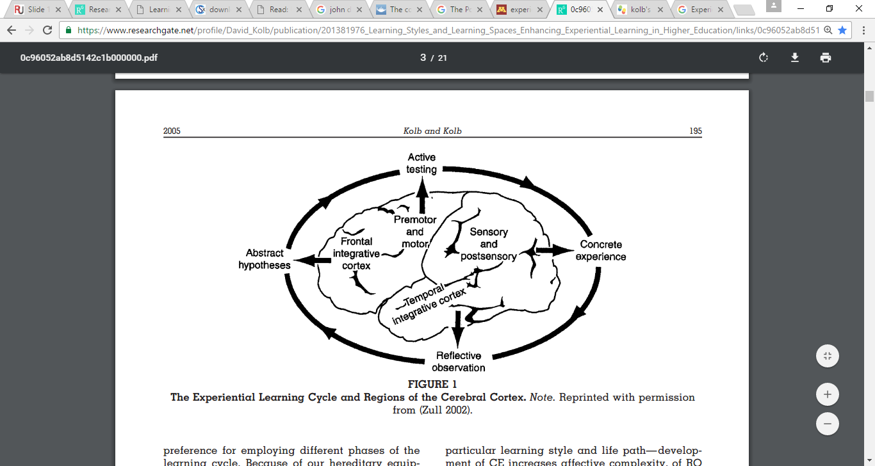
To be able to develop each session I need to be able to learn from my experiences. Experiential learning theory defines learning as ‘the process whereby knowledge is created through the transformation of experience. Knowledge results from the combination of grasping and transforming experience’ (Kolb 1984, p.41) Following the planning and undertaking of each session I have used Kolb’s (1984) ‘Experiential Learning Model’ to reflect on the session and evaluate my learning. The experiential learning theory provides the basis for the model and was formed from the work undertaken by several scholars, who shared the same propositions, the most notable of these scholars was John Dewey’s ‘Experiential learning model’ Kolb (2014, p.33). Dewey believed that “education must be conceived as a continuing reconstruction of experience: . . . the process and goal of education are one and the same thing” (Dewey 1897, p.79). Dewey proposed that all learning requires reflection and feedback to be effective and is something which is an ongoing process. Kolb used these propositions as a basis for his four-stage experiential learning theory model, (see Fig 1.) a cycle that starts with a concrete experience upon which reflections are made. These reflections give way to abstract hypothesis or different ways to approaching an idea, which the learner then uses to actively test with, to learn and expand their knowledge. For the learning to be effective the learner needs to engage with all the stages of the model see Fig1. This model of evaluating the experience has been used after each session to assess my development.

Figure 1:(Zull, 2002)
Dewey (2007) believed that understanding of an experience is needed so that education [or learning] may be intelligently conducted upon the basis of that experience. To understand and progress my personal development during the session I need to reflect on the experience so that I can evaluate what was learned and plan and improve it in future sessions. Evidence of this evaluation and continual improvement is in appendix A sessions logs 5 through to 7, in session 5 log my stern rudder when surfing was identified as a weakness upon reflection of the session ‘the coach noted that when I was on the wave I often used correction strokes such as a sweep or bow to keep my boat on the wave instead of a stern rudder’. This reflection led to abstract conceptualization about how I could improve this, and was continued over the following 2 sessions where the 4-stage process was carried out using the smart goals and Kolb’s experiential learning model. Using Kolb’s model has helped me identify key weakness and allowed me to work on them in a planned manner.
The main overall goal for the sessions was to work towards obtaining my 3star open canoe award, develop and won on my coaching technique. The first goal was to work towards achieving my 3star open canoe award, this award ‘indicates that a candidate can consider themselves as an intermediate open canoe paddler rather than a beginner’ (British Canoe Union, 2015). This award is also a prerequisite for completing a level 2 coaching assessment which I have received training for. To develop my skills as a coach I need to develop my skills as a paddler. The skills that I identified as weaknesses at the beginning in relation to the syllabus in appendix C are:
- Polling
- successfully entering crossing and exiting a simple flow
These can be seen in appendix A logs 2 and 4. Throughout the sessions more skills developed that I did not initially identify as weaknesses these are:
- Painter use
- Towing and use of towline
- Personal risk management
These can be seen in the reflections of logs 3 and 4. The development of these skills has been helpful in progressing me towards achieving my 3-star award. The use of Kolb’s model in evaluating my session has helped me identify these weakness and work on them. In log 4 the main aim for the session was to work on polling and sailing. ‘poles come into their own on long shallow river and lake sections … where there is insufficient paddle depth’ Ferrero (2006b, p.246). for this session, I planned to use the river as this is the most appropriate environment for learning and in relation to an assessment. However due to fish breeding and laying eggs on the river bed we were not able to pole on the river as not to displace any eggs that may be there. Aswell there was little wind so we were unable to sail, so we focused on polling. I had briefly read some information about the techniques used to poll so had a basic understanding.
The session undertook a self-guided problem-solving approach whereby I tried to poll, got some information from the coach and then tried again. I think that this worked well for me as I enjoy this style of learning. After reflecting on this session, I feel that I learn best when I am working things out for myself this leads me to believe that I am more of a kinaesthetic learner. ‘Individuals that are kinaesthetic learn best with and active “hands-on” approach. These learners favour interaction with the physical world’ Pourhossein (2012, p.106). The best way to learn as a kinaesthetic learner is to ‘include hands on demonstrations’ this is evident in log 5 appendix A when part of the session was to develop surfing skills. ’instead I was advised to use a stern rudder which would help keep me on the wave without being pushed off it. I asked the coach for a demonstration to help me better understand what they exactly wanted me to do, before trying for myself’ (Appendix A log 5. However, you do not just learn through one style. Because I also read up on the skill prior to practicing I also use some aspects of auditory learning ‘These individuals discover information through listening and interpreting information by the means of pitch, emphasis, and speed’ Pourhossein (2012, p.106). in this situation and other I used the information that I had gather from watching and reading to piece together the correct skill through trial and error. I also did this in log 6 when learning to flat spin whilst surfing ‘I had previously watched videos of surf kayaking and noticed they perform a simple looking trick called a flat spin. I began attempting the flat spin from the knowledge I had built up’ (Appendix A log 6) understanding the way in which I learn has been beneficial as it allows me to better plan sessions so that I can maximise the effectiveness of the session for me.
The idea that people have more than one way of learning comes from Howard Gardner’s Multiple Intelligence Theory (1983,1999a), he believed that there is more than one type of intelligence and potentially more than one way to learn. Aside from the three general categories ‘visual learners, auditory learners, and kinaesthetic learners’ (Northern Illinois University, no date, p.1), Gardner identified 8 different intelligences. These are ‘linguistic intelligence, logical-mathematical intelligence, spatial intelligence, musical intelligence, bodily-kinaesthetic intelligence, naturalistic intelligence, interpersonal intelligence, and intrapersonal intelligence’ (Gardner, 1999b). A person possesses these 8 intelligences, some more prevalent than others ’each of these frames is autonomous, changeable, and trainable and they interact to facilitate the solution of daily problems (Gardner, 1999a). However, these intelligences in themselves are not learning styles ‘the theory can be said to provide a roadmap to a number of alternative pathways to learning’. Vita, G. D. (2001, p.167). Understanding these different learning styles has helped me better plan the sessions around my preferred style of learning, this has helped me better achieve my desired overall outcome. Structuring my session goals around my preferred learning styles has helped me to stay engaged and interested in what I am covering.
The unplanned part of these session was where I learned secondary skills such as making the canoe ready and personal risk management. This began with an introduction to the dynamics of a submerged canoe Ferrero (2006a, p.225) says one cubic meter of water weighs 1 tonne so a submerged canoe may weight upwards of 1 tonne and could move around 6-8kph in moving water. To swim downstream of a flooded canoe is extremely dangerous and in all case the best option is to stay on the upstream side of the canoe and swim to the side. This is something I had not previously considered when paddling, as a member of a group I have a responsibility to manage the risk to myself. We then looked at the use of a painter and a throw line and how it could be used as a swim line. A swim line or throw bag is’ attached to the stern grab loop of the canoe…with the clean end protruding above the air bag ready to grab’ Ferrero (2006a, p. 225-226). The session progressed and there was opportunity to see a swim line in use which can be read in appendix A log 4. The reflection of the session brought to light my personal preparation and management of how I set up my boat. This is something which is crucial to the development of myself as a paddler and myself as a coach, which links into the overall goal of developing coaching skills. As a coach one of the Competencies that needs to be considered is ‘Decision Making… decisions which focus on the aspect of safety and the personal well- being of the learners and the group’ Taylor (2006, p.9).
As a coach, there you are essentially an outdoor leader and have a role of responsibility towards yourself and your group. Outdoor Leadership is ‘The Practice of leading individuals and groups into natural settings’ Martin et al. (2006, p. 6) as a coach you lead participants through the various stages of their learning in the chosen activity. As a coach, there are many decisions that need to be made to deliver a session. ‘The result of this decision making may need to balance a number of conflicting elements, by the selective application and understanding of coaching tools and competencies’ Taylor (2006, p.8) these competencies are:
‘1. Knowledge
- About the subject matter- technical, tactical, and physical.
- About the individuals you are working with-as individuals and within the group interactions.
- About the venues and environments, you intend to work in.
2. Decision making
- That occurs before, during and after the session or programme.
- Decisions that are concerned with the selection of ’best fit’ coaching methods and approaches.
- Decisions, which focus on aspect of safety and the personal well- being of the learners and group we work with.
- The management of the learning environment to provide a platform to achieve the identified learning outcomes.
3. Action
- Overt behaviours by the coach in the efforts to meet the aims and objective of the session or programme.
- Action in the interactive nature of a coaching delivery. Those situations where the learning process will have to be managed and guided by the coach with the aim of producing more positive results.’ Taylor (2006, p.8-9).
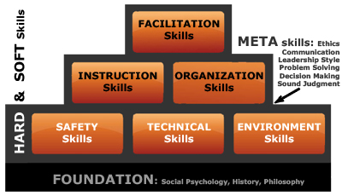
To reflect on my development as a coach regarding these competencies I will be using the Brick Wall Model developed by Priest and Gass (1997). Priest found that ‘the general skills or sets of competencies needed for leadership are like a brick wall with a foundation, two kinds of bricks, and mortar to glue it all together’ Priest (2016b). Although this model was developed for leadership I think it can also be used to analyse coach competencies. the model is made up of three sets ‘hard, soft, and meta skills for outdoor leadership’ Priest (1999, p.237). The foundation or “hard skills” are the tangible skills which are easily recognised and trainable for example technical knowledge of paddle strokes. The second bricks or “soft skills” ‘tend to be amorphous, intangible, difficult to measure, and tough to train or assess’ Priest (1999, p.237). An example of soft skills could be facilitation of learning, organisation or leadership skills and organisational skills. When coaching this may be selecting appropriate activities organising the session or recognise the needs of group members. Finally, “meta skills” are the binding material of soft and hard skills these ‘meta skills [are] communication, ethics, leader style, problem solving, decision making, and sound judgment’ Priest (2016b). Using this model, I can evaluate my current skills as a coach and plan sessions around improving weaknesses. Taylors (2006) coach competencies link into the model, the hard skills are the knowledge competencies, soft skills cover the decision making e.g. planning learner facilitation and the meta skills are the action e.g. how you communicate with the participant. Fig 2 shows the brick wall model and the skills within it.
Figure 2 Priest (2016a)
This next section will identify weaknesses in my own competencies, relating to section of the model.
Hard Skills
The coaching sessions that I did in appendix A were great in allowing me opportunities to help my peer’s reach their goals and develop and improve my coaching, without having a manager or boss evaluating me. The sessions allowed me to identify some hard skills that need improving, the most notable of these was my knowledge of technical skills. In appendix A log 6 I taught the wrong skills due to a lack of this knowledge. ‘I quickly learnt that unlike a river it is important to edge into the wave to prevent capsizing... due to a lack of knowledge I thought that edging is the same on both river and sea so I coached my peers in this style’ (Appendix A, log 6). In this situation, the issue was easily resolved as I received advice from another coach. I think the problem with this was simple a lack of specific knowledge, it was also my first time paddling in this environment, so there was a lot of new information to take on. To improve this, I will as previously stated undertake more reading and research to make sure the information is correct. It would also be a good idea to just consult another coach to confirm my knowledge before passing it on. This is something I have continued to do when coaching to make sure the information being passed on is correct.
I also feel that as a coach there are some safety considerations I need to improve in my own personal kit that I carry. In appendix, A, log book 3 a FSRT session was carried out and personal safety equipment was covered. ‘The coach also carried a tape sling and karabiners which can be used as a simple tow line or when rescuing people into canoes. They also carried a whistle to attract attention and a throw line’ (Appendix A, log 3). A sling and karabiner is not something I carry as well as a throw line, ‘a coach has both a moral and legal duty of care to those being coached’ Ferrero (2006c, p.107) to be able to keep the group safe and in control ‘during these activities, outdoor leaders need to be able to perform at a proficiency higher than that of the group members’ Priest (1999, p.237). Being able to manage my own personal safety allows me to operate at a higher proficiency and look after my participants better. Making sure I have the correct safety equipment to deal with situations will be something to continue forward through my development as a coach.
Soft Skills
One of the main areas of my soft skills development was the organisation of my session. For the first session, I planned to act as a coach so organised with the group what skills they wanted to cover and developed a plan for the session (Appendix D), covering those skills. Doing this allowed me to be more relaxed about what I was going to do and how I was going to do it. Organisation is a key skill as a coach or leader as it lays the foundation of a good session. This planning and preparation for this session can be seen in appendix A log 1 and Appendix D. However, when planning the session, I did not account for the level at which people learn, so where the planned time frames between each skill being learnt are small, this took longer to do and made the session longer so some skills were missed. in the future, I will plan a longer time to learn the skill and If participants are quicker, plan additional content that can be added on. This improvement of organisation improves the decision-making process needed for good coach competency by supplying a ‘platform to achieve the identified learning outcomes’ Taylor (2006, p.9). developing organisational skills ‘permit a leader to plan prepare execute and evaluate experiences for the specific needs of particular client groups…to make the experience a success’ Priest (1999,238).
Meta Skills
The meta skills that kept reoccurring throughout the coaching experiences was my communication, specifically as ‘I have a tendency to use over complex language which can sometime confuse participant’ (Appendix A, Log 5). Effective Communication is information exchange between two or more people resulting in behavioural change… outdoor leaders need to be able to generate, encode, link, send, transmit, receive, decode, and interpret such messages… they need to use paraphrasing, clarification, and feedback. Priest and Gass (1997, p.5). This is something that I struggle with, I find that communication what I want the participant to do is usually clear, and well translated but the information is not always concise, due to sometimes using over complex language. Although not a huge problem, it sometimes causes the participant to become distracted from what I want them to do. To counter this problem, I think I need to focus on making information as concise as possibly as to not confuse the participant. This also provides a base for them to develop an understanding before introducing more complex terminology.
To conclude throughout these sessions, I have been able to develop my coaching skills and recognise the strengths and weakness in them. Using Priest brick wall model allows me to see the different components of becoming a proficient coach. Analysing my skills using this model has allowed me to begin to develop me own style through reflection and watching others coach. Doing this has enabled me to analyse my impact on the group and become a better coach.
Overall the initial aims for the sessions have been met, I feel much more confident delivering coaching sessions and feel that I am ready to do a 3star open canoe assessment. Using the different theory’s and methods to review my development weekly has given me a great understanding of my weaknesses and strengths, allowing me to use goal setting to improve these weekly. I now see reflection as an ongoing process and greater understand the importance on reflecting regularly to improve myself as a personal paddler, coach, and facilitator. Using the session as a chance to improve my skills has been beneficial in that I can help my peers reach their goals and mine through coaching without the added pressures of being assed or delivering a paid session for a client. This has allowed me to take my time in developing my preferred methods and styles. In the future, I hope to gain my 3star qualification and achieve my level 2 coaching award.
Word count: 3899
Reference List:
Blaine Lawlor, K. and Hornyak, M. J. (2012) Smart Goals: How the Application of Smart Goals Can Contribute to Achievement of Student Learning Outcomes, Available at: http://dysgu.ydds.ac.uk/pluginfile.php/310292/mod_resource/content/0/SMART%20goals%20and%20student%20learning_Lawlor_2012.pdf (Accessed: 23 April 2017).
British Canoe union (2015) 3 Star Open Canoe Syllabus. Available at: http://canoescotland.org/sites/default/files/resources/documents/British%20Canoeing%20Star%20Awards/3%20Star%20Open%20Canoe%20Syllabus%20v3-2%20May15.pdf (Accessed: 25 April 2017).
British Canoe Union (2017) Level 1 Certificate in Paddlesport, Available at: https://www.britishcanoeing.org.uk/courses/level-1-certificate-in-coaching-paddlesport/#course-content (Accessed 15/02/2017).
British Canoeing (no date) Foundation Safety and Rescue Training Syllabus. Available at: http://canoescotland.org/sites/default/files/resources/documents/British%20Canoeing%20Safety%20Training/Foundation%20Safety%20and%20Rescue%20Training%20Syllabus%20v2-1%20May15.pdf (Accessed: 01 march 2017).
Cole, S. (2015) An Example of Risk Assessment Matrix[diagram]. Available at: http://safeworkpro.com/risk-assessment/an-example-of-risk-assessment-matrix (Accessed: 5 April 2017).
Dewey, J. (1897) ‘My Pedagogic Creed’, The School Journal, 54(3) pp.77-80.
Ferrero, F. (2006c) ‘Generic Safety Issues’, in Ferrero, F. (ed.) (2006b) The British Canoe Union Coaching Handbook. Great Britain: Presda Press, pp.17-112.
Ferrero, F. (ed.) (2006a) British Canoe Union Canoe and Kayak Handbook. 3rd edn. Great Britain: Presda Press.
Ferrero, F. (ed.) (2006b) The British Canoe Union Coaching Handbook. Great Britain: Presda Press.
Gardner, H. (1983). Frames of mind. The theory of multiple intelligences. New York. Basic Books.
Gardner, H. (1999a). Intelligence reframed. Multiple intelligences for the 21st century. New York: Basic Books.
Gardner, H. (1999b). The disciplined mind: What all students should understand. New York: Simon & Schuster.
Kolb, D. A. (2014) Experiential Learning Experience as the Source of Development and Learning. 2nd edn. United States of America.
Martin, B., Cashel, C., Wagstaff, W. and Breunig, M. (2006) Outdoor Leadership: Theory and Practice. United States of America: Human Kinetics.
Northern Illinois University (no date) Howard Gardner’s Theory of Multiple Intelligences, Available at: http://www.niu.edu/facdev/_pdf/guide/learning/howard_gardner_theory_multiple_intelligences.pdf (Accessed: 25 April 2017).
O’Neil, J. and Conzemius, A. (2006) The Power of Smart Goals. United States of America: Solution Tree Press.
O’Sullivan (2006) ’White Water Safety and Rescue’, in Ferrero, F. (ed.) (2006a) British Canoe Union Canoe and Kayak Handbook. 3rd edn. Great Britain: Presda Press, pp.316-311.
Pourhossein, A. (2012) ‘Visual, Auditory, Kinaesthetic Learning Styles and Their Impacts on English Language Teaching’, Journal of Studies in Education, 2, pp. 104-113.
Priest S.(2016a) THE BRICK WALL OF HARD, SOFT & META SKILLS [Diagram]. Available at: http://simonpriest.altervista.org/LM.html#BW Accessed: 27 April 2017).
Priest, S. (1999) ‘Outdoor Leadership Competencies’, in Miles, J.C and Priest, S. Adventure Programming. Cato Avenue: Venture Publishing, pp. 237-239.
Priest, S. (2016b) Leadership and Management. Available at: http://simonpriest.altervista.org/LM.html#BW (Accessed: 27 April 2017).
Priest, S. and Gass, M., A. (1997) Effective Leadership in Adventure Programming. United States of America: Human Kinetics.
Taylor, B. (2006)’Coaching’, in Ferrero, F. (ed.) (2006b) The British Canoe Union Coaching Handbook. Great Britain: Presda Press, pp.7-49.
Vita, G. D. (2001) Learning Styles, Culture and Inclusive Instruction in the Multicultural Classroom: A Business and Management Perspective, Available at: http://s3.amazonaws.com/academia.edu.documents/39796933/Learning_Styles_Culture_and_Inclusive_In20151108-15392-7rjj5t.pdf?AWSAccessKeyId=AKIAIWOWYYGZ2Y53UL3A&Expires=1493141267&Signature=VVI%2FQH%2ByizQ2%2BSGN%2F1TaevluX6Q%3D&response-content-disposition=inline%3B%20filename%3DLearning_Styles_Culture_and_Inclusive_In.pdf (Acccessed:25 April 17).
Zull, J. E. (2002) The art of changing the brain: Enriching teaching by exploring the biology of learning. Sterling, VA: Stylus. Diagram. Figure 1.

Appendix A
Session Log Books
Keywords: British Canoe Union (BCU)
Contents:

- Log: 09/02/2017
- Log: 16/02/2017
- Log: 02/03/2017
- Log: 09/03/2017
- Log: 16/03/2017
- Log: 23/03/2017
- Log: 30/03/2017

Smart Goals 9/02/2017 log:1
Specific | Help plan and assist with delivering a comprehensive coaching session on Turing a canoe with an aim of completing a 2* assessment, using Draw strokes, Forward and Revers Sweep Strokes, J stoke. The end aim is to develop my own coaching style through observation with a view to completing my level 1 coaching course.  One of the main focuses of the level 1 course is the ability. ‘The course focuses on how to coach introductory core skills…Steering, turning and manoeuvring’ (British Canoe Union, 2017).  The session I have planned is available in appendix D
Measurable | Dialog journals and reflections, Video analysis, discussion with other coaches.
Attainable | The goal is achievable within the period of the day.
Results-based | yes, participants should be able to easily reflect and see their own development, for myself my results will be based from assisting coaches on whether the session was effective.
Time Phased | The end of the day should achieve the goal
Weather / River conditions | River height not applicable as on lake. Overcast 2-3°C 26km wind, low precipitation
Venue | Llandysul Paddlers Lake
Review
(Concrete Experience) Was the smart goal achieved? | The smart goal was achieved within the allowed period the participants effectively learned how to turn a canoe whilst developing their skills. However, in terms of my personal development as a coach I took a more observational position which allowed me to observe the main instructor, helping develop my own ideas about coaching styles. Once the main instructor had delivered his instructions I then assisted with the participant’s individual development with the skill. Although I did not get a chance to teach a group, I did have ample experience to work one on one with participants. This gave me a great chance to develop my coaching skill, picking out small details of the paddle stokes.  The organisation of the session plan was good it allowed me to see an overview of what the session needed to cover and how I was going to do it, unfortunately learning each skill took longer than expected as I did not account for different speeds of participant learning.
(Reflection)Thoughts and feelings about the smart goal? | I felt that the delivery and communication of the main points I wanted to get across was very good, it was clear concise and understood. I need to improve on my technical knowledge of strokes and technical language to better deliver my coaching sessions. I also noticed that occasionally in my delivery of content I tended to over complicate the moves of the stroke. Another observational point was that whilst the instructor was focusing on one participant the others were often left with little to do.
(Abstract Ideas) what could you improve? | To improve my sessions and delivery of them there are some key points I have noted to look at:  - Simplification of communication  - More reading and familiarisation of strokes and explanations  - Identification of participant weaknesses  - Group management through applying tasks whilst allowing focus to be directed towards participants requiring more assistance. E.g. Setting tasks and playing games.  - Better management of time and plan for different levels of learning
Summary | To summarise the initial smart goal was achieved although through a slightly different route. This did give way to development of my own ideas about how I would run the session and gave me time to develop my skills through one on one coaching. I have learned from this session and now have some key points to work on and develop for next time. This will also aid me in undertaking my level 1 coaching qualification.
British Canoe Union (2017) Level 1 Certificate in Paddlesport, Available at: https://www.britishcanoeing.org.uk/courses/level-1-certificate-in-coaching-paddlesport/#course-content (Accessed 15/02/2017).
Smart Goals 16/02/2017 log:2
Specific | To successfully enter cross and exit a simple flow in accordance with the 3* star BCU open canoe award, part A.7.  As a group, we are undertaking a river trip and this is a perfect venue to practice and develop these skills. The syllabus training notes states that ‘Paddlers should demonstrate entering, crossing, and exiting a simple flow with appropriate angle, speed and boat tilt, and with minimal loss of ground.’ (British Canoe Union, 2015) to do this a range of technical skills should be used such as effective forward paddling, trim and both on side and offside strokes. This will be the focus of this practical session to progress my development to my 3-star assessment
Measurable | The measurement for this goal can be feedback from observers and coached, video analysis and completion of the syllabus training notes
Attainable | The venue is suitable and is achievable to my current ability
Results-based | The results of this session will be based on whether I can achieve the smart goal, I should be able to easily do this as I have completed similar tasks in the past.
Time Phased | I hope to achieve and develop the goal throughout the day
Weather / River conditions | 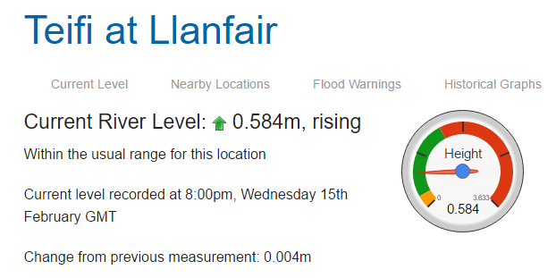 River levels are within normal zones 0.584, low probability of rain, location is coverd from wind and there is low probability of rain in Tregaron which is lake area which feeds river.  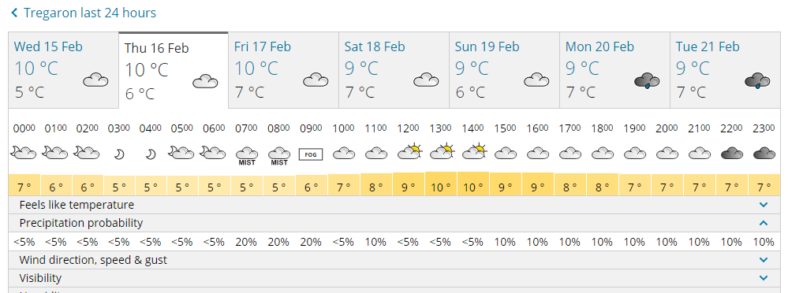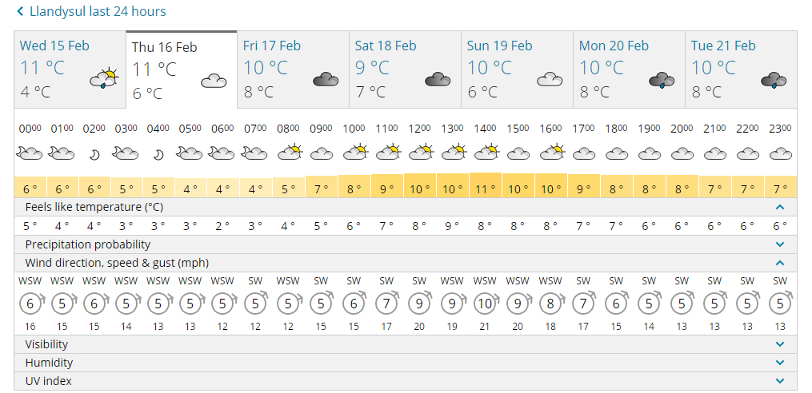
Venue | Llandysul Teifi river
Review
(Concrete Experience) Was the smart goal achieved? | The smart goal was achieved, I successfully entered exited and crossed a flow. I also attempted surfing the canoe which is a step beyond the syllabus. I used the white-water canoe which has a little more edge is smaller and nimbler. I also tried using a kayak paddle to paddle it as the boat is narrow enough. By the end of the river trip I felt comfortable and confident using various strokes to break out of a flow and back into the flow again also using the same strokes to ferry glide across the flow. Inside pivot, sweep, bow rudder, J-stroke, and Stern Rudder.
(Reflection)Thoughts and feelings about the smart goal? | I enjoyed the session on the river I learned a lot about the way different crafts handle, however due to time constraints I was pushed to spend enough time practicing skills. I also think I should have spent some time getting used to the craft on flat water before progressing straight onto moving, as I spent a majority of the time getting comfortable within the boat. The actual aspect of paddling the boat was fun and once I could feel comfortable in it I began pushing my limits a little further with edging and surfing etc.  I had done previous reading so had a solid understanding of the concepts involved which helped greatly when learning the movement
(Abstract Ideas) what could you improve? | To improve as previously stated I would have liked to have done a session in the morning on flat water to get a little more used to the canoe and the way it moves.  - Prior session in WW canoe  - More time spent on moving river  - Better time management  - Attempting goals with different paddle strokes
Summary | I enjoyed the river trip and felt that I had succeeded in completing my SMART goal objectives, I used strokes which I had previously learned effectively in one swift movement, most notably I used a sweep with a reverse sweep to bow draw to pull myself into an eddy.
British Canoe Union (2015) 3 Star Open Canoe Assessment Notes. Available at: file:///C:/Users/emlyn/Downloads/3-Star-Open-Canoe-Assessment-Notes.pdf (Accessed: 15 February 2017).

Smart Goals 02/03/2017 log:3
Specific | Recap the FSRT syllabus  -Specifically looking at the types of rescues  ‘Talk…Reach…Row and Tow…Go’ Ferrero (2006, p.320)  - Practicing different methods of boat rescues, i.e. Back deck carry, bulldozer, and a simple tow.
Measurable | The measure for the session will be successful and satisfactory completion of the identified goals by the overseeing coach.  As well as extrinsic feedback from the coach, I will also be able to intrinsically feel if I am performing a rescue correctly.
Attainable | The venue is suitable in accordance with the syllabus.’ Sheltered water, calm conditions’ British Canoeing (no date, p.2).
Results-based | The result for this session is whether the coach would allow to pass the FSRT course.
Time Phased | To be completed by the end of the day
Weather / River conditions | Weather is dry throughout the day with low temprature (will need to consider extra layers especially when working in water. Wind speed is high and comping from the west low 15mph, high 43mph with gust of upto 64mph . normally this would mean the FSRT course would be outside of the remit as the aspects of the venue face the oncoming wind, but the lake is situated in the bottom of the valley so is fairly shelterd. The river is not being used for this session but the height Is 1.251m and falling.  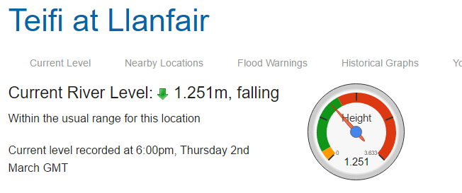  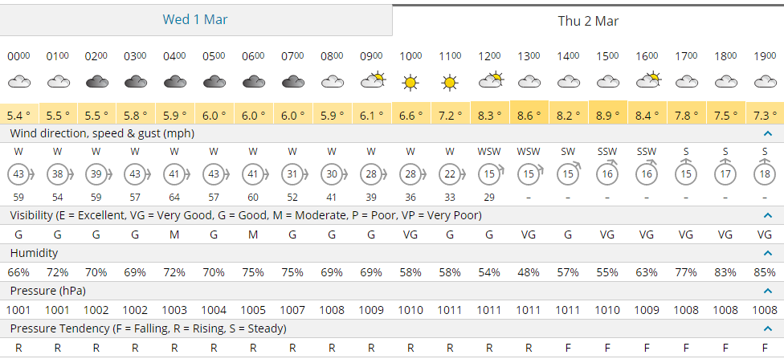
Venue | Llandysul paddlers lake
Review
(Concrete Experience) Was the smart goal achieved? | The day stated with an introduction about what kit should be carried, the obvious are personal protective equipment such as helmets buoyancy aids and appropriate foot wear were covered. What I learned most wat the personal rescue kit and this is something I need to improve. The coach carried two water safety knifes one blunt for cutting rope and a sharp one for puncturing rafts, ‘an easily accessible sharp knife, which can be used single- handed, is essential if ropes are being used’ O’Sullivan (2006, p.319). the coach also carried a tape sling and Karabiners which can be used as a simple tow line or when rescuing people into canoes. They also carried a whistle to attract attention and a throw line.  The smart goal was achieved. The session moved onto a throw line recap, a small obstacle course was set up and had to be completed. It included various targets to hit both over and underarm. After doing this activity I was slightly concerned with some of my throws, some of them frequently missed or did not hit the target altogether. The session moved onto the first two rescue methods which are bank based rescues a recap of the simple methods of recovering a swimmer from the water, the first being Talk. When rescuing the safety of the rescuer is paramount, the simplest way to ensure you do not become another casualty is to ‘avoid all physical contact with the victim and to shout encouragement and advice to the person’ Ferrero (2006, p.319). we practiced this method a few times with different scenarios before moving to reach. This is the next step, when reaching, the idea is to use something when on the bank to reach for the swimmer such as a paddle or throw line. during the session, we practiced this using both a throw line and a paddle. This rescue starts much the same as the talk in that you make yourself as loud and clear as possible before offering the paddle or rope to the swimmer to assist them with climbing up the bank. It’s important to note that when performing this rescue ‘the rescuer should be able to release the rope or paddle before this happens’ Ferrero (2006, p.320) The next step to cover is the row and tow, this is a boat based rescue this means paddling out to the swimmer and towing them into the shore. There are three methods for doing this. The first is the back deck carry where the swimmer lies on the back of the deck and is paddled to the shore, this is useful as the swimmer is protected by the boat and it is easy for the rescuer to paddle. The second is the simple tow, the swimmer holds onto the back or the boat and lies flat on the surface of the water, they are encouraged to kick, this rescue is slower but still effective. The issue with both rescue’s is that the swimmer cannot be seen, which poses some difficulty’s and may be stressful if the swimmer is uncomfortable in the water. The third option is the bulldozer, here the swimmer holds onto the bow of the boat and is paddled into the shore. This method is usefully if the swimmer is nervous or needs clear instructions, it also allows the rescuer to keep an eye on the swimmer. Attention needs to be made when paddling towards the bank as it is easier for the paddler to hit the bank. With these rescues, it was pointed out that you need to make sure the swimmer is calm before approaching them as to not put yourself in danger. The final rescue is go, this is a final resort rescue and involves the rescuer being attached to a floating line and swimming out to the swimmer, we did not get a chance to practice this rescue as we did not have appropriate equipment.
(Reflection)Thoughts and feelings about the smart goal? | When undertaking the Talk part of the rescue I noticed the importance of making yourself as visible as possible and keeping your distance until you knew it was safe to approach the swimmer without endangering yourself. This is something I had not considered before when undertaking a rescue, in this respect the smart goal was achieved. This was particularly emphasised as the instructor told the swimmers to act differently when being rescued, some swimmers were deaf and others were panicking, this was a focal point when performing the all the rescues and is something I will remember when performing rescues in the future.  Another learning point was the how poor some of my throws were when completing the throwline activity. I caused me to think about whether I would be able to throw a line to a swimmer in a real scenario, and I will definitely be putting more practice into this in the future.
(Abstract Ideas) what could you improve? | To improve the session, I would have brought more equipment to be able to practice the go rescues as I understand the concept but have yet to practically try one. I am also going to focus on improving my throwing and repacking of the bag.
Summary | This session was useful in recapping some of the technical details of the different rescues that may be need when paddling on flat water. I feel I have gained a lot of useful information about my performance and have some key areas to improve on.

British Canoeing (no date) Foundation Safety and Rescue Training Syllabus. Available at: http://canoescotland.org/sites/default/files/resources/documents/British%20Canoeing%20Safety%20Training/Foundation%20Safety%20and%20Rescue%20Training%20Syllabus%20v2-1%20May15.pdf (Accessed: 01 march 2017).
Ferrero, F. (ed.) (2006a) British Canoe Union Canoe and Kayak Handbook. 3rd edn. Great Britain: Presda Press.
O’Sullivan (2006) ’White Water Safety and Rescue’, in Ferrero, F. (ed.) (2006a) British Canoe Union Canoe and Kayak Handbook. 3rd edn. Great Britain: Presda Press, pp.316-311.
Smart Goals 09/03/2017 log:4
Specific | To successfully Learn polling and how to erect and use a sail in a canoe in accordance with A.8 and A.9 in training notes  ‘A.8 Poling Paddlers should demonstrate the use of the pole in either shallow or deep water, to propel the canoe over 25m turning to the left and the right.’  ‘Sailing Paddlers should be able to improvise and sail a downwind sailing rig for a tandem canoe. It must be evident that the improvised sail is having an effect on the boat’s movement. The canoe should remain on a reasonably straight downwind course with the stern paddler steering appropriately’
Measurable | The measurement for this goal can be feedback from observers and coached, video analysis and successful completion of the syllabus training notes
Attainable | The venue is suitable and is achievable within my current ability
Results-based | The goal is realistic within the given time and venue. I should also be able to learn how to poll in this environment. Confirmation of skills learned will come from overseeing coach.
Time Phased | I hope to achieve and develop the goal throughout the day
Weather / River conditions | 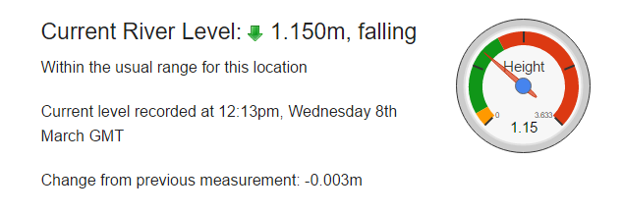 River levels are outside of normal zones 1.150m, low probability of rain, location is coverd from wind and there is low probability of rain probability of rain in  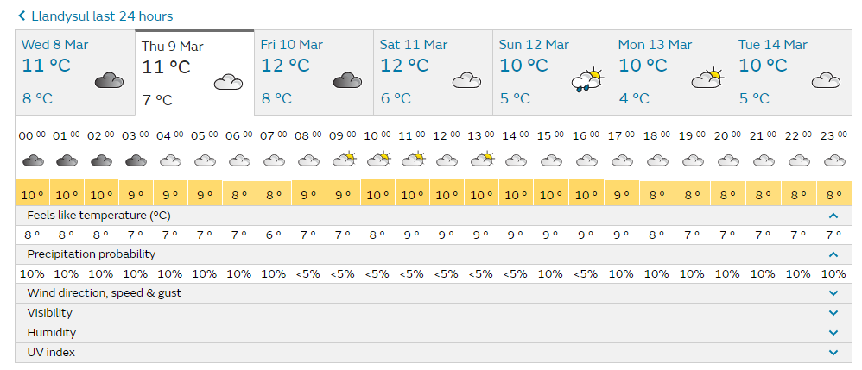
Venue | Llandysul Paddlers Lake
Review
(Concrete Experience) Was the smart goal achieved? | The smart goal was not completely achieved, I was unable to sail due to a lack of wind, but the aims of polling were achieved in accordance with the BCU handbook and guidance notes. However due to fish breeding and laying eggs on the river bed we were not able to pole on the river as not to displace any eggs that may be there. We continued to discuss the various technique required to poll on a river and the uses for them. due to being unable to go on the river the session was cut slightly short and we had to remain on the lake to practice polling.  The session progressed after lunch and as a group we decided to go on the river and look at similar techniques that I and the rest of the group covered in week 16/02/2017 (entering, exiting a flow, and ferrying across a river). This session started with a discussion about planning for a river trip. The focus of this was the emphasis on making the canoe ready, this included tying on swim lines, and how to use them Ferrero (2006, p.225) says that swimming occasionally happens when paddling, one cubic meter of water weighs 1 tonne so a submerged canoe may weight upwards of 1 tonne and could move around 6-8kph in moving water. To swim downstream of a flooded canoe is extremely dangerous and in all case the best option is to stay on the upstream side of the canoe and swim to the side. A swim line or throw bag is’ attached to the stern grab loop of the canoe…with the clean end protruding above the air bag ready to grab’ Ferrero (2006, p. 225-226). The idea behind the swim line is that the swimmer can keep hold of the canoe swim safely to the side and pendulum the flooded canoe into and eddy before emptying it out. The use of bailers was also cover when canoeing on moving water.  As a group, we then moved onto the river we talked about entering the water and how best to position yourself when lowering your boat into the water. Once on the water we started ferry gliding before moving through a section of rapids. Myself and another student safely made it through before the third student capsized, fortunately there was a swim line attached and they grabbed it and sawm to the side. However, the line was to short and before reaching the eddy the weight of the boat pulled the rope tight and out of the swimmer’s hands. One of the instructors then had to follow the capsized boat and empty its and bring it to the shore.
(Reflection)Thoughts and feelings about the smart goal? | The goal was achieved and I now have a better understanding of what and how to do polling. It would be beneficial to transfer theses skills onto the river to put them into practice. One of the biggest learning points for me was the swim line and how that can aid a rescue. Witnessing the swim and attempted rescue of the canoe was interesting as I got to see the use of a swim line in practice. One of the most notable point was ensuring the swim line is not to short, the one attached to the swimmer’s boat was to short (15m) and pulled tight before the swimmer could get into the eddy and pendulum the boat in. the BCU handbook recommends ‘twenty-thirty meters of floating line’ Ferrero (2006, p.225) this is something I am going to consider when preparing my canoe next time, I paddle on white water. Also interesting was when watching the coach attempt the rescue in moving water was quite different to flat water, both the boat and rescuer drifted for a long time down river before they managed to rescue the boat. In this situation aswell it is also important to remain on the upstream side of the submerged boat.
(Abstract Ideas) what could you improve? | To improve the session, I would have planned an alternative activity in case polling and sailing were unavailable options. The obvious improvement would be to use polling on the river to enable the it would have to be learned at a different time in the season when the fish are not breeding. In terms of my own development I will improve the setup of my canoe before paddling white water ensuring a throw line is attached and that it is an appropriate length.
Summary | Although not all the smart goals I set for myself were achieved, some interesting learning points developed from the session. These would not have occurred if the original plan could be followed efficiently. I have learned a lot about setting up the boat not only to make it safer for yourself but the rest of the group you may be with, and how a simple rescue can turn into a much more challenging one when being performed on moving water. I feel more equipped to deal with a situation myself when coaching or paddling as a member of a group. I am also pleased I understand polling more as I had only previously read about it and was a little confused on some of the aspects of it.

BCU (2015) 3 Star Open Canoe Assessment Notes. Available at: http://canoescotland.org/sites/default/files/resources/documents/British%20Canoeing%20Star%20Awards/3%20Star%20Open%20Canoe%20Assessment%20Notes%20v3-2%20May15.pdf (Accessed: 8 March 2017).
Ferrero, F. (ed.) (2006) British Canoe Union Canoe and Kayak Handbook. 3rd edn. Great Britain: Presda Press.
Smart Goals 16/03/2017 log:5
Specific | Using the lake and river to develop and refine competency of specific paddling skills on white water.  - The use of a stern rudder when surfing  - Bow rudder when breaking in and out  - Hanging draw on the move
Measurable | The measurement for this activity will be feedback from the coach aswell as intrinsic feedback upon successful completion of the desired skills.
Attainable | The goals are attainable in relation to my current ability
Results-based | This goal is oriented around refinement of skills which I have previously identified as weakness in my paddling ability. The aim is to work on improving them confirmation will come from the overseeing coach.
Time Phased | The initial development of the aims of the goal will be completed by the end of the session and then continual refinement will follow.
Weather / River conditions | River levels 0.6m and dropping, which is within normal levels.
Venue | River Teifi at Llandysul, Llandysul paddlers lake
Review
(Concrete Experience) Was the smart goal achieved? | The smart goal was achieved during the session. The day started unexpectedly with the arrival of a foreign student hoping to start the course next year so I undertook some coaching in the morning which gave me a great chance to put some more practice in. I worked with the student in a canoe helping them paddle forward and learn some simple strokes such as a sweep stroke and reverse paddling. During this session, I used the coaching method of Boat Body Blade to break down each movement to help the student learn, this worked well. After a short break, I then swapped with another student and went onto the river, here I practiced using the hanging draw to move across the flow whilst moving downstream, this worked well. We then moved further down the river and found some small waves to practice surfing, I began on the smaller waves before moving to the bigger, the coach noted that when I was on the wave I often used correction strokes such as a sweep or bow to keep my boat on the wave instead of a stern rudder. Doing this had the effect of slowing me down which caused me to be pulled off the wave, instead I was advised to use a stern rudder which would help keep me on the wave without being pushed off it. I asked the coach for a demonstration to help me better understand what they exactly wanted me to do, before trying for myself. Once we had surfed for a little while we continued down the river to a section where we could practice breaking in an out of the flow. Here the river funnelled into a narrower passage causing an increase in the speed of the flow meaning strong stokes had to be taken to get across the eddy line before initiating a bow rudder to turn. Again, the coach noted that the bow rudder I was doing was too far back (similar to a draw stroke). This had the same effect as using correction strokes on the wave in that the speed I had coming across the eddy line was lost when I initiated the bow rudder as it slowed me down. This caused instability in the turn and meant occasionally I had to brace to prevent a capsize. After being made aware of the problem I moved the bow rudder close to the bow and found that I turned much quicker and with more stability.
(Reflection)Thoughts and feelings about the experience? | Using the principles of Boat Body Blade to teach the stokes needed in a canoe worked very well and were effective. I enjoyed coaching but think there are some room for improvement, I have a tendency to use over complex language which can sometime confuse participant. Also looking into more games that could be used in a session to help make it more fun and interesting. At first using the stern rudder on the wave felt strange as I had become used to using correcting stokes, after a few attempts it became more natural and easy for me to stay on the wave. This is something which I wanted to achieve in my set smart goals and something I would like to continue to develop throughout the sessions. Using the rudder began to feel more natural and stable on the wave and allowed me to surf for longer and carve better.  Altering where I put the bow rudder helped with maintaining my speed when breaking in and the stability of the boat when in the flow. I think this is another skill to continue working on making sure the bow rudder is in the correct place for the strength of the flow.
(Abstract Ideas) what could you improve? | I have a tendency to use over complicated language when coaching, to improve this I need to work on making information as clear and concise as possible.  Continue to work on the use of a stern rudder. put myself in more situations where correct techniqiue for stern rudder is needed, for example surf kayaking.
Summary | This session was very good in that it allowed me to work with a participant who is not a peer, which puts a different emphasis on the style of coaching. I also felt that I learned a lot about my proficiency of paddling on the river especially when surfing.

Smart Goals 23/03/2017 log:6
Specific | Today we are going surfing at new gale, there are some specific skills I would like to work on  - Catching a wave and using a stern rudder  - Paddling a different boat (play boat)  - Carving on the wave using edge  - Capsizing and rolling  I would mainly like to focus on the continued development of my stern rudder from the previous session, I feel that this is the perfect environment to do this in.
Measurable | These objectives are intrinsically measurable and feedback from peers and coaches should help me realize my objectives
Attainable | These skills are attainable as I worked on surfing and stern rudder during the previous session on the river
Results-based | By the end of the session I hope to have surfed a wave without capsizing, and used the edge to carve the wave
Time Phased | The goal is achievable within the time frame
Weather / River conditions | Surf conditions were: 1-2ft at 7 seconds,low tide was 2.48m at 8:59am, high tide is 3.98m at 18:41pm  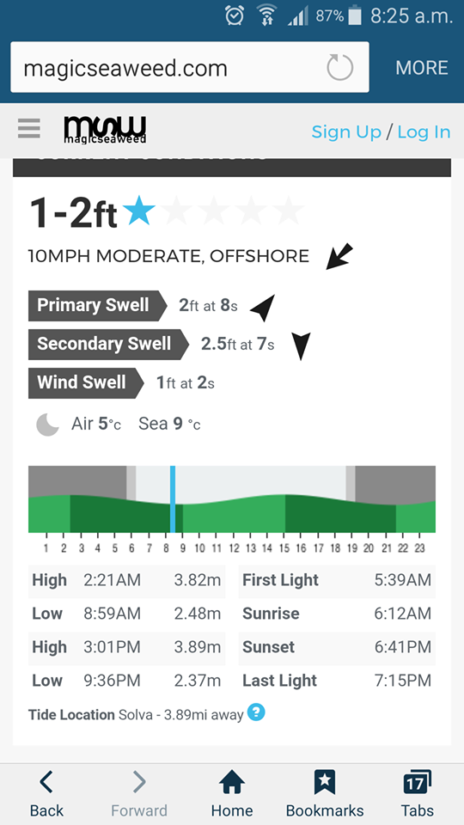
Venue | New Gale
Review
(Concrete Experience) Was the smart goal achieved? | The smart goal was achieved. I started out the session with coaching low braces to my peers helping them in the shallow waters to perfect the skill which would be needed to surf the waves. I quickly learnt that unlike a river it is important to edge into the wave to prevent capsizing. Unfortunately, due to a lack of knowledge I thought that edging is the same on both river and sea so I coached my peers in this style, but was unsure and consulted another and as corrected before reshowing my peers. Although not a major issue as it was a new environment for myself and my peer’s better knowledge would have helped myself and them get to grips with it quicker.  After helping my peers, I got in a play boat which is a new type of boat to me and spent some time practicing in the shallows before heading to the break and trying the bigger waves.  Upon catching my first wave I lent to far forward and flipped over, after this I began leaning back and surfing the waves. I got the hang on caving the wave using the stern rudder to control the direction and keep the boat on the wave. I managed to catch a few waves and really progressed in using the stern rudder combined with low brace to keep on the wave.  I had previously watched videos of surf kayaking and noticed they perform a simple looking trick called a flat spin. I began attempting the flat spin from the knowledge I had built up. I took a break and got some advice from one of the coaches and attempted to learn flat spins. At first I found this difficult as I continued to capsize because I was not controlling my edge properly, each time I swam I returned to the beach and got some further advice on what I was doing. The main point I was failing to do was look over my shoulder to “future water” or the beach, this naturally changes the edge of the boat and allows it to easily carve the wave. After a few more attempts I finally managed to do a flat spin whilst surfing the wave.
(Reflection)Thoughts and feelings about the experience? | I quickly adapted to the smaller and different boat after capsizing and changed the way I paddled. I really enjoyed this session as I felt it was very progressive. I could see the progression in my ability very rapidly from capsizing in the new environment and boat to successfully surfing using the stern rudder and progressing into learning a more advanced more the flat spin. I think that I was capsizing in the beginning was because I was not emphasising the carve by looking towards the beach. Once I emphasised that movement I was able to fine tune the other elements of the move without capsizing.  Because of the environment and the ease of progression I could achieve my smart goal, practice and refine it easily.  The one aspect of the goal that I did not achieve was rolling, when I capsized whilst surfing I became very disoriented and pulled my deck each time rather than attempting a roll. I feel annoyed at this as I am capable and should have attempted a role.  The environment and conditions also allowed for quick progression.
(Abstract Ideas) what could you improve? | Rolling, I became so disoriented in the water once capsized that I did not attempt to roll. On reflection, I should have allowed more time for the wave to subside and then attempted the roll.  In terms of the venue and progression there is nothing I would have changed I felt that the environment allowed for easy progression not only for my-self but my peers aswell.
Summary | For me the session went extremely well. I learned all of the stokes I set out to achieve and pushed past the set foals in learning how to flat spin. I thoroughly enjoyed this session, I think the was because it was a new environment and I could see and feel my progression. Also, the intrinsic and extrinsic motivation I received when I finally did a flat spin probably helped in making this one of the best paddling sessions I have had.

Smart Goals 30/03/2017 log:7
Specific | Returning to Llandysul my goals for the day are:  -Develop and perfect stern rudder Stern Rudder technique on moving water and whilst surfing  -push my comfort zone paddling in higher water
Measurable | The measurement for the stern rudder skill will be whether or not I can effectively surf the purpose-built wave on the Teifi river using it to cross the wave this will be particularly more difficult than normal as the river is high.
Attainable | The goal is attainable within the time limit of the day. It is also a progression from the surf session the previous week.
Results-based | The idea of this goal is to push myself outside of my comfort zone. The result will be dependent on whether or not I push myself beyond my comfort zone.
Time Phased | The goal is achievable within the time limit
Weather / River conditions | The river levels are 1.234m and rising which above the normal range between 0.28 and 0.73. The weather is raining all day with a real feel temperature of 8-12 degrees. The wind is coming from the south between 10-13 mph the river follows a westerly course so will be covered from the wind.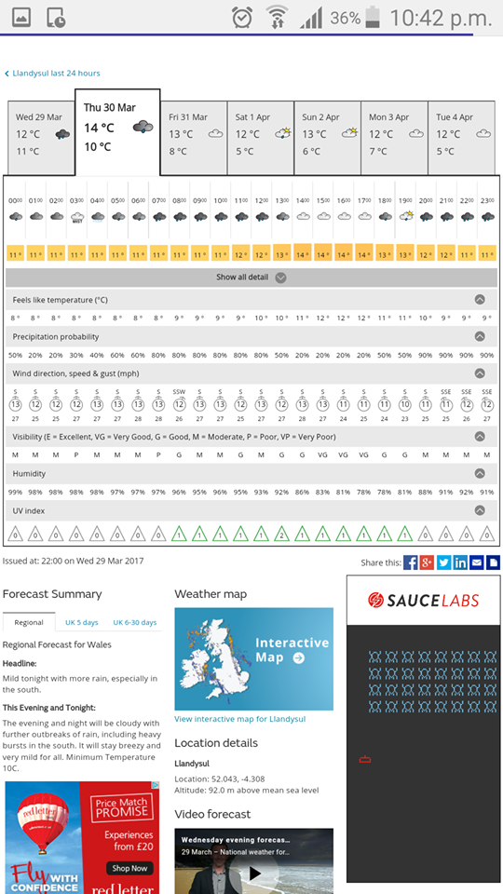  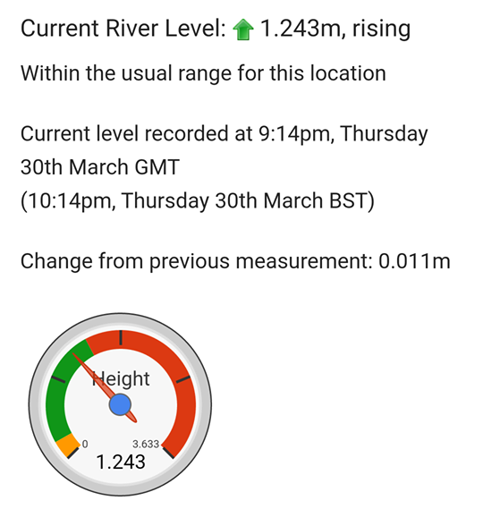
Venue | River Teifi at Llandysul
Review
(Concrete Experience) Was the smart goal achieved? | The day started with a quick warm up on the lake, some light stretching and paddling before moving onto the river. It was a lot higher than I was expecting so I went further up to see if the wave was paddle able, it was. With some persuasion, I went up to the wave entered the water and scoped my line. I first paddled through it and entered an eddy alongside it. It looked a lot bigger once on the water, I made a mental aim in my head that I wanted to surf the wave and then re-enter the flow at the end of the wave. I set myself up paddled forward and dropped into it, keeping my edge, and using my stern rudder I surfed across the wave with little adjustments. at the end of the wave I broke back into the main flow and re-joined the rest of the group. the rest of the session focused on paddling in higher faster water with emphasis on breaking in and out with speed and power across the eddy line.  Whilst entering the flow I was using a bow rudder, the coach pointed out that although it is a good stroke it’s not needed when the flow its strong as just a sweep stroke and edge will turn the boat. I continued to focus on using these skills instead of the bow rudder.  After lunch, we switched to using a raft, as a group we received a crash course in raft guiding before going on the river on our own. This was different as there is only one person in charge the rest of the crew do exactly what that one person instructs them to do. We navigated the stretch of river, it was interesting to see a different style of leadership used in a different craft on the river.  After the raft session, we began to practice rescuing using throw lines. I assisted with two students who had not done much throwing before, I also got to put into practice using a vector pull, and the use of a tree to take some of the tension of the rope.
(Reflection)Thoughts and feelings about the experience? | I felt confident that the smart goal had been achieved especially with the conditions of the river. I felt comfortable paddling higher water and that the skills I had learned were transferable. It was also good to notice the progression in my stern rudder when surfing from the first session on the 16/03/2017 to this session. I now feel much more comfortable using it to surf waves and adjust my position on the wave and river. When paddling higher water, I can understand better the need to use speed and power to cross the eddy line.  Being able to use a vector when using throw lines, and using tree as a support was also extremely beneficial. Doing this gave me a chance to practice this skill should I need to use it in a real situation later in my paddling life.
(Abstract Ideas) what could you improve? | To improve the session, I would have liked to have spent more time surfing the wave and paddling in the higher water. However, I think If as a group, we had continued to paddle some capsizes may have occurred, which could have lowered the morale and motivation after everyone had succeeded including myself.
Summary | This session was very good especially as I feel that the development of my stern rudder has been noticeable and I can see the improvement over the previous sessions.

APPENDIX B
Risk Assessments & Matrix
Contents:
- Risk analysis matrix
- Llandysul Lake risk assessment canoe& kayak
- Teifi River at Llandysul Risk Assessment Canoe & Kayak
- Surfing at Newgale Risk Assessment Canoe & Kayak
This risk analysis matrix will be used to write and evaluate the hazards identified in the risk assessments.
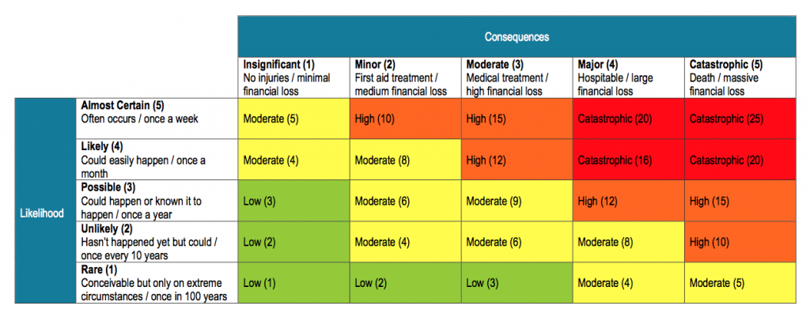
Cole, S. (2015) An Example of Risk Assessment Matrix[diagram]. Available at: http://safeworkpro.com/risk-assessment/an-example-of-risk-assessment-matrix (Accessed: 5 April 2017).
Llandysul Lake Risk Assessment- kayak & Canoe
No. | Hazzard |  | Unmanaged Risk | Who it effects | Control | Managed Risk
1 | Drowning |  | High (10) | Instructor & Group | - Ensure all participants are briefed about entering and exiting craft before session.  - All participants using correctly fitted and checked buoyancy aids helmets, and appropriate footwear when on and near the water.  - Appropriate warm up activity’s  - Select activity’s suitable to group ability.  - Instructor training, knowledge, supervision, and experience. | Low (2)
2 | Entrapment |  | High (12) | Instructor & Group | - Clean lines principle  - Ensure instructors have relevant training.  - Appropriate equipment is carried  - Brief group on entering and exiting a boat. | Low (2)
3 | Struck by paddle |  | Moderate (8) | Instructor & Group | - Make participants aware of the hazard.  - Wear helmets when on or near the water. | Low (2)
4 | Hypo/ hyperthermia and exposure |  | High (12) | Instructor & Group | - Appropriate clothing for the activity Inc. water proofs, sun cream, wetsuits buoyancy aids hats gloves.  - Instructor should ensure the group remains hydrated and give breaks if necessary.  - Appropriate first aid training and equipment. | Low (3)
5 | Slippery banks |  | Moderate (5) | Instructor & Group | - Brief group prior to activity.  - Maintain banks and vegetation growth.  - Correct handling of equipment when near banks. | Low (3)
6 | Injuries when carrying or emptying boats |  | Moderate (6) | Instructor & Group | - Brief group on correct procedure for lifting and carrying boats.  - Manage group accordingly. | Low (2)
7 | Stuck by boat on water |  | Moderate (4) | Instructor & Group | - Group supervision.  - Management of activity area.  - Vigilant of other users on lake. | Low (2)

Teifi River at Llandysul Assessment- kayak & Canoe
No. | Hazzard |  | Unmanaged Risk | Who it effects | Control | Managed Risk
1 | Drowning |  | High (10) | Instructor & Group | - Ensure all participants are briefed about entering and exiting craft before session.  - All participants using correctly fitted and checked buoyancy aids helmets, and appropriate footwear when on and near the water.  - Appropriate warm up activity’s  - Select activity’s suitable to group ability.  - Instructor training, knowledge, supervision, and experience. | Low (2)
2 | Entrapment |  | High (12) | Instructor & Group | - Clean lines principle  - Ensure instructors have relevant training.  - Appropriate equipment is carried  - Brief group on entering and exiting a boat. | Low (2)
3 | Struck by paddle |  | Moderate (8) | Instructor & Group | - Make participants aware of the hazard.  - Wear helmets when on or near the water. | Low (2)
4 | Hypo/ hyperthermia and exposure |  | High (12) | Instructor & Group | - Appropriate clothing for the activity Inc. water proofs, sun cream, wetsuits buoyancy aids hats gloves.  - Instructor should ensure the group remains hydrated and give breaks if necessary.  - Appropriate first aid training and equipment. | Low (3)
5 | Slippery banks |  | Moderate (5) | Instructor & Group | - Brief group prior to activity.  - Maintain banks and vegetation growth.  - Correct handling of equipment when near banks. | Low (3)
6 | Injuries when carrying or emptying boats |  | Moderate (6) | Instructor & Group | - Brief group on correct procedure for lifting and carrying boats.  - Manage group accordingly. | Low (2)
7 | Stuck by boat on water |  | Moderate (4) | Instructor & Group | - Group supervision.  - Management of activity area.  - Vigilant of other users on lake. | Low (2)
8 | Overhanging branches, obstacles |  | Moderate (9) | Instructor & Group | - Group management  - Instructor to brief group about signals  - CLAP principle (Communication, Line of sight, Anticipation, Position of most usefulness) | Low (3)
9 | Capsize and swim |  | High (10 | Instructor & Group | - Brief group on entering and exiting a boat and defensive swimming  - Instructor to carry correct safety equipment, e.g. Throw line, tow line  - All participants using correctly fitted and checked buoyancy aids helmets, and appropriate footwear when on and near the water. | Moderate (5)
10 | Conflict with other users |  | Moderate (6) | Instructor &group | - Stop and gain attention of other users.  - Communicate safe passage as not to disrupt them  - Instructor training and experience | Low (2)
11 | Bad River Conditions |  | High (12) | Instructor & Group | - Check weather forecast and river gauge.  - Plan session accordingly.  - Instructor training and experience. | Low (3)

Surfing at Newgale Assessment- kayak & Canoe
No. | Hazzard |  | Unmanaged Risk | Who it effects | Control | Managed Risk
1 | Drowning |  | High (10) | Instructor & Group | - Ensure all participants are briefed about entering and exiting craft before session.  - All participants using correctly fitted and checked buoyancy aids helmets, and appropriate footwear when on and near the water.  - Appropriate warm up activity’s  - Select activity’s suitable to group ability.  - Instructor training, knowledge, supervision, and experience. | Low (2)
2 | Entrapment |  | High (12) | Instructor & Group | - Clean lines principle  - Ensure instructors have relevant training.  - Appropriate equipment is carried.  - Brief group on entering and exiting a boat.  - Have surf buddies on beach ready to assist. | Low (2)
3 | Struck by paddle |  | Moderate (8) | Instructor & Group | - Make participants aware of the hazard.  - Wear helmets when on or near the water. | Low (2)
4 | Hypo/ hyperthermia and exposure |  | High (12) | Instructor & Group | - Appropriate clothing for the activity Inc. water proofs, sun cream, wetsuits buoyancy aids hats gloves.  - Instructor should ensure the group remains hydrated and give breaks if necessary.  - Appropriate first aid training and equipment. | Low (3)
5 | Injuries when carrying or emptying boats |  | Moderate (6) | Instructor & Group | - Brief group on correct procedure for lifting and carrying boats.  - Manage group accordingly. | Low (2)
6 | Stuck by boat, surf board or other craft on water |  | Moderate (4) | Instructor & Group | - Group supervision.  - Management of activity area.  - Vigilant of other users on lake.  - Set up surf zone.  - Return to break using, paddle out zone. | Low (2)
7 | Overhanging branches, obstacles |  | Moderate (9) | Instructor & Group | - Group management  - Instructor to brief group about signals.  - CLAP principle (Communication, Line of sight, Anticipation, Position of most usefulness). | Low (3)
9 | Capsize and swim |  | High (10 | Instructor & Group | - Brief group on entering and exiting a boat and defensive swimming.  - Instructor to carry correct safety equipment, e.g. Throw line, tow line.  - All participants using correctly fitted and checked buoyancy aids helmets, and appropriate footwear when on and near the water. | Moderate (5)
10 | Conflict with other users |  | Moderate (6) | Instructor &group | - Stop and gain attention of other users.  - Communicate with them to identify your working surf zone.  - Instructor training and experience.  - Brief group on best practice when surfing.  - Set up zone to work within. | Low (2)
11 | Bad Conditions |  | High (12) | Instructor & Group | - Check surf reports and weather conditions.  - Adjust session to suit group ability.  - Instructor Training and Ability. | Low (2)

Appendix C
3 Star Open Canoe Syllabus
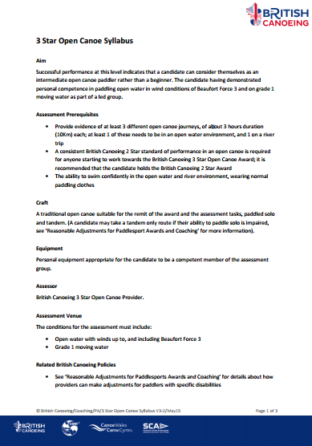

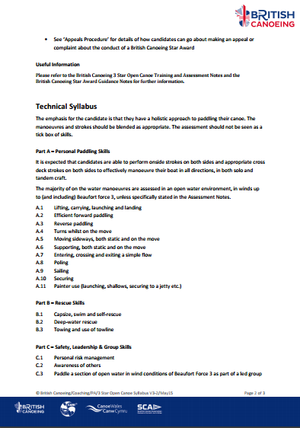
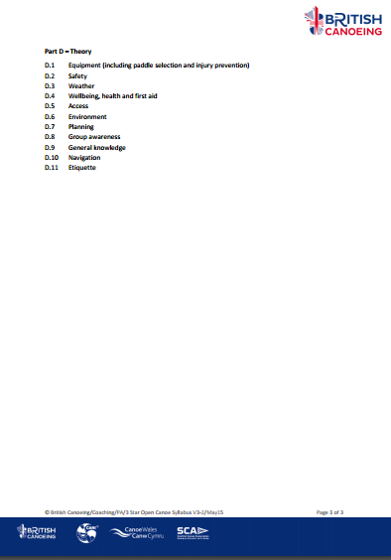
British Canoe union (2015) 3 Star Open Canoe Syllabus. Available at: http://canoescotland.org/sites/default/files/resources/documents/British%20Canoeing%20Star%20Awards/3%20Star%20Open%20Canoe%20Syllabus%20v3-2%20May15.pdf (Accessed: 25 April 2017).
Appendix D
Session Plan 9th February 2017
Specific- Deliver a comprehensive coaching session on Turing a canoe with an aim of completing a 2star assessment, using Draw strokes, Forward and Revers Sweep Strokes, J stoke, gain more knowledge of a c stroke and the steps required to successfully teach someone.
Plan B- if weather is to strong, practice these same strokes in a kayak
Measurable- Dialog journals and reflections, Video analysis, discussion with other coaches
Achievable- yes
Results based- yes participants should be able to easily reflect and see their own development, for myself my results will be based from assisting coaches on whether the session was effective.
Time phase- completion by the end of the day
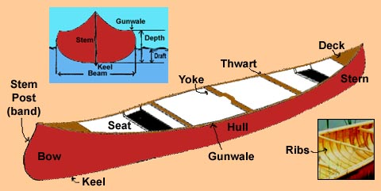

Plan A-Participants to be Solo Canoeing
Leave Cenefyn 9:30 plan to arrive around 10:00 be on water by 10:30
Recap of J stoke- demonstration with question answer style of discussion
Key points: note: if windy practice downwind
-rotation of trunk towards stroke (point knees to paddle side)
-normal power stoke drive side/ power face remains same throughout.
-thumbs up to thumbs down, move paddle from boat forming J
-keep pressure on drive side throughout
-Lower hand should remain outside gunwale
Practice/refining
Practice by leaving blade in water to feel the turn, experiment with changing the pitch of the paddle, explain is little steering is needed angle drops
Games set up relay race to practice using the j turn to paddle in a straight line.
30 mins-11:30
Move onto Sweep strokes
Sweep Strokes- Demonstration and explain key points for movement
Key Points note
-Blade reached towards bow of boat
-thumb up
-blade just below surface
- swept in arc drawing half circle from bow to stern
Practice/ Refine
Choose a partner to compete against. Make sure bows are facing each other whoever can turn 360 degrees wins the race, get them to practice on both sides and using reverse strokes.
Get participants to experiment with performing full and half arc sweeps
30 mins 11:30-12:00
Bow rudder
Bow draw/ rudder
Demonstration followed by explanation
- Turn body towards side of paddle/ look in direction you wish to turn trunk rotation
- Drive blade facing towards canoe slicing through the water thumb down
- Open the blade, angle of the blade will determine the amount of turn
- Keep lower arm flexed

Cross Bow Rudder
- Turn initiated on paddlers off side
- Indicator thumb pointing up
- Slicing action
- Open paddle blade away from canoe to cause a turn away from the blade
Activity
Set up small triangular course, and get participants to navigate it using bow rudder
Progressive: use a chaser and a catcher to navigate the course
12:00-12:30
Hanging draw/pry
Like bow rudder except done alongside the paddler to cause a sideways shift
-chest twisted towards the paddle, keeping arm in strong position
-blade sliced then opened away from the canoe
- sideways movement should start if necessary move the blade backwards or forward to keep boat straight
12:30 – 1:00 break for lunch
1:00-1:30 recap previous
Begin session on C stroke with assistance

