Performance Management

Course Title: LCMB7013



Modern Performance Management Concepts and Practices.

Student’s Name: Plamen Peev
Student’s number: 1815104
Lecturer: Hossein Shokri

Table of Contents

Introduction 3
Performance Management 3
Performance Management Aims 5
Creating a Strategic Approach 5
Performance Management Approach 6
Strategic Process 7
Formal and Informal Processes 8
Benefits of a Strategic Approach 8
Organisational and Employee Concerns 9
Approaches to Measuring Performance 9
Performance Appraisal 11
Aims of Pay and Reward Systems 13
Employee Engagement Satisfaction and Involvement 16
Employee Engagement 16
Employee Satisfaction 17
Employee Involvement 18
Recommendation 21
References 22
Appendix 25

Introduction

Many experts argue that implementing successful corporate change is a challenging endeavour (Kanter, et al., 1992). As a result, most companies should regard organisational transformation as a key capability (Burnes, 2005). It is critical that everyone understands what it takes to change successfully and swiftly, overcoming hurdles and resistance to change as easily and professionally as possible to avoid future harm to the organisation.
The report's goal is to introduce current concepts and methods for performance management, as well as to analyse and recommend a new strategy for performance management to SainCo. As a result, how a long-established traditional retail firm named SainCo. with an authoritarian management style recruits 2,000 new employees in ten different locations and must transition to new practises will be if it wants to compete in the marketplace. As a consulting firm, the report will consider and make appropriate proposals to the organisation for a new approach to performance management, which is the only way forward and is in line with the current business climate and the company's goal. The research will look at the concept of performance management and what it comprises, as well as employee concerns and organisational factors. The importance of employee involvement and participation in the company will then be explored. At the end of the report, recommendations for both the long and short term would be provided.

Performance Management

According to Armstrong & Taylor (2020), Performance Management (PM) is described as a management system that includes a prescribed set of actions - planning, monitoring, and review of performance - which represent the official approach of the organization to managing performance in sequence.
An ideal performance management process is a continual activity known as continuous improvement management or managing performance over the years. This involves routinely reviewing results against set objectives or balanced scorecard, as shown in Figure1, and ensuring that appropriate corrective action is taken. Individuals are responsible for managing and monitoring their own performance, while supervisors give comments, guidance, and direction. Management has to provide feedback and acknowledge good work when it is relevant, rather than saving it for a later. Also is entails revising objectives and on-the-job or coaching-based learning. An essential is to act with underperformers as soon as possible so that improvements can occur (Armstrong & Taylor, 2020).

Figure1: Balanced Scorecard

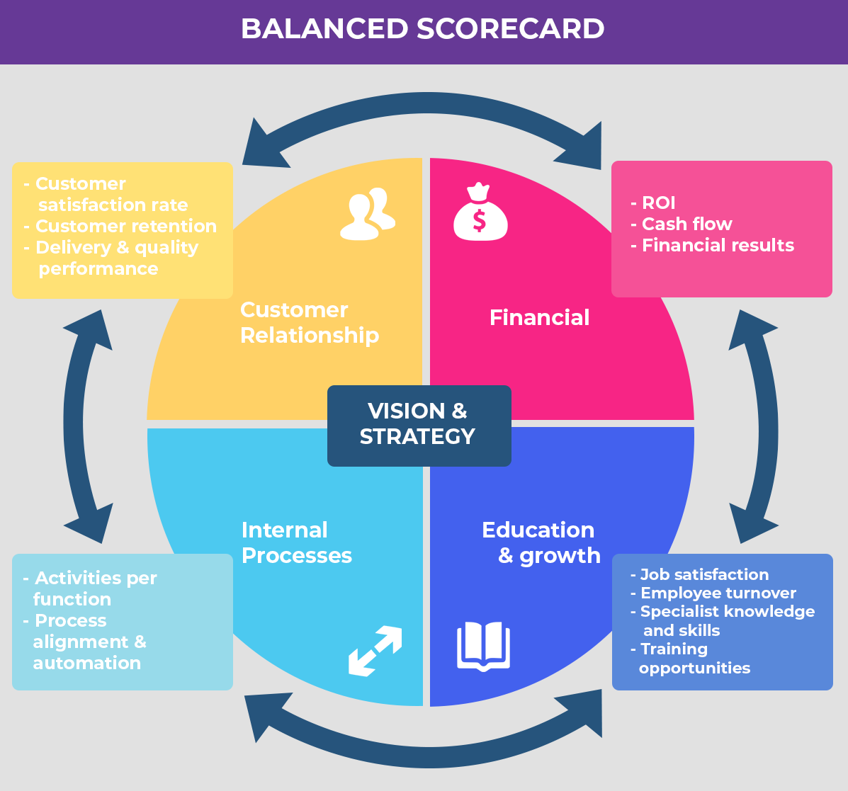

Source: (Academy, 2021)

While there are numerous benefits to establishing a balanced scorecard system in your business, there are also possible risks and downsides. While there are advantages to establishing a balanced performance system in your company, there are also possible risks and disadvantages that SainCo should be aware of. The major disadvantages of a balanced scorecard are that it must be customised for the organisation, that it needs management investment to be effective, that it could be tough, and that it requires a huge volume of information. Although the balanced scorecard is an established and right strategy with positive advantages, critically is to examine how the company handles and if the balanced-scorecard method is a good investment. Appendix A below presents examples of objectives and measurements of each of the four measuring approaches.

Performance Management Aims

The primary goal of PM is to boost the efficiency of particular individuals and/or teams, and hence boost organisations. When correctly is done, it guarantees that individuals understand what success entails and their part in attaining it. According to VerWeir and Berghe (2004), performance management entails establishing commitment and motivation to attain organizational goals. The benefits of approach performance management will help SainCo. accomplish its strategic objectives, increase individual and group performance, build employee capacities, establish a culture of performance and continuous development, and etc. Table 1 shows and summarises the advantages of successful performance management for both managers and people (Armstrong, 2018).
Table 1: Management and People Benefit
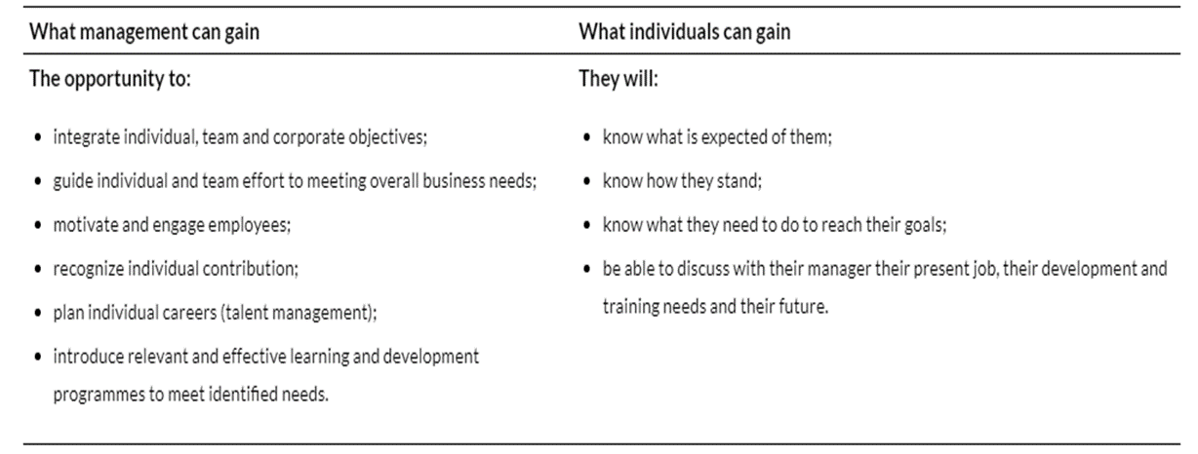
Source: (Armstrong, 2018)

Creating a Strategic Approach

PM is portrayed as a basis of long-term competitive advantage, in its purest and most modern form, merging individual and group contributions with organisational objectives, priorities, and integrating numerous HRM approaches into a systematic and effective 'bundle.' It is typically portrayed as a logical cascade process merging corporate and individual objectives, as shown in Figure 2, and supported by a range of performance management systems. The rising arrows highlight the importance of feedback in the process, which is typically shown as a top-down logical process.
Figure 2: Strategic Performance Management

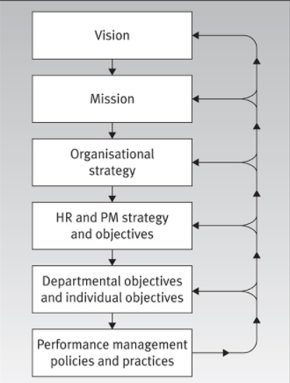

Source: (Hutchinson, 2013)
To completely grasp what 'strategic performance management' is and how it works, we must first define the term 'strategy.' There are many definitions and interpretations in the literature. Strategy, according to Stonehouse, and Snowdon (2007), comprises identifying a competitive advantage or deciding how to compete. The organization's vision and mission statement, which are important means of capturing and expressing what the organisation is about and its future orientation, are the beginning point for building a strategic approach to performance management. The idea of strategic fit conveys the second meaning of strategy. The emphasis is on the organisation and its surroundings. To gain a competitive edge, a company's talents and resources must be matched to the possibilities available in the external environment (Armstrong, 2011).

Performance Management Approach

PM is a planned and comprehensive approach for organisations to achieve long-term success by improving employee performance and developing the capabilities of their teams and people (Armstrong, 2018). Line managers manage performance, and performance management is designed to assist them in doing so. Performance management is the process of running a firm. It has to be a powerful instrument for assuring the achievement of the organisation's strategic goals. It should aid in the implementation of cultural change and be connected to other basic HR activities such as talent management, reward management, human capital management, development, and learning. As a consequence, PM leads to horizontal integration and the 'bundling' of HR practices, making them interconnected and, as a result, supplementing and supporting one another. system. According to Armstrong (2018) implementation of effective performance management is feasible, although it is possible to argue that where performance cannot be specified it also cannot be assessed or controlled.
According to Bates and Holton (1995), performance is a complex concept the measurement of which depending on a wide range of variables. There is also a stress on the need of determining whether the purpose of measurement is to evaluate performance outcomes, behaviour, or occasionally both. SainCo. will be informed of the performance management aims first, followed by an explanation of what management performance involves. The benefits of performance management approach will help SainCo. accomplish its strategic objectives, increase individual and group performance, build employee capacities, establish a culture of performance and continuous development, etc.

Strategic Process

Performance management is sometimes criticised as a top-down management-imposed system, although at the operational and individual levels, performance measurement is better viewed as an ongoing cycle or process which integrates numerous HR activities. According to Lowry (2002), when performance management is seen in this light, it might evolve into a more adaptive, continuous, and changing process that is more suitable for real-time organisations (Lowry, 2002, p. 131).
This process includes:
● Induction
● Job design
● Development and developing
● Coaching and mentoring
● Talent management
● Performance rating and review
● Career development
● Competency frameworks and rewarding

Potentially, the process begins before an employee is employed, with recruiting and selection, when persons with the potential to work well (AMO model, Figure 3) and who fit with the organization's objectives are picked.

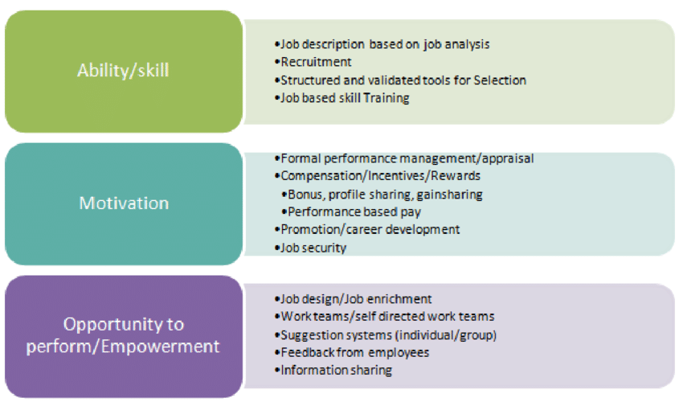
Figure 3: AMO Model
Source: (Amable, et al., 2019)

Formal and Informal Processes

The extent to which formal and informal procedures and practises are employed varies depending on the organisation. Formality gives clarity and structure while attempting to assure uniformity of treatment and justice while minimising the possibility of subjectivity and prejudice. Formal processes and regulations are especially necessary for inexperienced or insecure managers. However, there are certain disadvantages. These can be inconvenient, complicated, and time-consuming to manage, difficult to change fast, and perceived as restrictive by management. On the other side, allows for more flexibility, more personal engagement between managers and employees, and faster issue resolution. However, ensuring uniformity of treatment while eliminating subjectivity and prejudice is difficult. Furthermore, it is challenging to assure uniformity of treatment while avoiding subjectivity and bias.

Benefits of a Strategic Approach

In essence, a planned and integrated approach to performance management provides many benefits and can be very important for the future development of SainCo (Pulakos, 2009). Proper strategic management application assists the organisation in achieving its strategic objectives, improving individual and group performance, clarifying goals of the organisation, and developing a "line of sight" between the performance of the individual and the requirements of the organisation. Building a performance culture and quality enhancement, increasing engagement and motivation, defining individual roles, commitment, required performance standards, and behaviour are also some of the benefits of strategic performance management According to Biron (2011) providing the appropriate decision-making information from SainCo. related to human resources, remuneration, promotion, and/or poor performance - can be called a "tactical” force management goal.
For example, in the United Kingdom public sector, performance management has been utilised to effect cultural and ethos change. It may also be used to motivate staff to change and teach them the new skills they will need (Hutchinson, 2013).

Organisational and Employee Concerns

Defining and evaluating employee productivity is often viewed as an important and unavoidable performance management function, but it is also one of the hardest to master (Hutchinson, 2013). Work measurements are required by organisations such as SainCo, as well as managers and workers, for a number of reasons. They enable the identification of excellent and bad performance, provide a method of highlighting any skill or knowledge gaps, and serve as a means of tracking performance changes (Hutchinson, 2013). A clear conceptualization of performance is a suitable and reasonable starting point for measuring and controlling performance. 'If you can't define it, you can't quantify it,' says Armstrong (2009). Armstrong (2000) considered performance as what individuals can produce (i.e., outputs or results) and how they do it, concluding that while managing performance, all contributions (knowledge, skills, competences) and endpoints (quantifiable results) must be considered.

Approaches to Measuring Performance

This report will look at the two main different methods of measuring effectiveness: a results-focused approach and a behavioural approach. Work measurements are required by organisations, managers, and employees for a number of reasons. For SainCo they will enable the identification of excellent and bad performance, provide as a method of highlighting any skill or knowledge gaps, and serve as a means of tracking performance changes. Although most managers believe they can construct an overall image of an employee's performance, they require information in order to make evidence-based judgments regarding how employees should be deployed, developed, and rewarded.
Performance Behaviours is a process-oriented strategy that emphasises how a person conducts his or her work – qualitatively. Behaviours are likewise multifaceted and complicated. Breaking down behaviour into two dimensions is a typical approach of conceptualising it precisely. (Motowidlo & Van Scotter, 1994) 'Task performance' relates to the technical core of the organisation, and involves job-specific behaviours (i.e., the core tasks generally stated in the job description) as well as non-specific duties outside of the main duties. 'Contextual performance' relates to the role of the individual outside of their assigned task role, as it pertains to the integration into the overall organisation and contributing to the overall positive working environment.
The distinguishing aspect of this strategy (also known as the results-based approach) is the quantifiability of concrete consequences or results from work behaviours. Metrics are often based on product or service quantity (the number of units generated), quality (the number of defects or customer complaints), or financial consequences (the sales value). Stakeholder attitudes and emotions, such as customer and supplier satisfaction, might be incorporated, if necessary, although this introduces subjectivity into what is otherwise an objective process (Hutchinson, 2013).
Most organisations use the SMART acronym (S-specific, M-measurable, A-achievable, R-realistic, and T-time-bound) to identify some of the fundamental elements of objective-setting, which is guided by goal-setting theory (Figure 4). As a result, while developing new goals, SainCo must be aware that there will be clear practical implications for performance management. The method may be found in the creation of SMART objectives, which are widely utilised in goal planning.
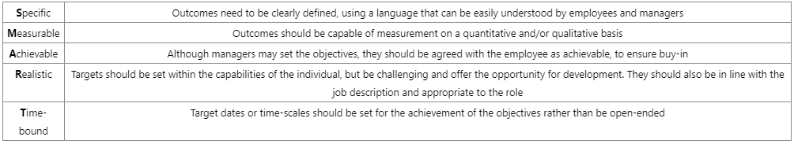
Table 2: Ensuring that objectives are SMART
Source: (Hutchinson, 2013)

Goal setting necessitates a focus that may not be suitable in all situations and may even be counterproductive in positions that demand creativity and improvisation.
The primary advantages of the Output-Based Approach can be simple and easy to understand, reassurance in measurement, clarity in what is required, motivation, and uses of a language familiar to all key stakeholders. The ethical approach to measuring and managing performance seeks to prevent issues of perceived control and unfairness by incorporating respect for persons, procedural fairness, openness in decision making, continuing conversation, rates’ education, and limiting the quantity of measurement.

Performance Appraisal

Performance appraisal is a continuous process that needs an appraiser to monitor and record the performance of others, to provide an evaluation judgment about the quality of that performance, to offer feedback to the rates, and ultimately to define developmental possibilities to those same rates (Brutus, et al., 2009).
According to the CIPD (2020), the formal appraisal process consists of five major components:
● Measurement - evaluating performance in relation to agreed-upon aims and objectives, as well as behaviour.
● Feedback - giving employees details on their past performance as well as what is needful for future success.
● Positive reinforcement - highlighting what has been done successfully, giving constructive remarks about what may be better, emphasising the significance of how the task is carried out and what must be done to improve in the future, as well as ensuring that effort is focused on value-added activities incorporating activities.
● Exchange of views - an active dialogue about what transpired, how appraisees may improve their performance, any needed assistance, and future opportunities.
● Agreement - all participants come to an agreement on what needs to be changed to enhance and sustain performance, as well as resolve concerns raised during the conversation.
Performance assessment systems differ in terms of the degree and frequency of formality, the extent to which workers engage in the process, the sources of rating (both SainCo's line managers, colleagues, and customers), and the relationship to compensation. The approach taken will, to a large extent, reflect the structure of the organisation, the resources available, the managerial attitudes and preferences, the sorts of employment offered, and the knowledge held within the organisation. (Redman & Wilkinson, 2009).
Using performance appraisals SainCo needs to be aware that the system is fundamentally about encouraging individuals to improve performance, and the method is based on motivational ideas such as goal setting, expectation theory, and equity theory. Having individual performance objectives and targets can promote employee identification with, and commitment to, the organization's aims and objectives. It moreover gives the ability to direct labour efforts that will benefit the organisation (Hutchinson, 2013). There are significant benefits to performance appraisal, including improved identification with and commitment to organisational goals and objectives, the opportunity to provide career counselling, determining other forms of support needed for underperformers, making performance-related reward decisions, and others. Giving feedback is an essential component of the performance review process and, when done effectively, would be a very motivating experience that reduces any sense of procedural unfairness. The solicitation of feedback is considered proactive human behaviour (Lam, et al., 2007) since it provides employees with information on how well they are really doing how they may improve. There are various types of appraisals, which are detailed further on.
According to DeNisi and Kluger (2000), interventions for feedback seem to be more helpful if they keep the staff's attention focused on objectives at the levels of task performance, and they are less likely to be useful if they are implemented at the personal level. A more recent strategy is to solicit input from a range of sources, including colleagues, the line manager, subordinates, customers, suppliers, and oneself (Figure 4). This approach, also known as multi-source or 360-degree appraisal (to represent feedback's all-encompassing approach), arose partly in response to some of the problems with more traditional methods and has proven a fertile ground for researchers to compare the effects of feedback from multiple sources.
Figure 4: 360-degree appraisal feedback
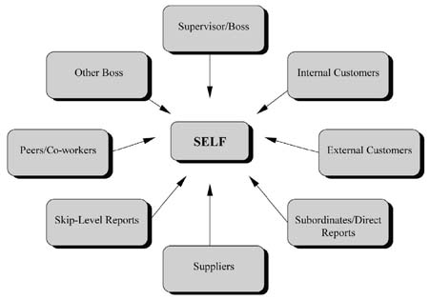
Source: (O’Boyle, 2014)
The benefits of 360-degree appraisal give a rather more balanced and accurate outlook of performance, uplift as regards self-awareness, and different appraisers can report on different behaviours. At the same time, those being appraised have a ‘voice’ and it is beneficial if the line manager is unfamiliar with the job and works within the service sector. There are disadvantages with 360-degree feedback that outweigh the advantages shown in Table 3.
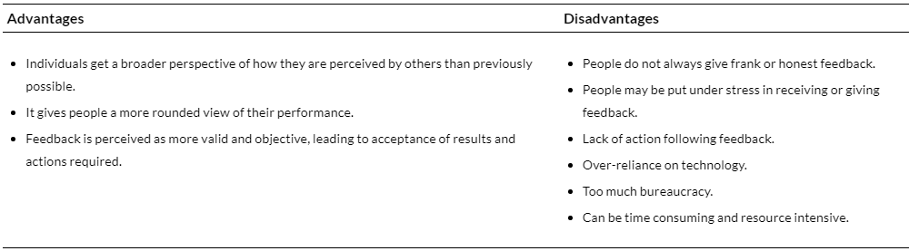
Table 3: 360-degree feedback - Advantages and disadvantages
Source: (Armstrong, 2018)
All prospective assessors are prone to subjectivity and biases, not only managers. Employees are not always passive agents in performance evaluation. Those being evaluated might influence assessments by participating in 'impression management,' which makes the appraiser believe they are better than they are. This has also been discovered that when an individual overestimates his / her own performance, appraisers are more prone to offer overly liberal evaluations in order to safeguard the employee's self-esteem and the managers-employee relationship (Murphy & Cleveland, 1995).
It should be emphasised for SainCo that 360-degree feedback costs time and money; this method is recommended for large companies and is as ineffective as for small businesses and does not work well in practice.

Aims of Pay and Reward Systems

The reward management system is focused on the strategies, regulations, and procedures that must be implemented to guarantee that the value of people and their efforts to the success of the organisational, departments, and teams’ objectives are acknowledged and rewarded. It responds to two essential questions. The first one is: How do we assess people's worth? and the second one is How will we compensate them in accordance with that value (Armstrong & Brown, 2019)? Reward management entails more than simply compensation and perks for employees. It is highly concerned with non-monetary benefits including recognition, liberty, an opportunity for learning, growth, and enhancing work responsibilities. According to Hutchison (2013) the concept of performance reward is not new: different types of incentive systems based on output or production level, and piecework have been around for centuries. Payment and benefit levels, as well as how awards should be administered concerned is with each individual organisation's reward policy (Armstrong & Brown, 2019).

Attracting talent and helping in employee retention is a key part of performance management and aims that could help SainCo for better performance. Supporting, motivating, and addressing the demands of workers of all groups, talent management, and encouraging and rewarding employees’ elements of the organization’s strategic plan are also key parts of performance management’ aims and to accomplish all of this, companies like SainCo should be analysed on a regular basis.

Performance measured can be individual, a team, a workgroup, a workplace, or an organisation whose performance is being measured. Individual payment-by-results (PBR) systems, which involve a direct relationship between individual performance and compensation, are likely to get the largest incentive effects, whereas reward schemes based on organizational-wide criteria have the poorest incentive effects (Bryson, et al., 2012). Collective group performance is also exposed to 'free-rider effects,' in which less effective individuals take advantage of better-performing peers, or to 'the Ringelmann effect,' named after Maximilien Ringelmann, who noticed that team-working together on a task results in significantly less effort than when members perform by itself (Kravitz & Martin, 1986). Group systems (based on the results of the workgroups) are likewise more likely to have more 'noise' than individual-based schemes since they are impacted by circumstances outside the individual's control (Bryson, et al., 2009).

Individual bonuses and merit pay raises were the most popular types of individual performance-related compensation schemes, followed by a mix of individual, group, and/or organisational performance. The least prevalent type of performance-based compensation is the piece rates, and the pattern holds true throughout all industries.
The overall motive for using PRR is to increase employee performance or productivity, and hence organisational performance. The major reasons in favour of applying this method for SainCo can be:

● elicit a better level of job effort from workers
● to assist in attracting and retaining staff
● loyalty and job satisfaction
● to put in place a more competitive compensation scheme
● to make change initiatives easier in the organisation
● to encourage increased employee participation
● to assign more responsibilities to line management
● to provide information regarding organisational objectives and performance requirements
● to have a measuring of control level
● to serve as a replacement for actual measuring performance

The core aim of improving performance is based on the fundamental idea that performance-related rewards (PRR) would improve work desire to perform.
Given the advantages of the system, SainCo needs to be aware there are many disadvantages described by Kohn (1993):
● Pay is not a motivator
● Rewards punish
● Rewards rupture relationships
● Reasons are ignored by rewards
● Risk-taking is discouraged by rewards
● Rewards undermine interest

SainCo needs to know that performance-based reward is not effective for all cultures (national or organisational level).
A controversial and polar kind of performance-related remuneration is Individualised performance-related pay (IPRP) (Hutchinson). Pay movement in the band is set by an evaluation of individual performance, which is often connected to a review ('Appraisal or merit-based compensation'). Pay progression is typically provided wholly on the basis of individual performance appraisal rates, or a general pay increase for employees including an element tied to individual performance. Table 4 summarises the major benefits and disadvantages of IPRP.

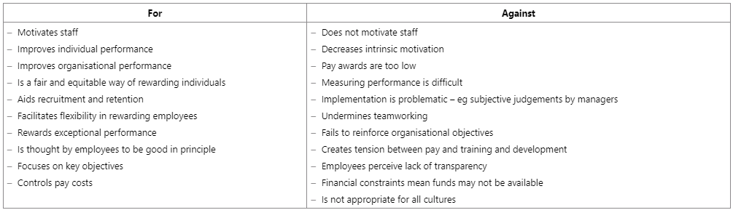
Table 4: Arguments Against IPRR
Source: (Hutchinson, 2013)
The particular arguments in support of IPRP are that it gives a direct line of sight between people's behaviour and their rewards, resulting in a powerful motivating impact, as recommended by expectancy theory.
There are other shapes of performance-based rewards known as a commission on sales, collaborative team rewards, bonuses for individuals, and the based rewards organisational. Organisation-based rewards are divided into two main groups long-term (sharing incentive plans, saving, option plane of the company, and enterprise manager schemes) and short-term rewards (profit and gain sharing). Recognition awards may be an effective incentive, but they are sometimes disregarded by organisations. They are typically less expensive than, for instance, merit-based compensation, and can take the form of payment or non-cash, apply to teams and individuals. Likewise, could be included in the formal incentive policy, or be more informal and left to the discretion of SainCo line managers. Recognition can be as straightforward as a verbal or written ‘thank you, and the key attraction is that this sort of reward represents a flexible, simple, cost-effective, and often immediate way to acknowledge good performance (Shields, et al., 2015).
To maximise success SainCo must be administered in a procedurally fair-way, control over employee's performance and rewards need to be of value (e.g., expectancy theory).

Employee Engagement Satisfaction and Involvement

Employee Engagement
Last 30 years employee engagement has piqued the interest of HR experts and line managers alike. Following the UK Government's very significant MacLeod Review in 2009, staff engagement it’s been one of the CIPD's latest competencies as well for many business consultants and HR professionals, providing global-oriented engagement research and solutions. A whole business has sprouted offering to consult, coach, and how organisations can boost engagement levels (Truss, et al., 2011). Being engaged is clearly beneficial to employees. The majority of definitions of employee engagement refer to employees who are happier, healthier, more fulfilled, or more motivated. Research has consistently demonstrated that higher levels of engagement are associated with higher levels of performance in organisations (CIPD, 2021).
According to Armstrong (2018), providing broad support for all Engage for Success performance management may enabler by ensuring that employees are aware of the organization's aims, values and have a voice in addressing their own goals in relation to those of the business. Sense of purpose engagement will be enhanced when an employee understands what their department has to do, and they have a clear sense of purpose in completing tasks that they feel are valuable. That strategy will be beneficial to SainCo's future development. Performance management allows for the recognition of accomplishments via feedback. When leaders reward good performance, it increases employee engagement by instilling a sense of loyalty to the workplace. It might convey to employees that their management and the organisation value them. Recognition is strong and effective compensation that fosters the behaviours that distinguish engaged employees (Macey & Schneider, 2008). Increasing employee engagement, SainCo should provide an opportunity for its employees to acquire new skills and progress. If PM is viewed as a tool for identifying and satisfying learning and development requirements, as it should be, it will help to increase levels of work or job engagement. Performance management also serves as a foundation for coaching by line managers and others in order to improve abilities or overcome weaknesses (Armstrong, 2018).
To generate a highly engaged staff, the SainCo management must create five things. They are as follows:
● Align efforts with strategy
● Empower
● Promote and encourage teamwork and collaboration
● Help people grow and develop
● Provide support and recognition where appropriate
Employee engagement is importantly linked to the business results of the organisation is the answer to the question of "Why SainCo should companies invest in employee engagement" (Markos & Sridevi , 2010).
According to Macey (2009), the work environment and the job employees do are the most crucial enablers of engagement. Engagement needs a work environment that not only demands more but also promotes information exchange, gives learning opportunities, and supports a balance in people's lives, therefore laying the foundations for continuous energy and personal initiative.

Employee Satisfaction

Employee satisfaction is the term describing whether or not employees are pleased and satisfied at work. Employee satisfaction, according to multiply measurements, is a factor in employee motivation, achievement goals, cost savings, customer satisfaction, staff productivity, positive employee morale, and other aspects of the workplace (Heathfield, 2020).
All line managers need to be able to handle employee loyalty and satisfaction – how committed are the employees to the company and if workers are really satisfied and what is their likelihood to stay in the organisation for longer terms. Measurement of employee satisfaction is one of the main aspects of Human Resource Management. The company has to make sure that worker satisfaction is high since this is a prerequisite for enhancing productivity, responsiveness, quality, and customer service. Personal and Organizational Variables (see Appendix B) influence the employee’s satisfaction. There are different strategic approaches in increasing employee satisfaction and loyalty that can be applied by SainCo.
The following are steps that an organisation may take to increase employee satisfaction and loyalty, hence increasing revenue and profit:
● Consistent and clear communication - attracting top talent.
● Creating a team - increased productivity and motivation.
● Training and Other Programs for Improvement
● Work Itself - employees may have more interest in their work
● Empower employees - Improved creativity
● Fair benefits and compensations - keep employees motivated.
● Developing career - can design more realistic goals and objectives.
● Monitor Performance and Reward for Contribution
● Feedback providing - Increased motivation, helps to improve working skills.
● Upbuild company culture
● Use of Information Technology - generate maximum possible outputs.
● Remain Positive
● Provide the best equipment and a safe working environment
This report emphasizes the importance and satisfaction with the working environment aspects below (see Appendix E).

Employee Involvement

The potential advantages of involving line managers in training, learning, and development (TLD)have long been recognised (see Appendix C). Line managers can guarantee that learning is closely related to workplace activities and are in the best position to evaluate learning results in terms of both the organisation and the employee (Purcell & Hutchinson, 2007). However, not all managers and supervisors are motivated or experienced enough to perform this function.
A direct role in assigning or recommending performance-related awards has line managers. This involves employing informal or 'unofficial' techniques to inspire and reward employees - something that is sometimes overlooked or undervalued. Access to training, secondments, flexible working, verbal appreciation, and more intrinsic types of incentive, such as more job discretion and responsibility or exciting project work, might all be part of this. Although they can be effective motivators, the difficulty with unofficial practices is that they are not subject to rigorous examination or monitoring (Hutchinson, 2013). Managing underperformance like illness, lack of competency, absence, low attendance, inappropriate behaviour is indeed a line manager's responsibility and are some of the most difficult areas of people management for any manager. In practice, managers prefer informality when dealing with conflicts and disciplinary concerns. This is due to, time and complexity of formal procedures, but also to a preference for relying on 'gut feeling' and instinct, as well as a lack of trust in dealing with standardised methods (Jones & Saundry, 2012). See Appendix D show HR appraisal of line managers' competence to manage people.
Evidence from a larger study of HRM in practice reveals that, while line managers can be involved, their methods are inconsistent in execution and have uneven inefficiency (McGovern, et al., 1997). Line managers' perceptions of how effectively they are supported in their performance management position will surely have an impact on how they manage.
Therefore, is a necessity for organisations like SainCo to invest more in LMs as well as for HR professionals and senior managers to collaborate more closely with line managers to assist them in their job of managing's people.
Line managers can be supported by the HR department in a variety of ways listed below:
● HR advice and support
● Include LMs in the creation of performance management policies. cautious recruiting and selection to achieve effective personnel management
● Clarify job expectations
● Provide training, learning, and development (TLD)
● Pay close attention to specific HR policies that promote good discretionary behaviour
● 360-degree feedback
● By provide recognition & reward for good people management
● By measure and monitor performance management activities
● Use and developing electronic HRM (e-HRM)
● Senior managers:
- a high-performance open culture
- clarification of roles
- positive role modelling
- practical support
- a sense of job security
The capacity of HR to provide such support obviously depends on the size and structural function of HR in the organisation. In the absence of such a function, support will be able to be provided by senior managers or external bodies.
Active assistance is needed from senior management, regardless of the existence of HR function, to create and transmit the strategic direction, values, and culture of the organization, as well as the introduction of mechanisms that promote an environment for positive development (Bowen & Ostroff, 2004).

Recommendation

At the end of this report, recommendations will be made to SainCo, which will help the company to a new approach to management following the current business environment and the company's goals.
Providing more performance management training for managers, including presentation training and constructive feedback performance management is more likely to be successful. (Haines III & Onge, 2012).
All levels managers of a hierarchy could play a significant part in the PM system's functioning. Management behaviour is also an indicator of how essential the PM system is, and as a result, it is likely to have a significant impact on how the system is actually implemented (Lawler & McDermott , 2003).
If SainCo seeks to improve its performance needs to stop using an authoritarian management style, and it is strongly recommended not to utilise Kodak performance management.
The Strategic Approach would benefit the company's management by supporting them in managing, providing information for making HR-related decisions, and facilitating organisational transformation.
Following World War II, many Japanese companies like "Toyota" in the industrial sector pioneered the concept of Kaizen (Translate from Japanese means "improvement”) for continual improvement.
● Process Kaizen focuses on making improvements to particular work areas to increase efficiency.
● Flow Kaizen is concerned with modifications that enhance material and information flow within the organisation.
This report will give SainCo the right answer as to whether this is the right choice of company to put into practice, providing the advantages and disadvantages of this successful and proven philosophy.
Advantages:
● giving a sense of worth and purpose to employees are, which boosts morale
● a gentler approach to transformation
● examining procedures helps to decrease mistakes and costs
● bolsters teamwork
● putting systems in place for improvements in the short and long term
Disadvantages:
● Short-term Kaizen activities may result in a brief and fleeting burst of exhilaration that is then abandoned.
● Companies with a culture of restricted communication and territoriality like SainCo first are recommended to work on culture reforms before implementing anything like Kaizen.

References
Academy, P., 2021. MARKETING THEORIES - BALANCED SCORECARD. [Online]
Available at: https://www.professionalacademy.com/blogs/marketing-theories-balanced-scorecard/
[Accessed 5th November 2021].
Amable, J. T., Marin-Garcia, J. A. & Santandreu-Mascarell, C., 2019. What are the main concerns of human resource managers in organizations?. Intangible Capital , 15(1), p. 75.
Armstrong, . M. & Taylor, S., 2020. Armstrong's Handbook of Human Resource Management Practice. 15 ed. London: KoganPage.
Armstrong, M., 2000. Performance Management: Key strategies and practical guidelines. 2nd ed. London: Kogan Page.
Armstrong, M., 2009. Armstrong's Handbook of Performance Management: An Evidence-Based Guide to Delivering High Performance. 4 ed. London: Kogan Page.
Armstrong, . M., 2011. Armstrong's handbook of strategic human resource management. 5 ed. London: Kogan Page.
Armstrong, M., 2018. Armstrong's handbook of performance management : an evidence-based guide to delivering high performance. 6 ed. London: Kogan Page.
Armstrong, M. & Brown, D., 2019. Armstrong's Handbook of Reward Management Practice: Improving Performance Through Reward. London: Kogan Page, Limited.
Bates, R. & Holton, E. F., 1995. Computerized performance monitoring: A review of human resource issues. Human Resource Management Review, 5(4), pp. 267-288.
Biron, M., Farndale , E. & Paauwe, J., 2011. Performance management effectiveness: lessons from world-leading firms. The International Journal of Human Resource Management, 22(6), pp. 1294-1311.
Bowen, D. E. & Ostroff, C., 2004. Understanding HRM–firm performance linkages: the role of the “strength” of the HRM system. Academy of Management Review, 29(2), pp. 203-221.
Brutus, S., Fletcher, C. & Baldry, C., 2009. The influence of independent self-construal on rater self-efficacy in performance appraisal. The International Journal of Human Resource Management, 20(9), pp. 1999-2011.
Bryson, A. et al., 2012. Paying For Performance: Incentive Pay Schemes and Employees' Financial Participation. Centre for Economic Performance-Paper No 1112.
Bryson, A., Pendleton, A. & Whitfield, K., 2009. The Changing Use of Contingent Pay at the Modern British Workplace. National Institute of Economic and Social Research DISCUSSION PAPER NO. 319.
Burnes, B., 2005. Complexity theories and organizational change. International Journal of Management Reviews, 7(2), pp. 73-90.
CIPD, 2015. Learning and Development. [Online]
Available at: https://www.cipd.co.uk/Images/learning-development_2015_tcm18-11298.pdf
[Accessed 16th December 2021].
CIPD, 2020. Performance reviews. [Online]
Available at: https://www.cipd.co.uk/knowledge/fundamentals/people/performance/appraisals-factsheet#6539
[Accessed 25th November 2021].
CIPD, 2021. Employee engagement and motivation. [Online]
Available at: https://www.cipd.co.uk/knowledge/fundamentals/relations/engagement/factsheet#6229
[Accessed 15th December 2021].
DeNisi, A. S. & Kluger, A. N., 2000. Feedback Effectiveness: Can 360-Degree Appraisals Be Improved?. Academy of Management, 14(1), pp. 129-139.
Haines III, V. & Onge, S. S., 2012. Performance management effectiveness: practices or context?. International Journal of Human Resource Management, 23(6), pp. 1158-1175.
Heathfield, S. M., 2020. How to Foster Employee Satisfaction. [Online]
Available at: https://www.thebalancecareers.com/employee-satisfaction-1918014#citation-1
[Accessed 15th December 2021].
Hutchinson, S., 2013. Performance management theory and practice. London: Kogan Page.
Jones, C. & Saundry, R., 2012. The practice of discipline: evaluating the roles and relationship between managers and HR professionals. Human Resource Management Journal, 22(3), pp. 252-266.
Kanter, R., Stein, B. & Jick, T., 1992. The Challenge of Organizational Change. New York: Free press.
Kohn, A., 1993. Why Incentive Plans Cannot Work. [Online]
Available at: https://hbr.org/1993/09/why-incentive-plans-cannot-work
[Accessed 3th December 2021].
Kravitz, D. A. & Martin, B., 1986. Ringelmann Rediscovered: The Original Article. Journal of Personality and Social Psychology, 50(5), pp. 936-941.
Lam, W., Huang, X. & Snape, E., 2007. Feedback-Seeking Behavior and Leader-Member Exchange: Do Supervisor-Attributed Motives Matter?. Academy of Management Journal, 50(2), p. 348–363.
Lawler, E. & McDermott , M., 2003. Current performance management practices; examining the impacts. World at Work Journal, 12(2), pp. 49-60.
Lowry, D., 2002. Human Resources in Organisations. In: L. John , ed. John Leopold ed. Harlow, Essex: Pearson education limited, p. 131.
Macey, W. H., Schneider, B., Barbera, K. M. & Young, S. A., 2009. Employee Engagement Tools for Analysis, Practice, and Competitive Advantage. s.l.:Wiley.
Macey, W. & Schneider, B., 2008. The Meaning of Employee Engagement. Industrial and Organizational Psychology, 1(1), pp. 3-30.
Mackay, A., 2005. A Practitioner’s Guide to the Balanced Scorecard. [Online]
Available at: https://www.cimaglobal.com/Documents/Thought_leadership_docs/tech_resrep_a_practitioners_guide_to_the_balanced_scorecard_2005.pdf
[Accessed 4th January 2022].
Markos, S. & Sridevi , S. M., 2010. Employee Engagement: The Key to Improving Performance. International Journal of Business and Management, 5(12).
McGovern, P. et al., 1997. Human resource management on the line?. Human Resource Management Journal, 7(4), pp. 12-29.
Motowidlo, S. J. & Van Scotter, J. R., 1994. Evidence That Task Performance Should Be Distinguished From Contextual Performance. Journal of Applied Psychology, 79(4), pp. 475-480.
Murphy, K. R. & Cleveland, J. N., 1995. Understanding Performance Appraisal: Social, Organizational, and Goal-Based Perspectives. London: SAGE Publications.
O’Boyle, I., 2014. Determining Best Practice in Performance Monitoring and Evaluation of Sport Coaches: Lessons from the Traditional Business Environment.. International Journal of Sports Science & Coaching , 9(1), pp. 233-245.
Pulakos, . E. D., 2009. Performance Management. In: A New Approach for Driving Business Results. 1st ed. Chichester: John Wiley & Son Ltd, p. 5.
Purcell, J. & Hutchinson, S., 2007. Front-line managers as agents in the HRM-performance causal chain: theory, analysis and evidence. Human Resource Management Journal, 17(1), pp. 3-20.
Redman, T. & Wilkinson, A., 2009. Contemporary human resource management : text and cases. 3 ed. Harlow: Financial Times Prentice Hall.
Sageer, A., Rafat, S. & Agarwal, P., 2012. Identification of Variables Affecting Employee Satisfaction and Their Impact on the Organization. Journal of Business and Management, 5(1), pp. 32-39.
Shields, J. et al., 2015. Managing Employee Performance and Reward. Concepts, Practices, Strategies. 2 ed. Cambridge: Cambridge University Press.
Society for Human Resource Management, 2016. Employee job satisfaction and engagement. [Online]
Available at: https://www.shrm.org/hr-today/trends-and-forecasting/research-and-surveys/documents/2016-employee-job-satisfaction-and-engagement-report.pdf
[Accessed 5th January 2022].
Stonehouse, G. & Snowdon, B., 2007. Competitive Advantage Revisited: Michael Porter on Strategy and Competitiveness. Journal of Management Inquiry, 16(3), pp. 1-16.
Truss, K. et al., 2011. Employee engagement, organisational performance and individual well-being: exploring the evidence, developing the theory.. International Journal of Human Resource Management, 22(1), pp. 232-233.
Verweire, K. & Berghe, L. V. D., 2004. Integrated Performance Management: New Hype or New Paradigm?. Thousand Oaks CA: Sage Publications.

Appendix
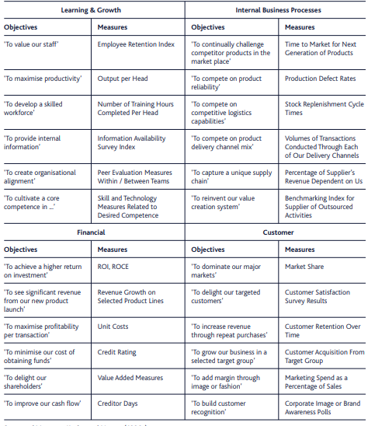
Appendix A: Examples of objectives and measures

Source: (Mackay, 2005)
Appendix B: According to Sageer (2012), there are two main variables from which Employee Satisfaction Depends: the first one is called Organizational Variables (Figure 5) and the second one Personal Variables (Figure 6).
Figure 5: Types of Organizational Variable
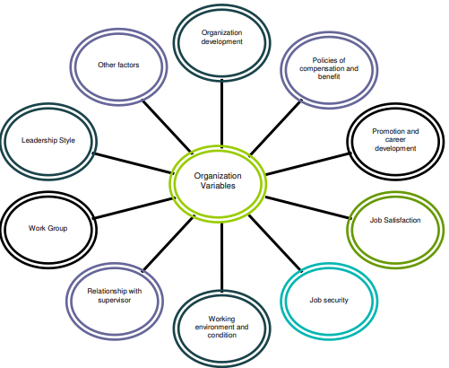
Source: (Sageer, et al., 2012)
Figure 6: Personal Variables
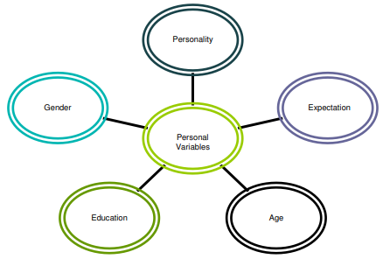
Source: (Sageer, et al., 2012)
Appendix C: The size of the L&D function.
According to research conducted by CIPD (2015), TLD which are at the heart of performance improvement is also key activities in which line managers have a considerable engagement. SainCo needs to be aware the number of employees engaged in the L&D function grows with the size of the organisation, yet there is significant variety, especially in bigger organisations (Table 5).
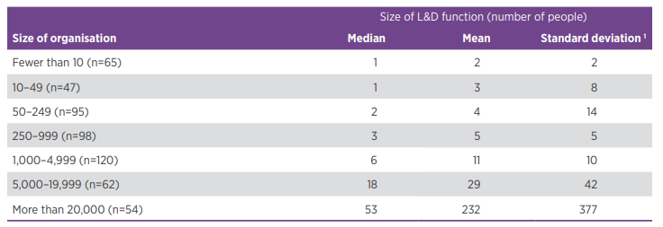
Table 5: The size of the L&D function, by size of organisation
Source: (CIPD, 2015)
Appendix D: HR appraisal of line managers.
Some line managers still consciously choose to behave inconsistently when having to apply HR practice in order to have some flexibility in dealing with individual employees, there is growing evidence that line managers face significant difficulty in implementing it (Table 6).
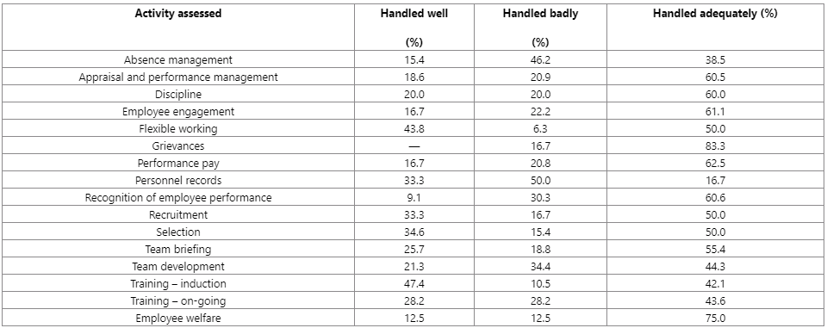
Table 6: HR appraisal of line managers' competence to manage people
Source: (Hutchinson, 2013)
Table 6: illustrates the competence of line managers to take on human resources positions and shows that most did not do well in the assigned tasks.
Appendix E: Importance of and satisfaction with work environment aspects.
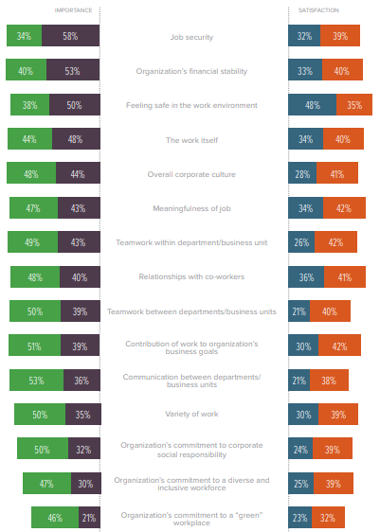
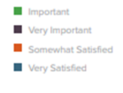

Source: (Society for Human Resource Management, 2016)

