Project Supervisor: Gordon Dickers
Dylan Evans
1701153@student.uwtsd.ac.uk
Abstract
This report will outline the authors findings on Artificial Intelligence specifically in the areas of genetic algorithms. The report will also outline other findings in the areas of artificial intelligence covering various techniques.
Investigation into genetic algorithms and implementation within a games environment
Research Methods
Table of Contents
1.0 Introduction 2
1.1 Title 2
1.2 Background 2
1.2.1 What is AI? 2
1.2.2 History of AI 3
1.2.3 What is the genetic algorithm? 4
1.2.4 Prisoner’s Dilemma (genetic Algorithms) 5
1.3 Aim of study & Outcome 6
2.0 Research & development methods 7
2.1 Research Methodology 7
2.2 Development Methodology 9
2.3 Risks 10
2.4 Analysis and Deliverables 10
3.0 Resources & planning 11
3.1 Resources 11
3.1.1 Physical Resources 11
3.1.2 Human Resources 11
3.2 Gantt Chart 12
4.0 References 13

Table of Figures
Figure 1:The Research Onion 7
Figure 2: Extreme Programming Model 9
Figure 3: Gantt Chart 12
Table of Tables
Table 1: Prisoner Dilemma Table 5

1.0 Introduction

1.1 Title
The title for this project is “investigation into genetic algorithms and implementation within a games environment”. The report covers the basis of genetic algorithms. The authors findings from research will be documented throughout the report.

1.2 Background

1.2.1 What is AI?
There are many different definitions of AI. Oxford dictionary defines artificial intelligence as:
“The theory and development of computer systems able to perform tasks normally requiring human intelligence, such as visual perception, speech recognition, decision-making, and translation between languages” [1].
From this quote in the oxford dictionary the author adds that his belief is that AI is much more than just human tasks being completed by computers and that it is an intelligence which can develop and learn just like humans can. Artificial intelligence has no limits to what it can and can’t do and is getting smarter and smarter every day.
To know what AI truly is, first the concept of intelligence should be understood. What is intelligence? The oxford dictionary states intelligence is “The ability to acquire and apply knowledge and skills”[2]. From this the author can compare this definition with the definition of artificial intelligence, the similarities between them is the capacity for knowledge. With AI the capacity for knowledge is defined by the creator but with human knowledge there is no capacity. This in the authors view is what makes intelligence artificial.
There are many different views to what AI is, one view is that computers are used to model intelligence to further understand it. This group of people believe that human knowledge is computational, and that AI is used to virtualise the human mind in order to complete tasks. Another view is the “pragmatic” view, this view the programmer programs the AI in a realistic way. The AI works by looking at things realistically and breaking them down, to solve the problems in engineering terms. This group of people will then decide whether the AI is successful by looking at the overall behaviour of the AI towards the subject area. [3]

1.2.2 History of AI
AI has been around for many years. There have been many different discussions over it from films like the terminator and blade runner, to virtual assistant’s like google assistant and Siri. AI is progressing every day getting better and better at what it’s programmed to do. For example the google assistant can now make phone calls to restaurants on your behalf to book tables or even book hairdressing appointments [4]. AI First became big when Alan Turing introduced the Turing test in 1950 Turing asked the question “can machines think” [5]. His test is simple a human convers with a machine through a computer if the AI can convince the human that it is human, then the AI is considered intelligent. One of the early AI’s ELIZA was ahead of its time it would talk to a human and respond intelligently. For example, a conversation ELIZA had with a human went as follows taken from the book an introduction to artificial intelligence [3]:
“TELL ME ABOUT YOUR PROBLEM
Men are alike
HOW DO YOU FEEL ABOUT MEN?
None of them can be trusted
NOT ANY?
Well very few
COULD YOU BE MORE PRECISE PLEASE?
My grandfather was trustworthy
TELL ME ABOUT YOUR GRANDFATHER”
From this the author can see how the AI thinks it takes key words from the sentence like grandfather and asks more about them. This is the basis for many AI’s today but where ELIZA fell down was the context for the conversation when the question “How did your parents treat you as a child” was asked the humans reply was “they gave me a grandfather clock” ELIZA then took from this sentence the word grandfather and asked “Tell me about your grandfather”. AI has come much further than this with AI’s like Google assistant, Alexa and Siri. They can all see the context of a question for example you can ask a question “Who is the president of the united states?” and then can follow up with “How old is he?”. From this the author can see how far AI has come.

1.2.3 What is the genetic algorithm?
There are three main rules to genetic algorithms: Selection rules, Crossover rules, and mutation rules. The basis of these rules is the most advanced individual is selected by checking the “fitness” of the individual this then becomes a parent, this parent then gets combined with another parent to make a new mutated individual. The mutations of this individual are random based upon the genes of the parents [6][7][8].
The neat genetic algorithm is split up into 4 main functions.
Fitness – This is how the ability of the ai is defined. Within this function the algorithm will calculate how fit the player is and find the fittest player from the population to then continue into the next generation. For example, if there was a car track and the AI was programmed to learn how to travel around the track, the fitness of the AI could increase the further they get around the track.
Mutation – From this function the algorithm finds the two fittest players and then multiplies and mutates them in the next generation. This then increases the intelligence each generation as only the most intelligent players brains survive.
Player – Within this function the brain of the player is generated which stores how the ai thinks and progresses using the genetic algorithm. This function is also where the mutation takes place.
Population – Within this function the players are multiplied to make the population within this function the fitness is calculated, and the best player is found. All the other players will be killed, and the best player will then be mutated.
All the functions summarised by the author are taken from GitHub. This isn’t a academic source but is widely used within the software engineering industry and the author of the code is a trusted source [9].
There are different methods when it comes to genetic algorithms one of these methods is known as Neat (NeuroEvolution of Augmenting Topologies). Neat is suitable for supervised and non-supervised learning [10]. The neat algorithm is the authors algorithm of choice within the study of genetic algorithms. The author believes that this research on neat is worthwhile as the materials available online and in literature are very poorly documented. With this gap in materials the author will be able to give people a further understanding of the field.

1.2.4 Prisoner’s Dilemma (genetic Algorithms)
The prisoner’s dilemma is a great example of the use of the genetic algorithm. The dilemma is there are two prisoners in separate cells who are unable to converse with each other. The prisoners are given two choices to defect or to remain in the cell. If one prisoner defects they will be rewarded and the other punished. Whereas if both prisoners defect, they shall both be punished. The third situation is when both prisoners remain in the cell in this situation both prisoners would be given a bigger reward for good behaviour. The strategies and outcomes are broken down below:
Table 1: Prisoner Dilemma Table
Player 1 Decision | Player 2 Decision | Player 1 outcome | Player 2 Outcome
Defect | Defect | Punished as both players defected | Punished as both players defected
Defect | Cooperate | Rewarded as only 1 prisoner defected | Punished as other prisoner defected
Cooperate | Defect | Punished as other prisoner defected | Rewarded as only 1 prisoner defected
Cooperate | Cooperate | Bigger reward given as both players cooperated | Bigger reward given as both players cooperated

This example can be used in a genetic algorithm the prisoners will be the players and at first the selections made by the players will be randomised. The scores of the players will be noted and the players with the best scores will then progress into the next generation. Each generation will have a different outcome as the players will make different decisions. The genetic algorithm will improve the outcomes as the game progresses by keeping the players with the highest scores (best outcomes).[8]

1.3 Aim of study & Outcome
The main purpose of the research is to implement the neat algorithm to help visualise the genetic algorithm and to help people within the industry of Artificial Intelligence (AI) and or other relevant industries. The objectives are to:
- Visualise the neat genetic algorithm within a computer program such as a maze.
- Help the industry and surrounding industries of AI further understand the neat algorithm.
- Use languages like python[11], processing[12] and c++[13] to fulfil the first aim to visualise the neat genetic algorithm.
At the end of the study the author Dylan Evans will submit a working visualisation of the neat genetic algorithm, visualising how the genetic algorithm learns in each generation. This program will give the user a more in-depth idea of how the genetic algorithm works and further help the AI industry and related industries. The neat algorithm is very poorly documented, and the author strongly believes that documenting it further and visualising it within a game environment makes the research worth doing.
The author can find out if the outcome of the project is successful by asking computing students if the visualisation helps them to further understand the genetic algorithm and how each generation gets progressively better each time. The author can also compare the aims to the finished project to make sure that each aim has been met to a high standard and improve any area where required.

2.0 Research & development methods

2.1 Research Methodology
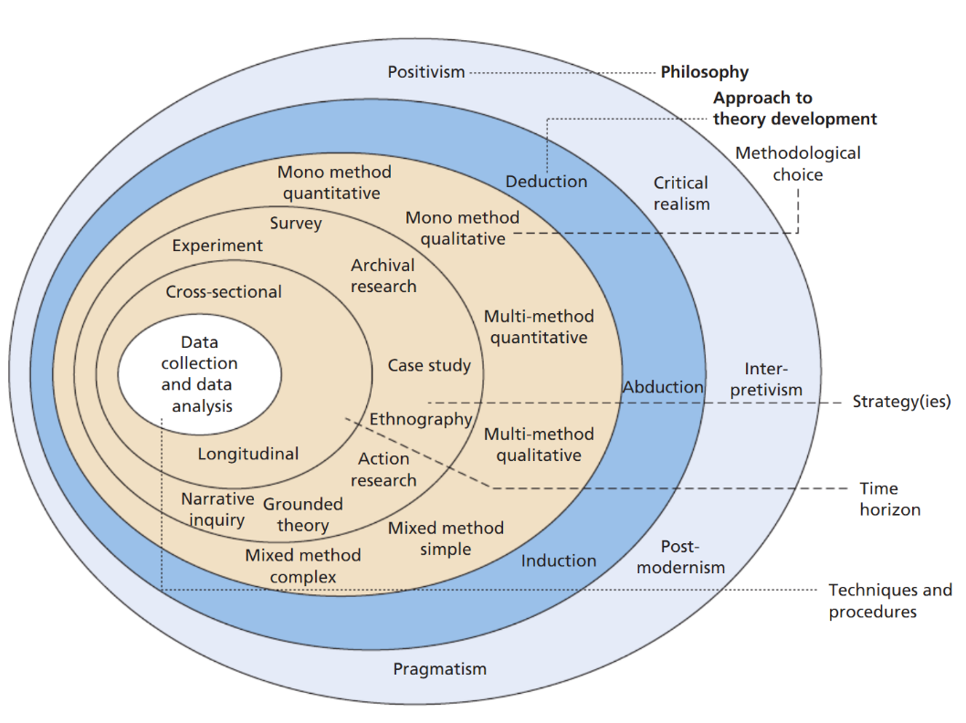
The research requires a philosophy, approach and a strategy before research can commence. There are many different philosophy’s as shown below the “research onion” shows many of these. This “research onion” also shows approaches and strategies making it the perfect reference when choosing a philosophy, approach and a strategy.
Figure 1:The Research Onion
[14]
From this as the author is doing a software development-based project “positivism” would be the best philosophy to use. Taken from the report entitled Understanding research philosophies and approaches “Epistemology - what constitutes acceptable knowledge” [14], positivism’s Epistemology is a scientific method which is close to being an approach used by software developers software development, therefore making this the best option in views of the author.
The author did not choose postmodernism as his philosophy as it is not suited to AI and genetic algorithms. From the report Understanding research philosophies and approaches “What counts as ‘truth’ and ‘knowledge’ is decided by dominants ideologies” [14]. From this quote the author decided that this wouldn’t be the best philosophy as AI doesn’t have a dominant ideology as everyone has different views about AI.
The approach best suited to the “positivism” philosophy in the authors view would be deduction. The reasoning behind this decision is that the data can be used against a hypotheses of existing data [14]. This is useful within genetic algorithms as the hypothesis is what the author would build the algorithm on. For example, if the aim of the game was for the ball to reach a target the hypothesis would be that the ball would move around the screen until it finds the ball and then learn the fastest route. The author would then create a genetic algorithm based upon this hypophysis.
An alternative approach would be induction the author chose not to use this method as it doesn’t fit in with “positivism”. The other reason why the author decided not to use induction is that the method is based upon theory generation [14]. This wouldn’t suit the genetic algorithm as doesn’t generate theory it is taught theory to the build upon itself.
The main strategy chosen by the author is experiment. The author believes this to be the best method for the project as the project is an experiment to see how a genetic algorithm can help an AI in a game progress through it. Experiment also fits in well with the authors philosophy “positivism”. The project will involve a lot of development in terms of the algorithm this will have to be tested in different scenarios to make sure that it works. Testing an algorithm is very experimental therefore the author has chosen this as his main strategy.
The two other strategies that the author will use are case study and survey. These strategies fit in well with the authors philosophy “positivism”. The case study will be used to study how the algorithm progresses the AI throughout the game. The survey will be used to find peoples opinion on AI and Genetic Algorithms and how they could be used to enhance the industry.
The author is choosing cross sectional for his research. The reason behind this is as his research is over a short period of time, whereas longitudinal is over a longer period for example, 20 years. Something that the author needs to consider is that cross sectional takes a “snapshot” in time the author needs to make sure that this is in the middle of his study and not at the beginning or end. This way the research will be fair as the last iteration of an AI using the genetic algorithm as its progression will be a lot smarter than the first.[15]
The author has decided that the population of the study will be university students studying computing and related topics. A population size of around 100 will be adequate for the questionnaire. The author will take the information from this study and then incorporate the feedback into his final project.

2.2 Development Methodology
The development methodology the author has decided to use is Extreme Programming Methodology. The author has chosen this as his methodology as the flow of the model suits the project brilliantly, as shown in the image below:
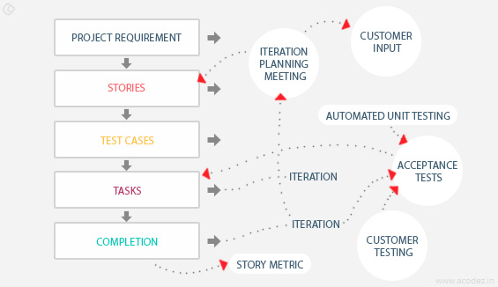
[16]
Figure 2: Extreme Programming Model
From this model the development requires test cases to progress to the overall completion which fits in perfectly with the research methodology. Below is a breakdown of how this model will be implemented into the authors project:
Project requirement: The project will be broken down into individual requirements (aims and objectives) to get to the goal of the project to simulate the genetic algorithm in a games environment.
Stories: A project plan will be made in a form of a Gantt chart in order to manage the project to make sure that it is completed on time to a high standard not missing any information.
Test cases: The author will generate some game scenarios to test his genetic algorithm with these test cases the author can document how the genetic algorithm learns how to progress within each generation.
Tasks: The author will monitor each iteration of the genetic algorithm and modify the logic of the game to further enhance the algorithm.
Completion: The project will be completed and compared with the plan to make sure that everything is complete.

2.3 Risks
Risks of the project need to be considered before beginning. If the risks are considered earlier on in the project they can be avoided. The main risk of the authors project is the lack of materials available online documenting the neat algorithm which is going to be one of the authors focuses. This risk can be minimalized by finding as much materials as possible before starting the project.
Some other risks of the authors’ project are:
- Time – As the project has such a large scope the author could go overboard to how much work goes in and run out of time for the project deadline.
- Budget – Similar to the time risk the scope is large being the author could go overboard with the materials purchased for the project making the project over budget and creating added costs which aren’t required.
- Programming knowledge – the author could choose a language he is not familiar with and spend too much time learning the language and not have enough time to implement the project. To minimalize the project the author has chosen the language Processing [12] which is based upon the language python the author is familiar with python making it easy for Dylan Evans to learn and then implement in the project.
- Licensing of software – the author could come across a barrier when it comes to obtaining licenses of software it may only be available to the commercial industry. To prevent this risk the author has made sure that the software he will be using is open source or student licenses are available.

2.4 Analysis and Deliverables
The data collected for this project will be the outcome of the genetic algorithm being used against a game. This data will be taken to document how a genetic algorithm learns to progress through a game. This data will be analysed by compare each generation and seeing what each generation does and how it makes its decisions.
The finial deliverables for the project are a completed genetic algorithm capable of progressing through a game and getting progressively better at the game after each generation. The minimum success would be a working algorithm capable of this.
The outcome of the project will need to be compared to the original aims of the project to make sure that each one has been met. The author will also perform multiple tests upon the software to make sure that there are no errors and the algorithm successfully performs each of its tasks. The algorithm must choose the “fittest” player to progress and then be mutated with another “fit” player for the intelligence of the AI to get progressively better after each generation.

3.0 Resources & planning
For the project to be successful the project needs to be planned out and resources need to be allocated. This can be done using project management tools. If the project isn’t planed and resources are not allocated the project will be difficult to manage and crucial information and requirements may be missed out.

3.1 Resources

3.1.1 Physical Resources
- C++ (Language) [13] – this is one of the languages that the author will use for the game.
- Processing (Language) [12]– this is the main language used for the genetic algorithm this language is based upon the programming language python which the author is familiar with making it easy to learn.
- Python (Language) [11]– this is one of the languages that the author will use for the genetic algorithm to communicate with the game.
- Visual Studio Code (Editor) [17]– The author will use visual studio code as his main editor in designing the algorithm and game.
- Processing editor [12]– on top of using visual studio code the author will also use the editor which comes with processing as it comes built in with intelisense related to the processing language which will help the author code while minimalizing errors.
- Access to the library catalogue – the author will utilise the library system to research his project.
- Computer capable of performing genetic algorithms.

3.1.2 Human Resources
- Gordon Dickers (Project supervisor)
- Students available (preferably computing students) to take a survey based upon AI and Genetic algorithms.
- Test subjects to try the algorithm and give feedback on how to make the algorithm better.

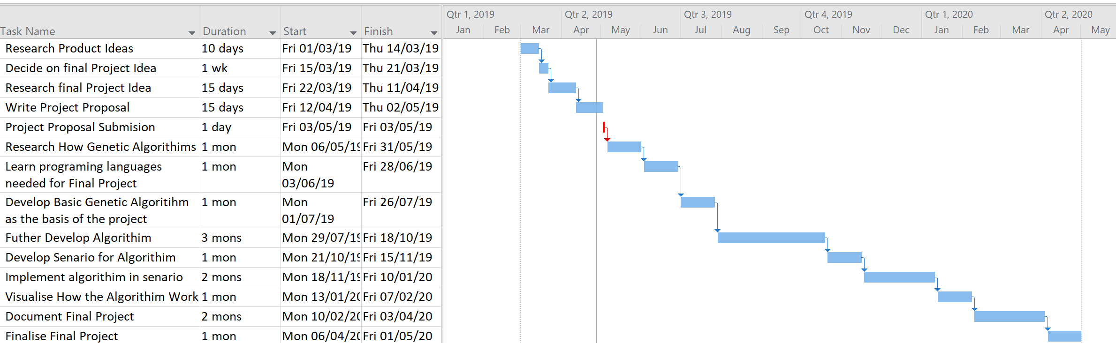
Gantt Chart
Figure 3: Gantt Chart
To plan the projects timescale a Gantt chart has been used. This Gantt chart outlines each stage of the project and how it will be developed at each stage. The Gantt chart will be a crucial element of the Extreme Programming Methodology as it is a requirement of this methodology to plan out the project and use the plan as a reference to make sure the project is competed to the highest standard.

4.0 References
[1] “Definition of artificial intelligence by Oxford Dictionaries.” [Online]. Available: https://en.oxforddictionaries.com/definition/artificial_intelligence. [Accessed: 26-Apr-2019].
[2] “Definition of intelligence by Oxford Dictionaries.” [Online]. Available: https://en.oxforddictionaries.com/definition/intelligence. [Accessed: 28-Apr-2019].
[3] J. Finlay, An introduction to artificial intelligence. London: UCL Press, 1996.
[4] Y. M. Yaniv Leviathan, “Google AI Blog: Google Duplex: An AI System for Accomplishing Real-World Tasks Over the Phone.” [Online]. Available: https://ai.googleblog.com/2018/05/duplex-ai-system-for-natural-conversation.html. [Accessed: 02-May-2019].
[5] “Alan Turing.” 1950.
[6] Mathworks, “What Is the Genetic Algorithm?” [Online]. Available: https://uk.mathworks.com/help/gads/what-is-the-genetic-algorithm.html. [Accessed: 25-Apr-2019].
[7] V. Hlaváč, “GENETIC PROGRAMMING WITH EITHER STOCHASTIC OR DETERMINISTIC CONSTANT EVALUATION,” Neural Netw. World, vol. 28, no. 2, pp. 119–131, 2018.
[8] Z. Michalewicz, Genetic algorithms [plus] data structures = evolution programs. Berlin ; New York: Springer-Verlag, 1992.
[9] Code Bullet, “NEAT_Template/TemplateNeat GitHub.” [Online]. Available: https://github.com/Code-Bullet/NEAT_Template/tree/master/TemplateNeat. [Accessed: 02-May-2019].
[10] L. Chen and D. Alahakoon, “NeuroEvolution of Augmenting Topologies with Learning for Data Classification,” in 2006 International Conference on Information and Automation, 2006, pp. 367–371.
[11] python.org, “Python Language.” [Online]. Available: https://www.python.org/. [Accessed: 26-Apr-2019].
[12] Processing.org, “Processing Language.” [Online]. Available: https://processing.org/. [Accessed: 26-Apr-2019].
[13] Microsoft, “Visual C++.” [Online]. Available: https://docs.microsoft.com/en-us/cpp/?view=vs-2019. [Accessed: 26-Apr-2019].
[14] M. Saunders, P. Lewis, and A. Thornhill, “Understanding research philosophies and approaches,” Res. Methods Bus. Students, vol. 4, pp. 106–135, 2009.
[15] Institute for Work & Health, “Cross-sectional vs. longitudinal studies,” 2015. [Online]. Available: https://www.iwh.on.ca/what-researchers-mean-by/cross-sectional-vs-longitudinal-studies. [Accessed: 01-May-2019].
[16] Jamsheer K, “12 Best Software Development Methodologies with Pros &amp; Cons.” [Online]. Available: https://acodez.in/12-best-software-development-methodologies-pros-cons/#Extreme_Programming_Methodology. [Accessed: 01-May-2019].
[17] Microsoft, “Visual Studio Code.” [Online]. Available: https://code.visualstudio.com/. [Accessed: 02-May-2019].

