Table of Contents
Introduction 2
Task 1 2
1.Strategic Threat Analysis: A Framework-Based Approach to Modern Cyber Incidents 2
1.1 Mapping the Adversary Campaign to the MITRE ATT&CK® Framework 3
1.2 Analyzing the Root Cause of the Breach 5
1.3 Synthesizing Strategic Recommendations for Prevention and Detection 7
Task 2 9
2.Operation IP Shield: A Comprehensive Red Team Engagement Framework 9
2.1 Introduction: The Imperative of Adversary Emulation in Modern Defense 9
2.2 Campaign Design: Formalizing Engagement Rules and Adversary Playbooks 10
2.3 Environment & Execution: Constructing the Hybrid Lab and Executing with Stealth 12
2.4 Reporting & Analysis: Translating Technical Actions into Strategic Insight 14
Conclusion 16
References 17

Introduction
This is a detailed submission that provides a two-part strategic analysis and an emulation project exercise that aims to complete the learning outcomes of the Ethical Hacking module. In modern times, where cyber threats are more advanced and carefully coordinated, organisations in the pharmaceutical, healthcare, and research industries are at a greater risk than ever before, to their most valuable intellectual property and sensitive data. The assignment addresses this challenge directly by establishing a strict, frame-based approach to the study and critique of organisational defences. The former is the Strategic Threat Analysis, which breaks down a real-world cyber incident into an ATT&CK®-based map of adversary tactics, techniques, and procedures (TTPs) to identify the underlying causes and craft an intelligent and strategic defence. The second element is Operation IP Shield that shifts the analysis to active testing where a professional red team engagement simulates an Advanced Persistent Threat (APT) in order to realistically test the defensive position of the fictional Cureton Pharmaceutical Company hybrid infrastructure. These activities can combine the state-of-the-art academic research, especially the groundbreaking survey of MITRE ATT&CK by Al-Sada, Sadighian, and Oligeri (2022) with practical technical planning, implementation and critical reporting. This work captures the transition between reactive security and the proactive, adversarially knowledgeable defence, the systematic knowledge and hands-on implementation of high-level principles of offensive security demanded at Level 7.

Task 1

1.Strategic Threat Analysis: A Framework-Based Approach to Modern Cyber Incidents
The modern cybersecurity environment with which pharmaceutical, healthcare, and critical research organisations struggle is marked by the increase in the level of sophistication and strategic aims of the adversarial campaigns. Being stewards of irreplaceable intellectual property and other sensitive personal information, they are valuable targets to the enemies of both non-state ransomware collectives and state-aligned advanced persistent threat (APT) organizations. The offensive security paradigm has thus been transformed to more advanced penetration testing and emulating adversaries and red team operations aimed at testing the defensive posture, detection, and incident response effectiveness of an organisation in a rigorous way. This discussion argues that a framework-based and strict methodology is essential to take apart these multifaceted attacks, identify their underlying causes and create operational, strategic defences. The MITRE ATT&CK® framework is the lingua franca that is crucial to this endeavor; it offers an organized body of knowledge of adversary tactics, techniques, and procedures (TTPs) based on experience. The paper will perform a strategic threat analysis, mapping a typical advanced attack into the MITRE ATT&CK Enterprise Matrix, a forensic investigation of the cause of the breach, and develop a detailed set of recommendations to prevent and detect it. The argument will be supported by critically exploring the corpus of research developed in the seminal survey by Al-Sada, Sadighian, and Oligeri (2022), which summarises the state of the art in scholarship based on ATT&CK, thus using peer-reviewed literature as a means to go through the tactical headlines when navigating towards strategic cybersecurity resilience.

1.1 Mapping the Adversary Campaign to the MITRE ATT&CK® Framework
The first stage of a strategic threat analysis is the systematically re-assembling the behaviour of an adversary into its own behaviours, which the MITRE ATT&CK framework is ideally contributed to. ATT&CK is not only a taxonomy but also a behavioural model that breaks down the lifecycle of an attack into tactical phases including initial access, execution, persistence, and impact each achieved via specific techniques and sub- techniques (Strom et al., 2018). As an example of this mapping, the example of a more advanced ransomware assault on a hospital network, such as the WannaCry campaign, can be broken down into at least ten major TTPs with the help of ATT&CK. The first access vector is commonly a socially engineered spearphishing attachment, the technique T1566.001, which uses human factors to obtain a footing (Oosthoek and Doerr, 2019). When executed, the adversaries can also use trusted system utilities, which is a characteristic of living-off-the-land (LOLBin) strategies; such as Windows Management Instrumentation (WMI) to execute (T1047) and PowerShell to deploy a payload later (Milajerdi et al., 2019). Creating or altering system processes (T1543) or structured tasks is often necessary to ensure persistence of the malware so that the malware will endure system reboots.
The next steps of the attack are illustrative of the enemy being concerned with the idea of carrying out actions in the shadows and gaining control. The most significant, defence evasion techniques are used, where attackers would utilise file and directory permissions alteration (T1222) or conceal artefacts in the system (T1564) to defeat off-the-shelf antivirus software. There is then the discovery phase during which the adversary performs reconnaissance in the compromised environment by means such as network service discovery (T1046) or system network configuration discovery (T1016) to map the terrain to traverse it horizontally (Applebaum et al., 2017). The act of lateral movement can be achieved by either abusing remote services (T1210) or by using the valid accounts compromised earlier in the chain so that the adversary is able to pivot off the initially infected workstation to critical servers, which may include those which may host patient databases or research files. The transmission of command and control (C2) is preserved using encrypted channels (T1573) or connection proxies (T1090), hiding malicious traffic in the normal network traffic. The impact as the last stage in tactics is achieved in a ransomware case by impacting data being encrypted (T1486) and blocking system recovery (T1490), which directly fulfils the goal of the adversary in disrupting and extorting. A visualization of such a sequence in the form of an ATT&CK matrix, as shown in the analysis of malware such as WannaCry, is a chaotic incident, converted into an easy-to-follow chronological narrative of adversary behaviour, which is the key blueprint of defensive analysis (Al-Sada et al., 2022).
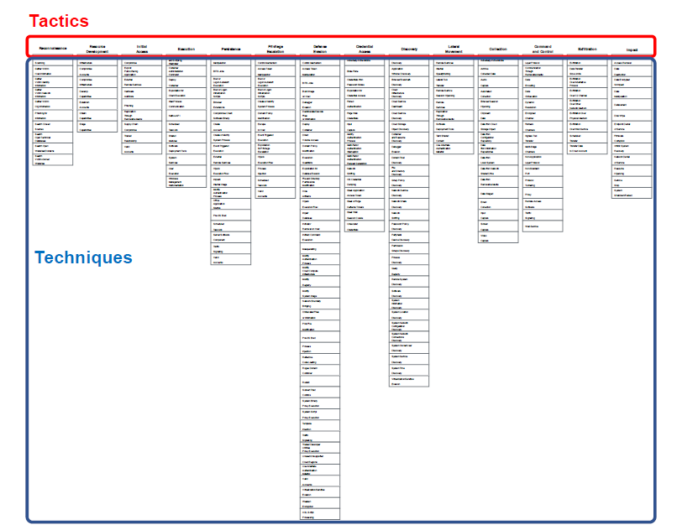
Fig 1:ITRE ATT&CK matrix: tactics and techniques
“This systematic deconstruction is made enabled by the very structure of the ATT&CK matrix itself, which structures the adversarial tactics (Columns) and techniques (Row) into a logical sequence, as shown in Figure 1 (Al-Sada et al., 2022, p. 3). This matrix gives the necessary taxonomy to organize every malicious action that can be seen in the campaign.”
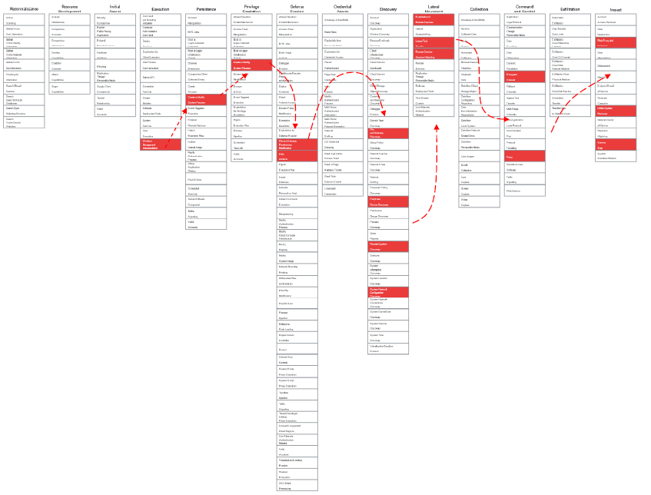
Fig 2 : WannaCry behaviour as a sequence of techniques
“With such a taxonomy, a certain attack campaign can be traced to outline its behavioural fingerprint. To illustrate an example, Figure 2 provides the template of this application by plotting the series of techniques used by the WannaCry ransomware along the tactical columns, which could be utilized in our analysis of the target healthcare breach (Al-Sada et al., 2022, p. 4).”

1.2 Analyzing the Root Cause of the Breach
An obsessive mapping of TTPs will always shed light on the vulnerabilities and control failures underlying the adversarial campaign that went uninterrupted. The cause of a significant intrusion in a critical organisation is rarely an isolated area of failure but a combination of inadequacies at both technical controls, architectural design and human factors. One of the main technical failures is the lack of proper endpoint visibility and protection. The effective implementation and continuity of fileless or LOLBin-based methods, as earlier plotted, signify a breakdown of old signature-based antivirus, and a possible weakness in the enhanced Endpoint Detection and Response (EDR) solutions. The EDR systems that are aimed at capturing and processing endpoint activities of suspicious behaviours are essential in identifying the latent anomalies that are linked to advanced TTPs (Hassan, Bates and Marino, 2020). Their lack or inadequate design is an essential failure on the defensive side.
These failures in control are intensified by architectural flaws, especially in the mixed infrastructures that contemporary enterprise evolves around. The situation is likely to be an on-prem network with core functionality, like an Active Directory domain to support R&D, loosely coupled with cloud-based solutions such as an AWS Virtual Private Cloud (VPC) with a clinical trial portal. This hybrid model is often plagued by security dissonance - i.e. identity and access control policies, network segmentation policies, and logging standards do not match across environments. Lack of effective micro-segmentation at the data centre level as well as between on-premises and cloud platforms forms a flat or poorly partitioned network. This architectural vulnerability directly allows the lateral movement techniques (e.g., T1210, T1570) that are mapped in the attack chain to enable an adversary that has compromised on a single system to move through the network with relative ease towards high-value targets (Xiong et al., 2022). Moreover, the absence of integrated security control over these heterogeneous environments implies that an activity in one area can escape the vigilance of the security measures in another area, which leaves such gaps that attackers skillfully use.
The human factor perhaps is the most enduring and even the most exploitable root cause. A combination of advanced social engineering, as well as the lack of security awareness training, is effective because the first access method of spearphishing (T1566.001), is successful. Technical controls may be circumvented by a human operator or attacker despite their existence; an example is that a user may unwillingly reveal credentials or confirm a rogue multi-factor authentication (MFA) prompt. The inability to deploy and enact phishing-resilient types of MFA, i.e., FIDO2 security keys, leaves a gaping hole. Besides, the root cause analysis should be applicable to shortcomings in procedures and governance. Poor patch management practices, inability to perform periodic defensive disjunctive evaluations in opposition to such frameworks as ATT&ACK, and the absence of threat-founded hunting processes permit the known vulnerabilities and TTPs to be weaponised effectively against the company (Georgiadou, Mouzakitis and Askounis, 2021). Therefore, the breach itself is not a phenomenon, but the symptom of a systemic issue in question where the flaws of technical, architectural, and human nature meet, a diagnosis that can be achieved through following the route of the adversary through the ATT&CK framework.

1.3 Synthesizing Strategic Recommendations for Prevention and Detection
The strategic response to the advanced threats should be proactive, multi-layered, and clearly informed by the TTPs discovered in the analysis. Recommendations must go beyond generic advice, providing a specific and practical guidance based on the ATT&CK framework to tighten the security belt, enhance visibility and resilience in the organisation. The initial pillar of this strategy is the introduction and stringent setting of certain security controls that will counter the mapped techniques. To reduce initial access through spearphishing, organisations should install phishing-resistant MFA everywhere, especially when accessing email, cloud service providers and VPNs (Al-Sada et al., 2022). The implementation of contemporary EDR platforms is not an option at the endpoint. Such solutions should have the custom detection rules that are tweaked to recognize the particular LOLBin patterns (e.g., unusual PowerShell or WMI sequences) and persistence methods (e.g., suspicious scheduled task creation) that are inherent to advanced attacks (Hassan, Bates & Marino, 2020). Moreover, application allowlisting has the potential to deeply undermine the capacity of an adversary to perform arbitrary payloads, which is a direct attack on both execution and persistence strategies.
The second strategic imperative entails the following fundamental architecture to hold breaches and restrict movement of the adversaries. The most significant aspect is the implementation of a wide set of micro-segmentation with the help of a zero-trust philosophy. Application and data sensitivity should be used to define network segments and east-west traffic should be tightly controlled to block all traffic, only allowing explicitly authorised traffic. This architectural change is a direct hindrance to the methods of lateral movement (T1210, T1570), where an enemy is limited to a small part of the network even after being compromised in the first place (Xiong et al., 2022). This should be applied to the cloud in hybrid environments, where identity-aware proxy access needs to be consistent and cloud VPCs and subscriptions need to be equally segmented. Moreover, architectural choices must be favourable to centralisation and encryption of credentials with solutions such as privileged access management (PAM) protecting against credential theft and misuse, a popular antecedent to subsequent lateral movement.
The third pillar is aimed at improving proactive monitoring, threat hunting as well as intelligence-driven defence. This starts with a process of optimising Security Information and Event Management (SIEM) systems to accept and correlate logs of all the assets of critical importance endpoints, network devices, cloud trails, and identity providers. Correlation rules need to be constructed to identify event sequences that correspond to high-priority ATT&CK techniques, past single- event alerts to behavioural detection (Milajerdi et al., 2019). In order to humanise this intelligence, organisations are required to be undertaking Cyber Threat Intelligence (CTI) enrichment. This includes using tools and works that translate Common Vulnerabilities and exposures (CVEs) to ATT&CK techniques and thus contextualizes patch prioritisation in the playbook of the adversary (Kuppa, Aouad and Le-Khac, 2021). Moreover, it is necessary to introduce an official threat-hunting program. The ATT&CK framework should assist hunters to formulate hypotheses such as, an adversary might persist on our domain controllers with the help of scheduled tasks, and actively seek indications of that specific TTP in endpoint and log data with advanced query languages (Jadidi and Lu, 2021). This proactive approach converts the security operation to a reactive alert- triage operation into an intelligence based hunter.
Last but not least, these technical solutions should be supported by strategic governance and the continuous evaluation. Regular defensive gap testing based on the MITRE ATT &CK framework as a baseline is an important habit. It is performed by mapping the current security controls (e.g., "we have EDR") against the techniques that they are intended to mitigate (e.g., "does our EDR detect T1047?") to detect areas of coverage and rank investments (Georgiadou, Mouzakitis & Askounis, 2021). The most challenging test of these integrated defences is red team exercises, which imitate realistic TTP chains as in the framework, and provide a concrete demonstration of the detection and response capabilities (Zilberman et al., 2020). Combining these recommendations hardening controls, redesigning architecture, empowering proactive hunting, and establishing rigorous assessment, an organisation can build a dynamic security posture that is resilient and can respond to the changes in the threat environment.
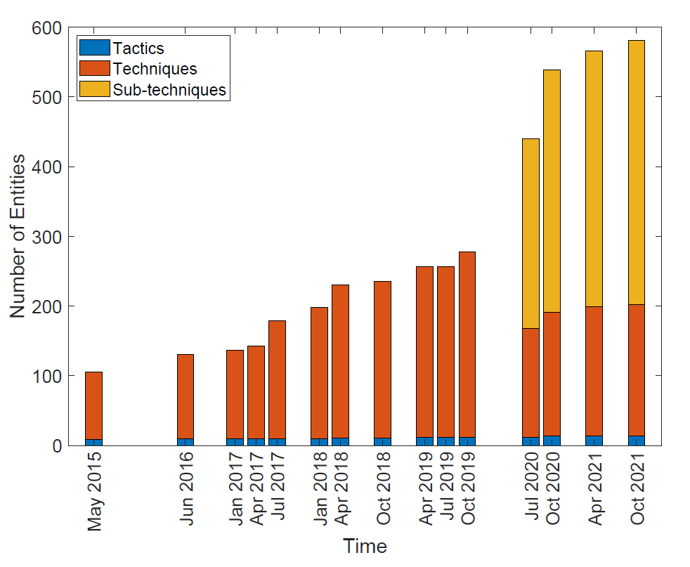
Fig 3: MITRE ATT&CK framework evolution over time in terms of number of Tactics, Techniques and Sub-Techniques.
“It is important to mention that ATT&CK framework is dynamic. As Figure 3 shows, it experiences constant enlargement, and techniques as well as sub-techniques increase in number considerably throughout the history to mirror the changing threat environment (Al-Sada et al., 2022, p. 5). So our defensive suggestions should focus on continuous control validation mechanisms and threat intelligence update in order to follow this evolution.”

Task 2

2.Operation IP Shield: A Comprehensive Red Team Engagement Framework

2.1 Introduction: The Imperative of Adversary Emulation in Modern Defense
The security of modern cyberspace of organizations, such as Cureton Pharmaceutical Company (CPC) that possess some of the most valuable intellectual property requires a shift in thought towards passive, compliance-focused security and active, intelligence-focused security. Offensive security has changed its goal of simple vulnerability scanning to advanced emulation of adversaries and red team activities, which simulate the tactics, techniques and procedures (TTPs) of actual threat actors in order to give a strict, realistic evaluation of an organization defensive position. This simulation is called Operation IP Shield, and is meant to imitate an Advanced Persistent Threat (APT) actor, possibly a highly advanced competitor or nation-state, that wants to steal proprietary research information. The challenge is to migrate the hybrid infrastructure of CPC, consisting of on-premises Active Directory network, an AWS VPC, and CI/CD pipelines, to withstand the pressure of a goal-oriented stealth attack. The philosophy behind such an operation is firmly based on the realization that successful defense must place one in the mindset of the adversary, a concept that the systemized knowledge of the MITRE ATT&CK framework intends to endorse very much. This report describes the overall execution of the Operation IP Shield, which includes campaign design, environment emulation, stealthy execution, and analysis reporting using scholarly research to inform every stage of the execution and make the emulation reflect the most advanced knowledge on APT tradecraft that is reflected in the existing literature on cybersecurity. This hybrid corporate setting reflects the growing interconnection of IT and OT, which is mentioned in the discourse of contemporary cyber-physical systems, where the technologies that are not deeply interconnected provide a wide, vast attacker space that is mastered by sophisticated adversaries (Al-Sada et al., 2022).

2.2 Campaign Design: Formalizing Engagement Rules and Adversary Playbooks
Design stage of red team involvement is key to legitimacy, safety as well as effectiveness. It makes it official what can be done, and draws up a finer map of the enemy to be imitated. The initial deliverable, the Rules of Engagement (RoE) document, is the contractual and ethical basis. This document clearly outlines the scope, targets, sanctioned techniques and communication protocols of the test, in such a way that all the activities are limited within approved limits. In the case of Operation IP Shield, the RoE would grant the ability to test the defined hybrid infrastructure: the on-premises Active Directory domain that controls the assets of the R&D, the AWS VPC that hosts the clinical trial data portal, and the CI/CD pipelines (e.g., GitHub Actions) that will be used to build the application. More importantly, it would determine stringent bans against the actions that are likely to cause disruptions in business, destroy data, or affect non-targeted production systems or third-party services. The RoE also requires active communication arteries with the blue team and CPC leadership including immediate reporting of any critical finding or unintended consequence. This formalization correlates with the professional red teaming and paradigms, such as the Unified Kill Chain, which turns the exercise into a disruptive ad-hoc test, instead of a controlled, measurable security assessment with distinct phases (Pols and van den Berg, 2017).
After the RoE, the elaborated Threat Emulation Plan transforms the overall mission into specific, practical order of adversary actions that are mapped to the MITRE ATT&CK framework. This plan goes further than generic "hacking" to simulate the computed approach of an APT organization that specializes in intellectual property theft, a technique that has been backed by research on threat modelling attacks in the APT style (Tatam et al., 2021). The main mission of the exfiltration of dummy research data is broken down into tactical steps. The Reconnaissance (TA0043) stage would entail intelligence collection of the public presence of CPC, such as the determination of key R&D personnel contacts through professional networks and technical data about open services, which would be akin to methods such as Search Open Websites/Domains (T1593). The first (TA0001) would probably be simulated through a spearphishing link (T1566.002) developed based on the reconnaissance step and including a document carrying a weapon on a scholar. Execution (TA0002) would be supported by PowerShell or Windows Script Host (T1059.001, T1064), whereas Persistence (TA0003) could be implemented with the help of Scheduled Task/Job (T1053) or malicious service (T1543.003). One of the central principles of the plan is stealth, which requires widespread use of Living-Off-the-Land Binaries (LOLBins) to be discovered, moved laterally and collected to avoid being detected by signature. Additionally, the plan identifies the utilization of a sophisticated Command and Control (C2) model, e.g. Cobalt Strike or open-source Sliver, to sustain encrypted and low-profile communication (T1573) with high-value hosts. This explicit mapping of objectives to ATT&CK IDs, plotted in a quasi-matrixic form like that of Figure 1 in the original literature, is a quantifiable, repeatable, and scholarly based blueprint of the engagement, allowing the type of systematic attack simulation discussed in the survey articles about open-source threat emulators (Zilberman et al., 2020).

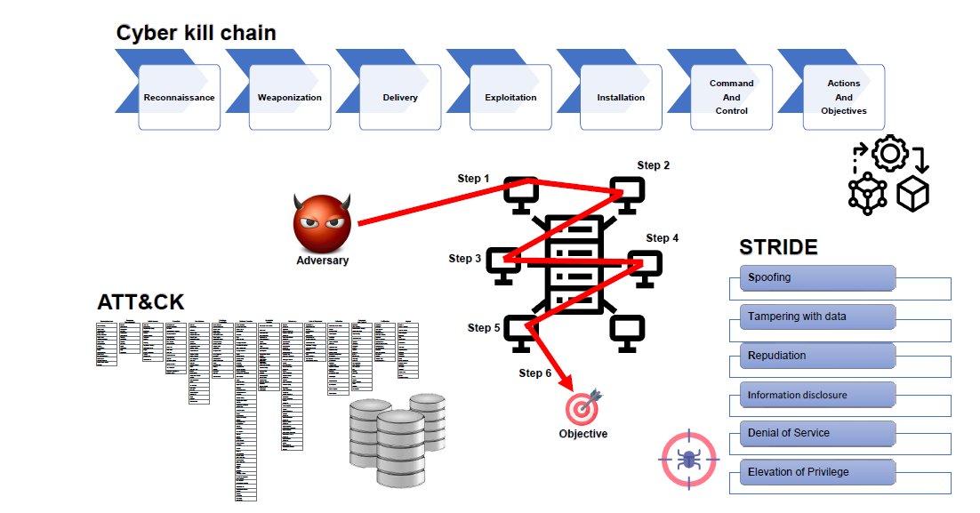
Fig 4: ATT&CK, Cyber Kill Chain and STRIDE: comparison and application scenarios
“The Threat Emulation Plan of Operation IP Shield is designed based on the integrated model of security frameworks. Since Figure 4 illustrates that the Cyber Kill Chain offers the overarching attack stages to structure the narrative, the MITRE ATT&CK framework offers the finer TTPs that we need to carry out and map our emulation to be structured yet precise (Al-Sada et al., 2022, p. 7) with regard to its technical aspects.”
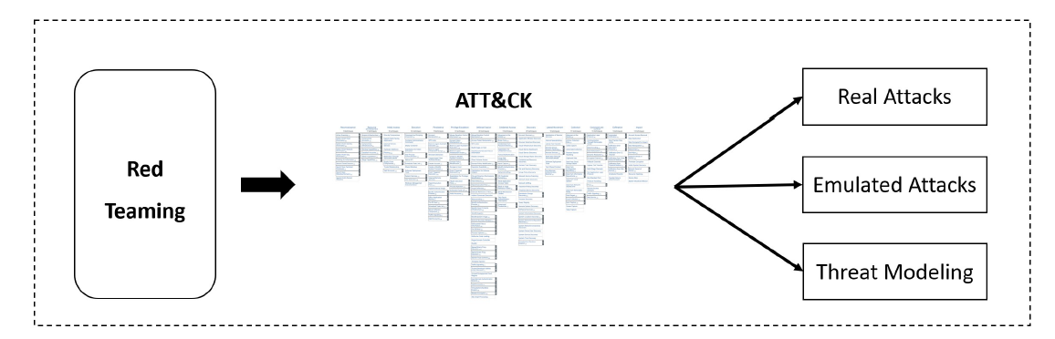
Fig 5: Red teaming with the ATT&CK matrix: We identified three main sub-categories
“The threat (Scenario) Modelling and Emulated Attacks categories included in the red teaming taxonomy of Figure 5 (Al-Sada et al., 2022, p. 18) are the two main categories that Operation IP Shield belongs to. We are working on the creation of an elaborate emulation strategy (modelling) that is subsequently performed with the help of tools that apply familiar techniques of ATT&CK (emulation), in direct accordance with this research-validated paradigm.”

2.3 Environment & Execution: Constructing the Hybrid Lab and Executing with Stealth
A safe and representative testing environment should be built before any execution is done. A requirement to ethical and effective testing is the designing and constructing of a virtualized lab environment that is a correct replication of the hybrid architecture as described by CPC. This laboratory would normally include a partitioned network on a hypervisor such as VMware ESXi or Proxmox. The on-premises part would contain virtual machines that will simulate a Windows Server Active Directory domain, which will include a domain controller, file servers that will store fictional research data, and workstations belonging to the user. The cloud segment would either be emulated with a dedicated and isolated AWS account with a VPC that is setup in the same way as production or, in the interest of cost and control, simulated locally with virtual machines setup to appear as web and database servers and a virtual firewall. These two segments would be connected by simulated VPN or direct routing connection that would mimic the hybrid connectivity. A local GitLab or GitHub Actions runner would be used to simulate the CI/CD pipeline. It is important to capture this design using a clear network diagram and capture the network topology, IP subnets, locations of critical assets, and speculation of where security controls such as network firewalls, intrusion detection systems (IDS), and endpoint sensors are likely to be located. The engagement can be safely exploited in this lab as a controlled microcosm and detailed forensic logging is possible, and detection logic can be tested without any risk to live operations, which research on security validation testbeds of industrial control systems has found to be important (Choi et al., 2020).
The performance of Operation IP Shield is the point at which the theoretical emulation plan collides with the essence of the real environment of the target as a ruthless pursuit of stealth and evasion as emphasized in the analysis of automated adversary emulation tools (Applebaum et al., 2017). It is starting with the delivery of the first access payload, which could be a malicious macro in a document or a link to a malicious site with an exploit kit. When a compromise was successful the initial payload would open a C2 channel. With the help of a framework such as Cobalt Strike, a Beacon payload would be loaded into memory, which would have been set with high sleep times and jitter to resemble benign traffic and avoid easy beaconing detection. LOLBins would be of great use during post-exploitation activities as defined in the emulation plan. To do discovery, one will run such commands as systeminfo, net view, and dsquery to map the network and active Directory structure (T1018, T1087.002). A key target would be credential access and to accomplish this, tools such as Mimikatz (in-memory) through PowerShell execution (T1003.001) would be used to steal hashes and tickets off of the memory of the compromised host. Lateral motion may use these stolen credentials using the net use command or Windows remote management (WinRM) (T1021.001, T1021.006). The point where my attention would be to focus would be the CI/CD pipeline. Red team may look into source code repositories, or directly on the developer workstations, with source code search commands such as findstr /s /i password api_key secret /.config /.json (T1552.001). A code injection in a GitHub Actions runner may grant hacker access to the AWS environment in case an associated IAM role is attached to the runner, a methodology that fits in the cloud persistence and execution techniques outlined in the ATT&CK for Cloud matrix. Studies on the characterization of attacker behavior on controlled competitions indicate that these credentialing-based hunting and abuse of trust relationships are typical features of advanced attacks (Munaiah et al., 2019). The last step of exfiltration would be to stage and carefully encrypt the dummy research data and then sicken it out via the current C2 channel, or just blend it into outgoing web traffic (e.g., DNS tunneling or HTTPS POST requests to a cloud storage provider controlled by the attacker, T1048). The operational speed would be low and measured all the way through, resembling how an APT would be patient with its adversary to avoid raising any threshold-based warning signals, a type of behavior that has been greatly studied in the context of real-world adversary emulation.

2.4 Reporting & Analysis: Translating Technical Actions into Strategic Insight
The red team engagement is unlocked at the time not of the execution but of the strict analysis and articulate presentation of the results. This necessitates coming up with two different reports that are audience specific. The Technical Report on the Blue Team is an engagement playbook of the forensic engagement. It contains a step-by-step overview of the attack chain, and it records every step carried out. Each step contains the corresponding MITRE ATT&CK Tactic, Technique, and Sub-Technique ID (e.g. to use net group "Domain Admins" /domain, it would refer to T1069.002 Permission Groups Discovery: Domain Groups). The report also contains real-life evidence of success: screenshots of damaged systems, logs of accessed files, listings of C2 session and evidence of data exfiltration. The most important component of it is the Detection Gap Analysis. This part will not just be a list of vulnerabilities, but a critical discussion of why the attack was successful. It provides responses to such questions as: Did the EDR issue an alert due to the particular LOLBin sequence or the memory injection method? Did the SIEM associate the abnormal outbound HTTPS traffic of the research server with the previous suspicious PowerShell logon of a user to his workstation? Did the cloud security posture management (CSPM) tool alert of the suspicious IAM role assumption of the CI/CD pipeline? This discussion turns the engagement into a straightforward examination into a direct, evidence-based roadmap of enhancing detective and preventive controls, which is highlighted in studies into defensive gap assessment and tactical provenance analysis, which concentrate on the causal interdependence between security activities (Hassan, Bates & Marino, 2020; Georgiadou, Mouzakitis and Askounis, 2021).
In strong contrast to the technical deep dive, the Executive Brief to the Board is an overview of the operational findings in the form of a business risk and strategic imperative narrative. It is not technical, summing up to the point that the red team (acting like an advanced threat agent) could quietly scout CPC network and steal its crown-jewel research data, and get away with it. This is presented as not an IT failure, but an existential business risk the billions of dollars of R&D investment, the damage to the competitive advantage, the severe regulatory fines, and the reputational damage will be impossible to repair. To ensure the security of the core assets of the company, as well as to ensure its further sustainability, the suggested security enhancements, i.e., investing in a more advanced behavior-based EDR system, a strict zero-trust network architecture with micro-segmentation, the 24/7 threat-hunting capability, and a better cloud security governance are suggested as necessary capital investments. The brevity employs the success of the red team as an unquestionable argument of the insufficiency of the existing security expenditure in comparison to the threat environment, thus making strategic investment in individuals, process, and technology. This trend of aligning technical aspects of security with the business goals is critical in gaining the support and provision of resources by the executive, which is a major challenge and centre of focus in cybersecurity management literature. Besides, the exercise has shown that security is a dynamic, confrontational game; the results of operation IP Shield are an empirical, practical baseline upon which CPC can evolve its vulnerability management or security program into a state of perceived insecurity to that of earned survival. The action of turning TTPs into actionable intelligence, as discussed in literature on advanced persistent graphs to create threats hunts, is directly useful to the generation of this strategic brief by linking technical activities with the associated business consequences (Berady et al., 2021).

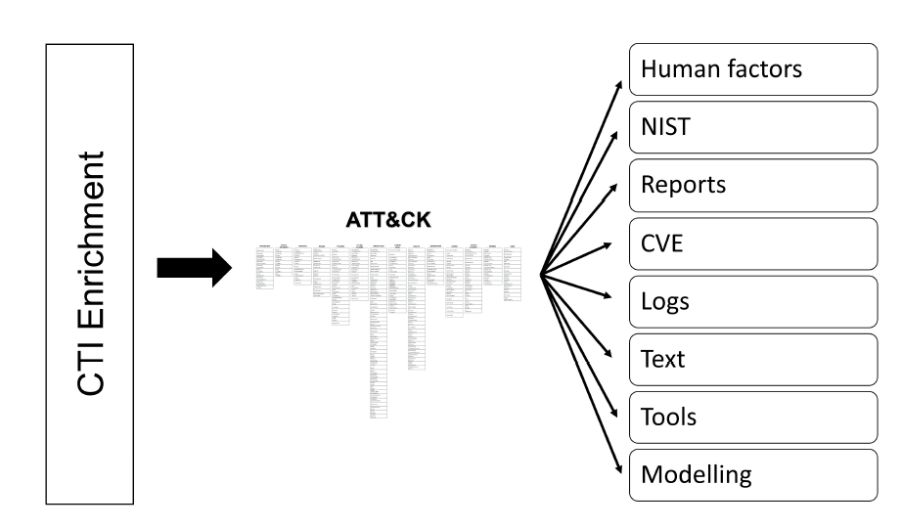
Fig 6: CTI Enrichment with the ATT&CK matrix: We identified different sources
“The following Detection Gap Analysis should be based on the use of Cyber Threat Intelligence (CTI) Enrichment processes. This, as shown in Figure 6, entails matching logs of internal events, security reports to ATT&CK knowledge base to put findings in perspective (Al-Sada et al., 2022, p. 24). As an illustration, the map of failed EDR alerts will be provided into particular ATT&CK techniques (e.g. T1059.001) in order to identify specific failures in detection logic.”

Conclusion
The assignment has logically followed the critical path of strategic threat intelligence to practical defensive validation, showing command over advanced concepts of offensive security that postgraduate level cybersecurity practice requires. The Strategic Threat Analysis was able to go beyond descriptive incident reporting and address a complex attack by using the MITRE ATT&CK framework to break it down into its technical, architectural, and human root causes, and then synthesise actionable and business-oriented prevention and detection recommendations. This intelligence was then applied in practice in the form of Operation IP Shield, which carefully planned and hypothetically carried out a red team operation in the stealth form to exercise a hybrid corporate environment. The drill made very clear the critical role of emulating adversaries, stealth tradecraft, and transforming technical discoveries into a forensic roadmap to security engineers and an effective risk narrative to the executive leadership. The most important point to note is that all the stages of this work were critically supported and justified by the active work with the contemporary scholarly literature, and hence the methodologies and recommendations are supplemented with the latest achievements of scholarly and professional discussions. Finally, this submission meets the learning outcomes of the module by not only giving an insight into cyber incidents and security tools, but also a strategic and evidence-based framework of how to persistently test and refine the resilience of an organisation to the advanced persistent threats that make the current online environment a complex and ever-changing context. The combination of steep critical thinking with the real-life security evaluation is an example of the professional qualifications and strategic acumen necessary to take major responsibility in the protection of vital organisational resources.

References
- Applebaum, A., Miller, D., Strom, B., Korban, C. and Wolf, R., 2016, December. Intelligent, automated red team emulation. In Proceedings of the 32nd annual conference on computer security applications (pp. 363-373).
- Georgiadou, A., Mouzakitis, S. and Askounis, D. (2021). Assessing MITRE ATT&CK Risk Using a Cyber-Security Culture Framework. Sensors, [online] 21(9), p.3267. doi:https://doi.org/10.3390/s21093267.
- ‌Hassan, W.U., Bates, A. and Marino, D. (2020). Tactical Provenance Analysis for Endpoint Detection and Response Systems. [online] IEEE Xplore. doi:https://doi.org/10.1109/SP40000.2020.00096.
- ‌Jadidi, Z. and Lu, Y., 2021. A threat hunting framework for industrial control systems. IEEE Access, 9, pp.164118-164130.
- Kuppa, A., Aouad, L. and Le-Khac, N.-A. (2021). Linking CVE’s to MITRE ATT&CK Techniques. The 16th International Conference on Availability, Reliability and Security. doi:https://doi.org/10.1145/3465481.3465758.
- ‌Mavroeidis, V. and Bromander, S. (2017). Cyber Threat Intelligence Model: An Evaluation of Taxonomies, Sharing Standards, and Ontologies within Cyber Threat Intelligence. [online] IEEE Xplore. doi:https://doi.org/10.1109/EISIC.2017.20.
- ‌Milajerdi, S.M., Gjomemo, R., Eshete, B., Sekar, R. and Venkatakrishnan, V.N. (2019). HOLMES: Real-Time APT Detection through Correlation of Suspicious Information Flows. [online] IEEE Xplore. doi:https://doi.org/10.1109/SP.2019.00026.
- ‌Oosthoek, K. and Doerr, C. (2019). SoK: ATT&CK Techniques and Trends in Windows Malware. Lecture Notes of the Institute for Computer Sciences, Social Informatics and Telecommunications Engineering, pp.406–425. doi:https://doi.org/10.1007/978-3-030-37228-6_20.
- ‌Strom, B., Applebaum, A., Miller, D., Nickels, K., Pennington, A. and Thomas, C. (2020). MITRE ATT&CK: Design and Philosophy. [online] MITRE. Available at: https://www.mitre.org/news-insights/publication/mitre-attck-design-and-philosophy.
- Xiong, W., Legrand, E., Åberg, O. and Lagerström, R. (2021). Cyber Security Threat Modeling Based on the MITRE Enterprise ATT&CK Matrix. Software and Systems Modeling, 21. doi:https://doi.org/10.1007/s10270-021-00898-7.
- Zilberman, P., Puzis, R., Bruskin, S., Shwarz, S. and Elovici, Y., 2020. Sok: A survey of open-source threat emulators. arXiv preprint arXiv:2003.01518.
- Al-Sada, B., Sadighian, A. and Oligeri, G. (2023). MITRE ATT&CK: State of the Art and Way Forward. [online] arXiv.org. doi:https://doi.org/10.48550/arXiv.2308.14016.
- ‌Berady, A., Jaume, M., Tong, V.V.T. and Guette, G. (2021). From TTP to IoC: Advanced Persistent Graphs for Threat Hunting. IEEE Transactions on Network and Service Management, pp.1–1. doi:https://doi.org/10.1109/tnsm.2021.3056999.
- ‌Choi, S., Choi, J., Yun, J.-H., Min, B.-G. and Kim, H. (2020). Expansion of {ICS} Testbed for Security Validation based on {MITRE} {ATT&CK} Techniques. [online] Usenix.org. Available at: https://www.usenix.org/conference/cset20/presentation/choi [Accessed 17 Dec. 2025].
- ‌Munaiah, N., Rahman, A., Pelletier, J., Williams, L. and Meneely, A., 2019, September. Characterizing attacker behavior in a cybersecurity penetration testing competition. In 2019 ACM/IEEE International Symposium on Empirical Software Engineering and Measurement (ESEM) (pp. 1-6). IEEE.
- Pols, P. and van den Berg, J., 2017. The unified kill chain. CSA Thesis, Hague, pp.1-104.
- Tatam, M., Shanmugam, B., Azam, S. and Kannoorpatti, K. (2021). A review of threat modelling approaches for APT-style attacks. Heliyon, 7(1), p.e05969. doi:https://doi.org/10.1016/j.heliyon.2021.e05969.

