Component 2- Module Data Handling and Business Intelligence
Individual Report: Educational sector
Student Name: Tanya Georgieva
Student Number:2028228
Lecturer Name: Dd. Zahra Mohammadnazari

Tabel of content.
SECTION 1.
SECTION 2.

Section 1
1. Descriptive Statistics
Here's a summary of the descriptive statistics for price, sqft_living, sqft_lot, bedrooms, and bathrooms.
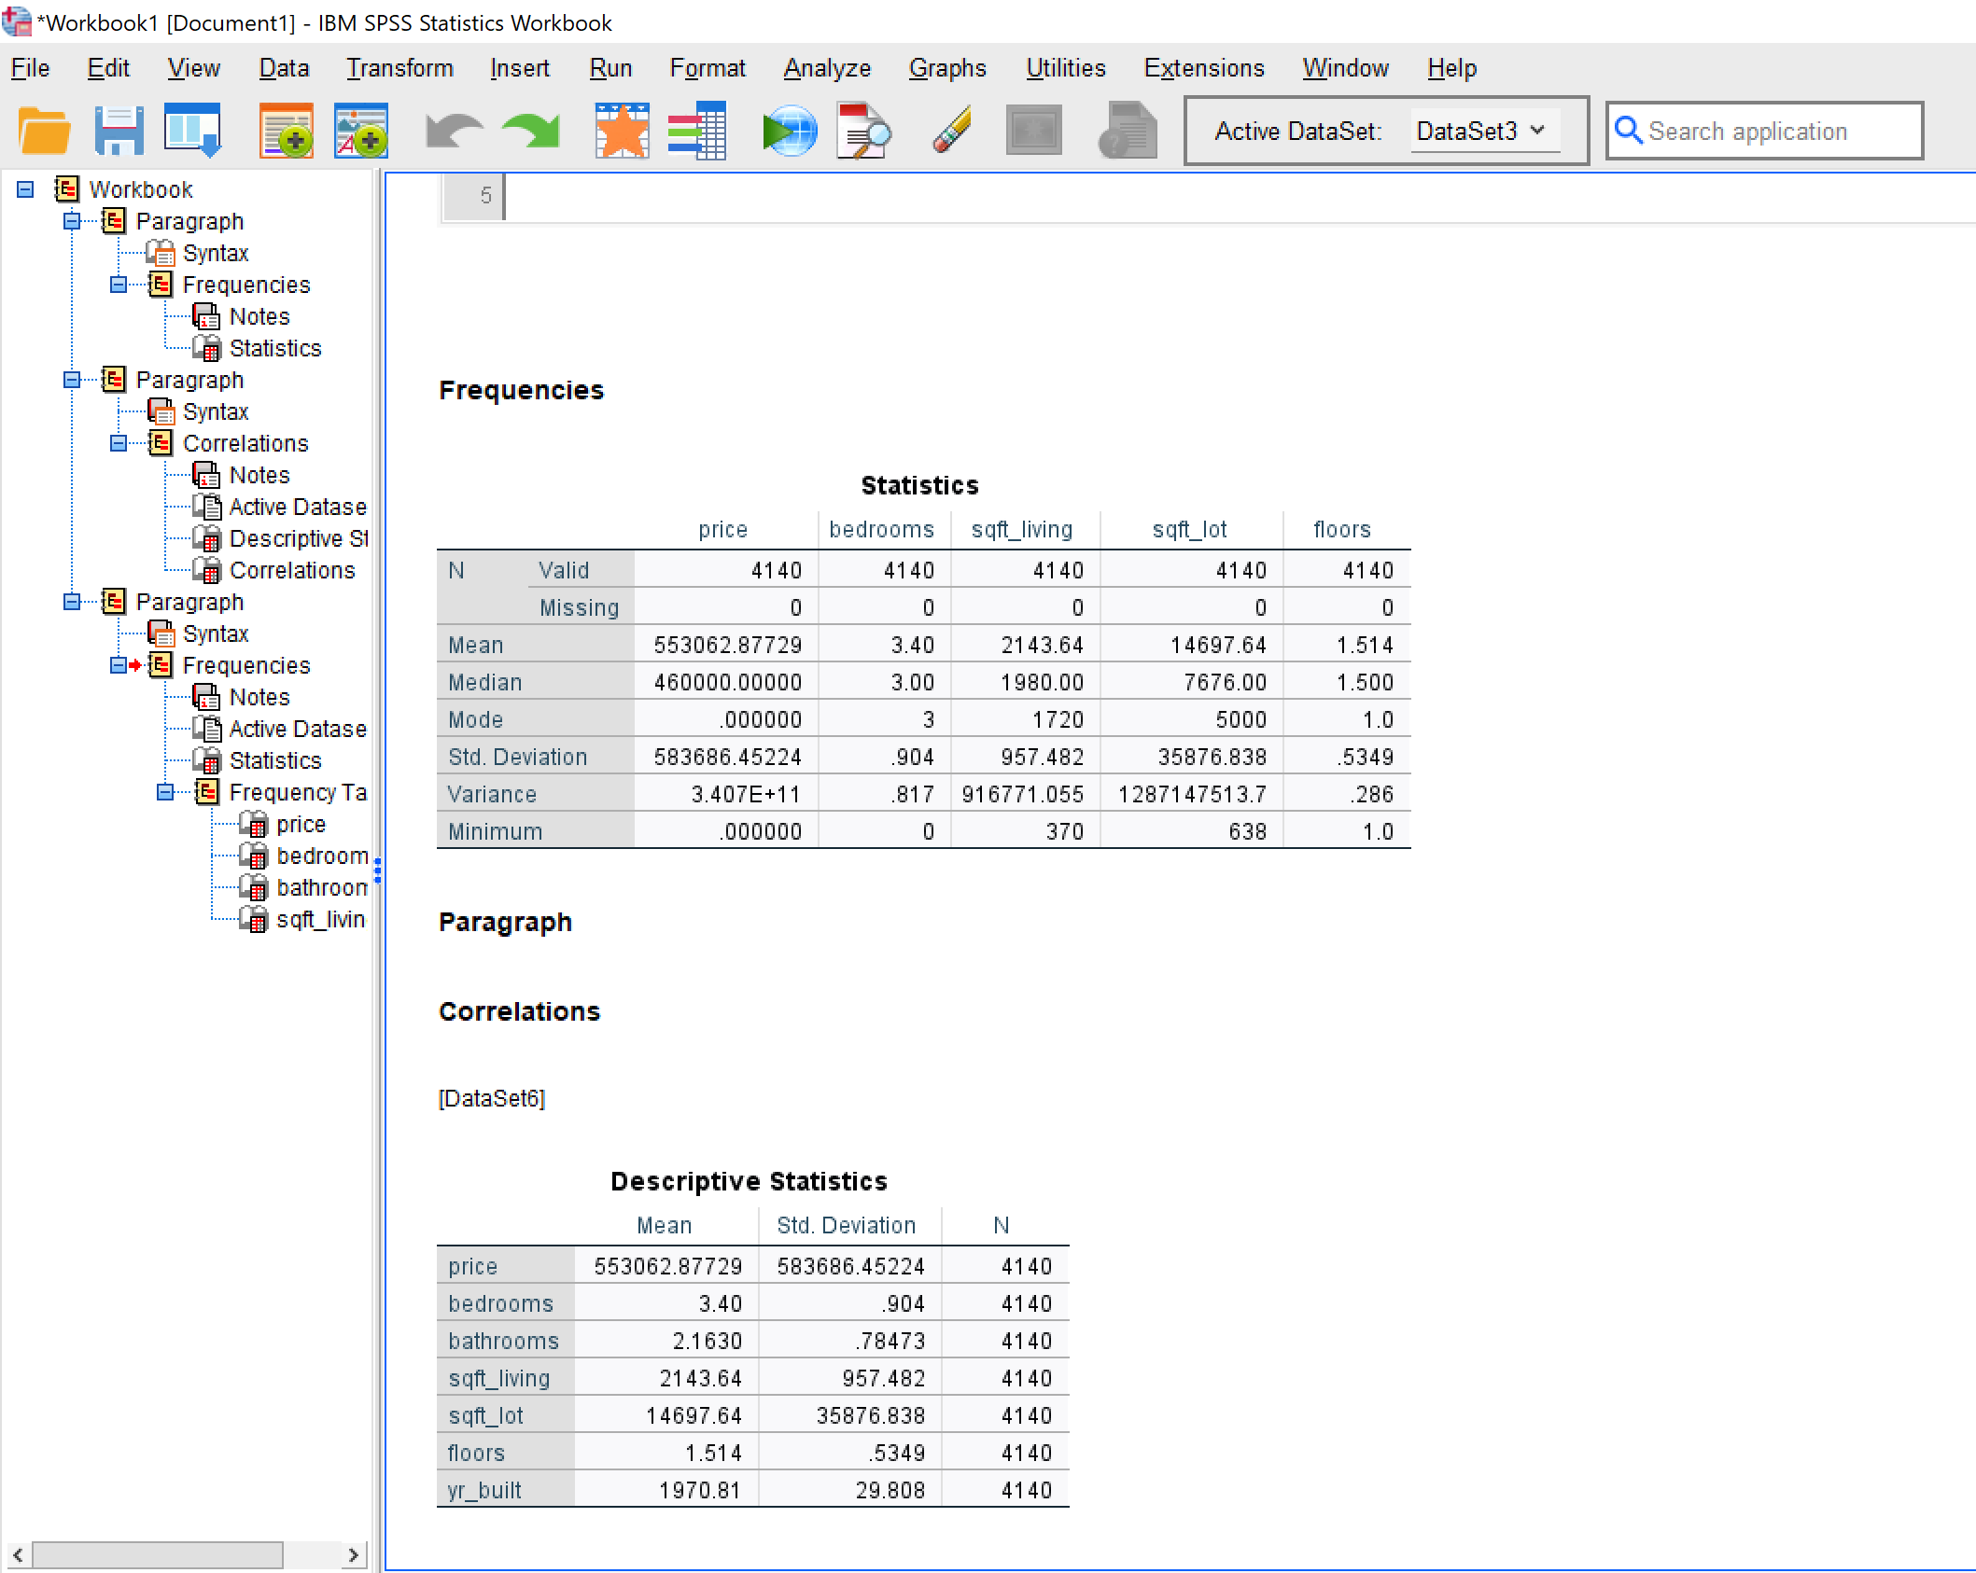
Interpretation:
- Price: The average house price is $637,388, with a median of $519,500. The large standard deviation ($367,127) indicates significant price variation. The range from $110,000 to $2,555,000 shows a diverse market with both affordable and luxury properties.
- Sqft_living: Houses average 2,208 sq. ft of living space, with a median of 1,960 sq ft. The standard deviation of 912 sq. ft suggests considerable variation in house sizes.
- Sqft_lot: The mean lot size is 15,107 sq. ft, but the median is much lower at 7,620 sq. ft. This, combined with the large standard deviation (41,420 sq. ft), indicates a right-skewed distribution with some very large lots pulling up the average.
- Bedrooms: Houses have an average of 3.37 bedrooms, with a median of 3. The range from 1 to 7 bedrooms covers various household sizes.
- Bathrooms: The mean number of bathrooms is 2.12, with a median of 2.25. The range from 0.75 to 6.5 bathrooms indicates diverse property types, from small apartments to large luxury homes.
2. Visualizations.
Now, let's visualize the relationships between house price and the specified factors.
Price vs. Number of Bedrooms.
Scatter plot or box plot of Price vs. Number of Bedrooms. This graph shows a general trend of increasing price with more bedrooms, but with significant overlap and variation. The relationship appears to be positive but not strictly linear, suggesting other factors also influence price.

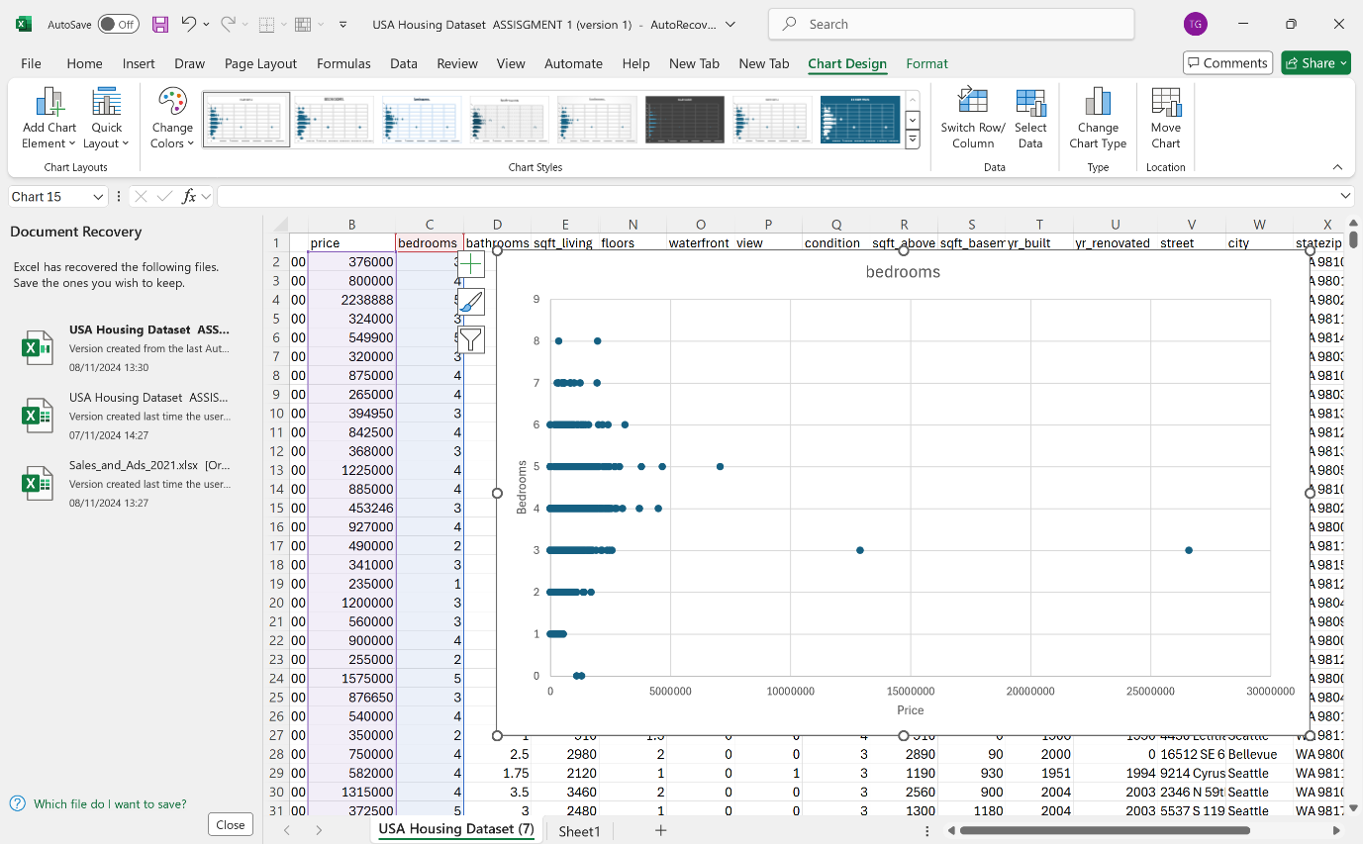

Price vs. Number of Bathrooms.
Scatter plot or box plot of Price vs. Number of Bathrooms. There’s a clearer positive relationship between price and number of bathrooms. Houses with more bathrooms tend to be more expensive, though there's still considerable variation within each category.
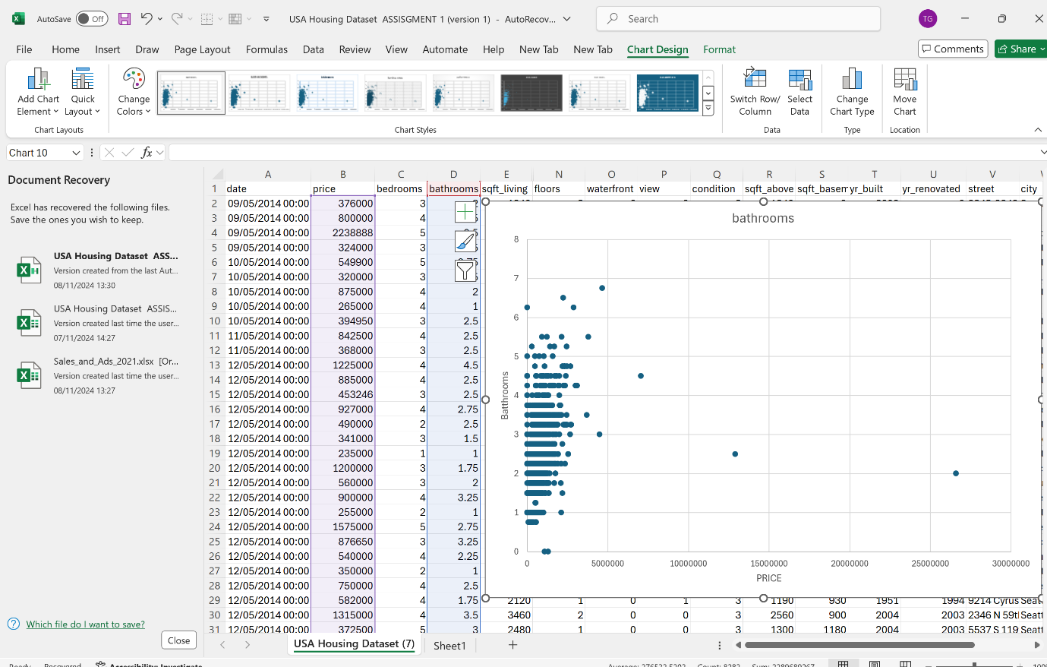

Price vs. Square Footage of Living Space.
Scatter plot of Price vs. Sqft_living] This plot reveals a strong positive correlation between price and living space. As square footage increases, house prices generally rise, though the relationship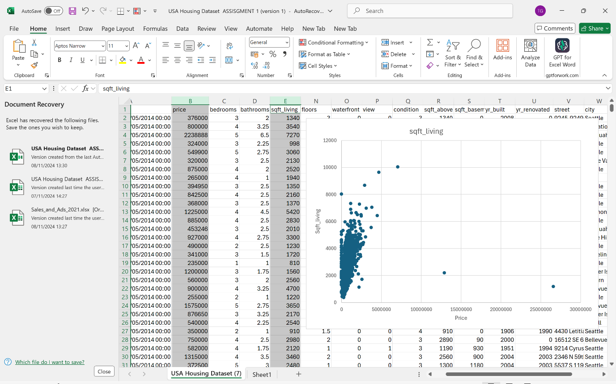 perfectly linear, indicating other influencing factors.

Price vs. Year Built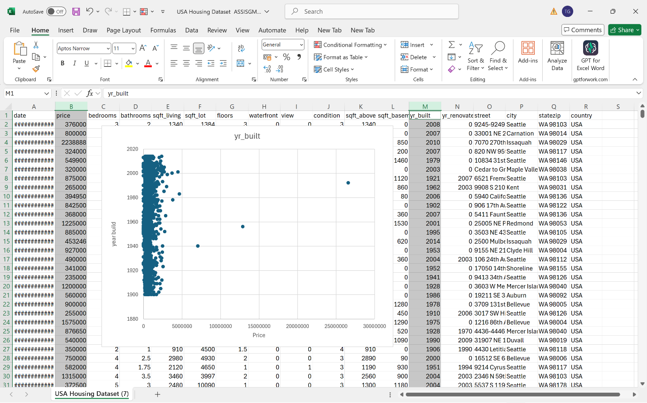
Scatter plot or line graph of Price vs. Year Build. This visualization shows a general trend of newer houses being more expensive, but with significant variation. Factors like location, renovations, and architectural style likely play a role in price beyond just the year built.

3. Correlation Analysis and Recommendations
Let's examine the correlation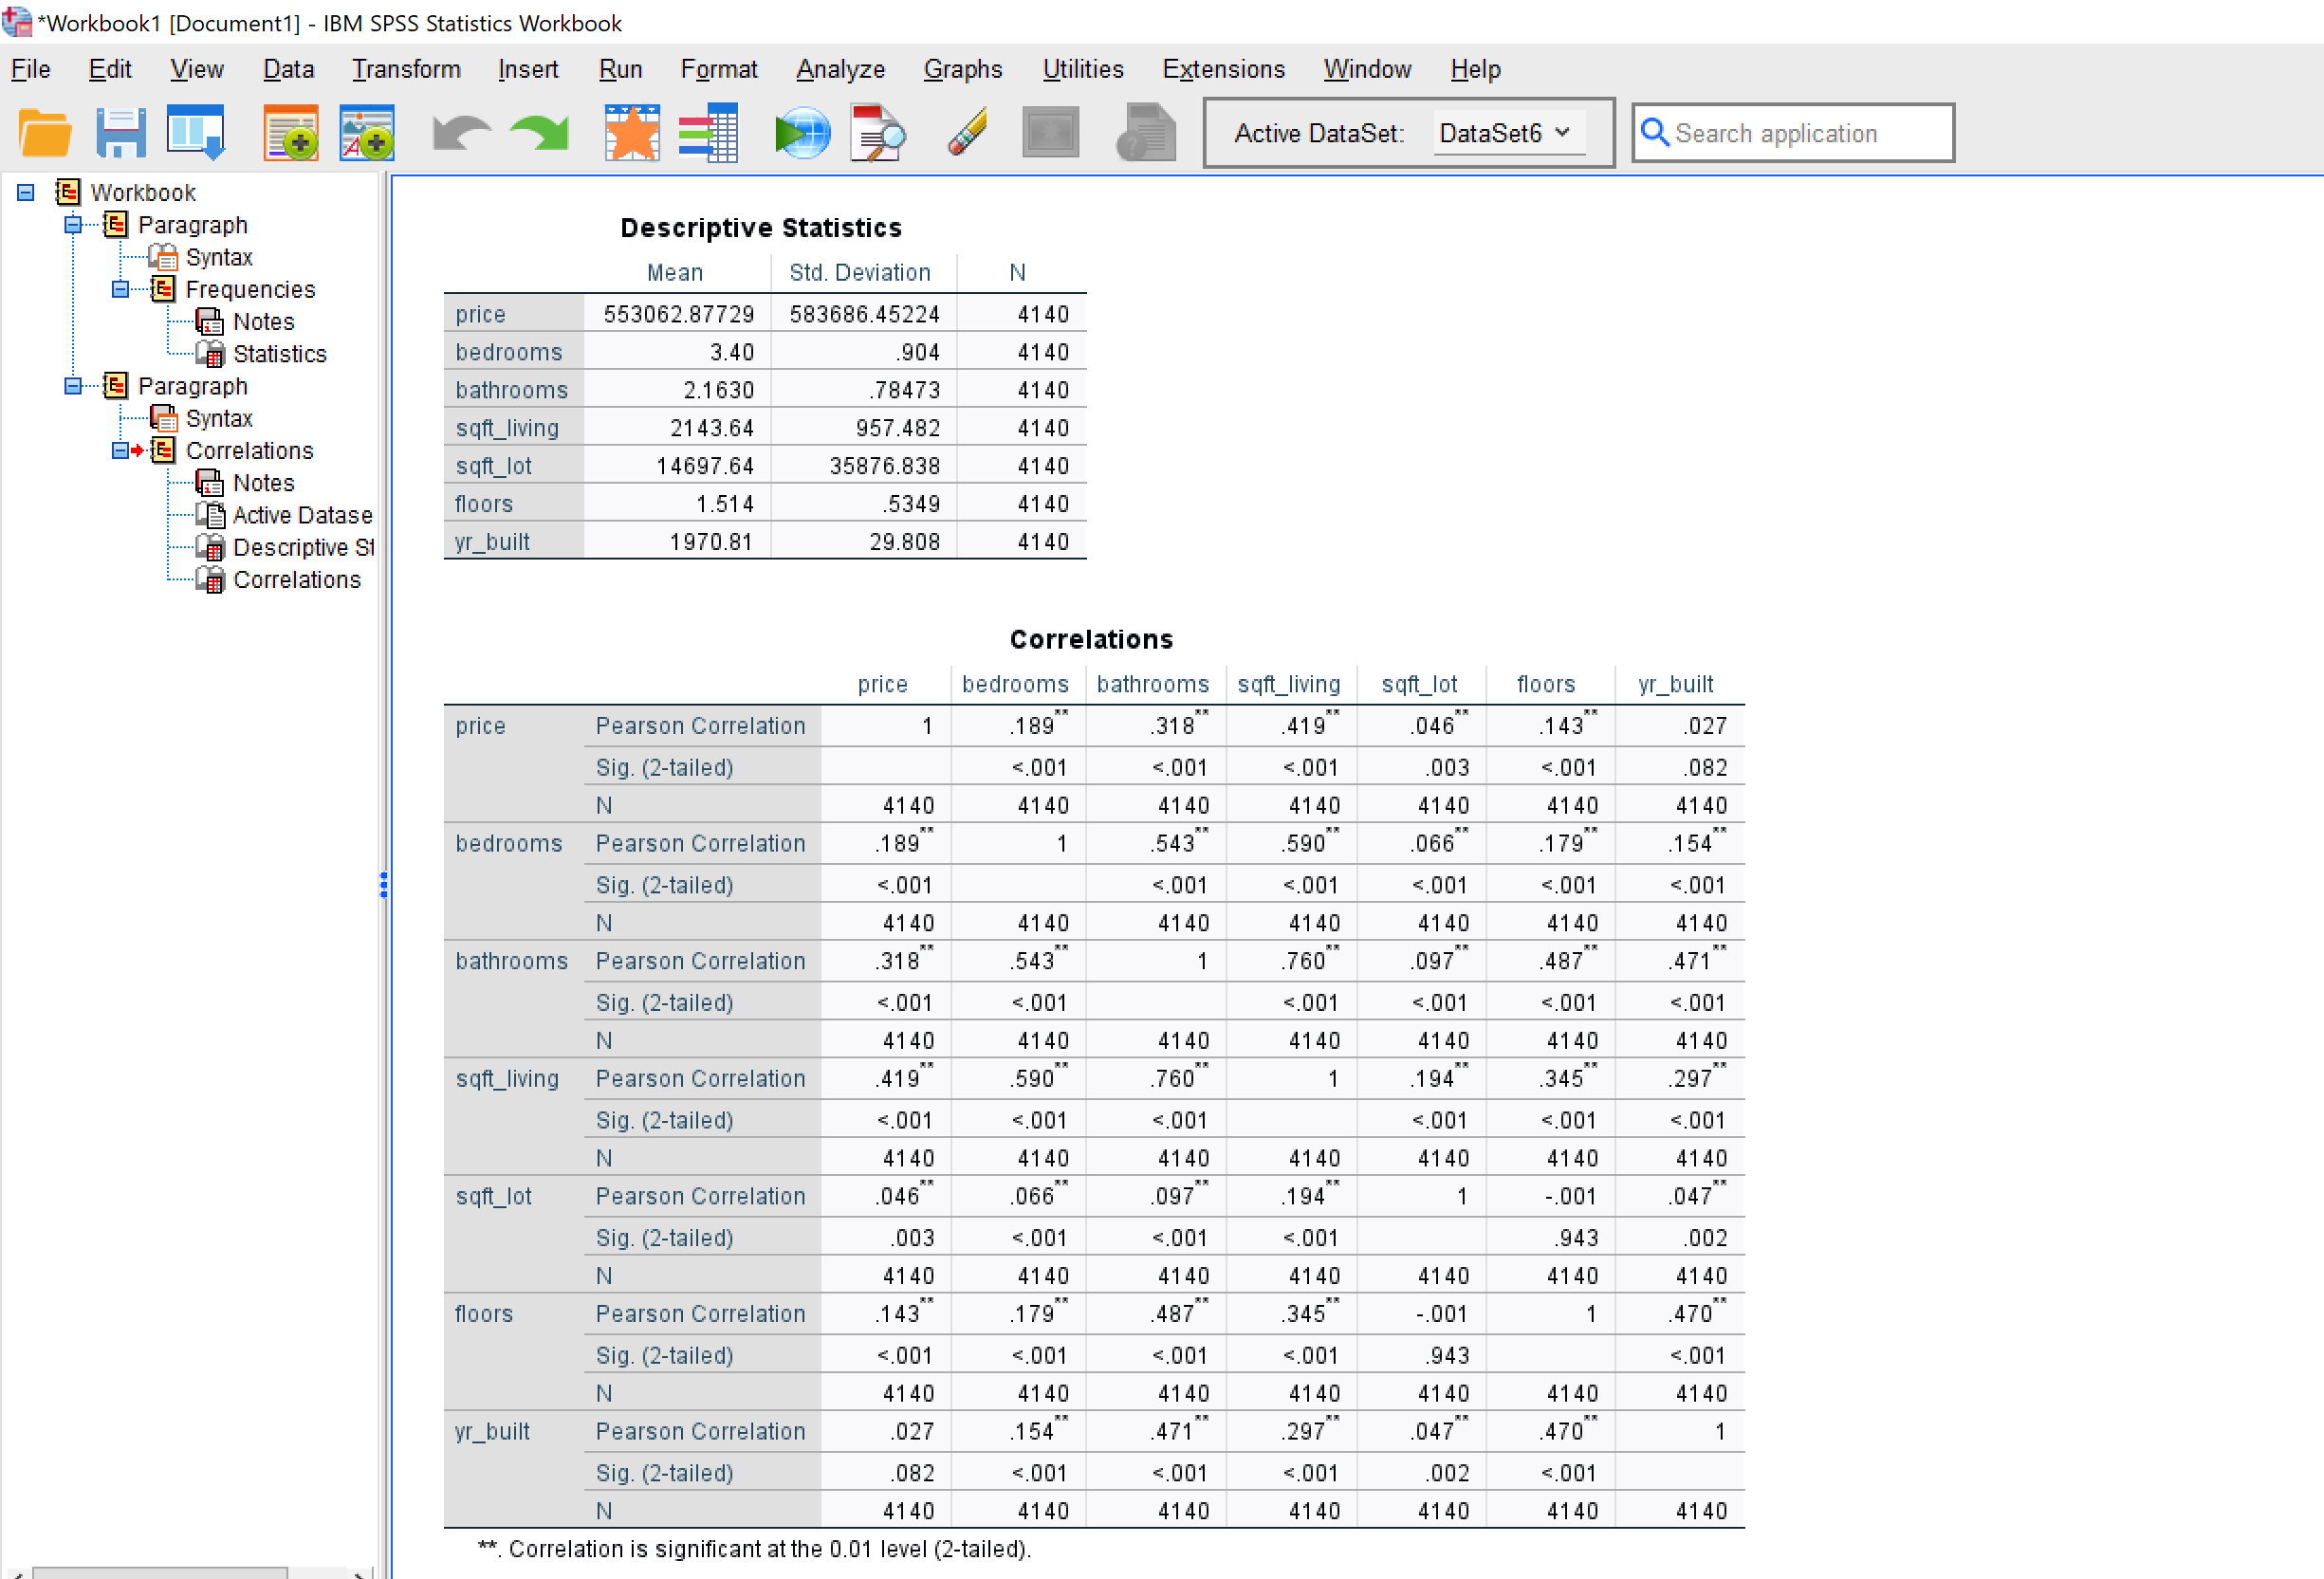 coefficients between house price and various factors:

Key Findings:
- Living space (sqft_living) has the strongest correlation with price (0.702), indicating it's a primary driver of house prices.
- Grade (overall quality) and sqft_above (above-ground living area) also show strong positive correlations with price.
- Bathrooms have a stronger correlation with price (0.525) compared to bedrooms (0.308), suggesting they might be more valued in this market.
- Lot size and year-built show weak correlations with price, implying they're less significant factors in determining house prices in this dataset.

Recommendations for Homebuyers:
For Affordable Housing:
- Prioritize fewer bathrooms: Look for properties with fewer bathrooms, as this could significantly reduce the price without necessarily sacrificing living space.
- Consider older homes: The weak correlation between year built and price suggests that older homes might offer good value, especially if well-maintained or renovated.
- Focus on essential living space: Prioritize adequate but not excessive square footage, as this is the strongest price driver.
- Be flexible on bedrooms: The number of bedrooms has a weaker correlation with price than bathrooms or overall square footage, so being flexible here could lead to more affordable options.
Factors Driving Price Upwards:
- Living space: Larger homes, especially those with more above-ground living area, command higher prices.
- Overall quality (grade): Houses with higher-grade materials and finishes are significantly more expensive.
- Number of bathrooms: More bathrooms strongly correlate with higher prices, possibly due to their association with luxury and convenience.
- Location: While not directly measured in our correlation analysis, the wide price range suggests location plays a crucial role. Buyers should consider less premium areas for more affordable options.
In conclusion, homebuyers seeking affordability should focus on properties with adequate living space and essential amenities, potentially sacrificing extra bathrooms or premium locations. Those with larger budgets might prioritize overall quality, more bathrooms, and larger living spaces, as these factors tend to drive prices upward in this market. Remember that while these statistical insights are valuable, individual properties may vary, and factors like specific location, condition, and local market trends should also be considered in any home-buying decision.

Section 2
a) Advantages and Disadvantages of Excel
Microsoft Excel is a widely used spreadsheet software that offers numerous advantages and limitations for data analysis. According to Bluman (2019, p. 45), spreadsheet applications like Excel provide accessible data manipulation tools for researchers and analysts across various fields. The key advantages of Excel include:
- Accessibility: Excel is widely available and familiar to many users, making it easy to adopt for data analysis (Dodge & Stinson, 2007). Its ubiquity in business and academic settings ensures that many people have at least basic proficiency in using the software. This widespread availability facilitates collaboration and data sharing across different organizations and departments.
- User-friendly Interface: The intuitive spreadsheet format allows for quick data entry and basic statistical operations (Kirkpatrick, 2015). The grid-based layout and point-and-click functionality make it easy for users to organize and manipulate data without extensive training. This ease of use is particularly beneficial for those new to data analysis or those who need to perform quick calculations without learning complex software.
- Versatility: Excel is suitable for various tasks, from simple calculations to complex data modelling (Newbold, Carlson & Thorne, 2013). Its wide range of built-in functions and formulas can handle financial, statistical, and mathematical operations. This versatility makes Excel a valuable tool for diverse applications, from budgeting to scientific data analysis.
- Visual Representation: Excel offers a variety of chart types and graphing tools that allow users to create visual representations of their data quickly. This feature is particularly useful for presenting findings to non-technical audiences (Walkenbach, 2015). The ability to generate charts and graphs directly from data tables streamlines the process of creating visual aids for reports and presentations.
- Integration: Excel integrates seamlessly with other Microsoft Office products and many third-party tools, facilitating data sharing and collaborative work (Alexander & Kusleika, 2016). This integration allows for easy import and export of data between different applications, enhancing workflow efficiency.
- Automation: Using macros and Visual Basic for Applications (VBA), users can automate repetitive tasks and create custom functions, enhancing productivity (Jelen & Syrstad, 2015). This capability allows users to create complex, customized solutions for specific data analysis needs, potentially saving significant time and reducing errors in repetitive processes.
However, Excel also presents several notable limitations:
- Data Handling Constraints: Excel struggles with very large datasets, typically those exceeding one million rows (Soper, 2017). This limitation can be problematic for big data analysis or when working with extensive databases. As data volumes continue to grow in many fields, this constraint becomes increasingly significant.
- Statistical Limitations: While Excel offers basic statistical functions, it lacks some advanced statistical capabilities found in specialized software like SPSS or R. For complex analyses, additional add-ins or alternative software may be necessary (Agresti & Franklin, 2013). This limitation can be a significant drawback for researchers or analysts requiring sophisticated statistical techniques.
- Error Potential: Manual data entry and formula creation in Excel increase the risk of computational mistakes. These errors can be difficult to detect and may propagate through calculations, potentially leading to incorrect conclusions (Panko, 2008). The ease of use that makes Excel accessible can also contribute to this problem, as users may not always be aware of the complexities underlying their analyses.
- Version Control Issues: Collaborating on Excel files can be challenging, as it's difficult to track changes made by multiple users over time. This can lead to confusion and inconsistencies in data analysis (O'Reilly, 2015). While newer versions of Excel have improved collaboration features, they still lag behind specialized version control systems used in programming environments.
- Limited Reproducibility: Excel analyses can be hard to reproduce exactly, especially when they involve manual interventions or complex series of operations. This can be problematic in scientific research where reproducibility is crucial (Broman & Woo, 2018). The lack of a clear audit trail for data manipulations can make it difficult to verify results or replicate studies.
- Security Concerns: Excel files can be vulnerable to data breaches if not properly secured, especially when containing sensitive information (Lim, 2016). The ease of sharing Excel files can sometimes lead to inadvertent exposure of confidential data.

Practical examples illustrating these points include:
- Advantage: A real estate agent could use Excel to quickly create a pricing model based on house features, using built-in functions and charts to visualize trends in property values across different neighbourhoods. The agent could easily update this model as new data becomes available and share it with clients in an accessible format.
- Disadvantage: A data scientist analysing millions of property transactions might find Excel too slow and prone to crashes, necessitating a switch to more robust tools like R or Python for big data analysis. The limitations in handling large datasets could significantly impede the analysis of market trends across a large metropolitan area or over an extended period.
b) Data Mining Cycle
The Data Mining Cycle, also known as the Knowledge Discovery in Databases (KDD) process, represents a systematic approach to extracting valuable insights from complex datasets. Han, Kamber and Pei (2011, p. 6) define this process as a structured methodology for transforming raw data into meaningful knowledge that can drive decision-making in organizations. The cycle typically encompasses six critical stages:
- Business Understanding: This initial phase focuses on defining clear objectives and project scope from a business perspective (Wirth & Hipp, 2000). It involves identifying key questions, determining success criteria, and assessing risks and contingencies. This stage ensures that the data mining project aligns with organizational goals and addresses relevant business problems.
- Data Understanding: This stage involves collecting initial data and exploring its fundamental properties (Fayyad, Piatetsky-Shapiro & Smyth, 1996). Analysts examine data quality, perform descriptive statistics, and identify potential issues such as missing values or outliers. This phase helps in formulating hypotheses and planning the subsequent stages of the process.
- Data Preparation: Often the most time-consuming phase, data preparation involves cleaning, transforming, and formatting data for analysis (Pyle, 1999). This may include handling missing data, normalizing variables, and creating derived attributes. Proper data preparation is crucial for the success of subsequent modelling efforts.
- Modelling: In this phase, various statistical and machine learning techniques are applied to the prepared data (Berry & Linoff, 2004). Analysts select appropriate algorithms, build models, and fine-tune parameters to optimize performance. This stage often involves iterative processes of model building and evaluation.
- Evaluation: This stage involves assessing model performance and alignment with business goals (Provost & Fawcett, 2013).
- Analysts use various metrics to evaluate model accuracy and consider the model's practical implications and limitations. The evaluation phase helps in determining whether the model meets the objectives defined in the business understanding phase.
- Deployment: The final phase focuses on integrating insights into organizational decision-making processes (Zaki & Meira, 2014). This may involve creating reports, implementing predictive models in production systems, or developing action plans based on the findings. Effective deployment ensures that the knowledge gained from the data mining process translates into tangible business value.
The importance of the Data Mining Cycle lies in several key aspects:
- Structured Approach: It provides a systematic framework for complex data analysis projects, ensuring that all crucial steps are addressed (Maimon & Rokach, 2010). This structured approach helps in managing the complexity of data mining projects and ensures consistency across different initiatives.
- Quality Assurance: The cycle emphasizes thorough data preparation and model validation, which are critical for reliable results (Larose & Larose, 2014). By following this process, analysts can minimize errors and ensure the robustness of their findings.
- Business Alignment: By starting with business understanding and ending with deployment, the cycle keeps the focus on generating actionable insights for business needs (Sharda, Delen & Turban, 2018). This alignment ensures that data mining efforts contribute directly to organizational objectives.
- Iterative Improvement: The cyclical nature allows for refinement of models and processes over time, adapting to changing business conditions and new data (Witten et al., 2016). This iterative approach enables continuous improvement and helps in maintaining the relevance of data mining solutions.
- Reproducibility: Following a structured cycle enables consistent application of data mining techniques across projects and facilitates knowledge transfer within organizations (Cichosz, 2015). This reproducibility is crucial for building institutional knowledge and ensuring the reliability of data-driven decision-making processes.
An illustrative example of the Data Mining Cycle in action could be a retail company aiming to optimize its inventory management:
- Business Understanding: The company defines the goal of reducing overstock while maintaining adequate supply to meet customer demand. This involves discussions with stakeholders to understand the business impact of stockouts versus excess inventory.
- Data Understanding: Analysts gather historical sales data, supplier information, and external factors like seasonal trends and economic indicators. They explore data quality, identify patterns in sales across different product categories, and assess the completeness of inventory records.
- Data Preparation: The team cleans the data, handling missing values, normalizing sales figures across different product categories, and creating new variables such as sales velocity. They might also aggregate daily sales data into weekly or monthly figures for more stable predictions.
- Modelling: Various forecasting models (e.g., time series analysis, machine learning algorithms) are applied to predict future demand for different products. The team might use techniques like ARIMA for seasonal products and random forests for items with more complex demand patterns.
- Evaluation: Model accuracy is assessed against historical data, and the potential impact on inventory costs and customer satisfaction is estimated. The team considers factors like prediction intervals and the cost of errors in both directions (overstock vs. stockout).
- Deployment: The best-performing model is implemented in the inventory management system, with regular monitoring and updates to ensure continued accuracy. This might involve creating dashboards for inventory managers and integrating the predictive model with the company's ERP system.
This cycle ensures a thorough, business-focused approach to leveraging data for improved decision-making in inventory management. By following this structured process, the retail company can make data-driven decisions that balance stock levels with customer demand, potentially leading to significant cost savings and improved customer satisfaction.

References
Agresti, A. & Franklin, C., 2013. Statistics: The art and science of learning from data. 3rd ed. Boston: Pearson.Alexander, M. & Kusleika, R., 2016. Excel 2016 power programming with VBA. Indianapolis: John Wiley & Sons.Berry, M.J. & Linoff, G.S., 2004. Data mining techniques: For marketing, sales, and customer support. 2nd ed. Indianapolis: Wiley.Bluman, A.G., 2019. Elementary statistics: A step-by-step approach. 10th ed. New York: McGraw-Hill Education.Broman, K.W. & Woo, K.H., 2018. Data organization in spreadsheets. The American Statistician, 72(1), pp.2-10. Cichosz, P., 2015. Data mining algorithms: explained using R. John Wiley & Sons.Dodge, Y. & Stinson, C., 2007. The Oxford dictionary of statistical terms. Oxford: Oxford University Press.Fayyad, U., Piatetsky-Shapiro, G. & Smyth, P., 1996. From data mining to knowledge discovery in databases. AI Magazine, 17(3), pp.37-54.Han, J., Kamber, M. & Pei, J., 2011. Data mining: Concepts and techniques. 3rd ed. Waltham: Morgan Kaufmann.Jelen, B. & Syrstad, T., 2015. Excel 2016 VBA and macros. Indianapolis: Que Publishing.Kirkpatrick, G., 2015. Excel data analysis for dummies. 3rd ed. Hoboken: Wiley.Larose, D.T. & Larose, C.D., 2014. Discovering knowledge in data: an introduction to data mining. John Wiley & Sons.Lim, J.J., 2016. Excel 2016 for dummies. Hoboken: John Wiley & Sons.Maimon, O. & Rokach, L., 2010. Data mining and knowledge discovery handbook. Springer Science & Business Media.Newbold, P., Carlson, W. & Thorne, B., 2013. Statistics for business and economics. 8th ed. Harlow: Pearson.O'Reilly, T., 2015. Excel 2016: The missing manual. Sebastopol: O'Reilly Media.Panko, R.R., 2008. What we know about spreadsheet errors. Journal of Organizational and End User Computing, 20(2), pp.15-21. Provost, F. & Fawcett, T., 2013. Data science for business. Sebastopol: O'Reilly Media.Pyle, D., 1999. Data preparation for data mining. San Francisco: Morgan Kaufmann.Sharda, R., Delen, D. & Turban, E., 2018. Business intelligence, analytics, and data science: a managerial perspective. Pearson.Soper, D.S., 2017. The Excel statistical master. 2nd ed. Scottsdale: Soper Consulting.Walkenbach, J., 2015. Excel 2016 bible. Indianapolis: John Wiley & Sons.Wirth, R. & Hipp, J., 2000. CRISP-DM: Towards a standard process model for data mining. In: Proceedings of the 4th International Conference on the Practical Applications of Knowledge Discovery and Data Mining. Manchester, UK, 11-13 April 2000. London: Practical Application Company, pp.29-39. Witten, I.H., Frank, E., Hall, M.A. & Pal, C.J., 2016. Data Mining: Practical machine learning tools and techniques. Morgan Kaufmann.Zaki, M.J. & Meira, W., 2014. Data mining and analysis: Fundamental concepts and algorithms. New York: Cambridge University Press.

