Modul Code: BMSW4002
Module Name:
Effective Team Working and Communication
Lecturer:
Anita Nan

Assignment task:
Understanding of the models of communication and the communication skills and refer to any case studies done to show how these helped students’ understanding.

Student ID: 1920793

Word count: 2,043
UWTSD, 2021

Contents

1. Introduction 3
2. Three Models of Communication 4
2.1. First model of communication: Shannon – Weaver 4
2.2. Second model of communication: Schramm 5
2.3. Third model of communication: Berlo 6
3. Communication Skills 7
3.1. Verbal communication skills – spoken and written 7
3.2. Non-verbal communication skills – body language 8
3.3. Active listening 9
4. Conclusion 10
References 11

Introduction

Communication is a process through which humans, like other living organisms and information systems, exchange information. Information exchange involves creating, editing and sending messages or information (Book, 2009). There are many ways to communicate and many different language methods. Speech and language are only part of the communication process.
Effective communication in the workplace is an integral part of business success; improves the relationships in the company and with the clients and increases the engagement of the employees and the overall efficiency of the team. Research by the American company Gartner shows that the huge 70% of business mistakes are due to poor communication. These statistics prove how critical communication is to job training and why more emphasis should be placed on clear instructions and conversations to prevent mistakes from happening in the workplace (Kiewiet, 2015).
Good communication is important in the workplace because it improves team building, increases growth, innovation, improves productivity, efficiency, loyalty, reduces conflict, increases employee engagement, and more.
This report examines some of the models of communication: Shannon - Weaver, Schramm, Berlo - explained theoretically and supported by examples from real workplace practice and visualized with schemes for a clearer explanation of the model.
For communication to be effective, participants must have very good verbal, non-verbal skills, as well as the ability to actively listen and understand the speaker. These skills are presented in the second part of the report and are explained with examples.

Three Models of Communication

First model of communication: Shannon – Weaver

Shannon was a mathematician from the United States, while Weaver was a physicist. This linear model is more technologically advanced than most linear models.
Sender (Information source) – The sender creates the request, selects the medium, and delivers the message.
Encoder (Transmitter) – An encoder is a sender who hires a computer to translate messages into signals or binary text. It may even be a simple connection to the computer.
Channel used to transmit messages is regarded as a channel.
Decoder (Receiver) – A decoder is a computer that transforms signals or binary data into messages, while a receiver translates messages from signals.
Receiver (Decoder) –The receiver is the one that delivers the message or the position of which the message must be sent. The message is relayed to the recipient, who receives input.
Noise –Noise refers to physical stimuli such as the atmosphere, people, and so on that prevent the message from reaching the intended recipient (Shannon and Weaver, 2018).
The sender encodes the message and transmits it to the recipient using a technical medium such as the telephone or telegraph. The sender translates the letter into machine-readable codes. The message is conveyed in code through a medium. Before recognising and reading the message, the receiver must decode it (Shannon and Weaver, 2018).

Scheme 1. Shannon and Weavr’s model of communication
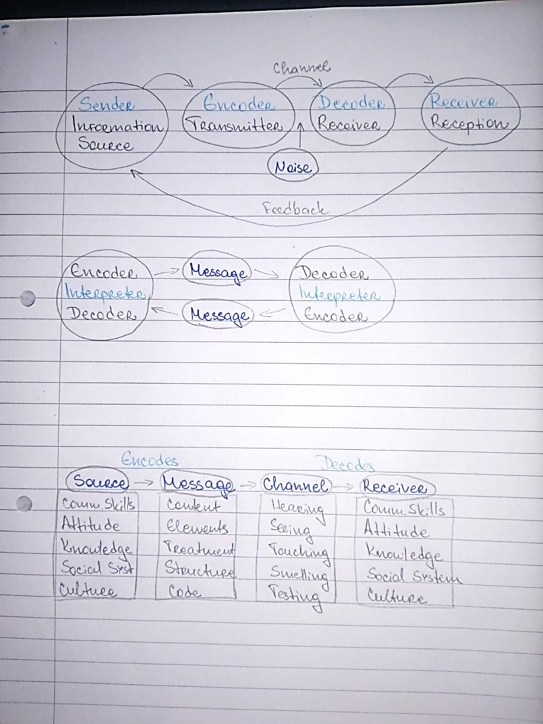
(UWTSD Student ID 1920793, 2021)
Example: A candidate asks at the reception desk where a noisy machine is currently operating, on what date is the meeting for his interview for a desired job. The receptionist answers on SECOND of May, the employee hears SEVENTH of May and omits her interview because the two dates sound close. The noise from the nearby machine does not allow the candidate to hear the date correctly, an air duct is used. If another channel was used - a piece of paper, an electronic device, a calendar, this error would be eliminated.

Second model of communication: Schramm

The Schramm Communication Model is a cyclical communication model that incorporates all fundamental communication concepts. The Schramm Relationship Paradigm presents a conventional method and description to communication. It can be used to decide how two people communicate when they exchange facts, thoughts, or attitudes (Schramm, 2016).
The idea and assumption that contact is a two-way street underpins the cyclical communication paradigm. This implies that there is at least one sender and one receiver. The model often includes at least one other component: the message itself. Typically, correspondence follows the conventional route, with a needless recipient and sender. The receiver and sender may even be the same individual. This is referred to as intra-personal contact. The former is referred to as interpersonal contact. Whereas several other communication structures and hypotheses are linear in form, the Schramm Communication Paradigm is circular. This implies that a communication must be submitted and answered from at least two people. To correctly understand the letter, both the sender and the receiver must encrypt and decode it (Schramm, 2016).

Scheme. 2. Schramm’s model of communication
(UWTSD Student ID 1920793, 2021)

Example: An employee offers a colleague to have lunch together, the colleague agrees and asks for a convenient day, offering Wednesday or Friday. The employee looks at his schedule and confirms for Friday. Thus, the employee and the colleague are both sender and recipient.

Third model of communication: Berlo

Sender of the message, or the individual who sends the message, is referred to as the sender. The message is sent to the recipient by the individual or source. The following are the sender-related factors, which often apply to the receiver: Communication Skills; Attitude; Knowledge; Social Systems; Culture (Berlo, 2014).
A message is the material that the sender sends to the recipient. It may be in the form of speech, audio, writing, recording, or some form of media. The following items have a substantial influence on the message: Content; Elements; Treatment; Structure; Code.
The means by which the message is conveyed is referred to as the channel. Technical machines, such as telephones and the internet, may be used as channels of mass media and other modes of communication. However, in general conversation, a human being's five senses function as a medium for communication traffic, and the following influences impact the channel's effectiveness: Hearing; Seeing; Touching; Smelling; Tasting.
The receiver of the message received during the procedure is referred to as the receiver. This model assumes that for communication to be accurate, the sender's thought pattern and all other factors listed above must be in sync. If the recipient and sender are not alike, the message will not have the desired result. The recipient must therefore be an outstanding listener. Such variables that are close to the sender's include Communication skills; Attitudes; Knowledge; Social Systems; Culture (Berlo, 2014).

Scheme. 3. Berlo’s model of communication
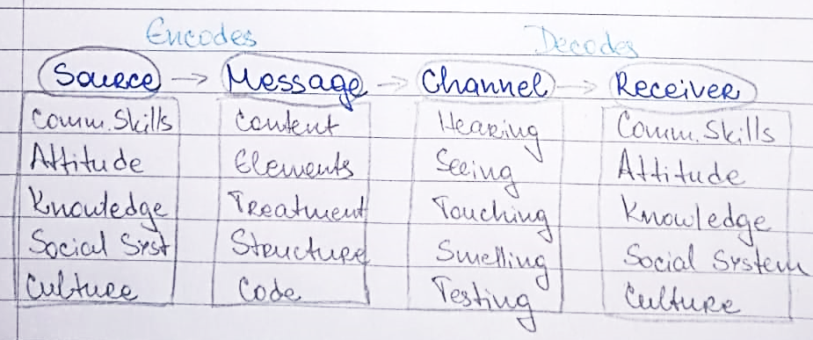
(UWTSD Student ID 1920793, 2021)

Example: European washing powder wants to break into the Arab market and distributes a promotional photo showing: Dirty clothes, washing powder to the right, clean clothes to the right, following the logic from left to right: dirty clothes treated with the product become clean. Residents of the Arab state read from right to left and they would read the sequence in reverse: clean clothes, go through the product offered and become dirty. The mistake comes from a poor knowledge of the new market.

Communication Skills

Verbal communication skills – spoken and written

Verbal communication - transmission of information through words. This concept includes oral and written language. Verbal communication is with the greatest rationality and awareness. When a person is engaged in mental activity, different words pop up in his subconscious. This means that human speech is an integral part of thinking. The concept of verbal communication consists of four processes: writing, reading, listening and speaking (Hofert, 2015).
There are colloquial expressions that may be vague to the interlocutor. Expressing your thoughts should be consistent and logical. To do this, you need to constantly improve and expand your vocabulary. For this purpose, you can attend public speaking courses, as well as spend as much time as possible reading.

Properly delivered speech can not only convince the interlocutor to accept your point of view, but also attract interest in your person. Attention must also be paid to the development of the ability to hear other people. Professional etiquette is an integral part of business communication, to the training of which some people dedicate many years. Verbal communication is considered speech.
Example: Radio advertising is an excellent example of everyday life, as a result of which people take certain actions such as buying a product or service. They were persuaded by the advertiser only on the basis of verbal communication.

Non-verbal communication skills – body language

Non-verbal communication takes place with the help of body language. This concept includes distance between people, touch and posture. Much attention is paid to facial expressions and gestures. It is important to pay attention to the fact that this form of communication is less conscious. Most people cannot take control of their own bodies. That is why the movements of the eyes and lips can clarify to the interlocutor the truth of the words of the speaker. In human psychology, gestures are classified into the following categories (Dockrell, 2017):
Communicative - gestures with which a person greets or says goodbye to another person, attracts attention, asks a question or denies something. There are more than a few dozen varieties of communicative gestures.
Modal - evaluation and expression of gestures of connections.
Descriptive - such gestures only make sense in relation to speech.
Facial expression - the movement of the facial muscles, which reflects a person's emotions. It should be noted that for representatives of different cultures facial gestures are universal. People show emotions such as anger, joy and sadness in the same way around the world (Dockrell, 2017).
Gestures serve as a major complement to the verbal transmission of information. So in some cases, gestures can completely replace words. The movements of the arms, shoulders, body and head are gestures.
Example: During business communication, people focus their gaze on the interlocutor's forehead. This action especially emphasizes the seriousness of the prevailing atmosphere. Social gaze - directed to the nose. It is this view that allows you to create an atmosphere of ease during communication. An intimate gaze is directed to the neck area of the interlocutor. Such a view may demonstrate an interest in closer communication.

Active listening

Active listening is one of the most important ingredients in communication and this is often the weak point in interaction. There is no active listening when there is no opening to the other in a dialogue. That is, he does not pay full attention to what the other person wants to express. Something that may differ from your own opinion, however, active listening means respectful attention to the other person.
Active listening is one of the most important skills for emotional intelligence and is directly related to the empathy of looking into each other's eyes as another. That is, like someone other than you, whose opinions are also determined by his own life history and experience (McGuire, 2011).
Expressing interest in this shared common present. Visiting the other without constantly looking at the clock. And while active listening may seem like a very simple learning skill in today's society, the reality is that new technologies encourage diffuse attention, as reflected in the usual telephone interruptions in face-to-face dialogue.
Example: In business communication, the technique is used for effective negotiation when needed to build partnerships. Sales require active listening to help the buyer: make a choice, fast and direct. Also, the technique is used to make objections, refusals.

Conclusion

Shannon worked in a telephone company and his task was to ensure the reliability of telephone connections (hence the metaphor "noise in
communication channel”). So, if we must find out what the conceptual metaphor for communication is in Shannon and Weaver's models.
The scar model views communication as a process in which both participants encode, decode, interpret, and transmit information and receive messages. this model is based on feedback.
According to Berlo, the source of information is communication skills, attitudes, knowledge, and a specific cultural background that influences the message. The source encodes the message, which contains content, elements, structure, code and processing. This message then goes to a channel that relies on the senses such as hearing, seeing, touch, smell, and taste.
Verbal communication - transmission of information through words. This concept includes oral and written language. Verbal communication is with the greatest rationality and awareness. When a person is engaged in mental activity, different words pop up in his subconscious. This means that human speech is an integral part of thinking.
Non-verbal communication is a way to send messages or signals without using words. This includes facial expressions, gestures, body language or posture, tone of voice and so on.
On the one hand, technology can be very useful, but you need to know how to use it to maintain effective communication skills. On the other hand, they can be an obstacle, as they cannot completely replace human interaction. It is important that good human communication skills do not fall completely behind the walls of new technologies.

References

- Berlo, D.K. (2014). The process of communication : an introduction to theory and practice from 1960. New York, N.Y., Etc.: Holt, Rinehart And Winston.
- Book, W. (2009). Communication. Chicago: World Book, Inc.
- Dockrell, S. (2017). An Investigation of the Use of Verbal and Non-verbal Communication Skills by Final-year Physiotherapy Students. Physiotherapy, 74(2), pp.52–55.
- Hofert, S., Burke, M., Balighian, E. and Serwint, J. (2015). Improving Provider-Patient Communication: A Verbal and Non-Verbal Communication Skills Curriculum. MedEdPORTAL Publications.
- Kiewiet, M.E. (2015). Six Workable Tips Toward Effective Communication Care + Action = Effective Communication. ABCA Bulletin, 36(1), pp.19–21.
- McGuire, R. (2011). Tips on . . .: Active listening. BMJ, 322(7302), pp.3–3.
- Schramm, W. (2016). Mass media and national development : the role of information in the developing countries from 1954. Stanford: Stanford University Press.
- Shannon, C.E. and Weaver, W. (2018). The mathematical theory of communication from 1948. Urbana: University Of Illinois Press.

