Coimbra Food Festivals
Student name: | Olivia Rose Roadnight | Student ID number: | 2501022
Programme: | BSc/HND Computing (All Streams)
Module: | L4 - Introduction to Web and Database Concepts
Date | 20/11/2025
Table of Contents
Introduction 2
Website Requirements and Purpose 2
Target Audience 2
Purpose, Goals and Objectives 2
Requirements 2
Functional Requirements 3
Non-Functional Requirements 3
Implementation 3
Structure, Layout, Styling and Design 3
HTML and CSS Appliance 4
Validation 4
Evaluation 5
Usability 5
Accessibility 6
SEO 6
Self-Evaluation 6
Improvements 6
Website Comparison [19] 6
Introduction 6
Content 7
Web design and layout 8
Summary Reflection 8
SEO Screenshots SEOptimer 9
SEO insights 10
Keywords 16
Conclusion: Which is Better and Why? 20
Conclusion 22
Appendices 22
HTML code 22
schedule.html 22
About.html 26
ContactPage.html 28
CSS code 32
References 38

Introduction
This report details the development process of Coimbra Food Festivals, covering the design and implementation, use of HTML and CSS, validation through testing, evaluation of usability, accessibility, functionality, SEO functions, and reflection on goal achievement and deployment.

Website Requirements and Purpose

Target Audience
My website targets tourist and foodies, interested in authentic Portuguese food and culture. Aiming to attract people who want authentic experiences, as this supports local businesses, boost in the local food community and increasing earning rates.

Purpose, Goals and Objectives
Its purpose is to promote food festivals in Coimbra, increasing tourism, support local businesses and sell Portugal’s cultural heritage.
The site will be accessible, visually appealing to catch the attention of my audience, easy to navigate and use. It includes 3 main pages – Home, About and Schedule - designed with consistency to intuitively navigate and explore the site content and images that encourage engagement.

Requirements
The main purpose is to promote food festivals in Coimbra by showing clear and organized information that helps both tourists and local visitors understand the event details. The website will include festival, stall, about and simple contact information for users to look for further help. The website will be easily navigable, accessible to a variety of users and be visually appealing.

Functional Requirements
User -interactable features the users have access to, such as:
- Clear and consistent layout and structure on all pages with clear headings, sections and text for users to follow a logical order for predictions in order of information
- My homepage will include a button “Learn More” to redirect users to find out more on history in the About page to find out more about the festival.
- Attractive appropriate images with a hover effect on some will promote Coimbra’s local culture and traditional food to make the site more appealing and engaging.
- The site will be responsive for browser and device compatibility, which allows users using a variety of diverse browsers and devices to be able to access my website easily as the layout of the site is adapted to the different devices and their screen sizes for easy usability and readability, and allows different browsers to adapt easily to your devices different search engines and readability, enabling seamless and smooth navigation without any lag, buffering or technical problems as I will ensure that the coding includes compatible code, such as a viewport to enable cross compatibility. Which as a result will appear professional, increase user experience and build an overall positive, credible brand image and reputation.
- Alt text for images to provide descriptions of them to users who rely on screen readers to “interpret the underlying code” and understand visual content. [1]
- Be functional and accessible for all user’s accessibility needs

Non-Functional Requirements
Non-Functional Requirements describe how websites should perform:
- Details about the festival such as dates, times, location, activities, stall listings and menus in a clear table structure for easy readability.
- In my structure I use different sized headings and fonts for easy differentiation, alt text on images, audio or video sources, for accessibility users with screen readers and braille displays as they “interpret the underlying code” [2] and “interact with the website” [3] on each page with descriptive text of the elements and logical structured layout in which they are read/listened to by the users
- The website will also include well structure readable and easily navigable content in a “Schedule Page” which covers the listing of stalls, menus, informative pages for transparency, credibility and builds trust between the customer and my website as it has provided a professional and navigable layout with functional elements tailored toward my target audience.

Implementation

Structure, Layout, Styling and Design
I will use a simple, consistent design with a horizontal navigation bar across all pages for familiarity. Colour palette will use warm organges, burgundy red for call-to-action buttons, and white text for contast, which is accessible for users with colour blindess. [4]The CSS file applies styling across all pages, spacing elements, responsive behaviour and structure sections for clarity.

HTML and CSS Appliance
I built the site using Visual Studio Code using HTML for a foundation structural layout and CSS for styling and responsiveness. HTML provides accessibility elements like alt text and chronological headings, whilst CSS controls colours, layout, spacing and hover effects. Both coding languages enable clear organization and better user experience. It will include:
- Homepage.html
- About.html
- schedule.html
- style.css
- images folder

Validation
HTML - (http://validator.w3.org/) About page

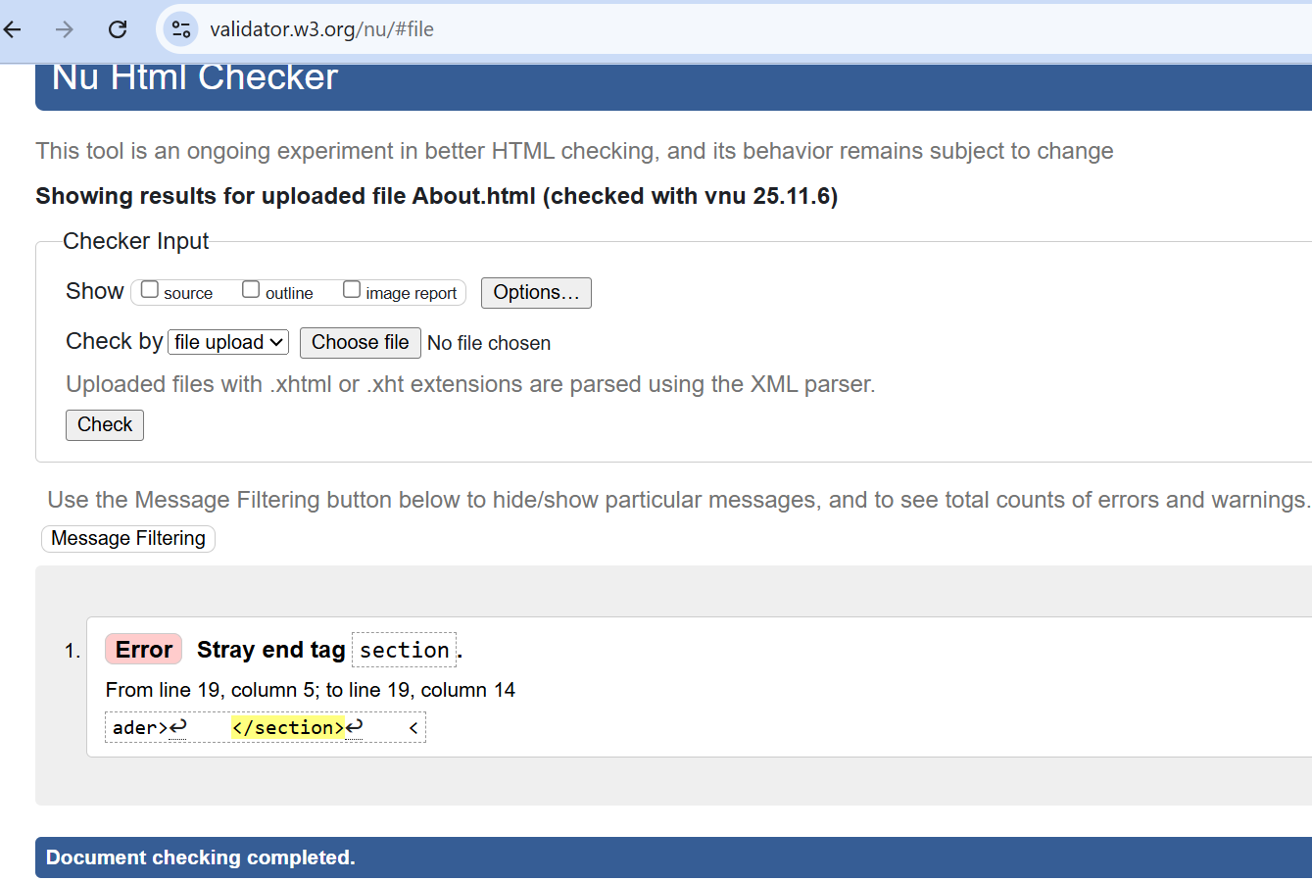
I have incorrectly ended my section tag outside of the header tag. However, I cannot fix this problem as the section on the page has changed elements of the text and making it look visually unappealing and cluttered, and I don’t know how to improve this. In the future I will ensure I know how to combat this by applying specialized knowledge from websites such as W3Schools.
CSS - (http://jigsaw.w3.org/css-validator/)
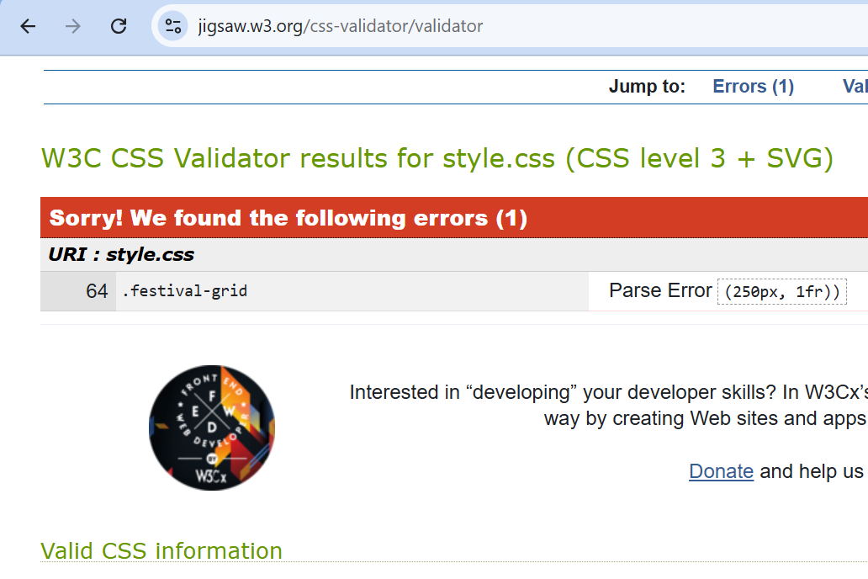
The issue was wrong dimensions in the “.festival-grid” class, which I fixed this by inserting the supported and CSS units.
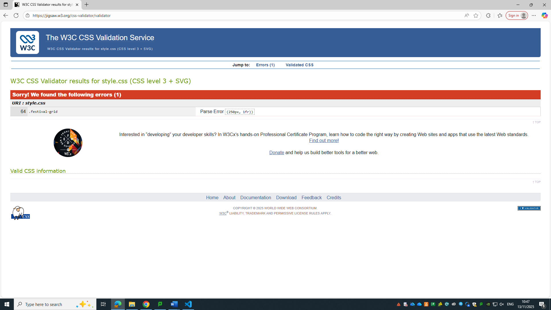

Evaluation

Usability
[5]Usability refers to how easily users can navigate a website. My website uses intuitive navigation, balanced spacing and clear colour contrast for [6] minimal cognitive load and improve readability. Users can navigate between pages with “minimal effort”, which supports retention and engagement. [7]

Accessibility
Accessibility is “the practice of designing ad developing websites so that all individuals, regardless of their disabilities” can access a website. [8] To comply with accessibility need I checked Coloors [9] [10]for WCAG accessibility standards [11].So all headings follow a logical structure, all image have alt text and page layout supports assistive technologies for a wider accessible audience. [12]
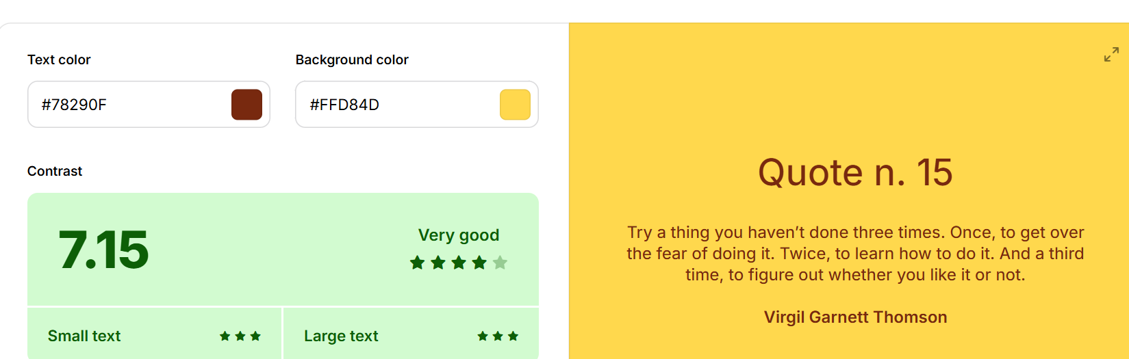

SEO
[13]SEO is the optimization process of a website which improves visibility in search engines. I used descriptive titles, meta viewport tag for the responsive layout scaling, relevant keywords such (“Coimbra”, “food festivals”, and “Portuguese cuisine”), appropriate heading structure such “h1-h3” and alt attributes [14], and use of semantic HTML to improve crawlability (functional and easy to access links [15] [16] [17] [18]

Self-Evaluation
The final version successfully meets the design and accessibility goals. This demonstrates my understanding of HTML and CSS principles [19] and how to manipulate them effectively for a functional and user-friendly website.

Improvements
Future improvements include adding interactive map of the location, social media integration and real-time updates for better engagement and user convenience.

Website Comparison [20]
I compared 2 websites: “festivation” and “Eventbrite”, both relating to festivals and events, with related target audience, making them suitable for evaluating structure , design, SEO, usability, functionality and compatibility.

Introduction
[21]Festivation is a website that documents and promotes cultural festivals for over 15 years around the world to “bridge the gap between travelers and authentic cultural experiences”, selling and providing information to tourists and festival enthusiasts about festivals and their locations in order to preserve cultural heritage and traditions of areas around the world. They also provide services including travel experts, cultural anthropologists and users with “deep knowledge of traditional celebrations worldwide” providing users knowledge of expectations and local customs to ensure tourists respect each cultural celebration.
[22]Eventbrite is a “global self-service ticketing platform” that sells live event tickets of all types to users looking to experience and attend events around the world that have interested in. It has given users the ability to “create, share and attend” these events, whilst providing necessary information for users to navigate themselves and prepare them for the events they have bought tickets for. Eventbrite is relevant to compare with my website as it provides pages and sections focused on events, schedules and event history which support user navigation and with search tools. It is not specific on selling food festivals but shares similarities.

Content
Festivation is simple, easy to follow, straightforward labeling of elements such as their navigation links, and there is a clear hierarchy to follow when reading, uses a “Table of Contents” for specific browsing, embedded links to help users explore travel, attractions or accommodation. Improving engagement as users can access everything without needing to leave the website.
Eventbrite is a well-structured, professional event listing website with consistent layouts, including information like titles, descriptions, date, time, location, booking buttons and pricing. It also includes helpful features for limiting searchability including categories, filters and recommendations. However, they are not tailored to the culture specifically compared to Festivation, also meaning it is not focused so much on the cultural background or provide additional user guides on how to act accordingly to respect locals and their traditions, making Eventbrite more generic.
 | Festivation | Eventbrite
SEO Performance | - Good SEO Performance with good user responsiveness slower mobile loading  - missing alt text on images  - basic meta tags  - lack of page speed optimization  - Long text (reduces keyword clarity for ease of searching and user navigability ease) | Strong SEO Performance with:  - Optimized meta descriptions and page titles  - Keyword predictions for events, dates and locations  - Fast loading speed  - Mobile-friendly
Keywords | Festivation uses a variety of specific keywords, such as Coimbra festival, food festivals in Portugal, street food in Coimbra and Portuguese markets. This supports users searching for relevant and key information however it is too niche for strong SEO rankings. | Eventbrite uses many keywords related to events, tickets, location, data, venue terms, supporting users searching and browsing the site as it is providing them easier ways to find and attend events, placing them higher in SEO rankings rather having too niche of words that focus on the history, culture and traditions of festivals
Usability | Navigation is simple, intuitive and predictable. Where users can quickly find details using headings and internal links. | Easy to use and encourages quick decision making. Reduces searching effort with search bar, filters and booking. Pages load smoothly and are consistent across devices.
Functionality | Contains helpful sources including:  - Calendar tool  - Booking links  - Embedded attraction and location links  - Chatbot button  These reduce user effort and improve experience by providing quick information | It has more interactable elements, including:  - Interactive maps  - Secure ticket purchase  - User accounts  - Reminders  - Calendar syncing  These improve user experience and encourage visitation retention
Compatibility | Responsive and adapt well across devices and screen sizes with no issues. | Fully responsive and functions across browsers and devices with no interface issues.
Design & UI

Web design and layout

Festivation uses simple and consistent layout that is easy to follow. It uses basic fonts and long paragraphs providing users, detailed trip information, increasing interest and confidence because the content is clear and readable. The Table of contents improves navigation and information more predictable. However, the limited colour palette and high percentage of text compared to visuals, may reduce engagement. Additionally, images are mainly decorative rather than showing real experiences, making the website feel less inviting.
Eventbrite uses a clean, consistent design with a professional colour palette, high-quality images, balanced spacing and clear hierarchy. The layout is structured and user-friendly, focusing on event titles and booking buttons to encourage purchases. It is more modern and visually appealing than Festivation but less culturally personalized and can feel repetitive across each event detail.

Summary Reflection
In conclusion, Eventbrite is the better performing (SEO)website as it provides a clearer, modern and user-friendly experience. Providing a clear layout and information hierarchy and booking system as it focuses on fast paced navigation and decision making on events.
Festination is simple, helpful and informative, with a focus for traveller browsing. Whilst Eventbrite has better SEO insights features and professional, providing strong SEO, booking system and a clear structured layout but is less informative. Both sites influenced how I designed my website, especially in clarity, accessibility, navigation, responsiveness and consistency.

SEO Screenshots SEOptimer
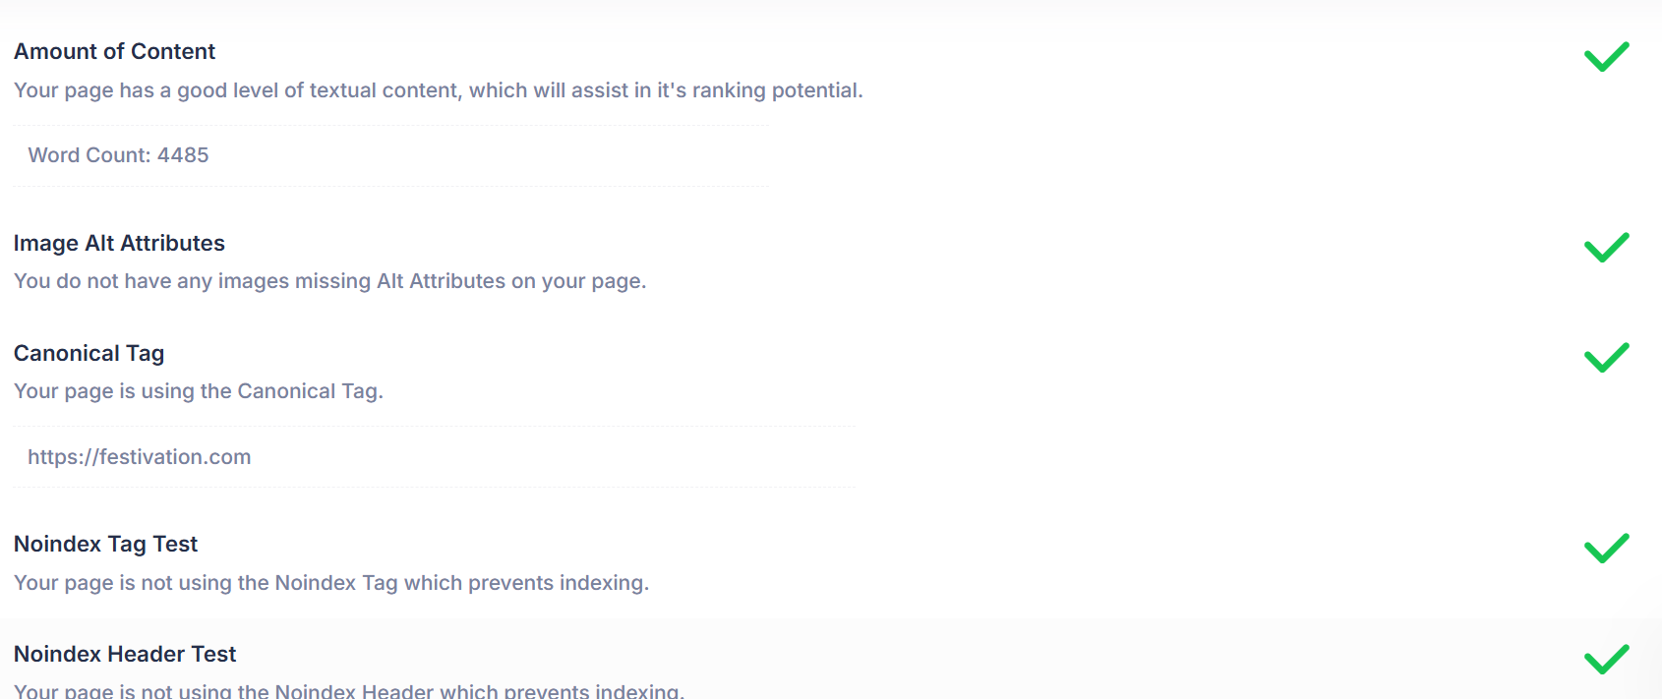
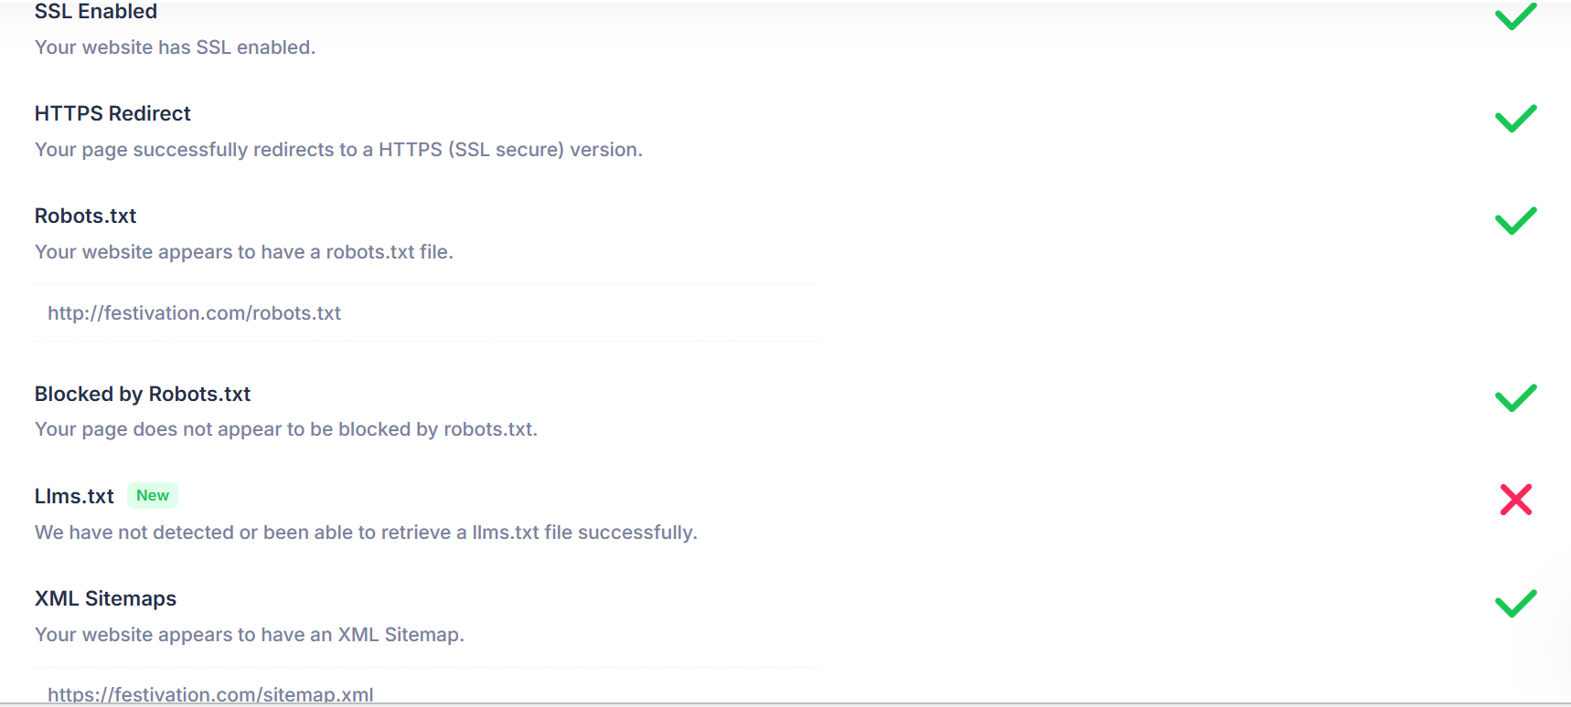
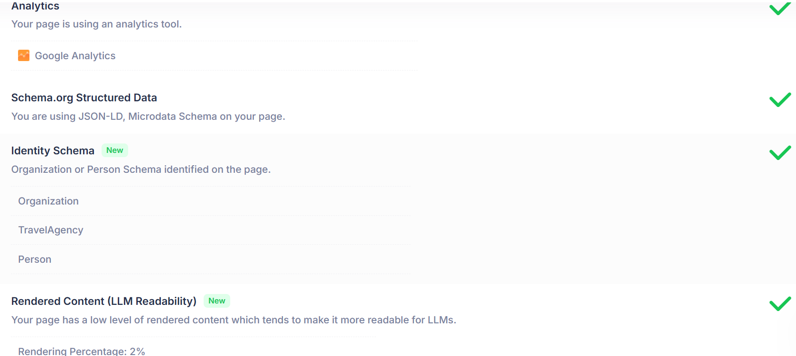

SEO insights
Festivation
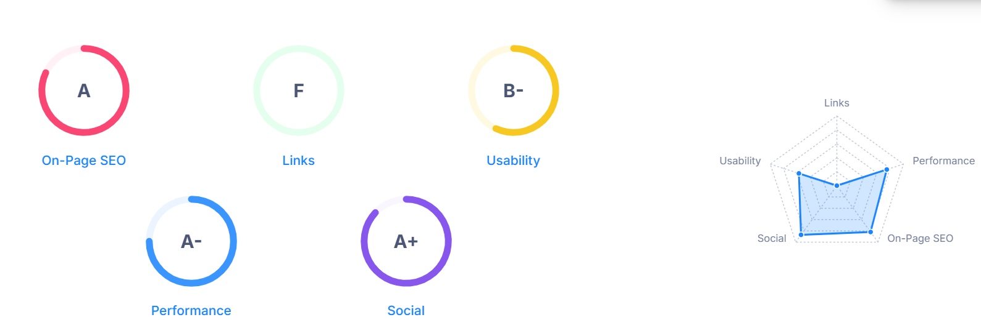
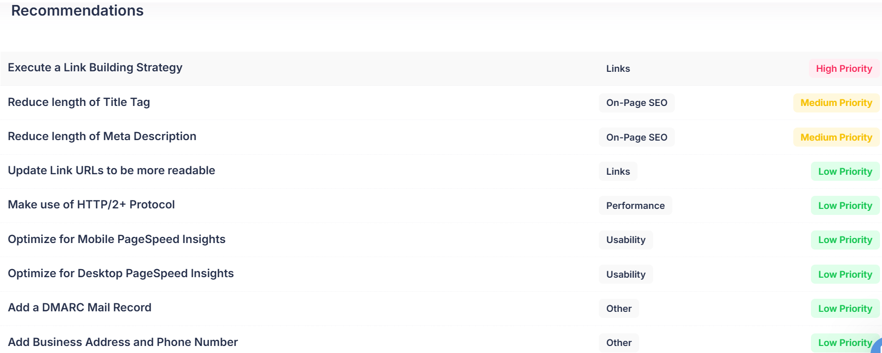
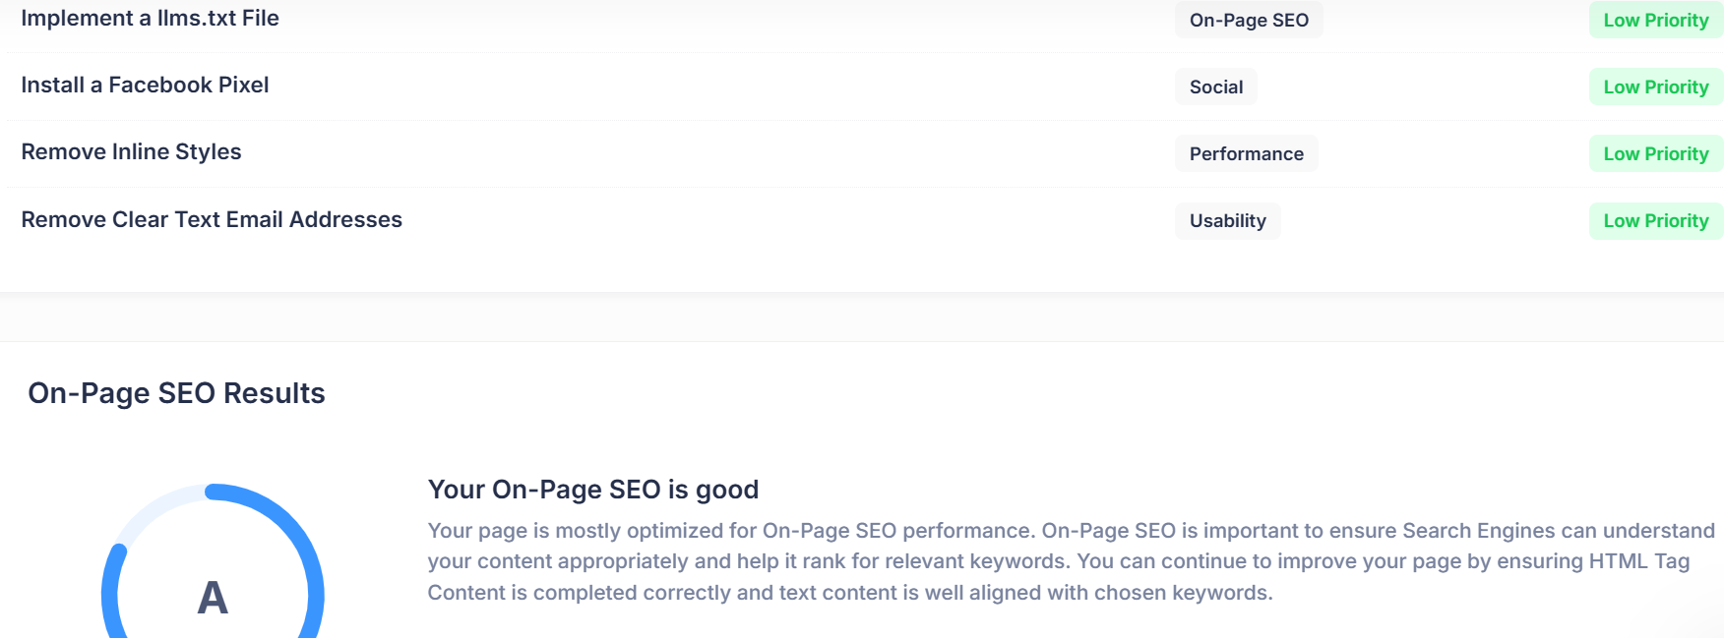
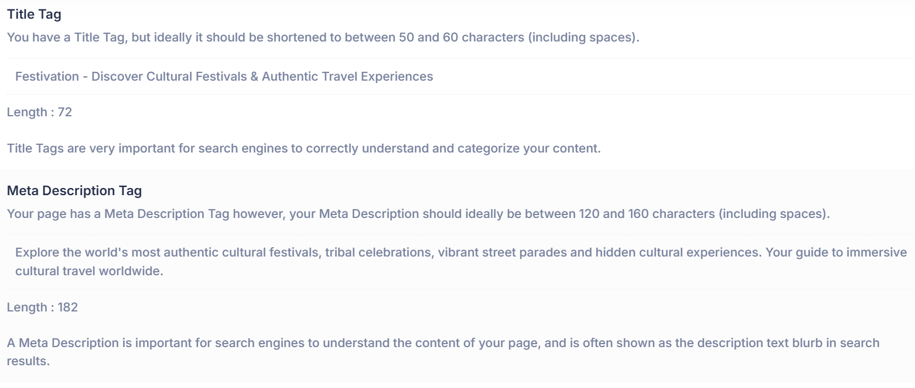
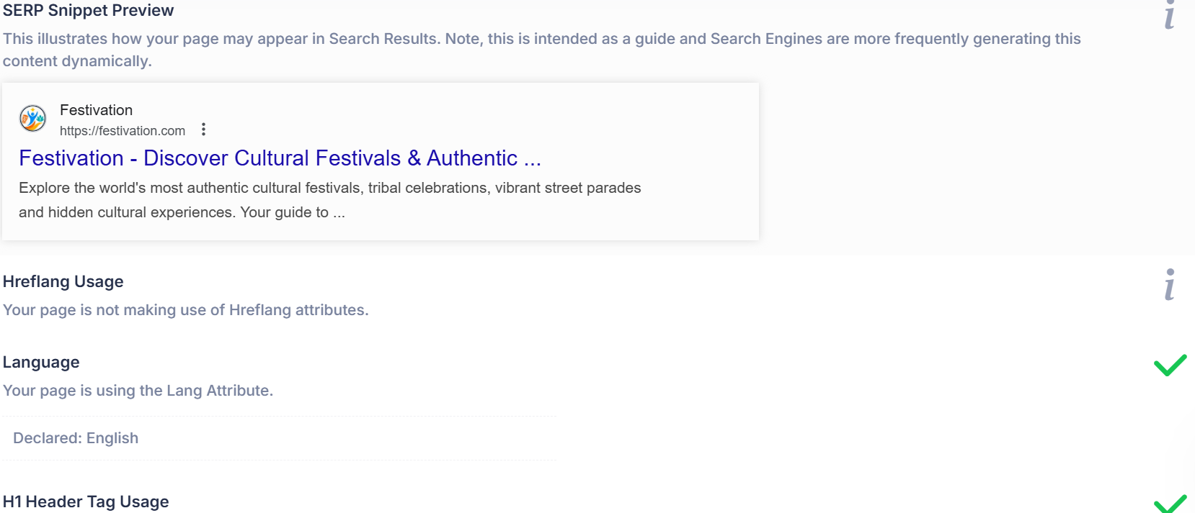
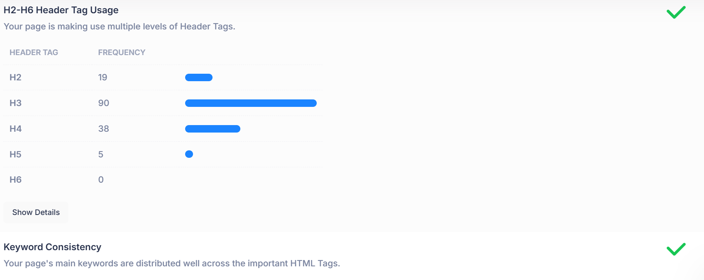
Eventbrite
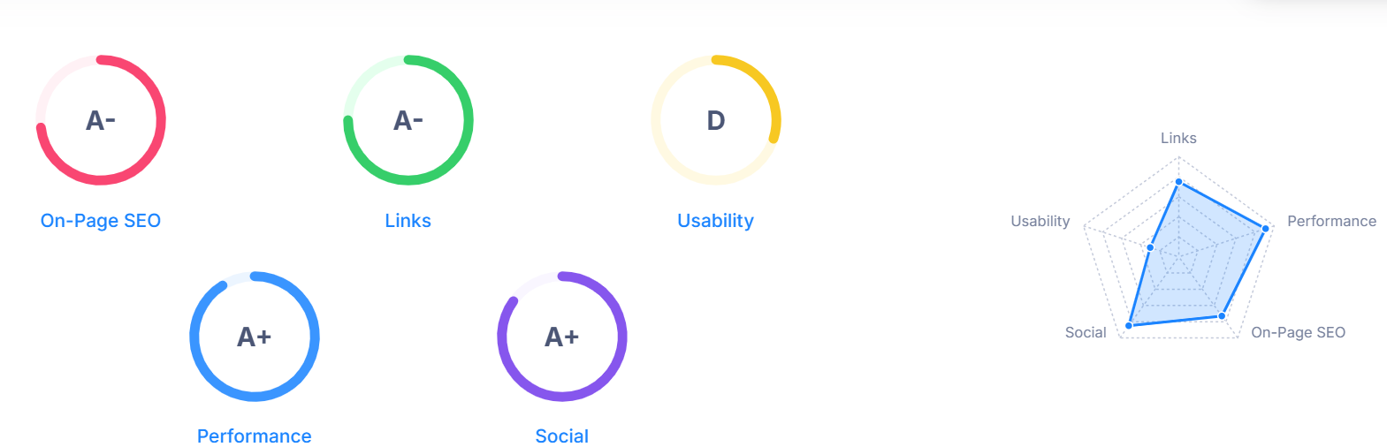
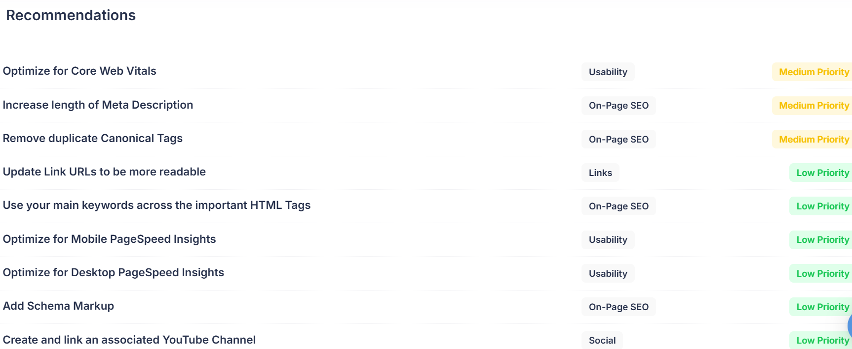
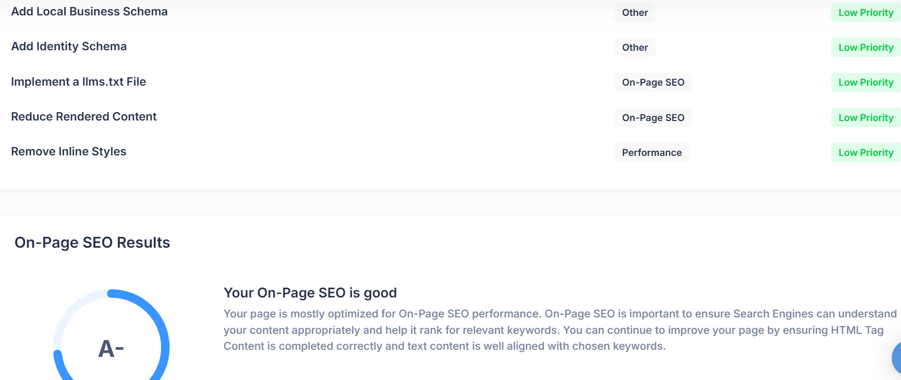

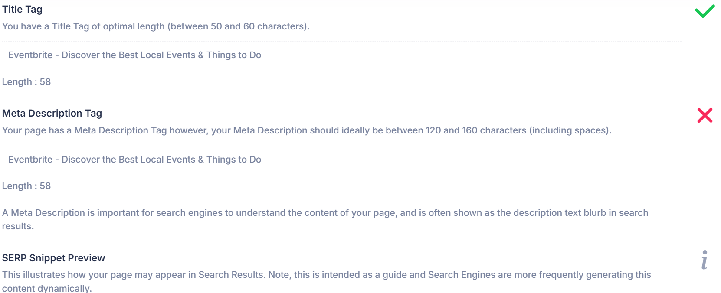
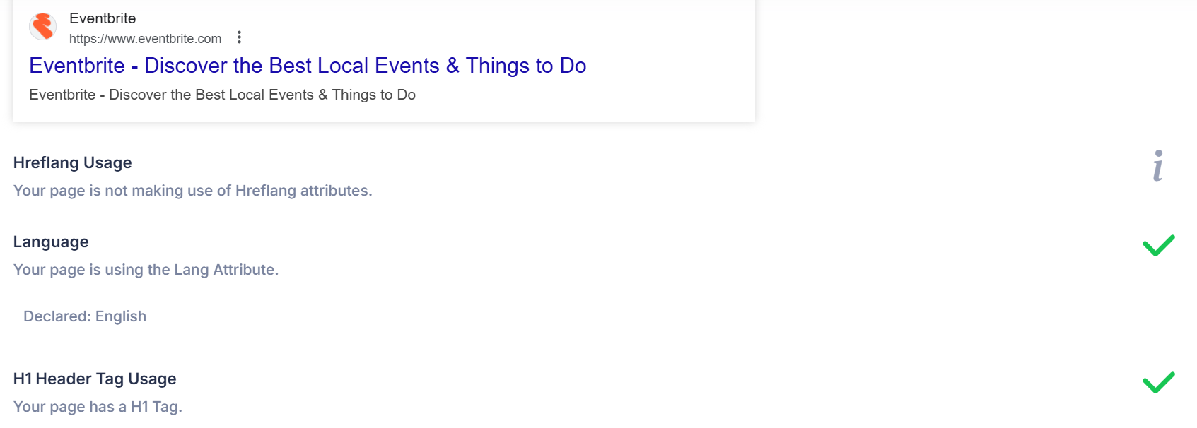
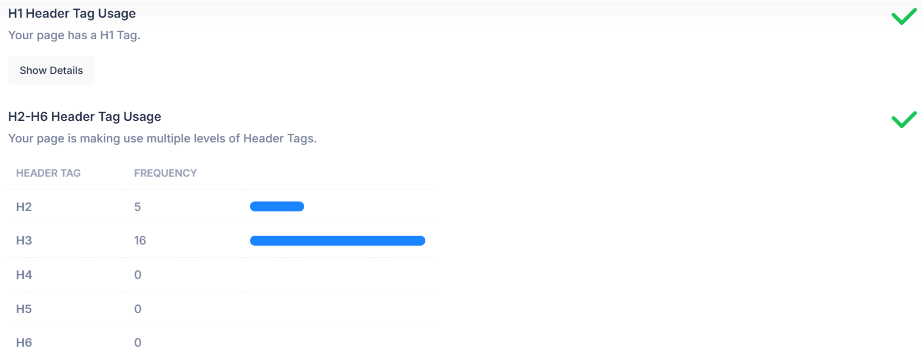
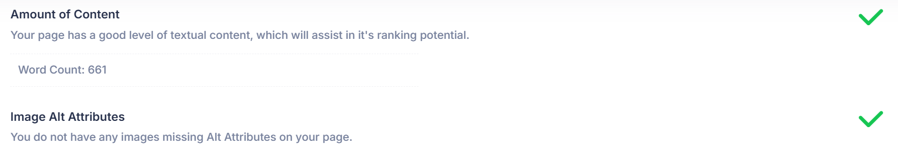
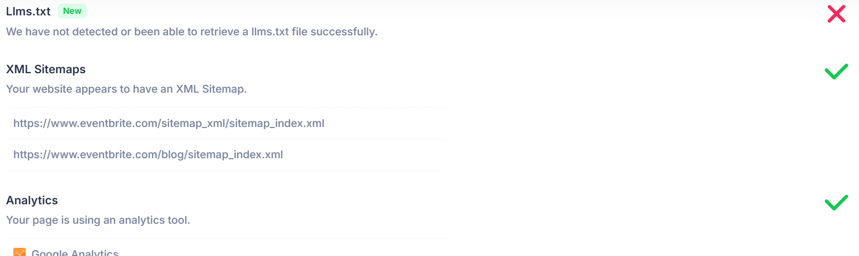

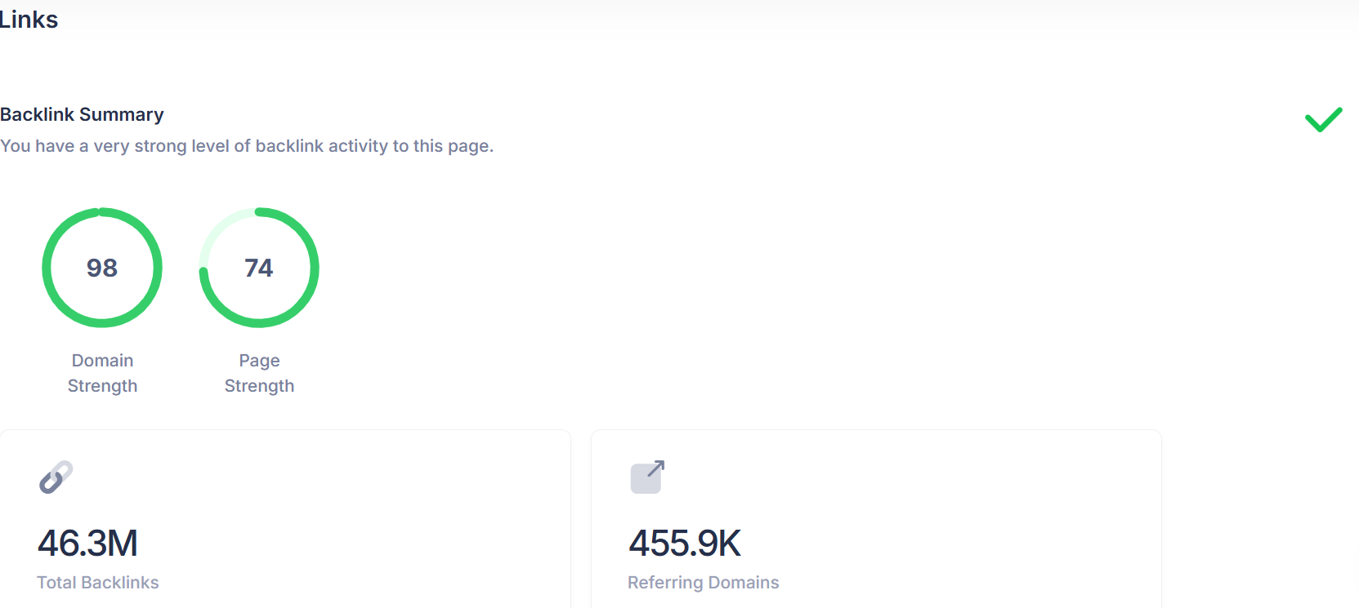
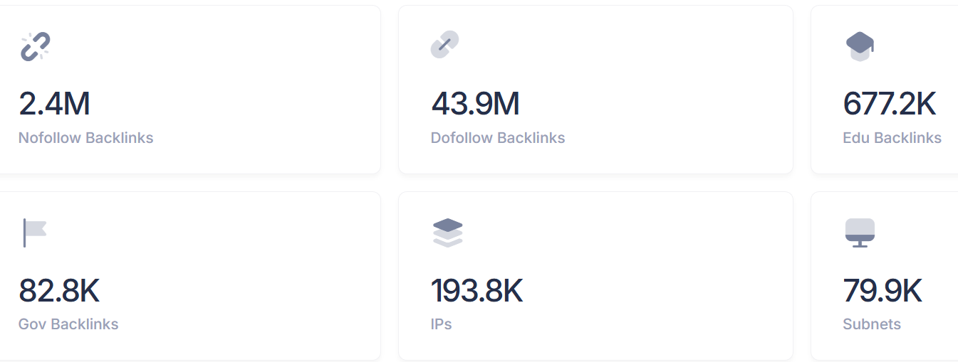
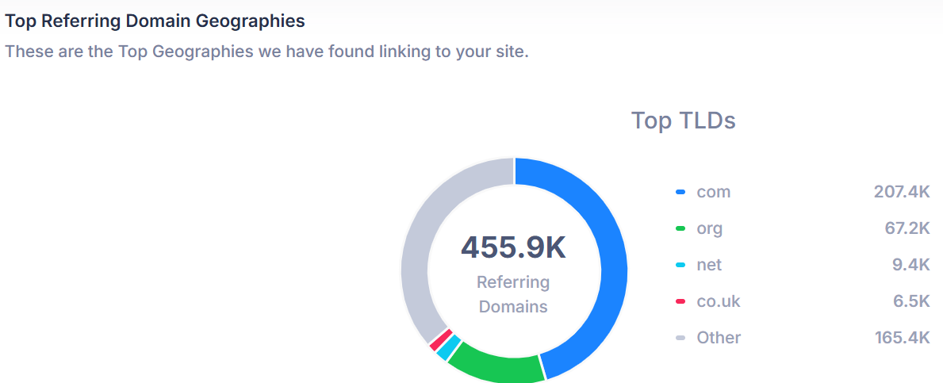
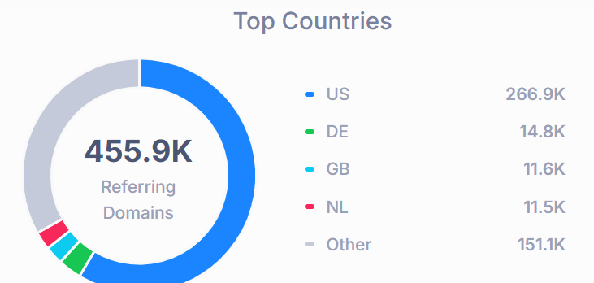
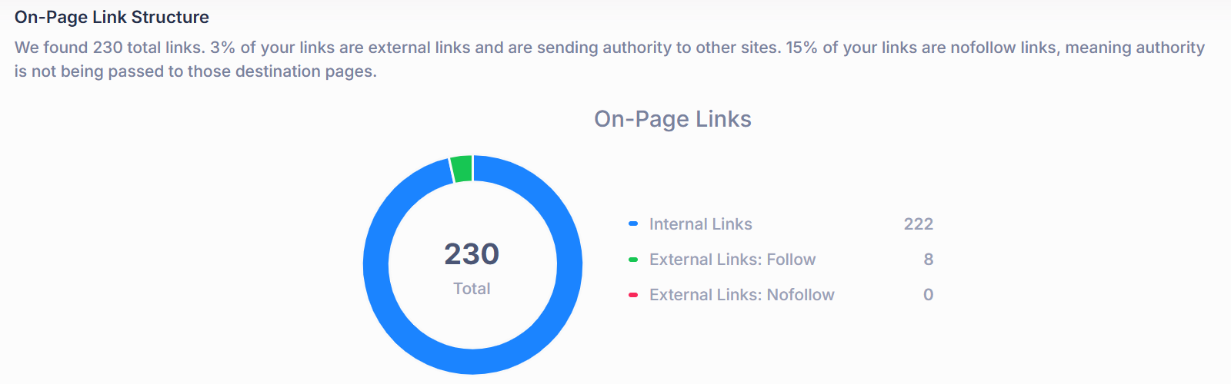

Keywords
Festivation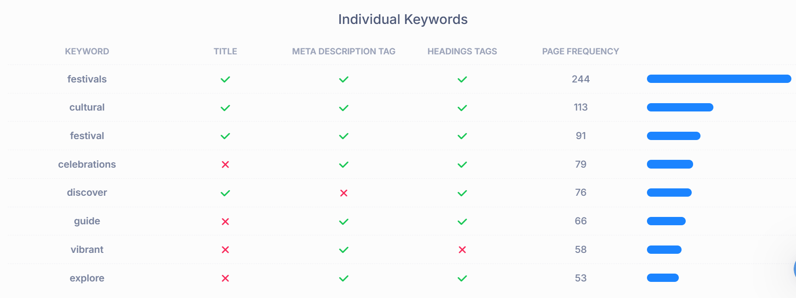
Eventbrite
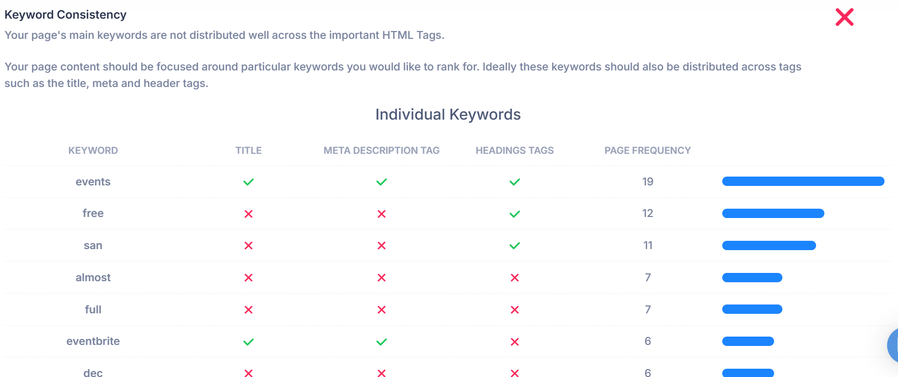

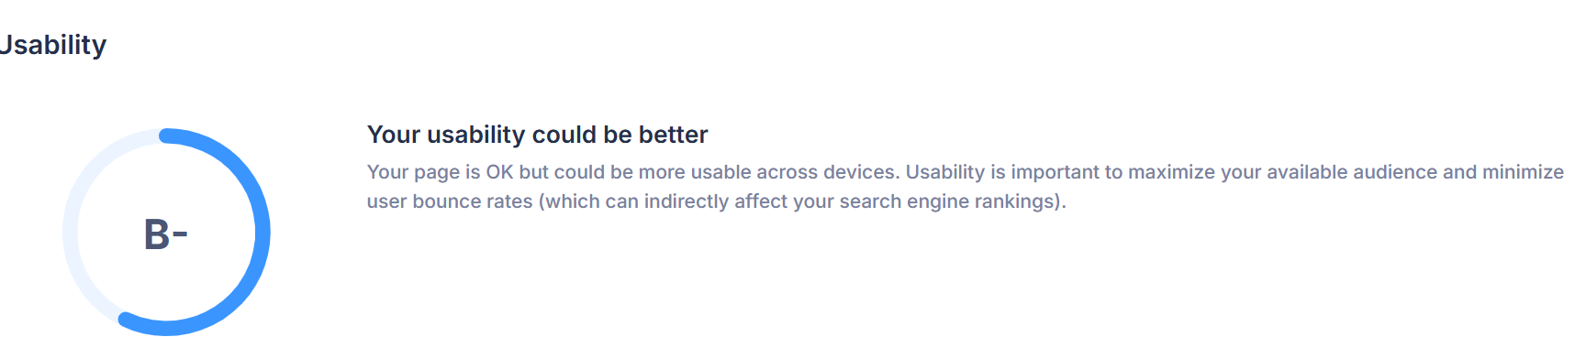

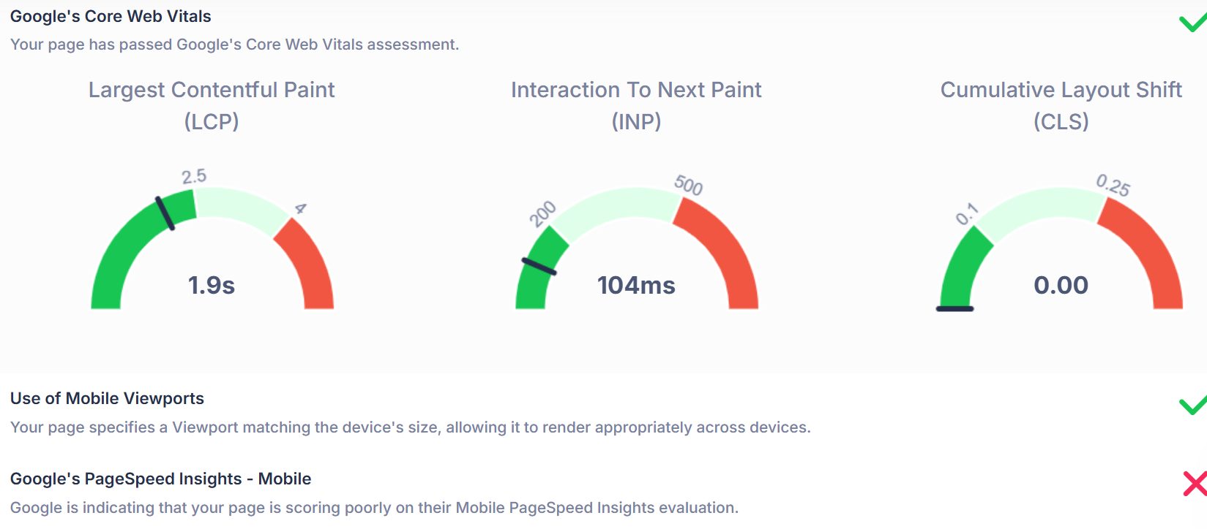
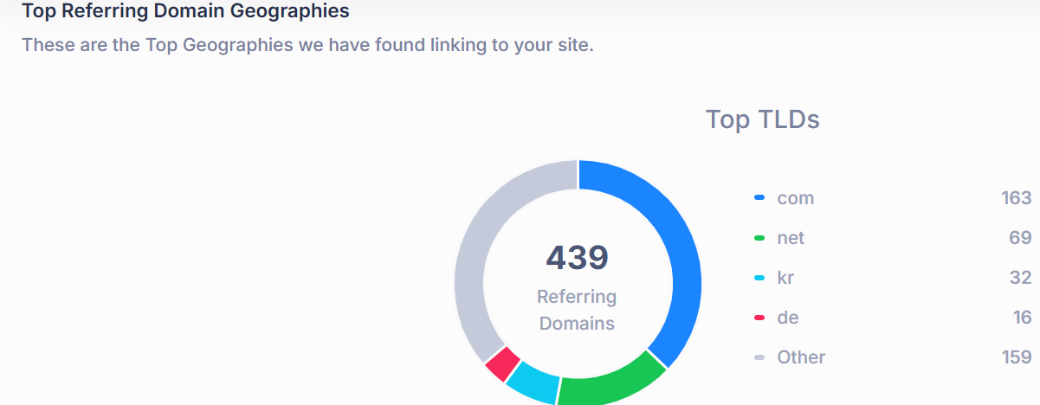
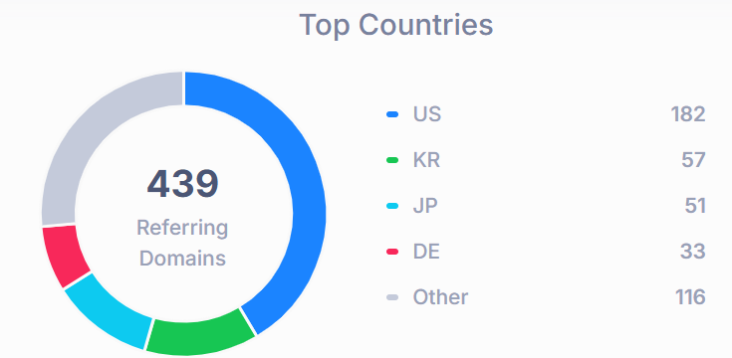
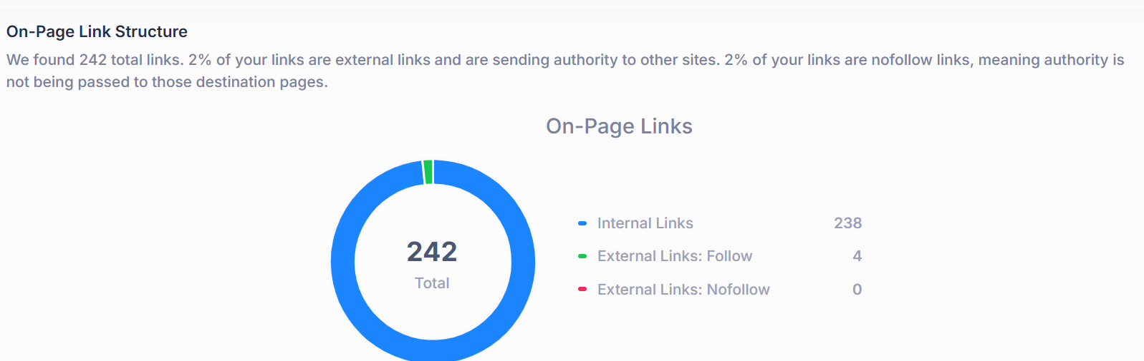
Eventbrite
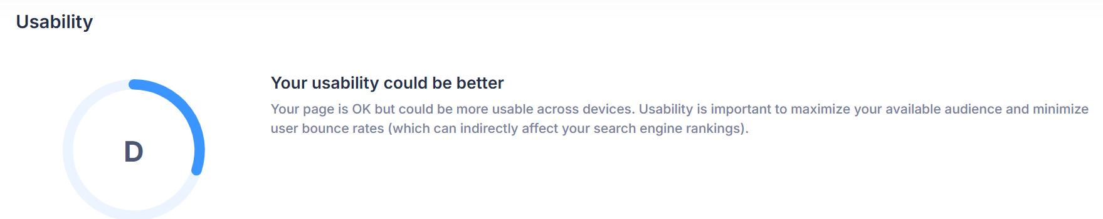
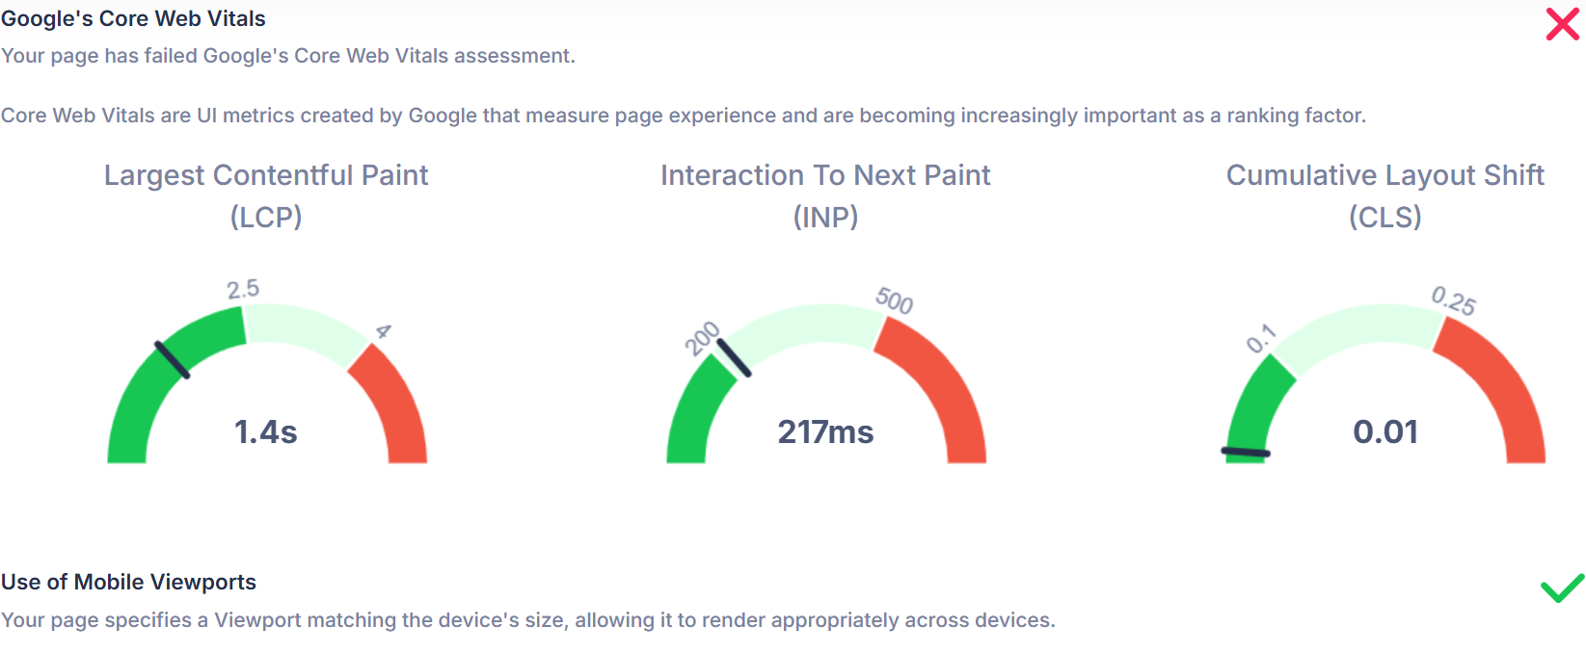
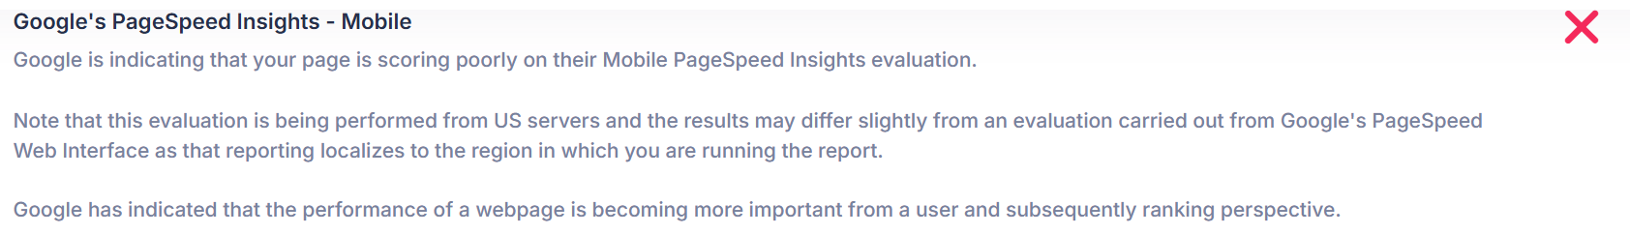

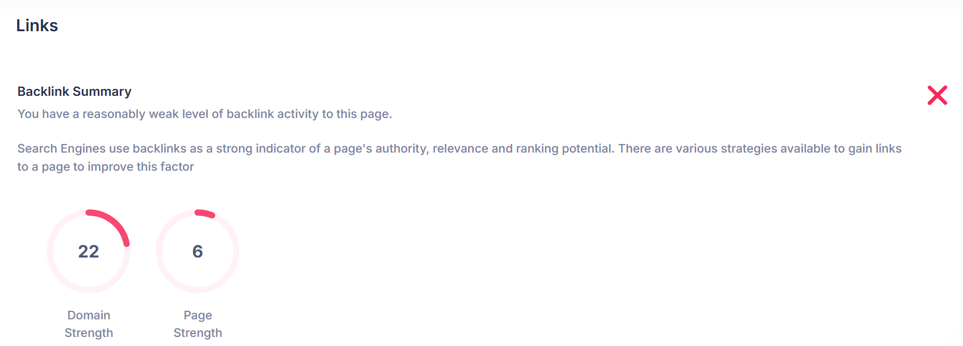
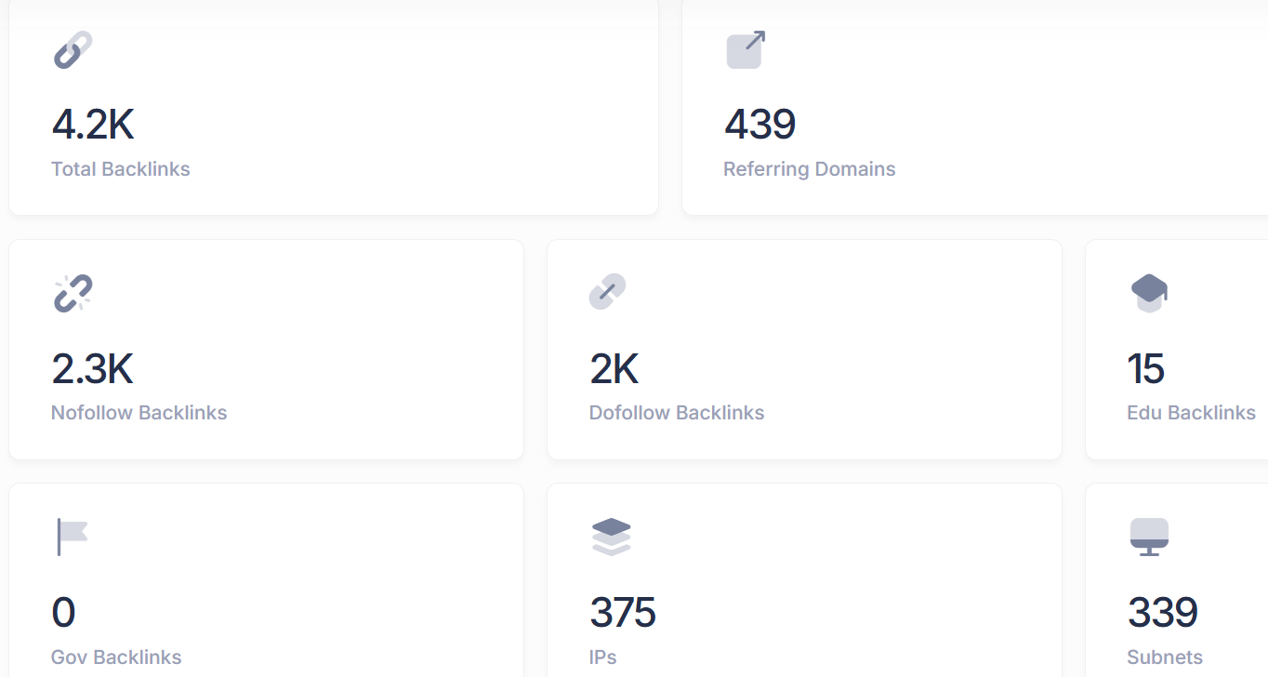

Conclusion: Which is Better and Why?
Festivation
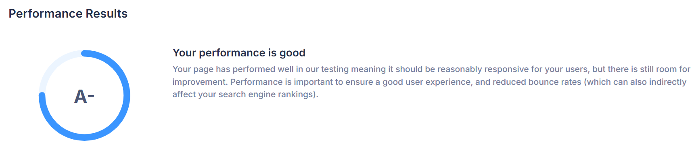
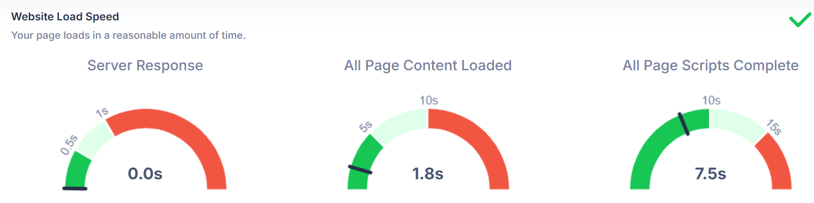
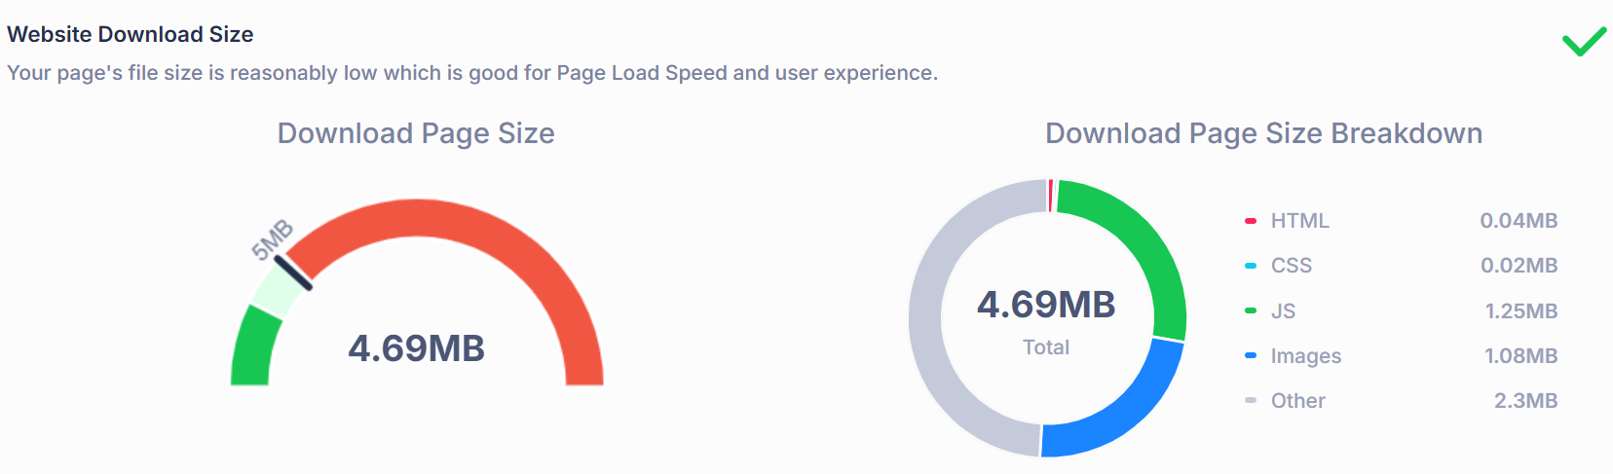
Eventbrite
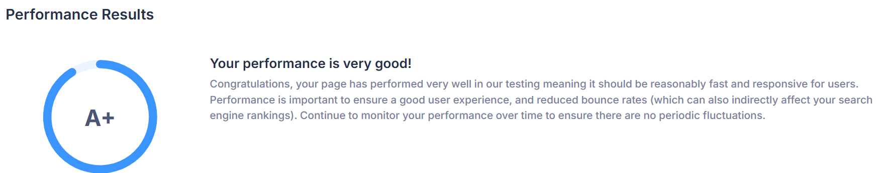
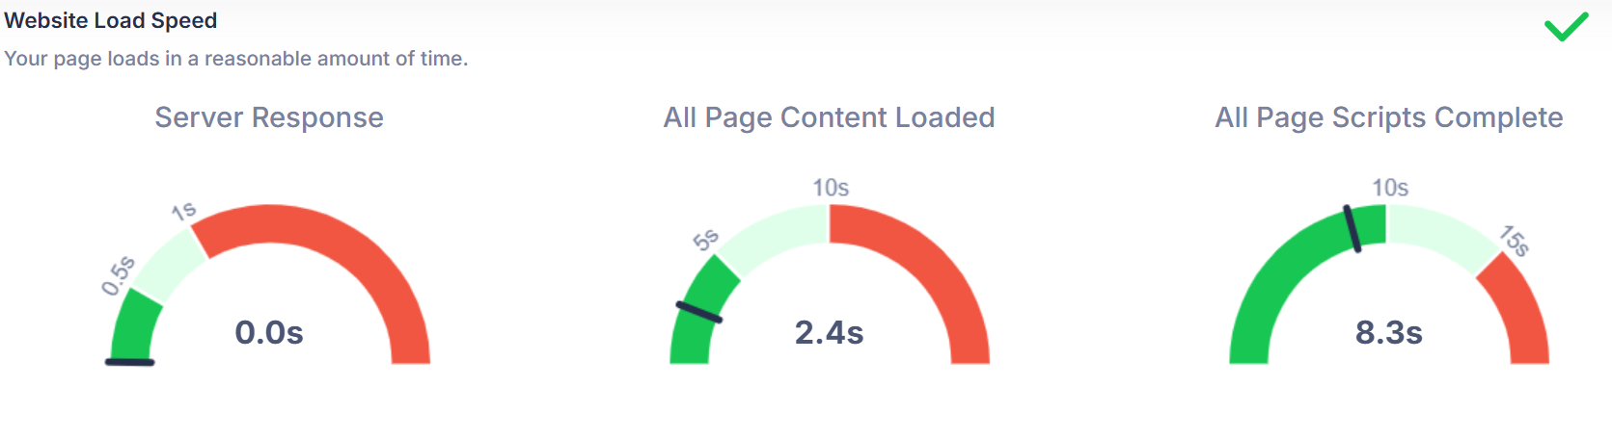
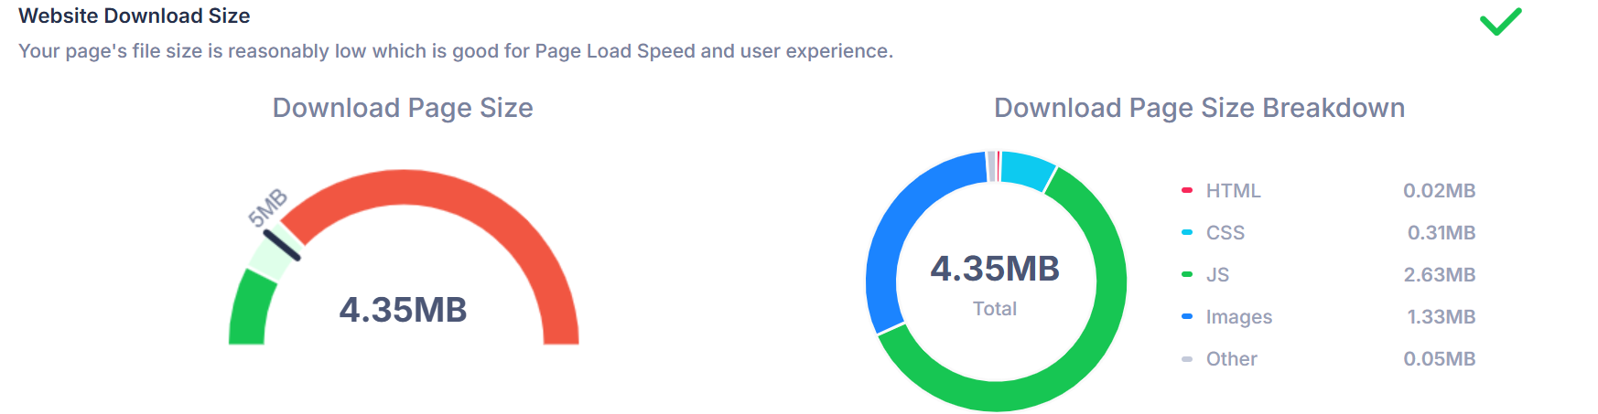

Conclusion
Overall, my report has detailed the design and development process of my accessible and visually engaging website, “Coimbra Food Festivals”. It demonstrated my knowledge of web standards, usability, accessibility and SEO practices. Through my self-evaluation reflection, I have shown that the website has fulfilled its main objectives and provided a strong foundation for further development and improvement.

Appendices

HTML code

schedule.html
<!DOCTYPE html>
<html lang="en">
<head>
<meta charset="UTF-8">
<title>Coimbra Food Festivals</title>
<link rel="stylesheet" href="style.css">
</head>

<body>
<nav>
<a href="HomePage.html"><u>Homepage</u></a>
<a href="schedule.html"><u>Schedule</u></a>
<a href="About.html"><u>About</u></a>
</nav>
<header>
<h1> Festival Schedule</h1>
<p> Here we will include a daily and yearly schedule of all festivals occuring in Coimbra, including dates, times, location, activities and the list of stall venues appearing at each festival.</p>
<h2>Dates</h2>
<style>
table, th, td {
border:1px solid black;
}
</style>
<table border="3">
<tr>
<th>Dates</th>
</tr>
<tr>
<td>16/07/2026</td>
</tr>
<tr>
<td>16/08/2026</td>
</tr>
</table>

<h2>Times</h2>
<table border="4">
<tr>
<th>Start - Finish</th>
</tr>
<tr>
<td>10am - 4pm</td>
</tr>
</table>

<h3>Location</h3>
<table border="5">
<tr>
<th>Location of 1st Festival</th>
<th>Location of 2nd Festival</th>
</tr>
<tr>
<td>Parque Verde do Mondego</td>
<td>City Center</td>
</tr>
</table>

<h2>Activities</h2>
<table border="6">
<tr>
<th>Traditional Local Taste Testing</th>
<th>Traditional Pastry Baking Session</th>
</tr>
<tr>
<td>Adults Only</td>
<td>All are welcome</td>
</tr>
</table>

<h2>Stall Listing and Menu</h2>
<table border="6">
<tr>
<th>Stalls</th>
<th>Tasca do Mondego</th>
<th>Casa de Doce Antigo</th>
<th>O Galo de Ouro</th>
<th>Maré Alta Coimbra</th>
<th>Pão da Sé</th>
<th>Adega do Estudante</th>
<th>A Praça dos Sabores</th>
<th>Gelato Lusitano</th>
<th>Cantinho do Fado</th>
</tr>
<tr>
<td>Chouriça Assada, Queijo da Serra Platter, Pão Alentejano, Azeitonas da Beira</td>
<td>Chanfana de Cabra, Arroz de Pato, Feijoada à Portuguesa, Broa de Milho</td>
<td>Pastéis de Tentúgal, Arrufadas de Coimbra, Encharcada, Travesseiros de Amêndoa</td>
<td>Frango Assado com Piri-Piri, Espetadas Mistas, Batatas à Moda da Casa, Mel e Limão Glaze</td>
<td>Polvo à Lagareiro, Amêijoas à Bulhão Pato, Sardinhas Assadas, Salada de Polvo</td>
<td>Tábua de Enchidos, Pão de Azeitona, Paté de Sardinha, Azeite & Ervas Dip</td>
<td>Petiscos Mix, Queijo Curado e Pão, Vinho da Casa (Tinto / Branco), Ginja Shot</td>
<td>Leitão da Bairrada, Bacalhau à Brás, Arroz Doce, Salada de Tomate e Cebola</td>
<td>Gelado de Figo e Mel, Gelado de Amêndoa, Gelado de Vinho do Porto, Copo de Duas Bolas</td>
<td>Peixinhos da Horta, Bolinhos de Bacalhau, Azeitonas & Queijo Snack, Ginja Fado Cocktail</td>
</tr>
</table>
</header>
</section>
<footer>
<p>&copy; All rights reserved to Food festivals, glorious food festivals, all year round in Wales and to the below</p>
<p> Links to the pages with rights to their Photos</p>
<a href="https://www.portugalist.com/coimbra-food/">Portugalist page on Coimbra food</a>
<br>
<a href="https://www.dreamstime.com/stock-images-coimbra-city-center-portugal-image40353204">Dreamstime stock image</a>
<br>
<a href="https://www.portugalist.com/coimbra-food/">Portugalist page on Coimbra food</a>
<br>
<a href="https://www.noticiasdecoimbra.pt/festival-das-artes-de-conimbriga-traz-comida-persa-a-condeixa-a-nova/"> Noticias de Coimbra</a>"

<p>Contact: email@gmail.com
</p>
<p> Follow us on</p>
<a href="https://www.instagram.com/?hl=en"><u>Instagram</u></a>
<a href="https://www.tiktok.com/?hl=en"><u>Tiktok</u>
</a>
</footer>
</body>
</html>

About.html
<!DOCTYPE html>
<html lang="en">
<head>
<meta charset="UTF-8">
<title>Coimbra Food Festivals</title>
<link rel="stylesheet" href="style.css">
</head>

<body>
<nav>
<a href="HomePage.html"><u>Homepage</u></a>
<a href="schedule.html"><u>Schedule</u></a>
<a href="About.html"><u>About</u></a>
</nav>
<header>
<h1> About Us</h1>
<p> Welcome to the About Us page where we'll discuss us and our history.</p>
</header>
</section>
<section class="about-coimbra">
<div class="info-box">
<h2>Gastronomy and Culture History of Coimbra</h2>
<p>
Coimbra’s food reflects both tradition and community. Dishes such as
<i>Leitão à Bairrada</i> and <i>Arrufadas de Coimbra</i> show the mix of
regional flavours passed down through generations. The city is also
recognised for its Fado music, university customs, and lively markets
where food and culture come together.
<br><small>(Source: Coimbra Região Gastronómica, 2025)</small>
</p>
</div>

<div class="photo-grid">
<img src="images/coimbra1.jpg" alt="Traditional dish from Coimbra" height="250"> <!-- image from https://www.portugalist.com/coimbra-food/ -->
<img src="images/coimbra2.jpg" alt="Coimbra city centre" height="250"> <!-- image from https://www.dreamstime.com/stock-images-coimbra-city-center-portugal-image40353204 -->
<img src="images/coimbra3.jpg" alt="Portuguese pastries" height="250"> <!-- image from https://www.portugalist.com/coimbra-food/ -->
</div>
</section>
<footer>
<p>&copy; All rights reserved to Food festivals, glorious food festivals, all year round in Wales and to the below</p>
<p> Links to the pages with rights to their Photos</p>
<a href="https://www.portugalist.com/coimbra-food/">Portugalist page on Coimbra food</a>
<br>
<a href="https://www.dreamstime.com/stock-images-coimbra-city-center-portugal-image40353204">Dreamstime stock image</a>
<br>
<a href="https://www.portugalist.com/coimbra-food/">Portugalist page on Coimbra food</a>
<br>
<a href="https://www.noticiasdecoimbra.pt/festival-das-artes-de-conimbriga-traz-comida-persa-a-condeixa-a-nova/"> Noticias de Coimbra</a>"

<p>Contact: email@gmail.com
</p>
<p> Follow us on</p>
<a href="https://www.instagram.com/?hl=en"><u>Instagram</u></a>
<a href="https://www.tiktok.com/?hl=en"><u>Tiktok</u>
</a>
</footer>
</body>
</html>

ContactPage.html
<!DOCTYPE html>
<html lang="en">
<head>
<meta charset="UTF-8">
<title>Coimbra Food Festivals</title>
<link rel="stylesheet" href="style.css">
</head>

<body>
<nav>
<a href="HomePage.html"><u>Homepage</u></a>
<a href="schedule.html"><u>Schedule</u></a>
<a href="ContactPage.html"><u>Contact</u></a>
<a href="About.html"><u>About</u></a>
</nav>
<header>
<h1> Contact Us</h1>
<p> If you have any questions or have problems using the site or looking for information, please fill out the form below.</p>
</header>
</section>
<section>
<form>
<label for="fname">First name:</label><br>
<input type="text" id="fname" name="fname" value="John"><br>
<label for="lname">Last name:</label><br>
<input type="text" id="lname" name="lname" value="Doe"><br><br>
<label for="email">Email</label><br>
<input type="text" id="email" name="email" value="email@gmail.com"><br><br>
<input type="submit" value="Submit">
</form>
</form>
</section>

</body>
<footer>
<p>&copy; All rights reserved to Food festivals, glorious food festivals, all year round in Wales and to the below</p>
<p> Links to the pages with rights to their Photos</p>
<a href="https://www.portugalist.com/coimbra-food/">Portugalist page on Coimbra food</a>
<br>
<a href="https://www.dreamstime.com/stock-images-coimbra-city-center-portugal-image40353204">Dreamstime stock image</a>
<br>
<a href="https://www.portugalist.com/coimbra-food/">Portugalist page on Coimbra food</a>
<br>
<a href="https://www.noticiasdecoimbra.pt/festival-das-artes-de-conimbriga-traz-comida-persa-a-condeixa-a-nova/"> Noticias de Coimbra</a>"

<p>Contact: email@gmail.com
</p>
<p> Follow us on</p>
<a href="https://www.instagram.com/?hl=en"><u>Instagram</u></a>
<a href="https://www.tiktok.com/?hl=en"><u>Tiktok</u>
</a>
</footer>
</html>
HomePage.html
<!DOCTYPE html>
<html lang="en">
<head>
<meta charset="UTF-8">
<title>Coimbra Food Festivals</title>
<link rel="stylesheet" href="style.css">
</head>

<body>
<nav>
<a href="HomePage.html"><u>Homepage</u></a>
<a href="schedule.html"><u>Schedule</u></a>
<a href="About.html"><u>About</u></a>
</nav>

<!-- Hero Section -->
<header>
<section class="hero">
<h1>Coimbra Food Festivals</h1>
<p>Discover Portugal's traditional flavours and history.</p>
</section> </header>
<!-- Photo of Festival Section -->
<section class="festival-photo">
<br>
<div class="festival-card">
<h2> <b>Introduction </b></h2>
<p>
Here we will cover all food festivals occurring in Coimbra areas, listing all possible information necessary including locations, dates, times, booking tickets, parking, stall listings with menus and links to their social media platforms for more browsing, history behind the areas, and if in need of more information than the stated, a contact form will be applicable to contact our team on the @ContactPage.
</p>
<div class="festival-grid">
<div class="festival-card">
<p>Here's where you can go to learn more about us!</p>
<a href="About.html" class="btn">Learn More</a>
</div>
</div>
</section>
<footer>
<p>&copy; All rights reserved to Food festivals, glorious food festivals, all year round in Wales and to the below</p>
<p> Links to the pages with rights to their Photos</p>
<a href="https://www.portugalist.com/coimbra-food/">Portugalist page on Coimbra food</a>
<br>
<a href="https://www.dreamstime.com/stock-images-coimbra-city-center-portugal-image40353204">Dreamstime stock image</a>
<br>
<a href="https://www.portugalist.com/coimbra-food/">Portugalist page on Coimbra food</a>
<br>
<a href="https://www.noticiasdecoimbra.pt/festival-das-artes-de-conimbriga-traz-comida-persa-a-condeixa-a-nova/"> Noticias de Coimbra</a>"

<p>Contact: email@gmail.com
</p>
<p> Follow us on</p>
<a href="https://www.instagram.com/?hl=en"><u>Instagram</u></a>
<a href="https://www.tiktok.com/?hl=en"><u>Tiktok</u>
</a>
</footer>
</body>
</html>

CSS code
/* Root Colours */
:root {
--main-orange:#78290f;
--main-yellow:#ffd84d;
}
/* Body Styling */
body {
font-family: Arial, Helvetica, sans-serif;
margin: 0;
padding: 0;
background-color: #fff;
color:#000;
}
/* Header */
header {
background-color: #ff8533;
color: #78290f;
text-align: center;
padding: 10px;
}
/* Navigation Menu (based on W3Schools example */
nav {
background-color: var(--main-yellow);
display: flex;
justify-content: center;
align-items: center;
padding: 8px 0;
}
nav a {
color: var(--main-orange);
padding: 10px 16px;
text-decoration: none;
font-weight: bold;
border-radius: 4px;
}
nav a:hover {
background-color: var(--main-orange);
color:#fff;
}
/* Hero Section */
.hero {
background-image: url("images/main.jpeg");
background-position: center;
background-size: cover;
height: 100vh;
color: white;
text-align: center;
display: flex;
flex-direction: column;
justify-content: center;
}
.hero h1 {
font-size: 2.8rem;
margin-bottom: 10px;
}
/* Festival Section */
.festival-photo {
padding: 40px 20px;
max-width: 1000px;
margin: auto;
}
.festival-grid {
display: grid;
grid-template-columns: repeat(auto-fit, minmax (250px, 1fr));
gap: 15px;
margin-top: 20px;
}
.festival-card {
background-color: #fff;
padding: 20px;
border-radius: 6px;
text-align: center;
box-shadow: 0 2px 5px rgba(0, 0, 0, 0.1);
transition: 0.3s;
}
.festival-card:hover {
transform: scale(1.02);
}
/* Buttons */
button, .btn {
background-color: var(--main-orange);
color: white;
padding: 10px 18px;
border: none;
border-radius: 4px;
cursor: pointer;
text-decoration: none;
}
button:hover, .btn:hover {
background-color: #ff9933;
}
/* Tables */
table {
width: 80%;
margin: 20px auto;
border-collapse: collapse;
text-align: center;
background-color: white;
}
th, td {
border: 1px solid #000;
padding: 10px;
background-color: #fff;
color: black;
}
/* Headings */
h2,h3 {
text-align: center;
color: #78290f;
font-family: 'Franklin Gothic Medium', 'Arial Narrow', Arial, sans-serif;
}
/* About Section */
.about-coimbra {
display: flex;
flex-wrap: wrap;
justify-content: space-between; /*spaces text and images */
background-color: #fffaf2;
gap: 30px;
padding: 40px 20px;
margin: 0 auto;
border-radius: 10px;
box-shadow: 0 2px 8px rgba(0, 0, 0, 0.1);
max-width: 1200px;
}
.info-box {
flex: 1 1 350px;
background-color: #fff;
color: #333;
padding: 20px;
border-radius: 8px;
line-height: 1.6;
box-shadow: 0 2px 5px rgba(0, 0, 0, 0.1);
}
.info-box h2 {
color: #ff6600;
font-size: 1.5rem;
margin-bottom: 10px;
}
.photo-grid {
flex: 1 1 250px;
display: grid;
grid-template-columns: repeat(2, 1fr);
gap: 10px;
}
.photo-grid img {
width: 100%;
height: 200px;
object-fit: cover;
border-radius: 6px;
transition: 0.3s;
}
.photo-grid img:hover {
transform: scale(1.05);
}
/* Footer */
footer {
background-color: #ff8533;
color: #78290f;
text-align: center;
padding: 10px;
}
footer a {
color: #000000;
text-decoration: underline;
margin: 0 10px;
}
footer a:hover {
color: var(--main-yellow);
}
/* Responsive Design from W3Schools Responive Navbar */
@media screen and (max-width:768px) {
nav {
flex-direction: column;
}
nav a {
display: block;
text-align: center;
margin: 4px 0;
}
.hero {
height: auto;
padding: 40px 20px;
}
.about-coimbra {
flex-direction: column;
}
}

References

[1] | D. Europa, “https://data.europa.eu/apps/,” [Online].
[2] | D. Europa, “https://data.europa.eu/apps/,” [Online].
[3] | D. Host, “https://www.dreamhost.com/blog/make-your-website-accessible/#:~:text=Install%20A%20Browser%20Extension%20For,it%20before%20it%20starts%20working,” [Online].
[4] | D. Europa, “Data Europa,” [Online]. Available: https://data.europa.eu/apps/data-visualisation-guide/accessible-colour-palettes.
[5] | C. Fugitive, “https://www.cubiclefugitive.com/post/blog/strategies-to-make-your-website-user-friendly#:~:text=User%2Dfriendliness%20refers%20to%20usability,%2C%20and%20device%2Dresponsive%20designs.,” [Online].
[6] | onenine, “https://onenine.com/website-information-architecture/#:~:text=High%20%E2%80%93%20A%20clear%20and%20intuitive%20navigation%20is%20fundamental%20to%20a%20positive%20user%20experience.,” [Online].
[7] | N. J., “https://www.nngroup.com/articles/usability-101-introduction-to-usability/,” [Online].
[8] | WCAG, “WCAG 101: Understanding the Web Content Accessibility Guidelines,” [Online]. Available: https://www.wcag.com/resource/what-is-wcag/#:~:text=The%20Web%20Content%20Accessibility%20Guidelines%20(WCAG)%2C%20developed%20by%20the,universal%20standard%20for%20digital%20accessibility..
[9] | C. S. University, “https://www.chhs.colostate.edu/accessibility/best-practices-how-tos/color-contrast-tools/,” [Online].
[10] | Coolors, “https://coolors.co/contrast-checker/6d2f1c-ffffff,” [Online].
[11] | W3C, “https://www.w3.org/TR/WCAG21/,” [Online].
[12] | D. A. Training, “https://digitalaccessibilitytraining.org/ark/article/23#:~:text=The%20content%20of%20this%20article,use%20of%20screen%20reading%20technology.,” [Online].
[13] | Wikipedia, “https://en.wikipedia.org/wiki/Search_engine_optimization#:~:text=Search%20engine%20optimization%20(SEO)%20is,media%20traffic%2C%20or%20paid%20traffic.,” [Online].
[14] | W3Schools, “https://www.w3schools.com/tags/att_img_alt.asp#:~:text=The%20alt%20attribute%20provides%20alternative,image%2C%20use%20the%20title%20attribute!,” [Online].
[15] | S. Atlas, “https://searchatlas.com/blog/crawlability-and-indexability/#:~:text=Crawlability%20means%20search%20engines%20can,website%20pages%20are%20fully%20crawlable.,” [Online].
[16] | G. Developers, “https://developers.google.com/search/docs/fundamentals/seo-starter-guide,” [Online].
[17] | A. Checker. [Online]. Available: https://www.accessibilitychecker.org/blog/semantic-html/.
[18] | saffronedge, “Semantic HTML: Key Benefits and Best Practicess,” [Online]. Available: https://www.saffronedge.com/blog/semantic-html/#:~:text=Integrating%20semantic%20HTML%20into%20your,search%20engine%20crawlers%20to%20index..
[19] | M. D. Network, “https://developer.mozilla.org/en-US/docs/Web/HTML,” [Online].
[20] | festivation.com, “festivation.com,” [Online]. Available: https://festivation.com/traditional-food-to-try-at-coimbra-street-festivals.
[21] | festivation.com, “About,” [Online]. Available: https://festivation.com/about.
[22] | eventbrite, “About Us,” [Online]. Available: https://www.eventbrite.co.uk/about/.
[23] | D. Host, “Dream Host,” [Online]. Available: https://www.dreamhost.com/blog/make-your-website-accessible/#:~:text=Install%20A%20Browser%20Extension%20For,it%20before%20it%20starts%20working..
[24] | C. B. B. Association, “https://www.cbba.es/the-impact-of-visual-content-on-web-design-a-key-to-engaging-websites/#:~:text=When%20we%20talk%20about%20visual,visuals%20encourages%20visitors%20to%20explore.,” [Online].
[25] | hellohumans, “https://hellohumans.agency/accessibility-best-practices/#:~:text=Screen%20readers%2C%20such%20as%20NVDA,%E2%80%9C,” [Online].
[26] | Gemini.
[27] | B12, “https://www.b12.io/glossary-of-web-design-terms/hover-effects/#:~:text=Hover%20effects%20add%20subtle%20changes,and%20make%20navigation%20feel%20intuitive.,” [Online].
[28] | S. -. J. Exchange, “https://ux.stackexchange.com/questions/33960/are-hover-states-necessary#:~:text=I'm%20not%20sure%20I,that%20the%20application%20is%20listening.,” [Online].
[29] | D. Nichols, “Coloring for Colorblindness,” [Online]. Available: https://davidmathlogic.com/colorblind/#%23D81B60-%231E88E5-%23FFC107-%23004D40.
[30] | Jelvix, “https://jelvix.com/blog/functional-vs-nonfunctional-requirements,” [Online].
[31] | launchnotes, “https://www.launchnotes.com/glossary/cognitive-load-in-product-management-and-operations#:~:text=It%20(%20cognitive%20load%20)%20refers%20to,leading%20to%20higher%20user%20satisfaction%20and%20retention.,” [Online].
[32] | Britannica, “https://www.britannica.com/topic/Web-script,” [Online].
[33] | D. Nichols, “Coloring for Colorblindness,” [Online].
[34] | D. Nichols, “Coloring for Colorblindness,” [Online].
[35] | C. Rich, “https://www.colourrich.co.uk/inside-design/how-to-carry-out-a-website-comparison-study/,” [Online].

