CHANGE AND STABILITY MANAGEMENT

How does modern business overcome new changes based on Walmart

Student Name: Zhou Yuting
Student Number:2218220

Contents

EXECUTIVE …………………………………………………………………….. 2

1. INTRODUCTION ……………………………………………….…..….…. 2

2. SITUATION OF WALMART ………………………………...………..…...…3

2.1 THE NATURE OF CHANGE …………………………………..……….4

2.2 THE FORCE FIELD ANALYSIS ……………………………………….5

2.3 THE DRIVERS FOR THE CHANGE …………………………………..5

2.4 THE RESISTERS FOR THE CHANGE ……………………………....6

2.5 THE STAKEHOLDER ANALYSIS …………………………….……...7

2.6 LEWIN’S THREE-STEP MODEL APPLIED FOR THE CHANGE .....8

2.7 KOTTER’S EIGHT-STEP MODEL APPLIED
FOR THE CHANGE ……………………………………………..……9

2.8 EVALUATION OF WALMART ………………………………….……10

3. RECOMMENDATION …………………………………………………..........11

REFERENCE ………………………………………….…………………..........12

EXECUTIVE
This paper analyses Walmart's e-commerce change management strategies, which were motivated by the need to maintain market competitiveness. To expand its product range and delivery possibilities, Walmart invested in its own online platform and bought other e-commerce businesses, which significantly increased online sales.

The force field analysis, stakeholder analysis, Lewin's three-step model, and Kotter's eight-step model are just a few of the change management concepts and methods that are used in this essay to analyse Walmart's change initiatives. The stakeholder study highlighted the impact of the change on consumers, employees, suppliers, and shareholders, while the force field analysis assisted in identifying the drivers and resistors of change, observed by He et al(2009).

Walmart's change initiatives were examined using Lewin's three-step model and Kotter's eight-step model, which emphasised the significance of instilling a sense of urgency, forming alliances, empowering others, communicating a vision, creating short-term wins, consolidating gains, and ingraining new methods into the organization's culture.

The report concludes by recommending that Walmart focus on improving customer experience through website design and navigation, enhancing delivery and pickup options, and investing in personalized marketing and promotions. Walmart should also continue to prioritize sustainability efforts, such as renewable energy, waste reduction, and sustainable sourcing.

Overall, Walmart's change management initiatives in the area of e-commerce have been successful in improving its online presence and increasing sales. By applying change management models and strategies, Walmart was able to identify drivers and resistors for change, address stakeholder needs, and implement new e-commerce infrastructure and practices. Recommendations for Walmart to continue to improve its e-commerce offerings and sustainability efforts will further solidify its position as a leader in the retail industry.

- INTRODUCTION

Walmart is a worldwide retail firm that runs a network of supermarkets, inexpensive department stores, and hypermarkets. Daniel (2023) has noted that Walmart recently realised the necessity to enhance its online presence in order to stay competitive in the e-commerce business. To expand its product variety and delivery possibilities, the company invested in its own online platform and bought other e-commerce businesses (Daniel, 2023). As a result, online sales significantly increased.

This report will examine and assess the efficacy of Walmart's change management activities in the domain of e-commerce. The purpose of the report is to examine the nature of change, drivers and resistors of change, stakeholder impact, and the implementation of new e-commerce infrastructure and practises. To do this, it will apply change management models and strategies, such as the force field analysis, stakeholder analysis, Lewin's three-step model, and Kotter's eight-step model. The essay will make suggestions for Walmart regarding how to enhance its sustainability initiatives and online shopping options (Spicer & Hyatt, 2017).

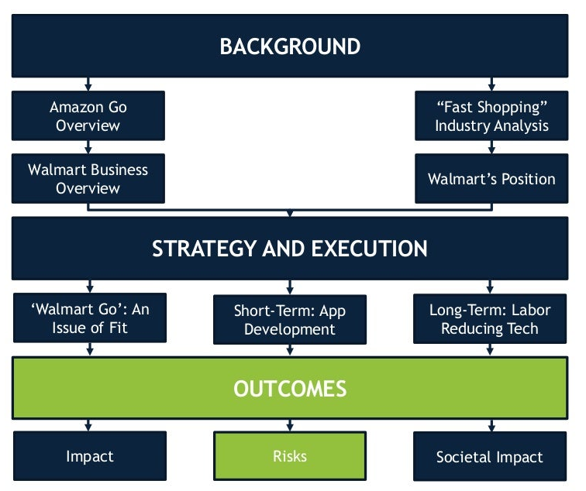
Overall, Walmart's e-commerce change management initiatives have been effective in increasing sales and improving the business's online presence (Rune, 2005). By implementing new e-commerce infrastructure and practises, responding to stakeholder needs, and identifying the drivers and resistors of change, Walmart was able to achieve its goals. Hornstein (2015) argued that suggestions that Walmart improve its online offerings and sustainability activities will help to further solidify its position as a pioneer in the retail industry.

Table1: Walmart Go (DataHawk.com, 2022)

- SITUATION OF WALMART

According to Sharma (2020), with a presence in 20 countries, Walmart is one of the biggest merchants in the world. The business runs a chain of grocery stores, budget department stores, and hypermarkets. In order to stay competitive in the e-commerce business, Walmart realised in recent years that its online presence needed to be improved. To boost its product variety and delivery options, the business made investments in both its own online platform and other e-commerce businesses, which led to a sharp rise in online sales, observed by Hussain (2018).
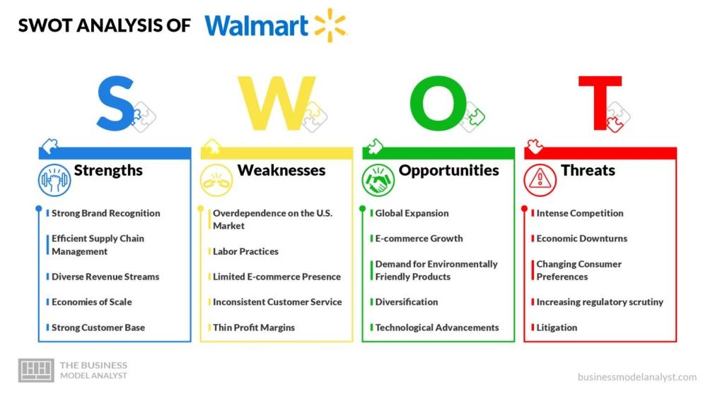
Table 2: SWOT Analysis of Walmart (businessmodelanalyst.com, 2023)

Customers seeking a mix of online and offline shopping experiences have been drawn to Walmart by the way it has used its physical stores to offer handy choices like online grocery pickup and delivery. Sales and consumer loyalty have increased as a result of Walmart's omnichannel strategy, which combines its physical stores and online platform (Song, 2018). Walmart's physical stores act as distribution hubs for online orders, making it possible for delivery options like same-day delivery and free two-day shipping to be quicker and more effective. Furthermore, Walmart provides a range of in-person and online services, such as curbside pickup, which enables customers to place online orders and pick up their purchases without having to get out of their cars.

In addition to emphasising e-commerce, Walmart has recently placed a high priority on sustainability initiatives. By 2040, the corporation plans to have zero emissions and improve its environmental practises (ESG, 2022). To meet its sustainability objectives, Walmart has made investments in sustainable sourcing methods, waste reduction techniques, and renewable energy sources (Pandey, 2021).

Overall, Walmart's investments in sustainability and e-commerce have paid off, as evidenced by the 97% increase in Q2 2020 in its online sales, which can be attributed in part to the COVID-19 pandemic and rising demand for online shopping (Perez, 2020). Walmart's omnichannel approach and dedication to sustainability show that business is willing to change in response to shifting cultural norms and consumer demands.

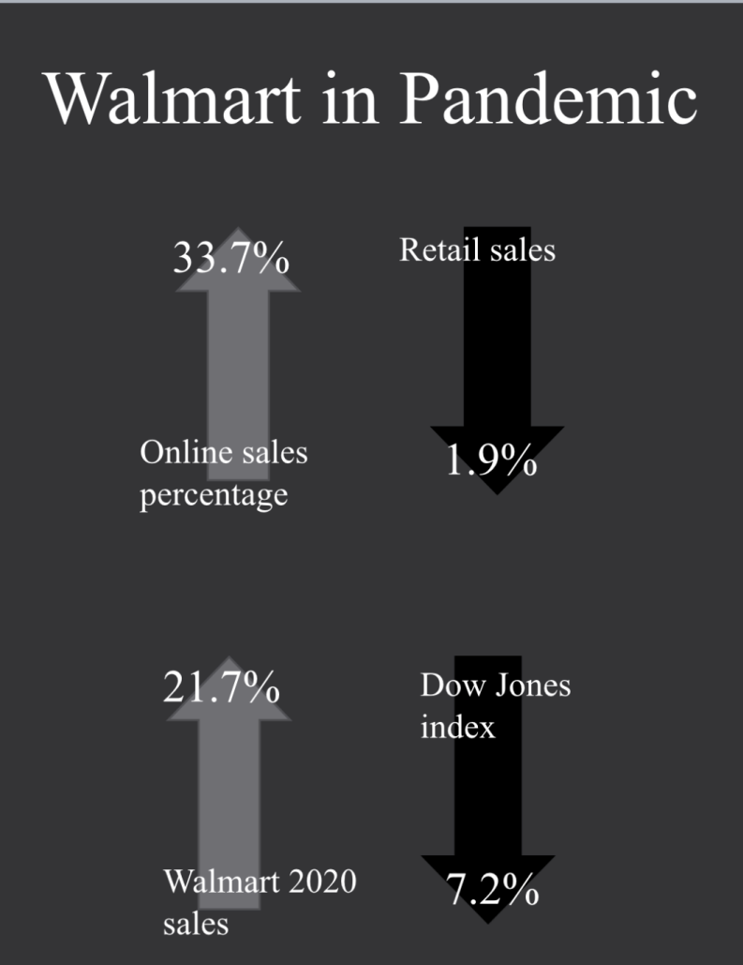
Table 3: Walmart in Pandemic (Stratably, 2021)

2.1 THE NATURE OF CHANGE
Walmart's decision to make modifications was inspired by its aim to strengthen its online presence in order to remain competitive in the e-commerce industry (Crick, 2020). Walmart recognised that traditional retail was no longer sufficient to meet the changing needs of its customers. The company invested in both its own online platform and other e-commerce enterprises to increase the range of products and delivery options available. Walmart had to undertake extensive operational changes, including to its marketing and customer service strategies, distribution and logistics systems, and other related areas.

The move was also influenced by outside variables like the e-commerce industry's explosive expansion and the intensifying rivalry from businesses like Amazon(Greenspan, 2023). Walmart understood that in order to stay competitive and increase its market share, it had to change the way it did business(Pereira, 2023). This necessitated large expenditures in the technology, logistics, and marketing supporting the e-commerce infrastructure.

Many changes were made at Walmart, including those to the organization's culture and values. Prior to switching to e-commerce, Walmart prioritised efficiency and cost-cutting, but this required a new focus on customer experience and innovation. Walmart aimed to create a more inventive, adaptable, and customer-focused culture to compete in the rapidly changing e-commerce market.

Walmart's corporate strategy, operations, culture, and values all need to be significantly changed if it is to maintain its position as a leader in the e-commerce market (Ignatius, 2017). The transformation was prompted by the need to adapt to changing consumer needs, societal standards, and outside market influences.

2.2 THE FORCE FIELD ANALYSIS
Walmart's change management strategies in the e-commerce market were altered as a result of the need to remain competitive and attract new customers, the spectacular growth of e-commerce, and the intensifying rivalry from companies like Amazon (Stankevičiūtė, 2012). Walmart realised that traditional retail was no longer sufficient to meet the changing demands of customers and that investing in e-commerce infrastructure was crucial for them to remain competitive.

There were strong resistors to change as well, though. The expense of investing in e-commerce infrastructure, including technology, shipping, and marketing, was one of the main inhibitors (Kestenbaum, 2021). This required substantial financial investments, and there was a chance that they might not be profitable. Additionally, there was a chance that current business models could be disrupted, and employees needed to be trained and educated on new technologies.

Walmart was able to determine the change's drivers and resistors as well as evaluate their respective merits with the use of the force field analysis (Abbas, 2023). Walmart acknowledged the importance of the forces driving change and the need to invest in e-commerce infrastructure in order to stay competitive. Walmart understood that there were major barriers to change, and that in order to successfully implement its change management programmes, it would need to deal with these barriers.

2.3 THE DRIVERS FOR THE CHANGE
The desire to remain competitive and draw in new clients, the explosive expansion of e-commerce, and the escalating competition from businesses like Amazon was the motivating factors behind Walmart's change management initiatives in the e-commerce space (Abbas, 2023).

First of all, Walmart saw that evolving consumer needs could no longer be met by traditional retail. Due to ease and a larger product range, buyers were increasingly flocking to online purchasing as e-commerce grew (Tampa, 2023). Walmart understood that it had to make investments in the e-commerce infrastructure in order to stay competitive and draw in new clients who valued the comfort and adaptability of online purchasing.

Second, e-commerce's explosive growth served as a powerful catalyst for change. The corporation saw that Walmart needed to change in order to stay competitive and that e-commerce was one of the retail sector's fastest-growing categories (Abbas, 2023). To extend its online services and fulfil the rising demand for online shopping, this calls for large expenditures in e-commerce infrastructure, including technology, logistics, and marketing.

And last, one of the major forces behind change was the escalating rivalry between businesses like Amazon. Walmart realised it needed to create a strategy to combat Amazon's advantages after realising the company was a significant rival in the e-commerce space (Abbas, 2023).Walmart knew it needed to use its physical stores to offer useful options like online grocery pickup and delivery in order to draw people looking for a mix of online and offline shopping experiences. Additionally, its online services needed to be improved.

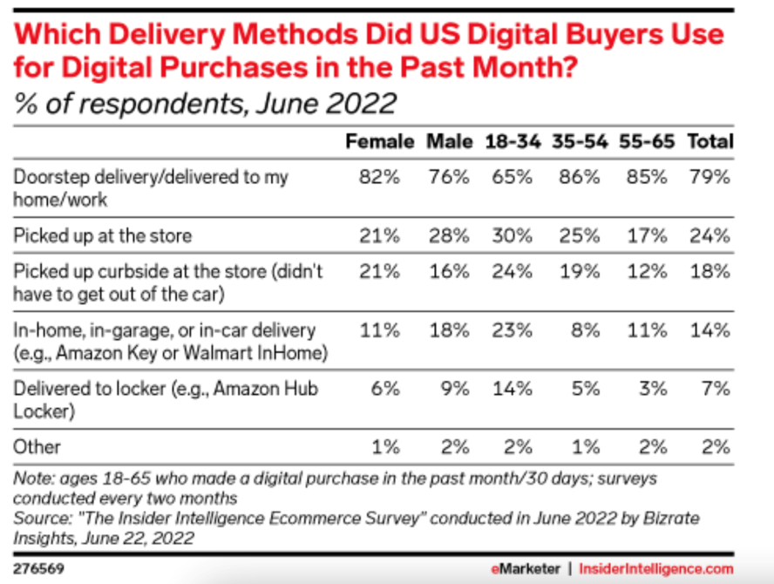
Table 4: Delivery Methods for digital purchases(Marketer, 2022)

Overall, a combination of internal and external concerns, such as the need to remain competitive, the expansion of e-commerce, and the rising rivalry from firms like Amazon, were the driving forces behind change at Walmart (Monteros, 2021). Walmart realised it had to change its business strategy in order to stay competitive and satisfy evolving consumer demands. This needed a change in organisational culture and values as well as large expenditures in e-commerce infrastructure.

2.4 THE RESISTERS FOR THE CHANGE
Cost: The expense of investing in e-commerce infrastructure, including technology, logistics, and marketing, was one of the main barriers to change. This required substantial financial investments, and there was a chance that they might not be profitable (Flora, 2022).
Existing business models were disrupted by the move to e-commerce, which necessitated considerable adjustments to Walmart's supply chain, logistics, and marketing plans (Meredith, 2022). It might be challenging to manage if this upsets current corporate structures and procedures.

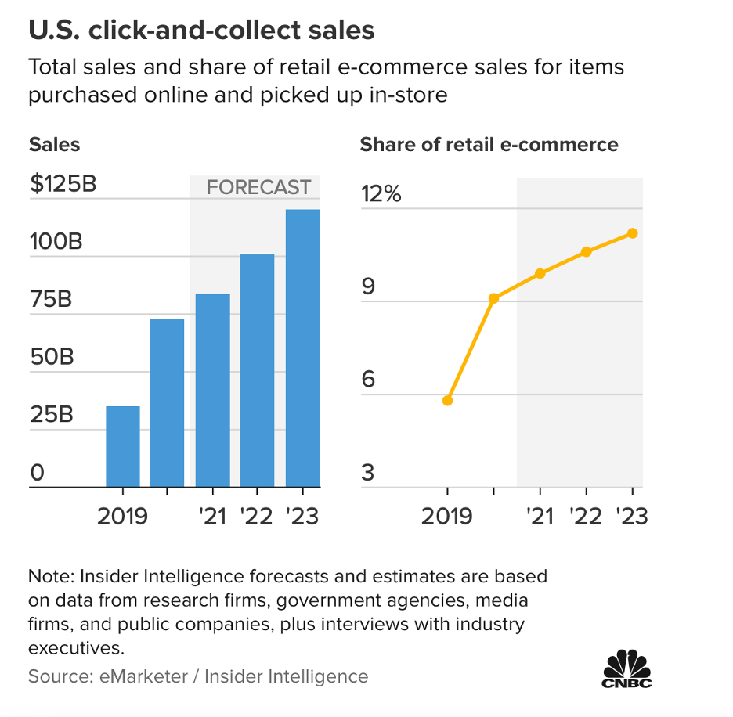
Table 5: Sales and shares of retail e-commerce(eMarketer, 2023)

Employee resistance: Some employees may not have had the new skills and competencies needed for the transition to e-commerce. The extensive training and education programmes that were required for this may have encountered resistance from some personnel (Abbas, 2023).

Cultural resistance: Walmart had previously prioritised cost reduction and efficiency, but the company now needs to place a fresh emphasis on customer experience and innovation as e-commerce takes hold (Edubirdie, 2023). It can be difficult to manage the change in organisational culture and values that was necessary.

Technical difficulties: The transition to e-commerce necessitated the adoption of new technologies and systems, which could be difficult to integrate with current systems and procedures. Technical difficulties and delays in implementation could result from this.

2.5 THE STAKEHOLDER ANALYSIS
Customers, employees, suppliers, and shareholders were among the stakeholder groups impacted by Walmart's change management initiatives in the field of e-commerce (Abbas, 2023).

Consumers: The change to e-commerce has an influence on a significant stakeholder group, including Walmart's consumers. Walmart needed to make sure that its online services satisfied shifting consumer expectations and offered a simple and straightforward buying experience (Richard, 2021). In order to enhance the online shopping experience and provide competitive pricing and delivery options, this requires investments in technology, logistics, and marketing.

Another significant stakeholder affected by the change to e-commerce was Walmart's workforce. To make sure that staff have the knowledge and abilities necessary to flourish in the new e-commerce environment, Walmart needed to offer sufficient training and educational programmes. In order to facilitate the transition to e-commerce, Walmart also wanted to make sure that its staff members were enthusiastic and engaged (Jason, 2019).

Suppliers: The change to e-commerce had an impact on Walmart's suppliers because the retailer needed to make sure that its supply chain and logistics operations could support the brand-new e-commerce activities (Matt, 2020). To make sure that they could adapt to the changing needs of Walmart's customers, this required cooperation and communication with suppliers (Melissa, 2022).

Shareholders: The change to e-commerce had an impact on Walmart's shareholders because the company had to invest a considerable amount of money in e-commerce infrastructure (Bentonville, 2015). Walmart had to explain its e-commerce strategy to shareholders and offer evidence that the investments would pay off.

2.6 LEWIN’S THREE-STEP MODEL APPLIED FOR THE CHANGE
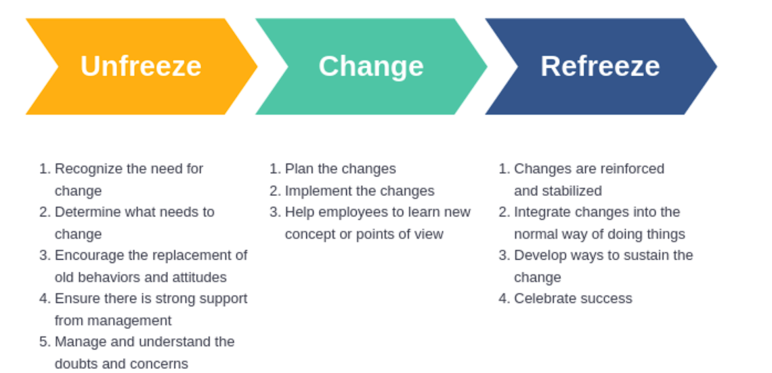
Table 6: Lewin's three-step Theory (Banker, 2021)

Unfreezing: The first phase in Lewin's three-step paradigm entails thaw out the current situation in order to provide room for change. Banker (2021) observed that this entails fostering a sense of urgency and raising awareness of the need for change. In the instance of Walmart's e-commerce change management initiatives, the unfreezing stage entailed raising awareness of the necessity of the switch and fostering a sense of urgency. In order to stay competitive in the e-commerce business, Walmart urgently communicated the need for change to its staff, shareholders, and customers.

Making the actual change is the second stage of Lewin's three-step paradigm. This entails putting new systems, practises, and procedures into place (DataHawk, 2022). Walmart's e-commerce change management activities involved investing in e-commerce infrastructure, such as technology, logistics, and marketing, in order to enhance its online offers and satisfy the rising demand for online purchasing. In order to take advantage of its physical locations and provide convenient options, Walmart also created new systems and procedures for online grocery pickup and delivery.

Refreezing: In the third stage of Lewin's three-stage paradigm, the new state is permanently anchored. This entails ensuring that the change is maintained and integrating the new systems, processes, and procedures into the organisational culture (Will, 2022). The refreezing step of Walmart's e-commerce change management activities involved integrating the new e-commerce systems, processes, and procedures into the organisational culture and making sure the change was long-lasting. In order to ensure that its staff members have the knowledge and abilities necessary to thrive in the new e-commerce environment, Walmart offered sufficient training and educational opportunities. Walmart also informed shareholders of its e-commerce plan and provided evidence that the investments will provide a profit.

2.7 KOTTER’S EIGHT-STEP MODEL APPLIED FOR THE CHANGE

The first step in Lewin's three-step paradigm is unfreezing, which calls for thawing out the current situation to provide room for change (CeMart, 2016). Creating a sense of urgency and increasing people's awareness of the need for change are crucial for this. The unfreezing stage in the case of Walmart's e-commerce change management activities entails creating urgency and increasing awareness of the need for the transformation. Walmart quickly informed its shareholders, employees, and consumers that it needed to modernise in order to compete in the e-commerce industry, observed by Fishman (2006).

Implementing the change is the second level of Lewin's three-step model. To do this, new procedures, frameworks, and procedures must be implemented (Perez, 2020). Walmart invested in e-commerce infrastructure, such as technology, logistics, and marketing, as part of its e-commerce change management programmes in order to improve its online offerings and meet the growing demand for online shopping. According to Shelley (2020), to maximise its physical locations and provide useful options, Walmart devised new procedures and practises for online grocery pickup and delivery.

Refreezing: The new state is firmly established in the third stage of Lewin's three-stage paradigm. This calls for maintaining the change and incorporating the new systems, processes, and procedures into the culture of the organisation. Refreezing involved integrating the new e-commerce systems, processes, and procedures into the organisational culture and ensuring the change was long-lasting. This was done as part of Walmart's e-commerce change management initiatives. Walmart provided enough training and educational opportunities to ensure that its employees had the skills required to prosper in the new e-commerce market. Walmart also disclosed its e-commerce strategy to shareholders and presented proof that the investments will generate a profit.

2.8 EVALUATION OF WALMART
The majority of Walmart's e-commerce change management strategies have been effective. Walmart invested in e-commerce infrastructure to enhance its online products and to fulfil the rising demand for online shopping after realising that it needed to increase its online presence to compete with e-commerce behemoths like Amazon (Mesilla, 2022). Walmart upgraded its online offerings to draw people searching for a mix of online and offline shopping experiences while using its existing shops to provide handy choices like online grocery pickup and delivery (Ashani, 2022).
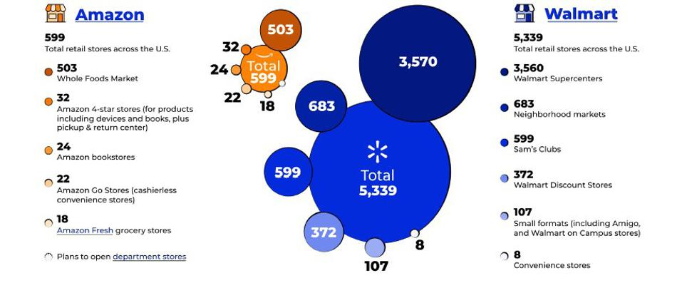
Table 7: Walmart and Amazon retail stores (Forbes.com, 2021)

Lewin's three-step model and Kotter's eight-step model implementation assisted Walmart in taking a methodical approach to its change management projects and dealing with change resistors (Reuters Staff, 2017). Walmart was able to successfully implement its e-commerce initiatives and enhance its online offerings by raising awareness of the need for change, developing a clear vision and strategy for the change initiative, communicating the vision to all stakeholders, empowering people to act on the vision, creating short-term wins, consolidating gains and producing more change, and anchoring new approaches in the organization's culture (Wong and Gao, 2014).

Due in part to the COVID-19 epidemic and rising online shopping demand, Walmart's investments in e-commerce have paid off, with its online sales rising by 79% in Q2 2020. Walmart has seen great success with its online grocery pickup and delivery services, expanding its selection to new regions and investing in technology to enhance the user experience. Walmart's investments in e-commerce have aided the business in positioning itself for future growth and helping it to remain competitive in the e-commerce market (BBC, 1999).

But there are still some areas where Walmart could improve. Walmart should keep investing in technology and logistics to improve the online shopping experience and offer competitive pricing and delivery options. Walmart should also keep spending money on employee education and training programmes to make sure that staff members have the skills essential to prosper in the new e-commerce climate. Last but not least, Walmart must continue to pay attention to what its customers want and adjust its online offerings accordingly.

Overall, Walmart's e-commerce change management activities have been largely effective, and the business has established itself as a market leader. To fulfil the evolving needs of its customers and to stay competitive in the e-commerce sector, Walmart should continue to invest in e-commerce infrastructure, although there is still room for improvement.

3. RECOMMENDATION
Maintaining an investment in e-commerce infrastructure would help Walmart to offer competitive price and delivery alternatives while also enhancing the online shopping experience. By doing this, Walmart will be able to accommodate its consumers' evolving needs while still remaining competitive in the e-commerce sector.

Invest in employee education and training programmes: Walmart should keep funding these initiatives to provide staff members the knowledge and abilities necessary to thrive in the new e-commerce environment. This will make sure that staff members are prepared to assist Walmart's e-commerce ambitions and offer exceptional customer service.

Customers' needs change over time, therefore Walmart should continue to pay attention to them and modify its online services to match their needs. This will ensure that customers continue to find Walmart's online services valuable and appealing.

Sustainability should be incorporated into e-commerce operations by Walmart by providing sustainable packaging options, promoting sustainable items, and reducing its environmental effect. This will show Walmart's dedication to sustainability and help it win over environmentally aware shoppers.

Reference
Ashani Thomas. (2022), ‘An Investigation into Walmart: Navigating Organizational Change Amid Post-COVID-19 Operation(s)’[Online] Available: https://www.linkedin.com/pulse/investigation-walmart-navigating-organizational-change-ashani-thomas. Accessed 2022, April 10th

An inside look at the ups and downs of Walmart’s journey. (2017), Harvard Business Review. [Online] Available: https://hbr.org/2017/03/we-need-people-to-lean-into-the-future Accessed 2023, July 18th.

Anthony Wong, I. and Hong Gao, J.(2014), ‘Exploring the direct and indirect effects of CSR on organizational commitment’. Int J Contemp Hospitality Mngt, 26(4), pp.500-525.

Abbas, T.(2023), Walmart Change Management Case Study, CMI. Available at: https://changemanagementinsight.com/walmart-change-management-case-study/ Accessed 2023, July 19th

BBC News (2015), ‘The Company File “Wal-Mart bids for Asda’ [Online] News.bbc.co.uk. Available: http://news.bbc.co.uk/1/hi/business/368430.stm Accessed 2015, January 8th

By, R. T. (2005), ‘Organisational change management: A critical review’. Journal of change management, 5(4), pp.369-380.

CeMart.com. (2016), ‘Why Walmart's supply chain is one of the world's best’ [Online]. Available: https://www.cemat.com.au/blog/walmarts-supply-chain. Accessed 2016, Oct 4th

Charles Fishman. (2006),‘The Wal-Mart Effect’ [Online].Penguin Random House, Available: https://www.penguinrandomhouse.com/books/294987/the-wal-mart-effect-by-charles-fishman/. Accessed 2006, April

Crick, J. M., & Crick, D. (2020). ‘Coopetition and COVID-19: Collaborative business-to-business marketing strategies in a pandemic crisis’. Industrial Marketing Management, 88, pp.206-213.

Daniel Pereira. (2023), ‘Walmart SWOT Analysis’ [Online] Available: https://businessmodelanalyst.com/walmart-swot-analysis/ Accessed 2023, March 23th

DataHawk.com.(2022),’Walmart Supply Chain Challenges and Solutions’ [Online]. Available: https://datahawk.co/blog/walmart-supply-chain-solutions, Accessed 2022, Dec 7th

Edubirdie, (2023), ‘Walmart: Management, Competencies And Business Model.’ [Online]. Available: https://edubirdie.com/examples/walmart-management-competencies-and-business-model/, Accessed 2023, Apr 29

ESG. (2022), ‘Equity & Inclusion at Walmart & Beyond’ [Online]. Available: https://corporate.walmart.com/esgreport/esg-issues/diversity-equality-inclusion, Accessed 2022, July 21th

ESG. (2022), ‘Product Supply Chain Sustainability’ [Online]. Available: https://corporate.walmart.com/esgreport/environmental/product-supply-chains-sustainability-overview, Accessed 2022, July 21th

ESG. (2014), ‘Walmart will accelerate investments in e-commerce and moderate global square footage growth’ [Online] Available: https://corporate.walmart.com/newsroom/2014/10/15/walmart-will-accelerate-investments-in-e-commerce-and-moderate-global-square-footage-growth, Accessed 2014, October 14th

ESG. (2015), ‘Walmart strategy drives growth and sustainable returns, Plans $20 billion share repurchase program over two years’ [Online]. Available: https://corporate.walmart.com/newsroom/2015/10/14/walmart-strategy-drives-growth-and-sustainable-returns-plans-20-billion-share-repurchase-program-over-two-years, Accessed 2015, October 14

Greenspan, R. (2023), ‘Amazon Five Forces Analysis (Porter model)’, [Online]. Panmore Institute. Available: https://panmore.com/amazon-com-inc-five-forces-analysis-recommendations-porters-model Accessed 2023, July 18.

He, W., Tan, E. L., Lee, E. W., & Li, T. Y. (2009), ‘A solution for integrated track and trace in supply chain based on RFID & GPS.’ In 2009 IEEE conference on emerging technologies & factory automation pp. 1-6.

Hornstein, H. A. (2015), ‘The integration of project management and organizational change management is now a necessity’. International journal of project management, 33(2), pp. 291-298.

Hussain, S. T., Lei, S., Akram, T., Haider, M. J., Hussain, S. H., & Ali, M. (2018), ‘Kurt Lewin's change model: A critical review of the role of leadership and employee involvement in organizational change’ Journal of Innovation & Knowledge, 3(3), pp.123-127.

Jason Del Rey. (2019), ‘Inside the conflict at Walmart that’s threatening its high-stakes race with Amazon’ [Online] Available: https://www.vox.com/recode/2019/7/3/18716431/walmart-jet-marc-lore-modcloth-amazon-ecommerce-losses-online-sales, Accessed 2019, Jul 3th

Kestenbaum, R. (2022), ‘Walmart is gaining on Amazon in e-commerce’, Forbes. Available: https://www.forbes.com/sites/richardkestenbaum/2021/10/20/walmart-is-gaining-on-amazon-in-e-commerce/?sh=6a0e8164653c Accessed 2023, July 17th.

Matt Rickerby. (2020), ‘Walmart Supply Chain: Why It Will Continue To Dominate Through 2023’. [Online]. Available: https://www.extensiv.com/blog/supply-chain-management/walmart, Accessed 2020, JAN 4th

Melissa Repko. (2022), ‘Walmart is using its thousands of stores to battle Amazon for e-commerce market share’, [Online] Available: https://www.cnbc.com/2022/06/02/walmart-bets-its-stores-will-give-it-an-edge-in-amazon-e-commerce-duel.html, Accessed 2022, JUN 22th

Meredith Flora. (2022), ‘Walmart Supply Chain: What Makes It (Still) So Successful’, [Online] Available: https://www.shipbob.com/blog/walmart-supply-chain/, Accessed 2022, August 19th

Monteros, M. (2021), ‘How Amazon and Walmart’s head-to-head competition is changing retail,’ Retail Dive. [Online] Available: https://www.retaildive.com/news/how-amazon-and-walmarts-head-to-head-competition-is-changing-retail/595762/ Accessed 2023, July 17th.

Meredith F. (2023) ‘Walmart supply chain: What makes it (still) so successful’ ShipBob. [Online] Available: https://www.shipbob.com/blog/walmart-supply-chain/ Accessed 2023, July 18th.

Pandey, R et al. (2021), ‘Factors Influencing Organization Success: A Case Study of Walmart’. International Journal of Tourism and Hospitality in Asia Pasific (IJTHAP), 4(2), pp. 112-123.

Pereira, D. (2023), ‘Walmart Swot Analysis (2023)’ Business Model Analyst. [Online] Available: https://businessmodelanalyst.com/walmart-swot-analysis/ Accessed 2023, July 19.

Reuters Staff. (2017), ‘Wal-Mart's leadership expands exec roles in online push’ [Online]. Available: https://www.reuters.com/article/us-walmart-restructuring-idUSKBN14X2HF. Accessed 2017, JANUARY 14th

Richard Kestenbaum. (2021), ‘Walmart Is Gaining On Amazon In E-Commerce’ [Online] Available: https://www.forbes.com/sites/richardkestenbaum/2021/10/20/walmart-is-gaining-on-amazon-in-e-commerce/?sh=12810af8653c, Accessed 2021, October 20th

Sarah Perez. (2020), ‘Pandemic helped drive Walmart e-commerce sales up 97% in second quarter’. [Online]. Available: https://techcrunch.com/2020/08/18/pandemic-helped-drive-walmart-e-commerce-sales-up-97-in-second-quarter/. Accessed 2020, August 18th

Sharma, P., Leung, T. Y., Kingshott, R. P., Davcik, N. S., & Cardinali, S. (2020). ‘Managing uncertainty during a global pandemic: An international business perspective’. Journal of business research, 116, pp.188-192.

Shelley E. Kohan. (2020), ‘Walmart’s Online Sales Have Surged 74% During the Pandemic’[Online]. Available: https://www.forbes.com/sites/shelleykohan/2020/05/19/walmart-revenue-up-86-e-commerce-up-74/?sh=7929224c66cc. Accessed 2020, May 19th

Stankevičiūtė, E., Grunda, R., & Bartkus, E. V. (2012), ‘Pursuing a cost leadership strategy and business sustainability objectives: Walmart case study.’ Economics and Management, 17(3), pp.1200-1206.

Spicer, A., & Hyatt, D. (2017), ‘Walmart’s emergent low-cost sustainable product strategy.’ California Management Review, 59(2), pp.116-141.

Song, X. (2018), ‘A study on management model of human resources in multinational companies based on cultural differences--taking walmart as an example’. In 2018 International Conference on Sports, Arts, Education and Management Engineering (SAEME 2018), pp. 292-295, Atlantis Press.

Steve Banker. (2021), ‘Walmart’s Massive Investment In A Supply Chain Transformation’ [Online]. Available: https://www.forbes.com/sites/stevebanker/2021/04/23/walmarts-massive-investment-in-a-supply-chain-transformation/?sh=47fa9aee340e, Accessed 2021, April 23th

Tricia McKinnon.(2023), ‘6 Reasons Walmart’s eCommerce Strategy is Winning’ [Online], Available: https://www.indigo9digital.com/blog/4-secrets-to-walmarts-ecommerce-sucess, Accessed 2023, March 9th

Will Kenton. (2022), ‘The Walmart Effect Explained, With Pros and Cons’[Online]. Available:
https://www.investopedia.com/terms/w/walmart-effect.asp.Accessed 2022, April 28th

