Assignment feedback

Student Name: Rosie Nye
Student University Email: 1400683@student.uwtsd.ac.uk
Module code: AHAN7028  Module title: Heritage: Representation and Interpretation | Student ID number:  1400683 |  | Educational support needs:  Yes
Assignment title: Research Report on the Representation and Interpretation of Carew Cheriton Air Tower

Assignment due date: 1/2/2019
Assignment Number: 2
(i.e. 1,2,3)
Marker’s signature: |  | Date:
Provisional.
NB. All marks are provisional until confirmed by the final examination board.

Research Report on the Representation and Interpretation of Carew Cheriton Air Tower.

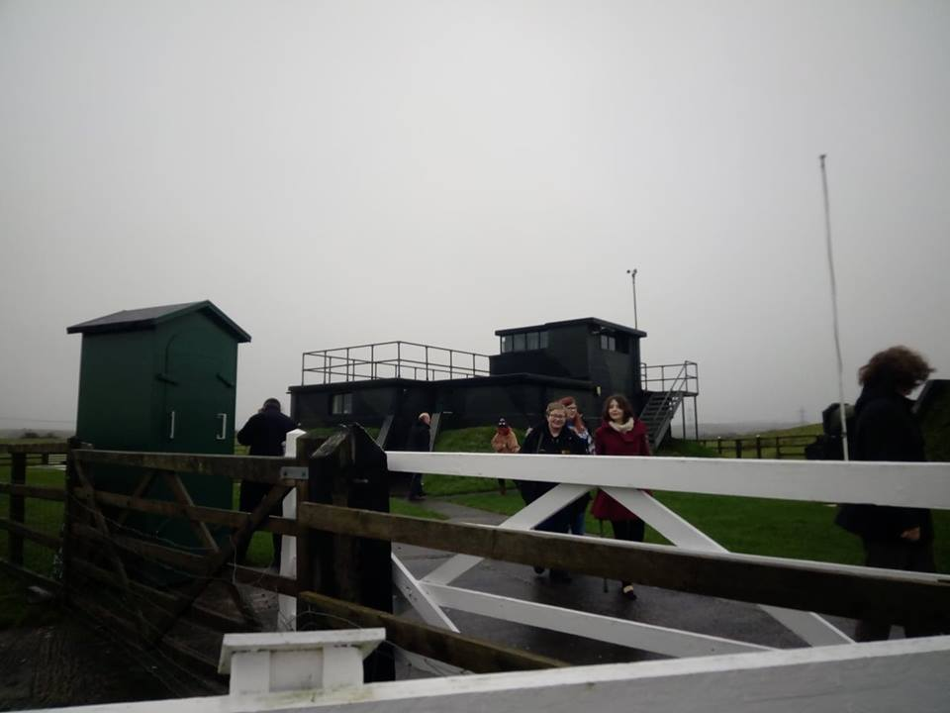

By Rosie Nye.
MRes Student in Heritage Practice
AHAN7028

1. Introduction
Heritage sites often rely on the interpretations and perceptions of tourists in order to promote the artefacts which they display (Poria et al 2016: 162). Tourists often arrive with preconceived ideas about the history that the site is showing (Assmann 1995: 130), thus impacting how a site is represented and interpreted. In order to fully understand this, it must first be accepted that heritage is the selective use of history to encourage and promote the present (McDowell 2016:40). Therefore, it can be suggested that the representation of sites is manipulated in order to suit the heritage which figures in authority wish to convey; a sentiment which will be further examined.
Within a heritage setting, interpretation, and the use of interpretation, are used to provide a discussion about an object or to translate artefacts and information into a language that visitors can comprehend (Edson and Dean 1994: 171). In order for sites of heritage to attract the desired number of visitors, they need to interpret and represent the past by providing “authentic” and eye-catching displays (MacDonald 1998: 120). Museums emphasise the use of interpretation and representation in an educational setting, passing along the knowledge to visitors (Glaser and Zenetou 1996: 41).
This report will examine the roles of representation and interpretation on the site of Carew Cheriton Air Tower (further referred to as C.C.A.T), Carew, Pembrokshire. It will identify the site, provide a brief theoretical background of the terms being discussed as well as providing an examination of the site; how the site is represented and interpreted and how the site manipulates the artefacts to put forward such interpretations and representations.

2. Introduction and brief history of the site.
Carew is a location which is saturated in history. From the medieval castle (Figure 1), an imposing and towering structure overlooking the landscape (King and Perks 1962: 270), to the one-thousand- year-old Celtic Tower (Figure 2), it is incredibly difficult to deny that Carew is a village of historical significance to both the archaeological record and the heritage sector. C.C.A.T is no exception to this. Originally established in 1915 as a Royal Navy Air Station, it was in 1938 that the new airfield began construction and period of frantic activity began (Thomas 2008, Brock 2008: 3).
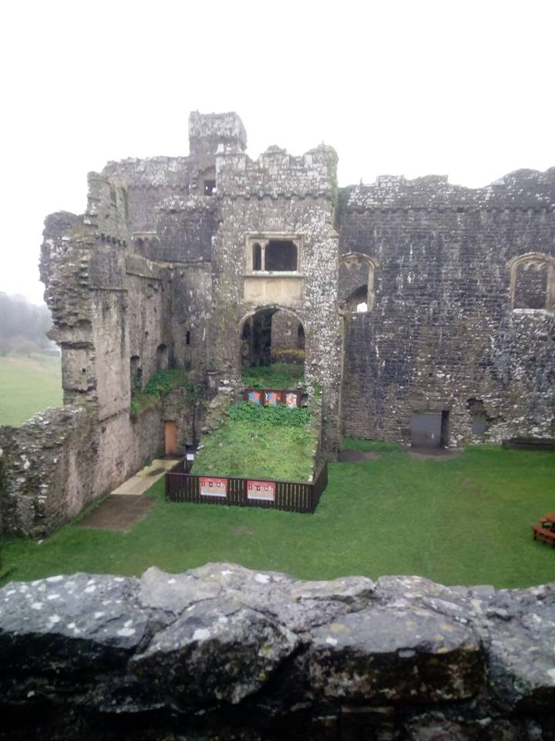
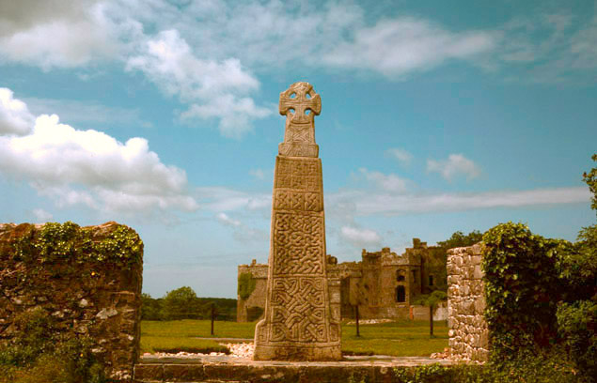
Fig. 2. The Celtic Tower (Cadw 2016).
Fig. 1. The Inside of Carew Castle (Nye 2018).

The first unit which arrived at Carew Cheriton Air Field was the ‘B’ Flight of Number I Anti-Aircraft Co-operation Unit with the Hawker Henley Aircraft (Thomas 2008), which spent the entire war at Carew. The site was under the control of Coastal Command and soon became home to the Avro Ansons of 217 Squadron (Thomas 2008); the squadron which carried out coastal water patrols. The entirety of the war would see the Coastal Command Development Unit spending a year at the airfield in order to develop and test new techniques in the battle against the U-Boats (Thomas 2008).
The German Luftwaffe took a particular interest in Carew Cheriton Air Field, and a number of air raids were conducted between July 1940 and April 1941, resulting in the loss of thirteen lives, including the twelve lives claimed in April 1941 when a sick bay obtained a direct hit (Thomas 2008).
In 1942, the airfield changed to the Technical Training Command in October 1942, the freshly established No. 10 Radio School beginning its training programme at the site. This training continued until the entire unit disbanded a few months after the end of the Second World War. Not long after this, the airfield closed (Thomas 2008).
Now, the location of C.C.A.T has joined the collection of World War Two sites which have become a time-capsule; a site frozen in time. After being left to the landscape for the rest of the twentieth century, a community project begun in 2000 to reconstruct and restore the site to its former glory.
In 2000, the Carew Cheriton Control Tower Group was formed and has painstaking restored (Figures 3 and 4) and looked after the site for the past nineteen years; preventing this wartime structure from falling completely into disrepair or being demolished (Carew Cheriton Website: 2016). The group has three main aims, as stated on the Carew Cheriton Website (2016):
- “ A lasting memorial to all who served on the airfield through two world wars. And to the airmen who main the supreme sacrifice during those years.
- A structure for education use focused on school ad group visits who are studying this period of modern day history.
- A tourist attraction offering a wartime experience.”
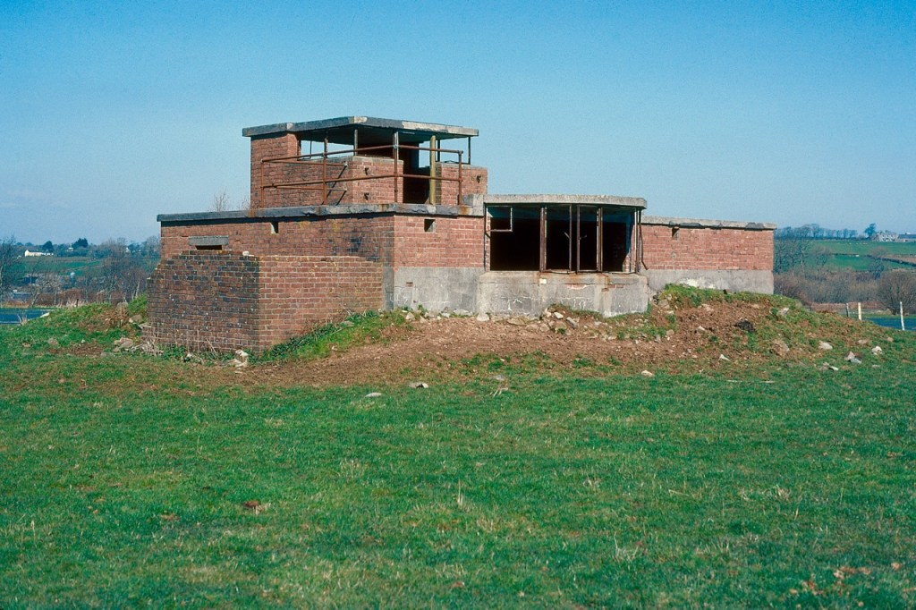

Fig.3. Carew Cheriton Air Tower before the restoration project. (Carew Control Tower Website 2016).

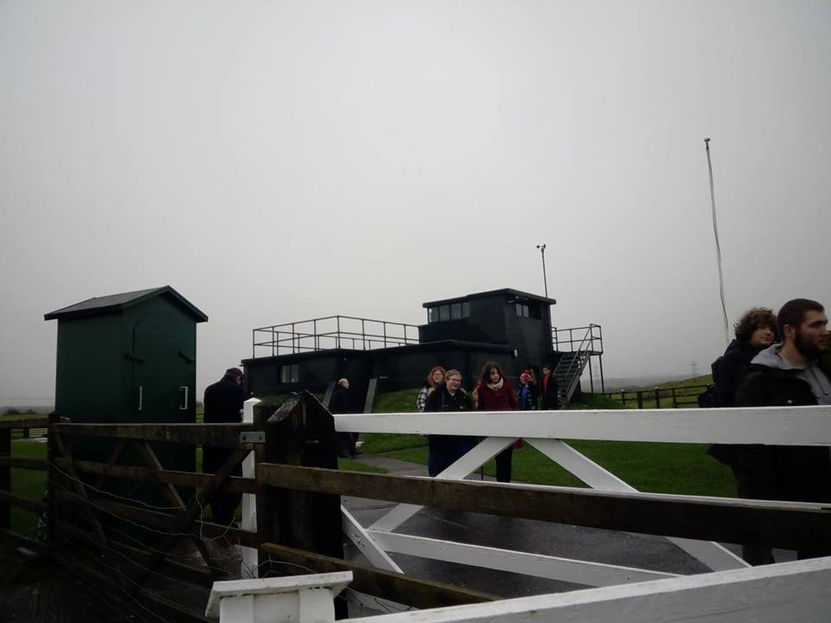

Fig.4. Carew Cheriton restored to how it used to look (Nye 2018).

The project involves a wide variety of groups from the entire local community and is now run by volunteers, jobs ranging from reconstruction and restoration to giving talks to local school children. C.C.A.T is now a location which is loved by many and provide the local area with an important heritage site.
One of the most interesting aspects of the site, is that is mostly run by volunteers who experienced the Second World War, therefore presenting the notion that the representation of the site put forward is one that could be considered both accurate and “authentic” (Waitt, 2000: 836). However, in order to examine this prospect, the theoretical perspectives of representation and interpretation must first be considered.
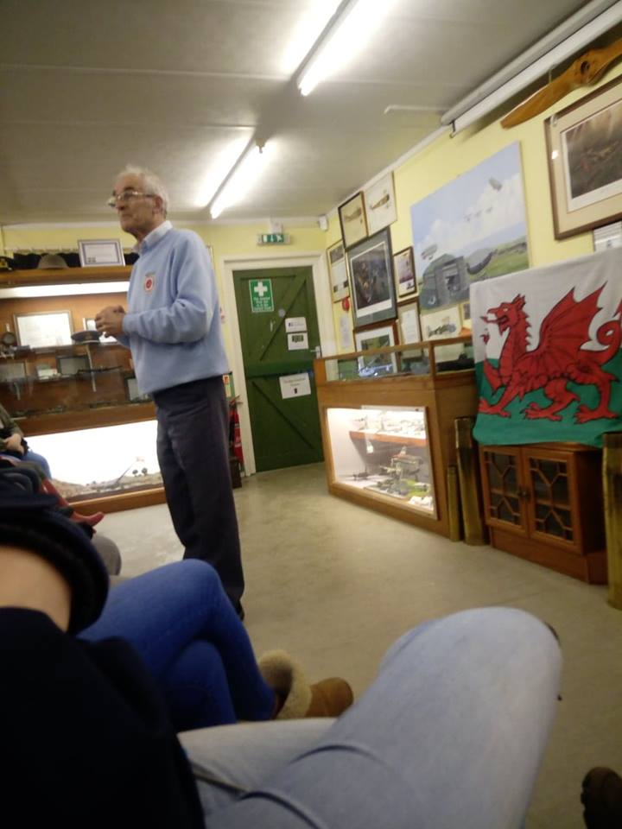
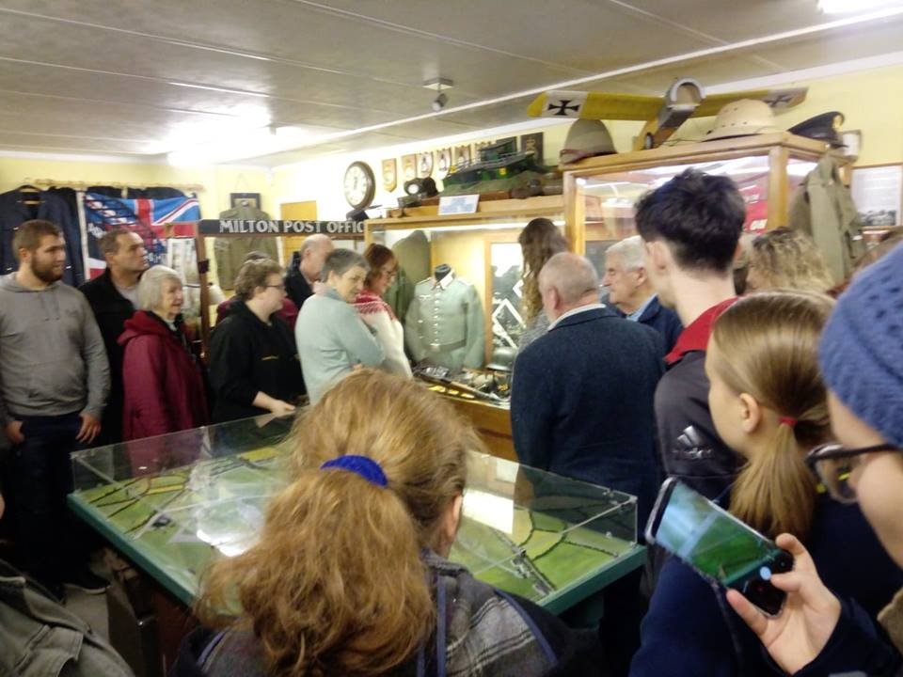
Fig.5. A talk by one of the volunteers (Nye 2018).
Fig.6. Volunteers talking to university students (Nye 2018).

3. Theoretical background to representation and interpretation.
According to Poria et al, despite the numerous definitions of the term “interpretation”, no universal definition has been presented (2009: 93). However, they do propose that a working definition that is adopted in their work is as follows: “Interpretation is the process of the transmission of knowledge, its diffusion, and its reception and perception by the individual” (2009: 93). Other definitions touched upon include the statement that “interpretation can be defined as the transmission of information”, interpretation creating an understanding of history for a visitor (Poria et al 2009: 93). Regardless of which definition is used when discussing the role of representation and interpretation, it can be, and has been, universally agreed, that it does have an impact (Uzzell 2006: 1). The majority of academic literature does show that interpretation is predominately visitor and individual orientated, Uzzell stating that an individual’s interpretation of a site is dependent on the attitudes that an individual has already conceived.
Hall in 1994, states that heritage sites predominately put forward a sole, monolithic interpretation influenced by a singular ideological structure. Interpretation is dependent on both individual perceptions and the closeness of public memory to the events or artefacts on display (Harvey 2001: 328). Visitors create their own interpretations which presents the notion that the dominant ideology thesis, as discussed by Walsh (1992: 131), are redundant; one’s reinterpretation of an object coinciding with the “produced” interpretation from the heritage site (Walsh 1992: 132). The Post-Modernist perceptions are, for the majority, superficial and do not offer opportunities for visitors to ask questions about the narratives being presented to them (Walsh 1992: 132). As such, Uzzell states how he believes that interpretation is now stuck in a rut and will only have any form of significant impact on the heritage industry where practice is influenced by articulated theories (Uzzell 2006: 2). What is of interest when considering theory in representation and interpretation, is that it is often simply stated and assumed in academic literature (Uzzell 2006: 2); a failure to put forward assumptions regarding theoretical perspectives. Nonetheless, these theoretical perspectives are still present in such literature even if not fully articulated.
Representation is needed in a heritage site for any interpretations of the past to be made. The link between the two is irrefutable; one cannot work without the other. By definition, representation is as follows. “Representation is the depiction or portrayal of someone or something in a particular way” (Oxford Living Dictionary 2019). From just looking at the definitions of the two words, it clear that the link, which has been mentioned, is almost essential for the display of a heritage site.
Representation and interpretation, like authenticity in heritage, is given legitimacy and validation by those who read the interpretations offered by heritage sites (Walsh 1992: 131). This suggests that interpretation and authenticity work hand in hand when examining heritage tourism. People’s interpretations and the successfulness of the representations are dependent on whether they could consider the artefacts or exhibitions to be “authentic” and a true depiction of the past (Belhasson and Caton 2006).
Throughout the course of this report, the above definition put forward by Poria et al will be the definition used in order to examine how C.C.A.T has been represented and interpreted since its restoration in the early 2000s. The close connections between how a site is represented and interpreted with the perception of authenticity will also be considered, as it would be difficult to examine one without considering the impacts of the other.

4. A description and examination of the site.
4:1. Museum and Learning Space.

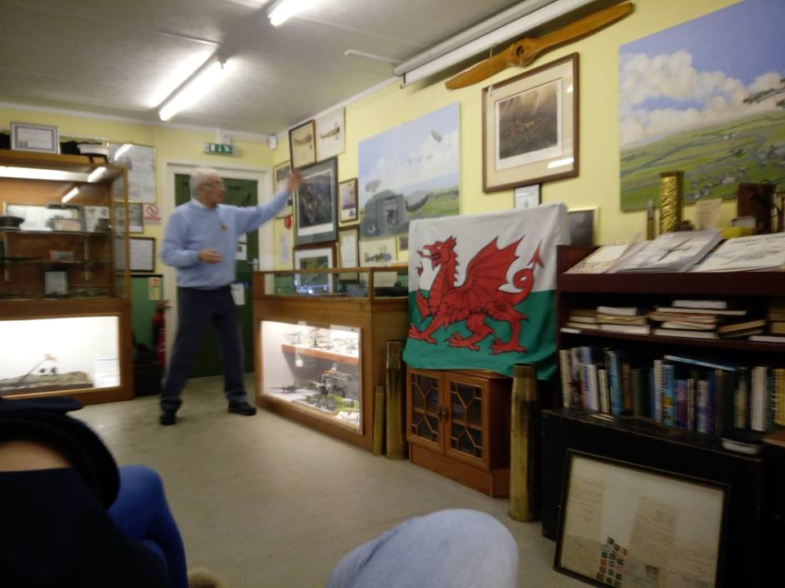

Fig.7. The main museum space (Nye 2018).

The first location the visitors are taken to is the museum (Figure 7), in one of the buildings near the control tower. Once inside, the individuals are able to sit in the museum are, surrounded by both First World War and Second World War artefacts. Glass cabinets line two of the walls, with information and photographs lining the other walls which can inform and educate. The wall at the head of the room has paintings of the site from both the wars with hand-made models supporting the information already available.
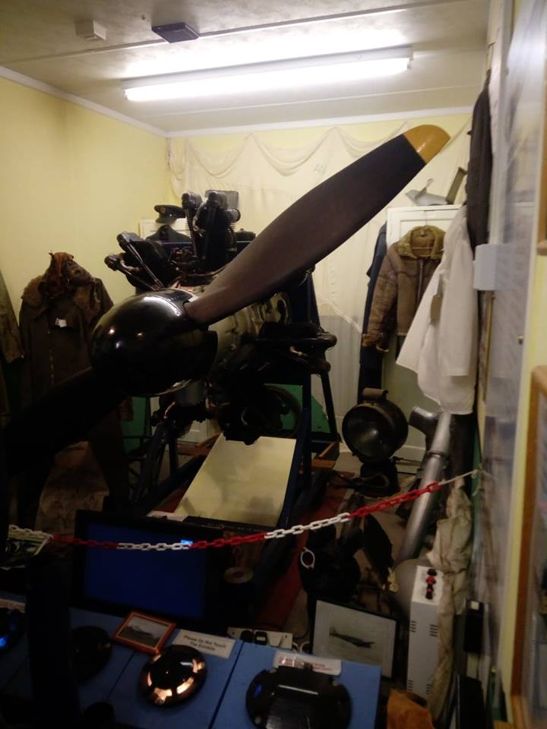
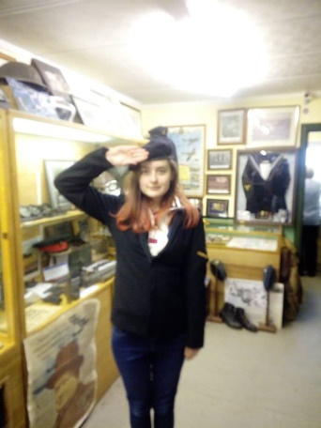
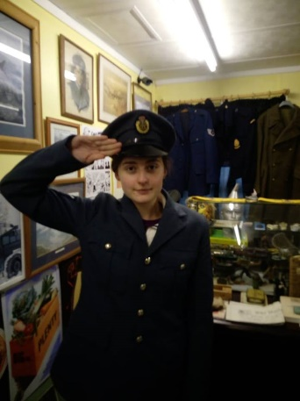
There are three other rooms connected to the main museum area. The first contains a propeller from a one of the World War Two aircraft (Figure 8); a sound system helping to recreate the atmosphere by playing the noises such a plane would have made. The second room contains a reconstruction of a World War Two post office at one end of the room (Figure 9). A model of the site in a glass container takes up most of the space, being located in the middle of the room. As with the main museum area, there are artefacts in glass cabinets on one wall, photos and written information on the other. Here, visitors are able to examine photographs of pilots and see how the site would have appeared in the 1930s and the 1940s. The final room contains military uniforms, which date the Second World War. These, visitors are allowed and encouraged to try on; in effect putting themselves into history (Figure 10). No longer are they disassociated with the events of the time, but now a part of it through the action of trying on uniforms. Individuals are now able to immerse themselves in the history they wish to be a part of.
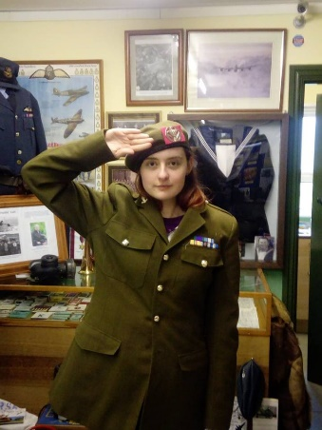

Fig.8. The Propeller Room (Nye 2018).
Fig.10. Photos of author in the uniforms that visitors can try on (Nye 2018).

Fig.9. The model of the airfield with the recreation of the Post Office in the background (Nye 2018).

Returning to the main area of the museum, visitors are able to enjoy a cup of tea and a biscuit whilst listening to intangible heritage; stories, personal and otherwise, being given by the volunteers who so passionately pieced the site back together. Further information is given to visitors in terms of showing visitors trench art (Figure 11), artefacts that are not available at any other museum, and informing people on how to tell the difference between a live and a dead bullet. Not only is the safety of visitors being considered, but the stories, especially the personal stories, provide a living link between the time period being examined and the present day.
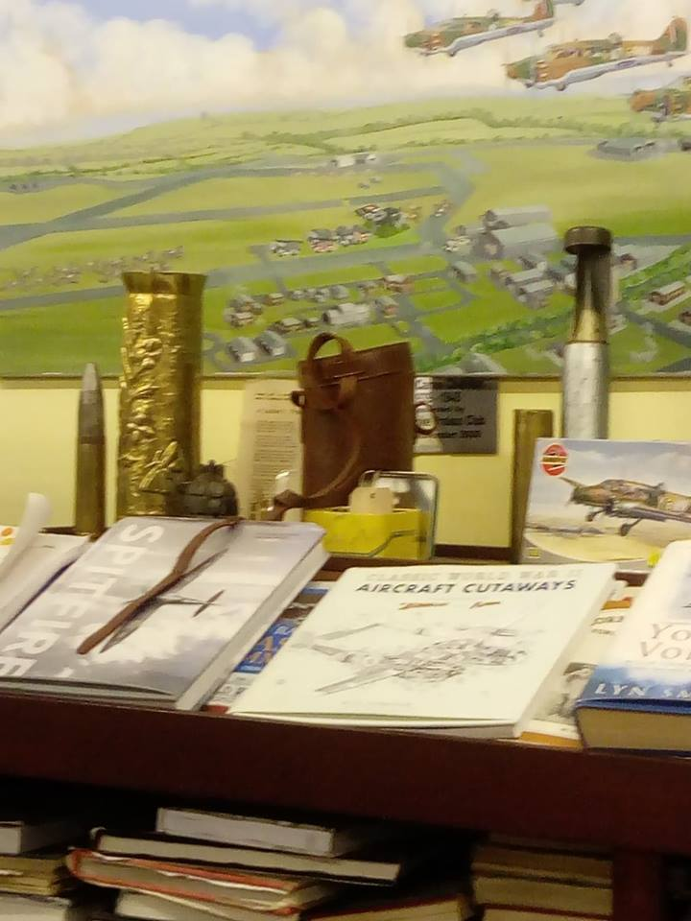

Fig.11. Trench Art can be seen to the left of the photograph (Nye 2018).
When examining the museum in terms of representation, it is clear that the majority is exhibited in a similar way to a large number of other museums. The artefacts are carefully and meticulously placed behind glass with little cards providing information to visitors. However, unlike some museums, C.C.A.T has the volunteers put forwards talks and take the visitors section by section into the other areas of the site. The use of intangible heritage adds to the interpretations which the visitors would have already obtained; further encouraged with the aids of the uniforms and the handling of artefacts. Such artefacts which the volunteers insist are the authentic article (see Section 6 for more details on authenticity). However, it could still be argued that representation and interpretation of the site is influenced by such intangible heritage and, as a result, the figures in authority.

4:2. Air hanger and reconstruction of vehicles
The next area of C.C.A.T that will be examined is that of the Air Hanger which houses the reconstruction of both air and ground vehicles. Situated not too far from the main area of the museum, it contains rebuilt WW2 vehicles, including a Morris Oxford Series 2 (Figure 13), as well as the reconstruction and restoration in progress of an Avro Anson C19 of RAF Transport Command (Figures 11 and 12).

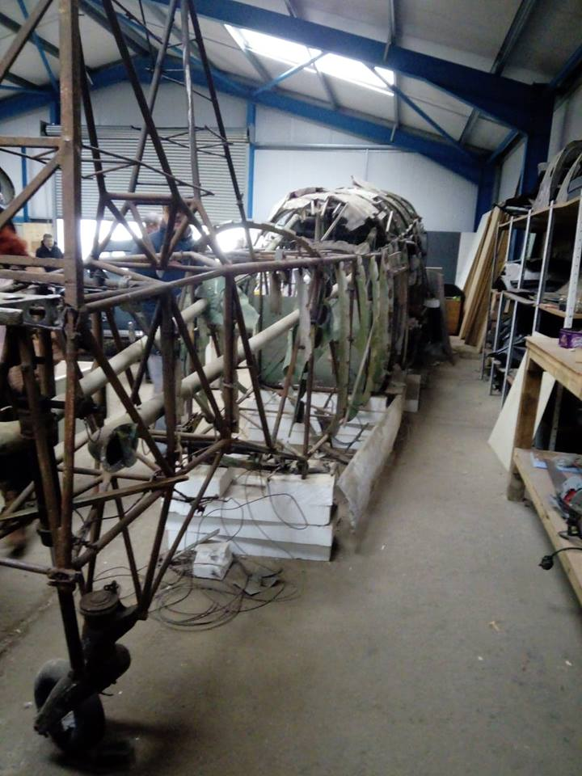
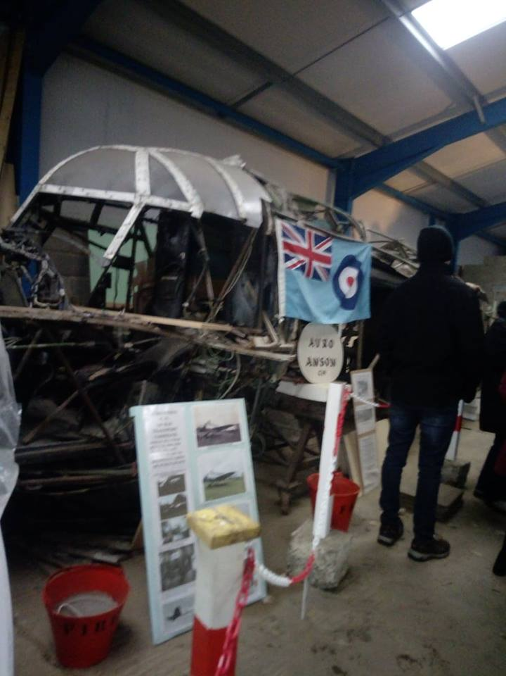
Fig.13. The Avro Anson Plane under reconstruction, tail end of the plane (Nye 2018).
Fig.12. The Avro Anson Plane under reconstruction (Nye 2018).

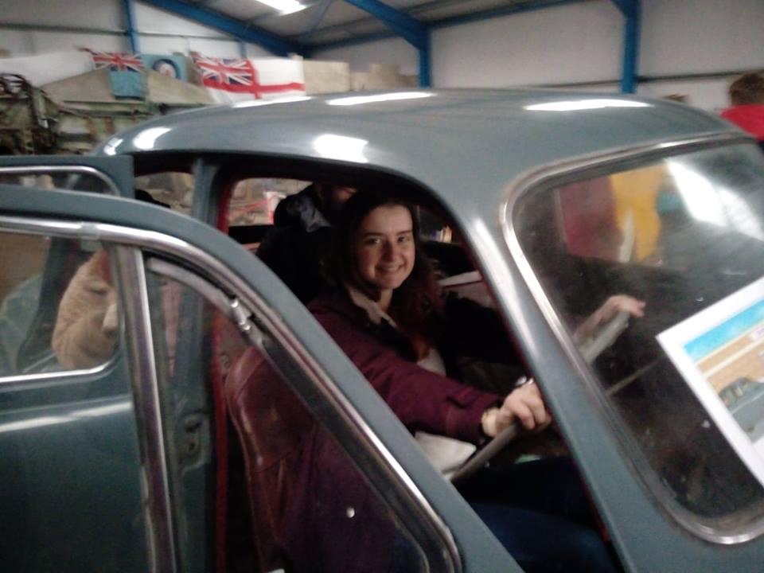

Fig.13. Myself being allowed to “drive” the Morris Oxford Series 2 (Nye 2018).

When visitors first enter the hanger, they are able to listen WW2 dance music whilst examining the vehicles at their leisure. The head of conservation often provides talks discussing and explaining the processes of reconstruction and restoration which are used in the building of the Avro Anson C19. Visitors are allowed, and encouraged, to thoroughly examine the restorations in order to obtain an understanding of the processes first hand. Not only this, visitors are allowed to sit in the vehicles, have their photos taken and pretend to drive (Figure 13), first hand engagement being clearly encouraged.
Here the representation and interpretation of the past can be split, quite literally, into sections. The reconstruction of the aircraft allows visitors to examine how some exhibitions are put together; therefore, they are able to put together their own interpretations without the constructed setting that the majority of other artefacts find themselves in. With that thought in mind, it must be considered that the talks provided could be referred to as the use of authority to influence the interpretations of the visitors. Visitors are commanded by the voice of authority; following the speaker around the hanger to see the separate parts of the plane.

4:3. Air Tower and Air Raid Shelter
The final locations that will be examined in this report, are that of the Air Tower and the Air Raid Shelter. Upon arrival, the tower is the first thing which catches your eye; commanding the attention away from the other buildings (Figure 14). The structure of the tower is unique, the wide window being one of its kind (Figure 15).

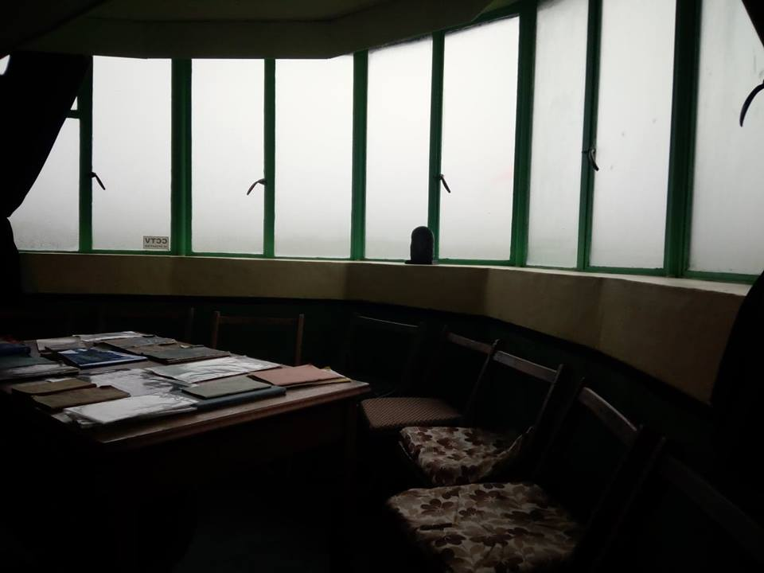
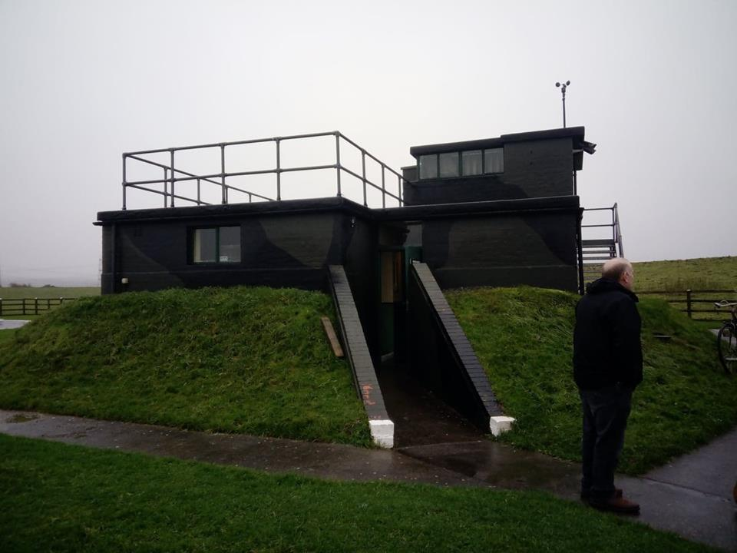
Fig.15. The unique observation window (Nye 2018).
Fig.14. The outside of the Air Tower (Nye 2018).

The inside of the tower has been painstakingly restored exactly the specific definitions and specifications of the original building. Even the paint is the exact colour that would have been present; samples of the original paint being taken to Dulux to get an exact match (Figure 16). WAAFs who used to work at the tower assisting the restoration with their knowledge of how the tower used to look. Personal stories are told with the use of props, such as a stuffed pigeon, costumes and Second World War Technology such as Morse Code Machines (Figure 17). Visitors are encouraged to engage with the stories and the props in order to obtain a better understanding of the atmosphere and experiences that would have been gained during the war. Once they choose to leave the building, they are able to climb up the ladder to the observation room before walking outside and descending a flight of stairs before walking to the air raid shelter. Here, visitors can place tin hats on their heads and join in with singing songs from the Second World War.
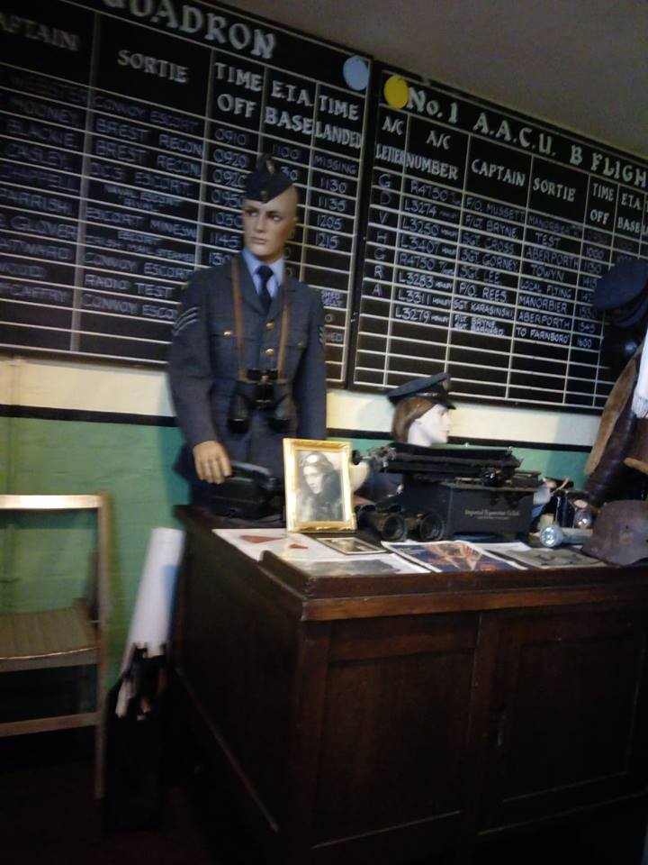
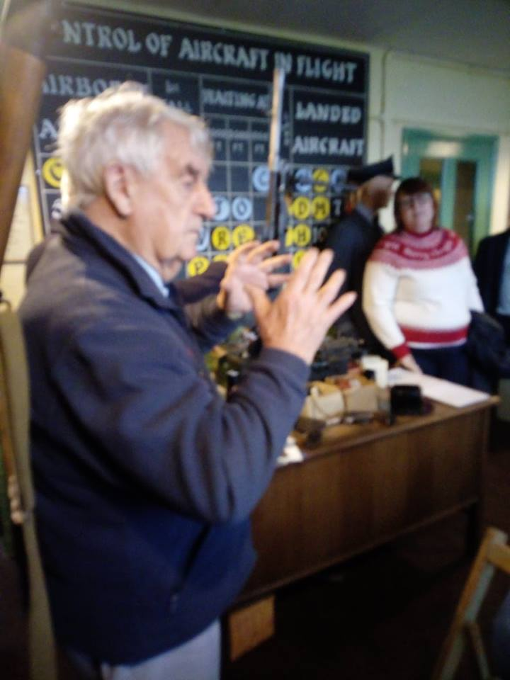

Fig.17. One of the volunteers discussing morse code (Nye 2018).
Fig.16. One of the reconstructions inside the tower (Nye 2018).
As has been mentioned, the volunteers tell personal stories in order to convey the history to the visitors. It seems that in each of the sections of the site, the interpretations are influenced strongly by the voices of authority and the feeling of being a part of a time gone. Furthermore, again the notion of nostalgia is influencing the representation of the site and the interpretations which the visitors will obtain. What also needs to be remembered is that visitors will be arriving to the site with their own interpretations before the examine the heritage in front of them. The curators would play on this notion to their advantage to ensure that, not only does the visitor enjoy their visit to the site, but also that they absorb the version of the past which they put forward. This will be further examined in Section 6 of the report.

5. Analysis and Comparison
In order to obtain a better understanding of how the site is represented, it would be prudent to examine another heritage site representing the same time period and compare the two. This section of the report will provide a brief examination of a second heritage site and a comparison between the site and C.C.A.T.
5:1 Tyneham Village.
Tyneham Village is a World War Two site located in the Lulworth area of Dorset (Figure 18). In 1943, the village was commandeered by the Ministry of Defence during the preparations for D-Day (Buckton 2008: 11). The villagers were told that they would be able to return once the emergency had abated. However, unfortunately in 1948, the village received a compulsory purchase order; freezing the village in time (Buckton 2008: 12). Over time, the village has fallen into disrepair, the refectory being cordoned off due to danger, and the roofs having been removed from the majority of buildings. Only the shells of the houses that were once home can be examined by the people who visit. Still in the hands of the Ministry of Defence, the site is open to the public for the majority of the year; visitors able to step back in time momentarily.
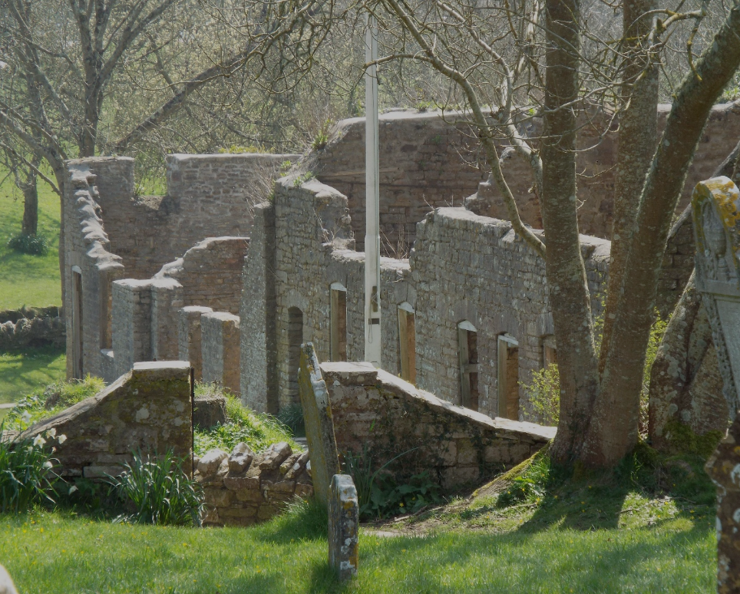

Fig.18. Tyneham Village (Nye, H 2018).

5:2 Comparison.
There is a notable difference between the heritage sites in how they have been represented and interpreted. As has been discussed, C.C.A.T has been restored to its original design. In contrast, Tyneham has been mostly left alone; now a location frozen in time. The roofs have been removed on the majority of buildings, nothing left inside. It is curious to see how the two locations from the same time period are interpreted and represented so differently to each other. This could be due to the fact that the two locations, although both from World War Two, have very different pasts. Tyneham is now owned, and has been owned for the past seventy years, by the Ministry of Defence, with numerous political actions from ex-residents attempting to regain what was once theirs. In contrast, C.C.A.T has been leased to the volunteers of the project, with freedom to reconstruct and restore; the two vastly different authorities having different methods of representation. The contrast in how the two sites are represented can be seen in Table 1. The most logistical reason as to why the sites are so different is fundamentally founded in the figures in authority manipulating the artefacts to convey the meanings and interpretation of the past that they wish to convey.
Tyneham | Carew Cheriton Air Tower
Left in situ | Restored
Owned by Ministry of Defence | Owned by the volunteers running the project
Open for set periods throughout the year | Open for set periods throughout the year
Information boards | Reconstruction of rooms, use of mannequins, Morse code machines etc
People left to explore, no tour guides/curators | Volunteers and people involved in restorations speak to visitors/ show them around the site
No specific museum (however, the village itself could now be considered a museum.) | Has a museum.

Table 1. A comparison of the two sites.

Comparison

6. Sense and Sensibility
6:1 Introduction.
Throughout the course of this report, I have identified the site that is being examined as well as providing a description and a discussion of how it represented and interpreted in relation to specific locations of C.C.A.T. In such, I have attempted to identify how interpretation and representation is influenced by a number of factors; a notion that is about to be further examined.
This section will examine a number of influencing aspects which could have an impact on the site as well as its representation and interpretation. It will identify how the figures in authority and the target audience have an impact. The final discussion, although there are more than the ones being highlighted, will be the more political influences on interpretation and representation; questioning whether the site can be contested and how it does not necessarily address all aspects of the time period it exhibits.

6:2 Telling a Story.
An aspect common to all heritage sites is the notion of empathy; the idea that we can travel into the past through the experiences we encounter (Walsh 1992: 101). When examining C.C.A.T there is a definite promotion of the idea that visitors are able to “travel back in time” through the feeling of nostalgia and the personal experiences which places them in a different time period. A number of heritage centres employ ‘post-modern’ media in their representation of the past, with C.C.A.T being no exception. Visitors can engage with sound, light, smells and costumes. However, these methods of representation could ‘drown out’ any intended education information (Walsh 1992: 106). It is almost too difficult to know when the entertainment stops, and the education starts. This notion of connecting to the past through entertainment methodologies would definitely impact the way in which Carew Cheriton is representing its past. As such, this can present the idea that Carew, as Walsh states, might be “merely attempting to titillate the sense and develop the simulacrum” (1992: 113).
Furthermore, the emphasis on the more entertaining aspects of the museum plays on the people’s nostalgia, having an immediate impact on how C.C.A.T is being represented. The curators of the site would recognise that this would encourage visitors to engage with the location, such as the singing of war songs in the air shelter. This manipulation of the representation of the site suggests that its interpretation is influenced by authority playing on the use of nostalgia and entertainment rather than education. The site at Carew could appear to entertain first and educate second.
Curators would also be employing and manipulating the use and perception of authenticity within the use of entertainment. It has often been stated by academics that visitors will travel for miles to engage with the authentic, or what they perceive to be authentic. The site boasts of original artefacts which people can engage with; from costumes to the reconstruction of the plane. However, other aspects are the result of staged authenticity, such as the reconstruction and restoration of the buildings and the artefacts inside. Nonetheless, authenticity adds to the nostalgic atmosphere which allows the audience to put forward their own interpretations of the site; encouraged by the trying on of “authentic” uniforms.
6:3 Contested aspects.
Having discussed how nostalgia is a key factor in the representation of C.C.A.T, it would be fruitful to now discuss how the site can be contested.
Through the extensive use of nostalgia to influence the representation and interpretation of the past, there is the issue that certain aspects of the Second World War have a tendency of getting softened. This is not only due to the figures in authority but also the idea that visitors attend such sites wearing the proverbial “rose-tinted glasses”. Holmes et al (2008: 875) states that observer perspectives have significant impacts on both positive and negative emotional engagements.
With the emphasis on nostalgia from both sides, it presents the issue that some aspects of the period get neglected; mainly the darker side of the past, which would detract from the light and almost ‘fluffy’ representation put forward.
For example, graphic descriptions of the war are not included, nor are the psychological impacts on the individuals involved. References is made to a number of the plane crashes which occurred at the heritage site, although photos and any form of graphic display are omitted.
When taking the unpleasant nature of the War into account and combined with the family-orientated nature of the site, it is clear that the representation for the past can bring to the forefront contested aspects. As C.C.A.T is predominantly a community project aimed at restoration and education, it would not be incorrect to state that the desire to educate results in the simplification of the past, to the extent that the representation and interpretation omits the more negative aspects.
This is further solidified with the use of entertainment to educate putting forward a softer representation, obscuring the colder and almost more realistic interpretations of what occurred. As all heritage sites are subject to those in authority, it shows that, again, authority, in the form of curators, heavily influences the interpretations and representations as well as what is remembered and forgotten. This suggests that the heritage on show is “not given but made” (McDowell 2016: 43).

Conclusion
It is clear from this report that the interpretation and representation of a site of heritage is heavily influenced by the figures of authority manipulating the use of nostalgia in order to obtain visits to the site. Individuals are able to obtain their own interpretations through the representations put forward in the museum and the opportunity to place themselves in the time period being presented through the use of uniforms and artefacts which can be actively engaged with. This report has addressed the issues surrounding how such sites can be contested; the idea that the representations are tinted through the awareness of the average age of the target audience as well as the fact that some aspects of the Second World War are not necessarily suitable to be openly advertised to a wide audience. Nonetheless, it is clear that any form of representation and interpretation is essential in the presentation of heritage.

References
Assmann, J., (1995). Collective Memory and Cultural Identity. New German Critique. 65: 125-133.
Brock, D., (2008). Wings over Carew. (2nd ed). Wales: Forrest Print.
Buckton, H., (2008). The Lost Villages: In Search of Britain’s Vanished Communities. I.B. Tauris & Co Ltd: London.
Cadw., (2016). Celtic Cross at Carew. https://cadw.gov.wales/daysout/carewcross/?lang=en Accessed 18/1/2019.
Carew Cheriton Air Tower Restoration Project,. (2016). Before the Restoration Project. https://www.carewcheritoncontroltower.co.uk/about/control-tower/ Accessed 18/1/2019.
Edson, G., and Dean. D., (1994). The Handbook for Museums. London and New York: Routledge
Glaser, J, R., and Zenetou, A. R., (1996). Museums: A Place to Work. Planning Museum Careers. London and New York: Routledge.
Hall, C. M., (1994). Tourism and Politics: Policy, Power and Place. Chichester: Wiley.
Harvey, D. C., (2001). Heritage Pasts and Heritage Presents: temporality, meaning and the scope of heritage studies. International Journal of Heritage Studies. 7(4): 319-338.
Holmes, E, A., Coughtrey, A, E., and Connor, A., (2008). Looking at or Through Rose-Tinted Glasses? Imagery Perspective and Positive Mood. Emotion. 8(6): 875-879.
MacDonald, S., (1998). The Politics of Display: Museums, Science, Culture. London and New York: Routledge.
McDowell, S., (2016). Heritage, Memory and Identity. In Granham, B., and Howard, P., (eds). (2016). The Ashgate Research Companion to Heritage and Identity. Routledge: London and New York.
Nye, H., (2018). Tyneham Village. Unpublished.
Nye, R., (2018). Photos from Carew Cheriton Air Tower and Castle. Unpublished.
Oxford Living Dictionary. (2019). Definition of the Word Representation. https://en.oxforddictionaries.com/definition/representation. Accessed 14/1/2019.
Poria, Y., Biran, A., and Reichel, A., (2009) Visitors’ Preferences for Interpretation at Heritage Sites. Journal of Travel Research. 48(1): 92-105.
Poria, Y., Reichel, A., and Biran, A., (2006). Heritage Site Management: Motivations and Expectations. Annals of Tourism Research. 33(1): 162-178.
Thomas, R., (2008). Papers from the Carew/Milton Section of the Planned Project of the Military History of Pembrokeshire 1648-2008.
Uzzell, D., (2006). Interpreting our Heritage: A theoretical interpretation.
Waitt, G., (2000). Consuming Heritage Perceived Historical Authenticity. Annals of Tourism Research. 27(4): 835-862.
Walsh, K., (1992). The Representation of the Past: Museums and Heritage in the Post-Modern World. Routledge: London and New York.

