Student number -1801786

BA Surface Pattern Design

Word Count 1,560

Tutors name - Julia Lockheart

EXHIBITION OF FAMOUS PLEATED GARMENTS

This exhibition is on display in the Mission Gallery Swansea.

This exhibition includes five pleated garments, Pleated Garments designed by Issey Miyaki 2009, Gold Lame Pleated Dress designed by William Travilla 1953, The Delphos Dress designed by Mariano Fortuny 1898, A Tudor Ruff, The Tarkhan Dress from an archaeological find 1913, which is the oldest garment on display and is proved to be over 5,000 years. Old. The display starts with the most modern and ending with the oldest garment.

A floor plan of the Mission Gallery shows where each garment is displayed.

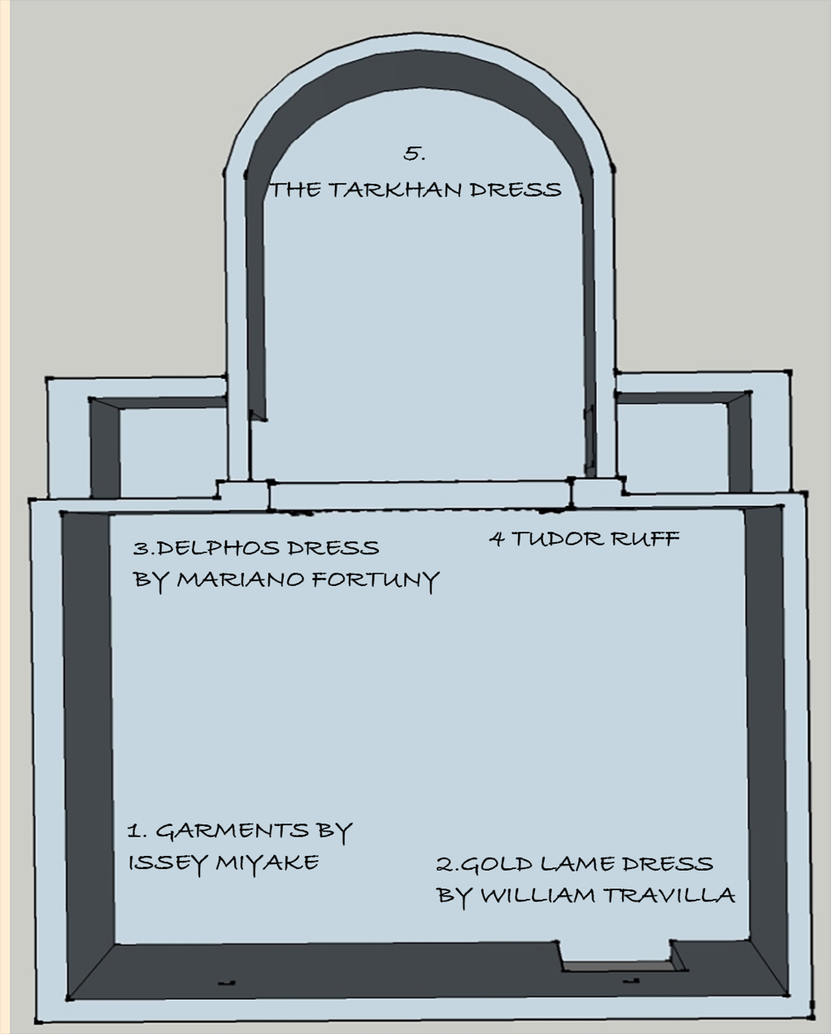

Fig.1 Mission Gallery floor plan

1.PLEATED GARMENTS BY ISSEY MIYAKE

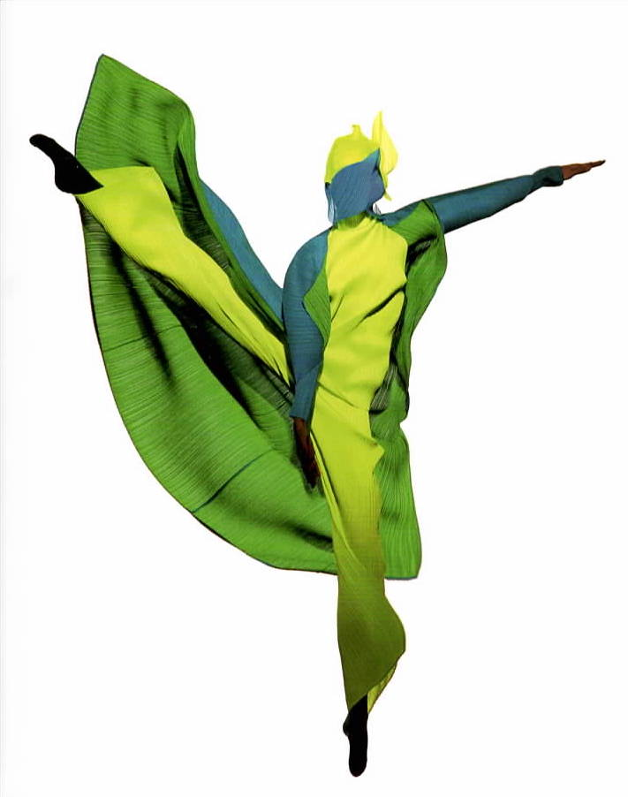
Fig. 2 Garments by Issey Miyake

Issey Miyake (1938-) is a Japanese fashion designer. The garments chosen for this exhibition are all pleated and are from his collection Pleats Please (2012). Some of the Pleats Please collection were worn by dancers showing how the fabric moves with the body. The garments will be displayed on a mannequin similar in shape to that of the dancer shown in the image. Issey Miyake’s pleats have become as well known in the fashion world alongside blue jeans, the T-shirt and the miniskirt.

Issey Miyake developed a synthetic fabric in which he could heat seal pleats (2012). The machines create various types of pleats, the basic pattern is named random pleats; another technique is called pleat and crush. At one point sixty workers were involved in creating garments for his Pleats Please collection. The garments are unique, pleats won’t fall out after washing, unlike hand pleated garments. The garment is usually made first then the pleated into shape. The synthetic fabric allows the fabric to be rolled up and stored without the garment losing it’s shape. It can be packed into a suitcase, for any length of time and when need can be removed and worn without the item showing any kind of creasing, it is instantly wearable.

2.Gold Lame Pleated Dress by William Travilla

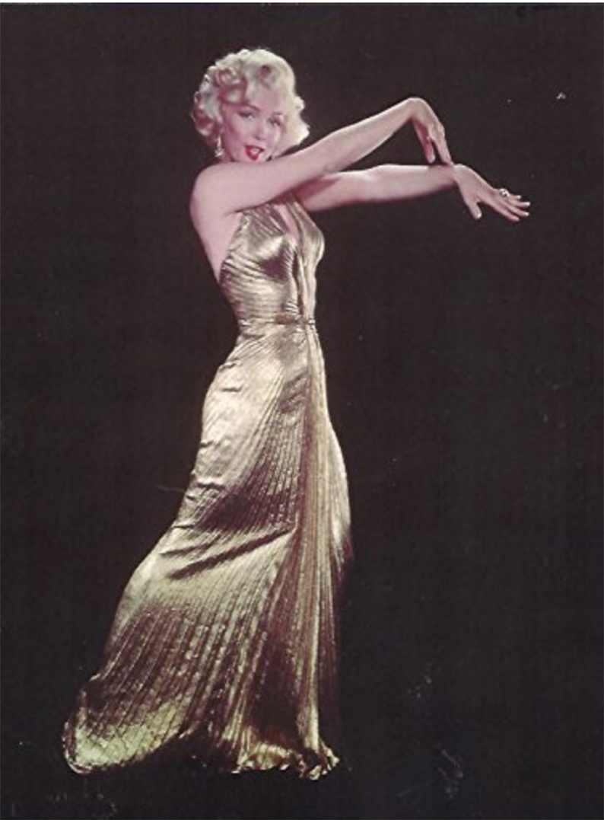

Fig 3. Gold Lame Dress

The gold lame dress (2019) is included in this exhibition for it’s pleated design, glamour, style and colour This gown was made by William Travilla a famous fashion designer who made dresses for Marilyn Monroe, for films she appeared in and he also made dresses for her privately. The dress will be displayed on a mannequin allowing the viewer to see front and back.

The gown featured in this exhibition was created from a single piece of circular gold lame material with sunburst pleats (2019). The dress was secured at the back of the neck, leaving the back uncovered. The dress had a plunging neckline culminating in tight pleats at the waistline secured with a beaded motif. From the waistline the garment draped the body to the floor fanning out the pleats. The gold lame material caught the light and showed the pleating in the fabric very clearly.

This dress was made for the film Gentlemen Prefer Blondes which was released for public viewing in 1953.

3.THE DELPHOS DRESS

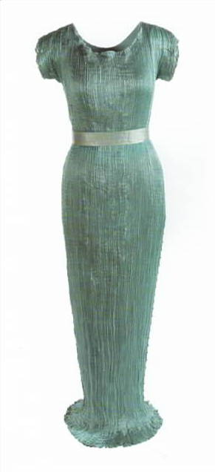

Fig. 4 The Delphos Dress

The Delphos dress (2015) is part of this exhibition not only for it’s pleated fabric but because it changed the way women dressed in the late 1890’s. Women were able to now wear dresses/gowns without restrictive corsets. The Delphos dress was embraced by women who could afford to wear such a garment.

The Delphos dress (2015) is made from pleated silk and satin. Some dresses needed four widths of fabric to complete. Marino Fortuny’s wife Henriette Negrin invented a pleating machine which was patented in 1906. The pleats were stitched into place by hand and the fabric was then passed through heated ceramic rods. The process was a closely guarded secret.

The Delphos dress (2015) has fine pleats and hangs from the body from the shoulders, glass Murano beads stitched onto silk cord were then attached to each side of the gown to weigh down the lightweight silk/satin fabric ensuring the dress achieved a smooth fit. When the dresses showed signs of wear, especially the seated area the dress would have to be sent back to Mariano Fortuny for the pleats to be reset.

4.THE TUDOR RUFF

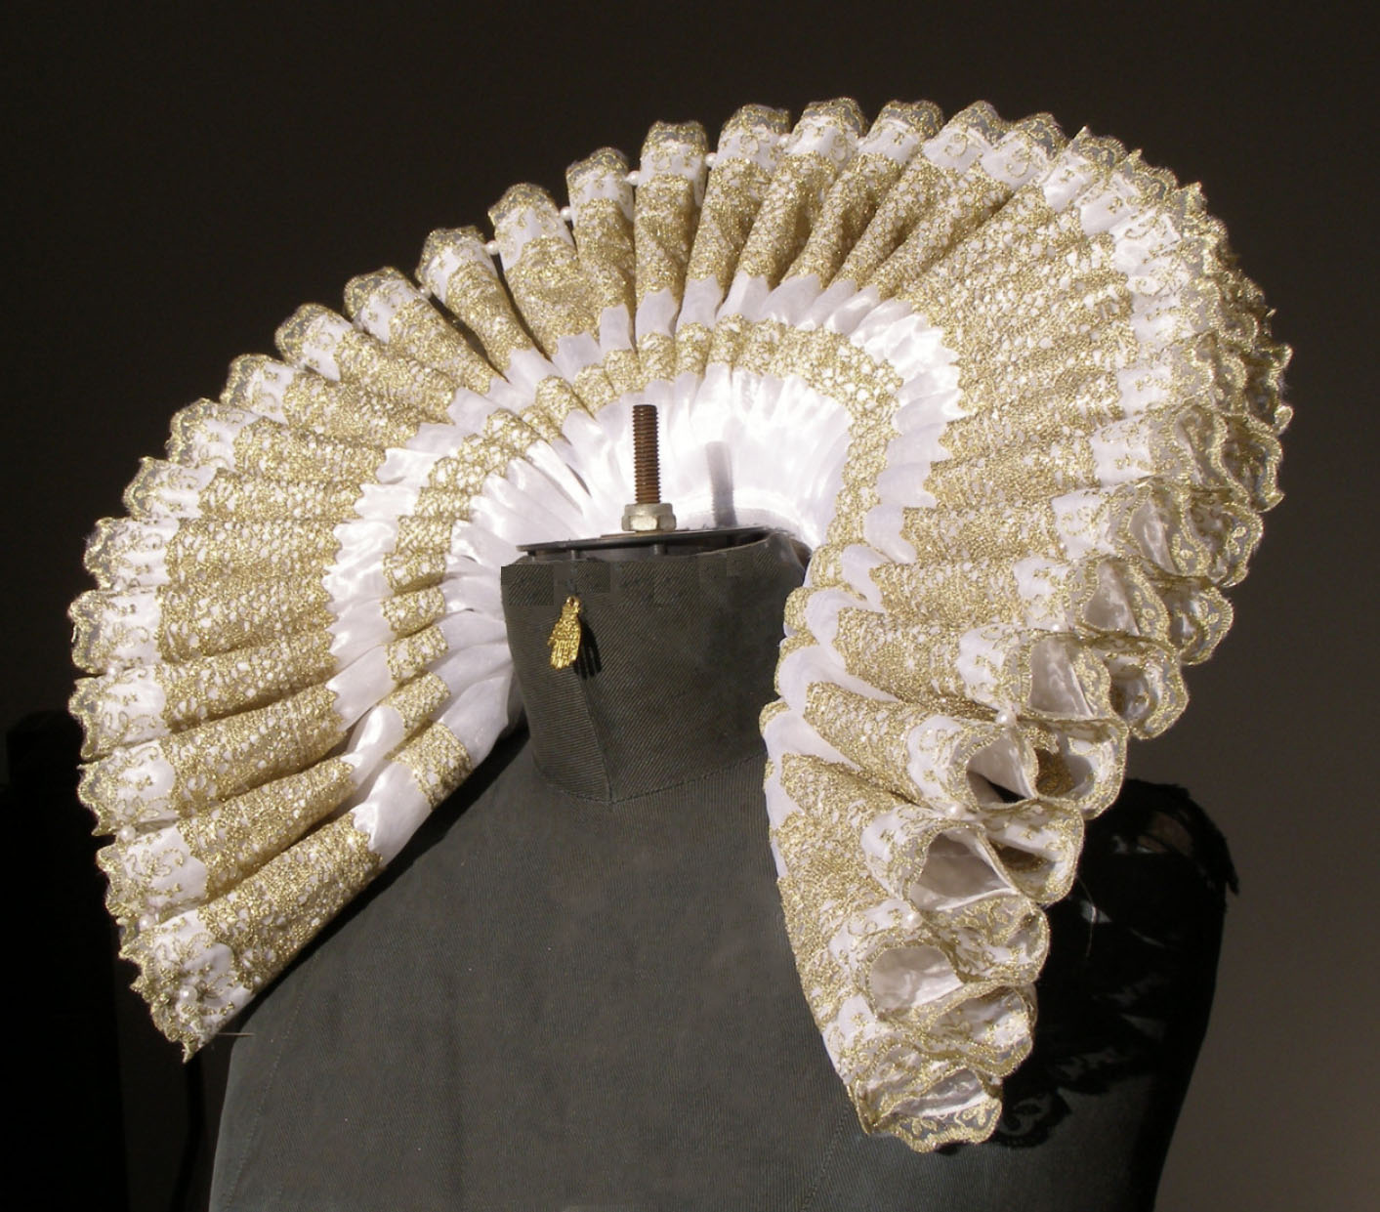

Fig. 5 The Tudor Ruff

The ruff (2019) was a crimped or pleated collar or frill and was most popular during the Elizabethan era. The ruff was worn separately from the dress or tunic. Men women and children wore ruffs at the collar and sometimes on the wrist. During the Elizabethan era it was very fashionable and a sign of status, the more wealthy a person was the more elaborate the ruff. Ruffs were made from fine linen and lace; the more extravagant ruffs were sewn with gold thread and adorned with pearls and other precious gems.

The ruff (2019) was stitched at the neckline and pleated and copious amounts of starch was used to keep the pleats in shape. Hundreds of pins were also needed to keep the pleats in situ. The more elaborate ruffs were ‘underpropped with a supportase’ (2009 Phyllis Tortora and Keith Eubank p.220). A supportasse was a wire frame attached behind the ruff as some extended far beyond the neckline. Some ruffs were made with up to six yards of fabric pleated with up to 600 pleats. When the ruff was washed the whole process had to be repeated.

5.THE TARKHAN DRESS
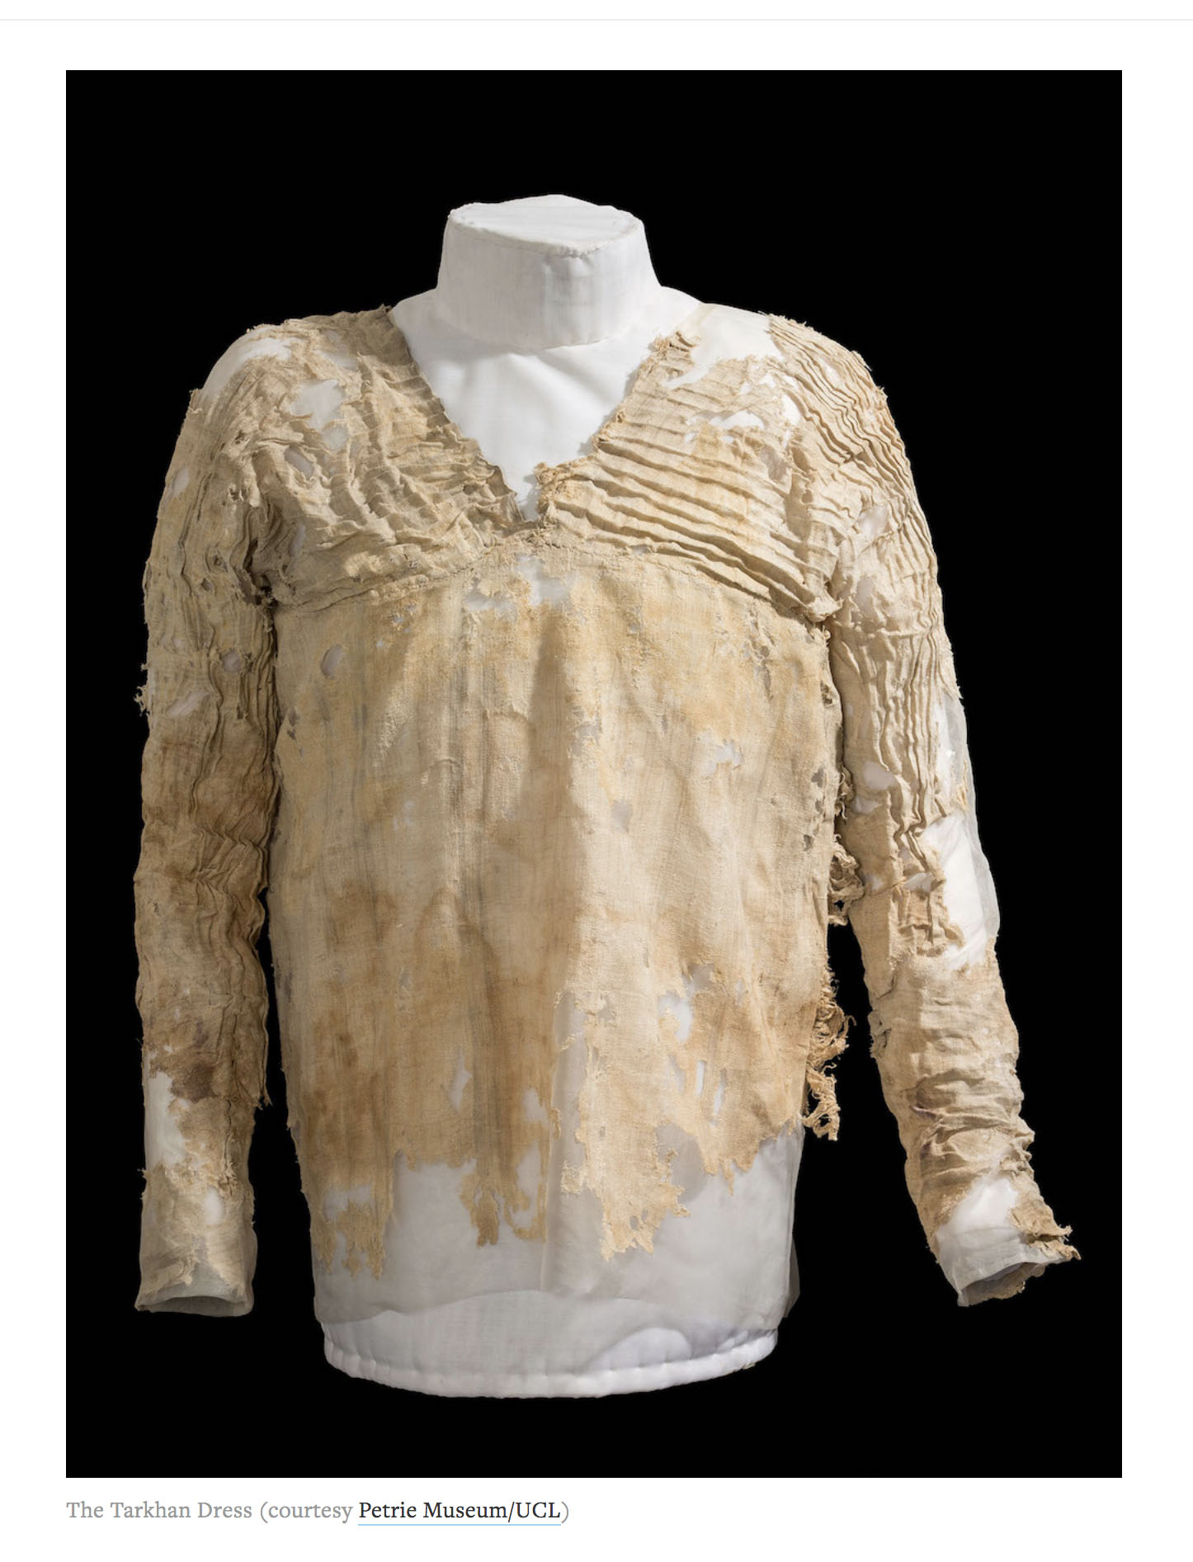

Fig. 6 The Tarkhan Dress

This garment was chosen because it is the oldest woven Egyptian garment that exists to the present day (2019). The garment was discovered by the famous archaeologist Sir William Matthew Filnders Petrie in 1913 during an excavation in Tarkhan, an Egyptian Cemetery located 50 miles south of Cairo (UCL 2019). The garment wasn’t really discovered until 1977 when the items were sent for conservation to the Victoria and Albert Conservation Workshop when a person cleaning a pile of rags noticed stitching and realised it was an actual garment. A radio carbon test took place in 2015 by the University of Oxford’s radio carbon unit and it confirmed the garment was made between 3842-3102 BC establishing it as the oldest surviving woven garment that exists today.

The dress itself was made from three pieces of linen with a natural pale grey stripe. The garment has pleating around the neck across the bodice and on the sleeves which appear to be a few centimetres apart. It is not clear how the Egyptians actually made the pleats (Vogelsang-Eastwood 2000 p.282). Three examples of Egyptian pleats exist, pleated fabric which include pleats a few centimetres apart, pleats close together so they almost touch each other and herringbone pleats where the first pleats are vertical and the following pleating is horizontal revealing a chevron design. The bodice of the Tarkhan Dress appears to show the pleats being a few centimetres apart, the pleats on the sleeves seem to be made closer together.

In conclusion pleats have been around for a very long time, the Egyptian garment shown in this exhibition is proof enough to support this fact. Hundreds of examples of different types of pleating and pleated fabrics can be found by searching through historical books, databases and online sources. All examples show different types of pleating but basically there are mainly three types of man- made pleats (2017), accordian pleats, side pleats and box pleats. All other pleats are a variation of the basic three pleats as mentioned.

Machine pleating differs, most pleating by machines is type of pleat that isn’t exact, the process of putting the fabric or garment through a pleating machine causes the pleat to mostly have a crushed appearance, however Issey Miyake’s creation are an exception to the rule in that he found a way to pleat his garments with multiple sized pleats.

All the garments shown in this exhibition will therefore have some or all of the three types of pleat listed. This exhibition is a small insight into the world of pleated garments.

Bibliography

de Osma, G (2015) Mariano Fortuny His Life and Work London: V & A Publishing

Kalajihan, L and Kalajihan, G (2017) Pleating Philadelphia USA: Schiffer Fashion Press

Miyake, I. (2012) Pleats Please Germany: Taschen Gmbh

Nicholson,P (2009) Ancient Egyptian Materials and Technology Cambridge:Cambridge University Press

Tortora, P and Eubank,K (2009) Survey of Historic Costumes 5th Ed. London:Bloomsbury Publishing

References

britannica.com (2019) Available at https://www.britannica.com (Accessed 20th April 2019)

gettyimages.co.uk (2019) Available at https://www.gettyimages.com
Accessed 1st May 2019

igetakickoutofyou.me (2019) Available at https://www.igetakickoutofyou.me…/dresses-and-controversy-in-gentlemen-prefer-blondes/ (Accessed 10th April 2019)

Petrie Museum University College of London (2019) Available at https://www.ucl.ac.uk/culture/petrie-museum Accessed 30 March 2019

worldofshakespeare.com (2019) Available at https://www.worldofshakespeare.com/strictly-shakespeare/history (Accessed 5th April 2019)

List of Images

Fig. 1 Mission Gallery Floorplan

Fig.2 Garments by Issey Miyake - Miyake, I. (2012) Pleats Please

Fig.3 Gold Lame Dress - https://gettyimages.co.uk

Fig 4 The Delphos Dress - de Osma, G (2015) Mariano Fortuny His Life and Work

Fig.5 The Tudor Ruff - Tortora, P and Eubank,K (2009) Survey of Historic Costumes

Fig 6. The Tarkhan Dress - Petrie Museum University College of London (2019)

