Executive Summary

This research report aims to identify ways of increasing the number of young people employed within Hywel Dda University Health Board and gain an understanding as to why the number of young people between 16 and 25 years old equate to less than 7% of the total workforce.

The objective of the research was to identify trends in youth employment, barriers young people face accessing the labour market and identifying reasons why HDUHB is not an employer of choice. In addition, this report explores how the organisation can support the local youth population into employment.

The methodology for gathering data included both primary and secondary sources. The secondary data was collated through carrying out a literature review and by using Internal IT based systems including Trac and ESR. In addition, the research identifies trends in youth employment within the UK and considers how organisations can support young people into the labour market. It outlines the barriers faced by young people trying to access the labour market and the cultures within organisations that has a detrimental effect on youth employment. Finally, research identifies how the organisation can offer support to young people to provide them with the experience and skills to access the labour market.

Primary data was collected through a focus group and questionnaires. Focus groups consisted of sixteen representatives from external agencies who support young people, namely the Job Centre, Careers Wales, work-based learning providers and youth groups. The questionnaires gathered feedback from 106 young people between December 2018 and January 2019 to understand the reasons for them not applying for vacancies within the organisation. Questionnaires were collated across three counties, providing both qualitative and quantitative data. The sample consisted of young people who were unemployed, attending post compulsory education, employed and accessing work-based learning provision.

The results of the focus groups identified that young people perceived that there was too much competition and therefore was not worth applying, with 88% of the focus group stating that the Health Board should offer a greater provision of work experience and apprenticeships to support the transition into employment. The questionnaires revealed that 84% of young people had never considered employment within the NHS, with 81% stating that it was due to lack of experience, qualification or no suitable vacancies. 13% of young people stated that they did not want a job in care, with only 4% realising the range of career options. There were 88% of young people who would consider an apprenticeship and 91% would be happy to earn the National Minimum Apprentice wage of £3.70 per hour (rising to £3.90 in April 2019).

The recommendations of the report that the Executive Team are being asked to consider are as follows:

- Revisit all Band 2 Job Descriptions, to ensure experience/qualifications are desirable and not essential, allowing young people to meet the essential criteria.
- Introduce a wider range of work experience initiatives, including Engage to Change, Traineeships, Youth Obligation and other youth employment initiatives.
- Set up a task and finish group to look at promoting the NHS within both primary and secondary education, increasing awareness of the breadth of careers.
- Set up an Apprenticeship Academy to provide more opportunities for young people, using the national apprentice rate.
- Set up a task and finish group to identify ways of educating the workforce in relation to the barriers faced by young people accessing the labour market.

Introduction (Terms of Reference)
Less than 1% of the workforce at HDUHB are under 20 years of age and less than 6% are under 25. This is a concern, with the number of employees now being close to their retirement increasing (Employee Staff Records, 2018). It is crucial that we grow our own workforce to ensure employees have the right skills, at the right time, especially with around 30,000 NHS staff retiring annually and 80% of employers experience difficulty in recruiting (CIPD , 2012). Skills shortages are evident in some occupational sectors, including estates, clinical engineering, nursing and Maintenance (HDUHB, 2018).
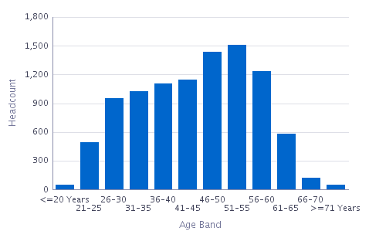
Figure 1.1 Age Profile of HDUHB Workforce (Employee Staff Records, 2018)

With limited applications from young people accessing job vacancies within the HDUHB, there is a need to gain an understanding of the current trends in youth employment and identify reasons why young people do not see the Health Board (HB) as an employer of choice. With the ageing workforce demographics, it is important to consider our future workforce strategy and why the number of young people being employed within the HB has not increased, despite increased vacancies. Analysing youth employment trends will allow the HB to change working practices to support the youth population into employment.

Aim: A critical analysis to identify ways of increasing the number of young people employed within Hywel Dda University Health Board

Objectives:
- Identify trends in youth employment and barriers to accessing the labour market.
- Identify reasons why young people do not consider HDUHB as an employer of choice.
- Explore how the organisation can support the local youth population into employment.
- To make recommendations to increase the percentage of young people HDUHB offer to young people.

Literature review

Youth Employment

“Youth unemployment undermines the health, well-being and future prospects of young people” (CIPD, 2012). Within the UK, overall youth unemployment is statistically higher than any other age category, with a greater disadvantage for young women, with an inequity of careers support and options (Youth Employment UK, 2018). Despite the inequity, the percentage of young males unemployed was 13.4% as oppose to females being lower at 9.5% (House of Commons, 2019).

From March to May 2019, 349,000 young people were unemployed within the UK, with youth unemployment being at 11.6% compared to 3.8% of the total UK population. During March to May 2019, 77,000 young people had been unemployed for over twelve months, classifying them as long term youth unemployed. (House of Commons, 2019).

Youth unemployment in the UK is considerably higher in comparison to Europe, with young people disadvantaged greatly (Carter, 2019). Within the UK in 2016, Wales has one of the highest youth unemployment rates (figure 2) (Wales Online, 2016). 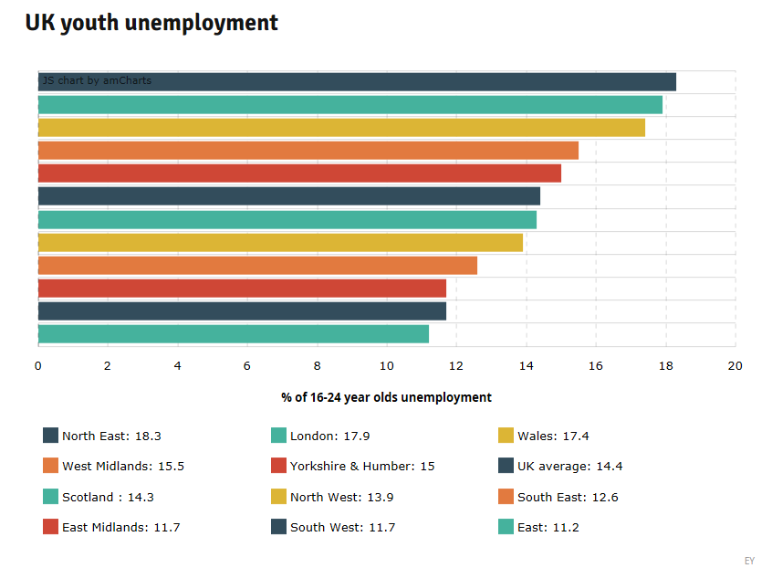

Figure 2.1 – Youth unemployment rates by location (Wales Online, 2016)
Although there has been an increase in youth unemployment, especially from 2008 to 2014, there has been an overall reduction in youth unemployment since 1993 (figure 3), with it being at its lowest over this time period (House of Commons, 2019).

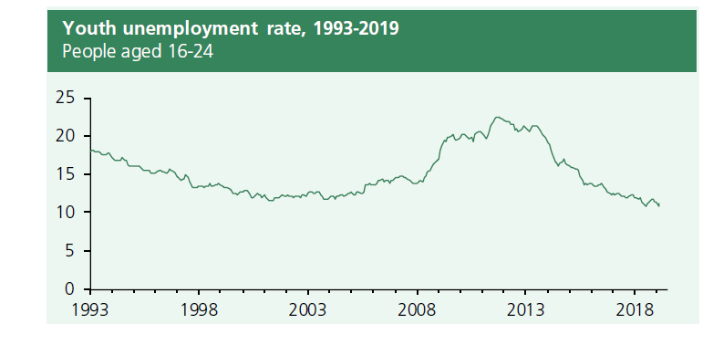
Figure 2.2 Youth Unemployment Rates (House of Commons, 2019)

Barriers to Youth Employment

According to Faragher (2014), 87% of employers feel that when young people leave school, they lack the skills and qualities to access the labour market. “Research conducted by the CIPD identified that employers pass on employing young people as they are deemed inexperienced and unable to hit the ground running. As they have little experience of interviews, employers conclude they appear to lack work ethic (CIPD, 2012). This is supported by the UK Youth Census stating “Society attribute negative stereotypes on young people including NEETS, millennials’, wearing hoodies, lack of social skills and poor work ethic” (Youth Employment UK, 2018). Young people are finding the transition from education to employment increasingly challenging. Due to the lack of experience of employers at supporting young people transitioning from education, this has a detrimental effect on their confidence and self-esteem (Carter, 2019).

The largest barrier faced by young people is the UK is lack of work experience, anxiety and not having the right skills (Youth Employment UK, 2018). Young people need support to access the labour market and lack opportunities to gain work experience, with many organisations being unaware of the support to provide young people with the opportunities within their organisations (CIPD, 2016).

76% of young people agree that work experience helps develop work related skills and supports gaining employment, whilst In addition, 57% agreed that it developed beneficial contacts (Youth Employment UK, 2018). A key recommendation of the Youth Voice Census Report 2018 was that the government should make work experience a statutory requirement of key stage 3,4 and 5.

How employers can support the local youth population

Welsh Government understands the importance of supporting young people into employment, introducing a number of initiatives that require the support and investment of organisations (Welsh Government, 2012). These are as follows:

The Youth Obligation Support Programme (YOSP)

The YOSP is a youth support programme providing experience to young people, between 16-18 years old, claiming Universal Credit. Providing employability support, individuals access work related training and if unemployed after six months, the Department of Works and Pensions (DWP) would find suitable work experience (Department for Work and Pensions, 2018).

The Traineeship Programme

The Traineeship programme supports young people from the age of 16-18 in Wales, access support into employment. Employers can support this initiative by offering longer term work experience placements (Welsh Government, 2017).

The Engagement Programme is designed for those that are not vocationally focused, requiring additional support to overcome barriers. This provides young people to access work tasters. The success of this programme depends on employers offering a supportive working environment (Welsh Government, 2017).

Other Youth Initiatives

There are a number of other work experience initiatives supporting young people, through the traditional school work experience offer and supporting those who may have barriers to accessing the labour market. These include the Cynnydd Project, supporting those between 11 and 24 years old at risk of disengaging (Welsh European Funding Office, 2015) and Engage to Change (Agoriad Cyf, 2018), supporting those who have a disability or learning difficulty.

Apprenticeships

Apprenticeships allow employers to offer opportunities to individuals entering the labour market, working alongside experienced employees and accessing qualifications by an approved provider. Recruiting apprentices can reduce labour costs for time the organisation is training and investing in the individual, whilst creating a skilled workforce (Skills Gateway , 2018). Although apprenticeships were predominately aimed at young people, the percentage of those going to young people under 25 has reduced from 99.8% in 2010, to 57% in 2016 (CIPD, 2016).
In April 2017, the apprenticeship levy was introduced by the UK government, applying to all UK employers, with an annual ‘pay bill’ of £3 million (Gov.UK, 2018). For HDUHB, this is approximately £1.8m.

Methodology
The purpose of this study is to identify ways of increasing the number of young people employed within HDUHB therefore data will be collected from those who work with young people to gain a greater understanding of the issues presented whilst providing support into employment. By collecting data from young people and youth support organisations provides different perspectives, thus increasing the reliability of the research. The two methods of collating primary data to be used are a focus group and questionnaires. Data will be analysed by comparing and contrasting primary and secondary research, whilst considering the current practices within the organisation.

A focus group was the preferred option as interviewing would not allow organisations to share views and discuss responses, which provide valuable discussion, allowing an understanding of key reasons (Taylor & Woodhams, 2016). Normally consisting of between 6-12 individuals (DePoy & Gitlin, 2016), this focus group will have 16 representatives as it is important to make sure there is a broad representation from those who work with young people. Recognising the drawback of focus groups being gaining commitment to attend (Taylor & Woodhams, 2016), having a greater number will alleviate the impact of no shows. From this focus group, it will inform the research and shape the questionnaire to gather data from young people.

The cross sectional paper-based questionnaire will gather information from young people between the age of 16 and 25 years of age. It is planned to collect 150 questionnaires from young people from various youth support groups, colleges and work-based learning providers across three counties, using simple random sampling, covering the breadth of HDUHB. Despite this being a relatively small sample, it reflects the wider characteristics of young people as they will be from different areas, have varied academic success and have a different employment status.

The methodology of this research focuses on an interpretivist philosophical approach as it does not rely on a scientific approach to formulate conclusions. Conclusions will be based on interactions with individuals, interpreting their responses (Anderson, 2013). The research will use a mixed method approach, collating both quantitative and qualitative data, which is becoming more popular amongst researchers (Bryman & Bell, 2015).

Research should be reliable, replicable and valid (Bryman & Bell, 2015). Methods used are reliable as these could be repeated in any situation as long as the sample meets the age criteria in the questionnaire and the focus group representatives work with the same age profile clients. From the data collected, conclusions will ensure the validity of the research (Taylor & Woodhams, 2016).

To ensure that the research was conducted ethically and professionally, permission was obtained from the Director of Workforce to conduct the research on behalf of the organisation. All questionnaire participants were informed of the way in which data collected was to be used and no personal identifiable information was collected, in line with the three ethical considerations for involving persons in research, namely the full disclosure of the purpose, confidentiality and participation is voluntary (DePoy & Gitlin, 2016). All participants within the focus group gave permission for the discussions to be recorded in writing and the research did not record comments made against an individual, respecting their reputation.

Findings
The research collected provides a broad sample, with Youth Support Staff being represented from each county within the focus group. These practitioners work with young people with differing academic levels, including those with barriers to access the labour market. The questionnaires had representation from the three counties (figure 4.1) and although it could be argued that this did not show parity, it does reflect the workforce population in each of the areas (figure 4.2). (Employee Staff Records, 2018)

Figure 4.2
Figure 4.1
Figure 4.1

In addition to the geographical diversity of the sample, the young people were also accessing different support from youth agencies (figure 4.3), which were also represented within the focus groups. There were differing levels of academic abilities, with 65% having not achieved 5 GCSE’s or more (figure 4.4).
Figure 4
Figure 4.4
Figure 4.3

84% of young people had not considered applying for a role within HDUHB (figure 4.5) and when analysing the reasons for this, it showed that 34% stated that they did not have the experience required and 23% did not have the qualifications, representing over half of the sample (figure 4.6).
Figure 4.6
Figure 4.5

Whilst the data collected from the focus group of youth support practitioners was based on their opinions and perceptions, this mirrored young people’s feedback with 50% stating that qualifications were a barrier (figure 4.7) and 88% surmising that experience had an impact (table 4.8).

Figure 4.8
Figure 4.7

The focus groups suggested that young people felt that there was too much competition and therefore was not worth applying for vacancies within HDUHB, with 88% stating that the HB should offer a greater provision of work experience and apprenticeships to support the transition into employment. When questioned, 88% of young people stated that they would consider an apprenticeship within the HB (figure 4.9) and of those, 86% would not be deterred from applying if the National Minimum Apprenticeship Wage was paid (figure 4.10).

Figure 4.10
Figure 4.9

13% of young people stated that they did not want a job in care, with only 4% of these realising the range of career options within the NHS.

In summary, many common themes were identified across both the focus group and the questionnaires, identifying the need for HDUHB to reconsider the entry requirements for lower paid roles within the organisation, thus removing barriers for 57% of those young people who participated in the sample.

The questionnaires also identified that 26% of those who had not considered HDUHB as an employer stated that they had not seen any suitable vacancies. With the HB advertising 400 vacancies per month, of which 38% are lower skilled roles (Owen, 2019) and with over 350 career choices within the NHS (NHS Wales, 2018), this suggests that vacancies are not visible to young people. Although the UK survey (Office for National Statistics, 2019) identifies that the methods used to identify suitable vacancies were similar across online job sites, organisation websites and social media (figure 4.12) this was not evident in the result of young people as this identifies that 98% of young people use online job sites, with 64% using social media and only 15% using employer websites (fig 4.11).

Figure 4.12
Figure 4.11

Conclusion
Research showed common themes, outlining the barriers that prevent young people accessing the labour market. Secondary research suggests that employers often fail to employ young people as they are inexperienced (CIPD, 2012), with both youth practitioners and young people stating that lack of experience was a barrier to accessing employment within the HB. Further investigation identifies that job descriptions state requirement for qualifications and experience not essential within the role (NHS Wales, 2019), which would deter the 65% of the sample applying as they would not meet the requirements

Research suggests that lack of work experience is the largest barrier (Youth Employment UK, 2018), identifying the need for HDUHB to offer wider opportunities to those prior to leaving school, supporting the transition into employment (Carter, 2019).

With 26% of the questionnaire sample identifying that HDUHB had no suitable vacancies, and only 4% realising the range of career opportunities, it is difficult to confirm whether this is down to where vacancies are advertised, how vacancies appear on

With clear evidence that young people have challenges accessing the labour market (CIPD, 2014), evidence suggests that if HDUHB don’t respond to this research, this will have a detrimental effect on workforce demographics and the stability of our future workforce (CIPD , 2012).

Recommendations for change

Recruitment and Selection
Consider other methods of advertising and revisit Job Descriptions, to ensure experience/qualifications are desirable and not essential, allowing young people to meet the essential criteria and removing the barriers faced by young people (Youth Employment UK, 2018).

Work Experience Initiatives
Introduce a work experience initiatives to support young people, including Engage to Change, Traineeships, Youth Obligation and other youth employment initiatives (Welsh Government, 2012).

Secondary and Primary School Promotions
Set up a task and finish group to look at promoting the NHS within both primary and secondary education, increasing awareness of the breadth of careers. This should include the Future Workforce Team, Recruitment, Medical Education and representatives from a variety of services.

Apprenticeship Academy
Set up an Apprenticeship Academy, providing opportunities using the suggested pay scales (Appendix 5) using the supplementary research provided (Appendix 4), educating the Workforce to promote apprenticeships within services. Offering apprentices will increase the young people within the organisation, supporting the youth population. Apprentices further promote the ‘Grow Your Own’ brand, supporting the local community. The introduction of apprentices would not only support areas with recruitment challenges, but build skills capacity for the future (Skills Gateway , 2018).

Workforce Training and Education

Set up a task and finish group to identify ways of educating the workforce in relation to working with young people, including management training. Consider campaigns focussing on good news stories of young people, thus changing the culture of our workforce.

Limitations

The methodology used was effective in gaining an overall understanding of why young people do not access employment opportunities within the HB. The focus group provided detailed information, however in order to understand the views of young people, this was not necessary. The focus group did however give a different perspective.

The research objectives should have been more focussed on one area, allowing for a greater depth of understanding. Despite these limitations, the research underpins the reasons for the stated recommendations.

