Environment design
3D Diorama and presentation
BA Computer Games Design

Rebecca Jones
2305750

Link to diorama presentation:
Environment design presentation video

Screenshots:
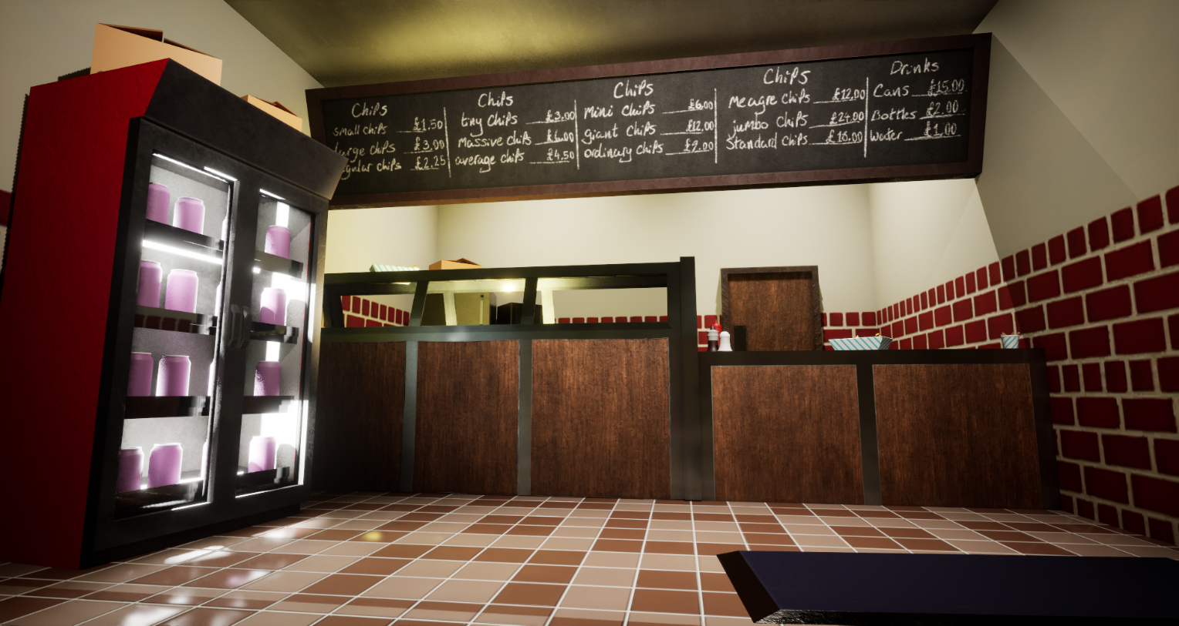
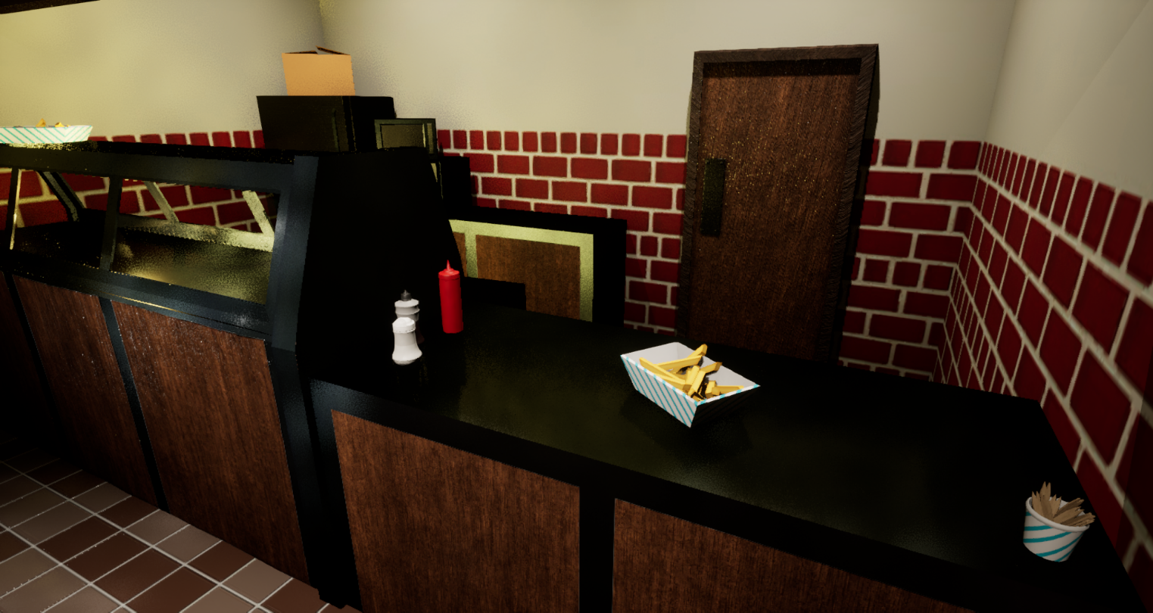
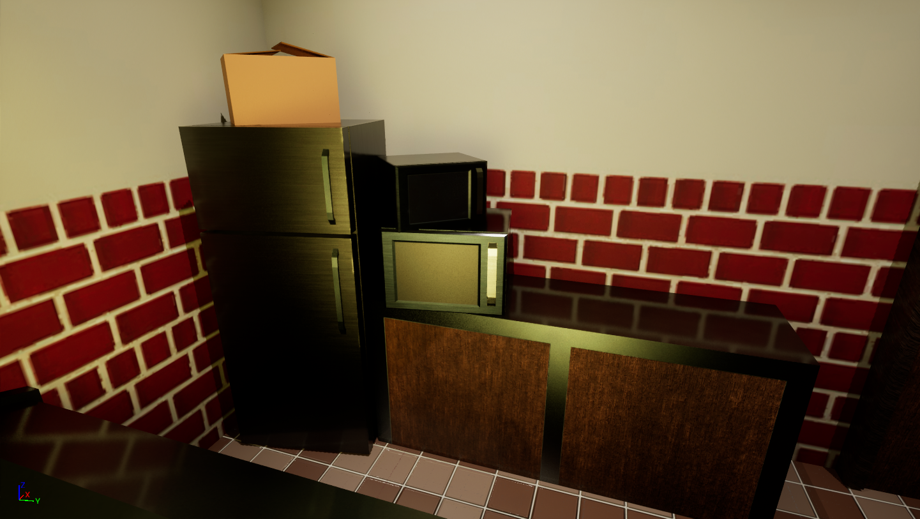
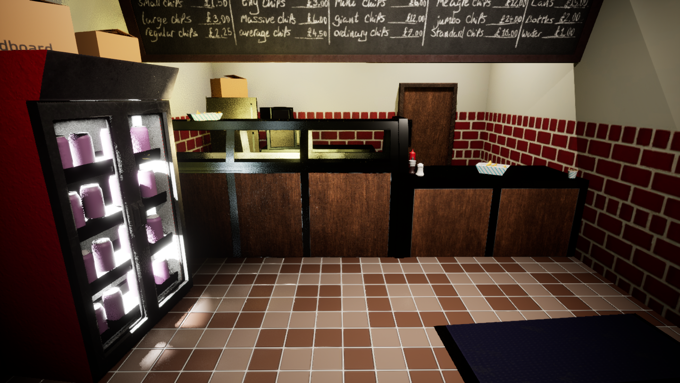
Bibliography:

- “Finding the best fish and chips in London | Food Tours | Insider Food,” YouTube, https://www.youtube.com/watch?v=4QrSF0sb-yM (accessed May 6, 2024).
- “Substance 3D painter textures into Unreal engine 5 including emission,” YouTube, https://www.youtube.com/watch?v=wcpz9_stKgs&t=31s (accessed May 6, 2024).
- “Substance painter: Complete how to create Glass tutorial (includes adding Dirt & exporting textures),” YouTube, https://www.youtube.com/watch?v=nGSXkBXDPJE&t=89s (accessed May 6, 2024).
- “Substance painter importing glass to Unreal engine UE4 easy and quick tutorial window realistic,” YouTube, https://www.youtube.com/watch?v=Lz7dV2OtdYY (accessed May 6, 2024).
- “Fill a jar with dynamics in Maya,” YouTube, https://www.youtube.com/watch?v=AWv41iqO_Jk (accessed May 6, 2024).
- Normalmap-Online, https://cpetry.github.io/NormalMap-Online/ (accessed May 6, 2024).
- “Architextures, the material editor for architects and Designers,” Architextures, https://architextures.org/ (accessed May 6, 2024).
- “Download Brown tile background, mosaic tile background, tile background, seamless pattern, mosaic seamless pattern, mosaic tiles texture or background. bathroom wall tiles, swimming pool tiles.,” Vecteezy, https://www.vecteezy.com/vector-art/26508262-brown-tile-background-mosaic-tile-background-tile-background-seamless-pattern-mosaic-seamless-pattern-mosaic-tiles-texture-or-background-bathroom-wall-tiles-swimming-pool-tiles (accessed May 6, 2024).

