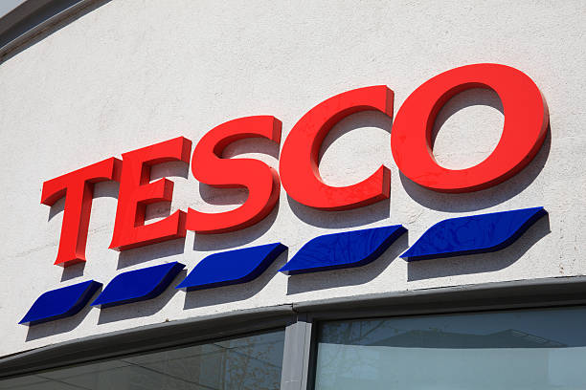

Design Thinking and innovation
LCLM6002
Table of contents
Introduction 3
Key industry and consumer trends, which impact Tesco 3
Part 1 Analysing organisation approach 4
Innovation ambition matrix 5
Current innovations and design the organisation is engaged in 5
Which new opportunities are on the horizon 6
Customer journey mapping 7
Current core customers of Tesco 7
Pain and gain points
Identifying places of customer journey where there is opportunity for digital innovation 9
Part 2 Proposing new digital transformation initiative 10
New digital transformation initiative 10
Updated and enhanced customer journey map 11
Positive impact of proposed initiative on Tesco 14
Measuring the impact and success of proposed initiative 14
Conclusion 14
References 15

Introduction
Design thinking is considered as an effective approach to solve different problems and bring innovation (Rösch et al., 2023). Design thinking and innovation is taken into account in this present aspect for analysing present condition of Tesco and bringing further changes. This assignment has focused on analysing key consumer and industry trends, which has a significant impact on Tesco in part 1. In this aspect, the innovation ambition matrix and customer journey map has been used to analyse the current innovation and current core customers regarding Tesco. Furthermore, in part 2, a new digital transformation initiative has been proposed. Proper discussion has been done considering the impact of proposed initiative and the impacts and success have been measured.

Key industry and consumer trends, which impact Tesco
Tesco being a British multinational merchandise and groceries is offering diverse products and services. The headquarter is located is Welwyn Garden City, UK. It was founded in the year 1991. Tesco has been employing around 423,092 employees (Tesco, 2025a). It is analysed that key industry trends related to retail sector have created significant impacts on Tesco.
Industry trends- Rapid adoption of e-commerce has impacted Tesco to enhance the digital shopping aspects. Increasing investment regarding the automation has brought certain scopes like reducing errors and increasing efficiency. Sustainability and (Environmental, governance and social) has created wider opportunities for Tesco to become more responsible in aspect of people, planet. Growing importance of ethical sourcing has been seen in regard to Tesco. Market saturation and competitive pricing has been considered as one of the factors, which have impacted Tesco. Besides, the supply chain disruption has created barriers to enhance operational efficiencies in regard to Tesco. Strict regulation on food safety has brought better outcomes through sustainable reporting in Tesco. It has been analysed that sustainability reporting has been considered as the major aspect and it has contributed towards the long term success of Tesco (Tesco, 2025b).
Customer trends- Health and wellness trends have created major shifts in the choices of consumers in UK. British consumers are engaged in healthy living. The engagement is further driven through emotional stability. Sales revenue of organic and healthy food items have been increased in UK. It has generated around 2.85 billion GBP (refer to fig 1). Shift to online valiand-collect, convenience based shopping have gained proper attention in present times. Loyalty and price sensitivity considering loyalty programs, discounts have created certain impacts on shopping experiences of customers in Tesco. For example, using Clubcard of Tesco has become considered as the cornerstone of Tesco’s loyalty strategy. Based on the reports of Euromonitor, it is analysed that loyalty programmes truly benefits customers and this also builds trust and loyalty among the customers (Euromonitor, 2025).
Sales value of plant-based meat substituutes in the Uk  530m USD | Sales value of artificial sweeteners in the UK  87,13m USD | Sales revenue of organic food and drinkin the uk  2.85bn GB

Figure 1: Health and wellness food trends
(Source: Statista, 2025a)
Demands of sustainable products have enforced many retailers of UK involving Tesco to bring changes in producing sustainable products. This has attracted the customers who are looking for locally sourced, ethically produced and eco-friendly goods or items. Moreover, the convenience and speed based on different technological implementation have brought innovation in businesses. Faster check out options and experiences has created positive impacts on Tesco and thus, it has made better recognition, profits, sales and productivity in the long run. It can be stated from the above analysis that both industry and consumer trends have created significant impacts on Tesco.

Part 1 Analysing organisation approach

Innovation ambition matrix
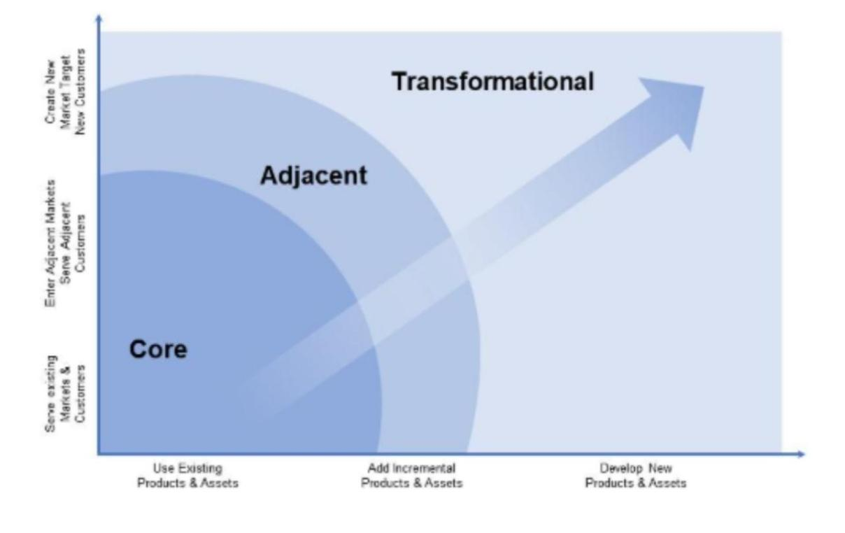
Figure 2: Innovation ambition matrix
(Source: Van den Ende, 2021)
The Innovation ambition matrix, which is developed by (Tuff & Nagi) is considered as an effective framework, which has categorised the efforts of innovation into three levels involving core, adjacent and transformational innovations. Core innovation is considered in aspect of incremental improvements related to existing services, products or processes. Besides, adjacent innovation is considered for expanding new areas through leveraging the existing capabilities. Apart from this, the last level, which is transformational innovation, focuses on creating entirely new markets and offers. In consideration to chosen organisation, the application of present map can be done and level of innovation is highlighted in aspect of three levels.

Current innovations and design the organisation is engaged in
Core innovation- Tesco has scored 70% in this level. It can be analysed that Tesco has implemented self checkout options. Also, clubcard personalisation has brought many scopes for the customers. Improved home delivery services involving rapid delivery partnership. App enhancements have created positive shopping experiences. This has further brought loyalty among the customers (Mittermeier et al., 2022).
Adjacent innovation- Considering this level, Tesco has scored 20%. This is based on the aspect of including Whoosh rapid delivery services of Tesco. Tesco has partnered with quick commerce providers and Gorillas. It has also increased options of plant based items, which has increased more recognition in the present market.
Transformational innovation- In this context, the score is very low, which shows 10%. It is evaluated that Tesco has implemented and explored AI (Artificial intelligence) in supply chain optimisation process. Experimenting with self-driving vans and drones have created wider options of experimenting with autonomous delivery (Walls, 2021).
Analysis
Tesco is majorly relied on its core innovations and this helps to bring enhancement, convenience, operational efficiencies and personalisation. Tesco has also focused in exploring the adjacent markets like rapid deliveries, data driven advertisements (Bierganz, 2021). In addition, transformational changes have been witnessed less. However, it can come through autonomous stores, robotics, blockchain applications and virtual retailing environments.

Which new opportunities are on the horizon
In aspect of core innovation of Tesco, proper opportunities can be seen based on cashier-less stores and AI personalisation. This can help Tesco to gain proper scopes from the frictionless checkouts. Also, Tesco can focus on advanced stock management process related to predictive analytics and IoT (Internet of Things) (Treves, 2021). Furthermore, considering the adjacent innovation, launching of new retail service platforms like subscription models can be proved effective. Also, innovation in financial services can be brought through leveraging customer related data. Deeper partnership with the health and wellness brands can be developed in aspect of Tesco. Besides, in aspect of transformational innovation, Tesco needs to focus on innovative strategy. This is possible through creating fully automated store. It can create Amazon Go style. It can focus on expansion of Virtual stores through augmented and virtual reality (AR and VR). Integration in blockchain can help to increase the transparency of supply chain of Tesco. Moreover, using robotics in warehouse can enhance automation and can also create faster delivery options in the coming years.

Customer journey mapping

Current core customers of Tesco
Considering the customer journey map, it can be said that the core customers of Tesco include young professionals, busy families, budget-conscious shoppers, online shoppers and elderly professionals (Meng, 2024). Busy families always value time-saving, convenience and good values for money. Nowadays, young professionals prefer digital solutions, speed, ready to eat and fresh items. Besides, elderly shoppers prefer value assistance, in-store experiences and focus on adopting the digital tools. Moreover, it is analysed that budget conscious shoppers are also associated with Tesco who seeks better promotional offers, affordable range and loyalty rewards. It can be stated that individuals spend more than three hours daily in UK. The total time spent is considered based on smartphones, tablets and computers.
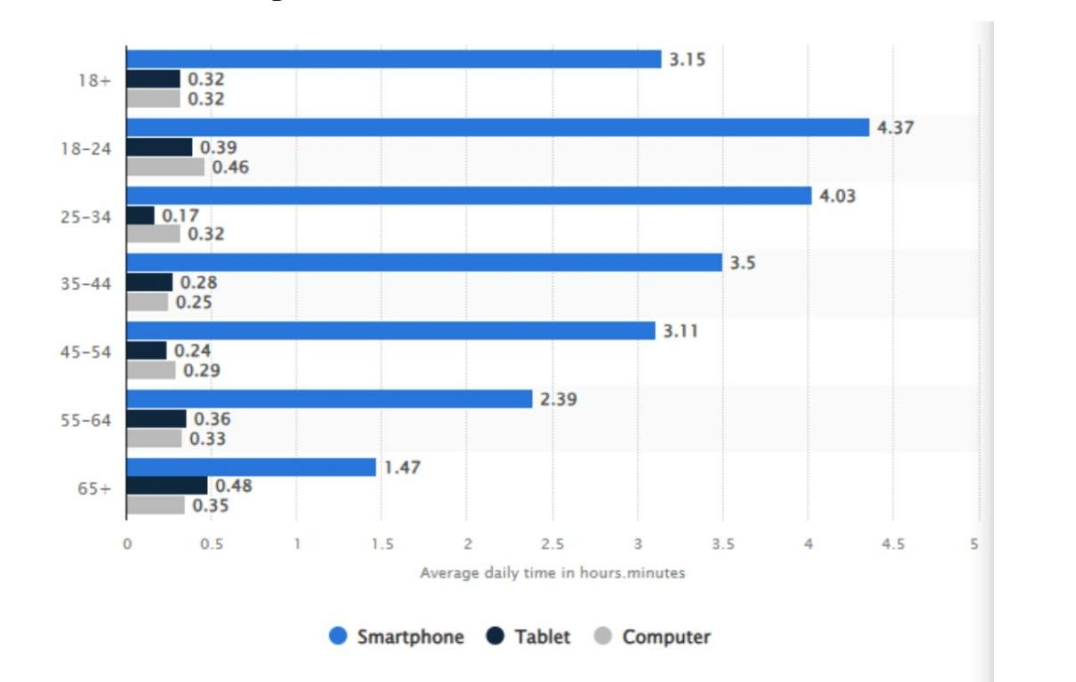
Figure 3: Online time spent
(Source: Statista, 2025b)
Considering the total time spent, it is identified that online shoppers always expect seamless experience based on browsing, accuracy in store information and quick deliveries. Thus, Tesco has some potential online shoppers, who are also considered as the core customers of business.
Furthermore, the stages of customer journey can be considered in aspect of Tesco, which includes:
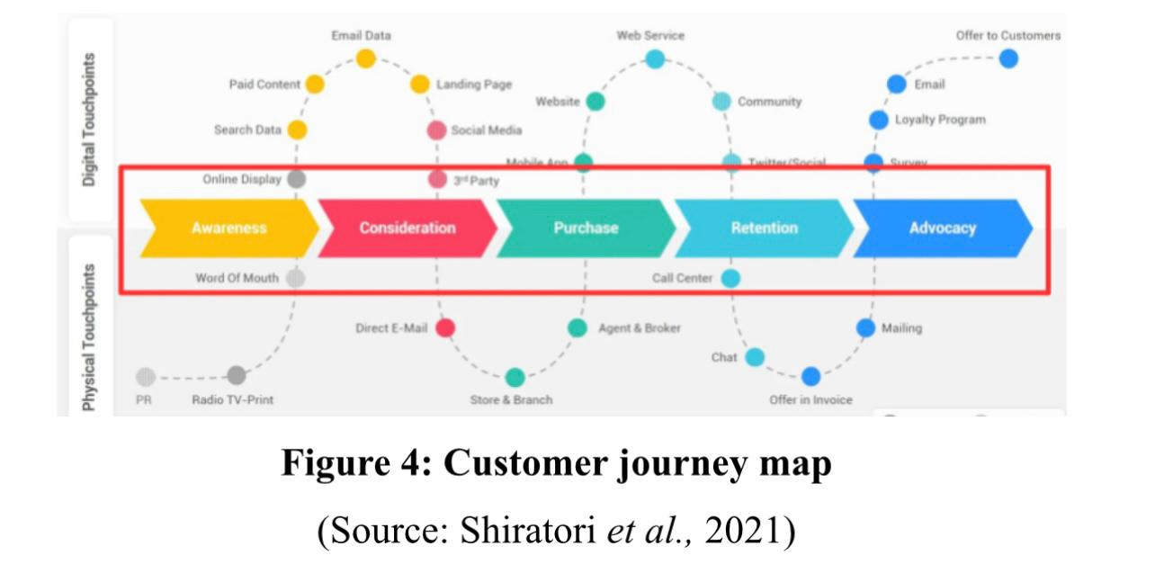
Awareness- In aspect of first stage of customer journey, it is analysed that creating proper awareness among the customers of Tesco has been done by browsing website, through word of mouth and seeing ads.
Consideration- In consideration of Tesco, furthermore, it is evaluated that customers are able to check availability, compare different prices of products and choose the best options. For example, the affordable prices of products and services of Tesco are considered in this aspect of Tesco.
Purchase- Both in-store and online shopping options are considered in the aspect of customers of Tesco.
Post-purchase- In post purchasing, the customer support and delivery tracking is analysed in aspect of Tesco
Retention/Loyalty- Receiving offers and using loyalty apps are considered valuable in consideration of Tesco. This helps to create loyalty and retain customers in the long run in regard to Tesco (Ziliani and Ieva, 2025).

Pain and gain points
In context of Tesco, certain pain points are identified, which creates negative experiences in aspect of core ns potential customers. In regard to in-store services of Tesco, unavailability of stocks, long queues, issues of navigation has created concerns. Besides, in consideration to online services of Tesco, inconsistent information of stocks, poor website user experiences have been analysed. Furthermore, in aspect of post purchasing regarding Tesco, delayed customer services are identified (Ali, 2024).
On the contrary certain gain points can be highlighted, which involve value, convenience and speed. Considering the factor convenience, multi-channel shopping provides valuable experiences based on online, in-store, click & collect options) (Frei et al., 2022). Besides, value, in this aspect, targeted discounts and clubcard pricing is considered to be effective for Tesco. Speed, in this regard, express delivery options and fast self-checkouts have created effective outcomes for Tesco.

Identifying places of customer journey where there is opportunity for digital innovation
Considering the above customer journey map of Tesco, furthermore, opportunities can be highlighted, which will bring digital innovation in Tesco. This can enhance the customer journey experiences through proposing valuable changes and implementing it. Tesco can bring certain changes through consideration of mobile scan and go. It can speed up the in-store shopping experiences for the busy customers (Nugraha et al., 2024). AI-powered personalisation can be brought in Tesco and this can focus on including better product suggestions and hyper-targeted promotions. Tesco can also bring real time GPS tracking and thus, it will be able to bring enhancement in the delivery tracking options. Voice enabled shopping experiences can also be provided to the customers of Tesco. Using augmented reality (AR) can propose totally different aspects for Tesco and the associated customers or online shoppers. With the help of this, the online shoppers can be able to view the features and sizes of products in 3D (three dimensional aspects).Using AI chatbots is also proved valuable for the customers to manage complaints through 24/7 services and create effective support for the customers in the long run.

Part 2 Proposing new digital transformation initiative

New digital transformation initiative
AI powered personalised shopping app can be involved in Tesco for enhancing the experiences of customers. This can further bring real-time offers, seamless shopping journeys and intelligent suggestions through use of AI (artificial intelligence) and machine learning. The proposed initiative can provide personalised product recommendations to the above-mentioned core customers of Tesco. Besides, AI can be used for browsing patterns, lifestyle choices and suggest tailored products or services for potential or core customers of Tesco. Using AI will be helpful for Tesco to consider predictive suggestions based on the trending items and create positive impacts on business development, growth and success in the long run (Oyekunle and Boohene, 2024). AI has been implemented in changing the shopping experiences of customers of Tesco and this is done through generating customised promotions and discounts by taking certain factors into account like past behaviour, customer locations. The proposed initiative can further create smart shopping lists. This will bring success through predicting the needs of individuals and meeting the particular needs within a speculated timeframe. In this consideration, furthermore, list optimisation can be proved beneficial as this meets the sustainable goals and objectives of business. Also, based on this new digital transformation innovation of Tesco, it can be seen that visual search can be done by the customers through uploading images. In addition, the products can be scanned from any location and customer will be able to get instant results finding item of Tesco, similar alternatives and availability of each item. AI implementation and application can be used for providing virtual shopping assistant (Aldoseri et al., 2024). In this process, AI chatbots are included for suggesting, guiding recipes and answer the product related queries, track deliveries. AI powered personalised shopping app will help the customers to use store layout data and conduct real-time aisle mapping. This has provided wider scopes to guide customers regarding the products. In consideration to the proposed shopping app, health and sustainability dashboard can be managed. It can create opportunities to track the carbon footprints, nutritional values. Hyper personalised offers are closely linked with the Clubcard of Tesco. In regard to the present initiative, gamified experience can be created and this will create positive experiences for the core and potential customers of Tesco. This will be done through unlocking extra discounts, badges and encourage customers to go for sustainable and healthy purchasing habits or options. Considering this imitative of digital transformation, certain opportunities can be brought in Tesco. Tesco can be able to witness data-driven innovation through leveraging vast amount of loyalty data and this also helps to understand the preferences of customers deeply. Effective partnership can be witnessed, which will encourage the collaboration with tech partners and enhance the application usage. In addition, continuous learning can also be brought through using AI models. This can continually evolve based on the changing trends related to each customer. The proposed app can bring hyper personalised experiences based on real time engagement. It can further support Tesco to meet the sustainable goals and objectives. It can also enhance the operational efficiencies based on stock optimisation and demand forecasting systems (Balakrishnan and Dwivedi, 2024).
The proposed initiative is designed in such a way that it can help Tesco to expand personalised shopping experiences based on personalised targets and plans. The proposed app is designed effectively for personalizing the shopping experiences, building customer loyalty and improving the overall convenience.

Updated and enhanced customer journey map
In this aspect, furthermore, the stages of customer journey are taken into account, which will highlight the enhanced and updated customer journey after implementing the AI powered personalised shopping app like:
Awareness- Considering Tesco, customers used to see app promotions on in store-posters, emails and social media.
Consideration- Based on the AI powered personalised shopping app, it is evaluated that customers of Tesco explore app features including shopping lists, suggestions and personalised offers (He and Zhang, 2023).
Onboarding- In aspect of onboarding, customers download apps, plan budgets, create effective profiles and input dietary preferences.
Shopping plan- In this context, customers try to build a shopping list and explore different offers related to Tesco.
Online / in-store shopping- Tesco is using app for in-store navigation, stock checking and barcode scanning.
Checkouts- The proposed app is used by the customers and they scan and go and also, digital coupons are used.
Post-purchase- Customers often use personalised feedbacks, next feedbacks and loyalty points in aspect of Tesco.
Advocacy and loyalty- In this regard, customer use experiences, use AI-powered gamification and participates in rewards.
Considering the enhanced customer journey map of Tesco, certain pain and gain points can be highlighted. The proposed changes in shopping cannot be proved relevant in aspect of personal shopping needs of each customer. Furthermore, in aspect of proposed app, overwhelming nature can be identified. The registration seems a time consuming process. Considering experiences related to new app, the customers can face difficulties while finding products in the large stores. Furthermore, certain difficulties can be faced in applying discounts and payment queues. Also, based on the new digital transformation initiative, customers of Tesco can face issues related to missed loyalty benefits. Lack of abilities to manage the app can create challenges for certain customers to effectively engage in the loyalty programs.
On the contrary, gain points are also associated with the proposed innovative initiative. AI powered personalised shopping app help the customers of Tesco to create better awareness related to cost and time saving processes. Besides, proper convenience can be seen in regard to personalised offers and recommendations. Customers are able to get positive experiences of faster navigation, product recommendations and faster checkouts. In aspect of proposed innovation, timely and personalised rewards are given to customers and this creates positive experiences of customers. Rewarding loyalty experience creates a positive experience of customers in Tesco. Based on the updated customer journey map, it is analysed that AI-powered app bring certain opportunities. The AI driven marketing has been able to meet the customer needs. Also, using AI chatbots have helped to answer various queries and create a positive impact. With this, smart onboarding can be seen, which focuses on predictive preferences and creating positive experiences for each customer of Tesco. On click payment suggestions have solved many problems of customers and this shows a positive customer journey map (Rana et al., 2022).
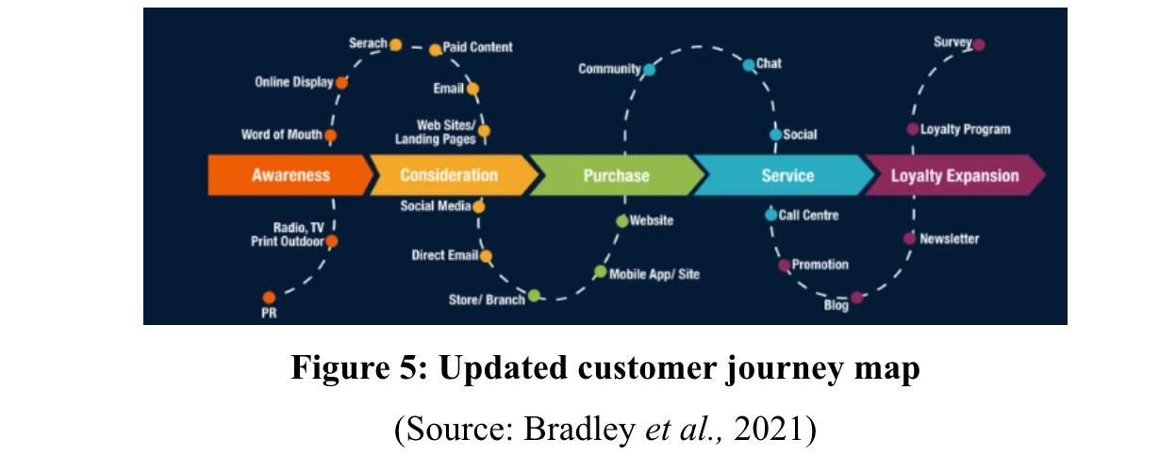
(Source: Bradley et al., 2021)
The above representation shows the ways journey map have been enhanced after implementing AI powered personalised shopping app. It has been analysed that using app has increased personalised targeting options and increasing the outcomes. Besides, shift can be seen in aspect of marketing as AI has helped to do predictive analysis and meet the exact needs and desires of each customer. After the new digital initiative, better customer experiences can be seen through personalised suggestions, voice guided shopping assistance, discounts and different offers. The above represented customer journey map has highlighted the process of interaction with the brand and thus, proper interaction is maintained at every touch point. Based on the update regarding the journey map of Tesco, it is seen that exact customer needs, problems are resolved and better engagement outcomes are identified.
In consideration to the proposed initiative, Tesco can bring proper changes and support customers to use their products and services more in the coming years. Also, it can be analysed that AI powered personalised shopping app have proper positive impacts on the business. Furthermore, based on the proposed initiative, effective strategies can be used for measuring the success or impacts of AI powered personalised shopping app on Tesco and the customer experiences. This shows a positive link between the proposed initiative and impacts on organisation and associated customers of Tesco.

Positive impact of proposed initiative on Tesco
It must be acknowledged that the implementation of an AI-powered personalised shopping app has the opportunity to improve Tesco’s customer experience, operational efficiency and overall competitiveness. In this current retail landscape, digitalisation and customer-centricity are both considered as key drivers of growth as innovation aligns effortlessly with Tesco’s strategic objectives and market trends (Bathija, 2021).
Firstly, this app would provide highly personalised shopping experiences by utilising customer data to recommend products, offer customised offers and forecast future purchases on the basis of customer buying behaviour. This will not only improve customer satisfaction and loyalty by managing convenient, relevant and enjoyable shopping experiences (Rane et al., 2023). Regarding shoppers, they would definitely benefit from time-saving features like pre-filtered baskets on the basis of last purchases, AI-powered recipe suggestions by using those personalised Tesco products and real-time stock updates which can all increase their retention and brand affinity.
From a business point of view, it can be said that personation helps to increase average basket size and frequency of customers visits. Their customers would also like to purchase recommended products and complementary items which surely boost revenue per customer. This company can also use behavioural data analytics to effectively manage tier stock, reduce waste and optimise inventory which completely align with their sustainability goals and cost-saving strategies. For example, as AI identifies a decline in interest in certain products then Tesco can make necessary adjustments in their inventory levels while reducing excess and improving supply chain responsiveness.
Moreover, the AI app can work as a powerful tool for Tesco’s marketing and promotional strategies (Malikireddy, 2024). Making targeted advertisements and offers on the basis of purchase history would definitely help to increase higher engagement rates and improved return on investment (ROI) white compared to traditional marketing. Besides, with the help of real-time feedback and usage patterns can inform Tesco regarding their customer trends which actually help to manage future product lines and strategic decisions.
This initiative also helps to influence digital transformation internally. This surely influenced a culture of innovation within Tesco, while upskilling employees with data-driven technologies and AI integration. By showing digital tools, this company can improve decision-making and operational agility, keeping it ahead of their competitors like Sainsbury’s and ASDA.
All these practices also help Tesco in managing their current commitment to sustainability and social responsibility. Utilising AI also helps to reduce food waste, manage their delivery routes and ensure lower energy consumption with the help of better inventory prediction, this company makes progress towards their net-zero and environmental targets (Elgalb and Gerges, 2024). AI uses historical sales data, weather patterns and other factors to predict customers’ upcoming demands, it also uses dynamic pricing strategies while focusing on factors like shelf life and predicted demand and managing food redistribution to minimise waste.
Finally, it can be said that an AI-powered shopping app is not only a customer-facing tool but it needs to be considered as a transformative asset. It seems to improve their value proposition, influence financial performance, support long-term strategic goals and strengthen their brand image as a forward-thinking customer-centric and sustainable retailer.

Measuring the impact and success of proposed initiative
In order to ensure the effectiveness of the AI-enabled personalised shopping app, Tesco can really develop a dynamic framework to measure the impact and success by using both qualitative quantitative indicators. Some effective key performance indicators (KPIs) are as follows
- Average basket size and frequency of purchases: It helps to analyse both the average basket size and the frequency of purchases to understand if this app is increasing their spending per user or not (D’Acunto et al., 2021).
- Customer satisfaction scores and Net Promoter Score (NPS): These key metrics are essential for improving customer experience and brand loyalty. The first one focuses on immediate interactions and the second one helps in measuring customer loyalty and willingness to recommend.
- Customer retention rate and app usage frequency: These signifies whether the app is increasing customer spending or not (Lin et al., 2020). It also reflects user engagement and how effectively it keeps their customers coming back.
- Conversion rate: Conversion rates on personalised offers help to reflect how efficient recommendations are in influencing customers behaviour. It makes personalised offers and recommendations more appealing to individual customers which increase the likelihood of their purchasing.
- Operational efficiency metrics: It helps to detect inventory turnover rate and food waste reduction amount, so that this company can optimise their operations, reduce costs and improve their profitability (Olayinka, 2021).
This company can monitor data-driven insights like
- Measuring the success rate of product recommendations through click-to-buy conversion.
- Collecting the latest data also helps to understand trends in customer choices and behaviours (Okeleke et al., 2024).
- It also helps to ensure delivery performance improvements on the basis of AI logistics suggestions.
Through feedback mechanisms like in-app surveys, focus groups and user reviews it will offer qualitative data on the app’s usability, significance and impact. These are equally efficient in determining areas for necessary improvements. Moreover, they can also consider regular benchmarking in this against latest sales and engagement figures because it will help this company in better understanding their ROI and critically assessing how well this app supports their overall strategic goals like sustainability, digital innovation and customer-centric growth. Overall, managing a continuous feedback and analytics loop will help this company in continuously monitoring, analysing and improving the app over time. This also ensures a robust asset which is coordinated with changing market expectations and customer needs.

Conclusion
In conclusion, it can be said that the part one section helps to develop an appropriate organisation approach through identifying what current innovation and design the organisation is recently engaged in and what opportunities they have in this industry. Analysing customer journey mapping helps Tesco to determine pain points like unavailability of stock, long queues and navigation issues along with gain points like online and in-store shopping experience, click & collect and express delivery options. The second section comes with the idea of a new digital transformation initiative which is AI-powered personalised shopping app to change customers' shopping experience. It can be said that the proposed AI-powered personalised shopping app not only reflects a strategic innovation for Tesco, but also helps to transform their customer engagement, operational performance and digital footprint. Measuring the success of this app through KPIs, customer feedback and data analytics help them in continuous improvement and strategic alignment.

References
Aldoseri, A., Al-Khalifa, K.N. and Hamouda, A.M., (2024). AI-powered innovation in digital transformation: Key pillars and industry impact. Sustainability, 16(5), p.1790.
Ali, S., (2024). Investigating the impact of business analytics on consumer experience and loyalty in the supermarket industry of Ireland (Doctoral dissertation, Dublin Business School).
Balakrishnan, J. and Dwivedi, Y.K., (2024). Conversational commerce: entering the next stage of AI-powered digital assistants. Annals of Operations Research, 333(2), pp.653-687.
Bathija, A., (2021). Digitalisation in the Banking Sector–the Need for New Customer-Centric Business Models. Годишник на Бургаски свободен университет, 44(1), pp.297-313.
Bierganz, M., (2021). Delivering Virtual Value: The Role of Virtual Value Creation in e-Grocery Business Models and Resulting Implications for Today’s Grocery Retail Firms (Master's thesis, Universidade Catolica Portuguesa (Portugal).
Bradley, C., Oliveira, L., Birrell, S. and Cain, R., (2021). A new perspective on personas and customer journey maps: Proposing systemic UX. International Journal of Human-Computer Studies, 148, p.102583.
D’Acunto, F., Malmendier, U., Ospina, J. and Weber, M., (2021). Exposure to grocery prices and inflation expectations. Journal of Political Economy, 129(5), pp.1615-1639.
Elgalb, A. and Gerges, M., (2024). Optimizing Supply Chain Logistics with Big Data and AI: Applications for Reducing Food Waste. Journal of Current Science and Research Review, 2(02), pp.29-39.
Euromonitor, (2025). New concepts regarding loyalty. [Online]. Available at: New Concepts in Loyalty | Market Research Report | Euromonitor. [Accessed on 28.06.2025].
Frei, R., Jack, L. and Krzyzaniak, S.A., (2022). Mapping product returns processes in multichannel retailing: Challenges and opportunities. Sustainability, 14(3), p.1382.
He, A.Z. and Zhang, Y., (2023). AI-powered touch points in the customer journey: a systematic literature review and research agenda. Journal of Research in Interactive Marketing, 17(4), pp.620-639.
Lin, Y.H., Chen, S.Y., Lin, P.H., Tai, A.S., Pan, Y.C., Hsieh, C.E. and Lin, S.H., (2020). Assessing user retention of a mobile app: survival analysis. JMIR mHealth and uHealth, 8(11), p.e16309.
Malikireddy, S.K.R., (2024). Generative AI for retail marketing: Automated campaign creation and optimization. World Journal of Advanced Engineering Technology and Sciences, 13(1), pp.1058-1068.
Meng, S., (2024). Operation Management of Grocery Retailer in the UK: A Case of Tesco. Pacific International Journal, 7(2), pp.136-142.
Mittermeier, F., Hund, A. and Beimborn, D., (2022). Entrepreneurial Support Systems in the Digital Era: A Taxonomy of Digital Company Builders. In AMCIS.
Nugraha, A.P., Mulyadi, M. and Suriani, S., (2024). Customer Journey Mapping: Understanding Consumer Behavior Digitally. Berajah Journal, 4(2), pp.327-336.
Okeleke, P.A., Ajiga, D., Folorunsho, S.O. and Ezeigweneme, C., (2024). Predictive analytics for market trends using AI: A study in consumer behavior. International Journal of Engineering Research Updates, 7(1), pp.36-49.
Olayinka, O.H., (2021). Big data integration and real-time analytics for enhancing operational efficiency and market responsiveness. Int J Sci Res Arch, 4(1), pp.280-96.
Oyekunle, D. and Boohene, D., (2024). Digital transformation potential: The role of artificial intelligence in business. International Journal of Professional Business Review: Int. J. Prof. Bus. Rev., 9(3), p.1.
Rana, J., Gaur, L., Singh, G., Awan, U. and Rasheed, M.I., (2022). Reinforcing customer journey through artificial intelligence: a review and research agenda. International Journal of Emerging Markets, 17(7), pp.1738-1758.
Rane, N., (2023). Enhancing customer loyalty through Artificial Intelligence (AI), Internet of Things (IoT), and Big Data technologies: improving customer satisfaction, engagement, relationship, and experience. Internet of Things (IoT), and Big Data Technologies: Improving Customer Satisfaction, Engagement, Relationship, and Experience (October 13, 2023).
Rösch, N., Tiberius, V. and Kraus, S., (2023). Design thinking for innovation: context factors, process, and outcomes. European Journal of Innovation Management, 26(7), pp.160-176.
Shiratori, E.K.A., Trevisan, A.H. and Mascarenhas, J., (2021). The customer journey in a product-service system business model. Procedia CIRP, 100, pp.313-318.
Statista, (2025). Health and wellness food trends. [Online]. Available at: Health and wellness food trends in the United Kingdom - statistics & facts | Statista. [Accessed on 28.06.2025].
Tesco, (2025a). About Tesco. [Online]. Available at: Tesco PLC | Community, Investors & Sustainability. [Accessed on 28.06.2025].
Tesco, (2025b). Sustainability reporting in Tesco. [Online]. Available at: Sustainability Report 2025. [Accessed on 28.06.2025].
Treves, L., (2021). Business Models in the Digital Age: The Internet of Things. Contemporary Issues in International Business and Entrepreneurship.
Van den Ende, J., (2021). Innovation management. Bloomsbury Publishing.
Walls, A.J., (2021). Design‐Led Innovation: A Framework for the Design of Enterprise Innovation Systems. Design Management Journal, 16(1), pp.93-110.
Ziliani, C. and Ieva, M., (2025). Loyalty Management: Driving Engagement with Loyalty Programs and Customer Experience. Taylor & Francis.

