Portfolio Writing
2501546
BA Graphic Design
1470 Words
Donna Williams

For this assessment, I confirm that I have NOT used Generative AI to support me in structuring my submission, including creating a draft argument structure, identifying parts and headings.
I confirm that I have not used Generative AI to create text for my submission. I confirm that I have not used Generative AI for creative materials, such as images.

Task One – Semiotic analysis
Tangled
Semiotics is the study of signs and sign-using behaviour. It was discovered by Ferdinand de Saussure and Charles Sanders Peirce. Saussure defined semiotics as “the life of signs within society.” (Saussure, 2011) while Peirce defined it as “something which stands to somebody for something,” (Perice,1955). Two slightly different interpretations to the study which I will be using to depict the movie poster of Tangled.
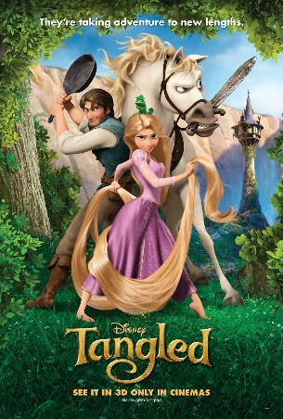
Tangled is an American animated musical fantasy comedy film that is based on the Brothers Grimm (Grimm & Grimm, 2003) German fairy tale “Rapunzel”. It is produced by Walt Disney Animation Studios. The film was written by Dan Folgelman and directed by Nathan Greno and Bryon Howard. The poster was designed by Proof and is #3 of 6 posters (Impawards.com, 2025) that were designed for this movie, all of which were designed by various artists and studios involved in the film’s productions.

In this movie poster, the first thing to catch the viewers eyes are the characters of the movie, Rapunzel, Flynn, Pascal and Maximus. The arrangement of the characters is an iconic sign of this showing their importance in the movie (Rose, 2016) the clear main character being Rapunzel as she is in the centre. Her stance symbolizes her determination to achieve her dream. The positioning of Fylnn Ryder back-to-back with Rapunzel symbolizes an alliance with the two characters suggesting that at one point they were on different sides and have overcome this to help one another throughout the movie. In the poster Pascal is seen to be on top of Rapunzels head. This indicates that the two have a close relationship and suggests he is a companion figure for Rapunzel which is often found in traditional fairy tales (Luthi,1986).
Peirce’s perception of a sign “Standing for something to someone in some respect” (Perice,1955) is apparent in the title “Tangled” to symbol her life to be messed up allowing the viewer to depict the type of Disney princess Rapunzel will be. The serif type face represents a formal and upper-class style linking to Rapunzel royal status (Bordwell & Thompson, 2017). The titles colour being the same as her hair directly connotates again that she is the main character and this is her story. The off-gold shade decodes her innocence and purity (Warner, 2014) which is juxtaposed by my analysis of her facial expression and positioning. The ‘G’ in ‘Tangled’ is curled which imitates Rapunzel’s hair and directly matches the hair she also holding suggesting that her hair is part of the main plot of the movie.
My first response to this poster was that it was an innocent Disney movie about a princess with long hair, however after analysing the semiotics of the characters and the typography use it is shown to involve adventure, struggle and have a deeper understanding of her story.

Bibliography
Bordwell, D. & Thompson, K. (2017) Film Art: An Introduction. 11th edn. New York: McGraw-Hill.
Grimm, J. & Grimm, W. (2003) The Complete Fairy Tales. London: Vintage.
Impawards.com. (2025). Tangled Movie Poster (#3 of 6). [online] Available at: http://www.impawards.com/2010/tangled_ver3.html [Accessed 29 Nov. 2025].
Lüthi, M. (1986) The European Folktale: Form and Nature. Bloomington: Indiana University Press.
Peirce, C.S. (1955) Philosophical Writings of Peirce. New York: Dover Publications.
Rose, G. (2016) Visual Methodologies: An Introduction to Researching with Visual Materials. 4th edn. London: Sage.
Saussure, F. de (2011) Course in General Linguistics. London: Duckworth.
Warner, M. (2014) Once Upon a Time: A Short History of Fairy Tale. Oxford: Oxford University Press.

Task 2 – Manifesto Statements
- Knowledge is Power.
- Create what makes you happy.
- If at first you don’t succeed try, try again.
- Be yourself.
- You are held accountable for your actions.
- Treat others how you wish to be treated.
- Stand up for your beliefs.
- Get into a routine.
Create what makes you happy
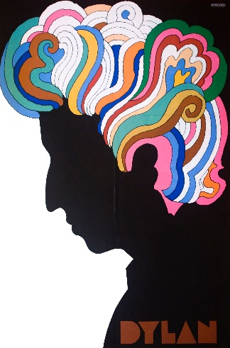
Fig.1 (Glazer, 1966)
Being able to create my own happiness is very important to me. This manifesto allows for a wide range of different definitions of what I can create to make me happy. From creating a calm working environment or creating a design. Being able to make a relaxing space, decluttering to help me focus is something I rely on every day. This creativity allows for other ways to flow. For example, creating an empty workspace for my self allows me room to sketch and paint, to create what makes me happy. In this piece Glazer (1966) shows a black figure, he uses colour and wild shapes to show that happiness is a wide spectrum, believing that design should do more than just communicate (Glazer, 2000). I like to interpret the image as what it looks like in my head when I am creative. The piece decodes that even in a dark moment, your creativity is always with you.
Bibliography
Glaser, M. (2000) Art is Work. New York: Overlook Press.
Glaser, M. (1966) Dylan. [Poster]. New York: CBS Records.

Treat others how you wish to be treated
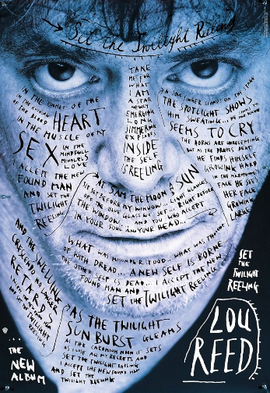
Fig.2 (Sagmeister, 1996)
Treating others how you wish to be treated involves respect, kindness and empathy. Respecting someone’s decisions and actions allowing them to feel valued as a person. This is important to me as being understood why I chose to do something makes me feel seen. Treating someone with kindness proves empathy and develops patients. I believe it is important in relationships, platonic or romantic, to be able to build each other up and support one another. It builds trust and shows good morals. Personally, I would not choose to surround myself with people who make me feel anything less than valued. In this piece (Sagmeister, 1996) Heller (2003) emphasises his empathetic approach to communication linking to always treating someone with kindness and respect as you never know what someone is going through (Heller, 2003). Being treated correctly is expected in relationships.
Bibliography
Heller, S. (2003) The Design Imperative: The Art of Ethical Communication. New York: Allworth Press.
Sagmeister, S. (1996) Set the Twilight Reeling: Album Poster. New York: Sire Records.

Get into a routine
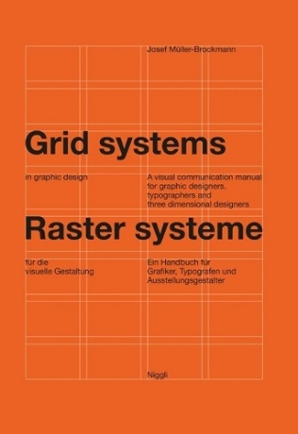
Fig.3 (Müller-Brockmann, 1981)
A routine helps me structure my days and projects. It helps me to feel productive and well balanced, being something I rely on every day. Being able to have a routine stops me to feel overwhelmed and allows me to feel in control of a situation when I get stressed. I believe routine is good for mental health and gives emotional support through any situation. Whether it’s a routine of chores on a Sunday or a routine for design. In this image, Müller-Brockmann shows how he uses routine with his designs. He uses and relies on a grid method in his work to develop his ideas. In this book he explains how a relatable and reliable method helps to establish structure, proportion and coherence (Müller-Brockmann, 1981).

Bibliography
Müller-Brockmann, J. (1981) Grid Systems in Graphic Design. Zurich: Niggli.

Task 3 – Practice-based Writing
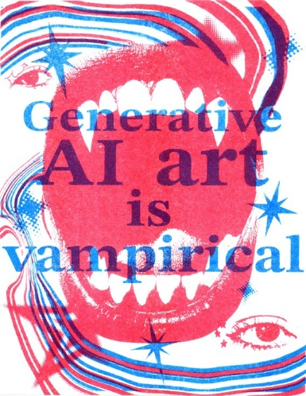
Fig.1 (May, 2025)
My intention with this piece was to create a design for an inspirational graphic design quote so they can appear on Instagram. Each design had to include a hand-crafted element. For this quote I chose to use Riso printing because of the ability for its bright colours and textures in the image (Hughes, 2014). Riso printing is an eco-friendly printing system that relies on soy-based inks (Quinn, 2019) and is a mix between screen printing and photocopying. To achieve such bright colours, it separates into layers which is printed one by one to build up an image, using over prints to create different colours. For example, I used blue on top of red to get the third colour purple. I sent my design in grey scale in two different layers to use two colours. The machine burns the stencil called a ‘master’ for the first design and then layers the second design. I chose the final piece to print blue on top of red as I wanted the main image to be the darker colour. In my first test I used red text on top of the blue image, and it made the image look insignificant to the text and I wanted them to be equal (Butler, 2012). I also balanced the colours out by using each colour the same amount in the design. I erased certain parts of the red layer design to allow for the blue to show through better and vice versa.
The quote “Generative A.I. art is Vampirical” is from an open letter by Molly Crabapple. In the letter she describes ‘vampirical’ as to be ruining current artists and destroying past generations (Crabapple & Center for Artistic Inquiry and Reporting, 2023). I chose this quote as I believe it is very relevant today in the discussion of A.I. art. I wanted to present the quote with a bold serif typeface to present it to be formal and contain context. The serif typeface allows for a harsh impact of the message with the use of sharp edges. The stars around the design also help tie in the whole image to the text.
I wanted the emotion of this design to convey an energetic and political energy. I did this by looking at Barbara Kruger’s use of text in her work. She influenced me to make the quote the focus of the design and for the rest of the design to be behind it. I made the collage of images for the background to follow a 1970s-1980s punk subculture, focusing on punk zines (Duncombe, 2008). I did this by using aggressive imagery and the high contrast between colours. The confrontational imagery comes from the open mouth and the eyes as it suggests a sense of intensity which matches the unfiltered quote (Kruger, 2010).
I feel the strongest part of this outcome is the contrast between colours and how well it turned out from the Riso Printer. I enjoyed focusing my design and taking inspiration from punk zines. I like how it helps the image indicate a strong message. A refinement I would make in the future would be to work on the alignment of the layers; however, it shows a nice, handcrafted element from the Riso printing. If I were to develop this further, I would erase the red design where the text is going to be positioned so that the text can stand out more on its own. Overall, it was a very successful Riso print.

Bibliography
Butler, C. (2012) Postmodernism: A Very Short Introduction. Oxford: Oxford University Press.
Crabapple, M. & Center for Artistic Inquiry and Reporting (2023) Restrict AI Illustration from Publishing. Open Letter. [online] Available at: https://artisticinquiry.org/AI-Open-Letter [Accessed 08 Dec. 2025].
Duncombe, S. (2008) Notes from Underground: Zines and the Politics of Underground Culture. Bloomington: Indiana University Press.
Hughes, A. (2014) Printmaking: Traditional and Contemporary Techniques
Kruger, B. (2010) Barbara Kruger. New York: Rizzoli.
Quinn, A. (2019) Risograph: A Practical Guide

