
Motorcycle Technology

Motorcycle Technology | ACHA4027

Reid Lupton - 2517853
Motorcycle Engineering
1958 / Maximum: 2000
December 2025

Contents
Contents
Contents 1
Introduction 2
Chapter 1 3
Comparing the two bikes under dynamic situations using their geometry, power and gearing. 3
chapter 2 6
researching 2 other modern bikes and comparing their geometry to their applications 6
chapter 3 7
-Possible alterations to the R125 and SV650S to improve handling characteristics 7
Reference list 8

Introduction

In this report, accurate data was gathered through physical measurements and online research for the Suzuki SV650S (2009) and the Yamaha YZF-R125 (2019). This data consists of; the centre of gravity of the machine with and without the rider, engine data collected from a wheel-based dyno for the power torque graph and geometry data to plot accurate features onto a graph. These were used to compare their geometry and power features in dynamic situations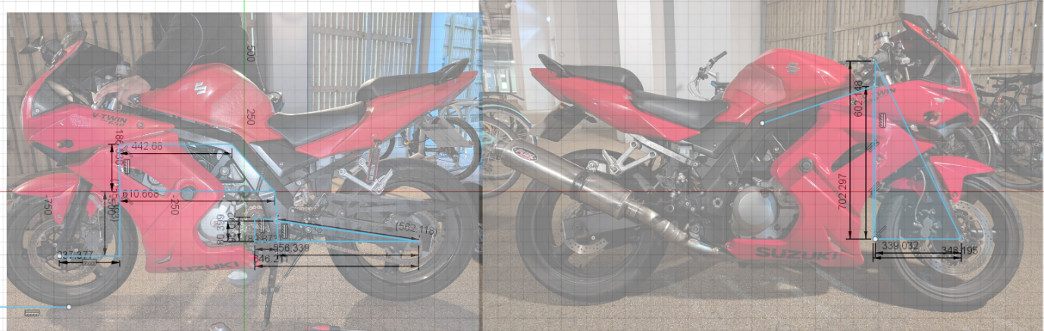
Figure 1- shows the SV650S in CAD to gather geometry data
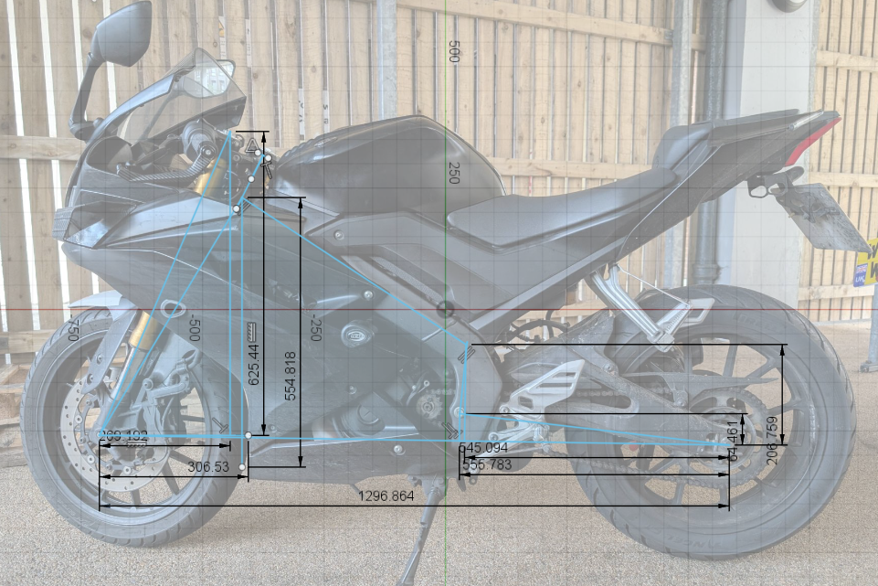
Figure 2 - shows the YZF R125 in CAD to gather geometry data

After the geometry features of two bikes are compared, two more modern bikes which are inaccessible, are compared using data collected from photographs and data found online to plot their geometry data onto graphs.
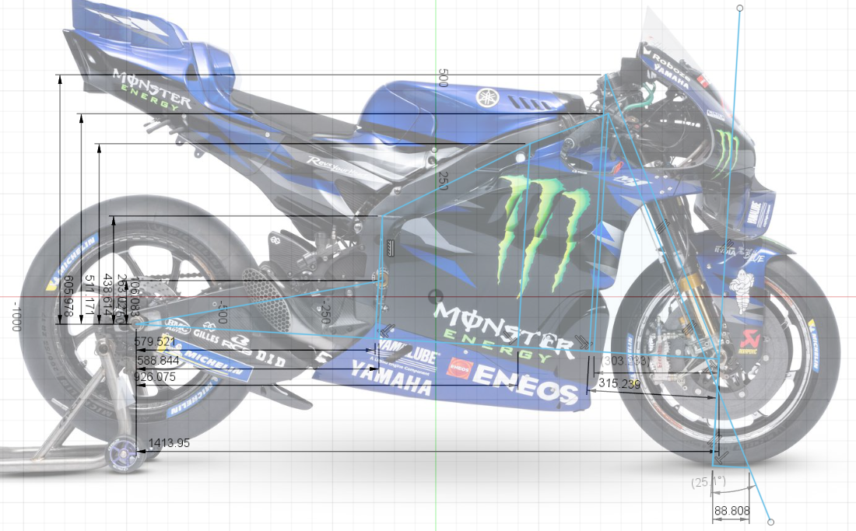
Figure 3 - shows the Factory Yamaha YZF M1 in CAD software to gather data on its geometry features
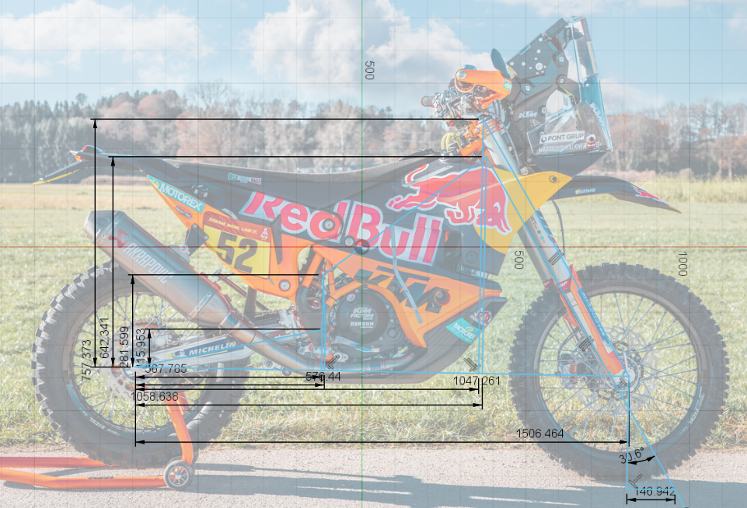
Figure 4 - shows the KTM 450 Rally in CAD software to gather data on its geometry features

Chapter 1

Comparing the two bikes under dynamic situations using their geometry, power and gearing.

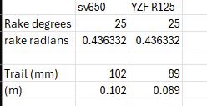
The Suzuki SV650S and the Yamaha YZF R125 are both classed as sport bikes, despite the major difference in power and weight, they both are designed to be most effective on track. This is due to multiple different geometric features on these bikes. The first difference I discovered when collecting the data was that the rake angle is the same for both bikes, but the trail on the R125 has a 13mm shorter trail. This diffrnce in trail allows the r125 to be less stable in a streight line allowing the rider to initiate and hold a turn easier, the sv on the other had has a larger trail making the rider work harder to initiate a turn. The diffrence in trail could be due to the fact the SV650S’s need for more stabilty at higher speeds as the SV650S can reach 137MPH in its stock gearing where the R125 can only reach 85MPH. this diffrence in top speed will require more stabilty at higher speeds which requires a longer trail for the SV650S.
Figure 5- displaying the data of rake and trail for both bikes
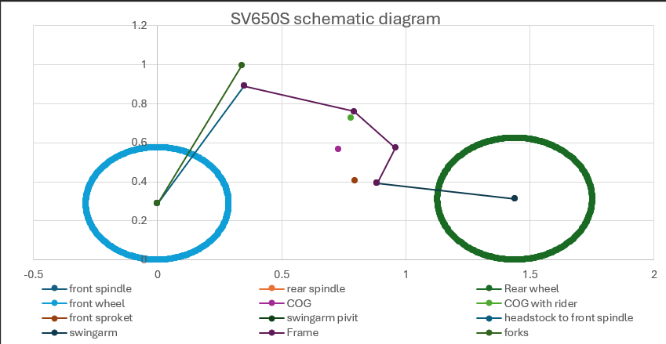
Figure 6 a schematic diagram of the SV650S
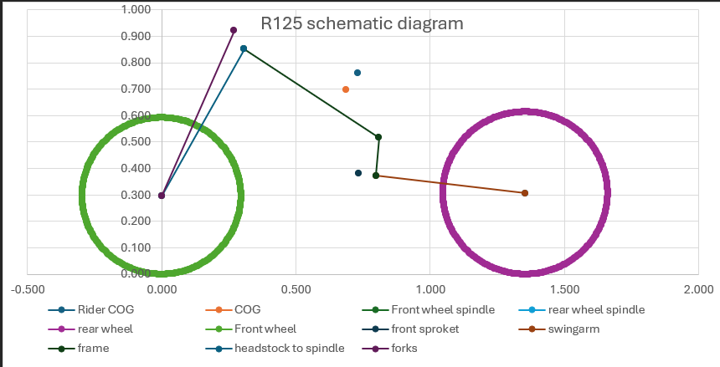
Figure 7 schematic diagram of the R125
Dispite the trail sugesting the that the SV650S will be harder on the rider to initiate the turn and more stable at speed than the R125, this is only renforced by the data showing the center of gravity of both bikes. Figure 2 and 3 show a side on view of the SV650S and R125its centre of gravity, with and without the rider. The R125 diagram shows that the centre of gravity is above the frame making it easier to initiate ta turn as the majority of the weight is high up on the bike, where on the sv650s, the COG with the rider is high on the bike but is lower than the r125. This makes the SV650S rider have less effect on the COG when trying to turn as the bike, becuese the bike is much heavier compared to the R125.
Having a smaller front wheel has a very similar effect of reducing the trail, the SV650S has a smaller front wheel than the R125 which will reduce the effect of having a longer trail. Having a longer trail but smaller front wheel allows for a longer wheelbase which give more stabilty at high speed and fast corners but reduces the speed the bike can turn into the corner. In these current configurations, if the bikes had the same power and weight, the R125’s geometry weould be faster around a small track with slower corners. However the SV650S would be much better as larger tracks with fast corners due to its longer wheelbase lower centre of gravity and longer trail.

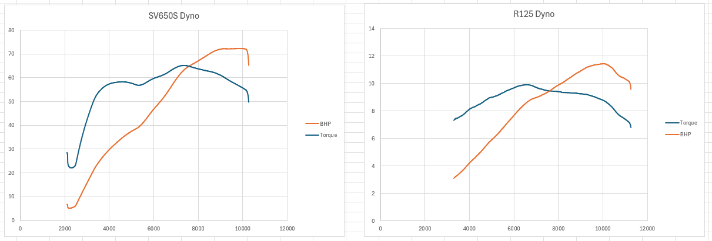
Figure 8- dyno results for the sv650s and r125
When looking at the power of the two bikes, in figure 4, it is clear that they are in completley different classes. The R125 is making 12.8BHP and weighs 228.4kg (with rider) resulting in a power to wieght of 0.05. This is because this bike is limited to meet licence restrictions and is optimised to maximise its ability within its restriction. The SV650S, while compatible withdiffrent types of licences is unrestricded in this test, produced 72.2BHP and weighs 267.25KG (with rider). This results in a power to weight of 0.27 for the SV650S. The R125, compared to the SV650S its significantly down on power.
The R125 will acelerate slower and reach a top speed slower than the SV650S, in almost every track condition, the sv650S will have a faster lap time primerily due to the power diffrence. Looking at the torque plotted on figure 4 it shows similaritys and diffrences in how the power is delivered. The sv650s has a sharp climb of torque from 2,000 – 5,000 RPM increasing from 23NM to 58NM where it falls then climbs once again to peak 65NM where it then falls again steadily. The R125 has a slow increase in torque peaking at 6,500 RPM at 9.9NM then falls to 9NM where it thenslowly decreases to 8.7NM, finaly it falls at a steep drop to 6.7NM. this diffrence in power will allow the sv650S to acealerate off from a stop significalty faster due to its impressive jump in torque of 35NM in only 2,000 RPM. This power diffrence also it aids the rider throught the stages of going through a corner. The SV650S will have significantly more engine breaking than the R125 allowing the rider to slow the bike down faster and then on exit to a corner the SV650 can acelerate magnitudes faster out of the corner.

chapter 2

researching two other modern bikes and comparing their geometry to their applications

I have researched the Yamaha factory YZF-M1 and the KTM 450 Rally replica modified and used in the Paris Dakar 2025, to gather data for their geometry data and what affect these have to specialise in their respective series.
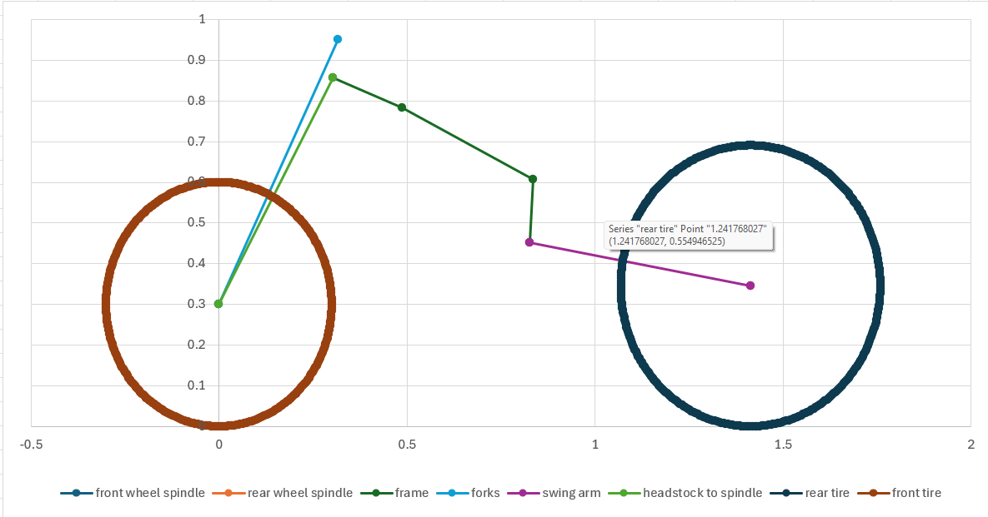
Figure 9 – shows the geometry data for the Yamaha YZF M1 2025
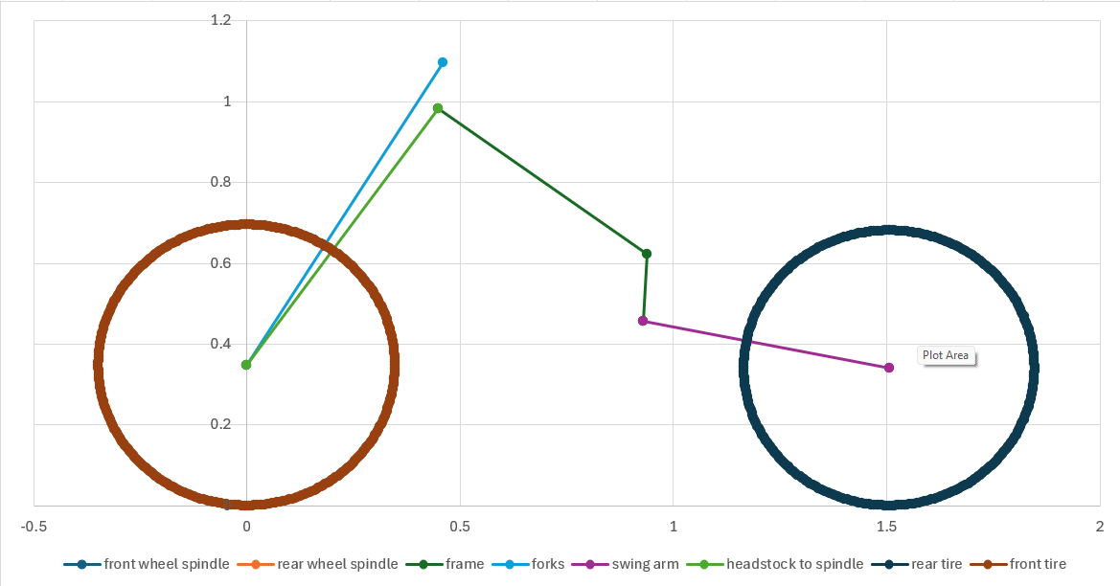
Figure 10 - shows the geometry data for the KTM 450 Rally

In figure 9, the YZF M1 is displayed to have a rake of 25.1 degrees and a trail of 88.808mm. this will be an advantage to an advanced rider in Moto GP as the bike becomes naturally much more unstable in a straight line compared to road super sport bikes. The Rake itself will make the front unstable and easier for a rider or other forces to turn the bike however such a small trail will make the bike extremely unstable and very fast turn in response but very little self centring effect which will require significant rider skill to keep the bike straight. On the other hand, in figure 10, the KTM 450 has a large rake and trail. The KTM’s rake is 30.6 degrees and a fairly extreme 146.942mm. Unlike the Moto GP bike, these figures for rake and trail both aid the rider as the bike naturally wants to go in a line with a large self centring force. This is beneficial for the Dakar as when off-roading as there is less forces pushing the bike to be unstable at speed.
Another feature that separates the two bikes is the size of the front wheel. The KTM has a large wheel measuring 68.12cm which also give a straight line advantage with more mechanical trail. This makes the bike harder to change direction, if the KTM were on a track against the M1 it would require much more force to enter and remain in a corner but will naturally want to be stable in a line. The Moto GP M1 bike has a standard and verry common 17 inch front wheel, and with the tire the diameter is 60cm this gives much less gyroscopic stabilisation, especially with the light weight forged magnesium/ aluminium alloy wheels. This will make turn in faster and stability in a line worse. The geometry of the MotoGP M1 requires them to use steering dampeners otherwise the straight line instability would be excessively dangerous.

chapter 3

-Possible alterations to the R125 and SV650S to improve handling characteristics

Alterations to the R125 to reach the handling characteristics of the M1 would be to reduce the trail as the rake is almost identical from photos I have sourced and measured. This change in the R125 geometry would make it significantly harder to ride on road due to any slight bump at speed could initiate severe instability, and worst case cause a crash. On track, the reduced trail will increase its ability to respond to turning aiding the rider to achieve a faster lap at the cost of increasing the difficulty to stay straight at speeds.
Another change to the R125 suggested by the M1 would be a taller tire. The M1 has a front tire of 120/70.1/17 and the r125 has 100/80/17. A taller tire will allow for quicker turn response and higher angle of lean, allowing for faster corner speeds and entry transition. The rear wheel size difference would also likely need to be increase as the M1 has a significant difference in tire size from front to rear, about 9cm, where the R125 has a difference of 2cm. This will aid in turn in response and decrease straight line stability.
If the SV650S was to be converted to an offroad bike to relate to the KTM 450, the Rake and trail would both be changed to significantly increase straight line stability at speed as the current setup of the bike favours instability for a handling edge. This is the opposite of the desired characterise for an offroad bike. The front wheel on the SV650S would also need to be replaced with a larger diameter to aid in gyroscopic stability but also to allow the bike to go over harsh terrain.
Another alteration to the SV650S to reach the handling characteristics of the KTM 450 Rally, would be to lengthen its wheelbase to improve stability in a line as the current geometry of SV650S is in between sport and offroad as its more bias to a sport tourer then a pure super sport but its still classed as a super sport. It has a wheelbase of 1.44m which is very average and not very bias in ether aspect of straight line stability or turn in response. Increasing its length to increase the straight line stability and reducing turn response will make the SV650S better at dealing with offroad conditions.

conclusion
in conclusion, the SV650S and the R125 are both super sport designs but restricted to different legislation which produced a bike that is faster in a line but a noticeably more difficult to handle the bike in dynamic situations where the other struggles in straight line speed from lack of power but excels in handling.
When comparing race spec machines for two different sports, track racing and offroad endurance, geometry data shows track bikes favour more instability for fast turn response where they compromise on straight line stability, as they use steering dampers to remain stable in a line. Where offroad motorcycles much prefer stable and self centring geometry to aid in keeping the rider on track in harsh and dynamic conditions.
With the potential alterations to the SV650 and R125, the R125 could have a shorter trail and wheelbase to improve handling response to make a faster track bike inspired by the features of the M1, where the sport oriented SV650S to be compared to the offroad specialised KTM 450 it would require an increase in rake and trail to improve self centring characteristics.

Reference list
Used to aid in data collection for SV650 | Correia, A. (2005a). 2009 Suzuki SV 650. [online] Motorcyclespecs.co.za. Available at: https://www.motorcyclespecs.co.za/model/suzu/suzuki_sv650na%2009.htm#google_vignette [Accessed 14 Dec. 2025].
Used to aid data collection for R125 | Correia, A. (2005b). 2019 Yamaha YZF-R 125. [online] Motorcyclespecs.co.za. Available at: https://www.motorcyclespecs.co.za/model/yamaha/yamaha_r125_19.html#google_vignette [Accessed 14 Dec. 2025].
Yamaha factory YZF M1 2025 photo | Facebook.com. (2022). Facebook. [online] Available at: https://www.facebook.com/photo?fbid=1035488235279028&set=pcb.1035489485278903 [Accessed 14 Dec. 2025].
KTM 450 Rally 2025 photo | Team, E. (2020). Bikes of the 2021 Dakar Rally. [online] Enduro21. Available at: https://enduro21.com/en/bikes/latest/bikes-of-the-2021-dakar-rally.

