Student name: Cristina-Elena Enache
Student number: 2026057
Module name: Changemakers: Creativity and Value Creation
Module code: BMHP5014

BSc Health and Social Care

Changemakers: Creativity and Value Creation

Table of Contents

Introduction 3
Innovation, Creativity and Entrepreneurial Mindset and the Value Creation of Creativity 4
01. Innovation 4
02. Literature and Statistical Preview of Innovation 4
03. The Innovative Mindset 6
04. Creativity 6
05. Creative Mindset 7
06. Entrepreneurial Mindset 8
07. Entrepreneurship and Innovation 8
08. Entrepreneurship and Creativity 9
Creative Thinking for Creating Innovative Solutions or Value 10
Conclusion 11
References 13

Introduction

What is brand new, what constitutes innovation, and who are the people for whom it is brand new? In entrepreneurship, terms such as creativity in business and innovation are frequently used interchangeably, even though there are discernible distinctions between the two (Nicolaides, 2011). Creative thinking is essential to education and value creation. Globally, there is a growing need to encourage creativity to boost value creation. Creative thinking innovates new information that enhances learning processes. Several concepts have analytical tasks that limit innovative creativity's value development. Creative thinking is essential to education and value creation. In this report, I will talk about the differences and similarities between creativity and innovation and how I can develop my ability to think creatively.

Innovation, Creativity and Entrepreneurial Mindset and the Value Creation of Creativity

01. Innovation
A product, service, or procedure is considered innovative if it incorporates new technology. It is also possible for innovation to be social, societal, or commercial process-oriented. Regeneration or rejuvenation is what I am looking for here. Proactive and reactive are the two approaches to innovation that exist. Companies like Philips, Google, and Apple rely on inventions to keep one step ahead of the competition. Entrepreneurial innovation also necessitates a growth attitude since doing nothing results in degeneration (Nicolaides, 2011). So this is known as proactive innovations. On the other extreme, new technologies compel me to create something entirely new. As a result, this is considered a reactive innovation in that sense. Reliance on consumers or the government forces to be reactive innovators.

02. Literature and Statistical Preview of Innovation
According to Adobe's global study of over 5,000 employees, companies that engage in creativity seem to be more likely to inspire innovation (83 percent), boost employee productivity (78 percent), deliver a better experience for customers (78 percent), and be wealthy (73 percent). Despite this, 77 percent of those polled stated that they are under rising stress to be more productive than creative (Sturdy, Clark, Fincham and Handley, 2019).
According to research, process innovation seems more prevalent than product innovation. Innovation is more significant in larger medium-sized businesses than in smaller businesses with fewer than 100 employees. In the previous three years, more than nine out of ten businesses have implemented some reform (product or process innovation). Moreover, they independently developed the innovations (Openstax, 2022).
However, adopting an innovation plan is complex and fraught with the risk of failure. Numerous obstacles occur during the renewal process, including Time, Money, Goods, creative and business-savvy Employees, and Bureaucracy (permits and patents). Another study of 326 United States-based businesses reveals that serendipity is at its peak when resources are scarce (Andrew, et al. 2021 in Journal of Business Venturing).
Drucker categorised innovation sources in Table 0.1. Firms and people can innovate by focusing on market changes or inventiveness. Individuals and companies should seek innovation opportunities.
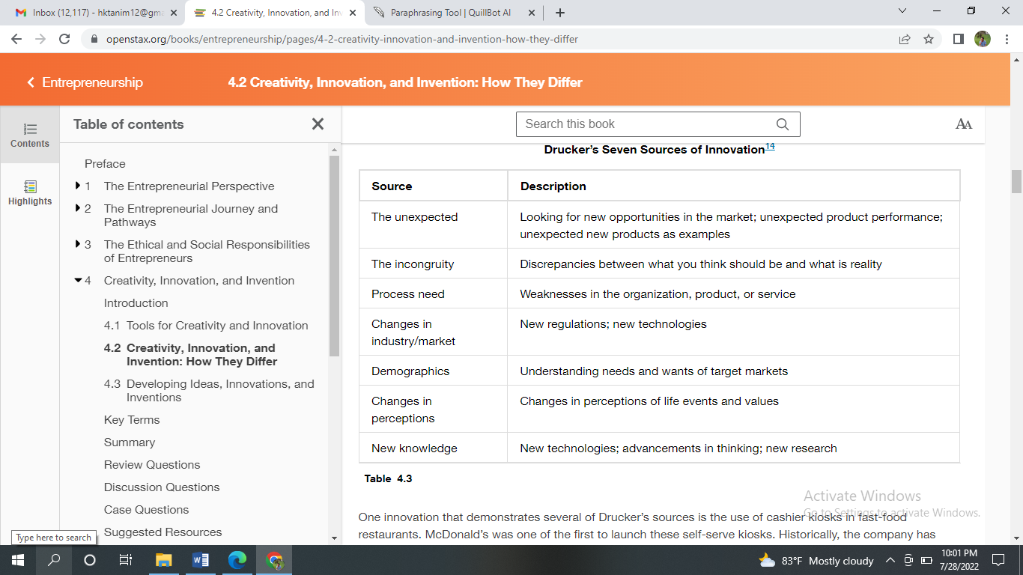
Table 0.1: Drucker’s Seven Sources of Innovation (Openstax, 2022)

03. The Innovative Mindset
All can invent. Innovation is all I need. Creativity, business understanding and tenacity are needed (Sturdy, Clark, Fincham and Handley, 2019). Anyone can enhance creativity. Creative minds think it is 10% inspiration and 90% perspiration, according to creative creator Maril Voogel. Innovation mindsets play with thoughts. Always sees potential. Ideas come from observing one's environment and questioning what is happening or not happening. It does not let constraints or the fear that it will not be anything stop them. It is flexible off the beaten path doing things differently to solve challenges (Openstax, 2022). One idea may be in a store while the other is still on the design board. Less inventive thinkers focus on difficulties and objections. It is a stuck mindset. Fear of failure makes them less willing to experiment. They maintain the status quo. They are risk-averse and lazy, not less creative.

04. Creativity
Creativity in business and creativity in the arts is not all that different. My favourite novels, songs, artworks, and existing products and services provide me with inspiration. Nature, interactions with other creative minds, and formal ideation exercises like brainstorming are all sources of creative inspiration for me. It is the deliberate process of allowing my mind to open up in all directions in response to a stated objective or difficulty. It is one of many ways to develop new ideas, and brainstorming is just one of many. When I set aside time to brainstorm, I will reap the benefits. For me, it's essential to set aside some time to think about a topic or problem from many angles. It takes time and effort to break out of my usual thought patterns and come up with new ideas (Jackson, 2016). I can expand my mental boundaries and grow as a person if I regularly make time to be creative. There are two styles of thought employed by entrepreneurs. Thinking in a logical, step-by-step manner is the hallmark of linear thinking, which is also known as vertical thinking. On the other hand, creative thinking is more commonly characterised by lateral thinking, which is characterised by an absence of preconceived notions and a willingness to consider new possibilities. Anything is conceivable if I reject logic. My business plan relies on a methodical approach to problem-solving. I can use my imagination to create creative solutions to emerging difficulties (Openstax, 2022). Linear and lateral thinking are summarised in Figure 0.1.
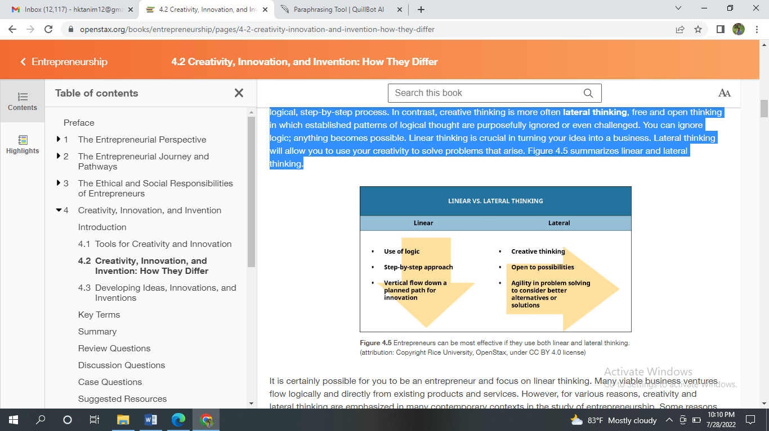
Figure 0.1: Linear vs Lateral Thinking (Openstax, 2022)
I can be an entrepreneur and think linearly. Current goods and services lead to many feasible company ideas. Creativity and lateral thinking have been stressed in many current entrepreneurship scenarios. Increased global rivalry, rapid technological progress, and complicated commerce and communication systems are factors. These factors explain why creativity should be valued in entrepreneurial settings. Product developers in the 21st century must do more than follow a strategy. Entrepreneurs have been encouraged to pioneer new goods, services, and procedures. Creativity abounds. Fine art, writing, graffiti, viral videos, innovative goods, services, ideas, and procedures are examples. Creativity is vast. It is wherever people try to solve big or tiny, practical or impractical problems.

05. Creative Mindset
My life, my creative activities and everything else I do takes on a new level of significance and value when I approach them with a creative attitude. Because I can enjoy the creative process and am open to new ways of thinking, having a mentality conducive to creativity enables me to take advantage of opportunities and possibilities that otherwise would not have been available to me (El-Jarn and Southern, 2020). Creativity is how I imbue our lives with significance; if I place a high value on it, take responsibility for it, and honour it, I will be able to transition into an existence that is genuine, authentic, and feels unrestricted. Believes in My Creativity, Embraces Curiosity, Revokes Judgment, Pauses the Internal Sceptic, Endorses Confusion, Endures Even When faced with Scepticism and Rejection, and Presses Into Childish Fantasy or a Kid's Curiosity are some of the attributes of the creative mindset.

06. Entrepreneurial Mindset
Being in an unpredictable and risky position does not mean I am not capable of succeeding if I have got the right mindset. An entrepreneur's ability to challenge the status quo, be innovative, be creative, and emphasise creating value is at the heart of entrepreneurship. In an entrepreneur's opinion, these elements are the most important (Culkin and Mallick, 2011). The entrepreneurial mind, therefore, has the drive as well as the capacity to operate proactively, reform the system through the set of resources, generate wealth for the organisation and the customer, and undertake calculated risk with confidence to reach pre-determined objectives. In the past, it has been widely accepted that each business effort must begin with a brilliant idea a fantastic item, a feasible marketplace, a large pool of resources, and so forth. Having a fantastic idea is critical to any meaningful endeavour, but what is even more critical is the ability to consistently turn that idea into reality while maintaining the business' ability to compete. There remains a crucial role for the entrepreneurial mindset to play in successfully transforming a business idea into reality, and combining outstanding ideas with leadership to accomplish success is essential. Managing a firm in a competitive market requires ongoing innovation. If I want to be successful as an entrepreneur, I must adopt this mindset. The entrepreneurial mindset is shown in this image.

07. Entrepreneurship and Innovation
Entrepreneurship and innovation are Siamese twins that serve one another to produce better results. The success stories of individuals like Mukesh Bansal (Myntra), Vamsi Krishna (Vedantu), Kailash Katkar (Quick Heal), Nandan Reddy, Sriharsha Majety, and Rahul Jaimini provide some shining examples of innovation and entrepreneurship (Swiggy). These individuals carved out a unique place in the market for their businesses thanks to their innovative concepts and superior managerial abilities. In order to prove their worth in their respective fields of expertise, aspiring entrepreneurs look to their mentors for guidance (Culkin and Mallick, 2011). According to management guru Peter F. Drucker, innovation is not just a high-tech phenomenon. It can happen in creative low-tech businesses, as well.

08. Entrepreneurship and Creativity
Getting rid of the prevalent misconception that creativity is a superhuman or supernatural gift is vital. It is not valid. It's not a secret that creativity exists. Individuals with the necessary drive and passion can build and enhance this personality trait. Those who can think outside the box and come up with ideas that no one else has come up with are the only ones who can benefit from this approach. In order to succeed, one must be self-reliant and spontaneous, as well as resourceful and able to solve problems. In order to generate new and helpful ideas, creative people are always on the lookout for new and unusual avenues of inquiry (Jonathan, 2018). Impatient with the current quo, these people are true entrepreneurs who continuously look for new methods to do things better.
Having an entrepreneurial mindset means combining creativity and innovation to acknowledge, introduce, and consider taking advantage of economic opportunities. This manifests in the commercial introduction of a business venture and the development of novel products and services that improve the lives of customers and society (Researchgate, 2022). New ventures need ideas. Persistence and different alternatives are crucial to creativity. Creative people germinate, grow, and develop ideas to create brilliant ideas. The creative process has six steps, as indicated.
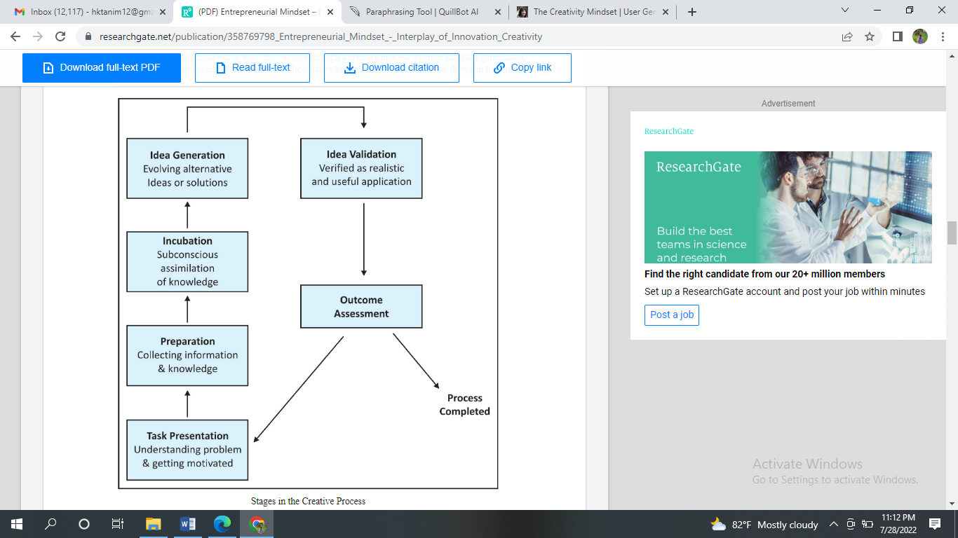
Figure 0.2: Creative Process (Researchgate, 2022)
Creative people are unique in their thinking and presume 'out-of-the-box' ideas. They are impartial as well as keen to come up with new items as well as contexts, trust in themselves, are firm in their judgment but respectful to show their feelings, are idealist, bursting with energy and drive, and willingness to assume to recognise their dream ideas (Jackson, 2016).

Creative Thinking for Creating Innovative Solutions or Value

Creative thinking is a critical 21st-century skill with far-reaching impacts. It lets us go to the moon, make art, build computers, and cure diseases. Creativity helps us be flexible and solve problems. It is remarkable how far knowledge and creativity have progressed throughout human history, from the most rudimentary to the most complete and in-depth understandings of their own life (Barile, Grimaldi, Loia and Sirianni, 2020). Tremendous advancements along this road of knowledge and creativity show that human intellect has no bounds based on what I know. Human knowledge is a history passed down by generations in a highly complicated system. Finding out what makes people creative is one of the primary challenges of creativity study. Having made the conscious decision to follow a creative route is a hallmark of those who are successful in their endeavours. Since those who create first select how to construct their path and stick to it, this could be a possible explanation. Even if the creative route is challenging, innovative ideas are born from it, and those who challenge the status quo are rarely rewarded for their efforts. A comprehensive understanding of the value of information that leads to innovation must begin with a type of skill with a motivated set of decisions (Edwards, Battisti and Neely, 2014). Teaching others to be creative entails showing them the benefits of decision-making based on creativity and encouraging them to do so.
Cognitive flexibility helps us adapt to our complex, fast-changing reality. The development of new notions and ways to solve problems is a top priority for most firms and companies due to its significance in innovation. To address 21st-century requirements, academics, business leaders, and policymakers prioritise creativity. This is especially troublesome for grads, which must be prepared for our creative economy. Adults need to handle 21st-century problems yet are not taught creative thinking abilities. All ages can benefit from creative performance training. Developing, analysing and implementing new curricular content, like creative thinking, takes time. During this transition time, schools and businesses could undertake a brief, well-developed, rigorously validated creative training system (Jackson, 2016). Earlier creativity training solutions differed fundamentally: the cognitive processes addressed, the methodologies utilised, the media used, and the activities performed. Some cognitive training approaches had more substantial impacts and higher success rates than idea generation training, suggesting that cognitive approaches will be helpful if there is an emphasis on implementing the strategy. Cognitive approaches might be lengthy. Thus, the duration of cognitive training methodologies may limit creativity training in education and industry.

Conclusion

I am quite pleased that, in today's society, mindsets are receiving so much attention. There is a distinction between a growth mindset and a maker mindset. A person's frame of mind can be defined as the thoughts and attitudes they bring to a circumstance in which they find themselves. The idea behind mindsets is that one's mental and emotional states can influence success with particular skills. It is essential, in my opinion, to have a creative frame of mind in order to be creative and I think this to be true for participating in the creative process.

References

Barile, S., Grimaldi, M., Loia, F. and Sirianni, C.A., (2020). Technology, value Co-Creation and innovation in service ecosystems: Toward sustainable Co-Innovation. Sustainability, 12(7), p.2759.
Culkin, N. and Mallick, S., (2011). Producing work-ready graduates: The role of the entrepreneurial university. International Journal of Market Research, 53(3), pp.347-368.
Edwards, T., Battisti, G. and Neely, A., (2014). Value creation and the UK economy: a review of strategic options. International Journal of Management Reviews, 5(3‐4), pp.191-213.
El-Jarn, H. and Southern, G., (2020). Can co-creation in extended reality technologies facilitate the design process?. Journal of Work-Applied Management.
Jackson, N., (2016). Making sense of creativity in higher education. In Developing creativity in higher education (pp. 217-235). Routledge.
Jonathan, P. ed., (2018). Local Economic and Employment Development (LEED) Entrepreneurship and Higher Education (No. 18). OECD Publishing.
Nicolaides, A., (2011). Entrepreneurship-the role of higher education in South Africa. Educational research, 2(4), pp.1043-1050.
Openstax.org. (2022). 4.2 Creativity, Innovation, and Invention: How They Differ - Entrepreneurship | OpenStax. [online] Available at: <https://openstax.org/books/entrepreneurship/pages/4-2-creativity-innovation-and-invention-how-they-differ> [Accessed 28 July 2022].
Researchgate. (2022). [online] Available at: <https://www.researchgate.net/publication/358769798_Entrepreneurial_Mindset_-_Interplay_of_Innovation_Creativity> [Accessed 28 July 2022].
Sturdy, A., Clark, T., Fincham, R. and Handley, K., (2019). Between innovation and legitimation—boundaries and knowledge flow in management consultancy. Organisation, 16(5), pp.627-653.

