Digital Skills and Research Methods
(BMSK4003)
Assessment 2
Rafeya Akther Chowdhury
1710684

Table of Contents:

Introduction 3

Short-term issues 4

Long-term issues 5

Conclusion 7

Appendix 8

References 10

Brexit

This report will look at if Brexit was the right decision financially. The aim of this report is to analyse the financial effects of Brexit, looking at it both in the short term and long term. Then the report will conclude on whether the decision to leave the European Union was the right one under a financial scope. It will take into account both Britain and the European Union’s perspective The problem with identifying such issues is the differing and unknown figures related to Brexit. The methods used to conclude on whether Brexit was the right decision or not include articles, books, reports and surveys. Using a variety of sources will help form a more coherent argument by understanding different perspectives. In short this report finds that Brexit has been the wrong decision financially both in the short term and long term. This is due to various factors which will be looked at in greater detail within the report itself.

Introduction

Brexit is the potential departure of the United Kingdom from the European Union. This definition is very important to understand, as during a survey when I asked 50 people to define Brexit only 25 had the correct answer. 50% of people did not either know what Brexit meant or had a very vague understanding of it. Therefore, not only is it important to know what Brexit is but the effects of it. A massive issue is the fact that many do not know what the repercussions are or what Theresa May wants from a withdrawal from the European Union. An exclusive BMG Research Survey for the independent showed that “three-quarters of the public have little idea what Theresa May wants overall.”

The European Union is a partnership of 28 European countries, which was first set up after World War two to ensure European integration through free trade and free movement. Brexit is a controversial topic which interests everyone in the country. Its political, social and economic consequences influence everyone’s lives. Brexit came about as a result of the EU referendum, in June 2016, where 51.9% of people voted to leave the EU. This triggered Article 50, which is the way to leave the European Union. Essentially, remain lost by 1.9% which highlights the balance of the arguments. It also demonstrates how close the decision was.
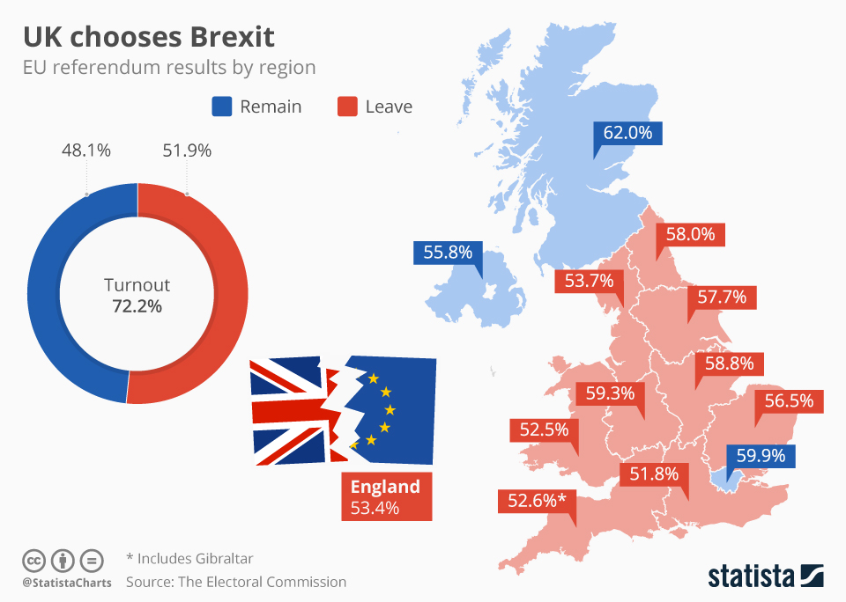

Short-term issues

From the above picture, it is evident that the nation is divided with both Scotland and Northern Ireland voting to remain while England and Wales voted to leave. It is also essential to point out London voted to remain.

First and foremost, it is crucial to scrutinize the economic repercussions of the decision to leave the European Union. The immediate aftermath was one of crisis with the pound falling a staggering 10%, it was a 31 year low on the currency markets. This of course indicates that Brexit was in fact a dire decision and the repercussions were felt in the stock market on a significant level. This would support the notion that leaving the EU was in fact the wrong decision.

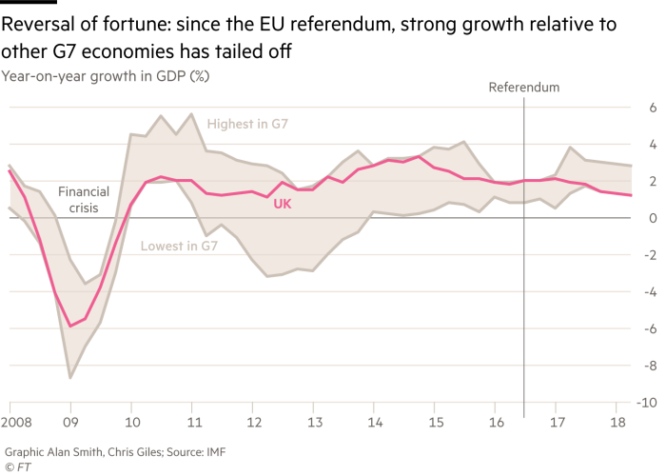

To further the idea that Brexit was the wrong decision financially, we can see from the above graph that the GDP of the UK since the referendum is the lowest relative to other G7 economies. Thereby, not only has the pound sunk to its lowest economical value but growth has also tailed off, meaning the economy is weak and is not growing. Combining the two destroys both the belief in the economy today and hope for the economy in the future. Now, using the above graph, if one was to predict which way the trend is heading it would be towards the zero mark. Hence, not only has the referendum had an immediate negative effect but is also increasingly looking like a long-term issue.

Long-term issues

Now, from my survey, out of the 25 people who knew what Brexit was, 13 people argued that separating from the European Union means we would not have to give money to the European Union anymore. One individual argued that the money saved could be invested in our own economy, or that it could be spent on Public services such as the National Health Service or Metropolitan Police Force. Now he firmly believed that the UK was giving the EU £350 million a week. That figure would be around the £17 Billion mark a year. Firstly, it must be understood that this figure is technically true but in reality it is not the case. It is a figure used to aggravate those against funding the European Union. The figure does not take into account the rebate the UK is afforded due to its previous years of funding. This rebate is in place before the UK even puts a penny in. So for example if we take the membership fee for 2016, the UKs bill was £17 Billion. Before paying a penny the UK was afforded a rebate of £4 Billion. That brings the figure down to £13 Billion, then we need to take into account how much of the European Union’s budget is spent on the UK. The European Union spent nearly £5 Billion on the UK, bringing the figure down to £8 Billion on a net expenditure. Looking at the hard figures the UK is then £8 Billion in loss. However, the free trade, free movement, opportunities for businesses, creation of jobs, trade and investment has no figure on it. So then the question arises if all of that worth the £8 Billion the UK really spends on the European Union. It would be impossible to calculate all the deals that this relationship creates. In my opinion all the opportunities created by being in the European Union outweigh the value of £8 Billion. The reason for this would be free trade. 43% of the UK’s exports are within the European Union, this is obviously influenced by the free trade market. In addition to that, the UK is in a trade defeciet in the European Union. This means the UK buys more from the EU then they sell to them. Brexit would not only put an end to subsidise deals but also alienate the European Union to play hardball with the UK when trading with them. Now spending £8 Billion in the European Union is worth it considering the UK receives subsidise deals on £320 Billion of goods and services. The reason as to why all these figures are relevant to this report is because in the long term the UK may be saving £8 Billion a year, but they would be losing much more on trade deals. So in the long run the UK is losing money from Brexit.

Therefore, belief in the outlandish figures quoted by various leaders of the Brexit movement need to be further analysed in order to fully ascertain what is being spent where. Now those who believe in the opportunities created by the European Union will claim that the £8 Billion is well spent money if it were possible to monetize opportunities, trade and jobs. On the other hand, Brexit believers will claim such opportunities do not amount to the £8 Billion the UK is spending on the European Union. But from the trade deals alone it is clear to see that the £8 Billion was well spent.

Furthermore, this divorce between the UK and the European Union is set to cost the UK in terms of growth. It was predicted that if the UK remained then the UKs GDP would be worth £2.7 Trillion by 2032. But as the UK are set to leave the ‘single market and strike a trade deal’ it will only be worth £2.6 Trillion. That is a decrease in growth by 5%, which would essentially cost the UK economy £2 Billion a week. It must be stressed that this is not the UK paying money, it is the UK losing potential growth. Obviously, these predictions have many other factors and rely on a stable market. Nevertheless, any loss of that amount or close to that amount is a disastrous situation. Now if we factor in the previous figure, quoted to be £350 million, of how much we pay into the European Union, it clearly is outmuscled by the potential growth provided by the European Union to the UKs GDP alone. Hence, just on potential growth the amount we used to pay in to the European Union is worth it, this is without all the other opportunities provided by the European Union. Once again this cements the notion that Brexit on a financial platform does not make sense in the long-term.

Conclusion

In conclusion, Brexit, in my opinion, has been the wrong decision financially both in the short term and long term. The short term effect has been a drop in the pound’s strength to an all-time low in 31 years, inflation and the GDP growth has tailed off during the following couple years. All these have played a huge role in our everyday lives including an increase in costs, budget cuts and less opportunities. These negative consequences clearly outline the disastrous immediate aftermath. Now in the long term we save £350 million a week but lose the ability to trade in the single market, lose investors and trade deals. Britain’s potential growth is slowed down by a rate of 5% (losing out on Billions). Therefore, once again the negatives outweigh the one potential positive. Unfortunately, this means Brexit as a financial decision was the wrong in the long term too. All of these consequences condemn Brexit to be a financial nightmare and concludes to be a catastrophic decision.

Appendix

- My Survey

Define Brexit below:

What is your opinion on Brexit?

Reference list:

- Independent article (2018). Brexit: New poll shows Britons don’t understand what Theresa May wants from withdrawal. [Online]
Available at: https://www.independent.co.uk/news/uk/politics/brexit-poll-new-public-dont-know-theresa-may-government-ideas-goals-brussels-negotiations-a8203291.html [Accessed 28 July 2018].

- BBC article. (2018). Brexit: All you need to know about the UK leaving the EU. [Online]
Available at: https://www.bbc.co.uk/news/uk-politics-32810887 [Accessed 28 July 2018].

- Statista (2016). UK: A Divided Nation. [Online]
Available at: https://www.statista.com/chart/5100/uk-chooses-brexit [Accessed 29 July 2018].

- Guardian article. (2016). Pound slumps to 31-year low following Brexit vote. [Online].
Available at: https://www.theguardian.com/business/2016/jun/23/british-pound-given-boost-by-projected-remain-win-in-eu-referendum [Accessed 29 July 2018].

- Financial Times article. (2018). What are the economic effects of Brexit so far? [Online].
Available at: https://www.ft.com/content/dfafc806-762d-11e8-a8c4-408cfba4327c [Accessed 1 August 2018].

- Full fact. (2017). The UK’s EU membership fee. [Online].
Available at: https://fullfact.org/europe/our-eu-membership-fee-55-million [Accessed 1 August 2018].

- Full Fact. (2017). Everything you might want to know about the UK’s trade with EU. [Online].
Available at: https://fullfact.org/europe/uk-eu-trade [Accessed 1 August 2018]

- Channel 4. (2018). Is Brexit really going to cost £2 Billion a week? [Online].
Available at: https://www.channel4.com/news/factcheck/is-brexit-really-going-to-cost-2-billion-a-week [Accessed 2 August 2018]

Refer to Appendix 1.
Independent article (2018). Brexit: New poll shows Britons don’t understand what Theresa May wants from withdrawal. [Online]
BBC article. (2018). Brexit: All you need to know about the UK leaving the EU. [Online]
Statista. (2016). UK: A Divided Nation. [Online].
Guardian article. (2016). Pound slumps to 31-year low following Brexit vote. [Online].
Financial Times article. (2018). What are the economic effects of Brexit so far? [Online].
Refer to Appendix 1.
Ibid.
Full Fact. (2017). The UK’s EU membership fee. [Online].
Full Fact. (2017). Everything you might want to know about the UK’s trade with EU. [Online].
Ibid.
Channel 4. (2018). Is Brexit really going to cost £2 Billion a week? [Online].

