Assignment 2: Project Management Jonathan Wilcox (2206641)
Changemakers - Creativity & Value Creation (ACC5033)
Table of Contents
E-Portfolio Link 2
Poster Links 2
Gantt Chart Links 2
E-Portfolio Screenshots 3
Home Page 3
Task 1 4
Task 2 7
Task 3 8
References 10
Appendix - Evidence of Engagement 11

E-Portfolio Link
The E-Portfolio was created using Google Sites. To access please click the link below.

https://sites.google.com/view/2206641-assignment-2/

Poster Links
Task 2 - Project Management.pptx

Gantt Chart Links
Gantt Chart.xlsx

E-Portfolio Screenshots

Home Page
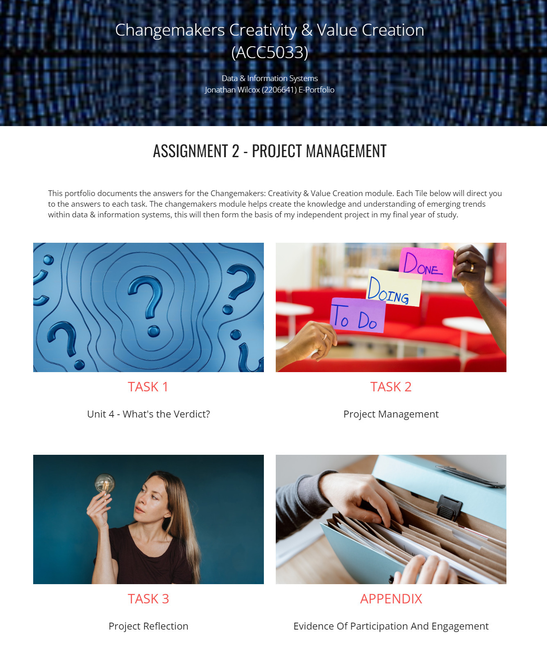

Task 1
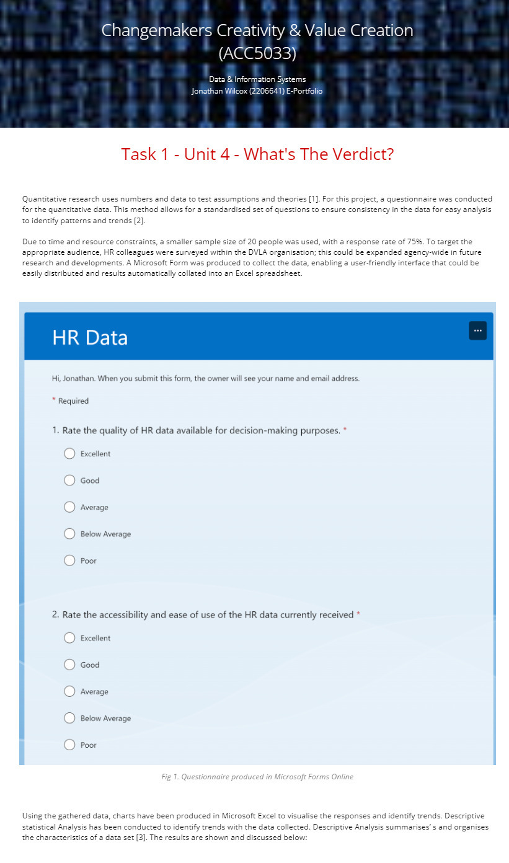

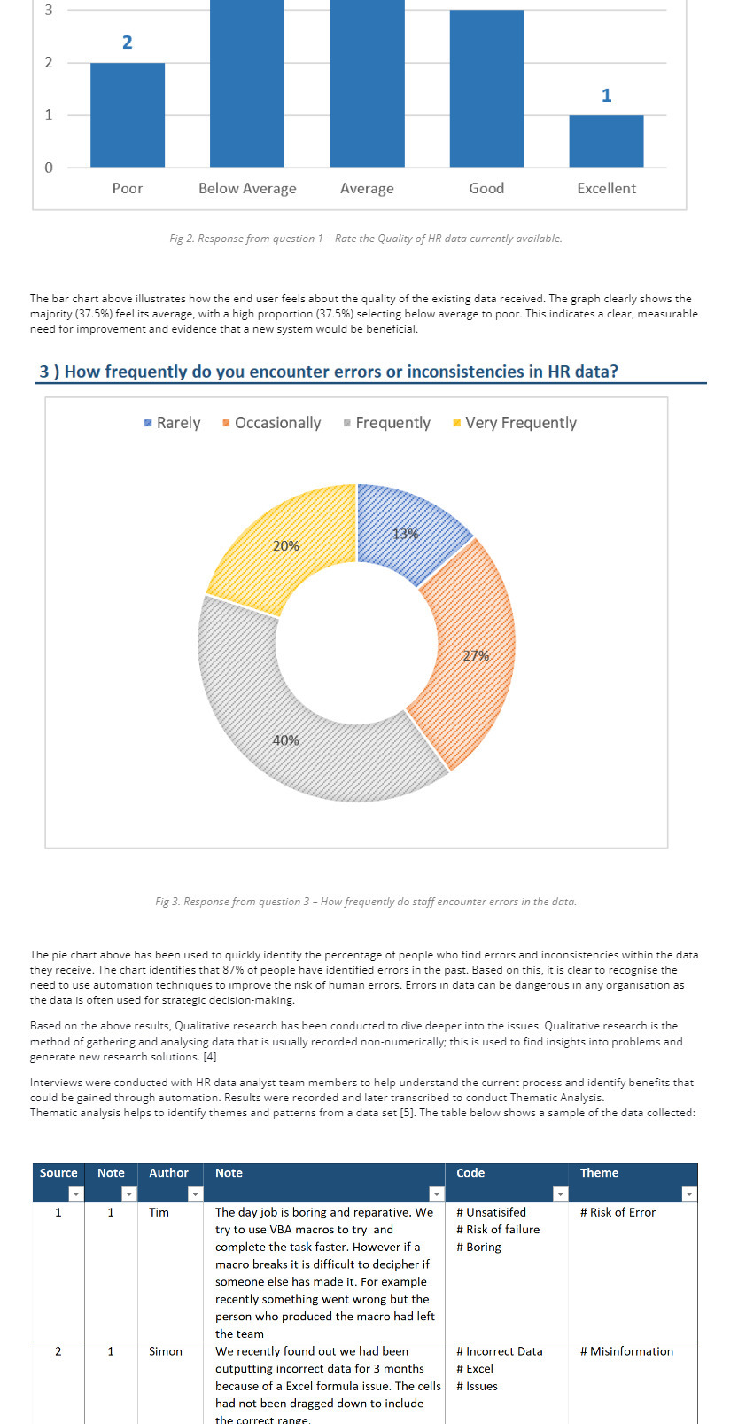
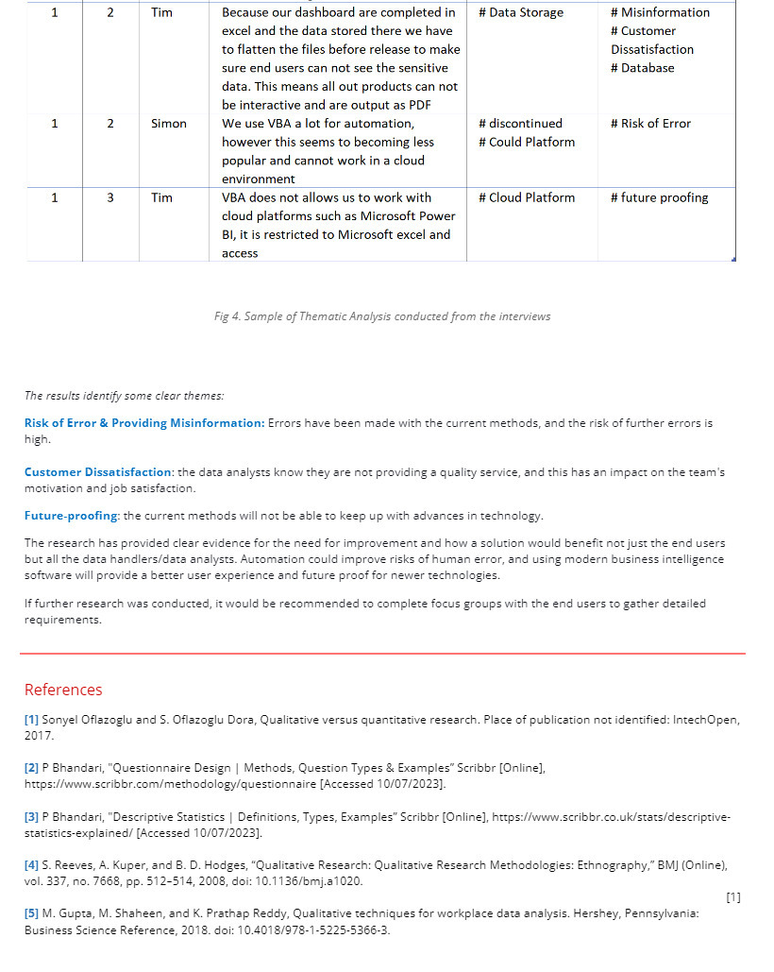

Task 2

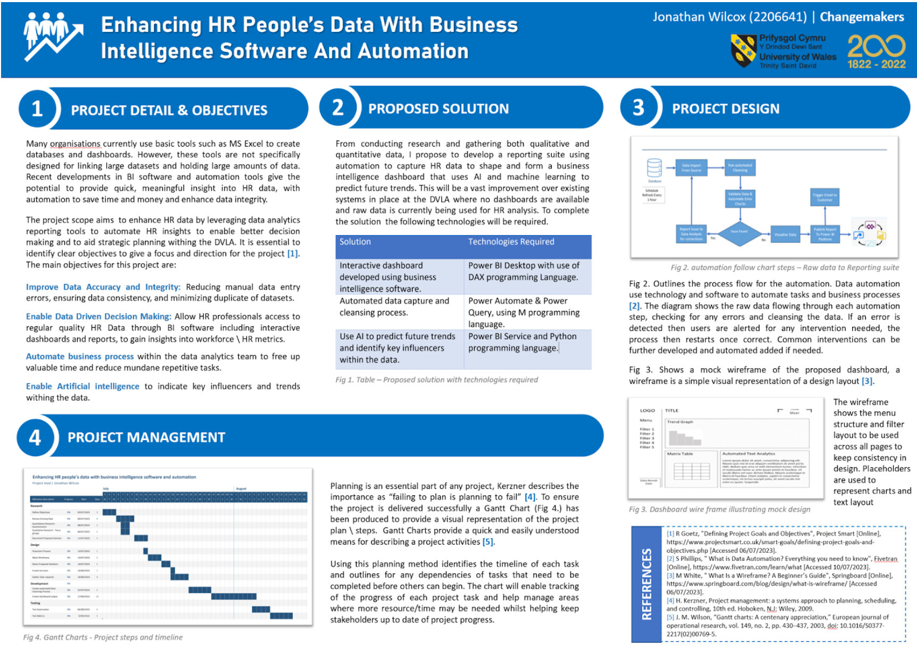

Task 3

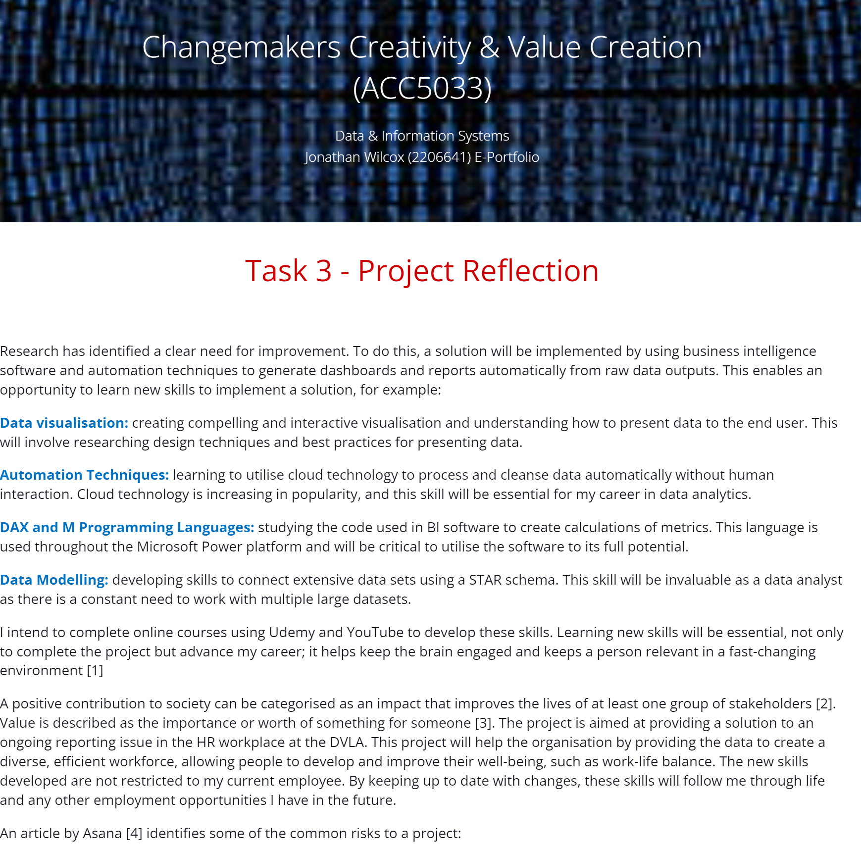

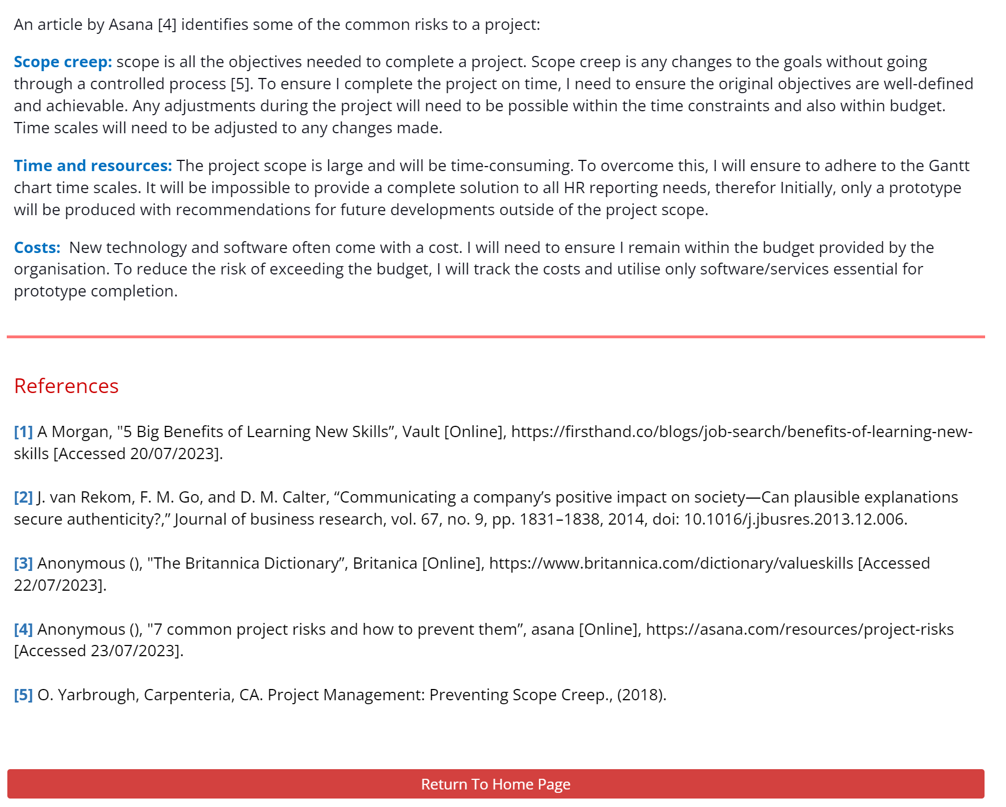

References

Task 1 - References

[1] Sonyel Oflazoglu and S. Oflazoglu Dora, Qualitative versus quantitative research. Place of publication not identified: IntechOpen, 2017.

[2] P Bhandari, "Questionnaire Design | Methods, Question Types & Examples” Scribbr [Online], https://www.scribbr.com/methodology/questionnaire [Accessed 10/07/2023].

[3] P Bhandari, "Descriptive Statistics | Definitions, Types, Examples” Scribbr [Online], https://www.scribbr.co.uk/stats/descriptive-statistics-explained/ [Accessed 10/07/2023].

[4] S. Reeves, A. Kuper, and B. D. Hodges, “Qualitative Research: Qualitative Research Methodologies: Ethnography,” BMJ (Online), vol. 337, no. 7668, pp. 512–514, 2008, doi: 10.1136/bmj.a1020.
[1]
[5] M. Gupta, M. Shaheen, and K. Prathap Reddy, Qualitative techniques for workplace data analysis. Hershey, Pennsylvania: Business Science Reference, 2018. doi: 10.4018/978-1-5225-5366-3.

Task 2 - References

[1] R Goetz, "Defining Project Goals and Objectives", Project Smart [Online], https://www.projectsmart.co.uk/smart-goals/defining-project-goals-and-objectives.php [Accessed 06/07/2023].

[2] S Phillips, " What is Data Automation? Everything you need to know", Fivetran [Online], https://www.fivetran.com/learn/what [Accessed 10/07/2023].

[3] M White, " What Is a Wireframe? A Beginner’s Guide", Springboard [Online], https://www.springboard.com/blog/design/what-is-wireframe/ [Accessed 06/07/2023].

[4] H. Kerzner, Project management: a systems approach to planning, scheduling, and controlling, 10th ed. Hoboken, N.J: Wiley, 2009.

[5] J. M. Wilson, “Gantt charts: A centenary appreciation,” European journal of operational research, vol. 149, no. 2, pp. 430–437, 2003, doi: 10.1016/S0377-2217(02)00769-5.

Task 3 - References

[1] A Morgan, "5 Big Benefits of Learning New Skills”, Vault [Online], https://firsthand.co/blogs/job-search/benefits-of-learning-new-skills [Accessed 20/07/2023].
[2] J. van Rekom, F. M. Go, and D. M. Calter, “Communicating a company’s positive impact on society—Can plausible explanations secure authenticity?,” Journal of business research, vol. 67, no. 9, pp. 1831–1838, 2014, doi: 10.1016/j.jbusres.2013.12.006.

[3] Anonymous (), "The Britannica Dictionary”, Britanica [Online], https://www.britannica.com/dictionary/valueskills [Accessed 22/07/2023].

[4] Anonymous (), "7 common project risks and how to prevent them”, asana [Online], https://asana.com/resources/project-risks [Accessed 23/07/2023].

[5] O. Yarbrough, Carpenteria, CA. Project Management: Preventing Scope Creep., (2018).

Appendix - Evidence of Engagement
The following pages demonstrate some of the topics I studied throughout the module.



