Digital Skills and Research Methods

BMSW4003

Abstract
The current study has shed light on the utilisation of virtual; learning environments in universities today. The significant majority of students favoured utilising Moodle in previous polls and studies due to its convenience, wealth of resources, and adaptability. Students are so confident in the efficacy of virtual learning environments that they actively promote them to their peers. However, not all students will have the technical tools necessary to fully use VLEs. This study gives a snapshot of virtual learning environments (VLEs) at the University of Wales Trinity Saint David London Campus with regards to in-depth study.

Table of content
1. Introduction 4
1.1 Introduction 4
1.2 Background of the Research 4
1.3 Aim and Objectives 4
1.3.1 Aim 4
1.3.2 Objectives 5
1.4 Research Questions 5
1.5 Research Rationale 5
2. Literature Review 5
2.1 Introduction 5
Concept of VLE 6
Positive and Negative Factors of VLE 6
Strategies to Overcome the problems 6
2.2 Summary 7
3. Research Methodology 7
3.1 Introduction 7
3.2 Research Methods 7
3.2.1 Research Design 7
3.2.2 Research Philosophy 7
3.2.3 Research Approach 8
3.2.4 Research Choice 8
3.2.5 Research Strategy 8
3.2.6 Sampling 8
3.2.7 Data Collection and Analysis 9
3.3 Ethical Considerations 9
3.4 Summary 9
Results/Findings, analysis and discussion 9
Primary data analysis 9
Secondary data analysis 14
Summary of the findings 15
Conclusion and Recommendations 15
Conclusion 15
Recommendations 15
References 16
Appendix 1: Questionnaire 18
Appendix 2: Survey Result 18

1. Introduction

1.1 Introduction
In today’s world, several universities have made the necessary measures to implement Moodle and familiarise students with VLEs. Previous research and surveys found that the vast majority of students preferred using Moodle because of its accessibility, quantity of learning materials, and flexibility. Students have faith enough in the value of VLEs to advocate for them within their social networks. However, some students may struggle with VLEs since they may not have access to sufficient technological resources. The current study provides a brief understanding of the utilisation of VLEs in the University of Wales Trinity Saint David London Campus with respect to thorough research precisely.

1.2 Background of the Research
Modern methods of information gathering, use, and interaction have been revolutionised by ICT (Awoyemi and Awoyemi, 2021). Knowledge creation, distribution, and access at universities have all been significantly influenced by the exponential growth of technology, claims Clark, (2021). The academic library has been transformed by the rise of information and communication technologies. Teaching a large number of pupils effectively is possible with the help of ICTs. The widespread use of ICT has made possible the establishment of virtual learning environments (VLEs) where students and teachers may interact digitally (VLE). Based on its adaptability, widespread use, and potential to establish a new, effective paradigm in education, the VLE has been called "one of the most important technical achievements of the century" by Corvalán, Recabarren and Echeverría, (2020). The research regarding the use and application of VLE in enhancing the education system in today’s digital era can open up new avenues for teaching and learning procedures precisely.

1.3 Aim and Objectives

1.3.1 Aim
The current study aims at examining the cause and consequences of adopting and implying VLE on the learning of students at Trinity Saint Davis university in Wales.

1.3.2 Objectives
1. To promote better interaction between the teaching-learning process, enable students to better comprehend collaborations with their classmates and support each other for success and sustenance precisely.
2. To reduce the institution maintenance cost, system management cost and so on with the help of enhanced VLEs in the institutional environment precisely.
3. To promote better educational opportunities and comfort to students via the appropriate use of VLEs precisely.

1.4 Research Questions
1. How do VLEs help students to enhance their performance level in academic and in co-curricular activities as well?
2. How can VLEs enable teachers to promote a better learning environment and opportunities for students?
3. How can institutions promote positive educational growth and sustenance with the help of VLEs precisely?

1.5 Research Rationale
The education system may benefit from learning about these modes and systems to better serve its consumers in this era of continually changing technology. Virtual learning environments (VLEs) let teachers and students fulfil information demands via constant online interactions emphasises that virtual learning environments (VLEs) are more than just technology; they allow learning enthusiasts to share data and facilitate learning and research. Since academic institutes are a rich mine of information, virtual learning environments (VLE) will provide students with a better foundation in their studies and enable them to remotely access additional research materials (David, 2021). To address student and faculty information needs, 21st-century academic institutes must implement VLE. Thus, teachers and students may have better conversations (Debois, 2022).

2. Literature Review

2.1 Introduction
A virtual learning environment is the modern-day reality. Starting from promoting better learning opportunities for students to helping educators frame student-oriented learning systems subsequently, VLEs have changed the mode of a teaching-learning system for better and forever. The literature review will attempt to demonstrate a positive impactful impression of VLEs with a special responsibility to situational analysis precisely.

Concept of VLE
As an alternative to traditional lecture halls, the VLE has grown in popularity. Many helpful resources for bettering classroom education are available via the VLE. Using VLEs to facilitate student-teacher and student-student interactions is only one of the many ways in which the incorporation of 3D into VLEs might improve educational outcomes (Diab-Bahman et al., 2021). VLE delivers tools like visual support, auditory features, and additional information to support 21st-century learning that is focused on the student. By offering challenges and creating healthy competition in a digital classroom, VLEs help students improve their performance in real-time.

Positive and Negative Factors of VLE
Positive Factors: Virtual learning environments (VLEs) provide students greater freedom in terms of when and where they study. Students demanding schedules may be better accommodated by having unrestricted, around-the-clock access to all course materials. Because of this, they are returning to school is feasible even if you are already working full-time or caring for a young child (Hamutoglu et al., 2020).
Plus, students may go at their own leisure and not feel rushed. There is no need for the slowest students to wait until the rest of the class catches up since everyone can re-watch the videos and re-read the texts as many times as they need to.
Negative Factors: In spite of the fact that virtual learning environments (VLEs) provide several types of interaction (including chats, group discussions, and live seminars), they are not a viable replacement for in-person meetings. In addition to preventing children from learning how to work together and resolve conflicts, this also prohibits them from making friends and exchanging materials with their peers (Weaver et al., 2021).

Strategies to Overcome the problems
Unfortunately, technological difficulties are to be expected whenever a VLE is used. Maybe there's a power outage where you are, but you still have a consistent internet connection. A student could also have trouble with things like content downloading and platform navigation (Karumbaiah et al., 2022). If this occurs, educators should let the students know and look into getting some kind of technological assistance. A student’s ability to study in an online school might be negatively affected by distractions.
Every online class should start with a discussion. Keep in mind that everything related to the classes (including homework, discussions, and lectures) will be conducted entirely online and in real-time. It won't take a student long to fall well behind the rest of the class if they skip even a single unit of the education centre. Make advantage of the many channels of contact provided by the institution (Lacka and Wong, 2021).
In addition, modern learning management software solutions are essential if educational institutions are to have any chance of overcoming these challenges.

2.2 Summary
Different factors, features, strategies, management techniques and improving strategies of VLEs have been discussed in the above section precisely. This provides an overall impression of the appropriateness of VLEs precisely.

3. Research Methodology

3.1 Introduction
The research methodology lays out the necessary steps to take and the suggested strategies to do them. The study methodology additionally pays close attention to the efficiency of the most probable ways that will be used to define the current work. With the help of an appropriate questionnaire schedule, the study will attempt to reach its desired outcome precisely.

3.2 Research Methods

3.2.1 Research Design
This study has decided to use a descriptive approach in order to complete the survey, analyse the data, and add to the current body of work. Researchers may get a deeper understanding of the dynamic between consumer enthusiasm and cultural influences by adopting this study design and avoiding common statistical test biases (Leino et al., 2021). Answers may be found in the existing research on VLEs' efficacy in assisting student learning, and descriptive study methodologies are useful for accurately articulating those answers.

3.2.2 Research Philosophy
To learn how best to use VLEs in today's institutions and to analyse their impacts, positivist research is essential. Researchers that adhere to the positivist school of thought believe that the same techniques used in the natural sciences may be applied to the study of social issues. that there is an objective reality that can be seen and quantified in social processes. In other words, the researcher takes a rigorous, scientific approach by gathering numerical data from the participants and analysing it using statistical tools (Mai and Muruges, 2022). The study's goal is to ascertain whether and how VLEs influence the learning capabilities of the learners to keep using the system further.

3.2.3 Research Approach
When investigating the effects of VLEs on students, deductive approaches to research are strongly recommended. To use this strategy, one must first rely upon previous information to formulate a hypothesis, which is then subjected to testing once it has been validated (Mubarak, Cao and Zhang, 2022). The study assumes that VLEs have positively facilitated the growth and success of students to a greater extent precisely.

3.2.4 Research Choice
It may be instructive to apply a mixed-method approach to data collection. Thus, it would be useful to have access to both quantitative and qualitative data. As a modern human being, you have access to a wealth of information and tools. Mixed-method studies might be more fruitful when they are guided by clear research topics. In-depth interviews may also provide a plethora of information. When many methods are used in tandem, there is a better chance that the collected data will be accurate and reliable (Peng, Lin and Wu, 2019). Quantitative data may be gathered via closed-ended surveys, while qualitative data can be gathered through questionnaire surveys and classroom observations. Once data collecting was complete, statistical analysis could begin.

3.2.5 Research Strategy
As a strategy for the research work, the students of the University of Wales Trinity Saint David have been taken into consideration as potential participants. An online survey via google form has been done (Racheva, 2022). There were a number of relevant questions regarding the student's attitudes towards the use of Moodle precisely. With respect to the gathered responses, the study will proceed with further demonstrating the effectiveness of VLEs in educational environments precisely.

3.2.6 Sampling
Sampling at random is fundamental for scientific research. This is a crucial consideration if the researcher wants trustworthy findings from the survey or study. This enables the sample to be considered representative of the entire and for statistical analysis to uncover any errors. When collecting samples, researchers may pick from a variety of approaches, each with its own advantages and disadvantages (Research-methodology, 2022). In this research, the study will collect data from a statistically meaningful sample of the population using an online survey instrument.

3.2.7 Data Collection and Analysis
The information for this research will be collected and analysed using both primary and secondary resources. If the study wants the research report to be as accurate and precise as possible, they need to use as many diverse methods as feasible (Ryan and Poole, 2019). Literature and theory reviews, data gathering, data cleaning, data analysis (using programmes like Excel), and data management are all examples of techniques used in this field.

3.3 Ethical Considerations
Research ethics provide a set of rules that must be observed at all times. Data collection from human subjects requires researchers and scientists to adhere to a code of ethics. For the current study, the confidentiality of all replies and participants will be strictly maintained. A number of options for responses will be provided to the students.

3.4 Summary
The efficiency of VLEs on student learning was analysed by questionnaires, interviews, and observations in the aforementioned study.

Results/Findings, analysis and discussion

Primary data analysis
Options | Response | Response in percentage
Yes | 22 | 88%
No | 3 | 12%
Table 1: Response to Question 1
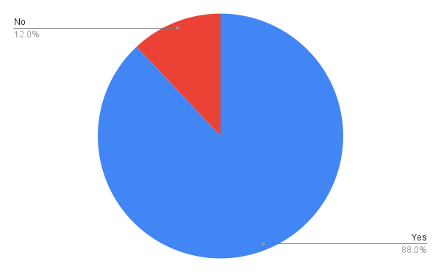
Figure 1: Analysis of Question 1
Options | Response | Response in percentage
Friendship | 10 | 40%
Agent | 5 | 20%
Family | 2 | 8%
University | 8 | 32%
Table 2: Response to Question 2

Options | Response | Response in percentage
Friendship | 10 | 40%
Agent | 5 | 20%
Family | 2 | 8%
University | 8 | 32%
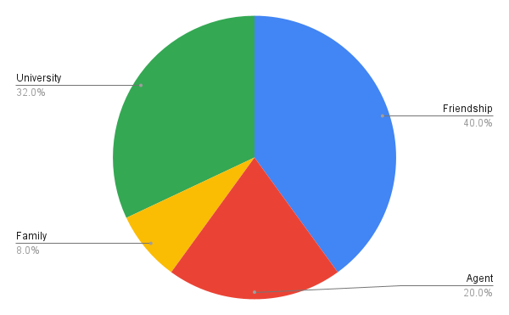
Figure 2: Analysis of Question 2

Options | Response | Response in percentage
Absolute | 18 | 72%
Possible | 3 | 12%
I will think about it | 3 | 12%
No | 1 | 4%
Table 3: Response to Question
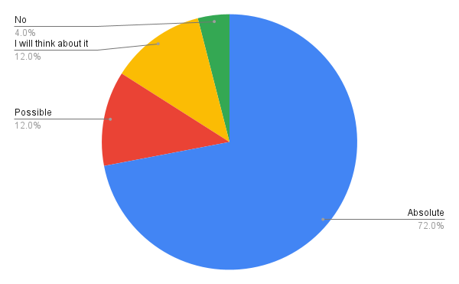3

Figure 3: Analysis of Question 3

Options | Response | Response in percentage
Regular | 16 | 64%
Very Regularly | 5 | 20%
Sometimes | 3 | 12%
Never | 1 | 4%
Table 4: Response to Question 4
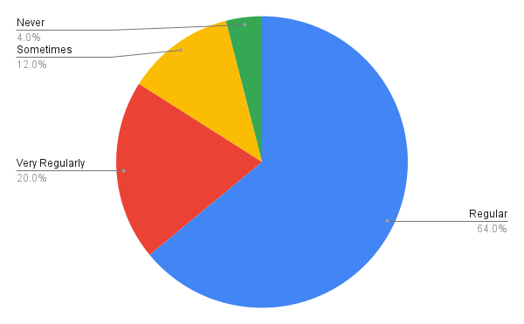
Figure 4: Analysis of Question 4

Options | Response | Response in percentage
Easy | 14 | 56%
Very Easy | 4 | 16%
Difficult | 5 | 20%
Very Difficult | 2 | 8%
Table 5: Response to Question 5
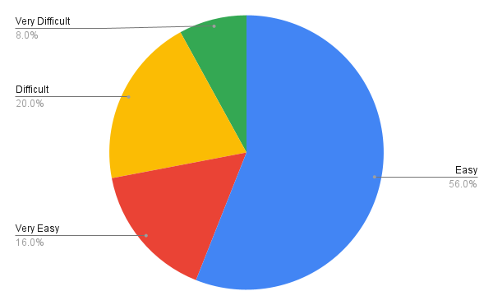
Figure 5: Analysis of Question 5

Secondary data analysis
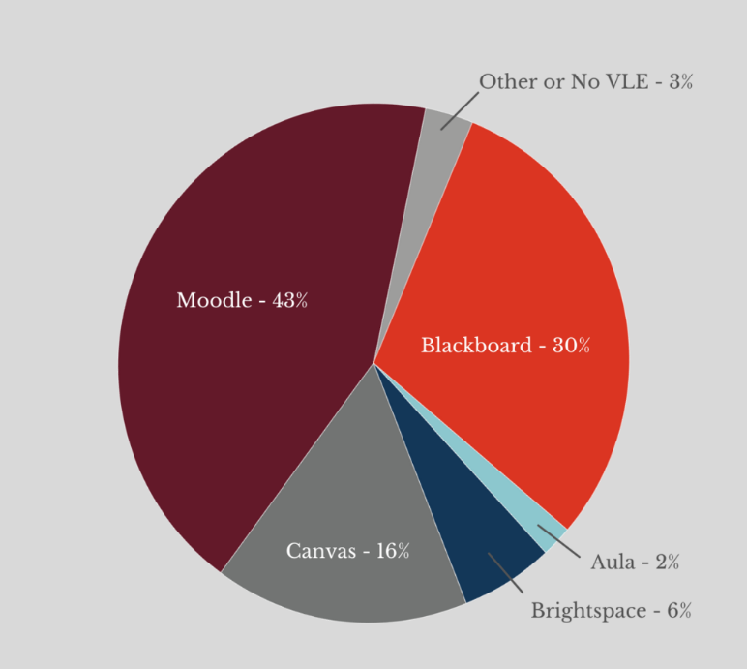
Figure 6: Use of VLE in the UK
From what has been uncovered so far, it is clear that VLEsw has had a profound impact on the way schools operate. Since the turn of the millennium, digital methods have been slowly gaining ground in classrooms everywhere, and as a result, today's youth spend almost all of their waking hours engrossed in cutting-edge gadgetry (Times higher education, 2020). The field of education is not immune to this either. Many students are now actively engaging in self-study with the aid of virtual learning environments. As a result, students may go through the material at their own speed. There has to be a greater focus on the process and administration of VLEs, and once that's done, there's no turning back for the students. There are no drawbacks to virtual learning environments (VLEs) other than a lack of supporting technology (Tsay et al., 2020). VLEs have the potential to radically alter the educational landscape after institutions have solved the technology access and adaptation problems facing their students.

Summary of the findings
The data show that the institution has taken appropriate steps to introduce Moodle and familiarise students with VLEs. According to the poll results, most students like Moodle because it is user-friendly, offers a wealth of resources, and allows them to study at their convenience. The students are confident enough in the benefits of VLEs to recommend them to peers, friends, and family. However, for certain students, virtual learning environments (VLEs) might be a challenge since they lack adequate access to modern technology. The college or university may look into the situation and help the students in need by taking the necessary measures. Aside from that, it is safe to say that the research yielded favourable and appropriately responding outcomes.

Conclusion and Recommendations

Conclusion
The findings suggest that the university has properly introduced Moodle and VLEs to students. Moodle is easy to use, has many resources, and lets students study when they choose, according to the survey. Students promote VLEs to friends and relatives. Virtual learning environments (VLEs) may be difficult for pupils without proper technology. The school may investigate and assist the pupils. Otherwise, the investigation produced positive and suitable results.

Recommendations
The institution needs to take good care of the fact that not every student is too smart to grasp smart technologies faster. Therefore the institution must enable special classes through which it can ultimately prepare students for the future environment subsequently (Tsay et al., 2020).
Educators need to adopt smart strategies so that they can utilise the benefits of VLEs to the fullest. The university must enable strong maintenance and management system for the VLEs to run smoothly without glitches and security issues precisely.

References
Awoyemi, R.A. and Awoyemi, R.O., 2021. A mediated approach to the virtual learning environment (VLE): Implications for academic libraries in the 21st century. International Journal of Library and Information Services (IJLIS), 10(2), pp.1-10.
Clark, D., 2021. Topic: Digital learning in the UK. Statista. Available at: https://www.statista.com/topics/8518/digital-learning-in-the-uk/#dossierKeyfigures [Accessed 10th December 2022].
Corvalán, B., Recabarren, M. and Echeverría, A., 2020. Evolution of students' interaction using a gamified virtual learning environment in an engineering course. Computer Applications in Engineering Education, 28(4), pp.979-993.
David, J., 2021. Differences between deductive and inductive approaches to research. how and what. Available at: https://howandwhat.net/differences-deductive-inductive/ [Accessed 8th December 2022].
Debois, S., 2022. 10 advantages and disadvantages of questionnaires. Pointerpro. Available at: https://pointerpro.com/blog/questionnaire-pros-and-cons/ [Accessed 11th December 2022].
Diab-Bahman, R., Al-Enzi, A., Sharafeddine, W. and Aftimos, S., 2021. The effect of attendance on student performance: implications of using virtual learning on overall performance. Journal of Applied Research in Higher Education.
Hamutoglu, N.B., Gemikonakli, O., Duman, I., Kirksekiz, A. and Kiyici, M., 2020. Evaluating student's experiences using a virtual learning environment: satisfaction and preferences. Educational Technology Research and Development, 68(1), pp.437-462.
Karumbaiah, S., Baker, R., Tao, Y. and Liu, Z., 2022, March. How does Students’ Effect in Virtual Learning Relate to Their Outcomes? A Systematic Review Challenging the Positive-Negative Dichotomy. In LAK22: 12th International Learning Analytics and Knowledge Conference (pp. 24-33).
Lacka, E. and Wong, T.C., 2021. Examining the impact of digital technologies on students’ higher education outcomes: the case of the virtual learning environment and social media. Studies in Higher Education, 46(8), pp.1621-1634.
Leino, R.K., Gardner, M.R., Cartwright, T. and Döring, A.K., 2021. Engagement in a virtual learning environment predicts academic achievement in research methods modules: A longitudinal study combining behavioural and self-reported data. Scholarship of Teaching and Learning in Psychology.
Mai, M.Y. and Muruges, G.R., 2022. Primary School Science Teachers' Attitude towards Using Virtual Learning Environment (VLE) in Teaching Science. European Journal of Education (EJE), 5(1), pp.132-143.
Mubarak, A.A., Cao, H. and Zhang, W., 2022. Prediction of students’ early dropout based on their interaction logs in the online learning environment. Interactive Learning Environments, 30(8), pp.1414-1433.
Peng, H.H., Lin, Y.T. and Wu, T.L., 2019, December. The effects of virtual learning environment on high school students’ English learning performance and attitude. In International Conference on Innovative Technologies and Learning (pp. 815-824). Springer, Cham.
Racheva, V., 2022. Virtual classroom six tips to improve your learner's attention. VEDAMO. Available at: https://www.vedamo.com/knowledge/improve-learners-attention-in-virtual-classroom/ [Accessed 11th December 2022].
Research-methodology, 2022. Ethical considerations - research methodology. Research-methodology. Available at: https://research-methodology.net/research-methodology/ethical-considerations/ [Accessed 9th December 2022].
Ryan, E. and Poole, C., 2019. Impact of virtual learning environment on students’ satisfaction, engagement, recall, and retention. Journal of medical imaging and radiation sciences, 50(3), pp.408-415.
Times higher education, 2020. The COVID-19 pandemic forces UK universities to reimagine their campuses. Times Higher Education (THE). Available at: https://www.timeshighereducation.com/hub/coursera/p/covid-19-pandemic-forces-uk-universities-reimagine-their-campuses [Accessed 10th December 2022].
Tsay, C.H.H., Kofinas, A.K., Trivedi, S.K. and Yang, Y., 2020. Overcoming the novelty effect in online gamified learning systems: An empirical evaluation of student engagement and performance. Journal of Computer Assisted Learning, 36(2), pp.128-146.
Weaver, K., Brown, D., Bostock, J. and Kirby, J., 2021. How far does VLE self-directed study facilitate improvements in written, practical and overall assessment results? Sports therapy case study. Innovations in Education and Teaching International, 58(2), pp.219-229.

Appendix 1: Questionnaire
1. Are you familiar with Moodle?
- Yes
- No
2. How did you find out about Moodle?
- Friendship
- Agent
- Family
- University
3. Do you recommend Moodle for studies in the future?
- Absolute
- Possible
- I will think about it
- No
4. You use VLE regularly?
- Regular
- Very regularly
- Sometimes
- Never
5. Do you find easy to access Moodle?
- Easy
- Very easy
- Difficult
- Very difficult

Appendix 2: Survey Results

