

Investigation and Evaluation of Social Media Promotion Strategies for Organisations

By Luke James Evans

Supervisor: James Williams

Second Marker: Beverly Holland

Project submitted as part of the requirements for the award of BSc(Hons) Business Information Technology

April 2019

Contents
Investigation and Evaluation of Social Media Promotion Strategies for Organisations 1
By Luke James Evans 1
Supervisor: James Williams 1
Second Marker: Beverly Holland 1
Project submitted as part of the requirements for the award of BSc(Hons) Business Information Technology 1
April 2019 1
1. Literature Review 4
1.1 Introduction to the project 4
1.1.1 Main Aim 5
1.1.2 Objectives 5
1.2 Introduction to social media 5
1.2.1 What is Social Media used for? 5
1.2.2 The Origin and History of Social media 6
1.2.3 Social media Platforms 6
1.2.3.1 Blogs, micro blogging and social networking platforms 6
1.2.3.2 Video sharing platforms 7
1.2.3.3 Image sharing platforms 7
1.2.3.4 Business suited platforms 7
1.2.4 What is Social Media marketing? 7
1.3 Social Media Promotion Strategies 8
1.3.1.1 Facebook 8
1.3.1.2 Facebook Promotion Strategies 8
1.3.1.3 Facebook Promotion Strategy KFC South Africa Case Study 9
1.3.2.1 Twitter 9
1.3.2.2 Twitter Promotion Strategies 9
1.3.2.3 Twitter Promotion Strategy TripCase Case Study 10
1.3.3.1 MySpace 10
1.3.4.1Reddit 10
1.3.4.2 Reddit Promotion Strategies 10
1.3.5.1 Twitch 11
1.3.5.2 Twitch Promotion Strategies 11
1.3.6.1 YouTube 11
1.3.6.2 YouTube Promotion Strategies 11
1.3.7.1Instagram 12
1.3.7.2 Instagram Promotion Strategies 12
1.3.7.3 Instagram Promotion Strategy Kao Case Study 12
1.3.8.1 Snapchat 13
1.3.8.2 Snapchat Promotion Strategies 13
1.3.9.1 LinkedIn 13
1.3.9.1 LinkedIn Promotion Strategies 13
1.4 Social Media Promotion strategy plan 14
1.5 Current Best Practises 15
1.6 Literature Review Conclusion 16
2.Research Methodology 18
2.1 Introduction 18
2.2 Methodology Choices 18
2.2.1 Philosophy 18
2.2.2 Approach 19
2.2.3 Strategies 19
2.3 Social Media Plan 19
2.3.1 Social Media Plan Diagram 20
2.3.2 Survey 21
2.3.2.1 Pilot Survey 21
2.3.3 Practical Implementation Experiment 21
2.3.4 Case Study 22
2.4.1 Survey Overview 23
2.4Social Networking Analytics 30
2.5Experiment Overview 31
2.6 Case Study Evaluation 40
3. Recommendations for businesses 40
4. Personal Reflection 41
5. Conclusion 41
Bibliography 43

Literature Review

1.1 Introduction to the project
This literature review will be to document everything for an investigation and evaluation of social media promotion strategies for organisations. It will be used to document findings on the chosen topic using a number of research methods as well as the use of evaluation to come to a comfortable conclusion about the final results. This document will also be used as a part of a Major third year project.
First of all in this literature review there will be a brief introduction to social media platforms and the history of social media itself. This extra research will hopefully add context to the research and conclusions that are yet to come. It will allow the reader to understand why promotion strategies are used on these platforms and see how humanity has used them to their advantage through their organisations.
Online research will be used to determine, out of the chosen social media platforms, which ones initially stand out. The research will be conducted using online tools such as research papers and analytic tools to determine which are the most used and social media demographic analysis tools to find out the age range of each platforms user base.
The main topic of social media promotion strategies for this major project will undergo extensive research for the literature review. The sources used for this part of research will be as credible as possible to ensure that the correct social media promotion strategies are being used and tested. The credibility of the results from the practical use of the chosen strategies are based off of this research.
Once the chosen social media promotion strategies are chosen, they will be applied to new pages on social media platforms for the chosen organisation. The documentation of this process will be ongoing as they’re applied.
The results of said applied strategies will be reviewed using chosen online tools which should show how successful each strategy is for the smaller organisation. A comparison will then be underway with the strategies used by a larger company. This comparison will show the best practises with the current acquired information.
Next, the reasoning behind each survey questions will be explained. The results will be analysed once the survey itself has been completed. The findings will then be applied to the previously acquired research.
An overall conclusion will be completed using all knowledge obtained from the entire major project. The data collected from online research on different effective strategies, results from the application of those strategies and the survey results will all the used to come to conclusive decisions and answer the projects ‘Main Aim’. This conclusion will allow the discovery of the best possible practises for an organisation using social media promotion strategies. The final evaluation should show which platforms are best for each target demographic and the most effective social media promotion strategies.

1.1.1 Main Aim
‘To investigate and compare social media promotion strategies and identify current best practises’.

1.1.2 Objectives
- Investigate Social Media Promotion Strategies.
- Analyse the effectiveness of social media strategies.
- Devise a social media promotion strategy.
- Test and evaluate each strategy to see how each one works and record the results.
- Use a survey to discover what the general public think about each strategy used on social media and record it.
- Evaluate the research, testing data and survey results to identify current best practises.

1.2 Introduction to social media
Social media is a collective online interface method for the input and output of data that was created and developed through the internet. The basic premise of social media is to enhance communication, interactions, data transfers and sharing of content over the internet. Each social media platform can hold different data to another. Each user can decide which social media platform to use and there are many for varied choice. Certain platforms may be preferred or designed to be suited for specific data output types to target a corner of the social media market [1].
Academic studies suggest that ‘low in-come families’ see the ability to use social media as a practical skill, whereas, ‘high in-come families’ see it as “a threat to formal education” or just another distraction [2].

1.2.1 What is Social Media used for?
Social media platforms are created by companies to allow this method of data output. Both the user and the company can receive a great benefit from this.
A user can have swift communication with peers on their chosen platform and there are a number or choices for them. These social media platforms allow communication for people around the world.
Businesses can advertise easily through multiple methods to reach their customers depending on the platform. Social media platforms can be used by businesses to track customer feedback and respond accordingly either personally or large posts. Many organisations that use social media will have a well thought out strategy which will include why they want to use it and what they hope to gain. Organisations use enterprise social media, which is split into two ways. It can be used to communicate with stakeholders, such as customers, investors and the general public. It can also be used for internal communication throughout the company.
The company who owns the platform will benefit from more and more people choosing their platform to use. The more people who use and enjoy the platform, the more likely they are to recommend it which is a reason a user will go to their platform over a competitor. Businesses can also pay them money for advertisement methods. These companies typically allow their users to access their platform for free to encourage the use and growth of it.
Social media is used for the communication of information between people. This information is generally going to be text, an example of a primarily text output platform would be Facebook. Other data types such as video would be mainly used on specialised platforms such as YouTube [3] [4].

1.2.2 The Origin and History of Social media
The creation of social media was a significant step for the internet and humanity. Social media in the current day is very prevalent throughout the world and used by a large amount of users across the planet which is only estimated to grow in numbers as it become more impactful [5].
As Social media was innovated over time, it began to “disrupt the one-to-many media model”. The more traditional methods of broadcasting had a major rival to compete with. Social media platforms allowed the consumers of these initial methods to become media creators themselves. As long as the user has an internet connection, then they can create their own media freely on these different platforms and perhaps paid to do so. Even the original media services such as News stations now use social media platforms for extra information or content from their audience or the general public. The invention of Social media in the late 90’s allowed the jump from networked communication to platform sociality. Networked communication allowed basic communication services but could never automatically connect people. Social media altered the way that people communicate publicly and privately; allowing quick posting to the internet for all to see or easy to use messaging systems for private conversations. Social media has adapted over time as newer and better platforms have emerged for all types of data transfers [6] [7].

1.2.3 Social media Platforms
Social media platforms can be categorised and split up to show their main purpose for users and businesses. These categories are created based off of the main data output type, or what the majority of users use it for. Social media platforms have been skyrocketing in popularity and growth for core uses of the everyday user and also businesses. The contents that users will see on each individual platform may vary depending on which region they are from. Social media platforms are constantly changing, updating and adapting as time goes on. Platforms that adapt can staff up to date with user needs, however, the platforms that don’t become obsolete and their user count will dwindle down over time [8]. Social media is a way for a business to internationally communicate with all their stake holders, customers, business partners and suppliers [9].

1.2.3.1 Blogs, micro blogging and social networking platforms
Blogs, micro blogs and social networks all fall into one category; these types of platforms focus on the text based posts, allowing users to share their thoughts using words. These platforms also allow higher quality of connectivity between their users; they allow people to ‘follow’ or ‘add’ user or business pages alike. Platforms that focus on this form of data communication usually allow the sharing of other forms of media such as images or video but that’s just to further their potential audience [10].

1.2.3.2 Video sharing platforms
Video sharing social media platforms simply allow users to upload any video they filmed with ease; it is what this type of platform is purposed for. Videos on these sites may end up being shared on other social media sites to spread awareness about their own and gain free publicity. Platforms of this form can vary; some may upload videos and some allow user’s stream live footage to their audience. Businesses use these sites as alternative advertisement methods as they tend spend a lot less to show the footage and there’s a chance that it can go ‘viral’ due to it possibly being seen by a much larger audience across the world. Like most social media types, these platforms usually allow users to ‘follow’ or ‘subscribe’ to their favourite creators to stay up to date with their video media posts.

1.2.3.3 Image sharing platforms
Image sharing platforms allow users to make posts about pictures they have taken or images they have created. Businesses can use platforms like this to showcase products, another alternative method for advertisement. These platforms usually allow audiences to ‘follow’ any user they want to stay up to date with image posts.

1.2.3.4 Business suited platforms
Business suited platforms are primarily for organisations; these sites are made to benefit companies in different ways. These are platforms that are set up primarily for companies to communicate and advertise to each other.

1.2.4 What is Social Media marketing?
More conventional forms of media such as television, radio and newspapers are “one-way” forms of communication. These traditional methods were very poor, communication wise; feedback was limited by this set system. Social media innovated the way information was translated and allowed almost instant feedback to the Media creators from their audience. Big companies can now tap into the huge potential of social media marketing, instead of using these orthodox methods of advertisement. Social media marketing is essentially a business using social media platforms to enhance their advertisement, as well as their internal and external communication. Using social media, it has never been easier for an organisation to share their created content with the public on a global scale; an large advantage of using social media to advertise instead of traditional methods would be that as long as the platform is available is their country, people can access their content from all across the world [11].

1.3 Social Media Promotion Strategies
Social Media Promotion Strategies are techniques used by organisations to advertise and boost awareness of a product, deal or the business itself through a social media platform. These strategies can possibly be applied through multiple platforms for boosted levels of awareness. These strategies can even be used to boost posts if they think it’s worthwhile. Strategies can come in many forms, for example, they can be linked to what format of media is being output on a platform, they could include the way it’s released to users or simply a tool provided by the platform so more users notice the post [12].

1.3.1.1 Facebook
Using the online tool ‘Google Trends’, anyone can see that Facebook is clearly the highest searched social media platform by Google users worldwide compared to all other platforms that will be talked about in this document [13].
Obviously Facebook has multiple ways to show other users content. Features such as ‘Share’ and ‘Like’ allows a user to spread a specific post further to whoever they are ‘friends’ with and this creates more awareness of said post.
Facebook is a Social media networking platform which allows users to ‘Add friend’. This feature allows people who know each other in real life to stay in touch over the internet by simply searching their name providing they have an account. Facebook revolutionised the Social media platform and blew up to be the largest platform on the planet [14].
Facebook now allows users to use a regional market place through its website or app. This feature can be compared to something like eBay where users who sell items could possibly consider this early on if they are a small business. It’s an opportunity for very small businesses to sell products in their local area to gage where they are at before they start to grow.

1.3.1.2 Facebook Promotion Strategies
One strategy that businesses tend to use is to treat the comments they get on their posts as feedback. This can be used on a vast number of platforms providing it allows some form of two-way communication. The business can reply to each comment and address any issues, queries or praise a customer or user might have.
One social media promotion strategy that is being used on Facebook and other main social media websites such as Twitter is for companies to be mindful of which media types are being posted and which is best consumed by their desired target audience. An example would be that advertising a seasonal sale would be a lot less eye catching if it was just one big block of text; a much better, online user friendly way of posting would be to hack bullet points for text and possibly accompanied by a graphic or video. Online users are much more likely to be interested in engaging content compared to an extensive text post. Graphics can be used to draw attention to a post using large text and vibrant colours. Meanwhile, video media is typically used to draw further attention to the video which will automatically draw traffic to that specific post.
One other promotion strategy that can be used is the ability for a business to pay for advertisement. Facebook allow payments from these companies to advertise their pages to other users on the platform. This ability can also be applied to individual posts made by that company’s page which will charge them depending on how much traffic the post gets so social media teams think very hard before paying to promote (boost) a post. This advert can also be directly targeted towards the businesses target audience or at least who they believe would be interested in the ad [15] [16].

1.3.1.3 Facebook Promotion Strategy KFC South Africa Case Study
A case study that was found during research shows how KFC successfully used Facebook ads, a paid promotion strategy on the platform, to attract new customers to their rebrand in South Africa. Their rebrand wanted to “re-energise” the business in this region after a portion of time where there is a noticeable decline for them. The paid Facebook advertisement allowed KFC to target the ad to South African users than are aged 18-50. The ads were also targeted towards urban locations where the KFC establishments tended to be.
Over the course of 2 weeks, the advert had a significant effect with only using 2.9% of their total campaign investment. A total of 37% overall reach came from both Facebook and Instagram. KFC then understood the potential in using Facebook ads as a strategy to raise awareness for their brand and also showing them the value in this method [17].

1.3.2.1 Twitter
Twitter was created during 2006 and was designed for a similar purpose as Facebook. Twitter is another traditional form of social media networking platform and a platform can its ‘blogging’ style of layout. Twitter is essentially a less intimate version of Facebook where users can follow companies or people they don’t even know with no response or ‘add back’ and that user can then see all of their posts or ‘tweets’. Twitter can be accessed through its online website or its app for mobile device users. It primarily focuses on its rapid data uploads in multiple formats which means users can have a stream of instant content depending on who they ‘follow’. Twitter is another social media platform that allows people to communicate with ease and engage online through either public tweets and replies or their direct messaging system.
Twitter has features such as ‘like’ and re-tweet’ which allow users to further share content that they have seen and enjoyed. This isn’t a strategy method per say, but these features do help when used with other techniques to increase the amount of awareness that ‘tweet’ gets [18].

1.3.2.2 Twitter Promotion Strategies
The main social media promotion strategy for businesses to use to increase the likelihood of users seeing their post on Twitter is to use Hash tags. Now Hash tags are used in posts to get people talking about them using key words. An example of a Hash Tag being used would be if a Company was having a seasonal sale, the company would use hash tags that would relate back to the post and topic. If the company is lucky and the posts along with the chosen hash tags gain a lot of recognition then there’s a chance that it could be shown in Twitters ‘Trending’ tab which all users can see. If something appears in the trending tab then the topic, original post or the account that tweeted it in the first place will temporarily gain acknowledgement but this can be enough for enough users to be aware of it and take action on what they have seen; if there was a sale on and a user saw it was trending then they are more likely to go check the sale out. The trending tab can be used another way to benefit a business; they can create posts with key words that are already in the trending tab which will obviously mean that more people are going to see it.
Twitter has a couple ways for businesses to make payments for advertisement. One is for a business to pay for ‘promote mode’ which means that their account and tweets will be seen by a lot more of the platforms users [19]. The other version for businesses to pay for advertisement on twitter is if they purchase and launch a Twitter Ads campaign; this involves the business choosing what is put in the advert to promote the company and then Twitter will show users across the platform at random over time [20].

1.3.2.3 Twitter Promotion Strategy TripCase Case Study
A case study was found during research which involved a company called ‘TripCase’ who own an App. They decided to take advantage of Twitters ad campaign service to increase the awareness and download of the app on mobile devices. The Twitter ad campaign allowed them to carefully select what kind of relevant audience the advert would be shown to. TripCase could focus their ads on specific countries; over 40 countries were targeted and the audience would have either iOS or android devices. This campaign for the company was a success overall, raising the apps engagement rate, when downloaded from Twitter, to 25%. TripCase used the method to test multiple campaigns and choose to build upon the better performing ones using Twitters useful analytic tools [21].

1.3.3.1 MySpace
MySpace is a prime example of a social media platform that did not adapt or change over time. As other platforms endured and changed as time went on and technology became more prominent, MySpace was left behind. MySpace was originally one of the biggest social media platforms before even Facebook came along. In the current day, MySpace is not recognised as a popular social media platform, but instead, a thing of the past. It is very unlikely that MySpace would be brought up in a conversation involving social media strategy methods or online marketing [22].

1.3.4.1Reddit
Reddit is the type of social media platform that can be easily split into sections. This site allows their users to divide different categories of information into ‘Sub-reddits’; this function allows users to easily find things they are interested in immediately. The popularity of a post on reddit is determined by the reaction from the topics particular sub-reddit; users who view the post can either decide to ‘Upvote’ or ‘Downvote’ it.
Reddit is different to other social media platforms because it has a smaller and more ‘particular’ community of users. It’s important for the business to find the correct sub-reddit to post on and ensure that reddit is not their primary social media platform.

Reddit Promotion Strategies
The main promotion strategy used by businesses on reddit is linked to a feature called ‘Redditads’. These are used to remind users of events that are happening on specific dates. This feature can also link users directly to the page the event is taking place on; for example, if the business is starting a sale at a specific date and time [23].

1.3.5.1 Twitch
Twitch is a form of video sharing platforms which allows its users to broadcast their content live to viewers from all across the world. Twitch is another platform that is split into categories; this is mainly due to its primary gamer audience, however, other categories have been implemented to accommodate different niches in the steaming community [24].

1.3.5.2 Twitch Promotion Strategies
One of the main social media strategies that are used on twitch is sponsorship for the content creators on the platform. Companies do not tend to directly stream their content on the platform, but instead, they see the popular streamers who have large audiences and sponsor them with payments or gifts that they can show off. This strategy can be very effective as audiences can be extremely impressionable by their favourite streamers and can be swayed by personalities to go look at a company’s products.

1.3.6.1 YouTube
According to research using online tools such as ‘Google trends’, YouTube is the second most searched for social media platforms out of the selection discussed in this document after Facebook [13].
YouTube was created in 2005 and ever since has been the number one source for video oriented media. YouTube as a platform primarily allows its users to upload videos of their choosing providing that said video meets their community guidelines. YouTube allows a sort of one-way course of communication where a member of a channels audience can leave a comment on a specific video for that channel owner to then read for feedback.
YouTube allows the audience of a video to ‘Like’ and ‘Dislike’ as they please, but they can only choose one or the other.

YouTube Promotion Strategies
One Strategy that is used on YouTube is the ability for a company to create a standard TV advert and then upload it to the internet for further exposure to YouTube users. These videos than then be further shared by the company on their other chosen platforms for even more exposure and views.
Another strategy that is used on YouTube and video sharing sites in general is tags that can be attached to videos which will make it easier for users to find their videos. These tags are input when a video is being uploaded by the creator and tend to be linked to the video; for example, if a company uploaded an advert onto YouTube about their Christmas sale and added a ‘Christmas’ tag then when that keyword is typed in by a user searching for a video, that video is far more likely to appear for them. Keywords are also applied when titling the video and are more likely to be found by the intended audience when they have a fitting title.
The main goal for a company who is uploading a video to YouTube is to make it go ‘viral’ over the internet. There is no true method to make a video go viral; however, large companies are going to have that large audience of consumers and customers that will help towards that video doing well. A video going viral means that a large number of people have seen the video and are talking about it throughout the globe. A viral video can boost exposure of small and large companies alike by showing this video to the world.
One other strategy that larger companies tend to use is to pay YouTube to advertise their advert throughout other creator’s videos. These adverts can be skipped after 5 seconds or incredibly short but it gets the brand out there to the audience of YouTube.
YouTube now allows users to live stream to their audience and this opens up a lot of opportunities for businesses. In a very similar way to streaming platforms like Twitch, businesses can pay popular streaming to be sponsored by the company to show off their brand or even products to their audience [25].

1.3.7.1Instagram
Instagram is primarily an image sharing platform that was created in 2010. Instagram can be accessed through its website but also through an app for mobile users. It has the social aspect of being able to ‘follow’ who you want to keep up to date with their image posts [26].

1.3.7.2 Instagram Promotion Strategies
Instagram is another platform that allows its users to make posts that have hash tags attached. Hash tags with key words allow the business to attract their target audience to specific posts.
Instagram is typically known for its more aesthetically pleasing images; so for example, a business that sells clothes may want to post images of professional models wearing their new clothing. These images can grab a user’s attention as well as tempting them to follow the link to that company’s website to discover more about the clothing [27].
Instagram has a linked feature with Facebook which allows advertisement across both simultaneously. This ability is one that isn’t found too often but it is possible due to Facebook owning Instagram.
Instagram allow their users to run daily ‘stories’ which are temporary posts. These are a key part in Instagram’s paid advertisement campaigns which take a business’s ad and show them through stories of relevant audiences for that business.

1.3.7.3 Instagram Promotion Strategy Kao Case Study
A case study was discovered while researching which involves a company called ‘Kao’ successfully introducing its new hair products using Instagram ad campaigns. The main aim of these campaigns was too create awareness of the companies for the new products and was specifically targeted towards women in their 20’s. The ads that they rolled out through the campaign show they use short videos as a media type due to their personal research on young people’s attention spans. The campaign was a success, resulting in a ’10-point’ lift in brand awareness involving users exposed to the ads. Their purchase intent for their advertised product also increased by ‘3-point’ and this was due to the success of the campaign. The ad campaign also ran over on Facebook due to both platforms being owned by one company; this option would significantly increase the amount of users reached and makes it more appealing for businesses looking for advertisement options [28].

1.3.8.1 Snapchat
Snapchat is a very unique form of social media platform as it isn’t set up in the standard social media platform template where there’s a website that users can post on. Snapchat takes a whole new direction with user communication and allows its users to easily communicate through text and images at the same time with ease. It does not have a website like other platforms, but instead sees the benefit of only having their platform on an app to focus on mobile users.
The Snapchat creators were initially the ones to create a ‘story’ feature which allowed a user to post something for a whole day and all their added users could see it. Although this can be compared to standard posts on traditional social media platform, it’s different because its temporary and it only gives insight into what that user has been doing for that day. This feature has spurred on a trend and a large number of other platforms like Facebook and Instagram have implemented this feature as it seems to be in high demand for the ever growing online presence.
Another feature is a recommended article section which other platforms tend to use for news output purposes [29].

1.3.8.2 Snapchat Promotion Strategies
One social media strategy that can be used by businesses through Snapchat is that a company can create an account where users can subscribe to. These users won’t be able to directly interact with the company but will be able to see the company’s story which will include graphics of deals or new products that are now available. These subtle advertisement techniques through mobile apps can be suggestible and even convince users to go to their website or possibly even contact the business through other means of social media. It’s very likely that they will see it as Snapchat allows users to automatically cycle through stories.
Another strategy that News outlets tend to use on Snapchat is pay for their article to be shown to every user to gain as much exposure as possible for maximum possible clicks and reads. These articles can also allow users to subscribe to stay up to date with future articles that the company may produce. It’s not only exposure for the writer but the company itself. These are called “Snap Ads” and are Snapchats equivalent to paid advertisement [30].

1.3.9.1 LinkedIn
LinkedIn is a business oriented social media platform that users can access through its website and mobile app. It was launched in 2003 which shows that it was one of the earlier platforms of social media. LinkedIn is a popular choice of platform for businesses to choose due to its professional online environment. Other platforms have an overwhelming number of casual users that post whatever they want; whereas on LinkedIn, businesses and users only make calculated posts towards a goal [31].

1.3.9.1 LinkedIn Promotion Strategies
LinkedIn is heavily catered towards businesses compared to most other platforms. A strategy used on LinkedIn is to take advantage of their premium tools. Not only can a business look to hire staff through LinkedIn, but the premium allows for the right candidates to find the business to apply for a job. The ‘Sales’ plan allows the business to communicate with customer and other businesses for multiple reasons; LinkedIn will also inform the business about their target market and perhaps give tips to assist with their promotion and growth. Finally, the ‘Business’ plan allows a business to promote and grow; it will also teach the business ways to promote their brand because perhaps they are just starting out. A premium account is a purchasable option and each plan is a different price but can help the company in the long run [32].

1.4 Social Media Promotion strategy plan
It was interesting to see if there diagrams that have been created by businesses specifically to plan out their social media promotion strategies. A couple template examples were found online and they all have a ‘flow chart’ type design where the direction of the plan is very clear.
The following example will be analysed to see how these plan diagrams are then later applied to the social media strategies themselves [33].
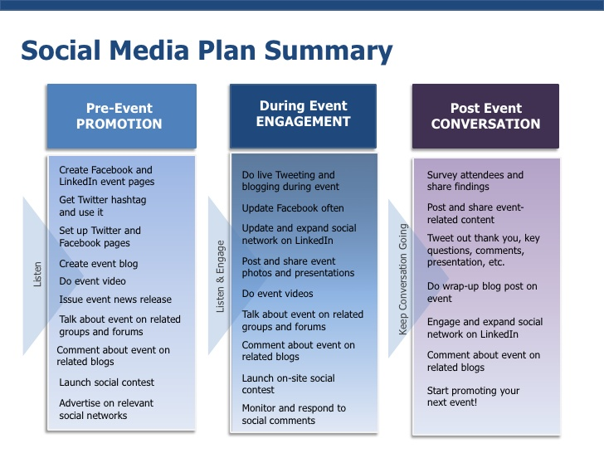
The diagram above shows a social media plan (summary) from ‘Leadtail’ who were creating it to prepare for strategies that will promote an event they were running. In the early stages of planning for ‘pre-event promotion’ they decide which social media platforms they would like to use; which in this case is Facebook, Twitter and LinkedIn. They also decide what promotion strategies they are going to use, hashtags for Twitter, engaging posts and video media type posts.
This example is relevant to the project due to its ‘timeline’ style where the plan updates as their event goes on; just like the plan for the projects primary research that will be changed over time for varied data collection purposes.

The next diagram that will be analysed is a social media plan from a business over a certain amount of time [34].
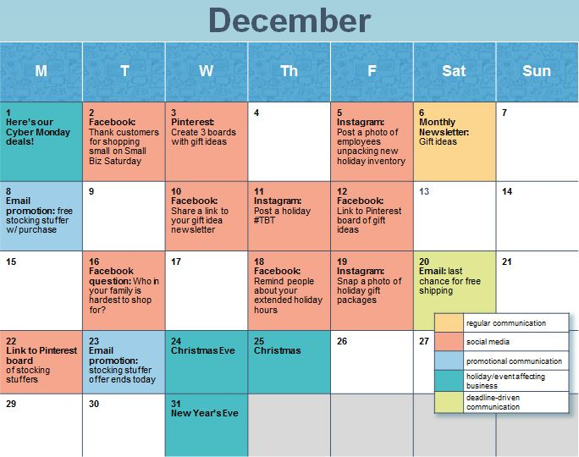
The diagram above shows a social media plan in diagram form created by a small business employee. The diagram created is an example template of a plan that is laid out in a calendar form. The diagram clearly shows the entire social media plan throughout the month of December as well as other key ways for business promotion which is correctly labelled. The social media platforms, social media strategies and media types were all assigned dates for when that specific strategy would be executed.
This example is also a relevant diagram to the current project because research will more than likely be done over the month so this could perhaps be a viable layout for the projects social media plan; however the posts will likely be done on the same days to make it easier to record the results.

1.5 Current Best Practises
The following best practises will be determined via online research and platform popularity. The best practises for social media platforms for businesses to use will be completely determined on which platforms will yield them a larger audience through base number of users and searches.
First of all, browser searches for social media platforms can be a good indicator as to whether a business can find a platform viable to advertise to a vast audience.
A more realistic indicator in the modern day climate for social media would be to research the analytics of app download numbers for different platforms. A research article was found to have statistics of specific social media apps exposure to mobile users. A diagram shows the percentage of app audience the top 10 apps managed to reach by the summer of 2017; four of those apps were major social media platforms. Facebook with 81%, YouTube with 71% and Instagram with 50%. This shows that social media presence is incredibly prominent through mobile app stores and these top platforms are a good basis for a business to start online advertisement [35].
Choosing best practises for strategies on the best choices for a social media platform will be conducted through online research. A book written by Gabriela Taylor mentions a few key social media platforms that can be used by businesses for online advertisement. These platforms include Facebook, Twitter and YouTube. It seems that the platforms that are deemed “best practises” for an organisations online advertisement include Facebook, Twitter, YouTube and Instagram. It is sensible to suggest that the best and preferred platform for social media advertisement for organisations is Facebook [36].
As for the best practises for strategies on these platforms, each individual platform needs to be looked at. In the case of advertising posts, paid advertisement on platforms like Facebook, Twitter and Instagram seem to be the best possible practises available to businesses. Paid promotion strategies effectiveness depend on how much the business wants to spend on promoting a specific post. Obviously the more a business spends on an advertisement campaign, the more people it will reach across the platform. A large benefit of using paid advertisement campaigns is that a business can set it up in a way where they can essentially target users who they think could be their potential audience. The best practises of unpaid promotion strategies are different for each platform; YouTube doesn’t have an easily accessible paid promotion strategy so users have to use strategies such as meta tags in their posted videos to find their target audience with key ‘search’ words [37].

1.6 Literature Review Conclusion
To conclude, the literature review overviewed a number of different topics that were relevant to the research topic. The first section of the literature review went over social media as a whole, what it is, the prevalence of it in the modern day, how it has changed over time and the history behind it. It also went over the different uses that social media has in the modern day to the everyday users and business alike.
The second section of the literature review looked at social media and how it can be split into different platforms. Platforms can specialise in certain media outputs and some may cater to many outputs. These different platform types showed that audiences may be split over their preferred platforms and media output types; for example, someone may use YouTube more because they prefer video content.
The third section goes over how companies are using these social media sites as advertising platforms and made the comparison to advertising techniques of older forms of media.
The fourth section is to look at how social media promotion plan diagrams can be used by businesses to know exactly what to do prior to the execution of the strategies. The analysis of the example templates show how these diagrams are laid out and perhaps showing how they can be applied to this project.
The fifth section of the literature was to research a number of social media platforms such as Facebook, Twitter and YouTube to discover what social media promotion strategies have been used by businesses. Case studies were analysed for a few platforms to acknowledge success stories of well-known promotion strategies.
The sixth section was simply to do an analysis of all platforms and their promotion strategy counter parts for businesses. The discovery of best practises for businesses when it comes to social media strategies was a focal point of this section and is a key part of the literature review as it can be used to create a hypothesis for any future research.

2.Research Methodology
The research methodology is where all primary data has been collected for the overall analysis of the project.

2.1 Introduction
The primary data from the research of this project will be the main source of information to reach the initial aim and objectives set prior. The point of this section is to show how the research is undertaken using different data collection methods and strategies.
Realistic objectives were created before the primary research began to ensure appropriate procedures were taken to achieve reliable results:
- To create a suitable survey that relates to social media strategies and distribute it avoiding bias in the process.
- Collect and analyse the survey results after an acceptable amount of results have been collected.
- Test social media strategies using the case study businesses social media pages.
- Collect the results from each individual post after a suitable amount of time.
- Compare all results from the survey, case study research experiment and literature review and come to a conclusion on best practises for social media promotion strategies.
A hypothesis was made prior to all primary research and it can be made simply by looking at the results found from the literature review research. The hypothesis being that statistically, Facebook should be the most used social media platforms which should make it the most viable option for businesses. The paid promotion strategy should also be the most effective social media strategy overall too.

2.2 Methodology Choices
Selecting a Methodology for research is important because it is the core basis of how the data is collected for analysis. The methodology can be split into three parts, philosophy, approach and strategies.

2.2.1 Philosophy
A philosophy for the methodology had to be chosen prior to the primary research taking place. Research is built upon with philosophies which include either positivism or phenomenology. It should be stated that research can involve both philosophies depending on what it is. The philosophy of research should include the way you think about how the data and knowledge develops [38].
Positivism is essentially based off of observation of real world experiences. Experiments are set up specifically for the observer to collect data for their research on simply what they see [39].
Phenomenology is based off of the social phenomenon’s that can produce subjective data. This can be how a person interprets an event and will reveal what they are thinking and feeling [40].
The appropriate philosophy to use for this specific research ended up involving both positivism and phenomenology.

2.2.2 Approach
An approach for the methodology towards the research had to be chosen as well, prior to the primary research. There are two key approaches that were looked at and analysed to allow for a decision on which one to choose for this specific research; these two approaches are deductive and inductive [41].
Deductive approach involves a hypothesis being set prior to the research starting. The research itself would be designed around the hypothesis and would test to see if it was accurate [42].
Inductive approach involves analysing data that you have collected and arriving at a new theory on that topic [43].
The appropriate approach that was chosen for this research is in fact, both deductive and inductive. An inductive approach was used due to the original theory of best practises coming from online research and deductive because the hypothesis created from the literature review could help structure the primary research.

2.2.3 Strategies
A strategy for the methodology had to be chosen to assist with the knowledge on how the research was going to be carried out. Three key strategies were used for this research and each one was useful in finding and collecting key information.
A survey is a strategy that is used to investigate the opinions of other through asking them questions. Surveys are a good way to collect a large amount of data in a small amount of time. They can also help answer questions that vital to the research.
Experimental is another type of strategy which was used to collect data from social media. An experiment is analysing the two individual components and recording the results after changes are made to one.
The final strategy that was be used for the primary research is using a case study. A case study an examination of an individual item, for this research, it involves looking at a specific business. The case study would assist in giving a platform for the experiment to take place but also allow feedback on the results [44].

2.3 Social Media Plan
The strategies had be planned out to ensure that each one would yield accurate results. In order to carry out the strategies relatively smoothly they each were meticulously planned beforehand instead of attempting to do it all in one go. Without the planning, mistakes would be made and perhaps vital data would have been missed out.

2.3.1 Social Media Plan Diagram
The social media plan diagram seen below references the examples found within the literature review. The idea of marking each section with a specific date derived from a particular diagram example and inspired the creation of this one, even if perhaps not being exactly the same layout.
The diagram was created to plan the ‘experiment’ for the research in an organised and meticulous format. This style of diagram is rarely seen but seemed to be useful for the planning stages of the research; it also adds a unique appearance to the piece of work. The diagram itself is split into three separate sections where social media plan is dissected and arranged into boxes depending on the date of initiation.
The first box refers to January 6th which marks the start of the experiment and the addition of unpaid promotion strategies on the case studies social media platforms pages. On this day, multiple different posts will be made of four significant social media platforms. The social media platforms included are Facebook, Twitter, YouTube and Instagram. First of all, three regular posts with no strategies involved will be posted to test the results of different media types on available platforms. Then chosen unpaid strategies will be added to new posts for comparison to the regular posts. The diagram clearly states that the first section of the experiment will last for two weeks exactly. A simple arrow within the diagram represents the flow of information and direction for the plans execution.
The second box refers to January 21st which marks the second stage of the plan; this section outlines the paid promotion strategies. New Regular posts arerequired; however, the paid advertisement and campaign options for the platforms will come into effectto show the comparison. The same platforms would be used for this stage apart from YouTube which cannot be utilised for such promotions.
Once the second stage is concluded after its two weeks interim period and the experiment comes to a close, the plan moves onto the third and final box in the diagram. This final box marks the end of the social media plan and the start of the data analysis. The analysis of the results is the penultimate point of this social media plan and will equal to this diagram being a success if followed correctly. This diagram is a unique way of setting up a social media plan and can possibly benefit any organisations social media teams.
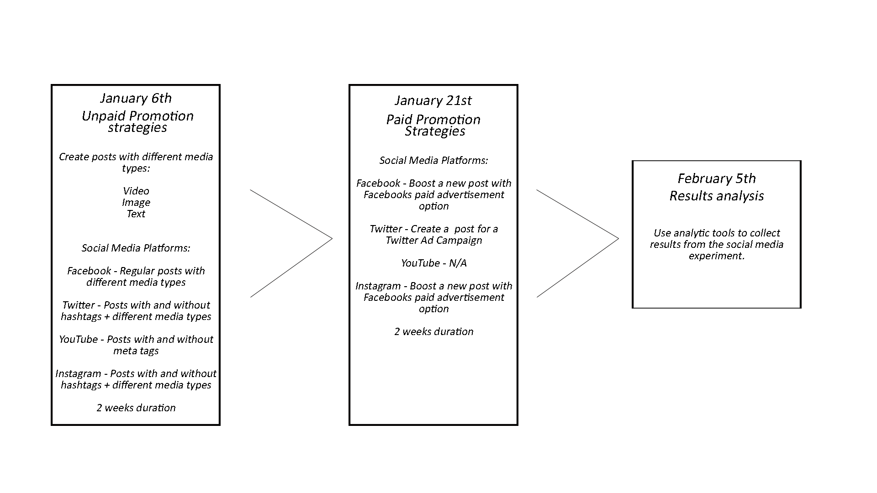

2.3.2 Survey
A survey was created for data to compare to the experiment results and the literature review. The questions within the survey were designed to answer key questions regarding best practises for social media and their promotion strategies. Many angles were thought about when choosing which questions to put into the survey, considering what different factors would affect the outcome of results. The survey will assist in coming to an accurate conclusion on best practises when all the results are compared. The survey was released to a total of 85 people overall through an online service called ‘Survey Monkey’ which allowed easy creation, customisation and distribution of the survey [45]. Bias had to be taken into account and to avoid it, the survey was distributed through 3rd parties to be completed by people in the work place and links through direct messages. The target audience for the survey was users of all kinds of popular social media platforms.

2.3.2.1 Pilot Survey
The survey was prototyped and cut down to essential questions that were the most applicable for the research. A pilot questionnaire was given out to 10 members of the public to see if questions were suitable or how they were set up; for example, numerous questions were cut from the final survey because they were too vague and the answered would not have been applicable to the comparison of other research results. Another example would be the way a person answers a question because the question “Which Social Media Platform are you most likely to use?” was originally set up so that they could put in their own options and this enforces human errors such as spelling mistakes; this would also make the results vary a lot so just the most popular platforms were added as options they can choose from.

2.3.3 Practical Implementation Experiment
The experiment part of the results will equal to results that the final conclusion will be built upon. The experiment ran over the course of 1 month where a few social media promotion strategies were tested on multiple platforms. All strategies and platforms for this experiment were chosen based off of the original research from the literature review. First of all, for 2 weeks (From 6th January until the 20th January), non-paid strategy methods were used on the chosen. Once the first round of results was collected, the next 2 weeks afterwards tested paid strategies (From 21st January until the 4th February).

2.3.4 Case Study
The case study for the research methodology will follow a company that deals with both B2C and B2B. This was a great opportunity to test how well the general best practises are with a small business implementing social media promotion strategies. The business in question, “OspreyUAV” is a company that currently, in its early parts of existence, creates videos and images using drones for charities. After some practise with offering free work to charities and social media advertisement, the business plans to be open to offers from customers and businesses alike [46].

2.4.1 Survey Overview
The survey consisted of nine questions that were well thought out and tested before being added. Each questions answers a different questions can involves social media promotion strategies or links to the experiment. This overview will be an analysis of the results that have been acquired after a total of 85 members of the public completed it. Each question may be referred to later as a way of comparison between the results. Survey Monkey was used to disperse the survey to people and it also has a way of taking the results and clearly displaying them. The way the results were displayed for each questions were set up to be different depending on the data output; for example, answering with a ‘Full Name’ could be displayed in a clear list, but more numerical results were displayed as bar charts.

To start with, question one: “Full Name”
This question is simply a way to verify that a real person is completing it and will, in turn, validate the results. It was also taken into account that proof of these people taking the survey would be needed if the results were to be looked back on.
The screenshot below shows the results from question one; they are to be expected, just a big, long list of names.
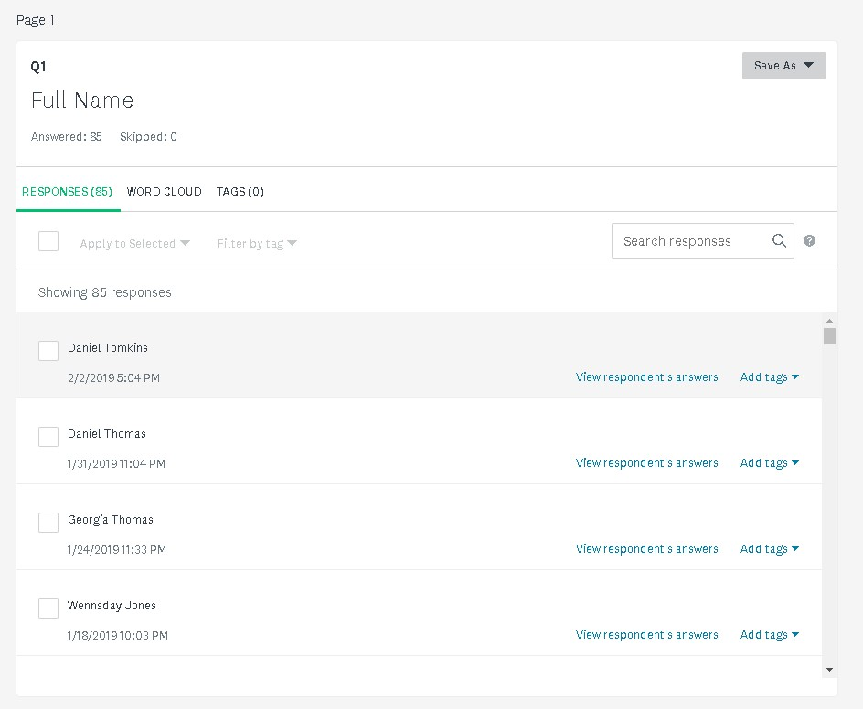

The second question: “What is your age?”
This questions is asked so there is a record of the age range that spans across social media users and to have something to refer to when asking if age is a factor in any of the results.
The screenshot below shows the results from the second question; the results from this question are percentage based. The diagram shows that at least one person from each age category took the survey which shows the diversity and age range in social media users. It did however, become apparent that certain age groups stood out such as, 18 to 24 (34.12%), 35 to 44 (31.76%) and 45 to 54 (17.65%).
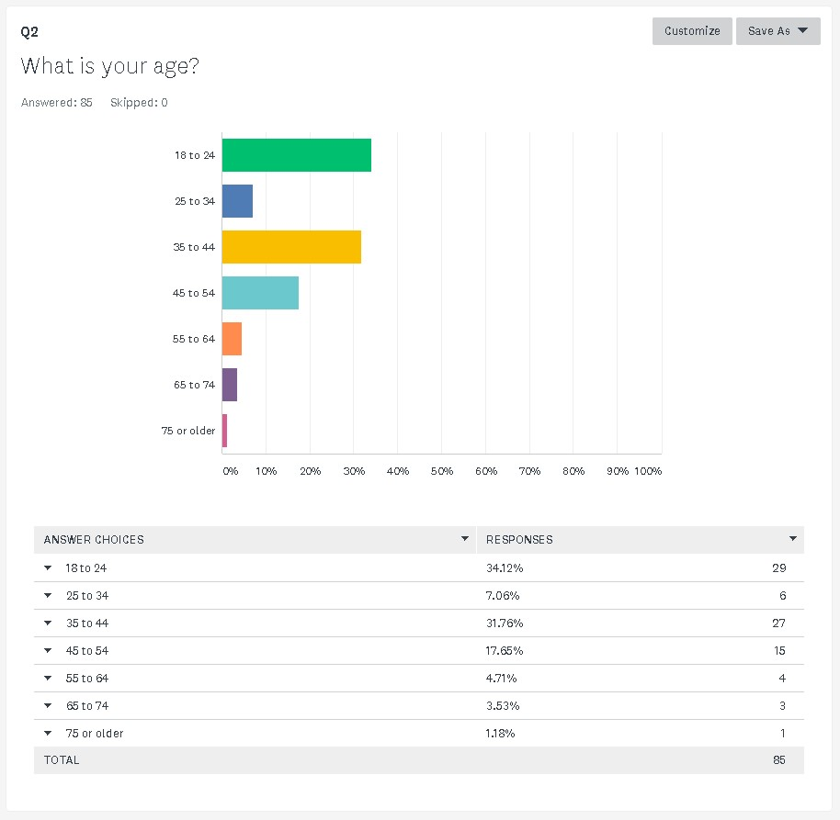

The third question: “What is your gender?”
This question is also asked to have a record of the range of gender across social media and this too will be referred to when asking if gender is a factor in any of the results.
The screenshot below shows the results from the third question; it’s a simple bar chart to show the difference between genders taking the survey and on social media. The results come in as Female participants reaching 62.35% and a total of 53 out of 85 people; whereas, Male participants reaching only 37.65% and a total of 32 out of 85 people.
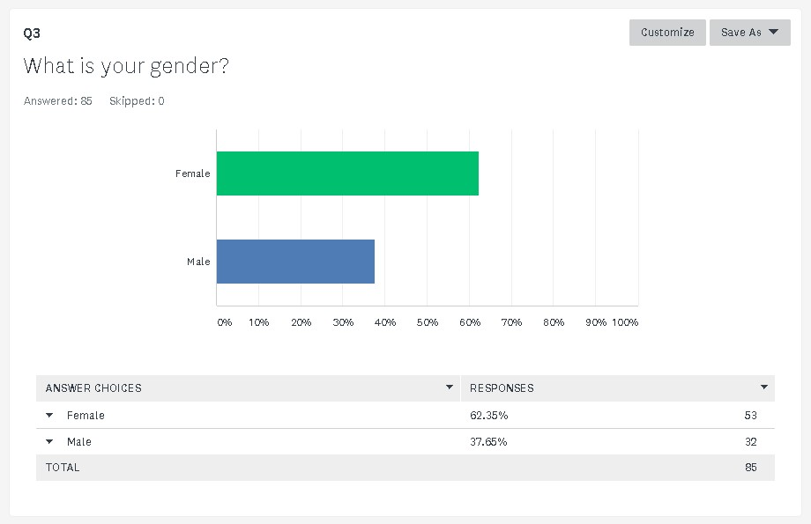

The fourth question: “Which social media platform are you most likely to use?”
This question was asked to see if the research in the literature review was conclusive and to also have something to compare with the experiment results.With these results, there is more concrete evidence for the best practice of which social media platform is more prominent for promotion strategies. This question discovers on average, which social media platform is used more by every day users.
The screenshot below shows the results from the fourth question; this question shows the popularity between different social media platforms which include Facebook, Twitter, YouTube and Instagram. Looking at the results, it is very clear that Facebook is the dominant platform with a majority percentage of 64.71% with a total of 55 out of 85 people choosing it over the other platforms. This makes the projects hypothesis look very plausible and further validates the original research within the literature review; the hypothesis stated that Facebook should be the most used platform andtherefore the most suitable for businesses to use social media promotion strategies on.
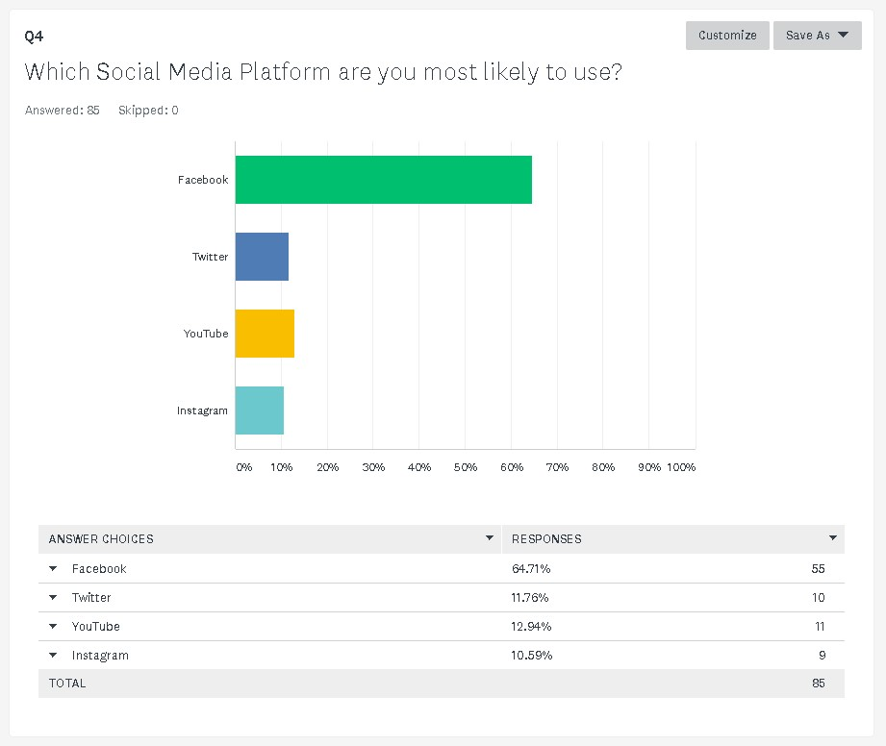

The fifth question: “Which format of media are you more likely to click on?”
This question is asked to see which media format is more likely to be clicked on for a social media post; text, image or video. This is because it can be applied by organisations to use the more likable media type when using promotion strategies to make them more effective. Also, no conclusive research on preferred media formats for social media posts were found during the literature review.
The screenshot below shows the results for the fifth question; this question shows the results of a person’s interpretation of what they think they are more likely to click on. The results convey that ‘Text’ is overall the media format that is most likely to be clicked on in a post with 41.18% and a total of 35 out of 85 people choosing it over ‘Image’ and ‘Video’. The results were close which may suggest that media format may not have too much of an impact on engagements when choosing one for a paid advert. Obviously someone may think differently to what they would actually do which is why these results may be disproven by the experiment.

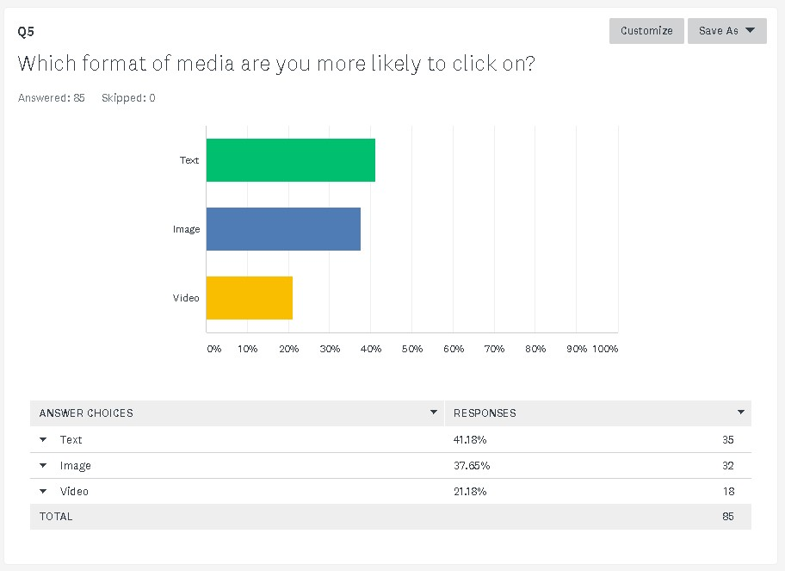

The sixth question: “Do you notice paid advertisements of social media?”
This question is simply to see if paid advertisement is worth the investment from a user’s stand point and to check if they had any significance.
The screenshot below shows the results for the sixth question; this question is to check if social media users consciously notice paid advertisements from organisations. The possibility that people notice brands but don’t realise that they are seeing an advert is real but can’t be measured due to it all being sub-conscious. The results show that the majority of people answered ‘Yes’ to noticing paid advertisement on social media which means that platforms display their ads clearly to their users at an average of 74.12% of the time. This is a vital questions because, according to the research from the literature review, paid advertisement is a best practice for social media promotion strategies.
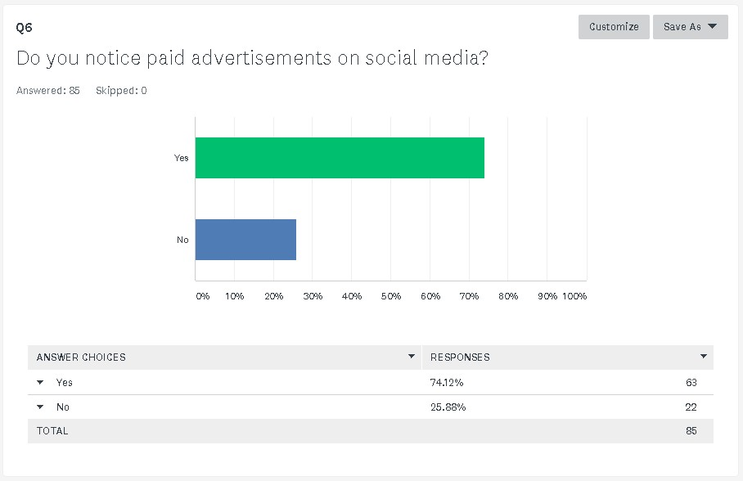

The seventh question: “How often do you further look into a company after seeing their social media advert?”
This question is to see how engaging a paid for social media advert can be for people. It asks to ensure the worth of the investment for these paid adverts from companies as they’re not going to pay for it if it equals to no further exposure of their brand and organisation.
The screenshot below shows the results for the seventh question; the answers for this question are split from 1 (being never) to 5 (being regularly). It appears that the majority of people either said either ‘Not often’ or ‘Sometimes’ which points towards users following through from adverts they’ve seen occasionally but not all the time. The results of ‘Not often’ come in at 47.06%, meanwhile ‘Regularly’ was much lower with 4.71%.
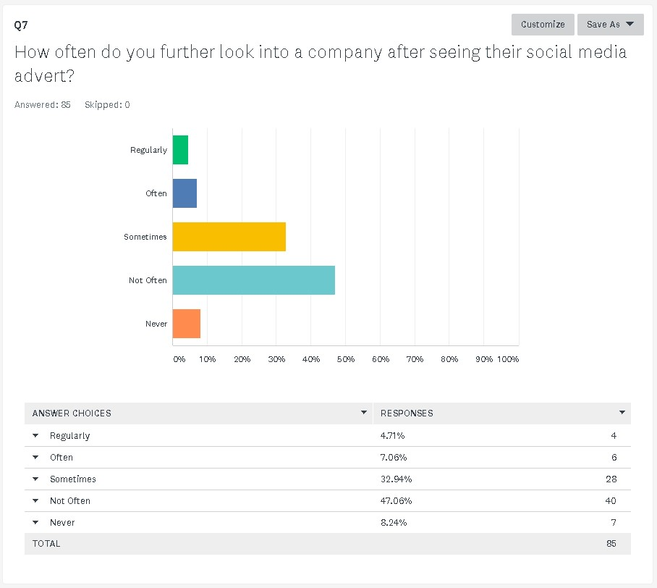

The eighth question: “How likely are you to purchase a product after seeing an advert on social media?”
This question not only looks into the further brand awareness from a paid advert but also if the organisation would possibly make money from the investment.
The screenshot below shows the results for the eighth question; this questions answers are also split into 5 set categories. The results for this question are very similar to the previous question, however there are far more people that will ‘Never’ purchase a product within this context due to it being a level up in interaction with an organisation. The result of ‘Not often’ was top with 40% and ‘Regularly’ only got 1.18%.
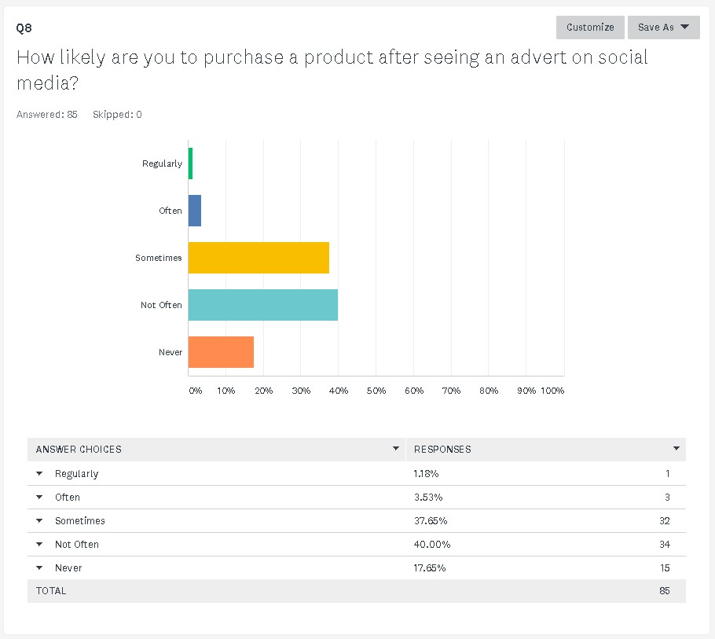
The ninth question: “How often do you feel that advertisements you see are targeted towards you?”
This questions acknowledges the advert algorithms for these social media platforms. Adverts are usually targeted towards people who would like a specific brand or product; this maybe because they have searched for similar things on that device before. This question is to see whether businesses find paid advertisement worth it depending on if the algorithms are good enough; if the algorithm is not up to par then the company is less likely to reach their target audience with their paid advert.
The screenshot below shows the results for the ninth question; this question is another that has its answers split into 5 categories. People found it far more likely that the advertisement they notice on social media is targeted specifically towards them; the results for ‘Regularly’ coming in at the top with 44.71%. With the decline of each answer category, the percentages also decrease in total; the result of ‘Never’ coming in at only 2.35%. These results suggest that the social media algorithms for target audiences work and can be very beneficial when created paid advertisement. This set of results solidifies further benefits of paid advertisement for businesses.
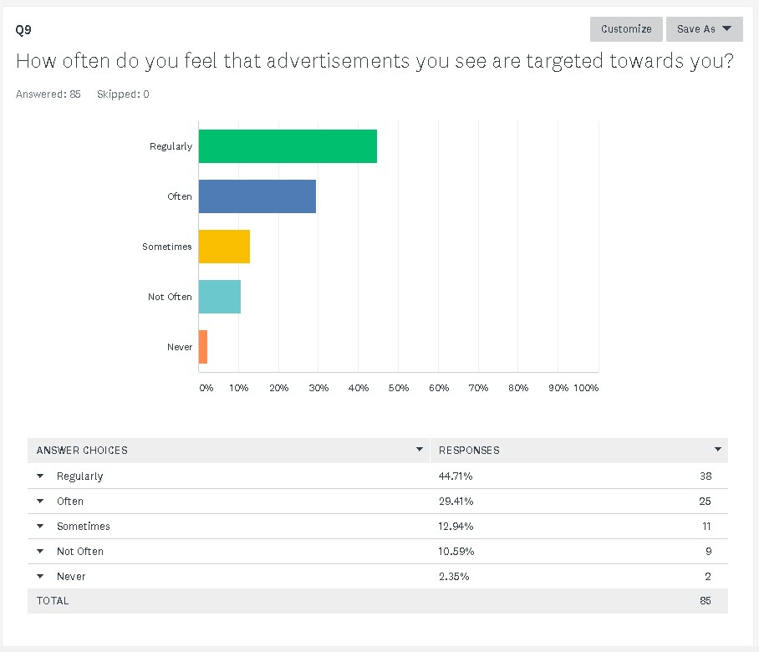

2.4Social Networking Analytics
To collect the results for the experiment, certain social networking analytical tools had to be used. These tools would allow anyone to view the level of engagement each post achieved in a clear format. External analytical tools were considered as well as internal methods from the platforms themselves. These social network analysis tools are used by businesses to optimize their understanding of what works through their social media platforms; the tools can provide crucial information for them to make changes needed to adapt and improve. Tools can not only provide graphs to display the statistics as a whole but have precise measurements for each aspect of a post [47].
All chosen platforms just so happened to have internal, built-in analytical tools which made the chosen easier. It was decided that the built-in tools would be used for all tested platforms as they provided adequate and relevant statistics. All the built-in tools were very easy to find and use; all that had to be done was to find the post that needed to be analysed.

2.5Experiment Overview
The experiment part of this project involved the testing of different social media promotion strategies through posting on case studies pages. The same social media platforms were used in this experiment; YouTube, Facebook, Twitter and Instagram were all found to be best practises within the literature review and were all mentioned in the survey for an accurate and fair comparison afterwards.
To begin with the analysis of the experiment, the unpaid promotion strategy results will be looked at first as per chronological order of the experiment. The first results to be analysed are the posts regarding the ‘Text’ media type on Facebook and Twitter posts; the screenshots below shows the results. It can be seen that a regular text based post got more impressions on Twitter than it did on Facebook.
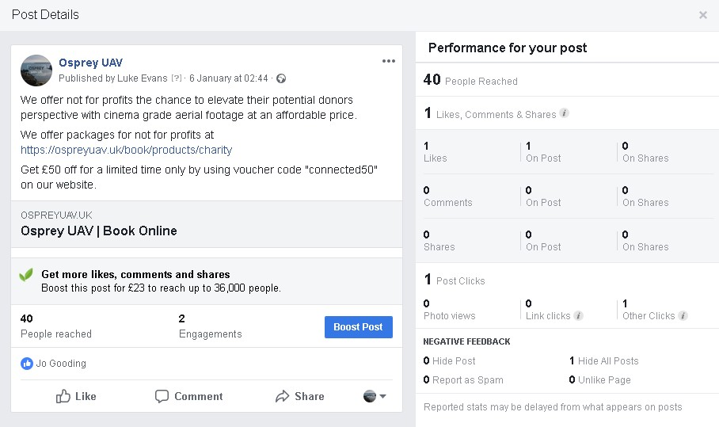
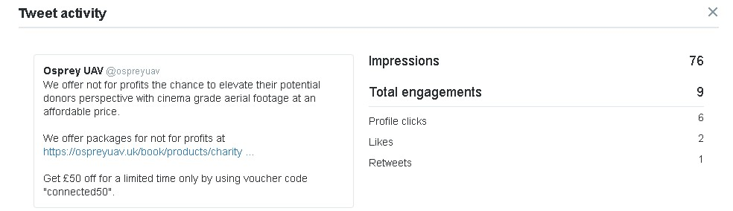
The screenshots below show the results from testing the ‘Image’ media type on Facebook and Twitter posts. It is clear for both platforms that Image based posts receive more impressions that Text based posts. In the case of Facebook, Image posts seem to cause people to engage a lot more with likes, comments and shares.
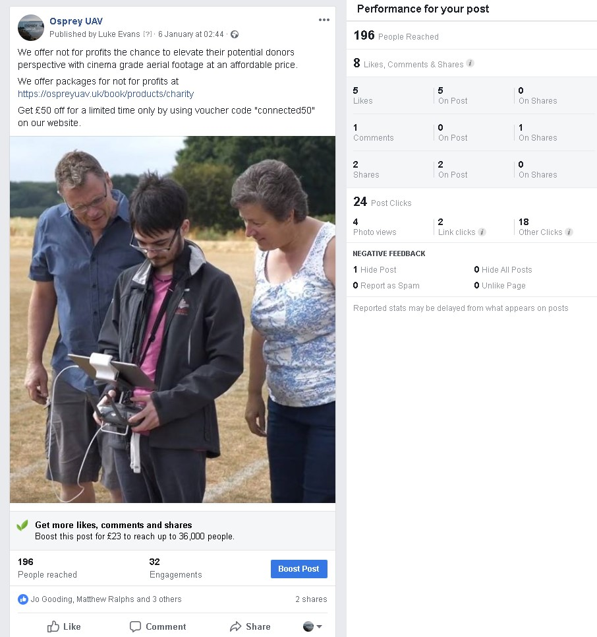
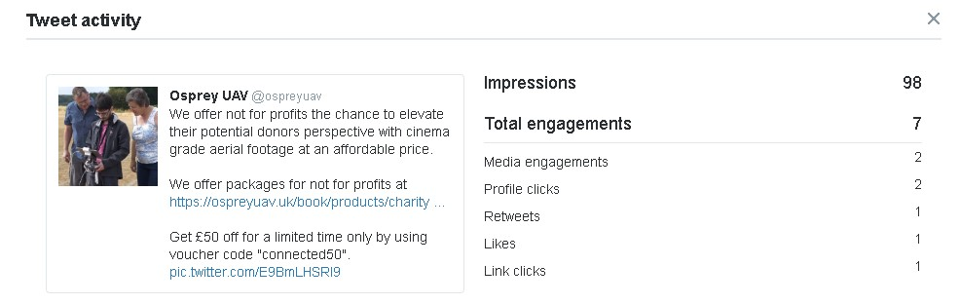
The screenshots below show the results from testing the ‘Video’ media type on Facebook and Twitter posts. Using video on Facebook seemed to drastically improve the number of impressions and engagements a post received. On Twitter it seemed as though the Video post performed similarly to the Image post.
Looking back at the survey results, it seems as though the answers and these results don’t match up. Perhaps it comes back around to the possibility that most people perceive themselves as more intellectual and feel that they would be more intrigued by a text based post; however, maybe subconsciously they are more drawn to Video based posts.
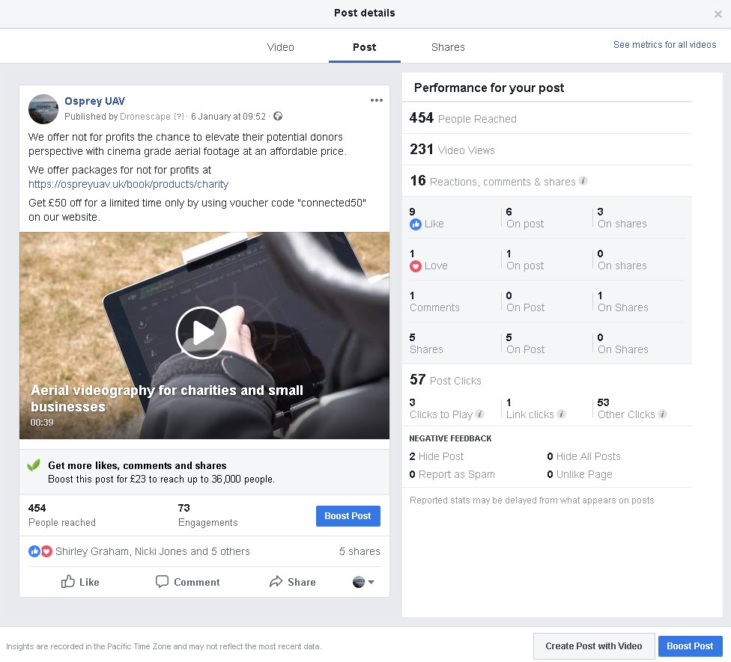
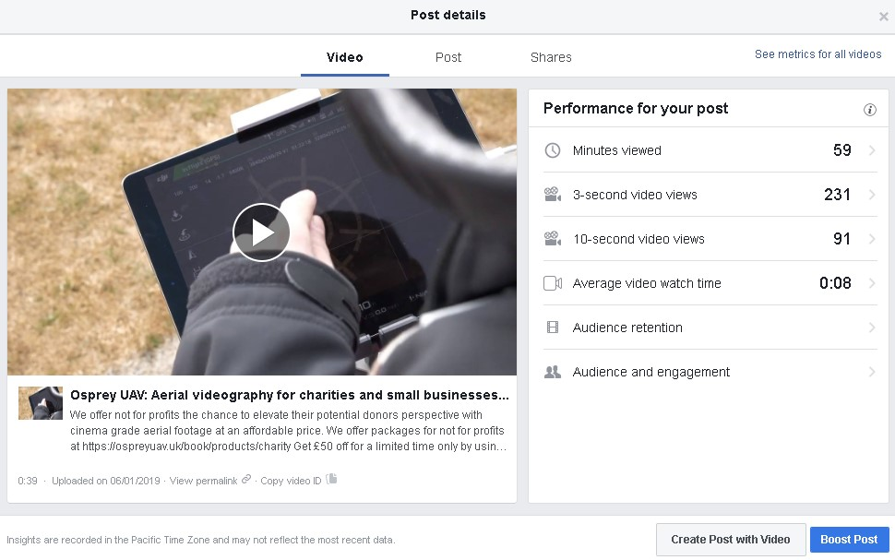
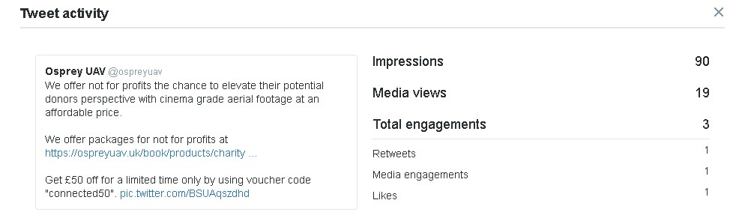
The screenshots below show the results from testing the unpaid promotion strategy of hash tags on Instagram and Twitter posts. This unpaid strategy is an addition to regular posts for users of a platform to find it easier to find things from key words. On Instagram, it appears that hash tags make a big improvement on how many people interact with and discover a post. A Twitter post with Text also substantially improved with its impressions and engagements with the addition of hash tags.
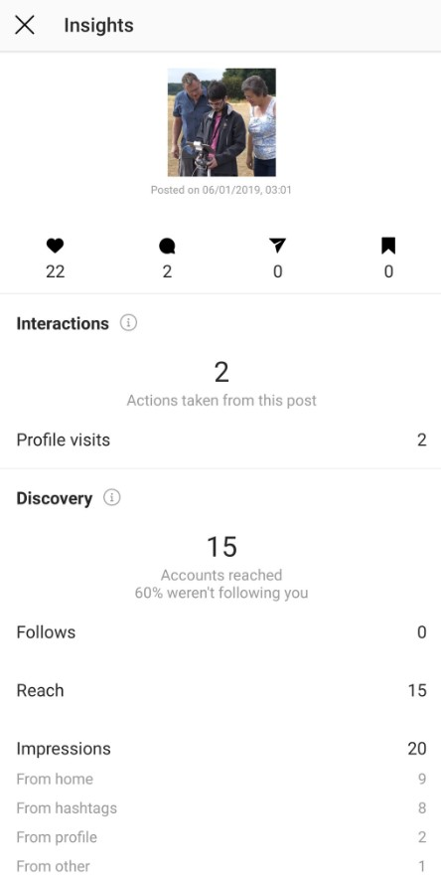
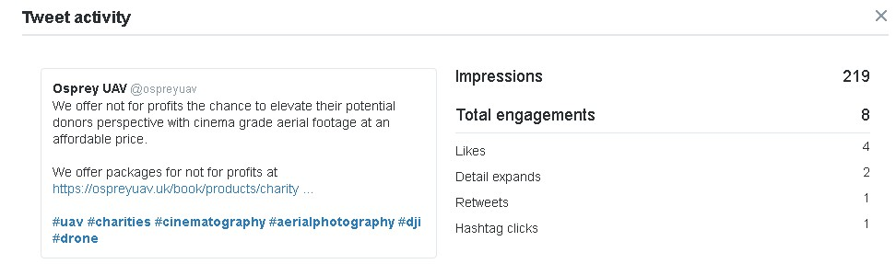
The screenshot below shows the results of an Instagram post that did not include hashtags. It’s clear that this post had far less interactions compared to the post that did include hashtags.
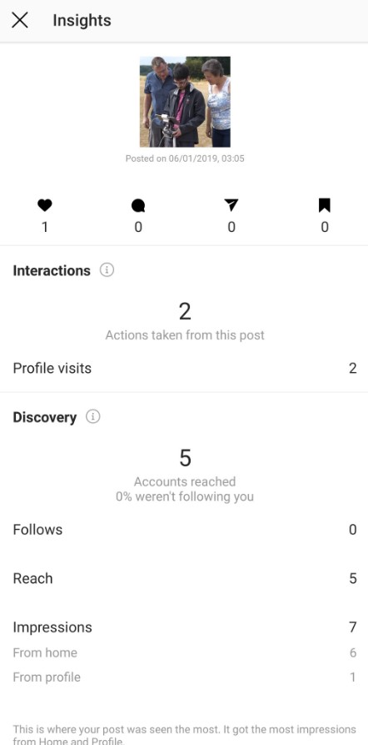
The screenshots below show the results from testing the Meta tags on videos uploaded to YouTube. For a small YouTube channel, the expectations for views were already fairly low. Meta tags managed to get one video 16 views compared to the video without Meta tags which had no views whatsoever. It appears that even on smaller channels, Meta tags can make the difference between a few viewers and no viewers at all.
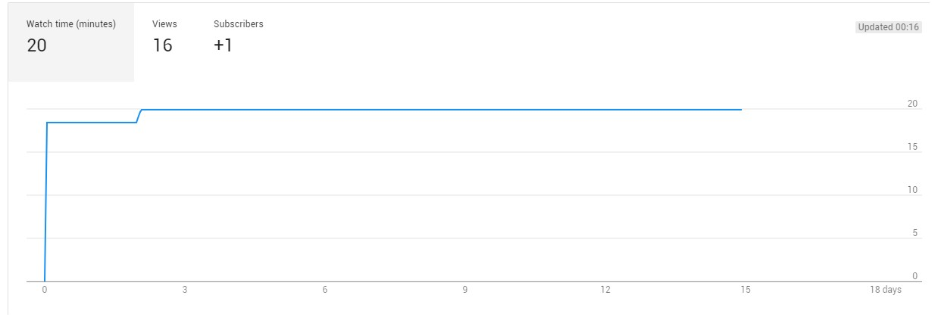

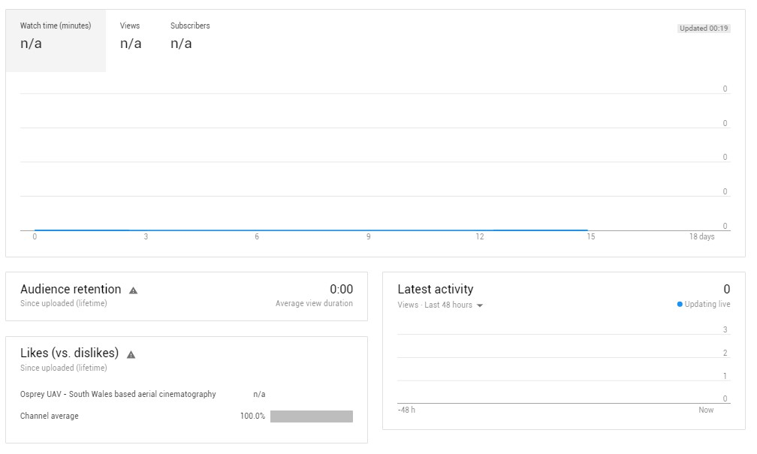
Now the paid promotion strategies will be discussed and analysed, which were available on Facebook, Instagram and Twitter. This was a fitting halfway point in the experiment because now the true distinction between unpaid and paid promotion strategies will come to light.
To start with, Facebook paid advertisement allowed to narrow down target audience of posts and gave back the results accordingly. The screenshot below shows the results of the gender, locations and placements.
Looking at the gender differentiation, it would seem that the post reached a majority of middle aged men. Looking back at the survey, perhaps the majority of men answering chose Facebook as their preferred social media platform.
As for location, the preference was set in the advertisement options that the post would be focussed in the UK where the business is based. The majority of views came from England and the rest from the rest of the countries inside the UK.
The placements were just interesting extra results which showed that by far the most people viewed the advert via a mobile device on their news feed.
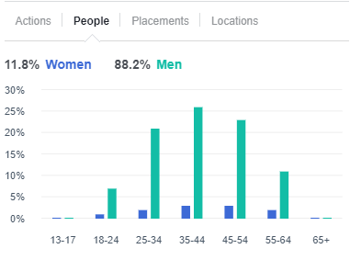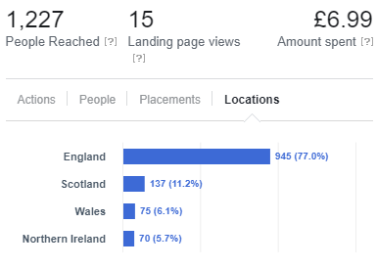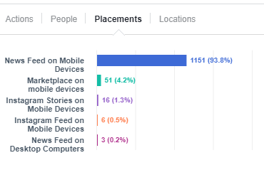
Now for the results of the advert itself, compared to the original video post, it exceeded expectations and reached far more people across the platform. This form of advertisement actually reached the most amounts of users out of all the posts. It seems from the results that the money it costs for businesses to ‘boost’ their social media posts are worth it due to the dramatic difference it makes. The screenshot below will show the details of the post as well as the results that came back.
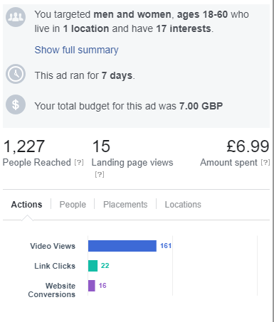
As for the Instagram paid promotion strategy, it links with Facebook due to them both being owned by the same company. This option simply removes a lot of steps for a business as they are able to increase their brands awareness across two large social media platforms with just one payment. The screenshot below shows the option for the paid advertisement to be run on Instagram as well as Facebook.
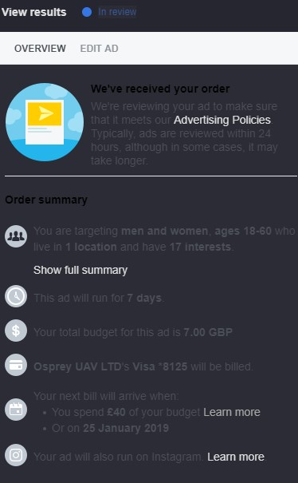
Twitters paid advertisement was also tested to see if it would match up to Facebooks and to see how much of a difference it would have compared to a regular post. The screenshot below shows the results from the Twitter advertisement campaign. The results show that this campaign had far more impressions compared to regular posts and posts with unpaid promotion strategies. The twitter ad campaign actually got more impressions than the Facebook paid ad; Facebook is by far the more popular platform looking at the literature results and the survey so these results are surprising.
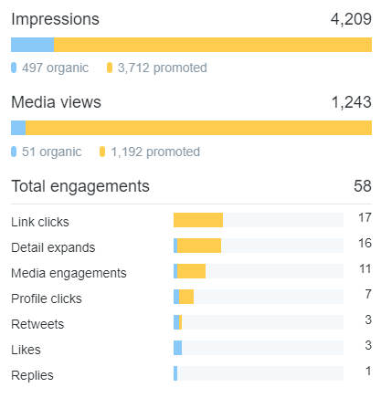
The paid advertisement results prove that this strategy can get users to notice your post more and can also get more of them to interact. Compared to the survey, the results match up quite well to justify saying that most of a business’s target audience will notice a paid advert and even look into the company further by ‘clicking’ links to their website. The Twitter Ad campaign also reached a higher peak of impressions than any other promotion strategy.

2.6 Case Study Evaluation
The owner of the case study business ‘Sam Austin’ of ‘Osprey UAV’ was asked to make a brief evaluation on how he thought the experiment went on his social media pages. He commented on a few things which he felt were key outcomes of the experiment and how he would adapt his social media use for his business moving forward. He viewed all the results for each post, strategy and media type before commenting:
“I was pleasantly surprised by the impact that paid advertisement had on the engagement of my social media posts. Paid Facebook advertisements seemed to be by far the best candidate moving forward.”
He refers to Facebook paid adverts as the best out of the tested strategies and was completely unsure prior to the experiment how impactful the strategies were going to be. He goes on to mention media types:
“I’m happy that the posts that involved my videos got the most engagements as video is an essential part of my business.”
His business works with filming video footage from drones so he was relieved that he can make good use of his high quality footage within future posts. The finishes his evaluation with:
“I’m happy that I took part in this experiment because it opened my eyes to new possibilities with social media promotion strategies”.
He was thankful for the insight on the results and took into account the things he can change to grow his online brand through social media.
The screenshots below shows the movements on the case study businesses website which was linked with all posts. A large spike in users happens when the paid advertisements are in full effect; the main spike happens when the many posts with non paid promotion strategies are made.
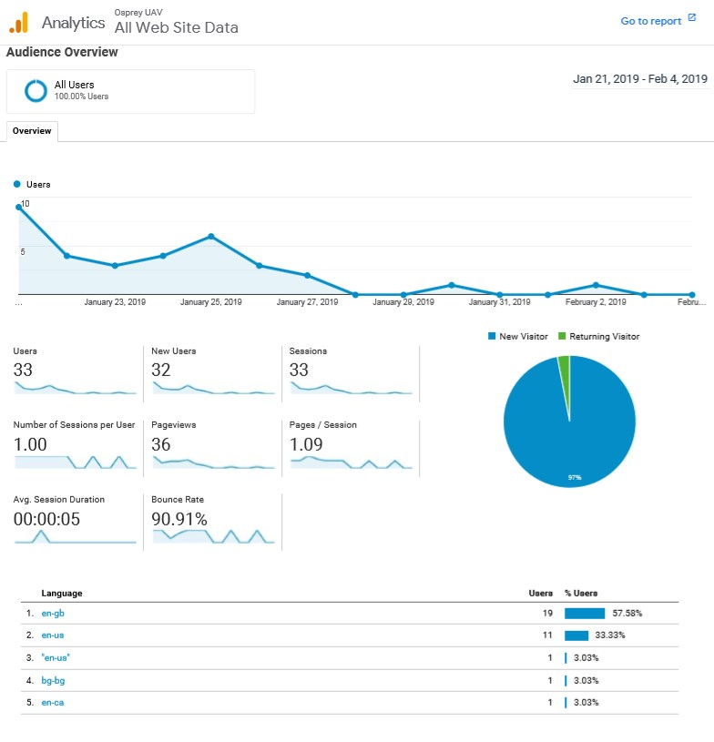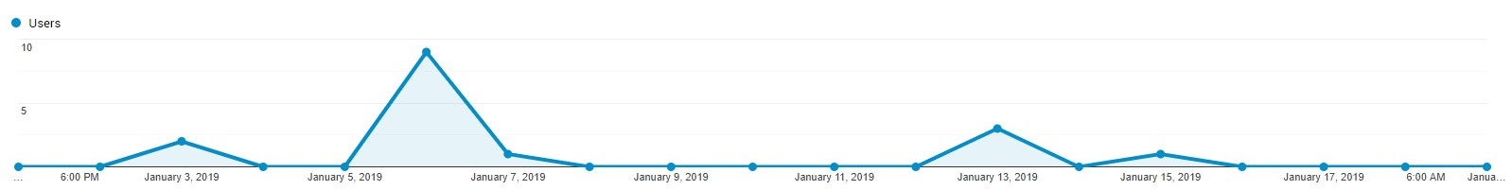

3. Recommendations for businesses
After an in depth analysis and comparison of the results from the experiment and survey, recommendations can be made that can be seen as ‘best practises’.
Paid advertisement is far superior to non paid promotion strategies and businesses will greatly benefit for their use online. Twitter and Facebook paid ads would definitely benefit any business looking to expand their influence and brand awareness through online means. Facebook being the larger platform, this platform may be the perfect starting point before expanding into new platforms like Twitter. Incorporating non paid promotion strategies would likely boost the amount of impressions a post would receive.
As for media types, video seemed to be the best and most attractive in practise however, text was the most popular on the survey. There is either a subconscious decision or it depends on the time and person; a variety of media types is recommended.
Another recommendation would be to adopt the idea of a ‘Social media plan diagram’. A diagram of this type helped with the planning of this particular experiment and would benefit a business on a weekly or monthly basis. It clearly structures the actions of the social media team and when they would take action.

4. Personal Reflection
While reflecting back on this project, it should be considered as a success due to conclusive and cohesive results were collected and analysed. There are a few things that could be done differently if the project were to be repeated. First of all, media types were tested during the experiment to see which one was the most popular with social media users; however, an oversight was that interactive posts such as public polls were not included and would be if the experiment was executed again. Another aspect that would be changed is have the survey results collected and analysed before the planning of the experiment has even started; during the project, the survey and experiment overlapped and what would happen next time is the survey results prior to experiment planning would help justify what is being tested using the extra data. It may also have been beneficial to test with posts using paid strategies and unpaid strategies to see how effective they can be together. The final oversight is that within the survey, people are asked for age and gender which doesn’t exactly amount to any valuable data other than the range of social media users; to add value to those survey results, additional research prior on the age range of specific social media platforms would be required. This would mean that calculations could be made to see how accurate the age range of the survey is compared to the research. These new results could help companies decide which platforms to invest into for advertisement depending on their target audience’s age range.

5. Conclusion
To conclude this document, a general overview of the project shall be made to follow the process and point out key findings. First of all, the main aim and objectives were set so the project had a clear path. It can be said now that the aim was followed throughout and the objectives were all completed.
During the early days of the assignment it was important to research into the core concepts of the topic; for example, social media branching off from generic forms of media like newspapers and TV. Social media was found to be based on wide spread communication but could be used for different means.
Next, different social media platforms were researched to see the many different options that both users and businesses have. Each platform had promotion strategies that could be used by companies to promote their posts, page and brand. Stand out platforms such as Facebook and Twitter were seen as ‘best practises’ as well as the option to use their version of paid promotion strategies.
Moving onto the research methodology, it was important that the correct methodologies were chosen for the research. The decisions made at this point would set the pace for the research and lay out how the data will be collected. The correct decisions were made and the results turned out to be relevant in answering questions on the topic, such as what the best practises are.
Planning for the experiment involved taking ideas from previous diagrams in the literature review coined “Social media Plan diagram”. A new diagram was created with those diagram in mind as inspiration; this new diagram clearly showed the direction of the experiment and what will be posted on each set date.
The survey questions were tested as a questionnaire before each one being finalised for the survey. The survey successfully identified which platform was most likely to be used as well as user awareness and interest of paid promotion strategies. These results justified paid promotion strategies as part of best practises once compared with the results of the experiment.
Finally, the experiment was successfully executed on multiple platforms as planned and the diagram was closely followed. A large number of results meant that multiple conclusions could be made thanks to the variety of posts. The best platform for purely numbers on average was Facebook; however, the peak number of impressions was on Twitter after the Ad campaign. All platforms tested are viable for businesses to use, but the best practises are paid advertisement for Facebook and Twitter. These best practises also fall into place well when referring back to the hypothesis; this was a prediction that paid advertisement on Facebook would end up being a go to best practise and it the hypothesis was correct.

Bibliography

[1] | M. Rouse, “Social Media,” What Is, [Online]. Available: https://whatis.techtarget.com/definition/social-media. [Accessed 27 October 2018].
[2] | D. Miller, E. Costa, N. Haynes, T. McDonald, R. Nicolescu, J. Sinanan, J. Spyer, S. Venkatraman and X. Wang, “Education and young people,” in How The World Changed Social Media, UCL Press, 2016, p. 3.
[3] | P. M. Leonardi, M. Huysman and C. Steinfield, “Enterprise Social Media: Definition, History, and Prospects for the Study of Social Technologies in Organizations,” Journal of Computer-Mediated Communication, vol. 19, no. 1, p. 19, 2013.
[4] | D. Barefoot and J. Szabo, Friends with Benefits: A Social Media Marketing Handbook, No Starch Press, 2010.
[5] | “Number of Social network users worldwide from 2010 to 2021,” statista, [Online]. Available: https://www.statista.com/statistics/278414/number-of-worldwide-social-network-users/. [Accessed 25 October 2018].
[6] | J. Van Dijck, The Culture of Connectivity: A Critical History of Social Media, OUP USA , 2013.
[7] | D. Hendricks, “Complete History of social media: Then and Now,” Small Business Trends, 8 May 2013. [Online]. Available: https://smallbiztrends.com/2013/05/the-complete-history-of-social-media-infographic.html. [Accessed 27 October 2018].
[8] | D. Miller, E. Costa, N. Haynes, T. McDonald, R. Nicolescu, J. Sinanan, J. Spyer, S. Venkatraman and X. Wang, “What is Social Media?,” in How The World Changed Social Media, UCL Press, 2016, pp. 1-2.
[9] | M. J. Culnan, P. J. McHugh and J. I. Zubillaga, “The need for a new approach to implementing social media,” How Large U.S. Companies Can Use Twitter And Other Social Media To Gain Business Value, vol. 9, no. 4, pp. 243-244, 2010.
[10] | W. G. Mangold and D. J. Faulds, “Social media: The new hybrid element of the promotion mix,” Business Horizons, vol. 52, no. 4, pp. 357-365, 2009.
[11] | D. Zarrella, The Social Media Marketing Book, O'Reilly Media, Inc, 2009.
[12] | K. A. Quesenberry, Social Media Strategy: Marketing and Advertising in the Consumer Revolution, Rowman & Littlefield, 2015.
[13] | “Google Trends | Compare,” Google, [Online]. Available: https://trends.google.com/trends/explore?q=%2Fm%2F02y1vz,%2Fm%2F0289n8t,%2Fm%2F0b2334,%2Fm%2F09jcvs,%2Fm%2F0glpjll. [Accessed 14 November 2018].
[14] | H. S. Noor Al-Deen and J. A. Hendricks, Social Media: Usage and Impact, Lexington Books, 2012.
[15] | A. Barysevich, “How to Target Specialized Audiences With Facebook Ads,” Social Media Examiner, 20 November 2017. [Online]. Available: https://www.socialmediaexaminer.com/target-specialized-audiences-facebook-ads/. [Accessed 12 November 2018].
[16] | P. Dunay, R. Krueger and J. Elad, Facebook Advertising For Dummies, John Wiley & Sons, 2010.
[17] | “KFC South Africa,” Facebook business, [Online]. Available: https://www.facebook.com/business/success/kfc-south-africa. [Accessed 29 January 2019].
[18] | P. Gil, “What Is Twitter & How Does It Work?,” Lifewire, [Online]. Available: https://www.lifewire.com/what-exactly-is-twitter-2483331. [Accessed 22 November 2019].
[19] | “Twitter Promote Mode Help,” Twitter, [Online]. Available: https://business.twitter.com/en/help/twitter-promote-mode-help.html. [Accessed 16 November 2018].
[20] | “How can we help?,” Twitter, [Online]. Available: https://business.twitter.com/en/help/campaign-setup.html. [Accessed 16 November 2018].
[21] | “TripCase,” Twitter business, [Online]. Available: https://business.twitter.com/en/success-stories/tripcase.html. [Accessed 16 November 2018].
[22] | E. Moreau, “Is Myspace Dead?,” Lifewire, 26 November 2018. [Online]. Available: https://www.lifewire.com/is-myspace-dead-3486012. [Accessed 22 November 2019].
[23] | E. Lee, “How to use Reddit in Your Content Marketing Strategy,” Reddit, 13 June 2018. [Online]. Available: https://www.dreamgrow.com/reddit-strategy-tips/. [Accessed 20 November 2018].
[24] | B. Stephenson, “Twitch: Everything You Need to Know,” Lifewire, [Online]. Available: https://www.lifewire.com/what-is-twitch-4143337. [Accessed 23 November 2019].
[25] | G. Jarboe, YouTube and Video Marketing: An hour a day, John Wiley & Sons, 2011.
[26] | E. Moreau, “What is Instagram, Anyway?,” Lifewire, [Online]. Available: https://www.lifewire.com/what-is-instagram-3486316. [Accessed 23 November 2019].
[27] | A. Johnston, “How to Create an Instagram Marketing Strategy,” Sprout Social, [Online]. Available: https://sproutsocial.com/insights/instagram-marketing-strategy-guide/. [Accessed 20 November 2018].
[28] | “Kao,” Instagram business, [Online]. Available: https://business.instagram.com/success/kao-merit-pyuan. [Accessed 23 November 2018].
[29] | M. Tillman and E. Betters, “What is Snapchat, how does it work and what is it used for?,” Pocket-lint, 27 September 2018. [Online]. Available: https://www.pocket-lint.com/apps/news/snapchat/131313-what-is-snapchat-how-does-it-work-and-what-is-it-used-for. [Accessed 20 November 2018].
[30] | S. Mannix, “6 Snapchat Advertising Options,” Mannix Marketing , [Online]. Available: https://www.mannixmarketing.com/blog/6-snapchat-advertising-options/. [Accessed 20 November 2018].
[31] | J. Alba, I'm on LinkedIn--Now What??? (Fourth Edition): A Guide to Getting the Most Out of LinkedIn, Happy About, 2014.
[32] | D. Nations, “What Is LinkedIn and Why Should You Be On It?,” Life wire, 5 September 2018. [Online]. Available: https://www.lifewire.com/what-is-linkedin-3486382. [Accessed 22 November 2018].
[33] | “Marketing Your Events with Social Media | Leadtail,” SlideShare, 12 October 2011. [Online]. Available: https://www.slideshare.net/Leadtail/marketing-your-events-with-social-media-leadtail. [Accessed 24 November 2018].
[34] | R. Pinkham, “How to Create a Holiday Social Media Calendar,” Constant Contact, [Online]. Available: https://blogs.constantcontact.com/social-media-calendar/#. [Accessed 24 November 2018].
[35] | A. Dogtiev, “App Download and Usage Statistics (2018),” Business of Apps, 2018. [Online]. Available: http://www.businessofapps.com/data/app-statistics/. [Accessed 29 December 2018].
[36] | G. Taylor, Advertising in a Digital Age: Best Practices for Adwords and Social Media Advertising, Global &amp, 2013.
[37] | W. Jolly, “The 6 Most Effective Types of Social Media Advertising in 2019,” Big Commerce, [Online]. Available: https://www.bigcommerce.co.uk/blog/social-media-advertising/#6-snapchat-advertising. [Accessed 6 January 2019].
[38] | M. Saunders, P. Lewis and A. Thornhill, “Understanding research philosophies and approaches,” Research Gate, January 2009. [Online]. Available: https://www.researchgate.net/publication/309102603_Understanding_research_philosophies_and_approaches. [Accessed 9 February 2019].
[39] | “Positivism Research Philosophy,” Research Methodology, [Online]. Available: https://research-methodology.net/research-philosophy/positivism/. [Accessed 9 February 2019].
[40] | “Phenomenology,” Research Methodology , [Online]. Available: https://research-methodology.net/research-philosophy/phenomenology/. [Accessed 9 February 2019].
[41] | “Research Approach,” Research Methodology, [Online]. Available: https://research-methodology.net/research-methodology/research-approach/. [Accessed 10 February 2019].
[42] | “Deductive Approach (Deductive reasoning),” Research Methodology, [Online]. Available: https://research-methodology.net/research-methodology/research-approach/deductive-approach-2/. [Accessed 10 February 2019].
[43] | “Inductive Approach (Inductive Reasoning),” Research Methodology , [Online]. Available: https://research-methodology.net/research-methodology/research-approach/inductive-approach-2/. [Accessed 10 February 2019].
[44] | S. Datt, “Defining research strategy in a research paper on business studies,” Project Guru, 14 September 2016. [Online]. Available: https://www.projectguru.in/publications/research-strategy-business-studies/. [Accessed 10 February 2019].
[45] | “Survey Monkey,” Survey Monkey, [Online]. Available: https://www.surveymonkey.co.uk/welcome/sem/?iv_=__iv_p_1_a_1402109516_g_58134154234_c_285331312022_k_monkey%20surveys_m_e_w_kwd-307992993815_n_g_d_c_v__l__t__r_1t1_x__y__f__o__z__i__j__s__e__h_9045394_ii__vi__&cmpid=&cvosrc=&keyword=monkey%20surveys&match. [Accessed 1 January 2019].
[46] | Osprey uav, [Online]. Available: https://ospreyuav.uk/landing. [Accessed 12 October 2018].
[47] | Bansal, Himani, Shrivastava, Gulshan, Nguyen, G. Nhu and Loredana-Mihaela, Social Network Analytics for Contemporary Business Organizations, IGI Global, 2018.

