Short Film Production

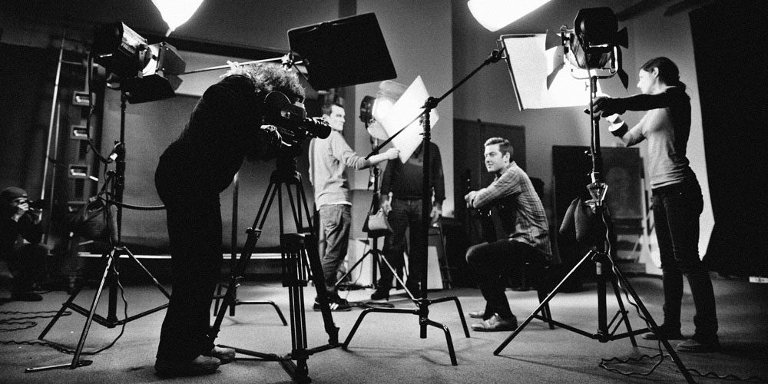

2021-22 ADPA5015

Level 5 module – 20 credits

Module Tutors:
- Lynne Seymour- lynne.seymour@uwtsd.ac.uk
- Keiron Self
- Lloyd Grayshon
- Dan Bailey- d.bailey@uwtsd.ac.uk
- Brett Aggersberg- b.aggersberg@uwtsd.ac.uk

Please make an appointment with your tutor for a tutorial if you have additional questions not covered in the sessions. If you need to consult the course team urgently, please email the staff member concerned.

Audio Visual equipment should be booked out at least 48hrs in advance using the online booking form: https://forms.office.com/Pages/ResponsePage.aspx?id=-REPTm4EBUWcuNshUjEeIZ0yOXUoB8JPgFxUtDden8lURUNENTZYNkZZRTEwWTdXTzZHNEUzUkU5VS4u

Module Aims and Learning Outcomes For Assessment

AIM(S)

- To introduce students to performance and production approaches particular to the screen.
- To develop students’ critical and analytical knowledge of the nature, function and practice of television and short film performance.

LEARNING OUTCOMES
Upon the successful completion of this module, the student should be able to:

- utilise knowledge and understanding of established theory and practice in the creation of on screen drama;
- critically analyse various strategies and approaches to performance or filmmaking.
- apply their knowledge and understanding in the realisation of a practical project.

CONTENT
- Students will be introduced to the dramatic language and practical conventions of screen acting and production through a series of contextual lectures and seminars. These will examine the institutional and technical codes and practices of recorded media as they relate to dramatic performance.

- Acting students will focus on the role of the `actor’ which will be examined alongside those of the other practitioners involved in these mediums. The specific demands that recorded media place upon the performer will be analysed with reference to performance skills and characterisation along with vocal and physical expression. Actor autonomy, non-sequential performance and performance-scale will be among a number of areas studied. This will include elements such as ideas generation and scripting to location scouting, organisation, props, costume, etc.

- Filmmaking students will focus on managing a short film production. This will include elements such as ideas generation and scripting to location scouting, organisation, props, costume, etc. Work will also include ensuring cinematography and editing techniques are developed appropriate to the film.

- All students will collaborate in groups to develop and execute an original or adapted script which will then be filmed and edited by Filmmaking students, featuring the performance and insight of the Acting students.

Transferable Skills:
Note-taking, oral expression, research skills, communication, evaluative and analytical skills, and media production.

Module evaluation:
At the end of this module, you will be asked to complete a module evaluation form.
Please refer to the anticipated learning outcomes when making your evaluation.

Study Time Allocation

The study time for the module is divided as follows:

Activity type | Hours | Percentage
Scheduled learning | 80 | 40%
Independent learning | 120 | 60%
Placement learning
TOTAL | 200 | 100%

ASSESSMENT

Assessment Component 1
(Tick one)
☐ | Written exam | ☐ | Coursework | ☒ | Practical

Mode of assessment | Volume | Weighting
Practical Project and Process Workbook | 5-10 min Practical Project and Process Workbook equivalent to 1500 words | 100%

Assessment Summary
Activity type | Percentage
Written exam
Coursework
Practical | X
TOTAL | 100%

ASSESSMENT

You will be continually assessed on your engagement and contribution to the group tasks and contribution to the development of the film including preproduction, as well as on the filming day for the actors, and the final edit for the filmmakers. Your ability to outline and reflect on the creative and professional filmmaking methods in your process workbook will also be assessed.

Reading List:

Module Code | ADPA5015
Module Title | Short Film Production
Classification | Reading List entry | Electronic*
Further | Batty, C. and Waldeback, Z. (2008) Writing for the Screen. Basingstoke: Palgrave
Further | Bauer, I. and Bauer, V. (2016) Screenwriting Fundamentals: The Art and Craft of Visual Writing. Oxon: Routledge.
Further | Barr, T. (1997) Acting for the Camera. New York: Harper Collins. | ☐
Further | Bernard, I. (1998) Film and Television: Acting from Stage to Screen. New York: Focal Press. | ☐
Further | Bennett, C. (2009) Acting on Television: A Craft Book for Screen Actors. London: Filament. | ☐
Further | Caine, M. (2000) Acting in Film. New York: Applause. | ☐
Further | Churcher, M. (2003) Acting for Film: Truth 24 Times a Second. London: Virgin. | ☐
Further | Dawkins, S. and Wynd, I. (2010) Video Production: Putting Theory into Practice. Basingstoke: Palgrave Macmillan.
Further | Field, S. (2007) The Screenwriter’s Workbook: Exercises and Step-by-step Instructions for Creating a Successful Screenplay. New York: Delta.
Further | Grove, E. (2008) Raindance Writers’ Lab: Write and Sell the Hot Screenplay (2nd ed.). Oxon: Focal Press.
Further | Kallas, C. (2010) Creative Screenwriting: Understanding Emotional Structure. Basingstoke: Palgrave.
Further | Life, R. (2019) Becoming an Actor’s Director: Directing Actors for Film and Television. Oxon: Routledge.
Further | Longmate, N. (1998) Writing for the BBC. London: BBC Books. | ☐
Further | Owens, J. (2017) Video Production Handbook. Oxon: Focal Press.
Further | Shepard, J.W. (2003) Acting for the Cameras: Proven Techniques for Auditioning and Performing in Film, Episodic TV, Sitcoms, Soap Operas, Commercials and Industrials. Hanover, N.H.: Smith & Kraus. | ☐
Further | Shepard, J.W. (2004) Auditioning and Acting for the Camera. New Hampshire: Smith and Kraus. | ☐
Further | Thurlow, C. & Thurlow, M. (2013) Making Short Films: The Complete Guide from Script to Screen (3rd ed.). London: Bloomsbury.
Further | Tucker, P. )2003) Secrets of Screen Acting. London: Routledge. | ☐
Further | Wooster, R & Conway P. (2020) Screen Acting Skills: A Practical Handbook for Students and Tutors. York: Methuen.
Further | Britten, B. (2014) From Stage to Screen: A Theatre Actor's Guide To Working On Camera. York: Methuen.

Students will be directed to appropriate online resources over the course of the module. The bibliography is subject to change depending on available software and associated texts.

Wk  beginning | Mon | Tues | Wed | Thu | Fri
Wk1  3rd January | BANK HOLIDAY | Module Launch –  9:00– 10:00  HG05 LS and BA  10:00 – 5:00 - HG05  Lloyd - Film analysis  Session Outline: Discussing types of shots and evaluating filming techniques. Showing film extracts and breaking down the way things are filmed for different purposes/atmosphere/  themes. | Keiron -  10:00-1:00 HG05  2:00-6:00 Parry 3  Session Outline:  Short Form intro – overview of telling story quickly, show examples and evaluate short form. Put into groups and start to discuss ideas for their group film. Task: each group to prep 2 ideas for a film and present to the full cohort on Mon 17th |  | Graduate Attribute Module Independent group work:  2:00-6:00 - Arrange your own work space  Work in your groups on some ideas and outlines.  You will meet with Lynne on Monday 10th to chat some outlines and ideas through before you meet with Keiron again on the 15th
Wk2  10th January  TV needed in Y Llwyfan (Tuesday - Lloyd) | 10-:00-6:00 TL12  Independent Group work Presentation  Lynne:  Session Outline  Working with the individual groups to discuss ideas etc  What challenges do you have? How can you communicate/collaborate better?  How can you focus ideas?  What is achievable? | 10:00-6:00 Y Llwyfan  Lloyd –  Session Outline: Auditions for film.  Holding mock auditions for the actors and film makers – to then view and review their success or failure and how to give notes and work with actors.  Setting tasks for Independent work Wed and Thu  **** | 10:00-1:00 HG05  Brett and Dan -  Session Outline: Pre-production information. Health and safety and risk assessment. Release forms and working safely | 10:00 – 6:00  Parry 3  Keiron-  Session Outline: Script - working with groups to further their ideas and help with creating a workable and appropriate short film treatment ready for presentation on Monday 17th | Graduate Attribute Module
Wk 3  17th January | 10:00 – 6:00 HG05  Keiron and Brett  Session Outline:  Script – Full cohort.  Groups present their treatment outlines to full cohort. From that session the decision is made on which film to flesh out and create. | Independent prep | 10:00 – 1:00  2:00-6:00  ONLINE  Keiron  Session Outline: Script – Rotating groups working on script writing and storyboarding.  Goals are set for each group to work towards for next session. | Independent prep | Graduate Attribute Module
Wk 4  24th January | 10:00 – 1:00 Parry 3  Keiron  Session Outline:  Script - Rotating Groups.  Goal setting for filming short sections or scenes as test footage/previz to feed back to Keiron with the footage and script work.  2:00 – 6:00 Parry 3  Keiron and Dan: Group Work Plan of action for shooting previz and also on within current safety guidelines. | Independent prep | Independent prep | 10:00 – 6:00 TL12  Keiron and Brett  Session Outline: Script and previz work and development. | Graduate Attribute Module
Wk 5  31st Jan | 10:00 – 6:00 HG05  Keiron  Session Outline: Script  Group work focusing on pitch and script preparation for presentation to Lloyd on Thursday. This session consolidates all recorded footage and script in order to be ready presentations to Lloyd on Wednesday 2nd  TV needed | Independent prep | 10:00 – 6:00  HG05  Keiron and Lloyd  Session Outline: Presentations – The teams presents their film ideas to the whole group with finished scripts, storyboards and recorded footage. | Independent prep | Graduate Attribute Module
Wk 6  7th Feb | On location  Filming Short Film 1 (prep rushes for viewing) | On location  Filming Short Film 1 (prep rushes for viewing) | On location  Filming Short Film 2 (prep rushes for viewing) | On location  Filming Short Film 2 (prep rushes for viewing) | On location  Filming Short Film 3 (prep rushes for viewing)
Wk 7  14th Feb | On location  Filming Short Film 3 (prep rushes for viewing) | On location  Filming Short Film 4 (prep rushes for viewing) | On location  Filming Short Film 4 (prep rushes for viewing) | 10:00-6:00 TL12  Lynne, Keiron, Brett  Session Content: Rushes viewing working with each group individually. | DEADLINE FOR ACTING STUDENTS HAND IN  Process Workbook Hand in and Module Questionnaires 4 hrs after THEIR Rushes meeting ends
Wk 8  21st February  READING WEEK  FOR ACTORS | 1:00-4:00pm TL12  Brett  Film Students -  Assembly Edit
Wk9  28th February |  |  |  | 10:00-6:00 TL12  Keiron: Editing with Filmmaking students  Split into short Film groups
Wk10  7th March |  |  |  | 10:00-6:00 TL12  Keiron and Lloyd: Editing with Filmmaking students  Split into short Film groups
Wk 11
15^{4h} March
Wk12  21st March | DEADLINE FOR FILM HAND IN  4:00pm  Process Workbook and Film Hand in and Module Questionnaires
Wk 13  28th March |  |  | 2:30 pm  SCREENING PREMIERE!!!  Room TBC

This schedule is subject to change and students are advised to check Moodle for the latest module information.

The following software will be used on this module:
Adobe Premiere. Other software may be recommended when appropriate.

FEEDBACK

Feedback is an essential part of all education and training programmes. It helps learners to maximise their potential at different stages of training, raise their awareness of strengths and areas for improvement, and identify actions to be taken to improve performance.

Feedback can be seen as informal (for example in day-to-day encounters between teachers and students or trainees, between peers or between colleagues) or formal (for example as part of written or clinical assessment). However, there is no sharp dividing line between assessment and teaching in the area of giving feedback on learning. Feedback is part of the overall dialogue or interaction between teacher and learner, not a one-way communication.

During your studies you will therefore receive feedback in many ways, including the following:

- Dialogue between teachers and students in formal classes.
- Direct questions and responses from teachers inside and outside formal classes.
- Email correspondence between teachers and students.
- Interactions between students and teachers using the module message board on Moodle.
- Informal comments and responses to pitches and presentations in classes.
- Comments and annotations added to written submissions, such as essays and reflective journals.
- Formal written feedback in response to assignments recorded on the summative assessment module feedback forms.

You will have an opportunity to discuss your feedback with your tutor.
Feedback will be returned on assessed work within 20 working days of submission.

