
Skills for the Workplace
Module Assignment Submission
Student Name: | Emma Leanne Nightingale
Student Number: | 2008693
Module No: | BMSK4008
Module Title: | Academic and Research Skills

Statement of Confirmation of Authenticity
By the act of making this submission, the student declares that this is the work of the student named above. The work has not, in whole or in part, been knowingly presented elsewhere for assessment, or where assessment has been built on a previous assessment, this has been identified. Where materials have been used from other sources it has been properly acknowledged. If this statement is untrue, the student acknowledges that an assessment offence has been committed.
Attention is drawn to the plagiarism and unfair practice policies of both the University and of ILM.
Permission for ILM to use this script
ILM uses learners’ submissions – on an anonymous basis – for assessment standardisation. By submitting, both the centre and the learner agree that ILM may use this script on condition that identifying information is removed. However, if you are unwilling to allow ILM use this script, please refuse by ticking the box: □

Table of Contents

Managing Remotely: Is it the Way Forward? 3

Part 1 3

1.1 Introduction 3

1.2 Research and finding 3

1.3 Conclusion 6

Part 2 7

Personal Reflection on Managing Remotely 7

2.1 Description 7

2.2 Feelings 8

2.3 Evaluation 8

2.4 Analysis 9

2.5 Conclusion 9

References 9

Appendix 1 11

Appendix 2 11

Appendix 3 12

Appendix 4 12

Appendix 5 13

Appendix 6 13

Appendix 7 14

Appendix 8 14

Appendix 9 14

Appendix 10 15

Appendix 11 15

Managing Remotely: Is it the Way Forward?

Part 1

1.1 Introduction

Remote working is a working style in which employees can work outside of the office environment. This has become more essential due to the Coronavirus pandemic thus forcing many organisations to adapt to this style of working. This can be on a full time or part time basis. This report will explore the advantages and disadvantages of remote working and managing remotely. It will look into the effects on both employers and employees.

1.2 Research and finding

BBC News (2020) discussed a number of studies undertaken regarding the future impact of remote working. 74% of companies who took part in one survey of 1000 firms by the Institute of Directors intended to continue with remote working after the pandemic and more than 50% of respondents would also like to reduce office space by continuing in this manner (Appendix 1).

A report by Felstead and Reuschke (2020) examines the impact of Covid19 and remote working on employers and employees alike. The Report is based on a survey undertaken during April, May and June 2020. It indicates that the number of employees working remotely had tripled between 1981 and 2019 (Appendix 2). A greater number of employees who worked from home would prefer to work from home in the future (Appendix 3). It shows there was a rise in remote working during April 2020 to 43.1%.

This had a greater impact on more highly skilled employees and was particularly located in areas such as London and the South East (Appendix 4). It also suggests that working from home had a negative impact on mental health during early months, but this improved as employees began to adjust (Appendix 5). Productivity seems to have either improved or stayed the same for many. 30.2% indicated that their productivity had dropped during this time. The findings suggested that full time remote workers seemed to have completed more work than part time workers (Appendix 6).

Mind (2021) highlights the importance of looking after yourself and your team's mental health during periods of remote working due to the effects of the Coronavirus. Managers should take regular breaks and ensure you do not work longer hours in order to be able to look after your own mental wellbeing as you need to be able support your team also. Regular check ins are important to avoid feeling isolated.
A regular review of your collaboration space is important to ensure you and your team are using the correct form to meet your team's needs. Encourage the use of a Wellness Action Plan (WAP) for all team members. Ensure your team is aware of where they can access support if they need to.

Jenkins (2020) notes the importance of employees having a separate platform to engage on a personal level and discuss non company related topics. This will help employees to connect with one another and build a good relationship.

Regular updates from Company Directors, Managers or other team members are extremely important as this enables employees to feel involved and valued by the Company. Providing acknowledgement and positive feedback to employees on their achievements during periods of remote work can have a very beneficial impact.

Setting boundaries and expectations during remote working allows staff to be completely informed and understand what is expected of them. This will help staff feel part of the team and also ensure employees are less likely to feel isolated during periods of remoting working. This could be done though a number of methods such as setting working hours, providing a clear understanding of the appropriate form of communications for particular tasks and ensuring managers have the correct tools to monitor productivity. This can also help foster high staff morale. Managers should ensure that staff do not feel overwhelmed and this should be monitored in order to be able to offer support to employees when necessary.

According to Atanacio (2020), it is important to give positive and/or negative feedback. Negative feedback should be constructive and thus giving the employee a clear understanding of your expectations. It also states it is extremely important to have a clear understanding of your employer and ensuring all employees are included in methods of communications. This could have a positive impact and actually improve productivity and help employees feel included and valued team members. It is important to have transparent communications and the importance of setting out clear ways in which communications should take place in an appropriate manner. This will ensure all team members are fully appraised and could help remote working employees feeling less isolated. It is also important the correct technologies are in place and all employees are fully trained in each method of technology to allow employees to use them efficiently. Managers should also be aware that the importance of recruiting driven, enthusiastic employees with good communication skills both verbally and in written are paramount. It reports that it is important to also connect with your employees thus allowing them to see you as an approachable manager. It is important to be approachable and empathic so employees feel they can come to you at any time. This could be achieved by hosting a friendly non work related get together to allow employees to see you on a more personal level not just a manager.

Mircolean (2021) course suggests that 5 million people are working in virtual teams with a mix of office based and remote working. This helps calibration but can cause challenges if managing said workers is not conducted correctly. Employ staff who are self-motivated, problem solvers and excellent communication skills can be beneficial. Establish work and performance expectations. Ensure there are a few hours a day when all the teams are online together to solve problems and ensure good communication. Use good project management software to trace performance to set tasks and send reminders. Good communication tools that are easy accessible with potential to record and store data. Discourage the over use of emails as things can get lost or long threads or people not copied in to emails in error. Managers responsibility would be setting rules and expectations and detailing tools and overseeing the team. Providing detailed instructions for tasks but ensure they're allowed freedom which indicates a level of trust in your employee. Correct level of communication at all times otherwise too much indicates lack of trust or too little lack of any concern in said tasks. This can be overcome by all team members knowing when you are available and keeping in touch with individuals regularly to see how they are doing. Key should be honesty, raise issues and look for solutions. Team must know they can come to you for support. Regular meetings using communication software can help combat this potential problem. Correct use of verbal and written communication at all times to ensure comments or statements are not misunderstood but clear direction for employees and with the correct level of professionalism and understanding. Select the correct communications tool for appropriate tasks in hand for example communicating bad news via telephone. If international ensure meetings are rotated to include all members of the team to ensure they feel valued members. Potentially provide detailed notes of meetings so non-attendees can be Privy to the same. Regarding cultural differences ensure appropriate language definitions are set out to avoid members of your team misinterpreting said language. and to encourage an inclusive team. Ensure correct training is undertaken. Good team relationships are paramount. The best way to communicate is face to face and managers should arrange a face to face meeting for all team members at least once a year so you can get to know each other on a personal level that helps encourage a good team better then.

According to CIPD (2020) regularly updates and clear guidelines on frequency of communications as a team is important. Adaptability is needed and to set goals within the teams and ensure staff are aware that a degree of flexibility is important to meet deadlines. Regular one to ones meetings are important for employers and employees and all pre-arranged meetings should be adhered to. Managers should prepare regular updates and encourage other staff members to do the same to ensure all staff are aware of developments. Positive feedback is as important as negative feedback. However Managers need to maintain a level of empathy when giving negative feedback as employees may be feeling isolated whilst working remotely and this must be taken into consideration. Listen carefully to employees as it is easy to misinterpret what your employee is trying to tell you due to not having a face to face conversation. Ensure you maintain a good working relationship with employees by having personal conversations not just work related topics as this could help strengthen your relationship.

Marks (2020) suggests that working from home is not always good for business. Although the pandemic has accelerated the shift to remote working, some degree of office face to face working should still be undertaken. Technology cannot encourage teamwork. It cannot create teams. Therefore, it is vital to have the correct mix of remote working and office working for companies to succeed.

Primary Research (Nightingale, 2021) among students conducted in 2021 has shown that 68.4% are working remotely, 17.5% worked remotely on a part time basis whilst the remaining 14% did not work remotely (Appendix 7). A large amount of students were either managing remotely on a full time basis 43.9% or part time 29.8% and remaining 26.3% did not (Appendix 8). Majority worked in the Public Sector 64.9% and the 2nd highest worked in Education 14% (Appendix 9). 92.7% were not working remotely or managing remotely before the Covid19 pandemic (Appendix 10). 35.8% agreed they enjoyed working or managing remotely and 26.4% strongly agreed with this statement. Only 5.7% strongly disagreed with this statement (Appendix 11).

The primary research undertaken suggests that the Public sector seems to have a higher amount of remote workers than other sectors. It also showed a larger proportion of employees working remotely or managing remotely were not working this way before the Covid 19 pandemic highlighting the impact the current pandemic has had on the workplace. Most seemed to be enjoying working or managing remotely.

According to the research above Managing Remotely can be successful for many Companies. There seems to be some crucial key points that managers can undertake that could improve the success of remote working. These include clear communication and setting expectations, supporting employees wellbeing and ensuring regular updates for all team members to feel valued team members. This will have a positive impact on productivity and team spirit.

The research also suggests that there has been a large increase of remote working due to the current Covid19 pandemic and the majority of remote workers would like to continue to work remotely after the pandemic is over. It also highlights the importance of understanding and supporting employees' mental wellbeing during periods of remote working.

1.3 Conclusion

Whilst the pandemic has sped up the remote working culture latest research would suggest it is the way forward. Whilst remote working and managing remotely is not plausible for all Companies but for many Companies it could potentially have a positive impact both financially and productivity. Communication skills for managing remotely is extremely important and key to managing a successful, productive and happy team.

Part 2

Personal Reflection on Managing Remotely


Gibbs (1988)

2.1 Description

I work at Hafod Primary School and we have approximately 50 members of staff. During the recent Covid19 pandemic we had a large number of Teachers and Teaching Assistants working remotely to support our pupils during a period of remote learning. We also had a small amount of staff coming in to school to assist in the Emergency Childcare Hub to provide childcare for critical workers children. I assisted and supported the Headteacher in completing detailed Risk Assessment for our School, Flying Start and Emergency Childcare Hub settings.

Our Headteacher set out clear expectations from the start ensuring staff were fully appraised of their expectations and roles during this period. Weekly teams meetings were conducted for all staff which gave the Headteacher and staff the platform to give updates and keep in touch. Our Headteacher set up clear goals and we monitored our pupils progressing during remote learning. Teachers were given clear guidance on how to provide the appropriate level of support to our pupils during an extremely difficult time, including helping them adapt to the new way of learning and supporting them with any IT issues whilst accessing online learning. Questionnaires were sent out to parents and pupils to ascertain how they were feeling, if they felt supported and how we could improve.

I was responsible for the running of our Emergency Childcare Hub (ECH). I arranged and set up the booking system for our ECH ensuring parents were eligible and met the criteria to receive this service. Ensured all parents/carers were kept up to date and completed the relevant consent forms. Managing and communicating to staff the rota to cover our ECH whilst complying with safeguarding regulations. Also trying to minimise the risk of Covid19 by ensuring staff had 10 days off in between each session if possible. I provided weekly updates to our parents of what tasks their child in the Emergency Childcare Hub had undertaken. This provided them with the knowledge of what homework, reading books and activities their children had completed so they could continue their remote learning whilst at home.

2.2 Feelings

Before the above period of remotely working/managing remotely I was apprehensive of what impact it would have on the team with no experience of working remotely previously. During the period of working remotely I felt supported and fully informed at all times. We have received extremely good feedback from all members of staff as they also felt fully appraised and had a clear understanding of their expectations. I felt the weekly teams meetings were extremely beneficial and received positive feedback and all members of staff joined in.

Our pupils and parents were sent monthly questionnaires to complete and the feedback were positive from many and they felt supported and informed. There was some negative feedback that some classes were using different styles of delivering remote learning via teams. This was causing some degree of difficulty in accessing the work and tasks for some. To overcome this all staff had training to create continuity for all classes and detailed videos were posted for parents and pupils with step by step guides. The feedback following this adjustment was extremely positive.

Our parents who were accessing the Emergency Childcare Hub also give positive feedback. They were sent a straightforward and accessible weekly booking form to complete. They felt the weekly updates of their child’s progress regarding remote learning was extremely beneficial.

2.3 Evaluation

Our weekly meetings were very useful and it was a good opportunity to check in on staff and give an opportunity to ask any questions or convey any worries. Our Headteacher also sent staff daily updates of her timetable so they were aware of her periods of availability if they wished to discuss any matters on a private basis. The weekly teams meeting by the Headteacher was followed by a fun quiz or bingo session which had a positive impact on morale and brought the team together. Our Teachers and Teaching Assistants had a weekly teams meeting with their pupils which was a great opportunity for a catch up and also for the children to see their friends. I feel this was beneficial for the staff and pupils alike.

2.4 Analysis

During my experience of being managed remotely I found the experience a positive one. I believe this was because our Headteacher kept us fully appraised at all times. We were always given clear and precise expectations.

I felt very supported and informed by our Headteacher. I feel she demonstrated good and clear communication methods. I believe this allowed all staff, pupils and parents to have a good experience during the period of remote working/remote learning. All stakeholders felt valued and appreciated.

2.5 Conclusion

From an employee's point of view I do not feel that our Headteacher could have done much more to make the experience any more positive. She proved to be a great leader and I have learnt a great deal from her leadership skills. I feel I have gained a greater understanding from the example she has set. I understand the importance of clear communication and transparency from the period of working remotely.

If we find ourselves in this situation again I feel we could improve by providing weekly reports on the tasks our pupils had undertaken during remote learning to our parents. This report could highlight the work their child had completed and give some feedback which would give the children something to focus on and also make the parents aware if more support is needed. This in turn could encourage better engagement between pupil and teacher.

In conclusion our unexpected period of remote working was an enjoyable and smooth process and I do believe this is largely due to our Headteachers great leadership skills and the procedures put into place.

References

Atanacio, A. (2020) How To Be a Successful Remote Manager. Available at: https://www.forbes.com/sites/theyec/2020/08/18/how-to-be-a-successful-remote-manager/?sh=17e0741b4814 (Accessed: 13.03.2021)

BBC News. (2020) Home working here to stay, study of businesses suggests. Available at: https://www.bbc.co.uk/news/amp/business-54413214 (Accessed 04.03.2021)

CIPD. (2020) Getting the most from remote working. Available at: https://www.cipd.co.uk/knowledge/fundamentals/relations/flexible-working/remote-working-top-tips (Accessed: 26.03.2021)

Felstead, A and Reuschke, D (2020) ‘Homeworking in the UK: before and during the 2020 lockdown’, WISERD Report, Cardiff: Wales Institute of Social and Economic Research. Available for download from: https://wiserd.ac.uk/publications/homeworking-ukand-during-2020-lockdown (Accessed 04.03.2021)

Gibbs, G. (1988) Learning by doing; A guide to teaching and learning methods. London: FEU

Jenkins, R. (2020) The Complete Toolkit for Leading Remote Workers. Available at: https://www.entrepreneur.com/article/348147 (Accessed: 09.03.2021)

Marks, G. (2020) 'We're not all going to be working from home, nor should we. Here's why', The Guardian, 11th June. Available at https://amp.theguardian.com/business/2020/jun/11/were-not-all-going-to-be-working-from-home-nor-should-we-heres-why (Accessed: 12.03.2021). (See page 9 of Guide)

Mind (2021) Coronavirus: Supporting yourself and your team Available at: https://www.mind.org.uk/workplace/coronavirus-and-work/tips-for-supporting-yourself-and-your-team/ (Accessed: 26.03.2021)

Mircolearn (2021) Managing Virtual Team. Available at: https://uwtsd.careercentre.me/elearning/scorm.aspx?CourseId=IY3fGaxRkicpsSf7l7X1fQ== (Accessed: 07.03.2021)

Nightingale, E.L (2021) Managing Remotely [online] available at https://forms.gle/YZ8doi9J2y3Enmgw8 (Accessed 24.03.21)

Appendix 1
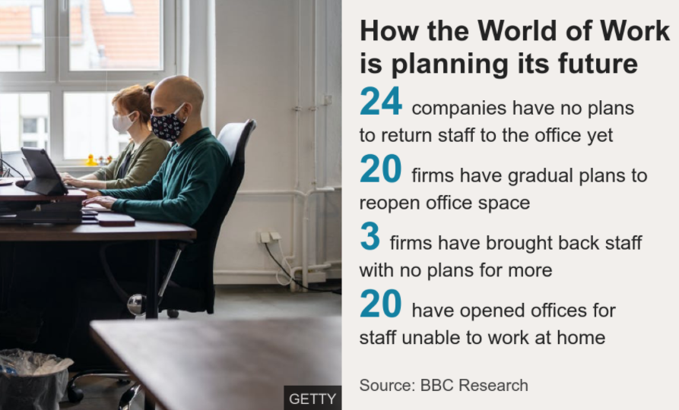

Appendix 2
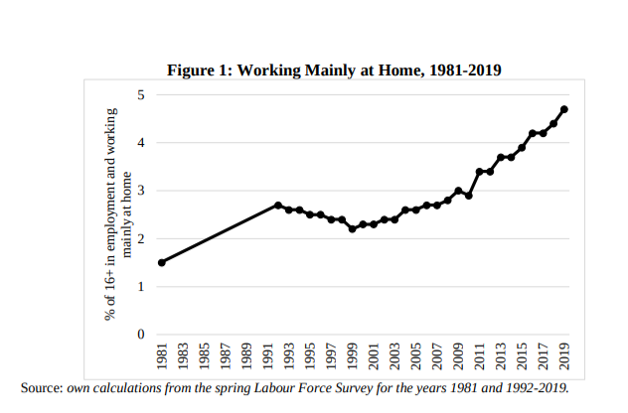

Appendix 3

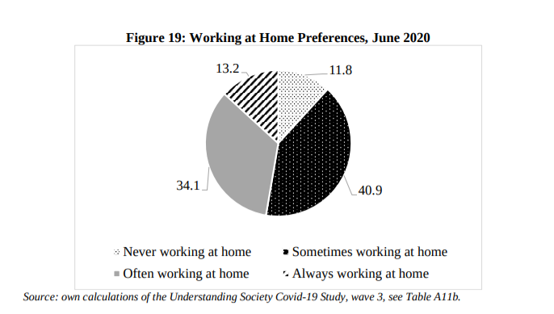

Appendix 4

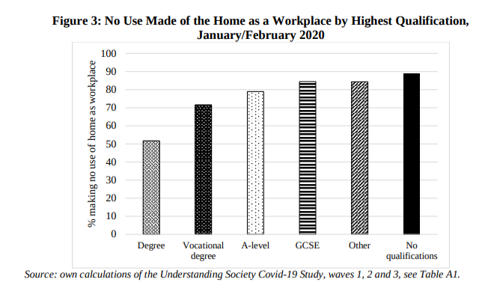
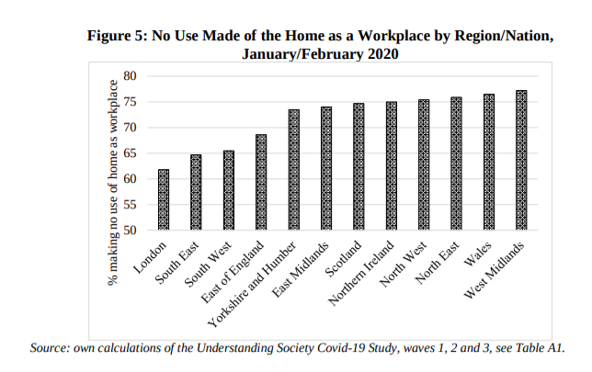

Appendix 5
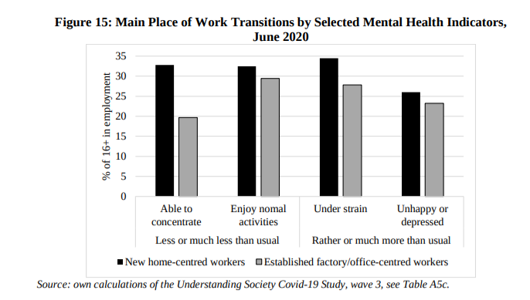

Appendix 6
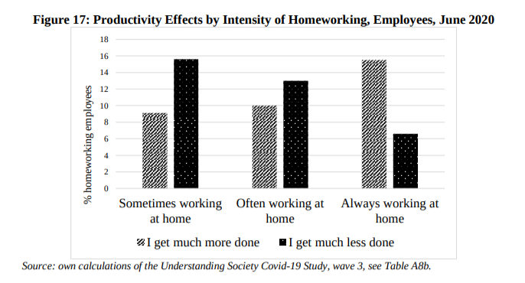

Appendix 7

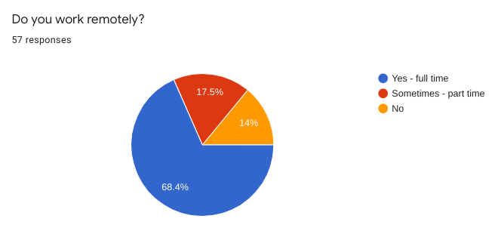

Appendix 8
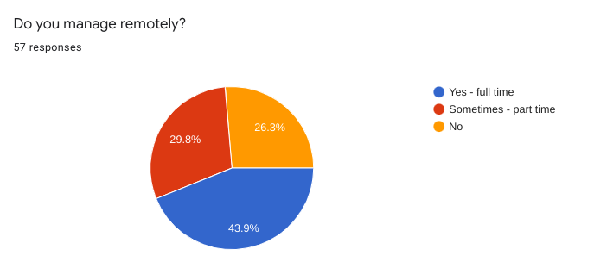

Appendix 9
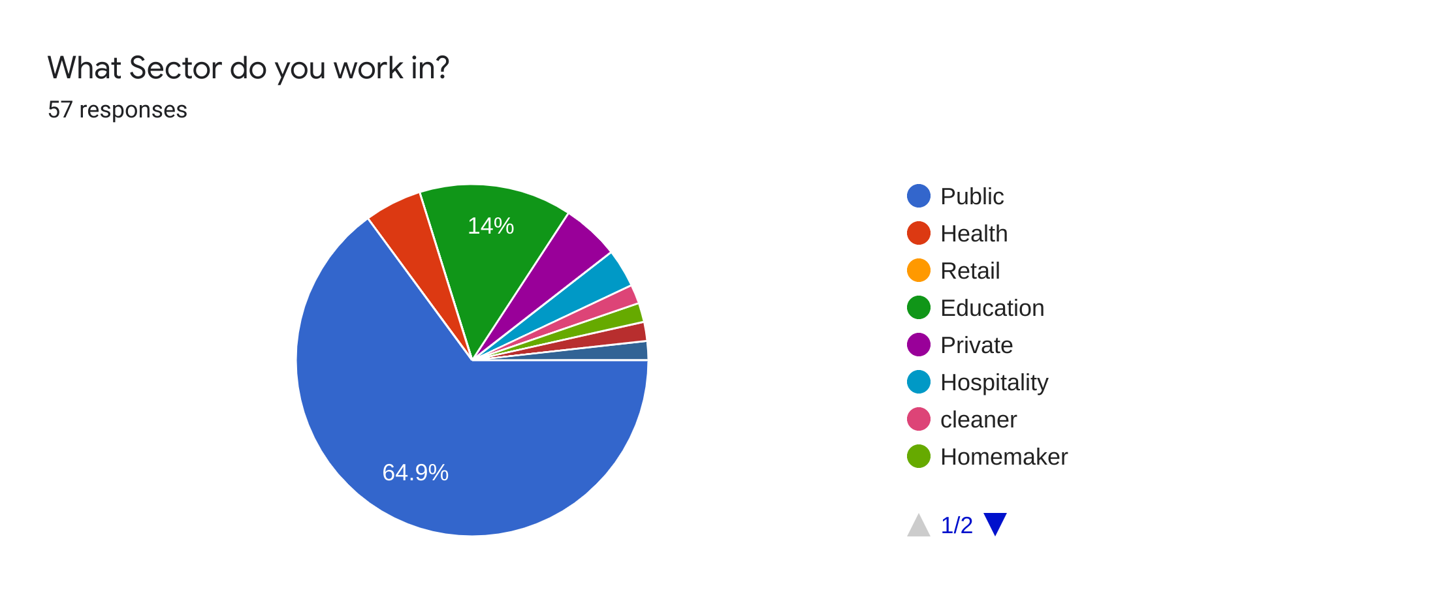

Appendix 10
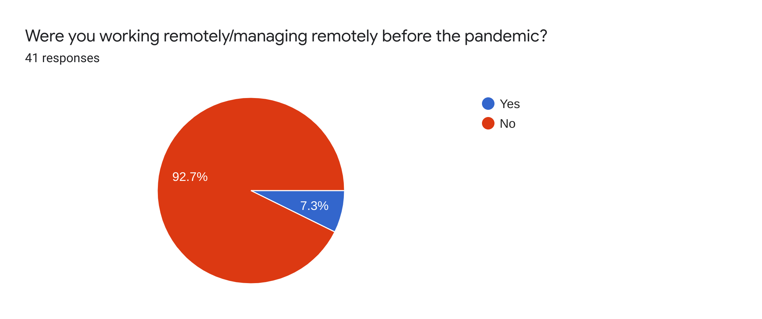

Appendix 11


