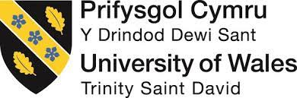
UNIVERSITY OF WALES: TRINITY SAINT DAVID
PRIFYSGOL CYMRU: Y DRINDOD DEWI SANT

School of Business

Visions for the Future:
Theoretical Perspectives on Management
HKBM7006

Professor: Dr. Eddie Yu

Research Paper (Individual Assignment)

Title of Paper:
An analysis of Hong Kong’s strategy in encouraging the youth for career development in the Guangdong−Hong Kong−Macau Greater Bay Area (GBA) of China with the 3H framework

Lee Wai Yip, Harry
University Student Number: 2031149
Programme: Doctor of Business Administration
Date: Aug 16, 2021

Abstract
Purpose - This paper attempts to theorize about Hong Kong’s strategy in encouraging the youth for economic development in the Guangdong-Hong Kong-Macau Greater Bay Area of China with a holistic framework – 3H (Heart-Head-Hand) framework (Yu, 2020). Using a descriptive approach, the paper introduces the announcement from China State Council of initiation of the Guangdong-Hong Kong-Macau Greater Bay Area (GBA) with more effective economic development in that zone. It also aligned with the Belt and Road initiative by the People's Republic of China that aims to link up Asia, Europe and Africa countries by inland and ocean connection to boost up geographic integration, improving international trade and regional economic growth. Hong Kong, as one of the most global and energetic cities in China, it has a lot of strategies and planning to encourage and support young people to work and develop their careers in other cities in the Greater Bay Area. The 3H framework has been used to analyze Hong Kong’s strategy, and the framework’s assumptions are initially tested.
Design/methodology/approach - Hong Kong’s implementation strategies are formulated from government’s press releases, The Greater Bay Area Youth Employment Scheme established, promotion activities from Chamber of Commerce and other political and business circles. A focus group discussion with fresh graduated students from one of Hong Kong’s universities has been conducted to gather their viewpoints of career development in Greater Bay Area. Interpretive analysis and pragmatism approach have been applied in studying the information collected.
Findings – As an exploratory study, the findings show that 3H framework identifies the effectiveness of a Hong Kong government’s strategy and planning for encouraging the youth to work out of their home city and pursue their careers in the cities nearby within the economic zone, more specifically, in Greater Bag area. Strategies, which failed to align with the assumed principles of 3H domains tend to be ineffective to attract the younger generation to work in GBA.
Originality/value – The 3H framework conceptualized a holistic management approach and its assumptions have been initially tested with current Hong Kong government’s strategies. The framework shows its predictability value for government’s strategic direction effectiveness.
Keywords 3H framework, Holistic management, Greater Bay Area, Youth career development, Hong Kong government

Introduction
Globalization has changed the spatial order of countries, regions, and cities (Sassen, 2003), it leads to restructuring of cities and zone, and reshaping the global urban landscape. Large-scale urbanized areas are gradually playing the role of foundation of the global economy. According to the 13th Five-Year Plan in 2016 from the State Council, the People's Republic of China, it mentioned the vision and actions for promoting the joint construction of the silk road economic belt and the 21st Century Maritime silk Road with Greater Bay Area. The Guangdong-Hong Kong-Macao Greater Bay Area was officially written into a national document, and it has been elevated to a national strategic level.
The Bay Area is a new form of mega-urban area, the most important economic growth and technological growth poles which would stimulus innovations altogether globally. More than 60% of the global economy is concentrated in the leading megacity region of the bay area (Walker & Schafran,2015), and the population migration from an inland area to the bay area has been increasing.
In 2019, the State Council, The People's Republic of China, officially announced the "Outline of the Development Plan for the Guangdong-Hong Kong-Macao Greater Bay Area". The strategic positioning of the planning of the Guangdong-Hong Kong-Macao Greater Bay Area is as follows:
- Vibrant world-class urban agglomeration
- An international scientific and technological innovation center with global influence
- An important support for the construction of the "Belt and Road"
- Demonstration zone for in-depth cooperation between the Mainland and Hong Kong and Macau
- A high-quality living circle suitable for living, working and traveling

Background
The development of the Guangdong-Hong Kong-Macao Greater Bay Area is a key national development strategy. It is to build a regional cooperation mechanism for world-class megacities innovation, cooperation platform construction, regional tourism cooperation and cross-border infrastructure development, such as transportation networks, ports, airports, information technology infrastructure and many more. Through further deepening co-operation among Guangdong, Hong Kong and Macao, the objectives of the development of the Greater Bay Area are to promote coordinated economic development in the Greater Bay Area, leverage the complementary advantages of the three places, and develop an international first-class bay area for living, working and travelling.
The Guangdong-Hong Kong-Macao Greater Bay Area is composed of the two special administrative regions of Hong Kong and Macau, and nine cities in Guangdong Province, including Guangzhou, Shenzhen, Zhuhai, Foshan, Huizhou, Dongguan, Zhongshan, Jiangmen, and Zhaoqing. The Guangdong-Hong Kong-Macao Greater Bay Area has a total area of ​​56,000 square kilometers, with a total population of more than 70 million and a total GDP of over $1.3 trillion in 2016 as shown in the figure 1 below.
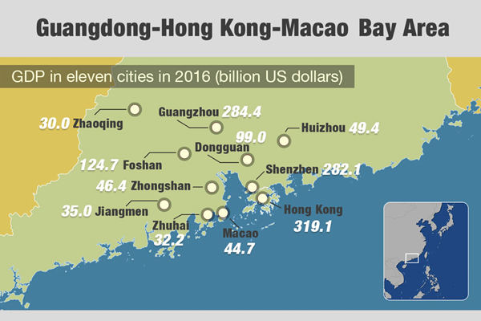
Figure 1: Cities in GBA with GDP for each
Source: The State Council of the People's Republic of China (2017)
The so-called bay area refers to the port group and city group composed of cities around the sea. Each city in the bay area performs different functions, thereby generating synergistic effects and promoting economic development in the area. The current world-class bay areas are the Tokyo Bay Area, the New York Bay Area and the San Francisco Bay Area.
The significance of the Guangdong-Hong Kong-Macao Greater Bay Area to national development is a major development strategy under the country's reform and opening up. It is not only has an important impact on the future development of the Pearl River Delta region, but also plays an important role in national development. According to the "Outline of the Development Plan for the Guangdong-Hong Kong-Macao Greater Bay Area", the development of the Guangdong-Hong Kong-Macao Greater Bay Area has the following significance to Hong Kong:
Connect with countries along the "Belt and Road"
The Guangdong-Hong Kong-Macao Greater Bay Area is China's "Southern Gate" facing the world. Hong Kong has a mature financial system and shipping system, a global business network, and a global offshore RMB business hub; Macau has an economic and trade service platform from Portuguese-speaking countries; Guangdong Province has been active in technological innovation in recent years, and the advanced manufacturing industry chain has been perfect. In addition, the Greater Bay Area has complete infrastructure facilities and the world's largest group of seaports and airports. Countries can use the Greater Bay Area to connect with countries along the "Belt and Road" and go to the world, especially to play a positive role in the smooth trade of the Maritime Silk Road.
Create a competitive business environment
The Guangdong-Hong Kong-Macao Greater Bay Area is at the forefront of economic development in the country. In the "Outline of the Development Plan for the Guangdong-Hong Kong-Macao Greater Bay Area", it has been stated that the state will provide high-quality, efficient and convenient judicial services and guarantees for the construction of the Greater Bay Area in the future, and improve the international commercial dispute resolution mechanism, establish a legal business environment. At the same time, in the future, administrative intervention will be reduced in policies and comprehensive market supervision will be strengthened to form a stable, fair, transparent, and predictable first-class business environment. In addition, Hong Kong is an international financial and trade center. It has a good business environment and comprehensive laws to protect various commercial activities. It can lead various cities in the region to standardize the industry order, open up the international market, and create a globally competitive business environment. It can also be used as a reference for various cities and regions in the mainland.
Enhance Hong Kong's comprehensive competitiveness
Each city in the Guangdong-Hong Kong-Macao Greater Bay Area has its own advantages and has the ability to become the most diversified urban agglomeration in the world. Therefore, Hong Kong can make full use of this opportunity to continuously strengthen its own advantages to enhance the competitiveness of the city. For example, as an intellectual property trading centre in Asia, Hong Kong can introduce intellectual property rights of overseas technologies for enterprises in the Greater Bay Area, and at the same time promote the achievements of innovation and technology in the region in the international market. Hong Kong can take advantage of its advantages as an international financial, shipping and trade centre to assist and promote the "going global" of cities in the Greater Bay Area, thereby enhancing Hong Kong's comprehensive competitiveness.
Break through the bottleneck of Hong Kong's development
At present, the industrial structure of Hong Kong is becoming more and more uniform, and the economy is overly tilted towards the service industry, which has caused Hong Kong to face a development bottleneck. The planning of the Greater Bay Area is expected to become a breakthrough point in the future development of Hong Kong’s cities. For example, Hong Kong has many talents in the technology industry. The development of high-tech industries in some cities in the Greater Bay Area is growing which would provide the youth in Hong Kong with development opportunities. At the same time, local companies also have a certain degree of understanding of international technology trends and technical standards, which can help the commercialization of mainland scientific and technological achievements and open up overseas markets. This shows that the planning of the Greater Bay Area brings opportunities for the development of Hong Kong's emerging industries.
Improve the living standards of Hong Kong people
The establishment of a comprehensive transportation network is a major focus of the planning of the Greater Bay Area. Through the increasingly improved transportation network, it has facilitated Hong Kong people who are interested in starting a business, employment, study or living in the Greater Bay Area, especially young people in Hong Kong. In addition, property prices and commodity prices in some cities in the Greater Bay Area are lower than those in Hong Kong, which can provide Hong Kong people with lower-cost medical and related living cost. This shows that the interaction and integration of the cities in the Greater Bay Area will help improve the living standards of Hong Kong people.
In order to encourage and support young people to work and develop their careers in cities in the Greater Bay Area, the Chief Executive, Mrs. Carrie Lam announced in the "2020 Policy Address" the launch of the "Greater Bay Area Youth Employment Program" to encourage companies with business in Hong Kong and the Greater Bay Area. Recruit and send graduates from local universities/colleges to work in cities in the Greater Bay Area.
The Information Service Department of Hong Kong Government (2020) reported that with the Greater Bay Area Youth Employment Program, any company that has operations in Hong Kong and cities in the Greater Bay Area can apply to participate in providing job vacancies for young people in Hong Kong. It aims to encourage and support young people to work and develop their careers in cities in the Guangdong-Hong Kong-Macao Greater Bay Area to understand the latest developments in Hong Kong and cities in the Greater Bay Area.
Mrs. Carrie Lam pointed out in her policy address that given the size of Hong Kong's economy and market, the youth unemployment rate may remain in double digits for a period. On the other hand, the Greater Bay Area, with a population of 70 million, has huge development potential and can provide opportunities for young people in Hong Kong. The relevant plan has received strong support from the Guangdong and Shenzhen governments. The authorities hope that young people can look at the country, seize the opportunities in study, employment, and life in the Greater Bay Area, and open up a broader space to realize their dreams.
Companies participating in the program must hire qualified graduates in Hong Kong in accordance with Hong Kong laws and send them to work and receive on-the-job training in cities in the Greater Bay Area. The plan provides 2,000 places, about 700 are specially set up for innovation and technology positions. The government will provide companies with a monthly allowance of 10,000 yuan for each employed graduate for a maximum period of 18 months.
The requirements from fresh graduate students are set as simple as possible. Young people who intend to apply for positions under the program must be Hong Kong residents, legally employable in Hong Kong, and hold a bachelor’s degree or above awarded by institutions in Hong Kong or outside Hong Kong from 2019 to 2021. They will be awarded Monthly salary of not less than 18,000 yuan. If the position is related to innovation and technology, eligible graduates must also hold degrees in science, technology, engineering or mathematics, and the candidates must work in Hong Kong and cities in the Greater Bay Area for 6 to 12 months.
The Hong Kong General Chamber of Commerce announced its member companies will provide about 300 positions to support the "Greater Bay Area Youth Employment Program" including The Hongkong and Shanghai Banking Corporation (HSBC), CK Asset Holdings Limited and Hong Kong Swire Group Co., Ltd., which have confirmed their participation.
Area of Interest
Even though there are a lot of efforts from Hong Kong government, the youth are not eager to work in Greater Bay Area. According to the research “Hong Kong Youth Employment and Greater Bay Area Development Index 2020” from the Hong Kong GuangDong Youth Association, Proactive Think Tank Limited and Hong Kong University Hong Kong (GuangDong Youth Association, 2021), it is found that there are more youth having a better understanding of the Greater Bay Area infrastructure from 55.9% 5o 86.3% according to figure 2. It shows there is a positive result with government and related commercial chambers’ promotion effort, which has significantly increased after the Greater Bay Area Youth Employment Program.
In figure 3, it shows the attractiveness level of industries in GBA from the Hong Kong young people. They are innovation industry, financial services, import and export, wholesaling and retailing, performing art and design, multi-media, logistics and so on. They are all within the scope from the "Outline of the Development Plan for the Guangdong-Hong Kong-Macao Greater Bay Area" under State Council, The People's Republic of China.
In figure 4 and figure 5, these relate to how is the recognition of competitive advantages in GBA and what are the key factors that would encourage them to work out from their home city, Hong Kong. Not surprising, the youth have a clear understanding of the advantages in the GBA cities, especially the lower living cost, more job opportunities, better increment on salary, lower housing cost and so on. They are also the factors that would attract the young people from figure 4. Figure 5 tries to give more information that would affect their motivation to work in GBA cities. The salary rate comes first which aligns to the living cost relatively, and for the language barriers, political views, culture differences, they are all generic factors to work out from the home city.
However, despite the fact that there are positive signs according from figure 2 to figure 5, the key findings in figure 6 and figure 7 are surprisingly different. There was a great drop from 24.4% to 18.9 % for the positive recognition to the GBA plan between 2018 and 2020. And for the negative recognition to the GBA plan, there was a huge increase from 2.6% to 15.7%. Between 2018 and 2020, there were social activity and covid-19 issue in Hong Kong, but the change is too big against other findings in the same research. Then, in figure 7, the final willingness of Hong Kong youth to develop the careers in GBA shows a discouraging result in the view of Hong Kong government. In 2020, there were 22.3% of the young people are willing to work in GBA cities while in 2018, it was 35.6%. Similar to the unwillingness rate, there was an increase from 31% to 51% between 2018 and 2021 which is a 20% increase.
Given the negative sign from the youth of Hong Kong to work in GBA cities, it is inevitably an important case for Hong Kong’s strategy analysis. It is not just talking about local economic development but also relating to mainland China’s national strategies. Hong Kong government, which takes the key role in the execution of the youth’s engagement in developing GBA, need to understand the problem behind. There is supporting finding to show that the ineffective in promoting GBA development, for example in figure 8, there are over 95% of young people do not hear before about the institutions established in nine cities in GBA. The paper attempts to theorise about Hong Kong’s strategy and execution in encouraging the youth to develop the career in GBA with the 3H framework on an exploratory basis.
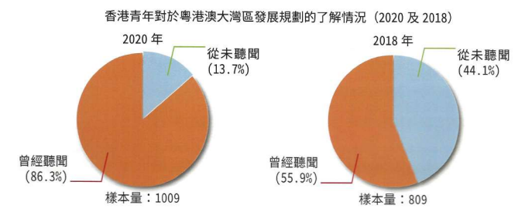
Figure 2: The understanding level to GBA from the Hong Kong young people
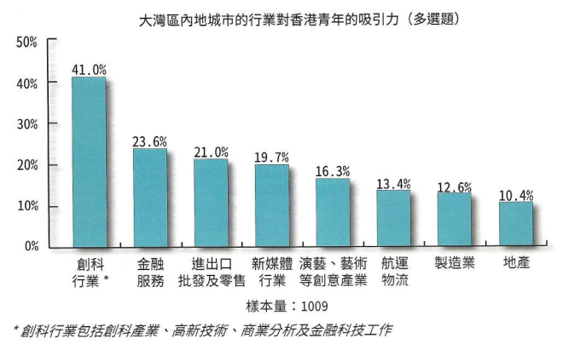
Figure 3: The attractiveness level of industries in GBA from the Hong Kong young people

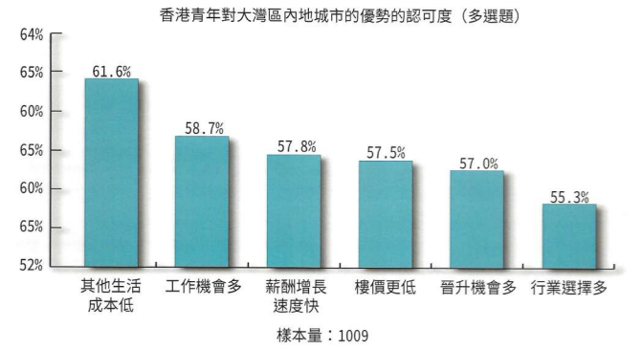
Figure 4: The recognition of competitive advantages in GBA from the Hong Kong young people
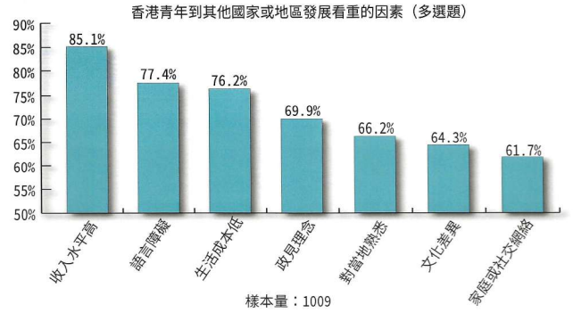
Figure 5: The key factors to develop the career out of their home city

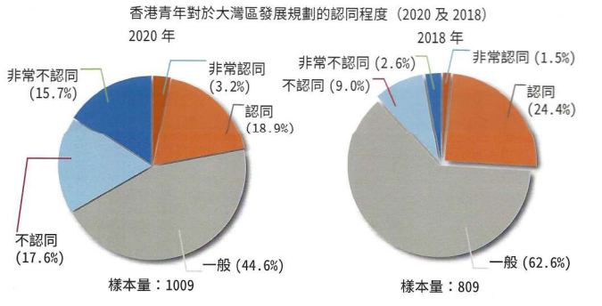
Figure 6: Hong Kong youth's degree of recognition to the GBA plan
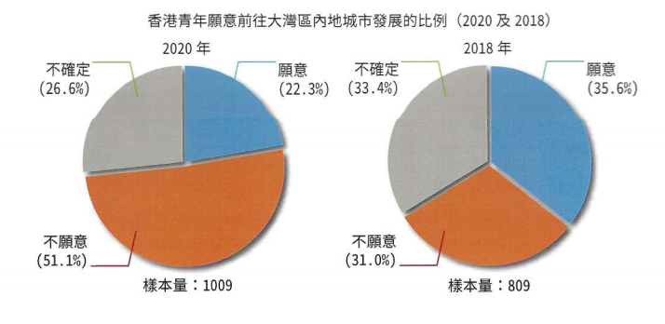
Figure 7: The willingness of Hong Kong youth to develop the careers in GBA
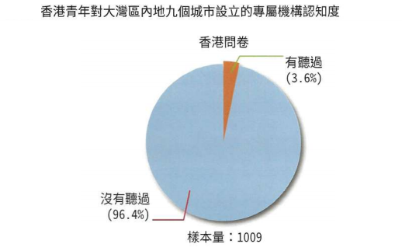
Figure 8: Hong Kong youth's awareness of the institutions established in nine cities in GBA
Source (Figure 2-8): The Hong Kong GuangDong Youth Association (2021)
Introducing the 3H framework
What is the 3H framework?
The question of what constitutes a good management, no matter in a company level, government level or an individual project, is always asked. Yu (2020, p.6) mentioned that “A good management is an art and science of getting things done effectively and efficiently through people and other required resources.” 3H framework (Yu, 2020, p.17) is a framework is a methodology for managing people and organizational issues in a holistic way to ensure individual performance and in turn the entire organizational performance can be efficiently and effectively managed.
The key areas of the framework are metaphorical expression of Heart, Head and Hand. It aims to develop an overall solution for the management of country, city or organization issues. Each H domain of the 3H framework has a series of theoretical foundations while these theoretical foundations come from the well-established literature in different fields shown below. The metaphorical expression of “Heart, Head and Hand” are necessary components and come together as an integrated strategy to set up a holistic approach to control the whole strategic process in order to achieve the desired goal. Yu (2020, p.18) pointed out that “. There are necessary and sufficient conditions to fulfil in order to meet the holistic management approach. Few organizations or nations can sustain long term competitiveness if they could only excel in partial conditions of the 3H framework. By referring to the 3H framework it can systematically guide us to develop and execute a holistic strategic plan.” According to Yu (2020, p.125), 3H framework should be used as a mental schema. If such mental schema is in leader’s minds, he or she should be able to formulate and execute the strategies and plans in an effective and efficient way.
3H framework related literature and concepts
According to Yu (2020, p.20), the well-established literature in different “H” are:
H1 Heart related literature:
Organizational behavior (OB) related (e.g., motivation , emotion, commitment, engagement, satisfaction, trust); leadership, management of change; values and organizational culture, cross cultural management; communication; managing groups and teams.
H2 Head related literature:
Organization architecture (organizational design, structure, alignment); strategic management related (e.g., macro-industry industry analysis, institution, resource based view, value chain, levels of strategy); management planning and control (e.g., balanced scorecard, strategy map).
H3 Hand related literature:
Competence related; functional strategy and practices, e.g., HR related: recruiting process, performance and compensation systems, training and coaching skills.
These theoretical foundations come from the well-established literature in different fields shown.
The conceptual framework
The following algebraic expression helps to conceptualize the functional relationship of the H domains.
Hong Kong’s GBA promotion performance to youth (PPY), the dependent variable, is a function of the complements among Heart (H1), Head (H2) and Head (H3) independent variables of Hong Kong’s youth promotion strategies.
PPY = f (H1cH2cH3)
PPY = Hong Kong’s GBA promotion performance to youth
c = Complement to integrate and connect
H1 = Heart domain (emotional appeal, leading, motivating and engaging people’s abilities)
H2 = Head domain (logical and strategic appeal, planning, organizational, cognitive abilities)
H3 = Hand domain (competence appeal, operational/ functional abilities)
Each H’s domain carries different weights. In this paper, H1 has heavier weight than H2 and H3, whereas H2 has a relatively heavier weight than H3. The reason is that, even though Hong Kong’s youth promotion strategy, system and competence are more advanced, if the chief executive fails to unify and motivate youth to participate, Hong Kong would fall apart from the GBA integration.
The diagram below demonstrates the desired and sufficient conditions (independent, moderating variables) requiring to effective and efficient Hong Kong’s GBA promotion performance to youth (dependent variable).
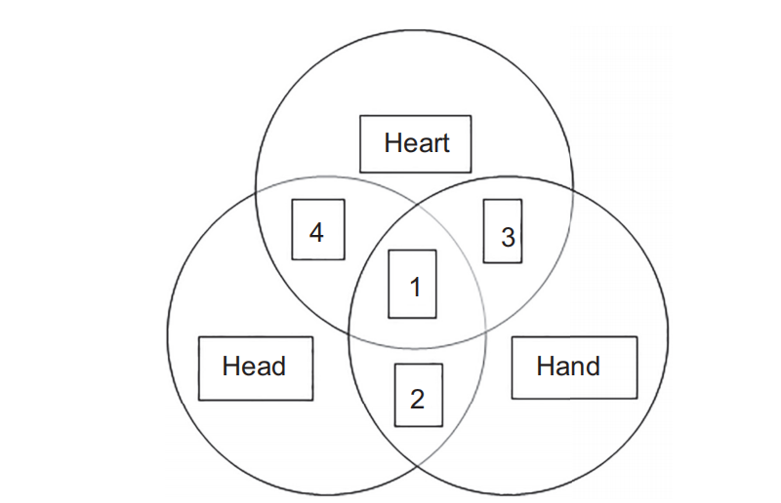
Source: (Yu, 2020, p. 30)
Four case scenarios
Case 4 - Effective leadership (H1) and sound strategy (H2) are in place but lacking
competent GBA professionals (H3).
Case 3 - Effective leadership (H1) and GBA professionals (H3) in place but lacking sound strategy (H2).
Case 2 – Sound strategy (H2) and GBA professionals (H3) are in place but lacking effective leadership (H1).
Case 1 – Integration of domains of H1, H2 and H3 shall secure the necessary and sufficient
conditions for effective and efficient Hong Kong’s GBA promotion performance to youth

The 3H framework posits that the effective and efficient Hong Kong’s GBA promotion performance to youth hinges on the level of synthesis among H1, H2 and H3 domains of Hong Kong as Case 1 – Intersection of three circles in the centre. This is a holistic approach arguably the way to encourage the youth to develop their career in GBA.
Research Questions with reference to the 3H framework
Hence, with the 3H holistic approach, it would support the paper to answer the research questions:
- How is current government leadership and strategy, and other Heart domain factors which caused major negative motivational result for the youth to work in Greater Bay Area?
- What are the key strategies issues and other Head domain factors, which lead to the inefficient promotion from Hong Kong government to the youth.
- What the key competence and other Hand domain issues for Hong Kong youth?
In this paper, we will discuss and provide opinions and suggestions to contribute to the development of youth in the Guangdong-Hong Kong-Macao Greater Bay Area.
Research method
A descriptive case was created based on content analysis on over 50 reports, press releases from different respected sources, e.g. State council, China press, Hong Kong government press, Universities’ research reference, focus group discussion transcripts with youth and broadcasting stations’ video clippings.
Interpretive analysis with pragmatism approach has been conducted in analysis the data and information derived from the content analysis. The assumptions of the study are created with the well-established literature in different “H” as mentioned above and tested with supporting conversational and or textual statements.

Underlying assumptions of the 3H framework for applying for this study
Literature based assumptions have been created, which is first referred to a H domain number
and the number within that domain, e.g. the first assumption of the Heart domain is referred
as: H1-1, as shown in table below which the key factors are extracted to be significant
implementation of Hong Kong’s GBA promotion strategies (Yu, 2020):
Domain |  | Assumptions and literature based
Heart (H1) – coded as H1-1 and H1-2 and so on | 1 | Heart-oriented leader shall create a conducive climate for uniting  people to achieve common national goals (Bui et al., 2017; Hunt,  2017).
 | 2 | People are willing to sacrifice for a honourable cause, purpose,  shared value and belief (Carton, 2018; Sussman et al., 1983).
 | 3 | Human nature has both good and bad elements, Heart-oriented  leader shall help employees develop their good selves and have them behaved themselves to control their bad elements (Hinton, 2013; Gurbuz et al., 2014).
Head (H2) | 1 | Effective strategic planning process is a necessary factor for national project success (Bryson et al., 2018; Genc and Sengul, 2015).
 | 2 | Planning, organizing and controlling process calls for rational, logical and strategic thinking to address short-, medium- and long-term needs of the national project (Hussey, 1999; Menon, 2018).
 | 3 | However, effective strategy translation and communication across  different levels of organisation is a necessary management  responsibility and it is an art more than a science (Tam et al., 2005).
Hand (H3) | 1 | Efficient execution of strategy with required competence and  resources is a necessary factor for national project success  (Grant, 1991).
 | 2 | Agility and speed to satisfy people’s needs are useful criteria for evaluating the competence of the nation in managing the incumbent project (Yu, 2020; Yu et al., 2016).
 | 3 | Leaders should know the level of competence that his followers  possessed. (Kor and Leblebici, 2005; McGrath et al., 1995).

Applying 3H framework to analyze Hong Kong’s strategy in encouraging youth to develop the career in GBA
Testing the proposed necessary and sufficient factors
According to Yu (2020, p.32), from the leadership perspective of the H1 domain, it can be broadly divided into the Heart and Head-oriented perspectives. The Heart-oriented perspective puts youth’s true development opportunities over all other considerations; whereas the Head-oriented approach is rational and puts economic and political interests first.
H1. Heart-oriented leadership that can engage and motivate followers is the first necessary factor.

According to the Public Opinion Programme conducted by University of Hong Kong (2021), the latest issue of Chief Executive and Government Popularity, the Chief Executive Carrie Lam scored 32 points, an increase of 1.3 points from the previous survey, and the net support rating dropped by 3 percentage points to a negative 50 percentage points. (H1-1)

From the focus group discussion, all the participants do not put a trust on Chief Executive Carrie Lam and she is a liar. (H1-1)

H2. Head domain driven effective strategy planning process is the second necessary factor.
H3. Hand domain that developed the competence to efficiently execute strategic goals is the third necessary factor.
Determine the sufficient factor with 3H framework on Hong Kong’s GBA promotion performance to youth

Limitations

Conclusion

- Research Aim
- Analysis, comparison and interpretation of relevant data from other Bay Areas such asUS and Japan, and how were they manage, key successful factors and lesson learnt, and hence providing key managerial issuss to the Hong Kong government, education-related departments, schools, associations, etc.
- Provide opinions and suggestions to contribute to the development of youth in the Guangdong-Hong Kong-Macao Greater Bay Area.
- Research Questions with reference to the 3H framework
- How is current government leadership and strategy, and other Heart domain factors which caused major negative motivational result for the youth to work in Greater Bay Area?
- What are the key strategies issues and other Head domain factors, which lead to the inefficient promotion from Hong Kong government to the youth.
- What the key competence and other Hand domain issues for Hong Kong youth?
The central government sees youth engagement as key to turning the Greater Bay Area into an arts and culture destination.
However, experts warn that cultural and political differences between Hong Kong and the mainland must first be bridged, and 3H is used to analysis the situation and provide critical managerial analysis.
- Significance of the issues
With improved connections between Mainland cities and the rest of the world, the “front shop, back factory” model of division of labour between Hong Kong and other GBA cities may no longer be fully applicable, and a new mode of collaboration should be sought.
Although there are many news, promotions and leaflets from Hong Kong government to introduce the GBA, they often flow into the fragmentation of information. This prevents young people from forming a systematic understanding of the planning of the Greater Bay Area. The formation of a relatively complete management system from Hong Kong government would operationally integrate the youth into the Greater Bay Area.

References
Hong Kong GuangDong Youth Association, 2021. Hong Kong Youth Employment and Greater Bay Area Development Index 2020. [pdf] Available at: < https://www.hkgdya.org.hk/a/118781-cht >[Accessed 26 July 2021]

Hui, Eddie C.M, Li, Xun, Chen, Tingting, & Lang, Wei. (2020). Deciphering the spatial structure of China's megacity region: A new bay area—The Guangdong-Hong Kong-Macao Greater Bay Area in the making. Cities, 105, 102168.

The Information Service Department of Hong Kong SAR Government, 2021. 2020 POLICY ADDRESS. [online] Available at: <https://www.news.gov.hk/eng/2021/01/20210108/20210108_155641_164.html?type=category&name=2020pa&tl=t> [Accessed 26 July 2021]

The State Council, The People’s Republic of China, 2016. 中华人民共和国国民经济和社会发展第十三个五年规划纲要. [online] Available at: <http://www.gov.cn/xinwen/2016-03/17/content_5054992.htm> [Accessed 26 July 2021]

The State Council, The People’s Republic of China, 2017. Beijing to make plans for Guangdong-Hong Kong-Macao Bay Area this year. [online] Available at: <http://english.www.gov.cn/news/top_news/2017/04/13/content_281475625476729.htm>
[Accessed 26 July 2021]

The State Council, The People’s Republic of China, 2019. 中共中央 国务院印发《粤港澳大湾区发展规划纲要》. [online] Available at: <http://www.gov.cn/zhengce/2019-02/18/content_5366593.htm#1> [Accessed 26 July 2021]

Walker, R., & Schafran, A. (2015). The strange case of the Bay Area. Environment and Planning A, 47(1), 10–29.

YSassen, S. (2003). Globalization or denationalization? Review of International Political Economy, 10(1), 1–22. Scott, A. J. (1991). Social network

Yu, E. (2021), “Seminar Day 1: Visions for the Future: Theoretical Perspectives on Management”, Lecture notes, BM7006, University of Wales –Trinity Saint David, delivered 19th and 20th June.

李芝蘭, 鍾碩殷 & 盧德明 2019, '讓粵港澳大灣區成為香港青年的真正選擇: 香港政府角色的思考', International Conferenceon the Greater Bay Area (Guangdong-Hong Kong-Macau), Hong Kong, 10/05/19 - 11/05/19.

