MANAGING PROJECTS IN THE ORGANISATION
(BMSW5009) (BLOGS)
Iosif Carpaci (1922471)

09/07/2025

Blog no.1 What is Gantt Chart?
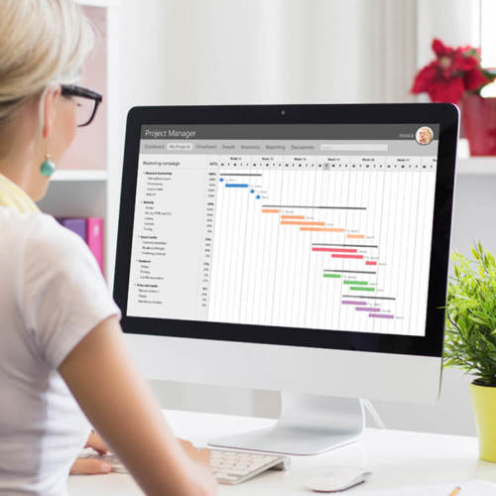

Gantt chart is a project management tool which helps and to give information to all project team what has been done and what is still to be done, Gantt chart is a tool that shows graphical representation of the activity against time. Gantt chart helps projects managers to monitor their progress; Gantt chart is used to monitor the progress and time schedule. Gantt chart help team to understand when the start date and the end date is and see where the progress is at how far away you are from the deadline of finishing the project. Gantt chart shows what has been done which task has been done and by who has been done. A Gantt chart is great to keeps task on track if there is a large team and multiple stakeholders. It is useful for time management and keep tracking on the project, you can use it in both ways as tracking tool or time management tool; by using Gantt chart you can see the problems in the project for preventing future project mistake’s and you can find out which are the critical path for the project.

Advantages of Gantt charts:

- Clear, and visual, of the plan
- It is easy to understand and simple to create
- You can see the progress and plan

Disadvantages of Gantt charts

- Do not show the task dependencies
- The schedule size is limited
- Can’t be adapted if there are project changes

Reference list Blog no.1

APM. (2025). What is Gantt charts. [Online]. apm. Last Updated: 2025. Available at: https://www.apm.org.uk/resources/find-a-resource/gantt-chart/ [Accessed 5 July 2025]

Blog no. 2 What is the McKinsey 7s model?

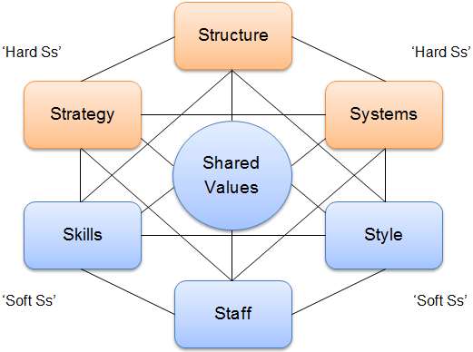

McKinsey 7s model is a strategic tool for management used to evaluate an organisation internal element. It is examining the following seven elements. Strategy, Structure, System, Shared values, Style, Staff and Skills, with all these skills an organisation can be much more effectively aligned with the projects and help the organisation to achieve its objectives. The key point of this tool is that all seven areas are interconnected with each other so in case of a further change in one of the seven elements there it requires changes in all areas for the model can be much more effectively.
The McKinsey 7s model can be applied to many situations it’s a good tool to use when are changes in the organisation, it helps to implement new strategy’s, to identify if there will be further change in different areas, and to keep the organisation running most effectively with the new changes.

Advantages of McKinsey 7s Model
- By having (hard ss) and (soft ss) elements the 7s Model it drives the organisation to a great performance as they are interconnected elements it helps organisation to success by not missing crucial areas.
- The 7s Model is valuable for its elements with the strategic goals, by analysing each ‘’s’’ of the 7s Model organisation can find the issues in the organisation.
- The 7s Model it helps the organisation to improve strategic planning.
- The 7s Model it provides universal model for analysing any organisational effectiveness, its capability is to adapt across any industry.

Disadvantages of McKinsey 7s Model
- The 7s Model is great for a stable environment as the 7s Model is not likely to changes which it makes it lack flexibility.
- The 7s Model does not show which elements you should prioritize to focus on so without any clear direction an organisation might struggle to find the crucial areas so then there will be no improvements.
- The 7s Model is not great in changes as each element is connected to all elements and by that then in case of a change must be change everything, so its complexity becomes time-consuming

Reference list Blog no.2

Ovidijus Jurevicius. (2025). McKinsey 7S Model. [Online]. strategic management insight. Last Updated: 16 June 2025. Available at: https://strategicmanagementinsight.com/tools/mckinsey-7s-model-framework/ [Accessed 5 July 2025].

procsi. (2025). the 7s model pros and cons. [Online]. procsi.com. Last Updated: 18 April 2025. Available at: https://www.prosci.com/blog/the-mckinsey-7-s-model [Accessed 5 July 2025]

Blog no. 3 What is a Kanban board?

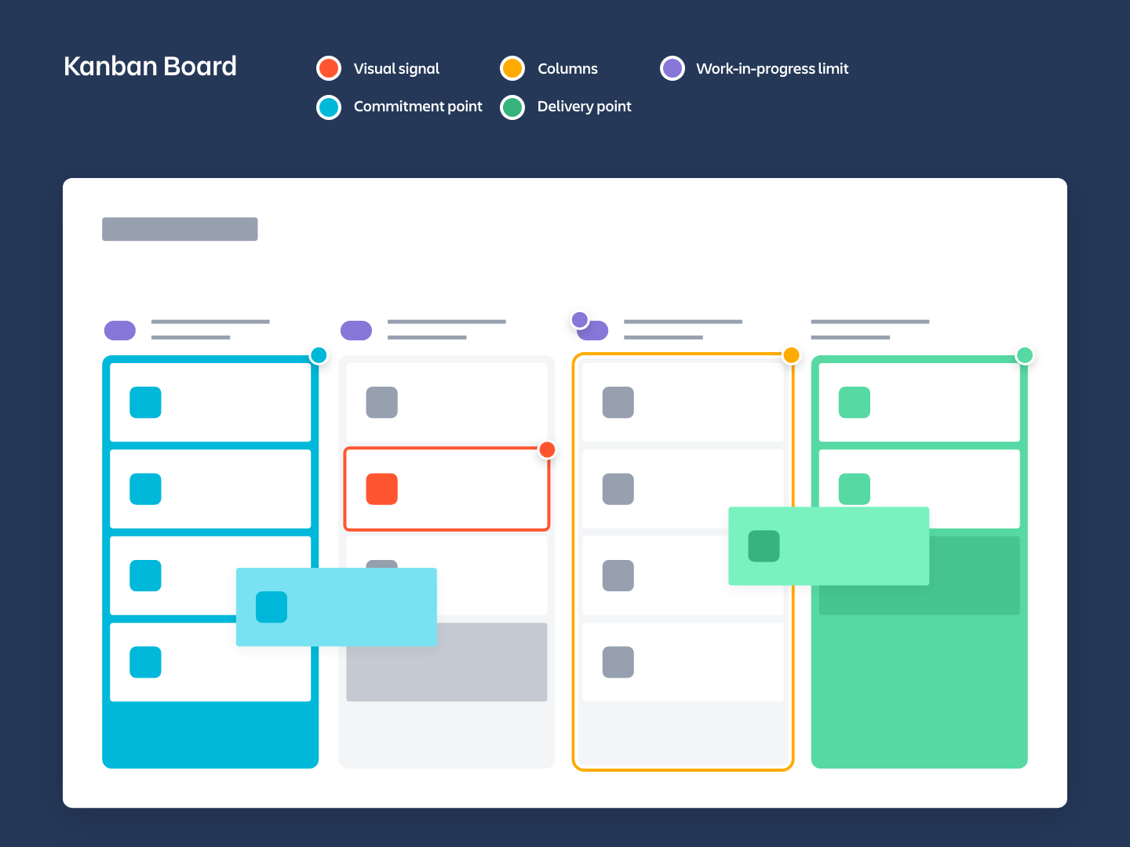

A Kanban board it an agile project management tool which helps to visualize work, limit work in progress and maximize the flow of the work kanban board helps teams to keep the order of the kanban cards so they can be done more effectively and keep work out the missing part of the board.
Kanban board has 5 steps. visual signal, columns, work-in-progress limit, commitment point, delivery point. With those steps you can find out who is assigned to do the work and can easily find out which are not doing the job. With the steps of the Kanban board, you can improve the workflow and do it more efficiency you can track the work, and you can share it with the team, so you know which is the next step. Kanban brings values into an organisation as there is respect for people who work in the team, and it keeps continuous improvements.
Kanban board can be easily created you can create vertical columns and use sticky notes onto a board; these sticky notes are for as the progress is going forward this sticky note must move together with the progress. The kanban board is more often use by IT companies as it helps them to track where they are with the project and what is next to be done is a great tool to be used in most business but not great for remote teams.

Advantages of kanban board
- Kanban board advantages are that you can track always where the project is at what stage you are and what its need changes.
- Kanban helps to find out the problem and you can solve it immediately before moving to the next step of kanban board.
- Kanban board helps teams to understand where the progress is and what is left even if they not talking to each other as there is a visual movement of the steps.
Disadvantages of Kanban board
- Kanban board has no start and stops date it has an ongoing process.
- There are no roles implemented to each candidate of the team each candidate must self-organize.
- Kanban board has more flexibility with the tasks and offers more time, and task can be changed as going along which it can takes longer to finish a project.

Reference list Blog no. 3

MAX REHKOPF. (2025). What is Kanban board?. [Online]. atlassian.com. Last Updated: 2025. Available at: https://www.atlassian.com/agile/kanban/boards [Accessed 5 July 2025]

Blog no.4 What is a Quad chart?

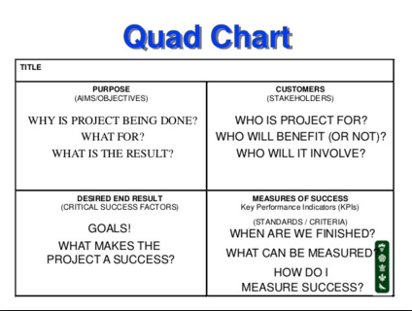

Quad chart is a chart with four sections used to describe an innovation or invention through writing; the Quad chart illustrates step by step an event of an invention (Ryan Keenan 2020).
Quad chart it can be split into 4 different steps as we talk into our class there was a question from our tutor what is the steps of a making coffee? So, then we must break it into 4 steps and find out the steps of making coffee, same in a project to find out the issue in a project you must break things and split without make any mistakes. If we look at the SWOT ANALYSIS it still a quadrant chart but quad chart helps you to break more in depth.

- Purpose: what is the company offer or what they can offer
- Capabilities: what the organisation offer it is much better than the rest of the organisations
- Customers: if you know your partners or your customers how many are they
- Success: show what type of business you do and create a path for customers to reach you.
As all the other tools in project management are useful Quad chart is an important key also in the project management it help to create more efficiency in an organisation

Reference list blog no.4
Author Ryan Keenan. (2020). quad chart. [Online]. positioning insights. Last Updated: 2020. Available at: https://positioninginsights.com.au/quad-charts/ [Accessed 5 July 2025]

Blog no.5 how to execute a project successfully?

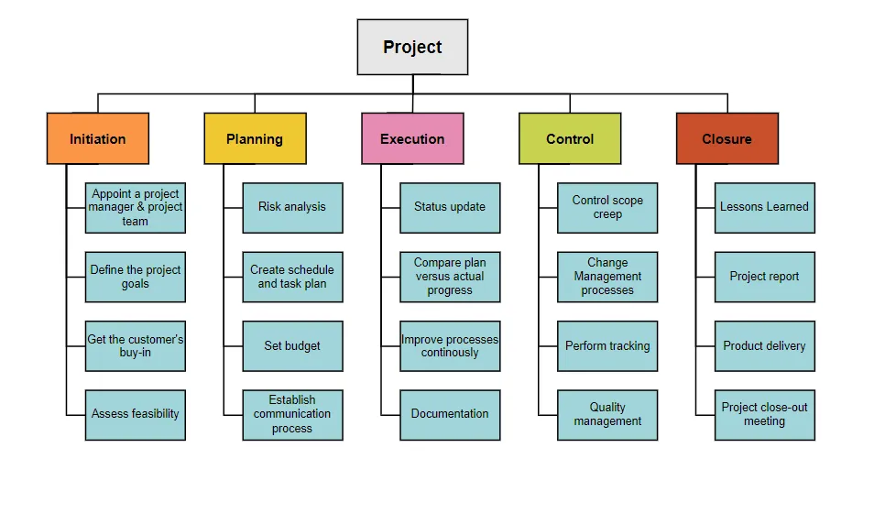

For my blog no.5 I needed to do a self-reflection so I choose what I have been doing in our group project I’m with the execution of the project at this stage I have to see the status update and to prepare for next step which is control I have to make sure everything is in place before move to the next step if there is needed I have to compare the actual plan and see what is the actual progress, see what are the project budgeting and if we are exceeded that. also, I must improve the process continuously by see what is done and what is left to be done, I need to find out all the documentation for the event that we are planning to do before we can move to the next step. The results are important as there needs to be delivering value, putting action to the plan, clear team communication.
By doing this we have to use all project management tools so we can be more time effectively and deliver a valued project to our stakeholders.

Reference list Blog no.5

Anne M. Carroll. (2024). project management execution. [Online]. project management.com. Last Updated: February 2024. Available at: https://project-management.com/project-management-phases-exploring-phase-3-execution/ [Accessed 5 July 2025]
GUSTAVO DE FELICE. (2024). project management. [Online]. GUSTAVO DE FELICE. Last Updated: February 2024. Available at: https://www.gustavodefelice.com/p/what-is-work-breakdown-structure-wbs-in-project [Accessed 5 July 2025]

