Problem Solving and Decision Making (BMSW4004_LON)
Prepared for Mr. Suneth Fernando
Task 2,
University of Trinity Saint David Prepared by
David Mafuta (2007846)
15/08/2021

Abstract:
This paper is all about Problem Solving. It is crucial hence problems will always be part of Mankind and decision-making skills will be the tool to solve problems amongst human being. This assessment is about solving a problem occurred in my previous workplace by using different methods (solutions).

Table of contents
Problem Definition
Evaluation of the current situation and Identification
SWOT analysis
PESTLE
Cause and Effect Diagram (Fishbone Analysis)
Alternative solutions
Solution 01
Solution 02
Solution 03
Solution 04
PMI Decision Making tool
My Plan
Implementation process review
Conclusion
References

- Problem Definition

It is a cleaning and security company with more than three thousand employees working full and part time. A well establish and organised organization in the United Kingdom. They produce cleaning materials and cleaning products. They are providing cleaning and security services to multiple companies in the UK. They have Production department, Human Resources department, Accountant and finance department, operations department.
The problem occurred in the operations department. The stakeholders were impacted by the problem hence the company could not deliver a job according to the contract specification. Therefore, the client was planning to sign a new contract with another reliable cleaning company who will be able to deliver a job accordingly. It took me four Months to observe what I defined as a problem.

- Evaluation of the current situation and Identification

In fact, When I was promoted as an Area Cleaning Manager in my previous company, the first four Month, after doing my round to introduce myself to all the sites managers and supervisors, and checking the timesheets, and auditing the sites at the same time, according to the client request, I discovered that 25% of the employees on my handover list never existed (dead names or never worked for the company before). I also discovered that the allocated time for my Area was divide by two; therefore, it was difficult for my team to perform well and keep the cleaning standards according to the client expectations. I could not hide it at all knowing the negative impact of that practice. I had a word with my line manager who was the operations manager w. He did not deny it and he even told me that event is line manager who is one of the directors was involved in that dirty business. He even went far again by proposing me to be part of that dirty game and start earning more money illegally. At that time, I did not have a choice than escalating the matter to the Human Resources department. Later, I discovered that other directors were also involved in that business. The operation manager and other directors were dismissed, and I was forced to resign and leave a peaceful life.

Presently, if I must evaluate the same situation again and define alternatives solutions, I will apply SWOT Analysis.
- SWOT Analysis (Houben,1999).
Below editable table is from google.
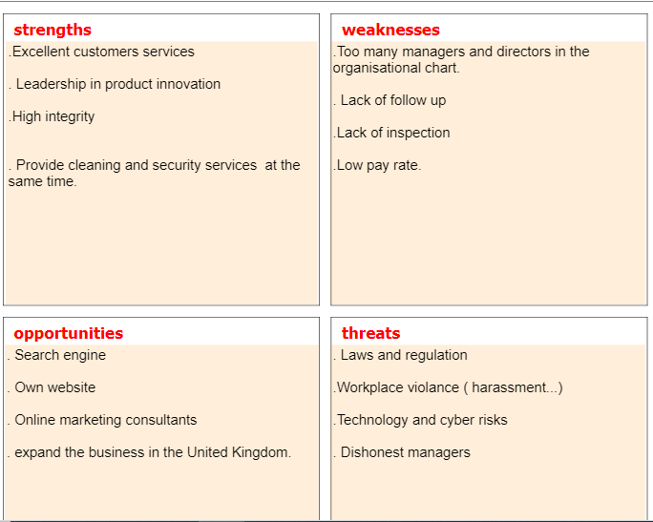

- PESTLE Analysis (Aithal, 2017).
Below editable template is from google.
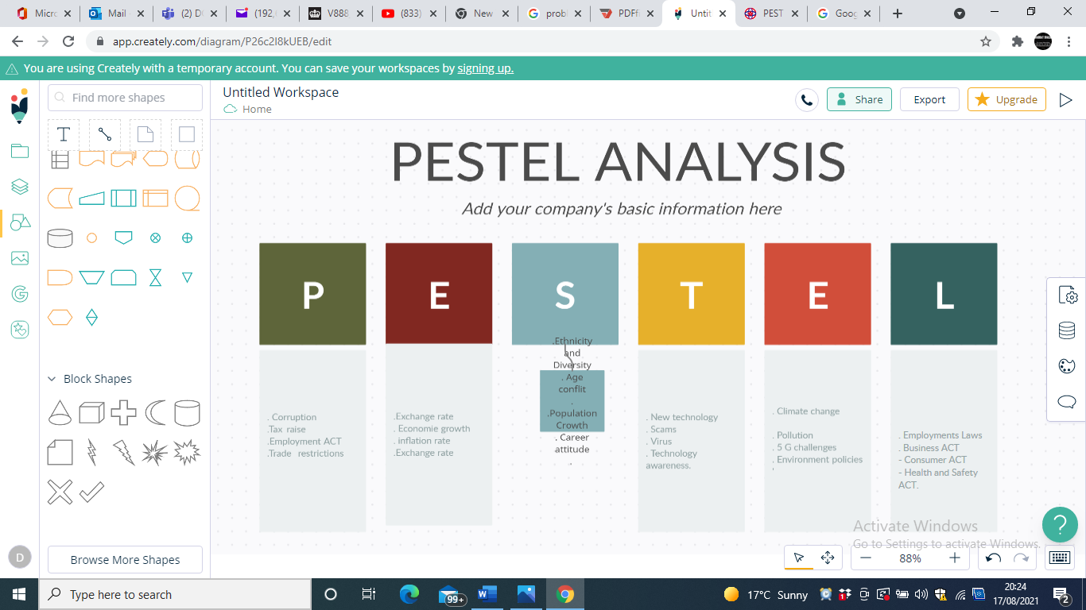
*Politic: Corruption, Tax raise, Employment ACT and Trade restrictions.
*Economies: Exchange rate, Economy growth, Inflation rate and Exchange rate.
Social: Ethnicity and Diversity, Age Conflict, Population Growth and Career attitude.
*Technology: New technology, Scams, Virus and Technology awareness.
*Environmental: Climate change, Pollution, 5 G challenges and Environmental.
*Legal: Employments Laws, Business ACT, Consumer ACT and Health and Safety ATC.

- Cause and Effect Diagram (Fishbone Analysis) (Luca, 2017).
Below editable template is from google.

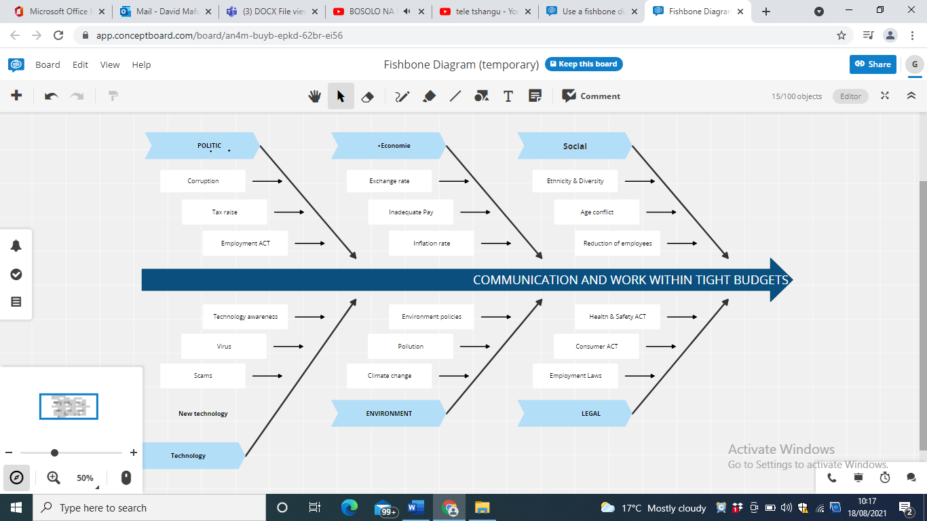

*Politic: Corruption, Tax raise and Employment ACT.
*Economy: Exchange rate, Inadequate Pay, and Inflation rate.
*Social: Ethnicity and Diversity, Age conflict and Reduction of employees.
*Technology: New Technology, Scams, Virus and Technology Awareness.
*Environmental: Climate Change, Pollution and Environmental Policies.
*Legal: Employment Laws, Consumer ACT and Health and Safety ACT.

- Define alternative Solution
6.1 Solution 01:
Improve the company communication by organising management meeting at least once a Month to talk about the stage of the company, the budgets and audit all the sites and Area’s managers to monitors the progress of the company. Also talk about the problems employees are facing at workplace.
6.2 Solution 2:
Allocate enough budges for all the areas hence the company was working with tight budget. Also audit the sites managers to assure that the hours allocated for each site are being used efficiently.
6.3 Solution 3:
Payment increases to avoid corruption, bribing and stilling hence managers and employees been complaining about the pay rate.
- PMI Decision Making tool

PMI is used to evaluate the options by drawing a table with a three column to evaluate (Ahmed, 2012).
Solution 01 – Improve the company communication – PMI Model (score scale is 5)
Plus Points | Minus Points | Interesting Points
- Clear goals for all the employees (5) | - Information overwhelms (-4) | 1. Job will be enjoyable (+4)
- Increases engagement (4) | 2. Can create distraction (-3) | 2. Employees would like to give their best (+4)
3.Create a good rapport (+4) | 3. Not take job seriously (-2) | 3. Socialising between workers and managers (+3)
4. Build trust (4) | 4. Potential for misunderstanding (-3) | 4. Helping each other to accomplish their task (+3)
5. Increase Managerial efficiency. (4) | 5. More talking than working  (-3) | 5. Promote professionalism  (+4)
Total Plus Points= (21) | Minus Points= (-15) | Interesting Points= (+18)
Final Value for solution 01= 21+18-15= 24
Solution 02 – Allocate enough budges– PMI Model (score scale is 5)
Plus Points | Minus Points | Interesting Points
- Enough time to accomplish his task (5) | - Being too comfortable (-3) | 1. Work motivation (+5)
- Working with precision (5) | 2. Expense allocations (-5) | 2. Creativity (+4)
- Working comfortably (4) | 3. Manipulate the system (-3) | 3. employees can do more than expected (+3)
- Having time to write a daily report (5) | 4. Can make employees to be lazy (-3) | 4. More permanent employees (+4)
- Having time to double check the work done (5) | - More use of the phone (-4) | 5. More referrals (+4)
Total Plus Points= (24) | Minus Points= (-18) | Interesting Points= (+20)
Final Value for solution 02= 24+20-18= 26
Solution 03 – Payment increases – PMI Model (score scale is 5)
Plus Points | Minus Points | Interesting Points
- Higher worker effort (5) | - Leading to inflation (-5) | - Increase motivation (+5)
2. Retain hard workers (4) | - Employees may target only money instead of working well (-3) | 2. Time keeping (+4)
3. Increase employee performance (5) | - Will increase employee’s taxes (-3) | 3. Good health (+3)
4.Increase productivity (5) | 4. Employees will prefer to do overtime and forget about their wellbeing (-3) | 4. Better social life (+4)
- Makes everybody happy (5) | - Less teamwork and more individual work incentives (-3) | - Enough money for holiday (+4)
Total Plus Points= (24) | Minus Points= (-17) | Interesting Points= (+20)
Final Value for solution 03= 24+20-17= 27
After applying the decision-making tools, to finding the best solutions for the problem, payment increases did stands out.
Firstly, if my line managers and other directors that was involved in this dirty practice had high-income, it is probable that they will not start stilling from the cleaners by reducing their pay rate; and receiving salaries for the cleaners that never existed or never worked for the company. Secondly, it is obvious that if cleaners were paid well, they would perform well and give their best. Therefore, the client will always be satisfied with the cleaning standards, and they will not request a challenging audit for four Months, the period I discovered this problem.
8. My Plan
The client requested a systematic audit for all his hundred sites hence the cleaning standards was dropped, and the cleaners were not able to raise the cleaning standard due to bad pay rate hence the operation managers and other directors were doing dirty business by paying themselves using a list of cleaners that not exist or never worked for the company. On top of that, late payment and tight budget (allocated cleaning hours).
My proposal is that:
- I will organise a meeting with the finance director who was not involved in the dirty business, and advise him to needs to leave his office, and go round to audit all the hundred sites and make a new list of effective employees by collecting information find on the signing sheet of each site and implementing the clocking system.
- After finishing his audit, he needs to organise a meeting with the payroll department to disregard the previous employees’ list and start using the new list for timesheet going forward.
- The hours that the dead names were getting pay will be distributed to all the sites according to the client’s specification.
- The company can recruit few more cleaners and increase the pay rate.
- On the other side, the company need to open a case in the county court of Law, for all the managers and directors that was involved in this problem. The company need to claim back all the stolen money that they use to take illegally from the employee’s salaries.

9. Implementation process review
Task | Duration | Resources required
- Meeting with the finance director | 2 days | Book a meeting room
- meeting with the payroll department | 5 days | Book a meeting room
- New hours distribution to all the sites | 9 days | New timesheet book, laptop
- Recruitment of few more cleaners and raise the pay rate | 4 days | Uniforms and badges
- Open a case in the county court of Law | 2 days | Court application form
- Arrange review meetings | 2 days at the end of the Month | Book a meeting room

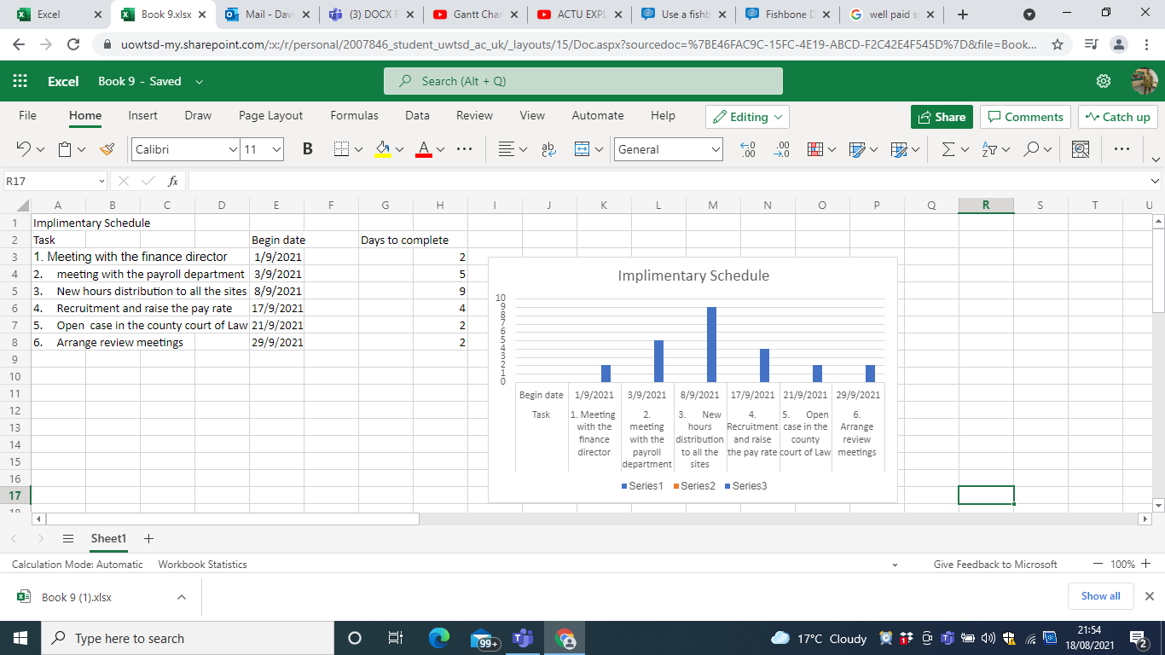

9.1. Security and Privacy: The Human Resources and the payroll department will be involved to secure my solution.
9.2. Implementation, Resource List – (Resource list is listed in implementation plan)
9.3. Documentation – completed
9.4 Monitoring Performance – arrange Monthly meetings with the finance director to identify the effectiveness of the solution implemented.
9.5 Acceptance Criteria – justify the solution with the help of PMI tool.

9.6 References:
The Finance director and the head of payroll department.
9.7 Plan Approval – draft implementation plan will be produced and presented to the board of directors and get the approval.
At the end of each Month, I will have a review meeting with the management committee/board to monitor the efficiency of the new solution and touch any area that need improvement. Also, to evaluate the job performance of each site manager and supervisor.

10. Conclusion:
Every word problem has a solution (Reusser,1997). Reusser is talking about Mathematical problems explaining that something student are afraid of difficult problems but after they discover that the solution to the problem was easy. Of course, in any aspect of our lives, when facing a problem, people tent to panic, loose control, and end up committing crucial errors. Therefore, in difficult situation, it is advised to keep calm and find a solution. However, all solutions are not appropriate if we do not use them for the right problem. The problem above is a constructive example. It was so complex and difficult to find a solution. Nevertheless, after implementing the right solution, with the help of PMI tool, it is obvious that the outcome will always be amazing.

11. References:
- Ahmed, M.T. and Omotunde, H., (2012). Theories and strategies of good decision making. International Journal of Scientific & Technology Research, 1(10), pp.51-54.
- Aithal, P.S., (2017). An effective method of developing business case studies based on company analysis. International Journal of Engineering Research and Modern Education (IJERME), ISSN (Online), pp.2455-4200.
- Houben, G., Lenie, K. and Vanhoof, K., (1999). A knowledge-based SWOT-analysis system as an instrument for strategic planning in small and medium sized enterprises. Decision support systems, 26(2), pp.125-135.
- Luca, L., Pasare, M., Stancioiu, A. and Brancu, C., (2017). Study to determine a new model of the Ishikawa diagram for quality improvement. Fiability & durability, 1, pp.249-54.
- Reusser, K. and Stebler, R., (1997). Every word problem has a solution—The social rationality of mathematical modeling in schools. Learning and instruction, 7(4), pp.309-327.

