Module: Human Resource Management
Topic: Transactional and Transformational Leadership: Study of Capgemini
Lecturer: Dr. Mushfiqur Rahman
Student Name: Ajith Kandula
Student ID: 2122120
Name of the University: University of Wales Trinity Saint David

Contents
Introduction...............................................................................................................................3
Different Leadership Models......................................................................................................3-4
Different Theories of Leadership and the Study of Capgemini...................................................4-6
Conclusion...................................................................................................................................6
References...................................................................................................................................6-7
List of Appendices........................................................................................................................7-9

Introduction
Leadership development is a procedure through which future leaders are identified. The entire process is bridged by Human Resource Management and International Human Resource Management which provides budding leaders with appropriate tools and training. Both Human Resource Management and International Human Resource Management play a critical role with respect to leadership. A global leader with exceptionally good leadership skills is the primary requirement for an organization to be successful. The culture of the organization should help positively for the budding leaders to be successful. Good companies have their strategies aimed towards the development of leaders for the future. The Human Resource Management and International Human Resource Management in these companies collaborate with the executive staff at the senior level for creating the ambience necessary for the birth of a leader (Juneja n.d.)

Different Leadership Models
Kurt Lewin, the German psychologist has been credited for defining various models for leadership. The three major leadership models are as follows:
- Autocratic Leadership: This style of leadership is synonymous with autocratic rulers who do not consider the opinions of others. It is also known as authoritarian leadership and all kinds of decisions and policies are taken single-handedly by the leader.
- Democratic Leadership: This kind of leadership is exactly the opposite of the authoritarian style of leadership. Also known as participative leadership, this kind of leadership takes all kinds of decisions and goals after discussing and considering everyone’s opinions. The employees have a cordial atmosphere of work and the final decision is taken by the leader after consultations.
- Laissez-faire Leadership: This kind of leadership believes in the rights of everyone and they have absolute freedom in taking a decision. The employees are empowered by the leader by supplying materials and information but the employees have a great scope to expand their own careers (University of Arizona staff 2022).

Different Theories of Leadership and the Study of Capgemini
Leadership development has over the years come up with several theories. One of the most popular theories is the Contingency Theory which asserts the birth of a leader during emergency or contingent situations. Founded by Fiedler in 1964, the contingency theory of leadership saw a phenomenal rise during the 70s but it declined with the emergence of the 21st century. As this theory depends upon the circumstances for a leader to rise, the development of this theory changes according to the circumstances. Capgemini, my case study organization has practised this theory during the biggest crisis in recent times, namely COVID-19 where the organization looked at leaders who will able to sustain the organization.
Another major theory of leadership development is charismatic leadership. As the name suggests, the leadership ability here depends upon emotions that are built on communication and evident attributes that reflect heroism and exceptional vision for which the leader can take any kind of risk (See Appendix A). While charismatic leadership does not belong to the traditional category of leadership, the sheer personality based on energetic, motivating factors drives the crowd to comply with their strategy. Charismatic leaders bind everyone together based on four major aspects. They have a grand vision, a statement about the vision, and strategies to reach the vision and they link the past, present and future of the organization to get unite everyone towards the vision. Charismatic leaders take steps to set an example for their followers. However, the theory is limited in its scope as it depends upon the followers having low self-esteem while the leader is at the upper level of the organization. The theory has also been criticized on the ground that leaders often driven by their self-interest and selfish goals do not take the other members’ good or the goals of the organization into consideration. In the case of Capgemini, leadership has always been influenced by a charismatic style of the leaders. The leaders have been visionaries who have maintained a good rapport with the employees, both on personal and professional levels. The leadership in Capgemini has been accessible for the employees which only reflects their vision of building an organization with good work culture (Harvey 2020).
Two more leadership theories that complement each other are transformational and transactional leadership. Transactional leadership believes in the existing structures and focuses on results and successes according to the prevailing structure. The leaders here motivate the followers by instructing the goals in the existing structure. The basic tenet of rewarding after success is one of the characteristics of this leadership. Transactional leadership is a form of laissez-faire leadership where decisions are taken after delegating all tasks to the employees (See Appendix B). Transformational leadership, on the other hand, has an influence over the followers and they work for the all-round growth of the organization. Transformational leadership as the name suggests has the capacity to take ground-breaking decisions which have been demanded by the need of the hour (See Appendix C). Transformational leaders promote the goals and the vision among the followers and implant the idea and influence among them. Transformational leaders take extra effort for all employees and provide individual attention to each of them. Transformational leadership however need not be confused with charismatic leadership as charismatic leadership works only on the charisma and personality traits of the leader but transformational leadership is much beyond that. Organization of Capgemini started as a consultancy firm but it soon understood the need for transformation with the changing dynamics of the market due to the emergence of technology. The term digital leadership is getting popular in recent times. Capgemini absolutely realizes the importance of this and believes that successful transformation of an organization is possible only when it is managed and led by an effective leader who understands the goals and visions for the change (Capgemini 2017)

Conclusion
Choosing an effective leader is definitely a challenge for an organization, especially in light of globalisation as a borderless world also means leaders and management teams can be from different zones. This leads to different issues because of the diversity of cultures. However, the universal traits of leadership should be focused on and it may be widely considered that transformational leadership goes beyond the borders and helps in the growth of an organization.

References
Capgemini (2017). Rising to the New Challenges of Transactional Services in the Public Sector. Capgemini. https://www.capgemini.com/wp-content/uploads/2017/07/Rising_to_the_New_Challenges_of_Transactional_Services_in_the_Public_Sector.pdf
Harvey, M. (2020, February 04). Hofstede Cultural Model and Dimensions of National Culture. Essay48. https://www.essay48.com/14039-Capgemini-Hofstede-Cultural-Model
Juneja, P. (n.d.), Role of Human Resource Management (HRM) in Leadership Management. Management Study Guide. https://www.managementstudyguide.com/role-of-hrm-in-leadership-development.htm
Sergeo Caredda (2020, August 21). Leadership Models: The Theory and the Practice. Sergeo Caredda. https://sergiocaredda.eu/organisation/leadership-models-the-theory-and-the-practice/
Suharyanto,A. & Lestari, R. D. (n.d.).‘The Fall and Rise of the Contingency Theory of Leadership’. IAPA Proceedings Conference. Indonesia.
UAGC Staff (2022, March 14). 4 Leadership Styles in Business: Leadership Style Quiz. University of Arizona Global Campus. https://www.uagc.edu/blog/4-leadership-styles-in-business

List of Appendices
Appendix A: Charismatic Leadership and their Traits
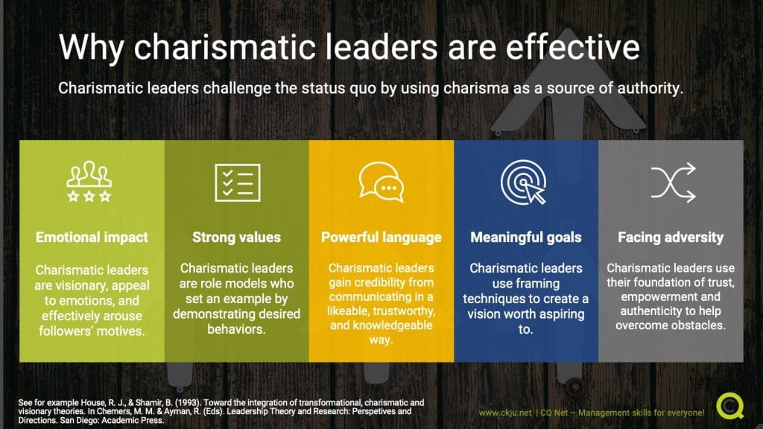
Note. Charismatic Leadership. By Digital Knowmad [Photograph]. 2019 CQ Net. (https://sergiocaredda.eu/organisation/leadership-models-the-theory-and-the-practice/ ).

Appendix B: Transactional leadership

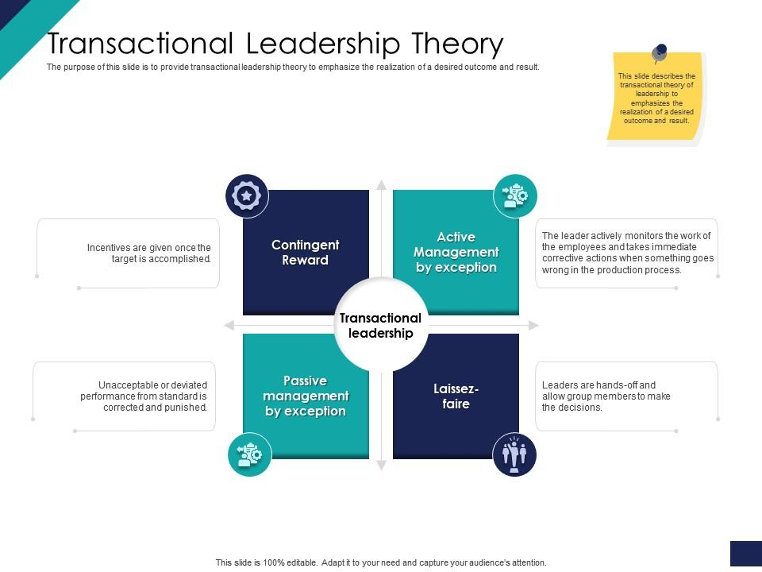

Note. Transactional leadership. By Slideteam [Photograph].2019.

(https://www.slideteam.net/effective-leadership-management-styles-approaches-transactional-leadership-theory-ppt-icon-good.html)

Appendix C: Transformational Leadership
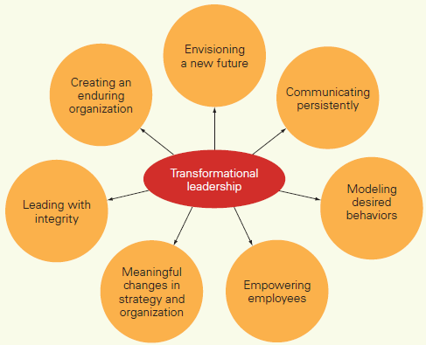
Note. Transformational Leadership. From WisdomJobs [Photograph]. 2020. (https://www.wisdomjobs.com/e-university/principles-of-management-tutorial-293/transformational-leadership-9508.html).

