LEVEL 4 ASSESSMENT SPECIFICATION

Student name: Tariq Hussain
Student ID number: 2506992
Programme: Certificate in Higher Education Business Skills for the
Lecturers name: Mucahit Ozden

Workplace
Module: Enterprise and Entrepreneurship
Module code: LCLM4006
Strong Fuel: Healthy and Sustainable Takeaway Business Plan
Words: 1554

Executive Summary
Strong Fuel is a healthy and sustainable takeaway business that provides freshly prepared salads, grain bowls, wraps, smoothies, and low-calorie hot meals served in environmentally friendly packaging. The business aims to meet the increasing demand for convenient, affordable, and nutritious food among busy urban consumers. Strong Fuel primarily targets individuals aged 18–35, with a particular focus on university students, young professionals, and health-conscious customers who value both quality food and sustainable business practices.
The health and wellness food market in the UK continues to grow as consumers become more aware of the importance of balanced diets, healthy lifestyles, and reducing their environmental impact. Many traditional fast-food outlets continue to offer meals that are high in calories, fat, and sugar, creating an opportunity for Strong Fuel to provide a healthier alternative without compromising on taste, convenience, or affordability. By combining fresh ingredients, customisable menu options, and eco-friendly packaging, the business aims to build a strong reputation and encourage repeat customers.
Strong Fuel's competitive advantage lies in its commitment to sustainability, high-quality ingredients, excellent customer service, and targeted digital marketing through social media platforms. The business will also offer online ordering and takeaway services to increase convenience and reach a wider customer base. These strategies are expected to strengthen brand awareness, attract loyal customers, and support long-term business growth.
To establish the business, approximately £15,000 in start-up funding will be required. This finance will be obtained through a UK Government Start Up Loan (British Business Bank, 2024). The funding will be used to purchase kitchen equipment, initial stock, environmentally friendly packaging, marketing materials, licences, insurance, and to cover other start-up and regulatory costs. A detailed financial forecast indicates that the business has strong potential for growth due to increasing consumer demand for healthier takeaway options, relatively low entry barriers, and the ability to expand operations in the future. Overall, Strong Fuel presents a realistic, sustainable, and commercially viable business opportunity with the potential to become a trusted healthy takeaway brand.

Contents
0-Executive Summary ……………………………………………………………… 2
1-Prospectus of the Business Idea………………………………………………… 4
1.1Business Concept………………………………………………………………… 4
1.2 Products and Target Market………………………………………………………… 4
1.3Legal and Management Organisation……………………………………………… 5
2-Market Research…………………………………………………………………… 5
2.1 PESTEL Analysis…………………………………………………………………… 5
2.1.1 Political and Legal Factors ……………………………………………………… 5
2.1.2 Economic Factors……………………………………………………………… 6
2.1.3 Social Factors…………………………………………………………………… 6
2.1.4 Technological Factors………………………………………………………… 6
2.1.5 Environmental Factors………………………………………………………… 6
2.2 Competitive Analysis……………………………………………………………… 7
3- Marketing Communications………………………………………………………… 8
3.1 Social Media Marketing ………………………………………………………… 8
3.2 Local Marketing …………………………………………………………………… 8
3.3 Advertisement……………………………………………………………………… 8
4- Risk Analysis …………………………………………………………………………. 9
5- Financials …………………………………………………………………………… 10
5.1 Cash Flow Forecast (1 Month) …………………………………………. 10
5.2 Cash Flow Forecast (12 Months) …………………………………………. 10 Conclusion ………………………………………………………………………… 11
References…………………………………………………………………………… 12

List of Figures

Figure 1: Target Market; Source: Adapted from Statista (2025) ………. 5
Figure 2: Health and Wellness Food Market Growth 2020-2025; Source: Adapted from Statista (2025) ………………………………………………………… 8
Figure 3: Distribution of Marketing Budget Across Channels; Source: Strong Fuel Business Plan (Author, 2026) ……………………………………………… 9
Figure 4: Initial Start-Up Costs; Source: Strong Fuel Business Plan
(Author, 2026) ………………………………………………………… 9 Figure 5: 12-Month Cash Flow Forecast; Source: Strong Fuel Business Plan (Author, 2026) …………………………………………………………… 10

Prospectus of the Business Idea.

Business Concept

Strong Fuel is a takeaway-only healthy food business operating from a rented commercial kitchen unit in Selly Oak Birmingham, close to Birmingham University and nearby offices. It offers budget-friendly meals in sustainable packaging, with no dine-in service. Meals are prepared fresh daily and sold via collection and local delivery within a 3-mile radius through Deliveroo and Uber Eats. The core concept is to offer balanced, nutritious meals convenient for busy customers while remaining environmentally responsible through biodegradable and recyclable packaging.

Products and Target Market

Strong Fuel will provide fresh salads, grain bowls, wraps, low-calorie hot meals, and smoothies priced between £6–£9 per meal to remain affordable for students and young professionals. The primary target market is male and female customers aged 18–30, specifically, university students and office workers in Birmingham. According to Statista (2025), more than 60% of UK consumers who belong to the age group of 18 to 34 years old prefer healthy eating which requires healthy options. Birmingham has University with more than 45,000 students and numerous office workers creating a large market base for local businesses. Investors will be attracted to this demand from customers.

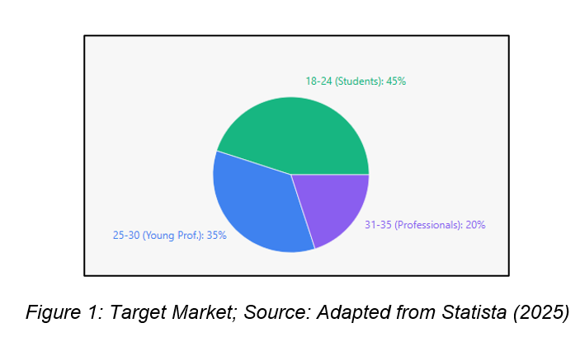

Legal and Management Organisation.

Strong Fuel will operate as a sole trader, requiring minimal setup costs whilst taking control in the initial phase (Burns,2022). This helps reduces financial risk. The organisation structure includes the owner having overall management, supplier management, finance and marketing. My wife will package and prepare food part-time. Part-time Kitchen assistant who will start when sales reach £8,000 per month. This helps keep labour costs low whilst being efficient.

Market Research

PESTEL Analysis

Political and Legal Factors
Strong Fuel must comply with food hygiene regulations, including business registration, food safety certification, and health and safety requirements. Guidance from the Food Standards Agency (2023) supports compliance and builds credibility with consumers.

Economic Factors
Economic pressures have made consumers more price-conscious; however, demand for affordable healthy food remains strong, particularly among younger consumers (Statista, 2024). Strong Fuel’s £6–£9 pricing directly addresses this need.

Social Factors
Social trends strongly favour healthy eating and sustainable food choices. Growing awareness of diet-related health risks and environmental impact has driven demand, particularly among youth demographics (Statista, 2025), which directly benefits Strong Fuel.
Technological Factors
Digital marketing, particularly through Instagram, allows small businesses to build brand awareness and reach targeted customers at low cost. Kumar (2023) highlights its effectiveness in engaging younger consumer segments.
Environmental Factors
Consumer demand for eco-friendly businesses is rising, with sustainable sourcing and packaging becoming a key competitive advantage (Ratajczak-Mrozek et al., 2025). Strong Fuel’s commitment to eco-friendly packaging directly supports this trend.
Competitive Analysis
Strong Fuel competes against fast-food chains, coffee shops, and local takeaways. While these competitors offer convenience, most fail to meet demand for nutritious, affordable, and sustainably food. The strength of Strong Fuel lies in its clearly evidenced unique value proposition. According to Statista (2025), over 60% of UK consumers aged 18 to 34 actively seek healthier food options, yet independent research by the Food Foundation (2023) found that fewer than 20% of takeaway outlets in urban areas provide nutritious meal options at affordable price points. Strong Fuel meets consumer needs on sustainability, health, and convenience are directly met. Furthermore, the Soil Association (2024) reports that 74% of UK consumers consider sustainable packaging an important factor making Strong Fuel’s eco-friendly brand as a genuine competitive advantage. Unlike Subway and Pret A Manger, Strong Fuel focuses entirely on healthy takeaway while being sustainable with student-friendly prices. Combined with specific targeting and marketing to younger, health-conscious urban consumers, Strong Fuel has the potential to distinguish itself from traditional competition. Its attention to product quality and ethical brand values enable the company to become a preferred option among people seeking a healthier and more sustainable alternative to traditional fast
foods (Kumar, 2023).
Figure 2 : Health and Wellness Food Market Growth 2020-2025; Source:
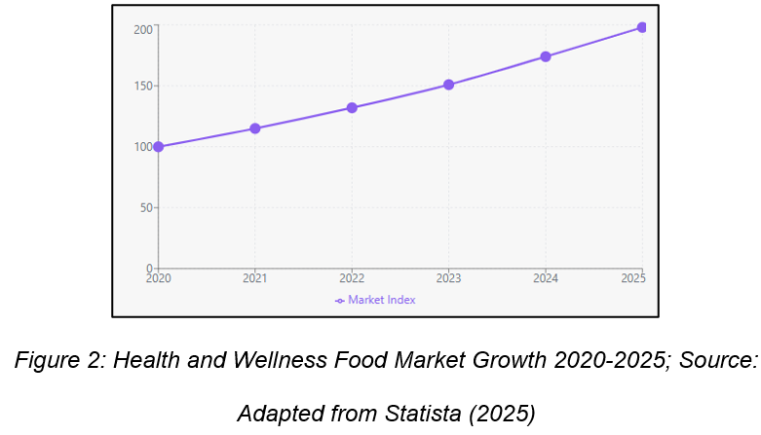
Adapted from Statista (2025)

Marketing Communications
Strong Fuel will use Instagram as its main platform instead of Facebook because 71% of UK users aged 18–29 use Instagram every day (Statista, 2025). Instagram is ideal to show healthy food pictures whilst making it trendy and popular. The marketing budget will be allocated as follows: 60% Instagram paid ads and content promotion
20% Google local search ads
10% university campus flyers
10% introductory student discount campaigns
TikTok and YouTube require more money, and time so will be used when profits enable this.
Social Media Marketing
Instagram will be the primary channel, showcasing food photography, behind- the-scenes content, and customer reviews to engage the 18–30 age group
(Statista, 2025).
Local Marketing
Posters and flyers at universities, gyms, and coworking spaces will target
local students and young professionals.

Advertisement
Specific promotions such as student discounts, meal packages, and referrals will be used to facilitate a trial purchase and induce a repetitive visit. The combination of meal and smoothie deals provides customers with additional value which results in better price perception. Strong Fuel uses its marketing position to show high costs which result from its need to maintain directness and brand values while showing customers its meal health benefits and packaging environmental sustainability. The brand will achieve market differentiation through its dual identity which positions it against traditional fast-food rivals while it competes within the health and wellness sector (Kumar, 2023; Statista, 2025). Strong Fuel will achieve successful audience engagement through its online presence and local advertising while avoiding high costs associated with traditional advertising.

Figure 3 : Distribution of Marketing Budget Across Channels; Source:

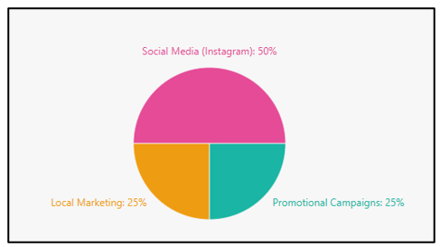

Figure 3: Distribution of Marketing Budget Across Channels; Source: Strong Fuel Business Plan (Author 2026)
Strong Fuel Business Plan (Author, 2026)

Risk Analysis
Risk | Impact | Mitigation
Rising food prices | Reduced profit margins | Use multiple suppliers and review menu pricing quarterly
Strong competition | Lower sales | Focus on unique healthy meals and eco-friendly branding
Poor online reviews | Damage reputation | Monitor customer feedback and respond quickly
Low initial sales | Cash flow issues | Use promotional offers and student discounts

Financials
The necessary funding to begin operations amounts to £15,000. This will be financed through a UK Government Start Up Loan, which provides loans of up to £25,000 to new businesses at a fixed interest rate of 6% per annum (British Business Bank, 2024). This government-backed scheme was selected over a commercial bank loan due to its lower interest rate, flexible repayment terms of up to five years, and the free mentoring support it includes for new business owners. The monthly expenses that we expect to incur will total
approximately:
Rent: £1,000–£1,200 per month based on commercial kitchen rental costs in Selly Oak and Birmingham city centre.
Ingredients: £2,000
Packaging: £500
Utilities &amp; Insurance: £400
Marketing: £600
Total monthly cost: £4,700
Strong Fuel will generate daily income of £320 from its sale of 40 meals which it prices at an average of £8. The business will generate monthly income of approximately £9,600. The business will produce monthly gross profit of £4,900 before tax, which demonstrates strong return potential for investors.
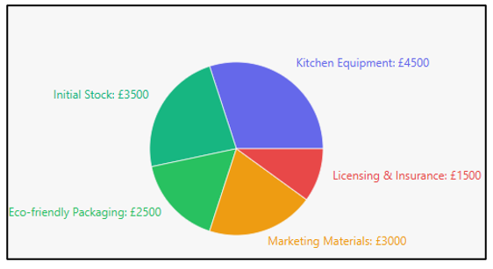

Figure 4 : Initial Start-Up Costs; Source: Strong Fuel Business Plan (Author, 2026)
The initial start-up costs that are expected within the first month of business are as follows: Kitchenware and cooking wares £4,500– (commercial food processor- £400, two induction hobs-£600, one refrigeration unit- £800, food preparation surfaces and utensils- £300, storage containers- £200, two blenders-£300 and general smallware- £1,900). Starting inventory of products £3,000 – (fresh vegetables and salad- £800, grains and pulses-£400, proteins- cost £700, smoothie ingredients and fruits- £500, condiments and sauces- £300 and beverages- £300).
Environmentally friendly packaging (£2,000) – which contains biodegradable meal boxes which cost £700 and compostable salad containers which cost £400 and paper bags and wrapping which cost £300 and recyclable smoothie cups and lids which cost £300 and branded stickers and labels which cost £300. Marketing and promotion material (£2,000) – which includes Instagram paid advertising campaign launch which costs £800 and printed posters and flyers for campus and gym distribution which costs £400 and introductory student discount vouchers which cost £300 and Google local search ads setup which costs £500. Costs on licensing, insurance, compliance with food hygiene (£3,500) – which includes food business registration with local authority which costs £0 because it is free via FSA and Level 2 Food Hygiene certificates for two staff members which cost £100 and public liability insurance which costs £1,200 per year and general business insurance which costs £800 and a contingency reserve for unexpected regulatory costs which costs £1,400. This investment ensures Strong Fuel is fully operational from day one, meeting all regulatory requirements and marketing needs. The low start-up costs and clear revenue model make it an attractive, scalable business opportunity
(Burns, 2022).

Cash Flow Forecast (12 Months)
Based on your figures:
Month | Sales (£) | Expenses (£) | Net Cash Flow (£) | Closing Balance (£)
Start-up Loan | 15,000 | - | 15,000 | 15,000
Month 1 | 9,600 | 4,700 | 4,900 | 19,900
Month 2 | 9,600 | 4,700 | 4,900 | 24,800
Month 3 | 9,600 | 4,700 | 4,900 | 29,700
Month 4 | 9,600 | 4,700 | 4,900 | 34,600
Month 5 | 9,600 | 4,700 | 4,900 | 39,500
Month 6 | 9,600 | 4,700 | 4,900 | 44,400
Month 7 | 10,500 | 5,200 | 5,300 | 49,700
Month 8 | 10,500 | 5,200 | 5,300 | 55,000
Month 9 | 10,500 | 5,200 | 5,300 | 60,300
Month 10 | 11,500 | 5,500 | 6,000 | 66,300
Month 11 | 11,500 | 5,500 | 6,000 | 72,300
Month 12 | 12,000 | 5,500 | 6,500 | 78,800

- Months 1–6 current forecast of 40 meals per day.
- Month 7 hiring of part-time assistant.
- Months 10–12 assume repeat customers and marketing.
- Closing balance demonstrates strong positive cash flow and business sustainability.

Conclusion
Strong Fuel offers a viable business opportunity by providing affordable, healthy takeaway meals in sustainable packaging to students and young professionals in Birmingham. The business benefits from growing consumer demand for nutritious food and environmentally responsible products. Supported by a clear marketing strategy, realistic financial forecasts, and a strategic location near Birmingham University, Strong Fuel has strong potential for profitability, customer growth, and future expansion within the Birmingham market.

References

Burns, P. (2022) Entrepreneurship and small business. Bloomsbury
Publishing. Available at:
https://www.academia.edu/download/57487418/enterprensuirship_and_s
mall_business_start-up__growth_and_maturity.pdf (Accessed: 19 January
2026).

Food Standards Agency (2023) Getting Ready to Start Your Food Business.
[online] Food Standards Agency. Available at:
https://www.food.gov.uk/business-guidance/getting-ready-to-start-your-
food-business (Accessed: 19 January 2026).

Kumar, P. (2023) Principles of Marketing. Sultan Chand &amp; Sons. Available at:
https://books.google.com/books?hl=en&amp;lr=&amp;id=09PREAAAQBAJ&amp;oi=fnd&pg=
PP1&dq=+Principles+of+marketing.&ots=kIL1ElNzck&A;sig=ETYlWFuClMQ
PQzI9WOTaK0nXwJQ (Accessed: 19 January 2026).

Ratajczak-Mrozek, M., Hauke-Lopes, A., Sajdak, M. and Wieczerzycki, M.
(2025) ‘Guiding entrepreneurial ecosystems towards sustainability:
identifying key changes and future research directions’, Journal of
Organizational Change Management, 38(2), pp. 321–339.

Statista (2024) Statista - The Statistics Portal. [online] Available at:
https://www.statista.com/markets/415/topic/468/food-
nutrition/?srsltid=AfmBOooKh07q6JDjBXTmcNztGIcYa3NXFAZW4DMz7Y
fVhW7vZxP3nNxd (Accessed: 19 January 2026).

Statista (2025) Topic: Health and wellness food trends in the UK. [online]
Available at: https://www.statista.com/topics/6843/health-and-wellness-
food-trends-in-the-
uk/?srsltid=AfmBOor5q85szhyhEbHFyHqpS2B46v6cYc8QaoerAfOtKh1En
HarLqVu (Accessed: 19 January 2026).

British Business Bank (2024) Start Up Loans: government-backed loans for
new businesses. [online] British Business Bank. Available at:
https://www.startuploans.co.uk (Accessed: 21 February 2026).

Food Foundation (2023) Healthy and sustainable food access in UK urban
areas. [online] The Food Foundation. Available at:
https://foodfoundation.org.uk (Accessed: 21 February 2026).

Rightmove (2025) Commercial kitchen units to rent in Stratford, East London.
[online] Rightmove. Available at: https://www.rightmove.co.uk/commercial-
property-to-rent (Accessed: 21 February 2026).

Simply Business (2024) Public liability insurance for food businesses. [online]
Simply Business. Available at: https://www.simplybusiness.co.uk
(Accessed: 21 February 2026).

Soil Association (2024) Organic market report 2024: consumer attitudes to
sustainable food and packaging. [online] Soil Association. Available at:
https://www.soilassociation.org (Accessed: 21 February 2026).

