Academic and Employability Skills

By Ana Stefaniu (1921012)

Introduction
Employability skill considered as the internal capability and knowledge of the employee through which they contribute efforts towards managing people and business goals. The present report and its findings will focus on the evaluation of employability skill requirement in the candidate or student that is now planning to apply for jobs. The report will critically evaluate some of the articles that are based on employability skills so that its importance for getting the expected job will analyse. The report will also cover analysis of the student in terms of employability skill so that its strengths and weaknesses towards employability skill will analyse. The main aim of this report analysis is to improve the employability skills within the students so that after completing their graduation, they can get opportunities. The report will also help to understand the support of skills for achieving professional growth and development opportunities.

Task 1

Article 1: ‘Employability Skills: The Skills You Need to Get a Job’https://www.skillsyouneed.com/general/employability-skills.html
This article has analysed that employability skills in the candidate are needed so that they can apply for the job. Employers of the organisation always look for the candidate who is suitable for the profile and have the quality of skills and abilities regarding employees or candidates so that the best candidate must be selected. It is also analysed from this article that experience and education are needed to get the job as per the expectations so that employee will get success in the assigned roles and responsibilities (Suleman, 2018). It is also analysed that person needs to improve employability skill so that they can improve performance in the workplace. It is important for employees or candidates to have some employability skills related to soft skill through which they can build a career in the workplace. There are some blocks that support person to develop or create a career in the sector where they are interested in.
The employee needs to work on internal skills such as- communication, interpersonal and decision making so that they can deal with the situations and team members effectively (Rowe and Zegwaard, 2017). In the current situation, the range of unemployment is getting high due to which improvement in the employability skill is required by which employees can apply for the job where they want. The article mainly focuses on employability skills in which it is analysed that team working skill is the most important skill that is needed in the candidate who is applying for the job. Communication with the other people in the workplace needs to be soft so that interpersonal skills can be achieved by maintaining healthy terms with co-workers. According to the article, verbal communication, listening to others, emotional intelligence, and influencing skills are important (Suleman, 2016).

Article 2: What Are The Top Skills That'll Get You A Job When You Graduate?’ https://targetjobs.co.uk/careers-advice/career-planning/273051-the-top-10-skills-thatll-get-you-a-job-when-you-graduate
This article is mainly related to analyse some important skills which are needed in the student for getting future jobs after completing their graduation. Every student dreamed of getting a job where they can develop skills and knowledge, but for getting that job, it is important for them to develop their skills during their graduation period. There are some important competencies which will support the student to get expected job opportunities by impressing the employer or interviewer during the interview (Jones, 2016). Career dependencies of the students are mainly related to the profession they are selected to work after their graduation. The student must have some specific skills that enhance the knowledge of them regarding the job and their selected profession. Following are some of the skills that are analysed in this article which every student must develop for getting job opportunities after their graduation:
The article has analysed that student must have commercial awareness where they are applying, and for this, they need to conduct a small research about the organisation before going for an interview. The candidate before applying for the job must get all the details about the organisation, including its work, profile, job description etc. They need to show to the interviewer that they have full knowledge and understanding about the profile and organisation (Nirmala and Kumar, 2018). Apart from this, the candidate must have strong and polite communication skill as the employability skill. The student is required not only verbal communication but also require strong written communication for maintaining information transparency with other people.
The employee is also needed problem-solving skill as the employability skill so that they can develop the capability of analysing the current issue in the organisation and its solution as per requirement. The analytical approach and logical thinking process are needed for developing problem-solving skill by which internal ability to resolve the issue is developed (Jones, 2016). On the other side, leadership skill is the most important skill that is needed in the candidate. It is expected from the candidate that they must guide and direct the team member by being a leader rather than a manager so that better coordination with the team can be developed. A leader needs to delegate equal roles and responsibilities among team members and set a good example of being an effective leader.

Article 3: Good vs. Bad Leaders, 2016 (Online) [Accessed through]<https://medium.com/@anand.mishra/how-to-become-a-better-leader-workplace-dos-and-don-ts-da6b8d207ee8#:~:text=A%20person%20that%20displays%20good%20leadership%20skills%20is%20able%20to>, [Accessed on 14 August 2020]
Leadership skills
Such skills are sometimes god gifted in many individuals, and many others practice these skills to become an effective leader. Individuals find new ways to achieve these traits for continuous career development. Leadership skills benefit the organisation and recruiters hunt for such talented individuals (Mehrabani and Mohammad, 2015). Leaders aim at developing strong teams that shares a common goal, work cooperatively, support each other, and make regular progress in the workplace. Effective leaders make new strategies to accomplish the tasks smoothly, constantly motivating the new and existing workforce, and keeping a track of record of all the organisational activities and employee’s performance.
Leadership attributes and practices are required in every business level. Good leaders always encourage and train the employees, and also aim at self-improvement by continuously teaches (Robertson, 2016). One can study to become an exceptional leader by attaining distinct leadership classes, developing small groups, working with successful leaders in the same field etc. leaders acts as role model for the employees, and inspire the trainees to gain high work experiences to become good leaders in future.
Other powerful leadership traits that are mandatory to be present in charismatic leaders are critical thinking, effective orator, accountable and dependable, emotionally stable, honest, awareness, democratic and impartial, future-oriented, managing challenges, accelerate innovation, disciplined, team player, develop best workplace relationships, and polite in behaviours. Various types of leadership theories that help in achieving best leadership traits are goal-setting theory, behavioural theory, transformational theory, situational theory, contingency theory, great man theory etc. (Phillips and Phillips, 2016).

Article 4: Essential Technical Skills, 2019 [Accessed through]<https://learning.linkedin.com/blog/learning-thought-leadership/most-in-demand-skills-2020#:~:text=Here%20are%20the%20skills%20in%20rank%20order,%20how%20they%20moved>, [Accessed on 14 August 2020]
Technical skills
The job-seekers with technological skills, knowledge, and experiences will highly impress the employers, and can use such skills in high-profiled projects. Applicants must be efficient in using latest web technology and tools. It helps the organisations in getting ahead of their competitors. Such skills vary from organisation to organisation, and from job to job. Technical skills can be developed by stiffing technical courses, learning to use new tools, applications and software, and upgrading with the innovative techniques.
Important technological skills one need to possess while appearing in an interview are: social media knowledge and use, video conferencing, IT programs, HTML and SEO skills, knowledge of SQL, bid data analysis, cloud computing, and data security and protection skills.
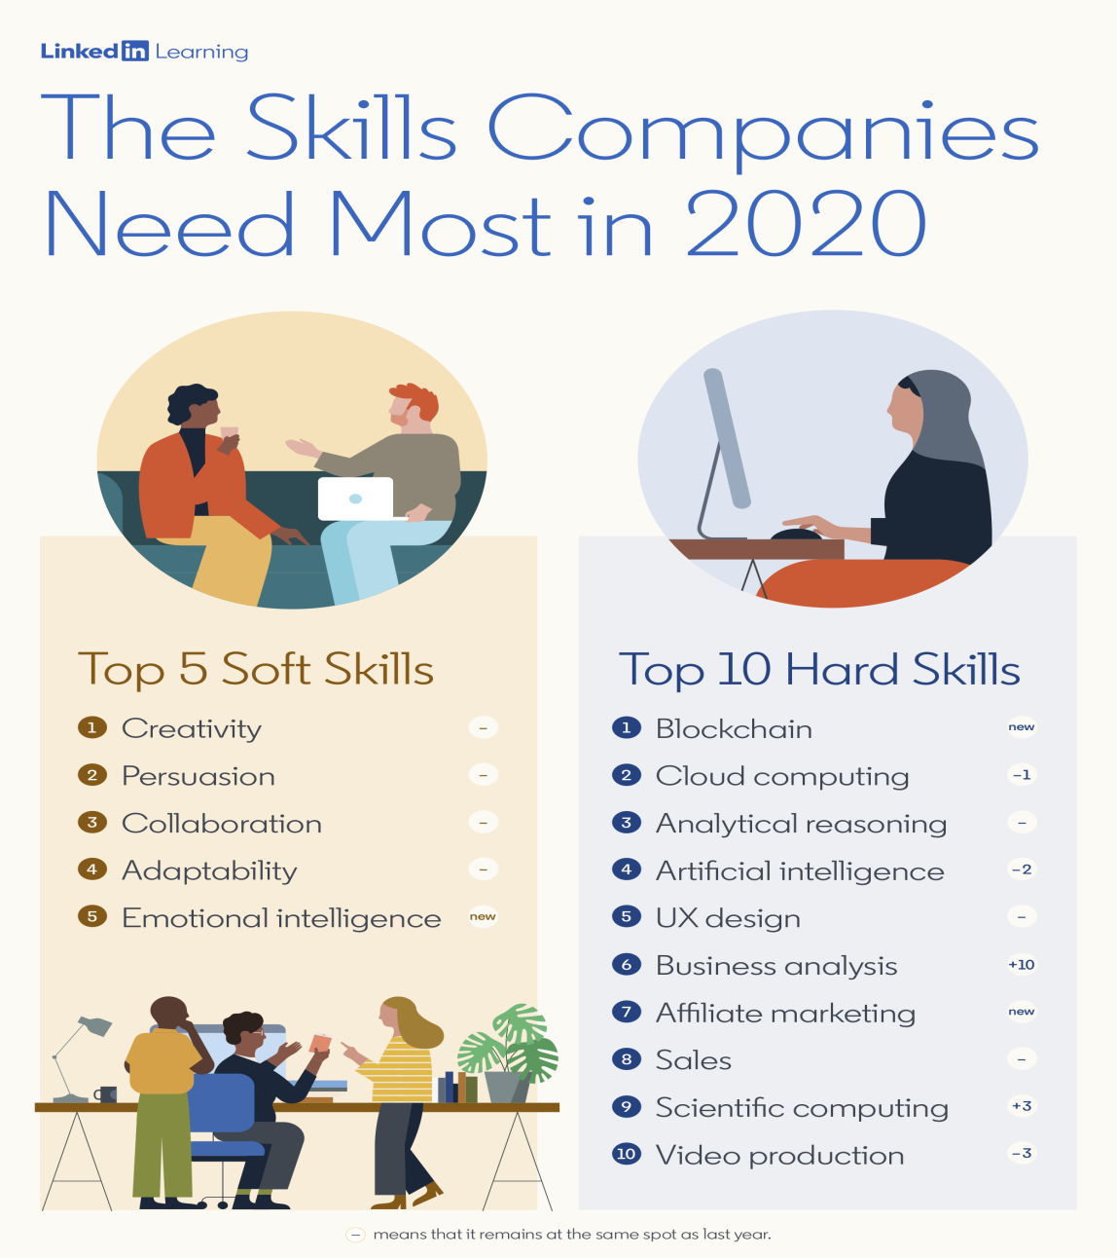

Analyse your own employability skills
Based on the above analysed employability skills and its requirement to get the job, I conducted my SWOT analysis so that I can understand areas which improvement is needed. Following is my SWOT analysis based on my employability skills:
SWOT Analysis (Personal)
Name Ana Stefaniu
Student ID 1921012
Strengths  - My verbal communication skill is my biggest strength that supported me to impress the interviewer  - I also have strong leadership skill that also supported me to motivate and encourage my team members to achieve the target | Weaknesses  - My written communication is quite weak as I sometimes get confused on how to present my points in words  - Time management skill in me also lacks due to which I failed to prioritise the activities
Opportunities  - I have the opportunity to grab the attention of an employer by improving my critical thinking through which I can enhance my problem-solving skill  - I also have the opportunity to commercial awareness by improving my research skill related to organisations where I am planning to apply. | Threats  - Threat from the competition is high, which may hinder my confidence and motivation level that is needed in my employability skills.  - I lacked in influencing skill due to which threat of reducing conflicts by using negotiation skill is associated with my career.

With the help of my SWOT analysis, it has analysed that I have opportunities to increase my understanding and knowledge about commercial awareness. It is important for me to use my research skills to gather information about industries and organisations so that I can improve my commercial awareness with the help of my research skills. I have strong leadership through which I can ensure teamwork and collaboration work. I also analysed that the Eisenhower Method supports me to prioritise the activities for time management. With the help of this time management skill, I can personally manage all the activities as per important and not important aspects so that urgent and not urgent task can be divided.

Conclusion
The above report and its analysis have concluded that employability skills in the students are important so that they can get prepared for the career where they are planning to apply. The above report has covered critical analysis of four articles that are based on employability skills. With the help of the above analysis, it has concluded that a candidate must carry communication, leadership, motivation, self-confidence etc. employability skills. These skills support the person to impress the employer and interviewer so that they can select a candidate based on analysed skills and experience. The report has also concluded that proper implementation of the employability skills supports the students to get a job as per their expectations and maintain sustainability in the profession. The report has further analysed employability skills in the student by conducting a SWOT analysis. The analysis has concluded that student has various skills which they can use to grab further opportunities in the market.

References
Jones, E., 2016. Mobility, graduate employability and local internationalisation. In Global and local internationalisation (pp. 105-116). Brill Sense.
Nägele, C. and Stalder, B.E., 2017. Competence and the need for transferable skills. In Competence-based vocational and professional education (pp. 739-753). Springer, Cham.
Nirmala, K. and Kumar, S.S., 2018. The impact of basic, higher-order thinking and affective skills on graduate employability. IUP Journal of Soft Skills, 12(1), pp.7-28.
Rowe, A.D. and Zegwaard, K.E., 2017. Developing graduate employability skills and attributes: Curriculum enhancement through work-integrated learning.
Scott, F.J., Connell, P., Thomson, L.A. and Willison, D., 2019. Empowering students by enhancing their employability skills. Journal of Further and Higher Education, 43(5), pp.692-707.
Suleman, F., 2016. Employability skills of higher education graduates: Little consensus on a much-discussed subject. Procedia-Social and Behavioral Sciences, 228, pp.169-174.
Suleman, F., 2018. The employability skills of higher education graduates: insights into conceptual frameworks and methodological options. Higher Education, 76(2), pp.263-278.
Tran, L.H.N., 2017. Developing employability skills via extra-curricular activities in Vietnamese universities: Student engagement and inhibitors of their engagement. Journal of Education and Work, 30(8), pp.854-867.

Appendix
Article 1
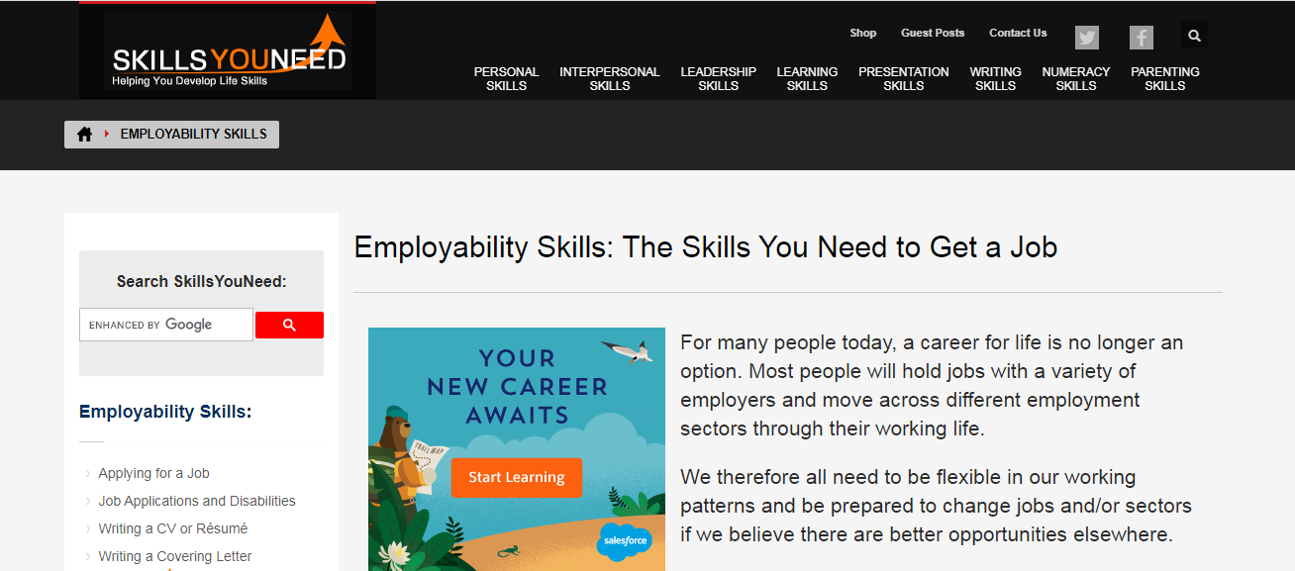
Article 2
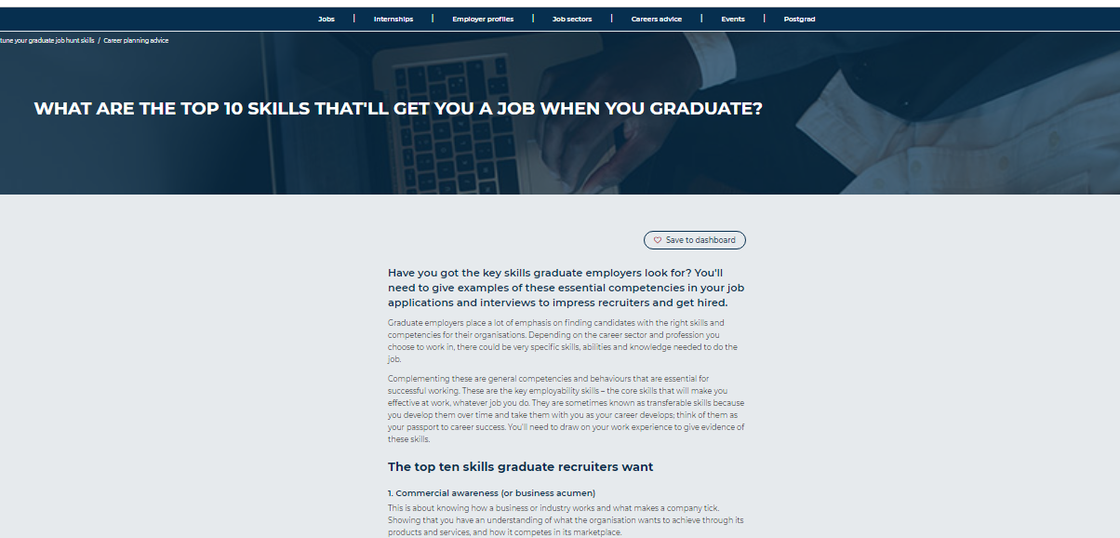

Article 3
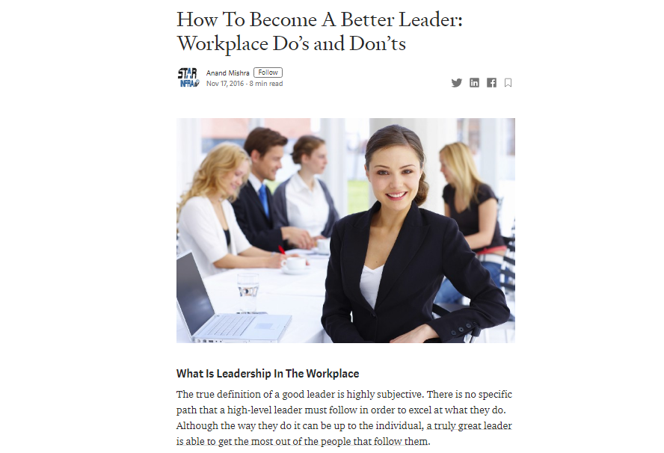

Article 4


