

LCHS7007 Population Health and Digital Health Promotion

Component 1
Student Name: - Shyam Rajeshbhai Bhalodiya
Student ID: - 2410700
Module Name :- Population Health and Digital Health Promotion
Course Coad :- (LCHS7007 Population Health and Digital Health Promotion
Module Leader :- Dr Ping Wu

Blog 1: MyFitnessPal: Tackling Obesity through Digital Nutrition Tracking
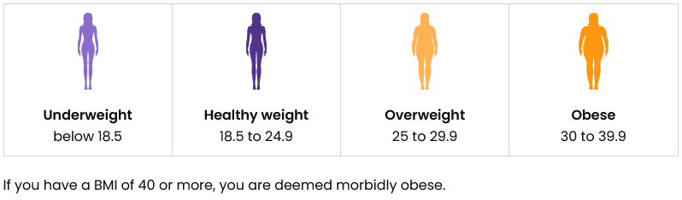
Obesity is known to have arisen as one of the most concerning health challenges around the world in the 21st century. It can be defined as abnormal or excessive fat accumulation that presents a risk to health (WHO, 2020). Obesity is also known for significantly increasing the risk of various health conditions, such as heart disease, diabetes, along with other chronic conditions. According to WHO (2024), in 2022, 1 in 8 people in the world were living with obesity, and adult obesity has more than doubled since 1990, and adolescent obesity has quadrupled. Such an alarming trend gives rise to the need for solutions that will be scalable and accessible, supporting healthier lifestyles and proper weight management.
Clear Benefits of MyFitnessPal
- Promotes mindful eating through clear visualization of daily calorie intake.
- Helps users achieve sustainable weight loss through personalized calorie and macro-nutrient goals.
- Encourages healthy behavior by highlighting nutritional values and guiding better food choices.
- Provides accountability and motivation through community interaction, enhancing adherence to dietary goals.

MyFitnessPal Overview
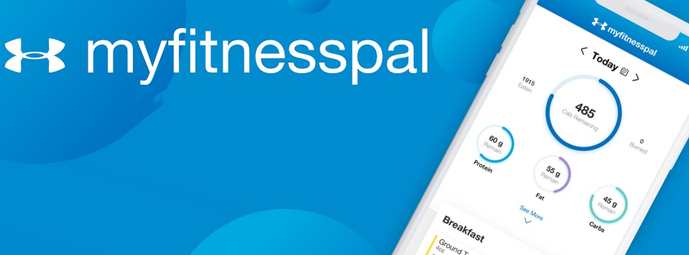
- MyFitnessPal can be defined as one such solution. It is known for being a digital application that is designed to help users to track their diet alongside physical activity (MyFitnessPal, 2024).
Source: MyFitnessPal, 2024
- MyFitnessPal features a vast food and nutrition database, along with other features including calorie-counting, meal planning and logging exercise routines. There is also an intuitive interface of the app, being able to provide data-driven feedback, empowering individuals to become much more aware of their eating habits and also make informed decisions to support their health goals (MyFitnessPal, 2024).

Evidence of Health Promotion Impact
Various studies also underscore the effectiveness of calorie-tracking apps such as MyFitnessPal regarding the promotion of weight loss and improved dietary habits. A study by Hu et al. (2020) underscores the fact that digital apps help in providing personalised nutrition recommendations, and also changes in one's food purchasing environment. It significantly helps in reducing weight among individuals with obesity. It is also essential to note that MyFitnessPal is also known to have consistently shared user-reported data, which indicates that millions of its users have successfully lost substantial weight. Many users have also attributed their success to consistent tracking and accountability provided by the app (MyFitnessPal, 2016).

Critical Analysis
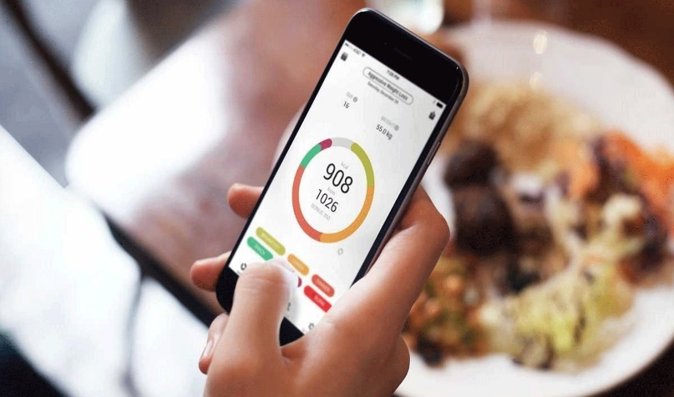
The strengths of the app reside in its user-friendly design, along with scientifically supported functionality and an extensive food database. The app is also known for encouraging self-monitoring, which can be defined as a key behaviour that is linked to successful weight management (Gavin et al., 2021).
However, it is argued by various critics that such an app might be contributing to obsessive calorie counting in various individuals. These are particularly evident in those at risk of disordered eating (Eikey, 2021). On the other hand, there is also the fact that long-term adherence can wane over time. It is essential to note that without wider emotional support, the impact of the app might be limited (Zhang, Zhao and Yu, 2023).
Key Features of MyFitnessPal
- Comprehensive calorie tracking
- Extensive nutritional information database
- Meal logging and personalized nutritional goals
- Fitness tracking integration
- Community support and motivational forums

Addressing Shortfalls
In order to address such shortfalls, it is necessary to integrate both behavioural along with psychological support in the app experience. Various features, such as mindfulness prompts along with a stress management tool, can help in mitigating obsessive tendencies, along with also encouraging a healthier relationship with food (Hu et al., 2023). On the other hand, it will also be beneficial to supplement the app with educational resources on nutrition along with a sustainable lifestyle.

Blog 2: SyntheFit: A Smart Digital Intervention for Sustainable Weight Management
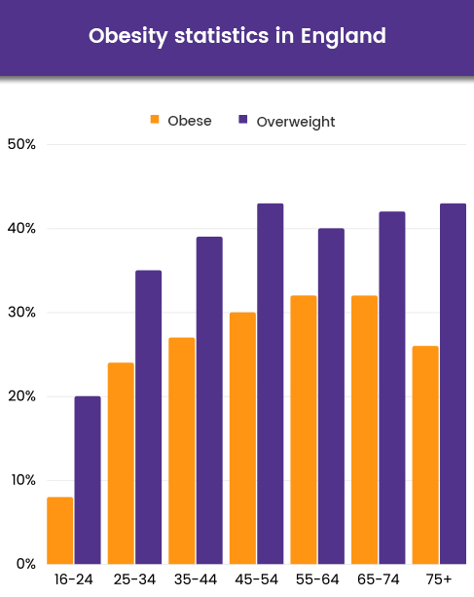
Obesity has been a pressing global health concern in the 21st century. It has the possibility of leading to various life-threatening chronic conditions, ranging from type 2 diabetes, cardiovascular diseases and certain types of cancers (Tiwari and Balasundaram, 2023). Traditional diet plans along with restrictive regimens are often known to fail in yielding sustainable results (Dorling, Martin and Redman, 2020). This brings up the urgent requirement for innovation along with long-term, and psychologically informed solutions. It is essential to note that when digital health technologies are designed with behavioural science alongside user engagement in focus, it has the possibility of presenting a promising result for combating obesity (Hinchliffe et al., 2022).

Introducing SyntheFit (Designed Technology)
One such potential solution is SyntheFit, which is an upcoming next-generation smartphone application. The app will be significantly focusing on reimagining weight management with implementing AI, mindfulness, alongside educational empowerment. Additionally, SyntheFit will also be offering users with personalised nutrition advice, that will be AI-driven in nature. It will also be customised for adapting to the dietary needs, preferences, and medical conditions of diverse users. The key features of SyntheFit will include providing dynamic meal plans for individual users, mindful eating coaching, virtual dietitian support, and community motivation groups, which will be designed for encouraging motivation.
Clear Benefits of NutriWise
- Combines nutritional tracking with mindfulness practices, reducing risk of obsessive dieting behaviors.
- Encourages sustainable eating habits through personalized guidance and mindful eating strategies.
- Enhances user motivation and long-term adherence through integrated community support and continuous positive reinforcement.

How SyntheFit Addresses Obesity
SyntheFit will be designed in a way that it will address the major drivers of obesity. The app will be promoting sustainable behavioural change, avoiding short-term fixes. SyntheFit will also be including AI-tailored meal plans, which will be developed by utilising data inputs. Those will include user preferences, their allergies, along with their health goals, which will help ensure the practicality of the overall dietary advice. The mindfulness component will also help users to get encouraged for building a healthy relationship with food, mainly focusing on hunger cues along with emotional triggers and intentional eating. On the other hand, its social features will include community features offering motivation and peer accountability.

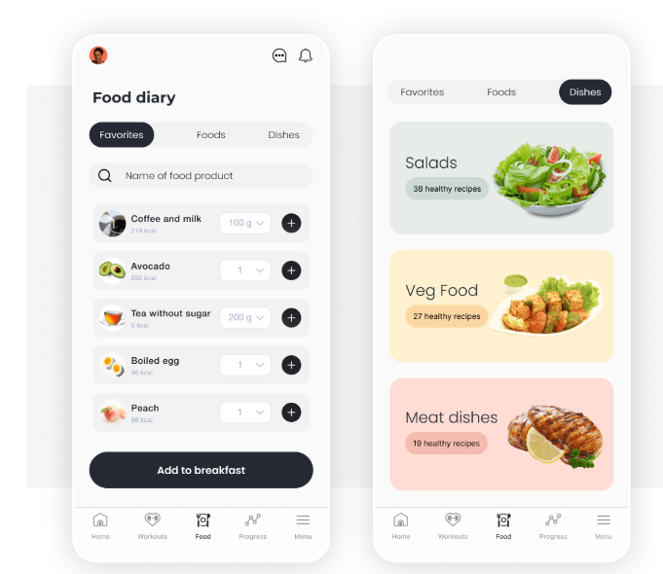
Critical Analysis of SyntheFit
One of many strengths of the app will be its integration of psychology alongside nutritional support. This will help in addressing the mental and physical dimensions of weight management. The app will also include a personalisation engine, which will help in improving user relevance (Omiwole et al., 2019). On the other hand, its mindfulness tools will help in reducing the major risk of restrictive or disordered eating patterns (Omiwole et al., 2019). It will be possible for the app to support long-term weight regulation by promoting various holistic lifestyle changes compared to rigid dieting. However, with advantages, the app also has potential challenges, such as digital literacy and access. This might result in limiting its usability among various older adults or even low-income populations (Durmuş, 2024).
Key Features of NutriWise
- AI-generated personalized nutrition plans.
- Mindful eating modules with guided sessions.
- Daily mindfulness reminders promoting mindful eating behaviors.
- Virtual dietitian support and real-time feedback.
- Active community groups for peer motivation and accountability.

Addressing Shortfalls
In order to mitigate such challenges, SyntheFit could focus on teaming up with various community health services to offer digital literacy workshops. This will help in ensuring wider accessibility (Fitzpatrick, 2023). On the other hand, by providing regular updates, such as content updates and motivational incentives, it will be possible to sustain engagement. It will also be possible to reinforce learning along with providing accountability by combining the app with in-person community health sessions through a hybrid model. By focusing on such improvements, the app could hold a strong potential as an essential tool in the fight against obesity.

References
Dorling, J.L., Martin, C.K. and Redman, L.M. (2020). Calorie restriction for enhanced longevity: The role of novel dietary strategies in the present obesogenic environment. Ageing Research Reviews, [online] 64, p.101038. https://doi.org/10.1016/j.arr.2020.101038.
Durmuş, A. (2024). The influence of digital literacy on mHealth app usability: The mediating role of patient expertise. DIGITAL HEALTH, 10. https://doi.org/10.1177/20552076241299061.
Eikey, E.V. (2021). Effects of diet and fitness apps on eating disorder behaviours: qualitative study. BJPsych Open, [online] 7(5). https://doi.org/10.1192/bjo.2021.1011.
Filho, Dr.P. (2022). Obesity Statistics 2022 • Facts and Figures in the UK. [online] www.healthexpress.co.uk. Available at: https://www.healthexpress.co.uk/obesity-statistics-uk [Accessed 27 Mar. 2025].
Fitzpatrick, P.J. (2023). Improving Health Literacy Using the Power of Digital Communications to Achieve Better Health Outcomes for Patients and Practitioners. Frontiers in Digital Health, [online] 5(1). https://doi.org/10.3389/fdgth.2023.1264780.
Gavin, K.L., Sherwood, N.E., Wolfson, J., Pereira, M.A. and Linde, J.A., (2021). Characterising self-monitoring behavior and its association with physical activity and weight loss maintenance. American Journal of Lifestyle Medicine, 15(2), pp.173-183.
Hinchliffe, N., Capehorn, M.S., Bewick, M. and Feenie, J. (2022). The Potential Role of Digital Health in Obesity Care. Advances in Therapy, 39(10). https://doi.org/10.1007/s12325-022-02265-4.
Hu, E.A., Nguyen, V., Langheier, J. and Shurney, D. (2020). Weight Reduction Through a Digital Nutrition and Food Purchasing Platform Among Users With Obesity: Longitudinal Study. Journal of Medical Internet Research, 22(9), p.e19634. https://doi.org/10.2196/19634.
Hu, J., He, W., Zhang, J.J. and Song, J. (2023). Examining the Impacts of Fitness App Features on User Well-Being. Information & Management, [online] 60(5), p.103796. doi:https://doi.org/10.1016/j.im.2023.103796.
MyFitnessPal (2016). Free Calorie Counter, Diet & Exercise Journal | MyFitnessPal.com. [online] Myfitnesspal.com. Available at: https://www.myfitnesspal.com/welcome/success_stories [Accessed 27 Mar. 2025].
MyFitnessPal (2024). MyFitnessPal. [online] Myfitnesspal.com. Available at: https://www.myfitnesspal.com/ [Accessed 27 Mar. 2025].
Omiwole, M., Richardson, C., Huniewicz, P., Dettmer, E. and Paslakis, G. (2019). Review of Mindfulness-Related Interventions to Modify Eating Behaviors in Adolescents. Nutrients, 11(12), p.2917. doi:https://doi.org/10.3390/nu11122917.
Tiwari, A. and Balasundaram, P. (2023). Public Health Considerations Regarding Obesity. [online] PubMed. Available at: https://www.ncbi.nlm.nih.gov/books/NBK572122/ [Accessed 27 Mar. 2025].
WHO (2020). Obesity. [online] WHO. Available at: https://www.who.int/health-topics/obesity [Accessed 27 Mar. 2025].
WHO (2024). Obesity and overweight. [online] World Health Organization. Available at: https://www.who.int/news-room/fact-sheets/detail/obesity-and-overweight [Accessed 27 Mar. 2025].
Zhang, T., Zhao, J. and Yu, L. (2023). The Effect of Fitness Apps Usage Intensity on Exercise Adherence Among Chinese College Students: Testing a Moderated Mediation Model. Psychology Research and Behavior Management, [online] 16, pp.1485–1494. https://doi.org/10.2147/PRBM.S408276.



