PROBLEM SOLVING AND DECISION MAKING

LECTURER NAME – Bianca Sanfilippo
course code – bmsw4004
Kabirat Aderoju Adegbite (2011967)

Table of Contents
Introduction 3
An overview of problems in healthcare 3
Problem definition or problem statement 3
Discuss the impact of the problem on all the stakeholders 7
Analysis (Decision-Making process) 9
Recommendations/ Alternative Solutions 11
Conclusion 13
Appendix 14
Fishbone Analysis 1.1 14
PESTLE Analysis 1.2 15
PMI Chart 1.3 16
ADKAR 1.4 17
References 19

Introduction
In this assignment I will be finding a problem within the healthcare and solution for the problem using different techniques/tools. I will be looking for different decision-making technique to solve the problem also looking at the impact of the problem on stake holders of the organisation. I will also be suggesting different solutions on how the problems can be for the healthcare system to operate well for the people that are affected by the problems.

An overview of problems in healthcare
There are many aspects of problems within the healthcare in UK that affects the workforce, this problem becomes a disadvantage to the growth of the organisation because there are many people to be considered in other for such problems not to occur. The problems are varied which affect many people lives such as Lack of communication between staff or management, Low pay and insufficient breaks, Low patients to staff ratio, gender inequality.

Problem definition or problem statement
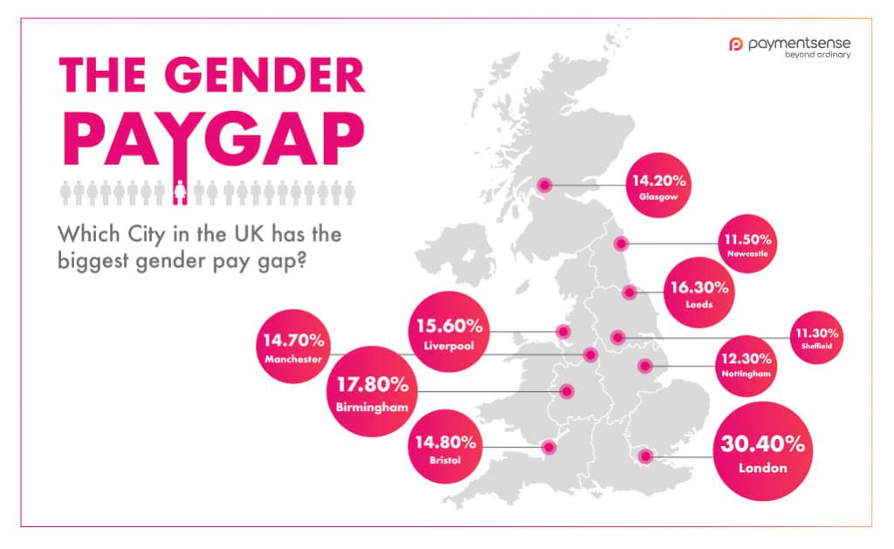

Figure 1: Gender inequalities / pay gap
Source: (PaymentSense, 2019)
I will be discussing Gender inequality / Gender pay gap is when individuals are being treated unequal due to their gender (Course.LumenLearning, 2021) , gender inequality / pay gap is not a discrimination but it is a the extent of inequality and it dives into equal pay for equal work between men and women (Ortiz-Ospina & Roser, 2018). The gender pay gap review the different regular earnings of men and women within an organisation, it highlights the percentage of men earnings. Gender inequality/ pay gap is a global problem that affect every individual in different part of the world. This problem is mainly between men and women which affect different areas of their work, social life, and family. The main issue in gender inequality is the pay gap amongst men and women who work in the NHS.
Professors Dame Jane Dacre and Carol Woodhams’s did a study and review the gender pay gap in medicine was done thoroughly and it is by far the most extensive study that was done for the gender pay gap in a selected sector which was ever undertaken particularly in the UK. The review gave an insight on how carefully they evaluate of the causes of the gender pay gap in medicine, but also address lays out concrete solutions to ensuring the problem addressed is balance (Dacre & Woodhams, 2020). They analysed the records of 86,000 trust doctors over a period of 10 years, 16,000 GPs and 4,500 clinical academics (Dacre & Woodhams, 2020).
In March 2020 an article was written by Professor Dame Jane Dacre about gender pay gap within the healthcare sector encouraging the government to act on the gender inequality issues and to allow women to take a bold step in senior position within the healthcare (Dacre, 2020).
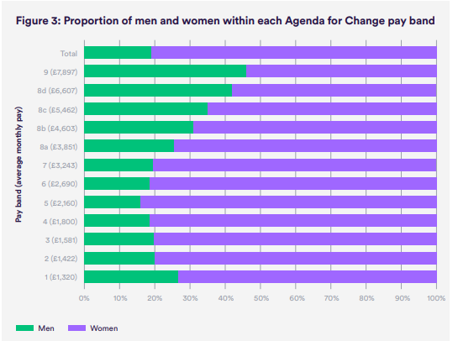

Figure: The chart above shows the capacity of men and women who worked in the NHS as of year 2018.
Source: (Appleby & Schlepper, 2019)

Study shows that the basic earning for majority of staff who work in the NHS is between £500 to £4,500 per month and there is noticeable group which is mainly men that their earnings is from £6,000 to 39,500 a month (Appleby & Schlepper, 2019). Staffs who are employed directly by NHS are 77% of whom are women and 23% are men, in December 2017 the average pay gap for men who work fulltime was 8.6%. This was equivalent to an earnings gap of £207 over that month, equivalent to around £2,500 a year (Appleby & Schlepper, 2019).
Nuffield trust research shows that the overall gender pay gap of 8.6% favours men, but the figure is a total for all staff within the NHS which has various people in different job roles, pay grades and personal attributes (Appleby & Schlepper, 2019).
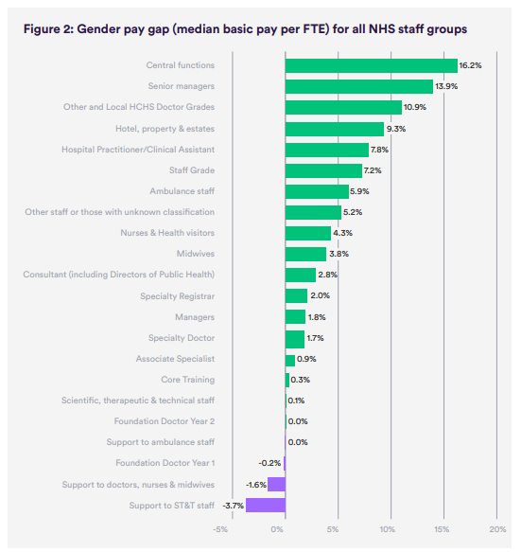
Figure: this image shows the gender page within different group of staffs in the NHS.
Source: (Appleby & Schlepper, 2019)
In NHS most of the staffs are women and despite those women make up almost half of the NHS staff and they are still in the minority of senior roles (NHSDigital, 2018). The British Medical Association state that the gender pay problem for women does not start at beginning of their career, the extent of this problem start between the ages women starts to give birth and have their own family and there will not be any changes until they reach about 60 years old before they start catching up with the men’s pay (British Medical Organisation, 2020). The gender pay gap is still a problem because women are still being underrepresented in the higher paid position within healthcare for example women who are in a supposed high position in a hospital as a doctor still earn about 18.9% less that men while the women who work at GPs earn 15.3% less than men (British Medical Organisation, 2021).
Management
Cutting down hours due to parental duties
Giving men better senior roles
Environment
Female being discouraged to apply for senior roles
The society are not raising the issues more as they should

Gender Inequalities / pay gap
Within
Healthcare

Health
Feeling unworthy and mentally drained.
Stressed.
People
Men colleague having more appraisal than women
Staff will not provide good service to their patient

Figure: fishbone Analysis
Source: Made by me
There are many potential aspects of this problem, but the main ones are that men will keep having more experience in the healthcare field because they are in more productive position, because some women especially the ones with family work short hours their work pattern will be different.
Covid -19 pandemic has also put a strain on the gender inequality/ pay gap because more women in the medical field will have to prioritise their family which might affect their career progression. This is because there are childcare issues and the women who work full time have had to cut down their hours (Dacre & Woodhams, 2020)
The government has advanced the legislation to tackle discrimination and encourage equality within the workplace, they advised company who employs more than 250 staff should ensure they issue headline details of their gender pay gap they are required to carry out this by following the guideline of the 2017 regulation of equality act 2010 (Appleby & Schlepper, 2019). The effect of this problem is that private or voluntary sector organisation are not liable to comply with the equality act 2010 in England, Wales, and Scotland, especially companies who have less than 250 employees (GovernmentEqualitiesOffice, 2016).
Jane Dacre have done some research to reduce the gender inequality/ gender pay. They have done reviewing and modernising the pay structure and reducing the number of salaries cut off points which would make a big difference, also decreasing the catch-up time for the people who have taken some time off or have decided to cut down (Dacre, 2020).

Discuss the impact of the problem on all the stakeholders
Political | Economical | Sociological | Technological | Legal | Environmental
The political factors are that the government are trying to make as many changes as possible so they can stop gender inequality. | Gender inequality is a common economical problem. The main issues are that men are still getting paid more than women even while in full time work. | The cultural aspect of gender inequalities is that it affects the health of individuals involved and their mental well-being also, because they will start feel like they are not good enough for the society to accept them and appreciate them for who they are or what they represent. | Technology has helped advanced gender inequality issue by speeding up decision making process, the internet allows all individuals to express their self and discuss gender inequality openly. Social media also contributes to spreading false news and post about people which affects their wellbeing. | There is a legislation that protects people from being discriminated against. It is called Equality Act 2010. | The Environment need to consider allowing women to have access to things globally without any limit also ensuring any policies written should be referring to both men and women. Preventing both gender from any form of violence but especially women and allowing them to speak and defend themselves.

Figure: PESTLE Analysis
Sources: Made by me
The impact of gender inequality/ pay gap on stake holders is that they will be affected badly because they do not want a bad reputation for the organization they work for or lose any form other investment. The impact of the gender inequality / pay gap is that staff will not be motivated to provide good care for their patient because they are not satisfied and not being listen to by their workplace. For example, most hospitals and GP doctors are male, some patient who prefer to have a woman care for them will be uncomfortable to attend the hospital or GP because they do not have any other option of care for them. Since most women who are in higher positions work part time which means patient must book their appointment during the times, they are in which can be an inconvenience for them.
Specifically, women who are professionals are the ones this problem will influence both mentally and physically because their self-confidence and self-worth will decrease drastically because they are not being considers and paid same way some men are being paid. Their contribution in the workplace will be affected because they have the impression that because they are not being motivated to go for higher positions and paid the salary that fits their position, they are working but the men in their workforce get more money than the average.
All employees who are accepted into any kind of employment should be aware of The Equality Act 2010 regulation 2017, it protects the employee from being discriminated in any shape or form.
- The equality act provides protection employees against discrimination, harassment, and victimization in services or in public, at work, school, association, and transport (Holden, 2019).
- This act protects individuals from being discriminated against because they are associated with someone who has a protected characteristic which are age, disability, gender reassignment, marriage and civil partnership, pregnancy and maternity, race, religion, or belief and sex (Holden, 2019)
- The equality act also allows claims of either direct or indirect gender pay discrimination and employment tribunals have powers to make recommendations if there are any suspect discrimination (Holden, 2019).

Analysis (Decision-Making process)
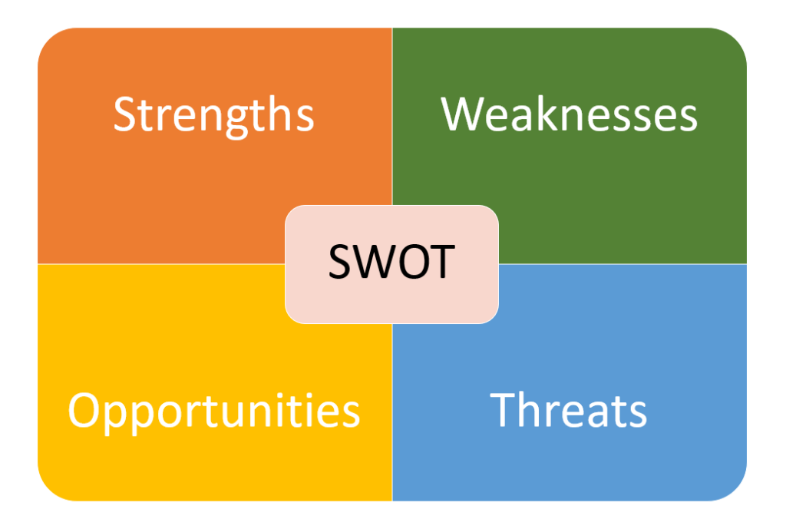Figure: SWOT Analysis
Source: (Tallyfy, 2018)
Strength- NHS are now using equality effect assessment to evaluate and review recruitment and promotion policies and the process to ensure any form of obstruction that preventing recruitment or promotion in their workforce will be removed (NHSHumberTeaching, 2020)
Weakness – Women could be in senior position are building family which makes it hard for them to go into full time work because of their children. The senior job opportunities are very demanding, and they need to ensure they are attentive and fully focus on the job.
Opportunities – NHS need to create more senior opportunities for women who have families and make it flexible for them to work also ensuring their payment is the same has the men colleague in their work environment. Encourage them by providing training system to handle workloads within the senior positions and support systems.
Threats – the threats will be that more women will be unemployed within the healthcare if care is not taken because they want to be treated equality and have higher expectations for them but if the healthcare sector are not improving the pay gap within their staffs, then a lot of women will be out of work.
There is a gender pay group which NHS England has created, which they are actively participating in the group improve the gender pay gap. The group role is to identify and support further new programs to improve the NHS and the NHS improvements position that’s dealing with gender pay. There group includes different department from the HR, OD group, Trade Unions, and the Women’s Network (PeopleandOrganisationDepartmentTeam, 2019).
As mentioned above the Equality Act 2010 Regulation 2017 ensures that all organization has more than 250 employees should ensure they publish their earnings for the year this is because unequal pay for men and women has been illegal for 45 years, if the information’s about their gender pay that is meant to be publish are not done accurately or reported at all then there will be penalties and the organization will risk having a bad reputation (GovernmentEqualitiesOffice, 2020). The act only applies to organizations that are publicly owned such as NHS.
Plus (+) | Minus (-) | Interesting/implications
Creating healthy and comfortable environment for female staffs (+5) | It might be time consuming and look unfair to the male staffs (-2) | Women will feel more comfortable attending work because they will be getting support (+5)
Create new job opportunity that women are underrepresented (+5) | Some people might end up unemployed (-3) | More opportunities for new recruited (+5)
Additional payment should be added to the work standard agreement for staff who have been promoted in order to avoid any form of debate or discussion about it (+5) | It will cost the employer more money and disrupt their budget (-2) | Less discussion will be held because payment will already have been added to work standard (+5)
Reducing the percentage of men getting promoted and increasing the promotion rate for women (+5) | Men will have less opportunity for advancing their career (-3) | Women will encourage their selves more and strive to keep applying for better opportunities (+5)
Flexible working opportunities should be offer including shared parental leave (+5) | Might disrupt working hours and back log of work will rise (-3) | Part time position will be available if needed so that parent can deal with their childcare issues (+5)
Take suggestions from women and incorporate it to their duties which will gain them experience (+5) | The men in the organisation might feel isolated or uncomfortable with new ideas (-1) | Their voices are being heard and making their job easier for them to understand and produce good quality of service (+5)
Employee should voice their opinions about their pays and treatment from their employers when they feel like they are being treated different (+5) | Employers might get the wrong idea that their staffs are feeling too entitled which could cause a lot of chaos  (-3) | Management will take opinions into considerations and act on it to avoid any form of slandering on the company (+5)
Ensuring all information about staff pay are being published accurately for government to review that all gender is paid for their work (+5) | staffs might see this information and feel like they are being cheated and some might even go as far as leaving the job. (-2) | There will be transparency and the organisation will also have good reputation (+5)
Total = (+40) | Total = (-19) | Total = (+40)

Figure: PMI
Sources: Made by me

Recommendations/ Alternative Solutions
Women who have taken time off work for their personal reasons should not be isolated rather than that, opportunities of new development for their experience should be offered to them in a positive light, such as creating new career pathways for them and be encourage them in taking new senior position which there are lesser women working there.
In regarding to payment for new job roles there should be policy or standard in place that allows women have additional payment, so that there will not be any form of dispute while in the position because everything will have been sorted and probably added to their new job agreement.
Awareness | Desire | Knowledge | Ability | Reinforcement
Gender inequality/ gender pay gap is an ongoing issue within the UK many individuals are not aware that this problem is within their organisation, NHS which is a big organisation within our community also has gender inequality/ pay gap problem in their organisation. NHS need to ensure they are transparent with their staffs and treat them equally either they are a man or woman. | NHS, which is a public service, need to ensure they are making a lot of changes or finding some sort of solution to reduce the gender inequality/ pay gap within their organisation for new employee. They need to ensure that the women in their organisation should not be paid less or treated differently because of their gender. They have set a good standard for the name of the organisation so that it does not tarnish their image because less people will not want to be associated with them. | Providing adequate training for women who are willing to take up on more opportunity, ensuring they are well prepared and have every support they need to manage the new position they are in.  Pay them well according to what they have work for not because they are a woman or because they have other responsibility in their personal life has a woman | Allow women employee give view of what they can contribute to in their working environment.  They should have access to things that men are majorly involve without being shut out or shutting down their opinions.  Letting women apply and have as much access to senior position as much as men do because majority of the men working in high position in NHS are men so women should be given same opportunity.  They should not be discouraged at any given time. | Updating and monitoring men and women salary in each department in the hospital every 3 month.  Monitoring promotion rate between both genders regularly and ensuring all department are following the Equality act 2010 regulation2017 guidelines  Manager should ensure all new women employee have their own voice and have the confidence to apply for senior roles.  Make training sector accessible for the new senior employees.  Monitoring the gender pay gap information that is publish is accurate without any clause or form of excuses.

Conclusion
In conclusion I think NHS should ensure they put in more effort in supporting women because majority of their staffs are women, and they need to be allowed to work during the times that’s convenient for them but of course putting the organization into consideration because they are still than employee in the organization. I think the men who are in the senior position and can recommend their female colleague for higher opportunity should also push the agenda of women having senior roles even if they have families.
Women who have families should not feel isolated from pursuing new opportunities because they might even do job better than the men in that position and they should be getting paid what they are worth not because they are women.
This problem could affect some women mental health as they will feel they are not worthy of new position or they are not capable of acquiring new experience for better job roles, to avoid this type of problem the healthcare sector must ensure employees get all the support they to make progression.
The training which NHS England decides to provide women should be of the same standard men have sort that there is not partiality and judgement based on their experience. They should be allowed to shadow their male counterparts and learn from themselves also so that they will be fit for the job.

Appendix

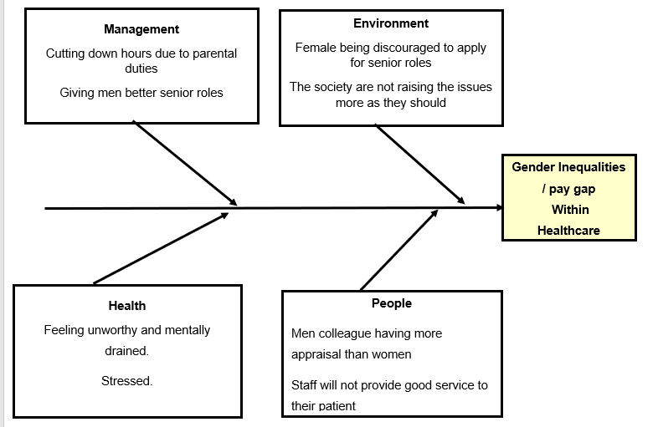
Fishbone Analysis 1.1

PESTLE Analysis 1.2
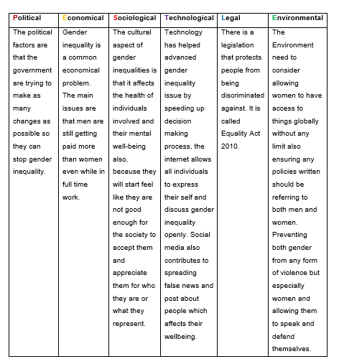

PMI Chart 1.3
Plus (+) | Minus (-) | Interesting/implications
Creating healthy and comfortable environment for female staffs (+5) | It might be time consuming and look unfair to the male staffs (-2) | Women will feel more comfortable attending work because they will be getting support (+5)
Create new job opportunity that women are underrepresented (+5) | Some people might end up unemployed (-3) | More opportunities for new recruited (+5)
Additional payment should be added to the work standard agreement for staff who have been promoted in order to avoid any form of debate or discussion about it (+5) | It will cost the employer more money and disrupt their budget (-2) | Less discussion will be held because payment will already have been added to work standard (+5)
Reducing the percentage of men getting promoted and increasing the promotion rate for women (+5) | Men will have less opportunity for advancing their career (-3) | Women will encourage their selves more and strive to keep applying for better opportunities (+5)
Flexible working opportunities should be offer including shared parental leave (+5) | Might disrupt working hours and back log of work will rise (-3) | Part time position will be available if needed so that parent can deal with their childcare issues (+5)
Take suggestions from women and incorporate it to their duties which will gain them experience (+5) | The men in the organisation might feel isolated or uncomfortable with new ideas (-1) | Their voices are being heard and making their job easier for them to understand and produce good quality of service (+5)
Employee should voice their opinions about their pays and treatment from their employers when they feel like they are being treated different (+5) | Employers might get the wrong idea that their staffs are feeling too entitled which could cause a lot of chaos  (-3) | Management will take opinions into considerations and act on it to avoid any form of slandering on the company (+5)
Ensuring all information about staff pay are being published accurately for government to review that all gender is paid for their work (+5) | staffs might see this information and feel like they are being cheated and some might even go as far as leaving the job. (-2) | There will be transparency and the organisation will also have good reputation (+5)
Total = (+40) | Total = (-19) | Total = (+40)

ADKAR 1.4
Awareness | Desire | Knowledge | Ability | Reinforcement
Gender inequality/ gender pay gap is an ongoing issue within the UK many individuals are not aware that this problem is within their organisation, NHS which is a big organisation within our community also has gender inequality/ pay gap problem in their organisation. NHS need to ensure they are transparent with their staffs and treat them equally either they are a man or woman. | NHS, which is a public service, need to ensure they are making a lot of changes or finding some sort of solution to reduce the gender inequality/ pay gap within their organisation for new employee. They need to ensure that the women in their organisation should not be paid less or treated differently because of their gender. They have set a good standard for the name of the organisation so that it does not tarnish their image because less people will not want to be associated with them. | Providing adequate training for women who are willing to take up on more opportunity, ensuring they are well prepared and have every support they need to manage the new position they are in.  Pay them well according to what they have work for not because they are a woman or because they have other responsibility in their personal life has a woman | Allow women employee give view of what they can contribute to in their working environment.  They should have access to things that men are majorly involve without being shut out or shutting down their opinions.  Letting women apply and have as much access to senior position as much as men do because majority of the men working in high position in NHS are men so women should be given same opportunity.  They should not be discouraged at any given time. | Updating and monitoring men and women salary in each department in the hospital every 3 month.  Monitoring promotion rate between both genders regularly and ensuring all department are following the Equality act 2010 regulation2017 guidelines  Manager should ensure all new women employee have their own voice and have the confidence to apply for senior roles.  Make training sector accessible for the new senior employees.  Monitoring the gender pay gap information that is publish is accurate without any clause or form of excuses.

References
Appleby, J. & Schlepper, L., 2019. Nuffield Trust. [Online]
Available at: https://www.nuffieldtrust.org.uk/files/2019-05/gender-pay-gap-briefing-ne1883-5.pdf
[Accessed 09 August 2021].
Appleby, J. & Schlepper, L., 2019. Nuffield Trust. [Online]
Available at: https://www.nuffieldtrust.org.uk/files/2019-05/gender-pay-gap-briefing-ne1883-5.pdf
[Accessed 11 August 2021].
British Medical Organisation, 2020. British Medical Organisation. [Online]
Available at: https://www.bma.org.uk/media/3617/bma-commentary-on-medicine-gender-pay-gap-dec-2020.pdf
[Accessed 06 August 2021].
British Medical Organisation, 2021. British Medical Organisation. [Online]
Available at: https://www.bma.org.uk/pay-and-contracts/pay/how-doctors-pay-is-decided/review-of-the-gender-pay-gap-in-medicine
[Accessed 06 August 2021].
Course.LumenLearning, 2021. Course.LumenLearning. [Online]
Available at: https://courses.lumenlearning.com/culturalanthropology/chapter/anthropology/
[Accessed 04 Aug 2021].
Dacre, P. D. J., 2020. GP Online. [Online]
Available at: https://www.gponline.com/viewpoint-nhs-bold-steps-end-gender-inequality-within-medicine/article/1676310
[Accessed 04 September 2021].
Dacre, P. D. J. & Woodhams, P. C., 2020. GOV.UK. [Online]
Available at: Mend the Gap: The Independent Review into Gender Pay Gaps in Medicine in England - December 2020 (publishing.service.gov.uk)
[Accessed 10 August 2021].
GovernmentEqualitiesOffice, 2016. Asset Publishing Service. [Online]
Available at: https://assets.publishing.service.gov.uk/government/uploads/system/uploads/attachment_data/file/500087/Government_response_-_Closing_the_Gender_Pay_Gap.pdf
[Accessed 07 August 2021].
GovernmentEqualitiesOffice, 2020. GOV.UK. [Online]
Available at: https://www.gov.uk/guidance/the-gender-pay-gap-information-employers-must-report
[Accessed 09 August 2021].
Holden, K., 2019. Business Advice. [Online]
Available at: https://businessadvice.co.uk/hr/employment-law/the-equality-act-gender-pay-gap-discrimination-and-inclusion/
[Accessed 08 August 2021].
NHSDigital, 2018. NHS Digital. [Online]
Available at: https://digital.nhs.uk/news-and-events/latest-news/narrowing-of-nhs-gender-divide-but-men-still-the-majority-in-senior-roles
[Accessed 05 August 2021].
NHSHumberTeaching, 2020. Humber NHS. [Online]
Available at: https://www.humber.nhs.uk/downloads/Equality%20and%20Diversity/2021/Gender%20Pay%20Gap%20Report%202020.pdf
[Accessed 09 August 2021].
Ortiz-Ospina, E. & Roser, M., 2018. Our World in data. [Online]
Available at: ourworldindata.org/economic-inequality-by-gender
[Accessed 06 August 2021].
PaymentSense, 2019. Payment Sense. [Online]
Available at: https://www.paymentsense.com/uk/blog/uk-gender-pay-gap/
[Accessed 10 August 2021].
PeopleandOrganisationDepartmentTeam, 2019. England NHS. [Online]
Available at: https://www.england.nhs.uk/wp-content/uploads/2018/03/gender-pay-gap-report-march-2019.pdf
[Accessed 11 August 2021].
Tallyfy, 2018. Tallyfy. [Online]
Available at: https://tallyfy.com/swot-analysis/
[Accessed 08 August 2021].

