University of Wales Trinity Saint David

School of Engineering

Bicycle Frame: Materials and Manufacturing Methods Report

Oksana Gomzjakova

1706480

Energy and Environmental Engineering

28.04.2018

Material & Manufacturing (M4X01511)
Contents
1. Introduction 3
2. Materials used for bicycle frame 4
2.1. Types of materials ……………………………………………………………………………………………………………………..4
2.1.1. Steel ……………………………………………………………………………………………………………………………………….4
2.1.2. Aluminum ……………………………………………………………………………………………………………………………….4
2.1.3. Titanium …………………………………………………………………………………………………………………………………4
2.1.4. Magnesium alloy …………………………………………………………………………………………………………………….5
2.1.5. Carbon Fibre …………………………………………………………………………………………………………………………..5
2.2. Carbon fibre as final material choice …………………………………………………………………………………………5
3. Manufacturing methods used for frame 8
3.1. Overview of processes ……………………………………………………………………………………………………………………..8
3.2. Final manufacturing method ……………………………………………………………………………………………………………9
4. Conclusion 11
References 12

Introduction
The purpose of this report is to research the variety of suitable materials to fabricate a bicycle frame, as well as possible manufacturing processes are involved to produce a bicycle frame. The pros and cons of different range of materials and processes are discussed in this work.
The frame of the bike is the main structure to support the external loads, so it is inevitably important to choose a suitable material and manufacturing process to produce it. At the Picture 1 is represented bicycle frame made from carbon fibre, it’s weight is only 1.600 grams (Hill, 2012):
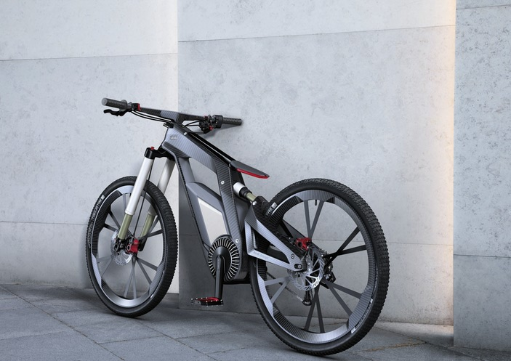
Picture 1: The Audi e-bike frame made from carbon fibre

Materials used for bicycle frame

  - Types of materials
The frame of bicycle is a critical part which can decide the final performance of the bicycle since it supports the whole structure of the bike. As Miravete describes (Miravete, 1993) this: “The frame should be strong enough to support the load and the impacts during normal and off-the-road riding. It also should have adequate flexibility which can absorb the vibration during riding and give the rider a comfort feeling without disturbing the alignment of the whole structure which is very important to minimize the energy loss.”
Bicycle frames are made from a vast assortment of materials or combination of materials. Despite the wide range of materials, the aim is always to make the strongest, the lightest frame possible for the money. Each material has different characteristics and will affect the cost, comfort, weight, stiffness, strength, durability and general 'feel' of the bike.
    - Steel
Steel is one of the first materials that has been used in bicycle production. It is available in vast range of alloys and tube shapes. Steel can easily be shaped. Steel tubes can be joined by a wide range of methods including silver soldering, brazing, gas metal arc welding (GMAW) and gas tungsten arc welding (GTAW). Also, steel tubes can be joined by adhesives. In most cases steel does not require any post-welding heat treatment (Cheung & Zabala, 2017) . One of advantages of using steel for bicycle frame is, that steel has great fatigue resistance. Although the cons is that steel has an endurance limit. Theoretically, steel frame could last forever but only in case the stresses are kept below this limit. Also, the steel frame is probably the heaviest comparing with other materials used for bike frames.
    - Aluminum
Also comes in an assortment of alloys and tubes. Aluminum can be shaped but requires annealing sometimes and further post-shaping heating. Aluminum tubes are usually joined by GTAW welding. The cons is that frames made of aluminum require post-welding heat treatment, which varies with the alloy. It is light and easy processing material, but it has no endurance limit, which means each riding brings it closer to failure. Also, the aluminum has quite low ultimate tensile stress feature comparing with steel. Another cons is, that aluminum frame could corrode and can react adversely with carbon fibre components.
    - Titanium
Titanium has a limited number of alloys and tube shapes available. The 3/2.5 alloy is most commonly used, and it can be shaped. Titanium tubes are usually joined by GTAW welding, but adhesives are also used for titanium frames. Welding is possible with shielding gas. Titanium tubes do not corrode and has an endurance limit. Although this material is very expensive, also, this resource is quite limited for extraction from earth.

    - Magnesium alloy
Magnesium alloy had a low density and high strength-to-weight ratio. Among the metals used for bicycle frames, magnesium has the best capacity to dampen road vibrations. It is also easy in the manufacturing processes, some of the alloys weld easy (Cheung & Zabala, 2017)
The advantages of using metals for bicycle frames is that metals are isotropic, which means that their properties are the same in all directions. While the carbon is extremely strong in an intended direction but not necessarily means it will be strong in other directions (Anderson, 2015)
    - Carbon fibre
Another, popular alternative for bicycle frames and components is carbon fibre composite material, which perhaps the best material to minimize weight and it is strong enough as can be ridden to its limit in the toughest places.
  - Carbon fibre as final material choice
Carbon fibre composites have been finally chosen to produce a bicycle frame. Carbon fibre reinforced polymer composite materials have been increasingly replacing conventional materials due to their superior characteristics, such as their excellent strength and low specific weight properties (Lee, et al., 2018). As opposed to the isotropic properties of metals, carbon fibre tubes anisotropic – the properties are depended on fibre angle, number of plies and sequence of layup. However, strength stiffness fall rapidly when the fibers are oriented off axis, as sown on Figure 1 (Unknown, 2015). The plies of a quasi-isotropic layup are stacked in a 0°, –45°, 45°, and 90° sequence or in a 0°, –60°, and 60° sequence as shown on Figure 2 (Unknown, 2017). These types of ply orientation simulate the properties of an isotropic material
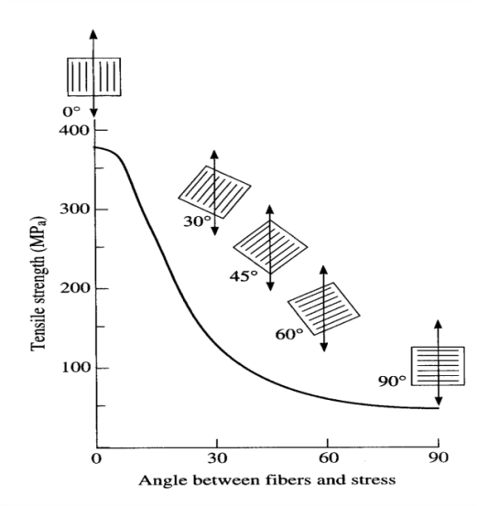
Figure 2. The relation of angles of plies

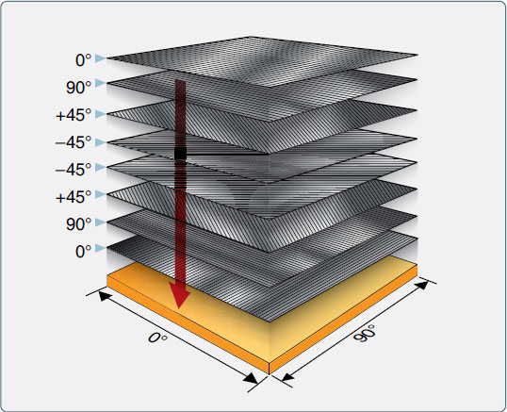
Figure 2. The quasi-isotropic material lay-up
This feature allows the engineer to tailor the ride characteristics of a frame.
Carbon fibre composites show much higher stiffness and low density, thus, allowing the thinner, stiffer and lighter frames. Moreover, they have comparatively low damage tolerance, compressive strength and ultimate strength. The structure of composite materials consists of two components, namely matrix and reinforcement. Matrices involve metallic, polymer or ceramic materials, whereas reinforcements are in the form of fibers, particles or crystal filaments. In general, reinforcements (fibers) act as the main load bearing element, whereas matrix encloses the fibers and protects them in the desired direction (Karatas & Gokkaya, 2018).
Carbon fibre construction also requires an epoxy resin, which fixes the fibers within a ply. Another vital characteristic of resin is its strength to handle impacts and vibrations, which is very important in bicycle frame structure. The properties of carbon fibre composite are based on the rule of mixtures, mathematical expressions that give a property of composite in terms of the properties quantity (Cheung & Zabala, 2017).
Another important pros of carbon fibre bicycle frame is that its strength, stiffness and ride characteristics are controllable during the manufacturing processes to give exactly what is required for the requirements of the riding and rider. Carbon fibre can be moulded into any shape, thus making highly aerodynamic designs as possible (Unknown, 2018).
Among all the superior characteristics, carbon fibre composite used for manufacturing the bike frames is that it is brittle. The frame from this material has quite low resistance to accidental knocks and frame could break suddenly, without warning.
Actual strength and stiffness of the individual fibres can vary, with the stiffness being described as modulus. Higher modulus is achieved by increasingly refining the filament production process, stripping each filament further and further down, and progressively making it smoother and thinner. While more resource-intensive, these thinner filaments also sit more tightly together in a tow and increase the stiffness of the tow overall. However, higher modulus is associated with increased brittleness, since each filament is thinner (Tips, 2018).
The carbon fibre has greater tensile strength than other metals used for frame manufacturing, and is not as dense so it is lighter as shown in Table 1 (Fancourt, 2013):
Steel 4130
Yield strength: 590 MPa
Ultimate Tensile Strength: 760 MPa
Density: 7.85 g/cm3

Titanium 3AL/2.5V
Yield strength: 500 MPa
Ultimate Tensile Strength: 620 MPa
Density: 4.48 g/cm3

Aluminium alloy 6061-T6
Yield strength: 275 MPa
Ultimate Tensile Strength: 310 MPa
Density: 2.7 g/cm3

Carbon fibre
Yield strength: varies
Ultimate Tensile Strength: 1600 MPa (as composite), 4137 MPa for fibres alone
Density: 1.75 g/cm3

Table 2 shows the popular materials used for frames and compare them by some of the mechanical properties (Milowicz, 2012)
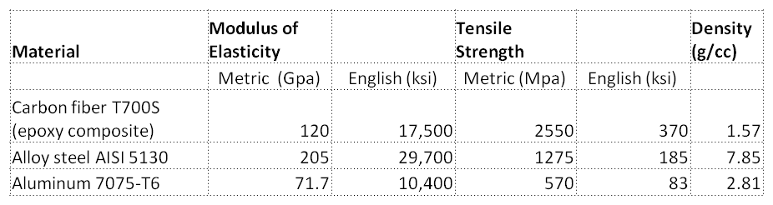
The carbon fibre material has been chosen after evaluating all cons and pros for its incredible characteristics.

Manufacturing methods used for frame
  - Overview of processes
The final choice of material to be used to produce a frame cannot be separated from those of process methods and shape. To make a shape, the material must be processed (or manufactured). These processes include primary forming processes (such as forging and casting), material removal processes (such as machining, drilling etc), joining processes (like welding) and finishing processes (painting) (Ashby, 2016). Purpose, material, shape and processing method are always in interaction and depend on each other.
There are four main steps in the manufacturing of the metal bicycle frames, such as steel and aluminum. Extruded tubes are hydroformed, miter cut, tungsten inert gas (TIG) welded and then heat treated.
1st step is the tubes are created through the process called extrusion. During this process aluminum slugs are obtained. These slugs are then pushed into a die during this process the tubes are created. The most common methods for altering bicycle tubes are hydroforming and mitering. The blank tube is placed in the die and the ends are sealed off. Fluid, usually water, with an anticorrosive additive is then pumped into the tube at high pressure. For tubes to easily and securely connect to one another in the shape of a frame, they must be miter cut. A machine specifically designed for tube mitering cuts the tubes clean and accurate. After these processes, the tubes must be joined together.
There are three most common methods for joining the aluminum tubes – welding, adhesive bonding and mechanical fastening. TIG welding provides high joint strength and it is also not costive moneywise. TIG welding is an arc welding process, in which heat is produced between a non-consumable tungsten electrode and the work metal. TIG welding uses the inert gas to keep the weld area clean, which prevents the metal from oxidizing during the welding process. This method is commonly chosen by bike frames manufacturers as it provides a high-quality finish on the weld surface (Dwyer, 2012)
The disadvantage of this method is that there is a significant loss in strength due to the welding process which can seriously affect the life of the aluminum bicycle frame.
After the metal frames are TIG welded, the frames are heat treated to recover the mechanical properties of metal that are lost during TIG welding. Heat-treating is a term used to describe the changing of the metallurgical structure, residual stress state, and mechanical properties of the metal by heating and cooling. The entire heat treating process allows to aluminum, for example, to recover 30% of the pre-weld tensile strength (ASM Handbook, 1991).
Another method in the manufacturing process used for frames is brazing. This is a method of joining two pieces of metals together with a third, molten filler metal. Brazed joints have great tensile strength- they are often stronger than the two metals being bonded together. Brazed joints withstand vibration and shock and are unaffected by normal changes in temperature. Because the metals to be joined are not themselves melted, they are not warped or otherwise distorted and retain their original metallurgical characteristics (GH Induction Atmospheres, 2010). Brazing produces less thermal distortion than welding due to the uniform heating of a brazed piece. In this process non-similar metals and non-metals could be brazed together. In comparison with a welded part, brazed joints have lack of joint strength due to the softer filler metals used.
  - Final manufacturing method
Carbon fiber composites are a man-made material that can be made to satisfy virtually any mechanical property without changing the overall structural shape of the part, they are entirely anisotropic. This means that in order to achieve optimal stiffness at any part of the frame, once the basic shape requirements are met, all that is needed is to improve the carbon fiber layup and the manufacturing process used.
Carbon fiber composite frames can be manufactured using the following two methods:
1. Resin transfer (RTM), or filament-winding method - used in lugged construction where pre-formed carbon tubes are bonded to internal, or external lugs, and are held in place with glue. Commonly the lug material is now also a carbon fiber composite.
2. Closed mold using bag, foam core, sacrificial core or polymer mandrel molding - used to make structural elements for tube-to-tube (bonded tube) frames, and to make monocoque frames.

- Resin transfer method
This was the original method of carbon frame manufacture and is a descendant of the lugged frame construction used for steel frames. Frames made using the lugged process can offer high performance, but the main reasons for the use of this method to make contemporary frames are: ease of custom geometry changes and lower labour and equipment costs.

The tubes themselves are commonly made via an RTM, or filament winding process where carbon tubes are woven around a solid mandrel (usually steel, or alloy) using carbon fiber yarn wound on a spool. With RTM process, resin is applied separately, i.e. not by using a pre-preg, while filament-wound tubes use resin impregnated carbon filaments. The RTM and filament-winding carbon tube manufacturing process can be largely automated, allowing economical production in countries with higher labour costs.
Lugged frame construction has no performance benefits over bonded tube, or monocoque frame construction. The tubes are invariably made of woven carbon fiber with the structural deficiencies and they remain free elements held in place by a combined mechanical force of glue and lug.

- Closed mold using bag, foam core, sacrificial core, or polymer mandrel molding

1) Tube-to-tube (or bonded tube construction)
This method can be likened to welding the tubes together. Pre-molded tubes and shapes are bonded to one another using over-wrapping with carbon fiber and resin. The joints are held in place using special mini molds and the frame is then either baked in the oven, or in some cases the mini molds have their own heating elements. The joints are thus thermoset and achieve excellent strength, comparable to the rest of the carbon fiber structure. Thermosetting is different to gluing in that a true carbon fiber composite is formed.
This method is appropriate for large volume mass production and has comparable performance to monocoque construction. Tube-to-tube frames are more limited in their shape and tube profiles since severe profile transitions require excessive use of non-structural putty, or filler to smooth out the joints. There is a recent trend to make ever larger elements for tube-to-tube construction so that the line between tube-to-tube and monocoque frames in terms of construction methodology is getting blurred.

2) Monocoque construction
The entire frame is laid up in a custom shaped mold. There are no tubes as such, just hollow carbon shapes that handle all the loads. Monocoque construction method is the best method for working with man-made composite materials. Because carbon fiber can be laid up precisely as desired, any shape and performance parameter can be obtained through combination of layup and shape of the mold. There are no extrinsic (i.e. tube end mating needs) factors that influence the final shape and performance, thus even the most carefully designed lugged or bonded tube frames are inferior in this regard.
However, there are no commercially available single mold monocoque frames. There are limitations on how small a shape or tube profile can be and still be successfully molded using the closed mold bag molding process, or even using sacrificial foam, solid foam, or silicon mandrel. This is due to the necessity to have compression material on the inside of the shapes that are being molded. Ensuring that adequate and even pressure is applied in the smallest sections, followed by the successful removal of the compression material after baking is very difficult. While full monocoque forming is possible with smaller shapes and profiles, failure rates are high and the resulting quality may not be adequate (Unknown, 2008)

Conclusion

Riders have a wide range of materials from which to choose and each material has pros and cons. Metals are stiff, they have relatively high elastic moduli. They are also, good conductors of heat and electricity. They can be made strong by alloying and by mechanical and heat treatment. But the main disadvantage of using metal materials for the bicycle frame is that they remain ductile and not so lightweight. Carbon fibre composite materials have been increasingly replacing conventional materials due to their superior characteristics, such as their excellent strength, durability, corrode-resistant and low specific weight properties. One of the most important disadvantages is that material itself and manufacturing processes are pricey and more complex, involving very expensive machinery.

References
Anderson, M., 2015. Roadcycling.uk. [Online]
Available at: https://roadcyclinguk.com/gear/gear-features/what-should-your-next-bike-be-made-from-carbon-vs-aluminium-vs-steel-vs-titanium/
[Accessed 14 April 2018].
Ashby, M. F., 2016. Materials Selection in Mechanical Design. Fifth ed. s.l.:Butterworth-Heinemann.
ASM Handbook, 1991. Heat Treating of Aluminum Alloys. s.l.:ASM International.
Cheung, S. S. & Zabala, M., 2017. Cycling Science. s.l.:Human Kynetics.
Cheung, S. S. & Zabala, M., 2017. Cycling Science. s.l.:Human Kinetcs.
Dwyer, F., 2012. Web.wpi.edu. [Online]
Available at: https://web.wpi.edu/Pubs/E-project/Available/E-project-042612-124752/unrestricted/Material_and_Design_Optimization_for_an_Aluminum_Bike_Frame.pdf
[Accessed 22 April 2018].
Fancourt, D., 2013. Cycletorque.com. [Online]
Available at: https://cycletorque.wordpress.com/2013/07/15/why-carbon-fibre/
[Accessed 20 April 2018].
GH Induction Atmospheres, 2010. Ghinduction.com. [Online]
Available at: www.ghinduction.com/wp-content/uploads/2011/09/GH-Brazing-Guide1.pdf
[Accessed 22 April 2018].
Hill, J. S., 2012. Cleantechnica.com. [Online]
Available at: https://cleantechnica.com/2012/07/17/audis-new-e-bike/
[Accessed 26 April 2018].
Karatas, M. A. & Gokkaya, H., 2018. A review of machinability of carbon fiber reinforced polymer (CFRP) and glas fiber reinforced polymer (GFRP) composite materials. Defence Technology, Volume 1.
Lee, J.-w., Park, S.-J., Kim, J.-h. & Murakami, R., 2018. Thermal characteristics of carbon fibre reinforced epoxy containing multi-walled carbon nanotubes. Results in Physics, Volume 9, pp. 1-5.
Mazumdar, S., 2012. Composites manufacturing: materials, product, and process engineering. s.l.:CrC Press.
Milowicz, D., 2012. Quora.com. [Online]
Available at: https://www.quora.com/How-much-lighter-is-carbon-fiber-than-steel-and-aluminum-How-much-stronger-is-it
[Accessed 20 April 2018].
Miravete, A., 1993. Composites Properties and Applications: Proceedings of the Ninth International Conference on Composite Materials.. Technology and Engineering, Volume 6, p. 21.
Tips, C., 2018. Cyclingtips.com. [Online]
Available at: https://cyclingtips.com/2018/01/how-carbon-fibre-bicycle-frames-are-made/
[Accessed 20 April 2018].
Unknown, 2008. Velocite-bikes.com. [Online]
Available at: http://www.velocite-bikes.com/carbon-fiber.html.html
[Accessed 22 April 2018].
Unknown, 2015. Quora.com. [Online]
Available at: https://www.quora.com/What-will-the-effect-be-on-composite-material-if-the-core-fibers-are-aligned-at-45-degrees-horizontally-What-physical-changes-would-we-observe
[Accessed 12 April 2018].
Unknown, 2017. Flight-mechanic.com. [Online]
Available at: http://www.flight-mechanic.com/composite-structures-laminated-structures/
[Accessed 15 April 2018].
Unknown, 2018. Britishcycling.org.uk. [Online]
Available at: https://www.britishcycling.org.uk/knowledge/article/izn20131118-All-Cycling-Frame-Materials-0
[Accessed 20 April 2018].

