Name: Sohail Ali
Id: 2209702
Course: Software Applications for Business
Module Name: Software Apps for Businesses
Assignment Title: Software Applications for Business- E Portfolio

Contents
Link of the website: https://sohailali12.wixsite.com/sohail-ali-portfolio 3
Task 1: e-Portfolio. 3
Task 2 – Mind-map. 5
Task 3 – Office Applications 7
Task3(A) 7
Task 3(b) 9
Task 4 – Digital Dashboard and Data Analytics software. 11
Task 5 - Communication, Collaboration & Project Management 13
Task5(i): 13
Task5(ii): 15

Link of the website: https://sohailali12.wixsite.com/sohail-ali-portfolio

Task 1: e-Portfolio.
Link of the homepage: https://sohailali12.wixsite.com/sohail-ali-portfolio.
Screenshot of the task answered:
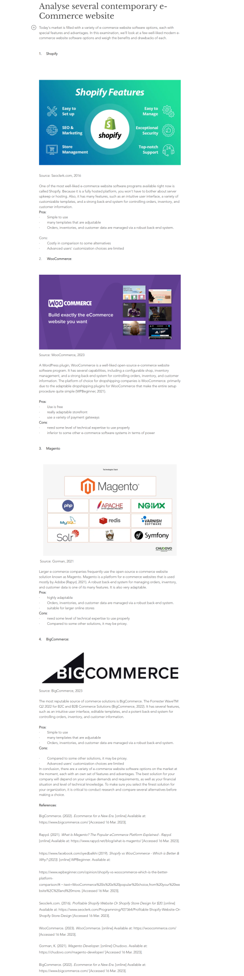
Link of the task-1 Answer: https://sohailali12.wixsite.com/sohail-ali-portfolio/post/analyse-several-contemporary-e-commerce-website

Task 2 – Mind-map.

Screenshot of the answer:

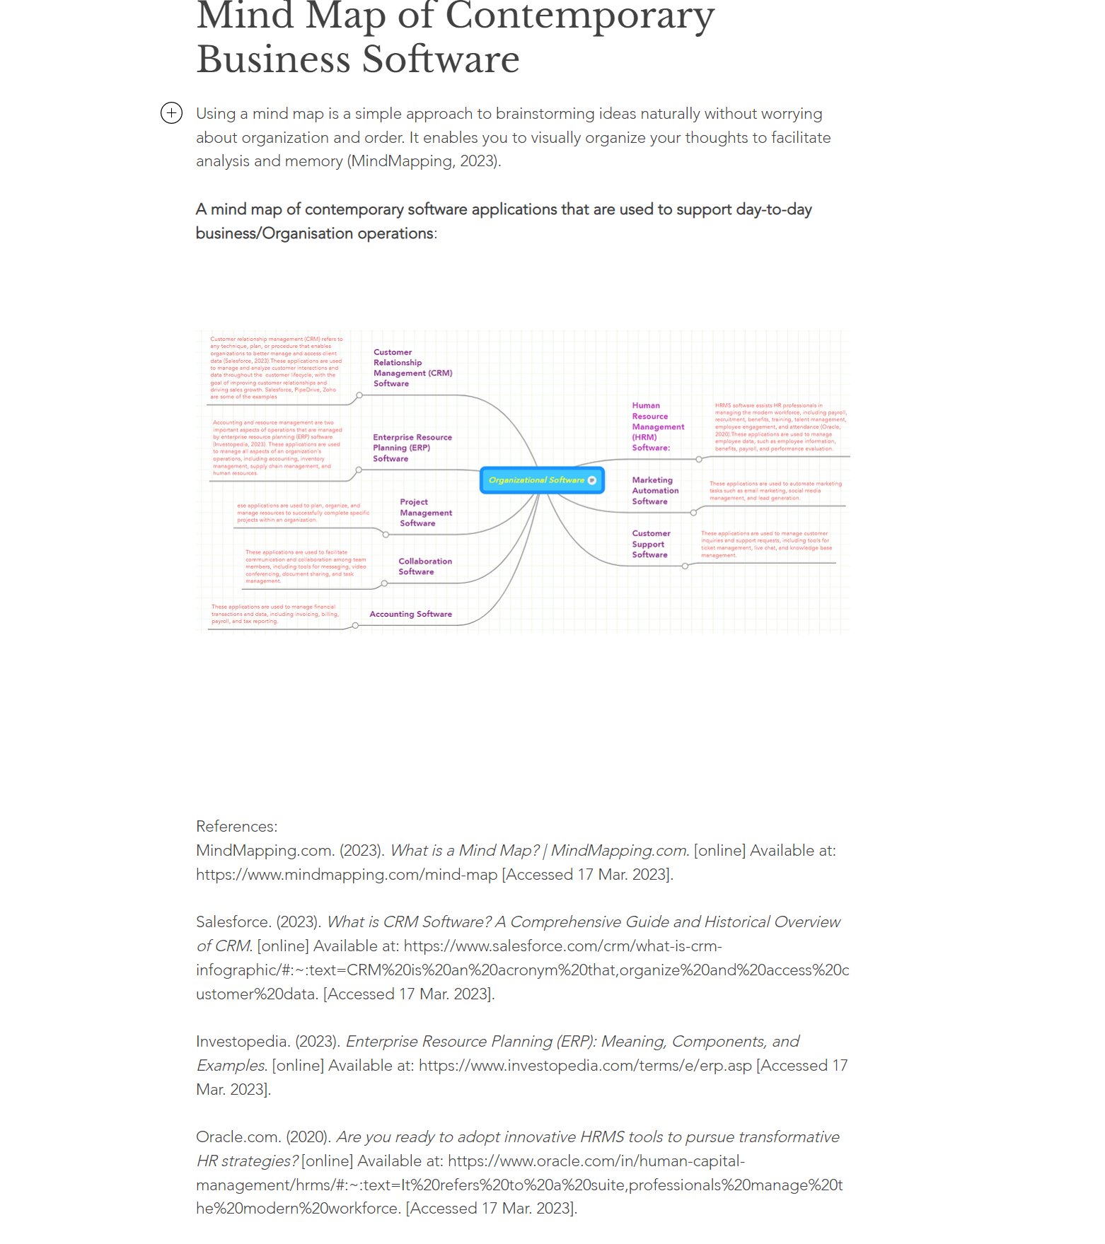
Mind Map:
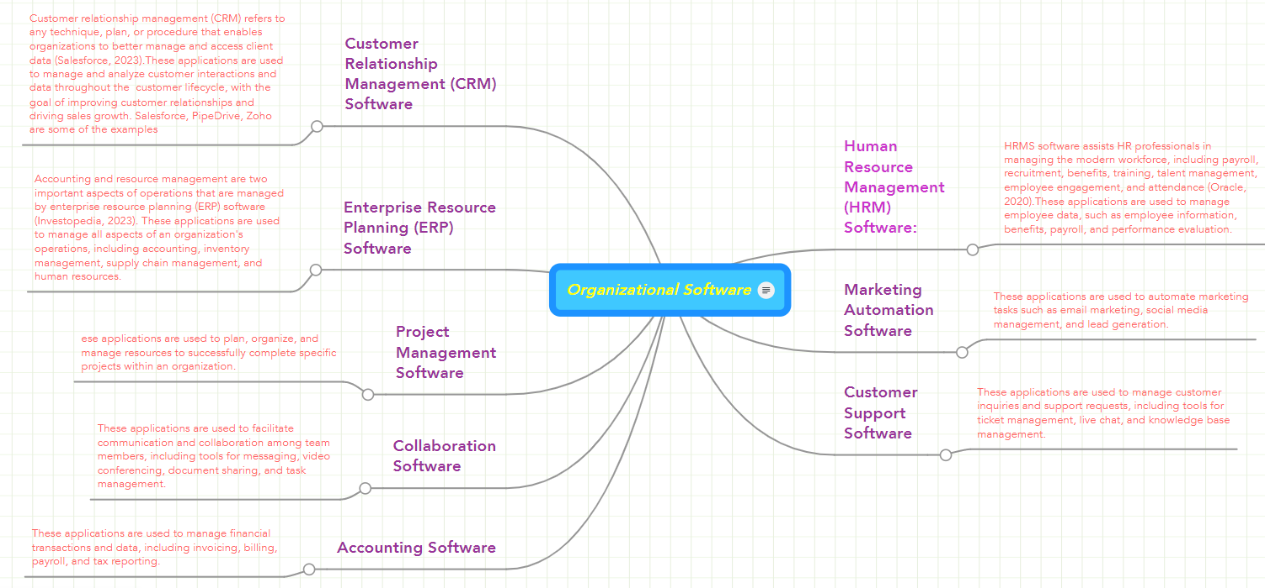
Link of the answer task-2: https://sohailali12.wixsite.com/sohail-ali-portfolio/post/mind-map-of-contemporary-business-software

Task 3 – Office Applications.

Task3(A)

Screenshot of the answer:
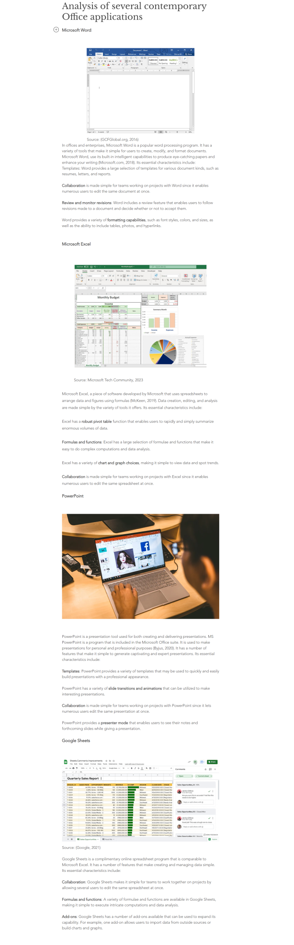

Link to the answer: https://sohailali12.wixsite.com/sohail-ali-portfolio/post/analysis-of-several-contemporary-office-applications

Task 3(b)

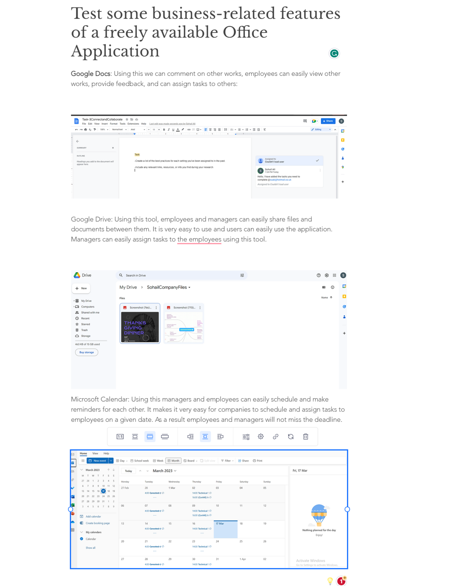
Link to the answer: https://sohailali12.wixsite.com/sohail-ali-portfolio/post/test-some-business-related-features-of-a-freely-available-office-application

Task 4 – Digital Dashboard and Data Analytics software.
Screenshot of the answer:

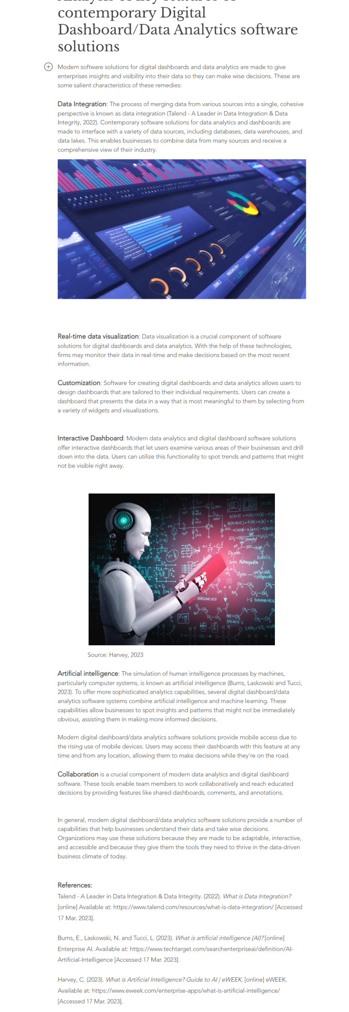
Link to the answer: https://sohailali12.wixsite.com/sohail-ali-portfolio/post/analysis-of-key-features-of-contemporary-digital-dashboard-data-analytics-software-solutions

Task 5 - Communication, Collaboration & Project Management

Task5(i):
Screenshot of the answer:

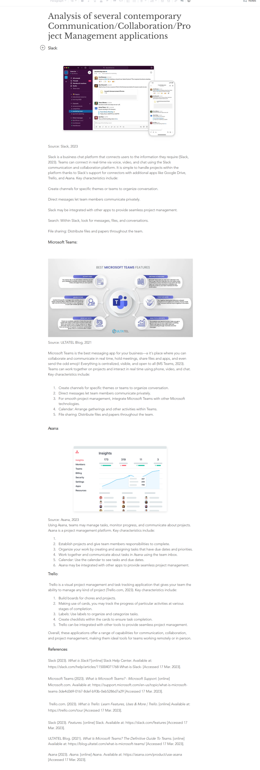
Link of the answer: https://sohailali12.wixsite.com/sohail-ali-portfolio/post/analysis-of-several-contemporary-communication-collaboration-project-management-applications

Task5(ii):
Screenshot of the answer:

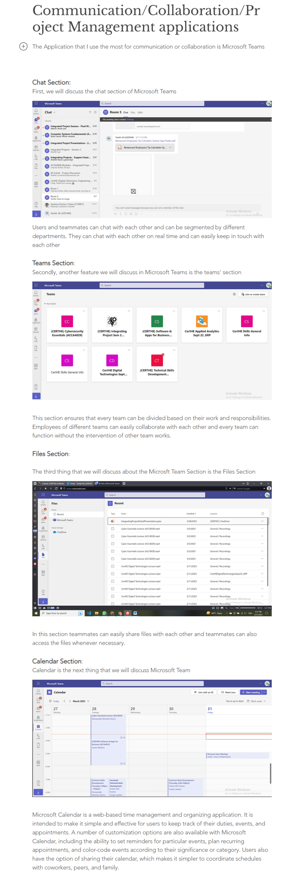
Link to the answer: https://sohailali12.wixsite.com/sohail-ali-portfolio/post/communication-collaboration-project-management-applications

