Improving Social Media Marketing Strategies

Table of Contents
1.0 Introduction 3
2.0 Background of the research 4
2.1 Literature review 4
2.2 Importance of the marketing strategies 4
2.2 Different methods of marketing strategies including their own advantages and disadvantages 5
3.0 Aims and Objectives of the research 6
4.0 Methodology 6
4.1 Research Process 7
5.0 Results 7
6.0 Discussion and Recommendations 9
7.0 Conclusion 11
8.0 References and Bibliography 12

1.0 Introduction
In this particular paper, I would like to identify various tools and techniques that would help to improve various marketing strategies. There are a lot of marketing strategies to promote a particular good or service of a company. But unfortunately all of them are not equally good to capture the large market share. In this paper, various ways of improving marketing communications channels would be recommended in this regard. For this purpose, I intend to conduct various surveys, interviews and questionnaires to identify the effective factors that will be explained at the methodology part of this particular papers. At result section of this particular report, I will analyze the overall result and at the discussion and recommendation section, I will discuss the overall effectiveness at the same time I will recommend some of the future recommendations and guidelines.

2.0 Background of the research

2.1 Literature review
The literature related to various marketing strategies is rich in its content because there have been conducted a huge research in this particular area of knowledge so far. Social media marketing is a unique part of the whole media marketing approach. According to Van der Merwe (2018) as various marketing strategies are still emerging from its appearance, so marketers need to focus on developing various tool to promote these marketing strategies. Technological advancement has been playing an important role to combat the overall marketing strategies and research process in term of future development. So marketers also need to incorporate various modern technologies with a view to improving existing marketing strategies. For improving these particular marketing strategies, market need to analyze the nature of existing market and for this purpose, they might go for conducting various surveys, preparing extensive questionnaires and implementing interviews. Markets need to identify the existing demand for a particular service or product that might help them to know the real scenario and ultimately it will help to design various tools with a view to improving marketing strategies (Resan, 2019).

2.2 Importance of the marketing strategies
The importance of marketing strategies cannot be denied in Today’s business world in terms of creating brand loyalty and reaching to the end customers (Romi, 2015). Marketing strategies are the integral part of any firm’s daily marketing related operations. According to Moses (2018) developing right marketing strategies for promoting a particular product and service is much more important to capture the large market share. So, there always have a huge appeal and importance of improving different marketing strategies. Following reasons include the immense importance of different marketing strategies
- Marketing strategies help to promote the business: marketing strategies help business firms a lot to promote their services and products to the end user and that is the single most advantage of marketing tools.
- Marketing strategies help to build a strong brand name: then marketing communication strategies help individual business firm to build a strong brand name. With the increment of introducing innovative marketing strategies, the sales of product start to increase (Faisal, 2016).
- Marketing strategies help to establish some loyal customers: another major importance of marketing communication strategies is that they help business firm to establish some loyal customers who will serve that business firm over the following years and thus these group of loyal customers would ultimately help firms to maximize their wealth in the long run.

2.2 Different methods of marketing strategies including their own advantages and disadvantages
In this particular section I would like to incorporate some of popular methods of marketing strategies with their respective advantages and disadvantages as follows:
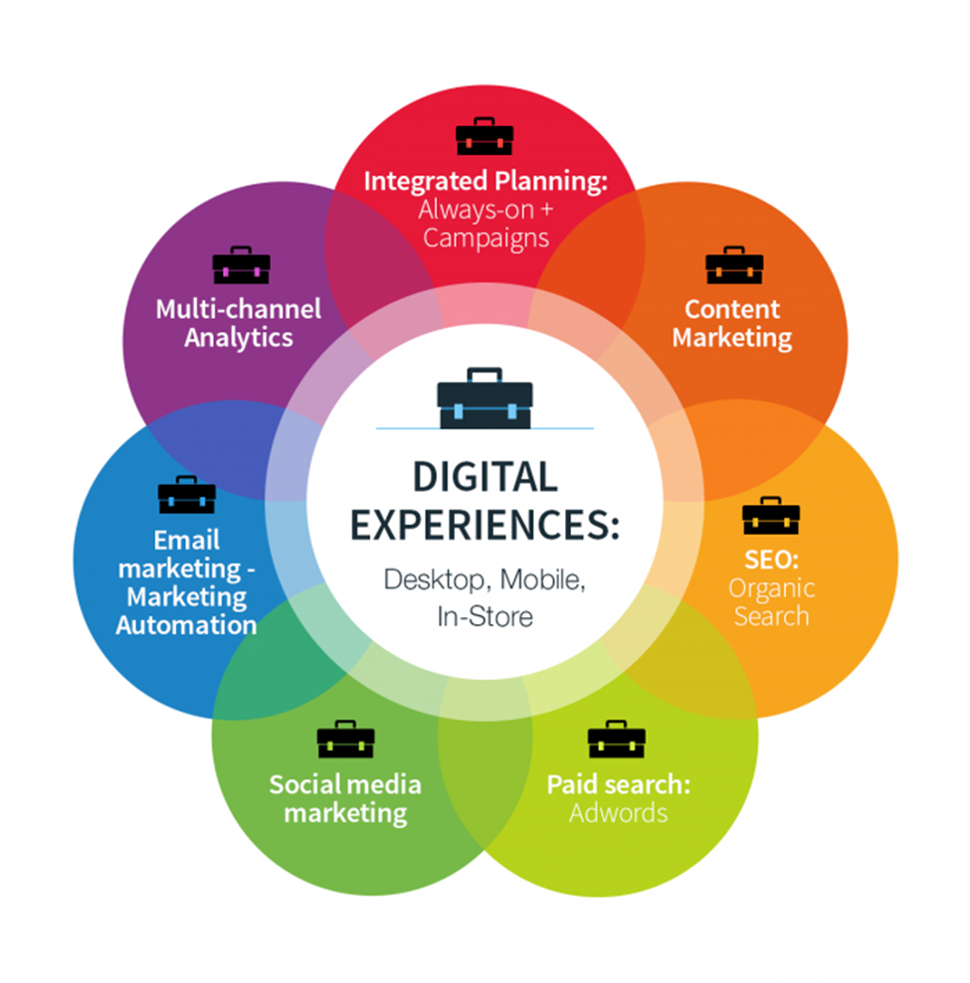
Figure 01: Different marketing methods (Bulter, 2017)
1) Social media marketing: social media marketing is one of the popular form of modern marketing approaches (Thomsett-Scott, 2019). Social media marketing has some advantages and also has some sorts of disadvantages. Around 37% of the world population use various social platforms thus this easy for the marketers to capture large customers. Social media marketing is disadvantageous in term of cost, time consuming and some sorts of technological aspects.
2) Email marketing: email marketing is one of the types of marketing strategies that might work much more sophisticated than that of other traditional approaches. This particular marketing method is advantageous in terms of lower competition, creating brand image and constant sending. Email marketing is disadvantageous in terms of tough of use, email design and impersonality.
3) SEO: SEO simply means how one can get free and organic traffic to his or her websites. So, it is basically getting the top or at least pages one of the SERPs. This particular marketing method is advantageous in terms of long term usefulness, not instantaneous and less competing. This particular marketing strategies is disadvantageous in terms of too much traffic, visibility and lack of trust.
4) Paid-search: this particular marketing mechanism goes with pay per click basis. At every click it might induce costs. Like other popular modern marketing communications strategies, it is also getting popular. This particular marketing method is advantageous in terms of easy to use, not sudden and less challenging. This particular marketing strategies is disadvantageous in terms of too much circulation, discernibility and nonexistence of faith.

3.0 Aims and Objectives of the research
- The very first and foremost aims and objectives of this particular study is to analyse how the various social media marketing strategies are used by the individual companies and to identify the overall importance of various media marketing strategies that might help attaching with prospective clienteles at a faster pace.
- Then this particular study also aims at investigating how the enhancement in consumer perceptions can be contributory with a view to providing better consumer services through various social media marketing strategies.
- Finally this research paper aims at determining the effect of brand awareness and brand loyalty on business performances with the help of various social media marketing strategies with their respective advantages and disadvantages.

4.0 Methodology
According to Jha (2017) the term methodology in research implies the step-by-step activities conducted by the research developers. This specific marketing research strategies’ methodology is gorgeous in the own framework. Moreover, this particular case study would allow customers the better indulgent of the occurrence of the actual scenario derived from various marketing strategies. Apart from this, this specific case study is a widespread background case that might integrate numerous phases; initially, to identify a context for implementing the various marketing strategies and furthermore for identifying the relevant samples. Finally, for helping the companies regarding discovering various suitable media marketing strategies by structuring an online gateway to organize surveys and interviews for recognizing real reactions.

4.1 Research Process
To conduct the mechanism behind the improving of social media marketing strategies, I have designed the whole research process into several steps for instance; a primary survey will be conducted by concentrating on the customers’ assertiveness to the internet and social media, their delineations of success. Moreover, people will also be questioned whether they will intend to use various social media marketing tools. Subsequently, a structure will be created to know the impact of various social media marketing such as website, twitter account and facebook on the performances of business’s daily marketing related operation. Finally after observing few days, a secondary survey will be conducted among the participants.

5.0 Results
In this particular section, for knowing the effects of social media marketing on business, I have conducted a survey. I have taken around 22 participants whose ages is between 15 to 32 years. I have examined their performances during the whole research procedure. Fortunately almost 100% answer from the participant was accomplished during this particular research proposal. For this purpose I also made a questionnaire and the analysis of their response to from that questionnaire, I have become able to know that there were 22 participants and most of them were adult males. From the total participants we got to know, 16 participants were males (75%) and 6 participants were female (25%). This particular survey also told us that 80% of participant's age was under the age of 25 and they were males. And the other 25% participant's age was above 25. The following table represents the gender distribution of participants and figure 1 shows the age of the participants in the study.

Gender | Number of Respondents | % of Respondents
Female | 16 | 75
Male | 6 | 25
Total | 22 | 100
Figure 02: Number of Respondents (Self-creation, 2020)
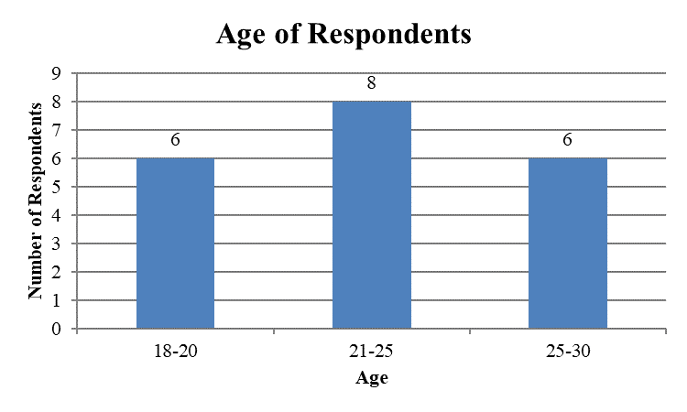
Figure 03: Age of Respondents (Self-creation, 2020)
From the survey, it has clearly noticed that all the 22 participants have use social media sites. It ratifies that almost everybody is involved in using various social media sites. This extensive research confirms that around 43% of the participants have Facebook, 17% have LinkedIn, and around 15% have Twitter and rest of 25% use Instagram.
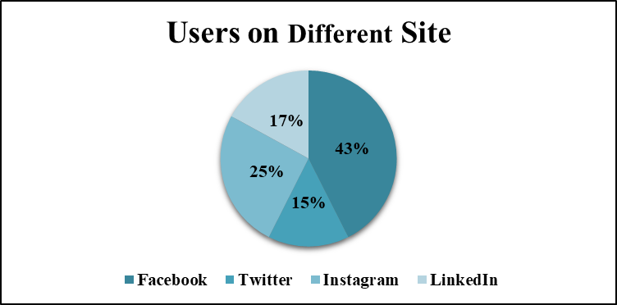
Figure 04: Users of different marketing media sites (Self-Creation, 2020)

6.0 Discussion and Recommendations
In this particular section of my research study of how to improve various social media marketing strategies, I intend to incorporate same sort of general discussion and I also recommend some recommendations regarding the overall future improvement of this particular area of knowledge. Evidence suggests that firms must choose inductive research strategy to examine various social media marketing strategies because inductive research approach provide a holistic way to conduct an effective research (Cahoon, 2019). Social media marketing strategies might be different depending on various media marketing styles and approaches. Exactly that why business firm must be careful to choose an applicable one.
From the earlier section I have found that today’s business world tends to capture various online and internet based platforms as their ways of promoting their products and services. I think these particular ways are still emerging as people are still fond of using various social sites. Business firms can easily take advantages from these emerging marketing platforms that has already been proved from the analysis of my earlier section. Apart from these, I have also found some sorts of loopholes underlying each and every form of internal and media based marketing communications strategies and marketers needs to address them. According to Paul Edwards (2017) various media marketing strategies help the business firm to capture the largest market share of a particular service and product. Beside all the concern of this particular section, I would like to recommends several points that might be much more effective for the development of future media marketing strategies as follows:
- I strongly recommend over the usages of modern technologies in the various marketing communication channels. As technology helps firm to maximize its wealth in the long run and also to meet the economy of scales. So, firms should incorporate various technologies into their daily marketing communications operations.
- Firms should calculate cost-benefit analysis just before the launching of any particular marketing communication and promotional strategies. There is some sort of sunk cost and inherent costs related to each of marketing strategies, firms also should be careful in these particular aspects.
- Business firms should focus on the overall effectiveness and long run consequences of each marketing communications strategies. If firms choose wrong marketing communication strategies that would create burden in the long run for the firms despite yielding at good result.
- Most importantly, business firms should choose such kind of marketing strategies that are much more relevant and consistence with the mission and vision of that business frim. If these strategies deviate from the mission and vision statements of the firms then firms must suffer in the long run.
All these recommendations must be bared in mind and taken seriously by the individual firm so that taken strategies become consistent with the firm’s long term goal and objectives.

7.0 Conclusion
After the completion of this research related to the marketing strategies, this particular paper concludes several points 1st of all research must focus on initiating future development of the marketing sectors considering each and every advantages and disadvantages related to different marketing communications channels then researchers must be careful in terms of conducting relevant surveys, interviews and questionnaire as sometimes these approaches might not provide the real scenario. Finally, researchers must be careful while analysing various marketing research style in term of their ethical aspects.

8.0 References and Bibliography
- Butler, R., 2017. Marketing Methods. New York: Alexander Hamilton Institute.
- Cahoon, M., 2019. Research Methodology. Edinburgh: Churchill Livingstone.
- Edwards, P. and Edwards, S., 2017. Social Media Marketing. [Boca Raton, Fla.]: Bar Charts, Inc.
- Faisal, A., 2016. Marketing Strategies in Online/Digital Marketing. Account and Financial Management Journal,.
- Jha, N., 2015. Research Methodology. Chandigarh: Abhishek Publications.
- Moses, L., 2018. Merchandising the Advertising Campaign. Journal of Marketing, 9(2), p.124.
- Resan, L., 2019. Marketing Strategies. [Ottawa]: Canada Mortgage and Housing Corporation.
- Romi, R., 2015. Implementing Marketing Strategies. Boston, Mass.: The Review.
- Thomsett-Scott, B., 2019. Marketing With Social Media.
- Van der Merwe, J., 2018. Marketing Strategies. Mowbray: Future Managers.

