Internet Security Assignment

SYNTHESIZE A SOLUTION TO A POTENTIAL REAL-LIFE SCENARIO
“BYOT” or “BYOD”
Author Name: Nabil Ouzahra Student number: P147535
Module Code: M5X01045
2nd year Computer Networks & Cybersecurity
Module Tutor: Dr Carlene Campbell
Email: nouzahra.147535@student.uwtsd.ac.uk

Abstract- Adopting a Bring Your Own Technology (BYOT) policy by any company can be very beneficial. However, the process of implementing it successfully needs appropriate planning, a good IT infrastructure and the right IT support team to be able to manage all the associated risks.
Contents
I. Introduction 2
II. Developing comprehensive “byot” framework for Golding-Harvest Ltd 2
A. Importance of a framwork policy 2
B. Implement plicies at corporate level 3
III. Comprehensive framework policy for Golding-Harvest Ltd. 3
A. Introduction: 3
B. Scope: 3
C. User policy (access control and privillage) 3
D. Device management policy 5
E. Security Policy 5
IV. Data flow diagram of “byot” management architecture 6
A. BYOT Data flow diagram 6
B. Data flow analysis 6
V. Configuration of Golding-Harvest Ltd enterprise network 6
VI. Mobile Device Management Software for “byot” 8
VII. advantages and disadvantages of byod for end users and business 10
A. Some advantages of BYOT: 10
B. Some disadvantages of BYOT: 11
VIII. Conclusion 12
REFERENCES 12

List of Figures:
Figure 1: Data flow diagram for BYOT policy
Figure 2: Example of corporate network structure
Figure 3: Golding Harvest network topology
Figure 4: Branch office topology
List of Acronyms:
BYOD: Bring Your Own Device
BYOT: Bring Your Own Technology
MDM: Mobile Device Management
IoT: Internet of Things
MAM: Mobile Application Management
IT: Information Technology

Introduction

In today’s world mobile phones and smart devices numbers keep increasing. It is estimated to be around 10 billion in 2018 [1]. This growth has made these mobile devices more and more integrated into our daily lives. Many companies and employers who used to prevent their employees from using their personal smart devices to access corporate emails, data and other resources for security reasons have started to accommodate the use of personal devices at work, for work and personal use to encourage productivity among employees and boost the rate of recruiting acceptance. At corporate and organisation level this accommodation is typically called Bring Your Own Device (BYOD) [2].
The trend of BYOD IT model comes with many pros and cons. Before identifying all the good and bad points when implementing this model, it is important to highlight the impact on IT resources as they can become considerably stretched to keep a high level of security, integrity and availability.
To implement successfully this model of Bring Your Own Device (BYOD) inside any organisation and mitigate the main risks, it is vital to draft a good comprehensive framework policy for this, ensure that this is implemented by the management throughout the company and have the right IT resources to support your policy.

Developing comprehensive “byot” framework for Golding-Harvest Ltd

Importance of a framwork policy

An IT security framework is an entity of documents and procedures designed and implemented to manage and control the information security at corporate or enterprise level. These frameworks are also called the “blueprint”. They help to create a security program to manage risks and protect company assets. The best examples of these frameworks are:
COBIT: Control Objectives for Information and Related Technology
ISO 27000: Framework designed by International Standards Organization [3].
The main purpose of drafting this comprehensive BYOT framework is to provide guidelines to the employees on how they can access the company’s network and data using their own devices for work and personal use and to specify the type of devices, operating system, apps allowed, Mobile Device Management that must be installed and all security details that should be implemented to ensure the safeguard of company data [4] . Also, it provides a legal umbrella for the company and its right to revoke this privilege when necessary if anyone misuses it [5].

Implement plicies at corporate level

It is important to have a well drafted BYOD policy in place. However, if it is not fully implemented by employees it will never be an effective policy. It is therefore very important that the management or Risk department ensures that all employees and clients fully understand all the threats and risks that can result if ignored.
Implementing BYOD policy should never be a headache to implement if the IT department provides training sessions to explain clearly the rules and regulations. It is important to establish a conversation between IT and employees so they can be educated about the reality of BYOD and how to use it responsibly [6] [7].

Comprehensive framework policy for Golding-Harvest Ltd.

Introduction:
Golding Harvest Ltd has always encouraged the use of mobile devices like tablets and smartphones inside the company to increase productivity and loyalty of employees and clients. It is also important for our company to achieve its business goals.
However mobile devices can cause great risks to the company’s data and IT infrastructure. Therefore Golding Harvest Ltd has developed this framework policy to protect the company’s assets and to provide guidelines to employees and clients to use their mobiles safely within our network.

Scope:
- All mobile devices including computer tablets and smartphones used to access the company’s network either owned by Golding Harvest Ltd or employees/vendors are subject to this policy. All users are subject to a risk assessment by the IT department prior to issuing written approval.
- All applications deployed to store or access Golding Harvest Ltd data like cloud storage are also subject to this policy.
- Any exemptions from this policy due to complexity, cost or difficulties will be subject to a risk assessment and the approval of the management department.

Agreement:
Employees and clients must agree to this policy’s terms and conditions prior to connecting their mobile devices to Golding Harvest LTD wireless network.

User policy (access control and privillage)

Technical Requirements:
- For Android devices: all devices must be updated to the latest Operation system 5.0.1 or later.
- For iOS devices: all devices must be updated to latest Operating system 11.0.1 or later.
- For Windows devices: all devices must be updated to latest Operating system 7.0 or later.
- An encryption password method should be used to store all user’s passwords used by this device (no clear text user password should be used).
- All mobile devices will be subject to true compliance on all security like password, encryption, etc. A Mobile Device Management software will be used to implement these policies.
Definition of adequate use:
- Golding Harvest defines adequate business use as every action and activity that could help and support achieving business goals.
- Employees should be sensible and reasonable when using their devices for personal reasons during company’s time.
- Some of the website are blocked and access is restricted during working time.
List of websites:
Facebook.com
ladbrook.co.uk, etc.
- These devices should never be used to save or send illegal data and/or other company business data.
- Not to be used for any business outside the company.
- Apps allowed to be used within the Golding Harvest network.
List of apps: Currency, eBay, Banking app, Mail, outlook, etc.
- Apps not allowed within the Golding Harvest network.
All untrusted apps which have not been downloaded from Google play store or iTunes.
Additional restricted list:
Dropbox, Facebook, Pandora, Netflix…
- Golding Harvest Ltd prohibits the use of phones to send emails or texts when driving. Only hands-free mode will be allowed.
User requirements:
- No jailbroken or rooted mobile devices should be used to access the company’s network. No firmware or software should be used to manipulate the functionality.
- Users must update their Operating System and install the latest patches from trusted sources like the manufacturer or network operator provider on a weekly basis or at least every once month.
- It is forbidden to use illegal or pirated software on these devices.
- Users should only install apps from official sources (Google play & iTunes). Golding Harvest IT department should be informed if anyone is not sure about the source.
- All mobile devices should be encrypted as per Golding Harvest Ltd BYOD policy.
- Users must check that an updated anti-malware is enabled on the PC intended to connect the mobile device before connecting.
- Only necessary data related to the user’s role should be loaded to their mobile devices.
- All users must report to the IT department ASAP if they suspect any unauthorised access to the network or data.
- The IT department must be informed instantly if any user has lost or had his device stolen.
- Users must ensure that the company’s data is sent only through the corporate email server and not via personal emails.
- Golding Harvest ltd is not responsible for any loss of data if the device is being wiped due to security issues. Users are fully responsible for backing-up all their private data.

Device management policy

- An approved Mobile Device Management (MDM) software must be installed on all devices connected to the company’s private network. It is prohibited to uninstall or temper with the configuration set by the IT department.
- All users must be vigilant and responsible of the physical protection of their devices and the data-assets of the company.
- The IT department must be notified immediately of any loss or theft of these mobile devices used by employees or vendors.
The IT department will take immediate action if any security breach is detected and all data on the device will be wiped (factory reset of the device).

Security Policy

- All users must enable password protection on their mobile devices and use strong passwords to access the company’s private network.
- Passwords must be eight characters minimum and a combination of symbols, numbers and upper and lower cases must be used.
- All passwords must be reset every 6 months.
- Screen lock must be enabled on all devices to protect the device if left on Idle for 3 minutes.
- All devices must comply with a list of anti-virus and malware software that should be used for protection.
- It is prohibited to share passwords between individuals.

Data flow diagram of “byot” management architecture

BYOT Data flow diagram

Figure – 1

Data flow analysis

This diagram shows the data flow of the wireless network. Only the devices enrolled and managed by Microsoft Intune inside the IT department can access the wireless network and take part in the BYOT policy.
Authentication access done for all three types of users:
- Employees will have full access to the corporate data via Vlan 10 using Radius server authentication.
- Vendors will have partial access to the company data via Vlan 20 using WPA2 authentication.
- Clients will have very limited access to the corporate data via Vlan 30 using WEP authentication.

Configuration of Golding-Harvest Ltd enterprise network

Typical large Corporate network structure would be built using “hierarchical networking model” using three layers: Core switching layer, Distribution layer and Access layer.
Example of corporate network structure
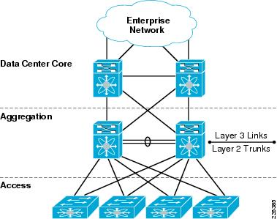
Figure – 2

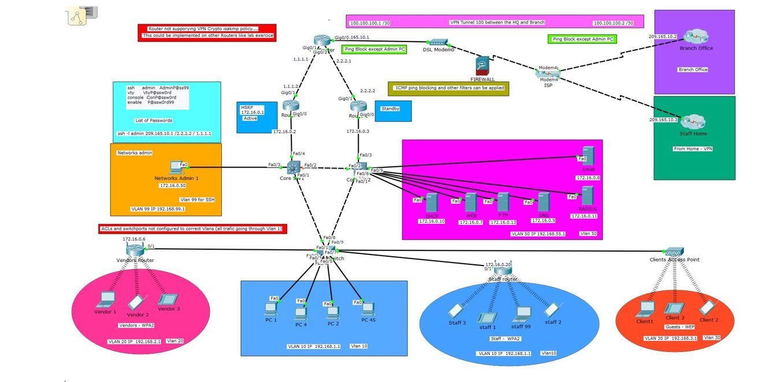
Golding Harvest network topology
Figure – 3

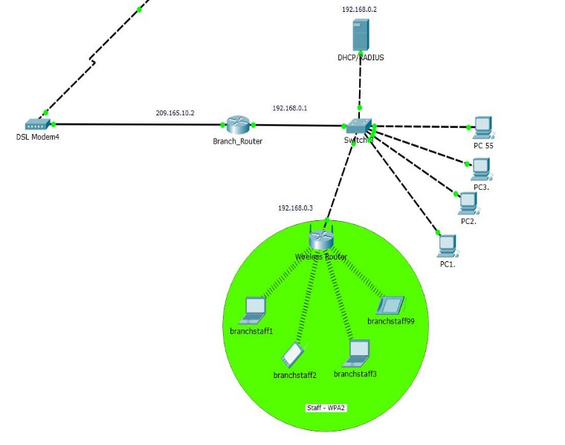
Branch Office topology
Figure – 4

Topology Analysis
It is important for any company to create a good IT infrastructure to support its business and help its employees to be more efficient and productive, but the more important is to protect this infrastructure. This task lays on the IT department and the management who together should have a strong plan in place.
Network security is simply all the actions taken to protect the hardware and software inside the company. The Network administrator’s main responsibility is to ensure the network availability, integrity and reliability.
No security system is 100 percent secure as hackers are always looking for any small weakness or loophole to exploit.
Golding Harvest should use all means to detect weaknesses within its network to be better protected, such as:
- Vulnerability assessment: security analysis software engineers should be able to detect vulnerabilities in computers and the entire network structure. A proactive plan should be in place for the worst case scenario.
- Penetration tests: regular testing should take place to check the rigidity of the network security.
- Network intrusion detection systems (NIDS): the use of monitoring software can also help detect any malicious activities within the network.
- Packet Analysers: this tool allows IT engineers to intercept and log the traffic of packets travelling In and Out of the wired or wireless network.
Security engineering is also key: designing a network so as to protect some important elements of the network like servers, core and distribution devices against any possible attacks.
System update: IT Engineers should keep the systems up-to-date, using the latest software patching, ensuring that all computers and mobile devices have the latest anti-viruses and malwares and that the firewall is working properly. All these actions can help prevent some of the most common attacks like:
- Zero day attacks
- Denial of service attacks
- Interception of data.
- SQL injection.
- Men in the middle attacks.
Separate Vlans: using different Vlans can help to manage the access to different servers (data) by applying access lists at core switch layer.
VPNs: Virtual Private Networks allow secure tunnel for the data to be transferred through the internet. The encryption of the data protects its integrity even if intercepted.
Firewall: is used to block unauthorised access to the network.
Internet security encryption protocols: Implementing some encryption protocols like:
- Secure Socket Layer (SSL)
- Transport Layer Security (TLS)
- Web-Sockets
- SSL certificates
- HTTPS
- End to end encryption [8] [9].

Physical security:
- All network devices should be secure in a locked room where access is limited to the IT department alone.
- Use of secure racks to protect the devices from any tempering (CCTV is also a good deterrent).
- All port slots at the back of devices should be secure.
- Wireless routers should be placed in safe places out of reach to avoid any tempering.
- Disabling USB ports and drives to protect the network from viruses and malware injections.
As for the users, the most important and prime weaknesses in any corporate network, a good training program for the users must be implemented to support the BYOT policy [9].

Mobile Device Management Software for “byot”
Mobile Device Management (MDM) software is an important tool to deploy when a company embraces the BYOT approach. This software can be used for different reasons:
It can provide a variety of services, from simple inventory of mobile devices used inside a company to full control and management anywhere to help prevent the loss of valuable data. However this new technology is still considered by some experts as “not the complete solution” [10].
When a new device connects to the network (enrolled), mobile device management software (MDM) provides some control of the device and allows the IT engineer to set the correct limitations, security settings and track the type of data and applications used. Some of these tools can be very helpful for the IT department and management to track activities and protect the integrity of the company’s data [11].
When it comes to choosing the appropriate MDM software for the company, it is important to consider some important factors:
- Brands: the variety of brands that the MDM can handle.
- Operating System: the variety of Operating System on these devices.
- Security: the additional security features that the MDM can provide comparing to another MDM.
- Application management: it is very important to consider using an MDM that allows the management of app downloads and setting or what is called Mobile Application Management (MAM), the reason being that most apps request an internal access to private data and this could lead to big data compromise.
Most of the time companies have personalised apps for their employees. The apps management tool will ease the task of the IT department to prevent the use of personal apps inside the corporate network.
- Flexibility and growth of the business.

- Cost and premiums related to these services.
Many MDM softwares may provide most of what was mentioned above. However when it comes to cost and level of support available using Microsoft products, all this would make Microsoft Intune the first choice by far.
Microsoft Intune is a cloud based management tool built to work with the most familiar products designed by Microsoft like Windows enterprise, Office 365, and Windows 10, that would encourage productivity among employees while keeping security and integrity of data.
Flexibility is a key feature on Intune. This cloud based product allows companies to adapt easily to their IT needs. It helps to create that balance between productivity and security with minimum IT resources [12].
Microsoft Intune supports a variety of mobile devices platforms [13]:
- All Apple iOS 9.0 or higher.
- Devices running Android 4.0 or higher, with the exception of a few Samsung Galaxy Ace phones.
- All Windows 10 mobiles.
- Devices running Windows 10 Internet of Things (IoT) Enterprise (x86, x64).
- Devices running Windows 10 Internet of Things (IoT) Mobile Enterprise.
- Mac OS X 10.9 or higher.
- Windows Phone 8.1 or higher.

The Microsoft Intune administrator console allows good control and management of apps to all devices enrolled in the BYOD solution [14].

advantages and disadvantages of byod for end users and business
With any technology solution applied in real life there will be pros and cons. It is therefore acceptable to have some drawbacks in this proposed solution.

Some advantages of BYOT:
- Attracting Talent and Satisfaction of Employees
With a BYOT solution, employees are happier to use their own favourite mobile device at work, and more likely to better protect it from loss or theft as it is considered as a personal asset. When it comes to employability, this solution would be a good attracting tool among young employees and will help companies to keep their top talents.
- Flexibility and Productivity
BYOT allows more flexibility in working hours. The fact that employees always have access to a mobile device at home, on break and when travelling makes them more available for the company.
Employees using their own devices that they are familiar with are more creative and more innovative thanks to the ability to collaborate and interact with different members from anywhere and at any time.
- Use of IT Infrastructure
In the current competitive market, most companies invest a great deal of money and time to improve and provide first class IT infrastructure to help drive the company towards success. Businesses especially start to embrace cloud based services and wireless technology. BYOT provides good opportunities to use these resources.
- Costs & Savings for Companies
One positive point of using a BYOT policy is the money saved by allowing employees to use their own devices instead of buying them [15] [16] [17][18].

Some disadvantages of BYOT:

The security risks of data loss at corporate level will increase when companies consider adopting BYOD because part of the network asset is no longer managed by the IT department. The device owner become the first responsible for updating their system and using it correctly.

- Managing security threats
One of the top risks companies face when they implement a BYOD policy is managing security. Before adopting this solution, it is important to develop a process to control all possible threats before giving access to the company’s data. For example, if an employee loses his device, the company should have a mechanism in place to allow wiping the data remotely and protecting the company’s data.

- Control of acceptable use
Allowing employees to use their own devices for work means that a big part of controlling appropriate use is lost. This is the reason why many companies take great care in defining appropriate use and giving training to their staff.
- Retrieving data
A BYOD policy should clearly address the risks that may occur when an employee leaves his job or changes company as the ex-employee could suddenly become a competitor using the data stored on his device.
Companies may face many barriers when implementing a BYOD policy. However, these barriers should not stop them from benefitting from all the positives that come with it.
Some of the barriers that companies could face:
- Users abusing policies
- Mobile devices could be lost or stolen.
- Losing some control over the use of applications.
- Risk of having the company’s data compromised.
- Stretching the IT resources to support a BYOD policy.
- Enrolling and de-enrolling of devices can be time consuming when employees join or leave the company [15][16][17].

Conclusion

Companies should never have any fear of implementing a BYOD policy regardless of the risks that may arise when doing so. The key question is “how to implement it?”. There is no doubt that this policy could bring great success to the company considering the potential increase in productivity, the efficiency, employees’ relationship and good moral.
The key answer would be to have the correct security structure to provide a good support to all mobile devices accessing the company’s data, to continue carrying out checks and control, and to provide training to users as they are the primary high risk.

REFERENCES

[1] EY, “Security and risk considerations for your mobile device program,” Insights governance, risk compliance, no. September, p. 12, 2013.
[2] C. Caldwell and K. Griffin, “BYOD (Bring Your Own Device) EXECUTIVE SUMMARY,” CF, vol. 10, no. 2.
[3] Joseph Granneman, “IT security frameworks and standards: Choosing the right one,” 2013. [Online]. Available: http://searchsecurity.techtarget.com/tip/IT-security-frameworks-and-standards-Choosing-the-right-one. [Accessed: 11-Dec-2017].
[4] Alan Earls, “BYOD: POLICIES AND CONSEQUENCES,” scmagazin.com, p. 33, 2016.
[5] Berry Megan, “Mobile Device (BYOD) Policy.”
[6] ICO, Data Protection Act 1988 (BYOD). .
[7] Sarah K. White, “How to implement an effective BYOD policy | CIO,” 2016. [Online]. Available: https://www.cio.com/article/3124127/byod/how-to-implement-an-effective-byod-policy.html. [Accessed: 27-Nov-2017].
[8] CAREY WODEHOUSE, “The Basics of IT Security.” [Online]. Available: https://www.upwork.com/hiring/development/understanding-it-security-and-network-security/. [Accessed: 02-Dec-2017].
[9] Dr Carlene Campbell, “M5X01045: Module Contents.” [Online]. Available: http://moodle.uwtsd.ac.uk/mod/folder/view.php?id=21320. [Accessed: 05-Dec-2017].
[10] Michael A. Davis, “BYOD - Here’s why mobile device management isn’t the complete solution,” United Business Media LLC, 2012. [Online]. Available: https://search-proquest-com.ezproxy.uwtsd.ac.uk/docview/1237629501/fulltext/5803CCFBF250425EPQ/1?accountid=130472. [Accessed: 10-Nov-2017].
[11] T. Henderson, “Top tools for BYOD management,” Netw. World, vol. 29, no. 19, 2012.
[12] Microsoft, “Microsoft_Intune_datasheet,” 2017.
[13] Microsoft, “Supported Device Platforms for hybrid MDM - Configuration Manager | Microsoft Docs,” 2017. [Online]. Available: https://docs.microsoft.com/en-us/sccm/mdm/plan-design/supported-device-platforms-for-hybrid. [Accessed: 04-Dec-2017].
[14] Microsoft, “Prerequisites for MAM policies | Microsoft Docs.” [Online]. Available: https://docs.microsoft.com/en-gb/intune-classic/deploy-use/get-ready-to-configure-mobile-app-management-policies-with-microsoft-intune. [Accessed: 04-Dec-2017].
[15] M. Olalere, M. T. Abdullah, R. Mahmod, and A. Abdullah, “A Review of Bring Your Own Device on Security Issues,” SAGE Open, vol. 5, no. 2, Apr. 2015.
[16] M. R. Waterfi and C. A. Dilworth, “BYOD: Where the Employee and the Enterprise Intersect,” vol. 40, no. 2, 2014.
[17] Nadeem Unuth, “Pros and Cons of BYOD at Work,” 2017. [Online]. Available: https://www.lifewire.com/pros-and-cons-of-byod-at-work-3426318. [Accessed: 05-Dec-2017].
[18] Kathy Vogler, “BOYD Considerations,” imageSource, p. 33, 2014.

marking criteria and Student FEEDBACK

This section details the assessment criteria. The extent to which these are demonstrated by you determines your mark. The marks available for each criterion are shown. Lecturers will use the space provided to comment on the achievement of the task(s), including those areas in which you have performed well and areas that would benefit from development/improvement.

Common Assessment Criteria Applied (Assignment 1) | Marks available | Marks  awarded
1. Research-informed Literature
Extent of research and/or own reading, selection of credible sources, application of appropriate referencing conventions.
While you have done referencing, some areas were lacking referencing. (Grade mark: 53.33%) | 15 | 8
2. Knowledge and Understanding of Subject
Extent of knowledge and understanding of concepts and underlying principles associated with the discipline.
Show Knowledge and good understanding of the field of study (Grade mark: 53.33%) | 15 | 8
3. Analysis
Analysis, evaluation and synthesis; logic, argument and judgement; analytical reflection; organisation of ideas and evidence
Good discussion of the topology, could relate more to the scenario given and cross-reference other areas. Conclusion can be improved upon by sum up key areas from the report and state any improvement for the future. (Grade mark: 62.50%) | 40 | 25
4. Practical Application and Deployment
Deployment of methods, materials, tools and techniques; application of concepts; formulation of innovative and creative solutions to solve problems.
Good implementation of an enterprise network, utilising a wireless network. Pings are successful across the network, the use of VLANs works well and configurations on routers and switches demonstrate a good understanding of security and network protocols (Grade mark: 80.00%) | 20 | 16
5. Skills for Professional Practice
Attributes in professional practice: individual and collaborative working; deployment of appropriate media; presentation and organisation.
Could do with formatting alignment. (Grade mark: 45.00%) | 10 | 4.5

Assignment Mark (Assessment marks are subject to ratification at the Exam Board. These comments and marks are to give feedback on module work and are for guidance only until they are confirmed. ) | Late Submission Penalties (tick if appropriate) |  | 62%
 | Up to four weeks late |  | 62%
 | First Attempt? |  | 62%

