

Nasreen Akhtar
2407148
BMHP5015
Changemakers: Building your Personal Brand for Sustainable Employment
Component 1: Online Portfolio of Set Exercises

Task 1 – Personal Brand
Working with families who are experiencing difficulties requires more than having good communication skills. It involves understanding individual circumstances, recognising when additional support is needed and helping people feel comfortable discussing sensitive situations. As someone who hopes to become a Family Support Worker, I want my professional identity to reflect these responsibilities.
I would describe my personal brand as being understanding, dependable and willing to take responsibility. I try to approach situations without making assumptions and believe that everyone deserves to be treated fairly. These values are particularly important when supporting families from different backgrounds. The British Association of Social Workers (2026) identifies respect for diversity and professional responsibility as important aspects of working effectively with individuals and communities.
However, I understand that my personal qualities must be supported by practical skills. Although I feel comfortable listening to others and offering reassurance, I would like to become more confident when dealing with challenging conversations or making decisions under pressure. Developing my knowledge of safeguarding and understanding how different services work together would also help me prepare for this role.
To achieve this, I intend to attend safeguarding training, seek volunteering opportunities involving children and families, and learn from experienced professionals. Skills for Care (2017) recognises the importance of values in social care, which reinforces my belief that professional development should involve both knowledge and personal behaviour.
By improving these areas, I hope to build a professional identity based on trust, responsibility and the ability to provide appropriate support to families.

Task 2 - Network Map and Rationale
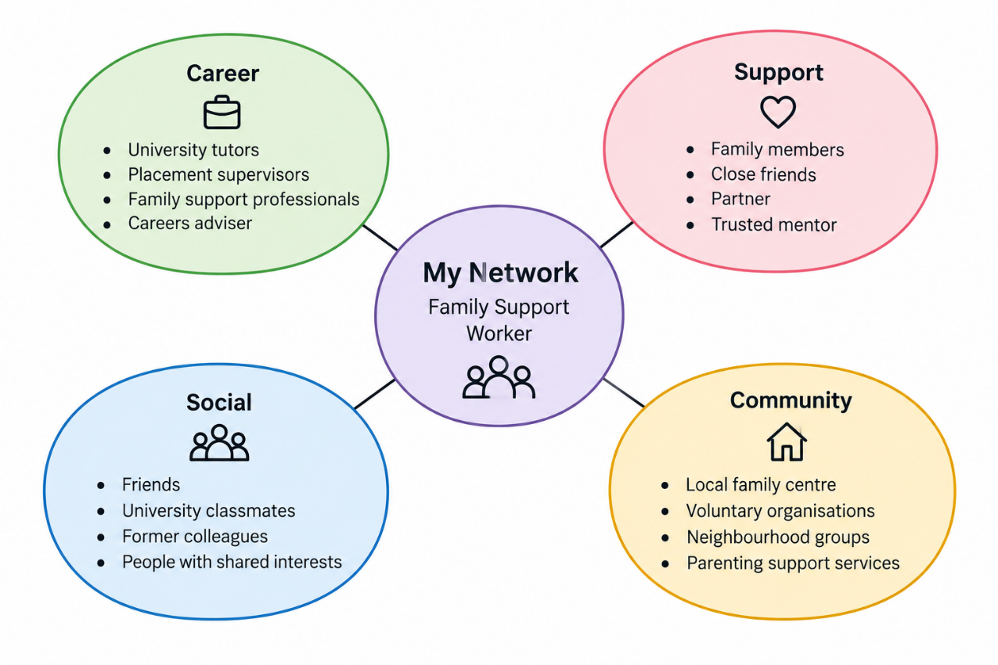

My network is mainly made up of people I know through my personal life and education. I would describe it as selective because I prefer to build relationships gradually and rely on people I trust. As I work towards becoming a Family Support Worker, I can see that my existing connections offer encouragement, but I still need to develop contacts within the sector.
Family members and close friends form the strongest part of my support network. They provide reassurance and practical help, particularly when I am managing competing responsibilities. Putnam (2000) explains how social connections can create trust and mutual support. These close relationships represent bonding social capital, although they do not necessarily provide information about employment in family services.
University classmates and former colleagues offer opportunities to exchange ideas and learn from different experiences. These are examples of bridging social capital. My network map also identifies connections I would like to develop, including family support practitioners, placement supervisors and local family centres. I have included these as future contacts rather than suggesting I already know them. Building relationships with professionals and organisations could strengthen my linking social capital by giving me access to guidance and opportunities (Woolcock, 2001).
The main weakness in my network is therefore the limited number of established professional connections relevant to family support. I plan to use university careers advice, enquire about volunteering with local family organisations and attend relevant events. This would help me understand the role more clearly while gradually building a network that supports my career plans.

Task 3- Blog
Why Are Unpaid Carers Struggling to Access Support?
Across the UK, millions of people help relatives, partners or friends with everyday tasks because of illness, disability or age. They might organise medication, prepare meals, attend appointments or provide emotional reassurance. Many do this alongside employment and family responsibilities. Yet getting help for themselves can be surprisingly difficult.
Caring can gradually become a full-time responsibility without anyone formally recognising it. Someone may see themselves simply as a daughter, husband or friend rather than an unpaid carer. This matters because people who do not recognise their caring role may not know that support exists or where to ask for it.
Even when carers seek help, accessing services can be difficult. Carers UK (2025a) found that 57% of respondents often or always felt overwhelmed by their caring responsibilities, while 66% said they needed more support with their health and wellbeing. These findings suggest that many carers are struggling to manage their responsibilities without enough support. For someone already balancing appointments, employment and caring duties, finding time to seek help can become another challenge.
The difficulties carers face can also affect their financial security. Carers UK (2025b) reported that many carers experience financial pressures alongside emotional strain. Some have to reduce their working hours or make difficult decisions about household spending. Caring can be rewarding, but it should not mean sacrificing personal health or financial stability.
There are rights and services that may help. In England, an adult caring for another adult can request a free carer's assessment through their local council. This considers how caring affects their wellbeing and what support they may need. Depending on circumstances, help might include practical advice, support groups or arrangements that allow the carer to take a break (NHS, no date). An assessment does not automatically guarantee every service requested, but it is an important starting point.
Support also needs to become easier to find. GP practices, hospitals and local councils could do more to recognise carers early and explain available options in plain language. Employers can help by understanding the pressures of combining work with caring. Most importantly, carers should be involved in decisions rather than treated as an unlimited source of unpaid help.
Looking after someone should not mean being left to manage alone. Recognising carers, listening to their needs and providing timely support would benefit both carers and the people who depend on them. This deserves greater attention across health and social care services.

Task 4- NHS Equality, Diversity and Inclusion Quiz
- What is the primary goal of the NHS Equality, Diversity, and Inclusion Improvement Plan?
The plan aims to improve fairness and inclusion across the NHS workforce by addressing discrimination and creating better working experiences for employees from different backgrounds.
- How does the NHS EDI Improvement Plan propose to tackle the gender pay gap?
NHS organisations are expected to examine differences in pay and take action where inequalities exist. This includes improving access to career development and promotion opportunities.
- What is meant by the term ‘intersectionality’ as used in the NHS EDI Improvement Plan?
Intersectionality describes how different personal characteristics, such as ethnicity, gender and disability, can combine and influence someone's experiences of inequality or discrimination.
- Why is it important for the NHS to create a psychologically safe work environment?
A psychologically safe workplace encourages employees to express concerns and report problems without worrying about negative consequences. This can improve communication and patient safety.
- How does the NHS EDI Improvement Plan suggest improving the experience of internationally recruited staff?
The plan encourages employers to provide appropriate induction, clear information about employment rights and continued support to help internationally recruited staff settle into their roles.
- What role does leadership play in advancing EDI objectives according to the NHS Improvement Plan?
NHS leaders are expected to demonstrate inclusive behaviour, address unfair practices and ensure that equality objectives are included in organisational decisions and performance reviews.
- Identify one way the NHS EDI Improvement Plan aims to reduce health inequalities within the workforce.
The plan encourages organisations to consider employees' wellbeing needs and provide suitable support, particularly for staff who experience additional barriers to good health.
- Why does the NHS EDI Improvement Plan emphasise the importance of collecting and analysing data on protected characteristics?
Collecting workforce information helps identify unequal experiences and opportunities between staff groups. Organisations can then use these findings to introduce improvements and measure progress.
- Explain how flexible working policies can contribute to equality and inclusion in the NHS workforce.
Flexible working arrangements can help employees manage responsibilities outside work, including childcare, caring duties and health needs. This can improve access to employment and career progression.
- What is one strategy mentioned in the NHS EDI Improvement Plan to combat bullying and harassment in the workplace?
NHS organisations are expected to examine reports of bullying and harassment, identify patterns affecting particular staff groups and take appropriate action to address these concerns.

Task 5- A Letter to Yourself
Dear Younger Me,

If there is one thing I wish you had understood earlier, it is that you cannot always avoid difficult conversations. I remember how uncomfortable you felt when people disagreed with you or questioned your decisions. Rather than explaining your thoughts, you would sometimes stay quiet to avoid upsetting anyone. At the time, keeping everyone happy seemed more important than expressing your own opinions.

What I have learnt since then is that communication involves more than listening to others. It also means recognising your own feelings and understanding how they influence your behaviour. This is an important part of emotional intelligence. You were often so concerned about how other people felt that you overlooked your own emotions. I wish you had realised that speaking honestly and respectfully does not make you difficult or inconsiderate.

There will be situations where people misunderstand your intentions or where your efforts are not appreciated. These experiences can affect your confidence, but they can also teach you resilience. Instead of allowing disagreements to discourage you, try to understand what happened and consider how you could respond differently. Not every situation will have the outcome you hoped for, and learning to accept that is part of growing.

As you get older, you will realise that these skills are especially important when supporting other people. Working with families requires patience, emotional awareness and the confidence to manage sensitive conversations. You cannot help everyone by agreeing with everything they say. Sometimes, providing meaningful support involves being honest, maintaining boundaries and making difficult decisions.

I hope you learn to trust your judgement while remaining open to other perspectives. You can be compassionate without ignoring your own needs, and confident without dismissing the feelings of others.

With love,
Your Future Self

Task 6- GANTT Chart
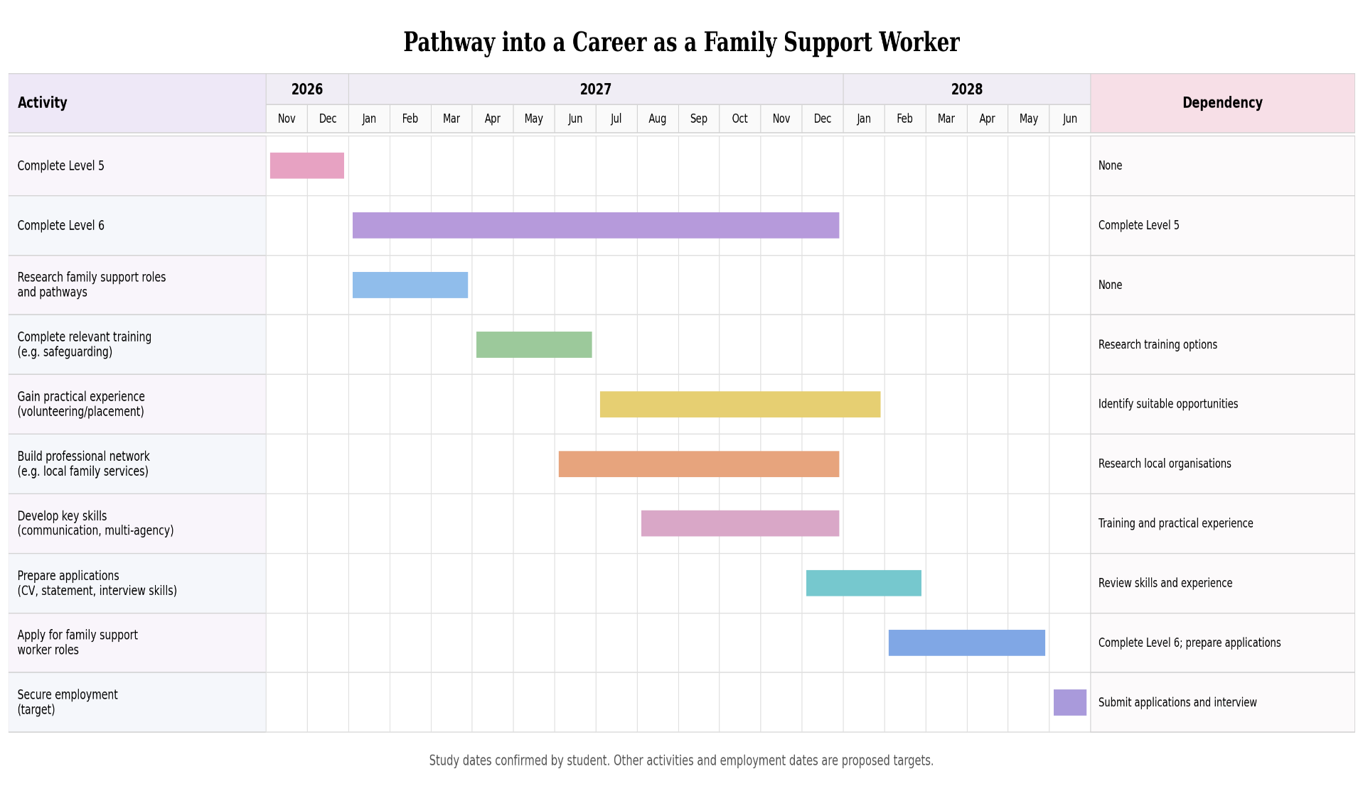

Task 7- Making Changes- Report
Introducing Personalised Activities in a Care Home
Introduction
If I were managing a care home, one change I would introduce is giving residents more choice over the activities they take part in. Care homes often organise group activities, but these may not interest everyone. I would like to introduce a programme that considers residents' hobbies, abilities and personal preferences, helping them feel more involved in their daily routines.
Planning the Change
Before making changes, I would speak to residents and their families to find out what activities they enjoy or have enjoyed in the past. NICE (2013) highlights the importance of meaningful activities for older people's mental wellbeing. Residents could choose from activities such as gardening, music, crafts or simply spending time with others.
I would use Lewin's change management model to help introduce the programme. Burnes (2004) explains how change can be managed through three stages. I would first discuss the idea with staff and explain why it could benefit residents. I would then trial the activities for four weeks before reviewing the results and deciding which ones should continue.
Skills Required
Introducing this programme would require patience, communication and organisation. I would need to consider residents' individual needs while making sure staff understood their responsibilities. The Care Quality Commission (2025) explains that care should reflect people's preferences and choices. I would also need to listen to feedback and be willing to make changes if something was not working.
Barriers and Solutions
One challenge could be staff shortages during busy periods, particularly when residents need help with meals or personal care. I would schedule activities around these routines and arrange staff cover so residents still receive the care they need.
Some residents may struggle with activities because of conditions such as dementia, arthritis or reduced mobility. I would adapt activities to their abilities, such as offering seated exercises or individual music sessions, without pressuring anyone to participate.
Safeguarding would also be important, especially during activities involving gardening tools, scissors or residents who may become confused or distressed. I would carry out risk assessments; ensure staff provide appropriate supervision and follow safeguarding procedures if any concerns arise.
Limited funding could make it difficult to purchase equipment and materials. I would use supplies already available in the care home and ask local businesses or community groups to donate suitable items.
Conclusion
I believe introducing personalised activities could improve residents' quality of life by giving them more choice and opportunities to take part in activities they enjoy. By involving residents and staff in the planning process and regularly gathering feedback, I would be able to assess whether the programme is meeting residents' needs and make improvements where necessary.

Reference List
- British Association of Social Workers (2026) Professional Capabilities Framework (PCF). Available at: https://basw.co.uk/training-cpd/professional-capabilities-framework/about-professional-capabilities-framework-pcf (Accessed: 21 October 2026).
- Burnes, B. (2004) 'Kurt Lewin and the planned approach to change: A re-appraisal', Journal of Management Studies, 41(6), pp. 977–1002. Available at: https://doi.org/10.1111/j.1467-6486.2004.00463.x.
- Care Quality Commission (2025) Regulation 9: Person-centred care. Available at: https://www.cqc.org.uk/guidance-regulation/providers/regulations-service-providers-and-managers/health-social-care-act/regulation-9 (Accessed: 21 October 2026).
- Carers UK (2025a) State of Caring: The impact of caring on carers' mental health and the need for support from social care services. Available at: https://www.carersuk.org/reports/state-of-caring-the-impact-of-caring-on-carers-mental-health-and-the-need-for-support-from-social-care-services (Accessed: 25 October 2026).
- Carers UK (2025b) State of Caring 2025: The cost of caring – the impact of caring across carers' lives. Available at: https://www.carersuk.org/reports/state-of-caring-2025-the-cost-of-caring-the-impact-of-caring-across-carers-lives (Accessed: 25 October 2026).
- National Institute for Health and Care Excellence (2013) Mental wellbeing of older people in care homes. Quality standard QS50. Available at: https://www.nice.org.uk/guidance/qs50 (Accessed: 25 October 2026).
- NHS (no date) Carer's assessments. Available at: https://www.nhs.uk/social-care-and-support/support-and-benefits-for-carers/carer-assessments/ (Accessed: 21 October 2026).
- NHS England (2023) NHS equality, diversity and inclusion improvement plan. Available at: https://www.england.nhs.uk/long-read/nhs-equality-diversity-and-inclusion-improvement-plan/ (Accessed: 25 October 2026).
- Putnam, R.D. (2000) Bowling alone: The collapse and revival of American community. New York: Simon & Schuster.
- Skills for Care (2017) What values do I need to work in social care? Available at: https://www.skillsforcare.org.uk/Documents/Recruitment-and-retention/Careers-in-care/What-values-do-I-need-to-work-in-social-care.pdf (Accessed: 25 October 2026).
- Woolcock, M. (2001) 'The place of social capital in understanding social and economic outcomes', Canadian Journal of Policy Research, 2(1), pp. 11–17.

