School of Hospitality and Tourism Management BA International Hotel Management
BMIH5004: Management and Organisational Behaviour
LEVEL 5
Mohammed Bilal Rehman
2013508
Executive summary
Organisational behaviour and management strategy can play quite the same role for a business. In this study for a hospitality company named Wyndham Hotels & Resorts their organisational structure was found a hierarchical format in which the CEO plays the role of controlling the overall company structure. However, some changes in this company were initiated with sustainable formations, resources and tools for all franchises and technological implementation for direct booking. Based on such changes whether they are aligned with the long-term objectives of the company was analysed. Finally based on the problems identified some recommendations for initiating a new pricing strategy and training from the CEO were discussed in this study.

Table of Contents
Introduction 1
Organisational structure, culture and Goals 2
Organisational structure of Wyndham Hotel 2
Evaluation of the corporate culture of Wyndham Hotel 3
The goal of Wyndham’s both corporate and individual unit levels 3
Recent Change Initiatives 4
Recent change initiatives from Wyndham Hotel and their impacts 4
The management of the changes in Wyndham Hotel 5
Strategic Direction 6
Examining the strategic directions of Wyndham Hotel 6
Analysis of the strategies for their long-term objectives 6
Conclusion 7
References 8

Introduction

Figure 1: Wyndham Hotels & Resorts.
Source: (Wyndhamhotels, 2023).
One of the largest hotel franchisors in the international context controlled from the United States is Wyndham Hotels & Resorts. Inc. This company is a well-known American Hospitality for its market positioning with around 9100 locations (Wyndhamhotels, 2023). This hotel was founded in 1981 in Dallas, Texas, United States by Trammell Crow. Including the hospitality brand this incorporated company has a total of 25 brands (Wyndhamhotels, 2023). According to the statistics of 2023, Wyndham Hotel has around 8400 employees working for them. Including the USA, and UK Wyndham Hotel has operations of hotels in 95 countries. The reason they can bring higher competition in the market is their award-winning loyalty program called Rewards by Wyndham. According to the statement of Wyndhamhotels (2023), this program contains 110 members which describes its popularity. The corporate culture and influencing strategy for operation by Wyndham Hotel is their ‘Call on Me’ service. At present, the annual revenue of Wyndham Hotel is around 1.2 billion GBP (Wyndham Hotels, 2023).
This study will evaluate the organisational structure, culture and goals of Wyndham Hotel including their recent change initiatives. Some strategic directions by the company and their implementation strategy which are dedicated to their long-term objectives will be discussed in this study. finally

Organisational structure, culture and Goals

Organisational structure of Wyndham Hotel
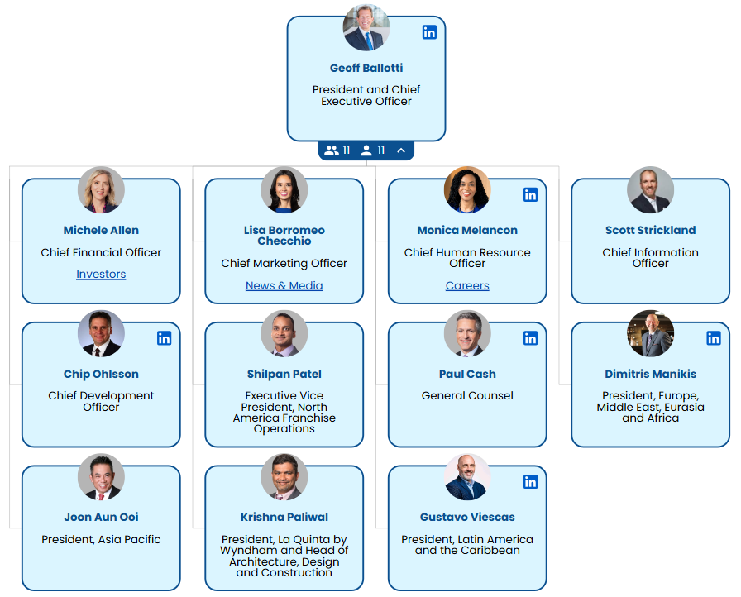
Figure 2: Organisational structure of Wyndham Hotels & Resorts. Inc.
Source: (Organimi, 2023).
As Wyndham Hotels is linked with global operations so for facilitate effective management and coordination across the border, they maintain a hierarchical organisational structure. According to Organimi (2023), hierarchical organizational structure is a part of the management style where a strict chain of command was used for connecting multiple levels of authority (Organimi, 2023). According to the responsibilities of all members of the hierarchy, the levels are defined. In Wyndham Hotel to ensure effective information passes with the maintenance of hierarchy at the top it is controlled by the CEO (Boddy, 2017). CEO only controls the executive leadership team. For the strategic direction handling CEO plays the role with the collaboration of executive leaders. The operations department of Wyndham Hotel has to report to the CEO for any actions they initiate. After the CEO the operation and franchising process was divided into two divisions brand management operations, sales and marketing, accounting and finance and finally development and HR (Organimi, 2023). All these departments get leads from the VP or general manager. Mainly the VP provides the report to the executive leaders for proceeding them to the CEO.

Evaluation of the corporate culture of Wyndham Hotel
Wyndham Hotels & Resorts, Inc. is a world leader in the hotel business. Its corporate culture is shaped by its hierarchical organisational structure. The mindset of the culture of Wyndham Hotel values great service and customer priorities (Mullins and Dosser, 2013). This ambition makes the company work together to build hospitality. This culture is very important in a hierarchical structure, where clear lines of power and communication help the chain of command work well and keep things running smoothly (Arnold, 2020). For Wyndham, this system makes it easier to make decisions and makes sure that all of its properties around the world follow the same brand standards.
The corporate culture from Wyndham encourages workers to be responsible and professional, with a focus on following service standards and giving customers the same experience every time (Robbins and Judge, 2017). These standards are enforced by managers at different levels which improves working efficiency. For example, a hotel manager makes sure that staff follows service rules so that every guest has a good time (Boddy, 2017). This top-down method helps Wyndham keep its brand image consistent across all of its franchises. This allows the company to provide guests around the world with reliable experiences.
On the other hand, Wyndham's inflexible structure can make it hard for some employees to bring objectives into their decisions (Arnold, 2020). This can stop them from being creative and making innovative ideas. In this, regard through the group's dynamic organisational behaviour the management of Wyndham has made sure of some collaborative actions. For this reason, workers from different areas like housekeeping, front desk and food services work together to solve problems in the business (Mullins and Dosser, 2013). This structured, team-based contact builds solidarity and reinforces Wyndham's focus on teamwork. Ultimately this makes customers satisfied with the employee's actions taken properly. So, Wyndham's hierarchical structure is supported by its corporate culture of service and responsibility (Charkina et al., 2021).

The goal of Wyndham’s both corporate and individual unit levels
Wyndham Hotels & Resorts, Inc. uses a hierarchical organisational structure to make it easier to manage and coordinate all the branches (Mullins, 2023). A strict chain of command is used in this structure to make sure that each level of power is clear. The CEO is in charge of the executive leadership team and ensures the company's major goals (Arnold, 2020). The CEO makes all the important decisions for operations, franchising, and other important areas. The executive leadership team is the only group that answers directly to the CEO.
The business is split into different teams that handle different tasks which are brand management, sales and marketing, accounting and finance, development, and human resources (Robbins and Judge, 2017). A Vice President is in charge of each area and reports to an executive leader. This makes sure that everyone is held accountable and that performance is consistent (Armstong, 2021). This organised way of reporting makes sure that everyone is working towards the same organization-wide goals. Each unit supports the overall strategic goals. Not only this but also members from each unit level make sure their area or department (Buchanan and Huczynski, 2007). This lets Wyndham provide a consistent brand experience around the world.

Recent Change Initiatives

Recent change initiatives from Wyndham Hotel and their impacts
Wyndham Hotels & Resorts, Inc. has recently made several change initiatives to better meet the needs of the changing market and improve its operational efficiency (Gill, 2020). Some of the factors bring such influences like guest satisfaction and getting environmentally friendly. According to statement Robbins and Judge (2017), Some of the company's most important projects are its attempts to turn digital or environment-friendly to grow its franchise support systems.
Digital transformation: Wyndham's involvement in digital transformation is one of its main initiatives for change. Wyndham created the Wyndham Direct program to meet the needs of customers who are more interested in digital activities (Mullins and Dosser, 2013). This program is a booking tool that allows corporate accounts to book directly with hotels and reservations. This project not only makes the experience of customers better but also improves Wyndham's data analytics by collecting booking data (Buchanan and Huczynski, 2007). This helps the company make better marketing and build relationships with customers. Some complications also arise due to such changes and initiatives like switching to digital systems employees need to get training besides their daily practices (Armstong, 2021). This raises short-term running costs and working pressures.
Environmental friendly change: Wyndham has also put more effort into being environmentally friendly, as they demand to have less impact on the world for their practices (Broderick, 2019). In this case, a program called Wyndham Green was initiated to use less energy, throw away less trash and install some sustainable sources (Huczynski and Buchanan, 2019). This project meets the growing demand from customers for eco-friendly travel choices and fits with global trends in sustainability (Mullins, 2023). Due to initiatives of sustainable technologies like lighting that uses less energy and systems operational expenses get increased.
Support for franchisees: Wyndham has also improved support for franchisees by releasing tools and resources which help hotel owners stick to brand standards. This includes training programs and operational resources that make franchisees simultaneously run the management. These programs make quality control better but they cost a higher to train people and create resources (Armstong, 2021). Though they strengthened brand integrity and customer loyalty across regions the investment increased for the company.

The management of the changes in Wyndham Hotel
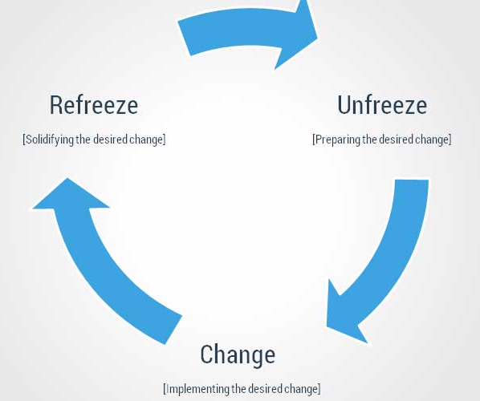
Figure 3: Lewin's 2-step model of change management.
Source: (Broderick, 2019).
Wyndham's method for their change initiatives fits well with Lewin's three-stage model (Broderick, 2019). Wyndham had to bring some changes in the "unfreeze" stage to adapt to a digital-first market and more environmentally friendly practices as customer standards were changing. For these employees and other administrators were prepared for change. This was for the launch of the Wyndham Green program and Direct booking system (Broderick, 2019). However, the unfreezing stage was quite difficult to manage for some franchisees not investing in green technologies.
During the change phase, Wyndham put these plans into action with clear communication and support. This was aligned with building a group to guide the necessary actions. For example, Wyndham makes sure that employees from all over the company use new technologies by offering extensive training programs (Broderick, 2019). This process also supports in the digital transformation. Employees for the company like this proactive approach but it also brings some problems like higher training costs and higher working pressures (Broderick, 2019).
Finally, during the refreeze phase Wyndham makes sure these changes become permanent in its business mindset and operational standards (Armstong, 2021). To make these changes managed well for the long term Wyndham brings eco-friendly practices and digital solutions. In the refreezing stage, some problems also arise like the high cost of support for the partners and the financial stress for the owners (Alyahya et al., 2023).

Strategic Direction

Examining the strategic directions of Wyndham Hotel
Brand Expansion: Though Wyndham Hotel is one of the most market-captured companies from the hospitality industry still has a strategic direction for brand expansion (Browning, 2021). The belief and objective which motivates the company is that a brand should not stop if they have scope to grow.
Sustainability initiatives: After the change initiatives with sustainable tools and resources added to the business management of Wyndham Hotel their strategic direction was concentrated in this process (Huczynski and Buchanan, 2019). As per the trend in the present hospitality market to support the perception of consumerism sustainability initiatives have become the strategic direction of Wyndham Hotel.
Customer loyalty program: Customer loyalty programs are also part of strategic directions for Wyndham Hotel. With such a process, customers from different franchises become aware of the service offered by the hotel (Organimi, 2023). Not only this but also different sides of customer segmentation do not have to be manually targeted but it is generated by their thinking.

Analysis of the strategies for their long-term objectives
Wyndham Direct program: The Wyndham Direct program is the part of strategy which has been applied by the company to make sure to ensure higher technological initiatives (Gill, 2020). With such strategies, the hotel's management will be able to prove themselves with trend practice and customer-centric. Besides this process as Wyndham management had not increased higher pricing it may bring some complications for reaching their ROI (Mullins, 2023). In this case, based on the management changes, some service-providing changes should be determined by Wyndham Hotels.
Eco-friendly travel choices: Eco-friendly travel choices are the best strategy which has been applied by Wyndham for making sure of their business sustainability. The customer satisfaction rate for Wyndham has also increased (Broderick, 2019). Tough with such implementations the objectives of sustainable business have been executed but lack of maintenance may bring barriers in the long-term process. A team of data analytics should be appointed to make sure that their practices are aligned with the ecosystem practice (Charkina et al., 2021).
Creative programs and operational resources: Niche segmented programs and operations resources for all the franchises of Wyndham had brought control of the organisational structure from the headquarters. This is the achievement of the long-term business success alignment (Huczynski and Buchanan, 2019). However, there will be control over all outlets by the CEO but there will be pressure on individuals. In this case, a group of training people personally by the CEO should be distributed in individual branches to make the working pressure balanced.

Conclusion
This study shows change changes management and organisational behaviour are very critical to implement and also maintain. As a large hotel company Wyndham after their varieties of changes contains some complications which can be determined with the effective change management model. This study confirmed some of the analyses of those changes and recommended the possible initiations.
Recommendations
The higher management of Wyndham Hotels should bring some changes in their pricing strategy and marketing format to make sure that they can achieve their ROI after the investment in their changes.
The CEO from Wyndham should have initiated a training program personally where the experts will be produced to distribute in all franchises. These individuals will fill the lack of a CEO from all franchises.
Wyndham should initiate big data analytics to monitor and control the total hospitality industry trends and properly follow them.

References
Adair, J. (2009) The Inspirational Leader (2nd Ed), London: Kogan Page
Alyahya, M., Aliedan, M., Agag, G. and Abdelmoety, Z.H. (2023). The Antecedents of Hotels’ Green Creativity: The Role of Green HRM, Environmentally Specific Servant Leadership, and Psychological Green Climate. Sustainability, 15(3), p.2629.
Armstong, M. (2021) Armstrong's handbook of performance management (7th Ed), London: Kogan Page
Armstrong, M. (2012) Armstrong’s Handbook of Management and Leadership (3rd Ed), London: Kogan Page.
Arnold, J. (2020) Work Psychology (7th edition) Harlow: Pearson Education Limited.
Bloisi, W. et al (2007) Management and Organisational Behaviour, (2nd edition) Maidenhead: McGraw-Hill.
Boddy, D. (2017) Management: An Introduction (7th Ed), Harlow, Pearson
Broderick, H. (2019). Lewin’s 3-Step Model of Organisational Change. [online] CollierBroderick. Available at: https://www.collierbroderick.ie/info-centre/management-development/change-management/lewins-3-step-model-of-organisational-change/.
Browning, L.D. (2021). Organisational Narratives and Organisational Structure. Journal of Organizational Change Management, 4(3), pp.59–67.
Buchanan, D. And Huczynski, A. (2007) Organisational Behaviour: An Introductory Text (6th edition), Harlow: Prentice Hall.
Charkina, T., Martseniuk, L., Zadoia, V. and Pikulina, O. (2021). Strategic Directions Of Hotel And Restaurant Business Management In The Conditions Of Crisis. Ekonomika ta derzhava, (2), p.19.
Gill, R. (2020). Change management--or change leadership? Journal of Change Management, 3(4), pp.307–318.
Huczynski, A. & Buchanan, D. (2019) Organisational Behaviour (10th Ed), Harlow: Pearson
Mullins, L & Dosser, P. (2013) Hospitality Management and Organisational Behaviour (5th Ed) Harlow, Pearson.
Mullins, L. (2019) Organisational Behaviour in the Workplace (12th edition) Harlow: Pearson
Mullins, L. (2023) Management and Organisational Behaviour (13th edition) Harlow: Pearson
Organimi (2023). Wyndham Hotels & Resorts’ Organizational Structure [Interactive Chart] Organimi. [online] Organimi. Available at: https://www.organimi.com/organizational-structures/wyndham-hotels-and-resorts/.
Robbins, S. & Judge (2017) Organizational Behaviour (17th edition) Harlow: Pearson Education Limited.
Rollinson, D. et al (2008 ) Organisational Behaviour and Analysis (4th edition) Harlow: Addison-Wesley Longman.
Wyndhamhotels (2023). Wyndham Hotels & Resorts | Search for Hotel Room Rates, Deals, and Getaways. [online] www.wyndhamhotels.com. Available at: https://www.wyndhamhotels.com/en-uk.

