Deploying a network directory service and creating and understanding active directory objects

Network Operating Systems and Services ACCA5023

Student : Brian Morris
Student Id : 1809130

Table of Contents
Deploying a network directory service and creating and understanding active directory objects 1
Network Operating Systems and Services ACCA5023 1
Table of figures 4
Domain Controller Build 6
Network Settings 6
Hostname 7
Installing the required roles and features 9
Configuring the Domain Controller role 14
Active directory Users and computers 17
Add additional user to Domain admins group 18
Standard user account 19
Permitted hours logon restriction 20
Time restrictions in effect 20
Per account user password restictions 22
Machine account creation 23
Adding the workstation to the domain 23
Sign in with domain account not local system. 25
New user profile creation from the OOBE 26
Local profile storage 27
Non Administrative user trying to login locally to server 28
Domain Name System 29
Active Directory 35
Multi Master and FSMO 35
File and Storage Services 36
DHCP 37
Delegation of Administration 39
AGDLP and AGUDLP 40
References 43

Table of figures
Figure 1- IP configuration of Domain Controller 6
Figure 2- Firewall Status of Domain Controller 7
Figure 3- Hostname detail via DOS command 7
Figure 4- Hostname details via Server Manager console 8
Figure 5- Add Roles and Features Dialogue box 9
Figure 6- Roles and Features Wizard welcome screen 9
Figure 7 -Installation type left at default 10
Figure 8- Select destination server where roles are to be installed 11
Figure 9- Select desired roles and features 12
Figure 10- Summary of services being installed 13
Figure 11-Functioanl levels, Roles and Recovery passwords 14
Figure 12- Data paths for Directory service components 15
Figure 13- PowerShell script of the above process 15
Figure 14- Additional installed roles / services that are available to manage 16
Figure 15- Active directory management console 17
Figure 16 -Additional user in Domain Admin group 18
Figure 17-Non administrative user in Domain Users Group 20
Figure 18- Applied Login hours restrictions 20
Figure 19- Waring dialogue of user login in outside of permitted hours 21
Figure 20-User account options to prevent password changes 22
Figure 21 Domain Computer Container not an Organizational Unit 23
Figure 22- Successfully adding workstation to the domain 23
Figure 23- Login into domain with domain credentials 25
Figure 24 - new local user profile creation OOBE 26
Figure 25- Illustration of local user profile storage creation 27
Figure 26- Unsuccessful logon attempt to local interactive console 28
Figure 27- Example of the default host file that ships with Windows clients 29
Figure 28- DNS console showing location of servers and services 30
Figure 29- Name server record from DC1-nwt 31
Figure 30- SOA record from DC1-nwt 32
Figure 31- SRV records from test server 32
Figure 32- details of service ports 33
Figure 33- Detail of Kerberos SRV record 33
Figure 34- PDC SRV record 34
Figure 35- small selection of DHCP options 37
Figure 36 - Scope Level Policy Priority 39
Figure 37- Domain user and groups naming convention 42

Domain Controller Build

Network Settings
Following the build of the stand alone server network settings were confirmed prior to creating a new Forest, Domain, and Domain controller.

IP config
Validation that IP address is as specified in the original specification

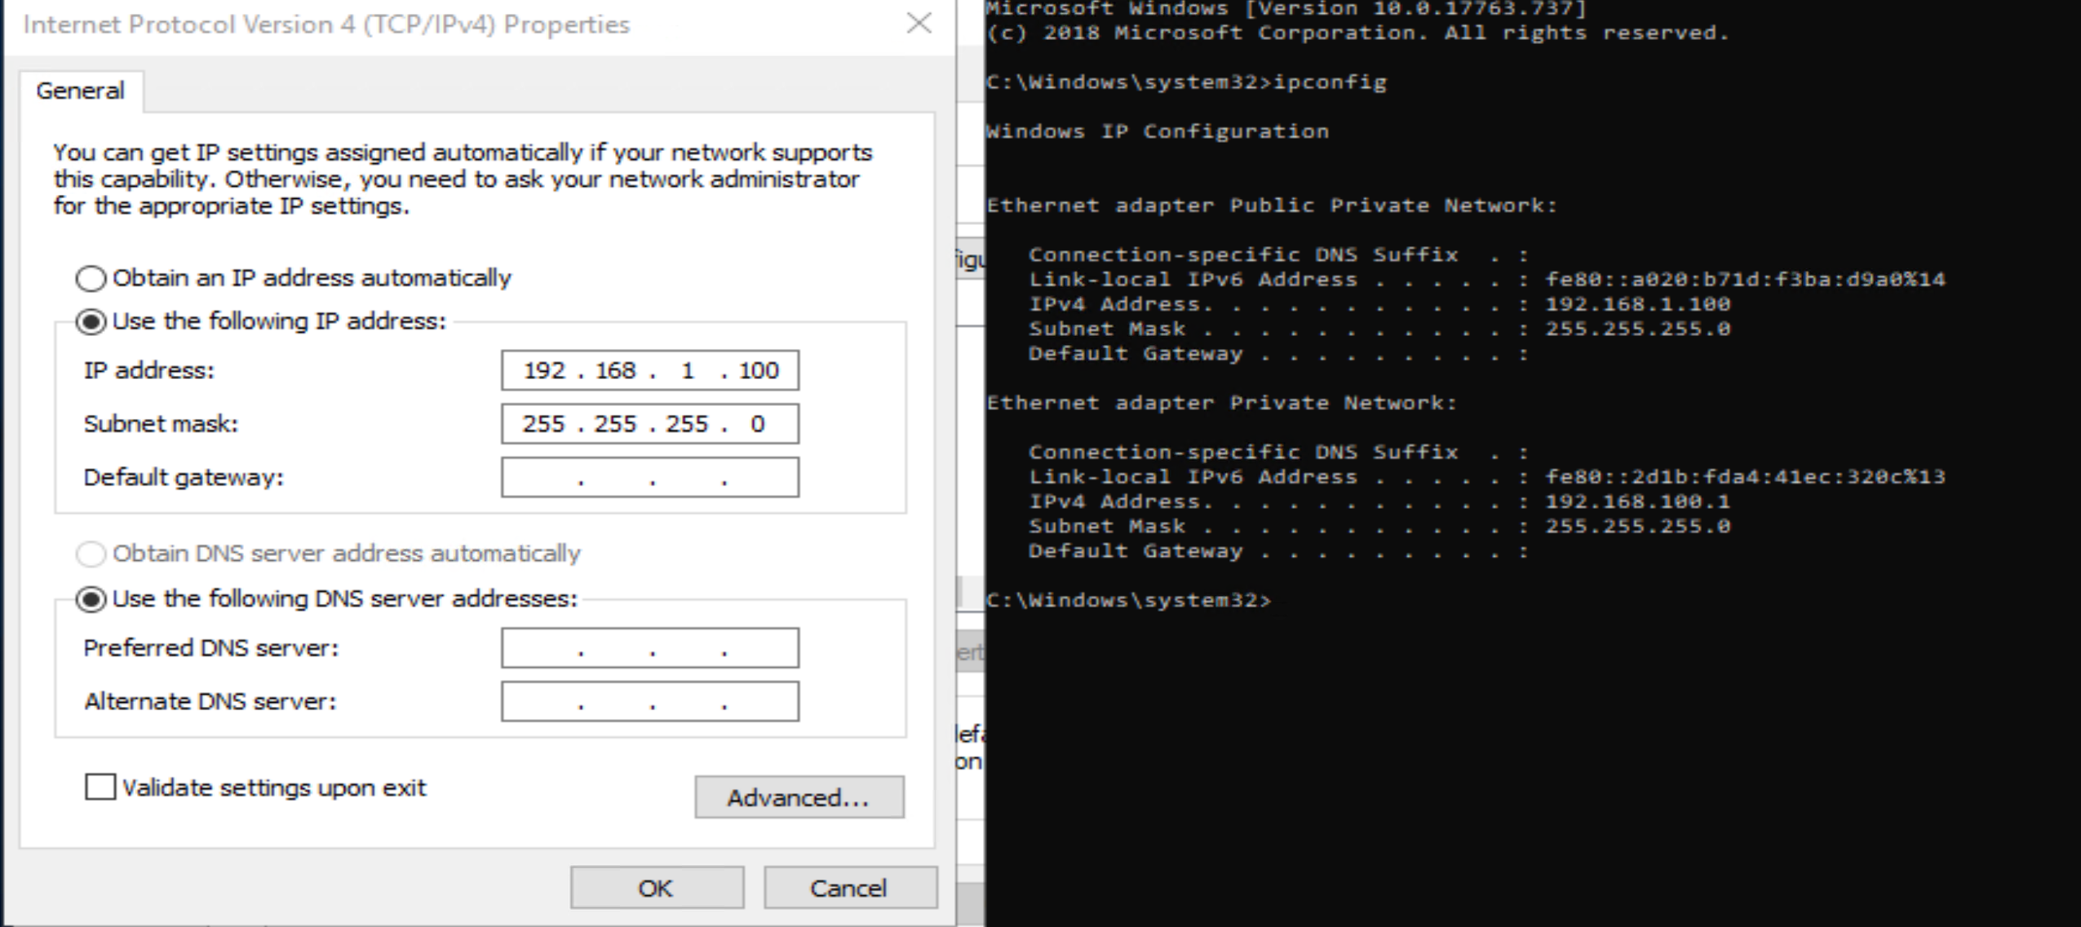
Figure 1- IP configuration of Domain Controller

Firewall Status
A review was undertaken to ensure the of the status of the firewall to confirm the status has not been changed since the service was disabled.

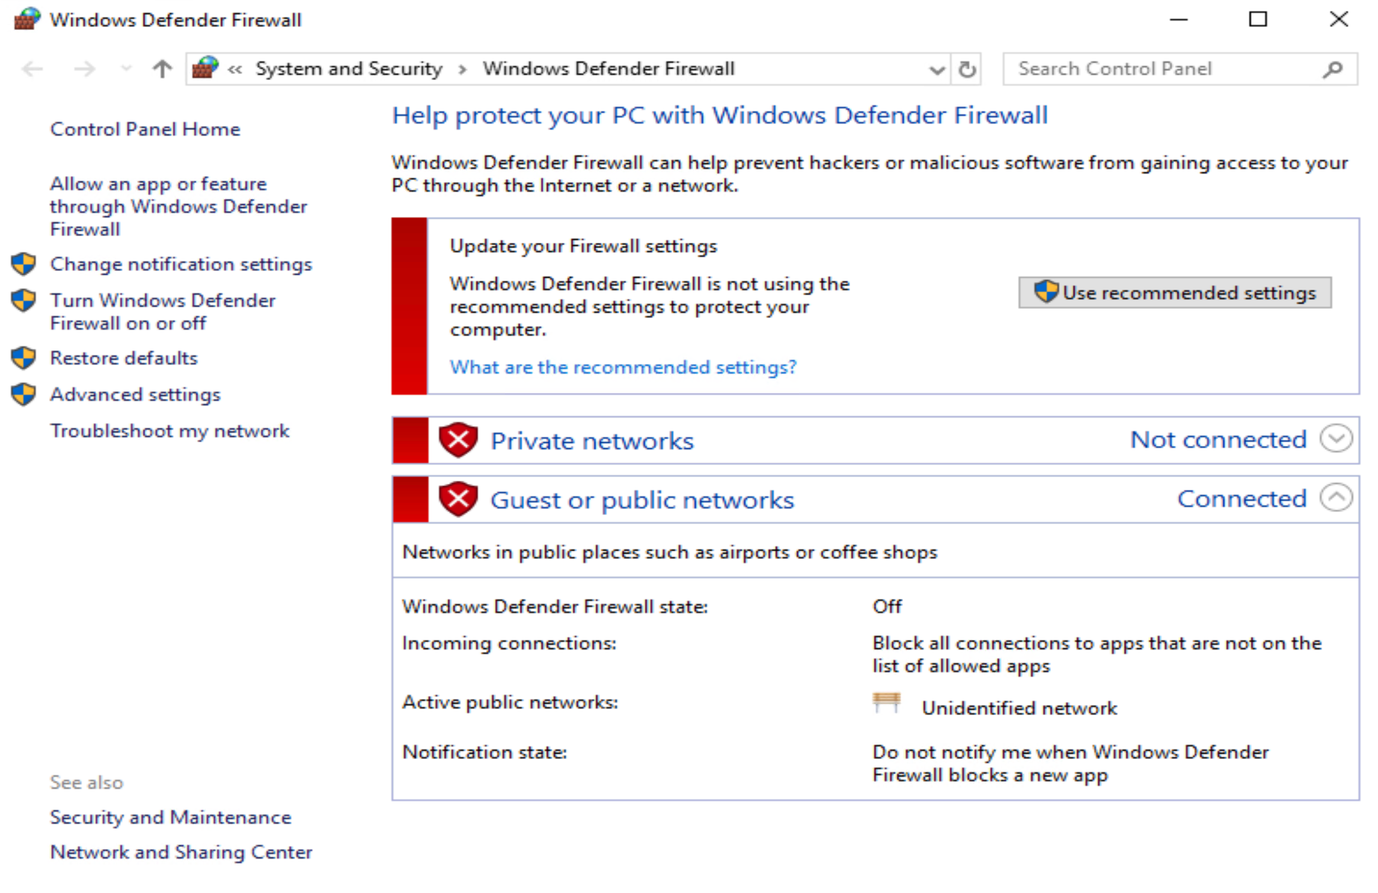
Figure 2- Firewall Status of Domain Controller

Hostname
The hostname was changed to the specified, named in the specification.

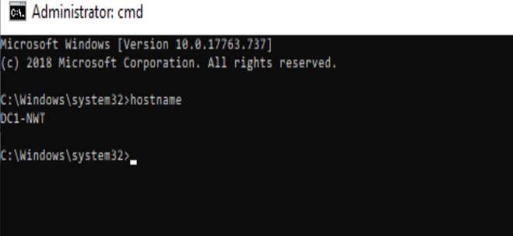
Figure 3- Hostname detail via DOS command

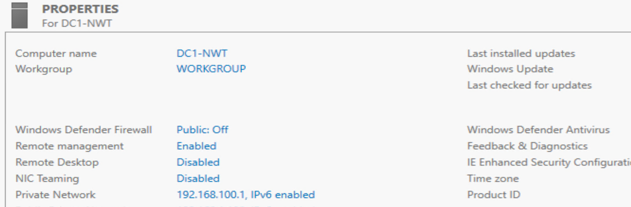
Figure 4- Hostname details via Server Manager console

Installing the required roles and features
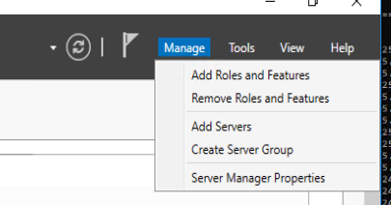
Figure 5- Add Roles and Features Dialogue box

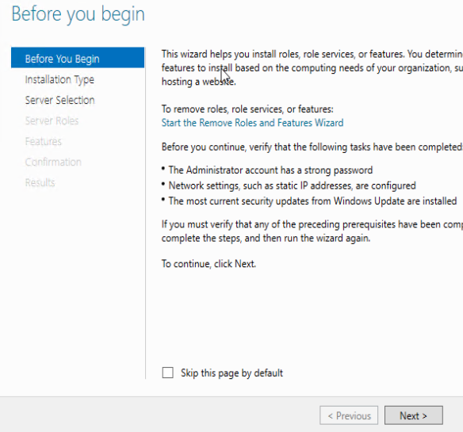
Figure 6- Roles and Features Wizard welcome screen

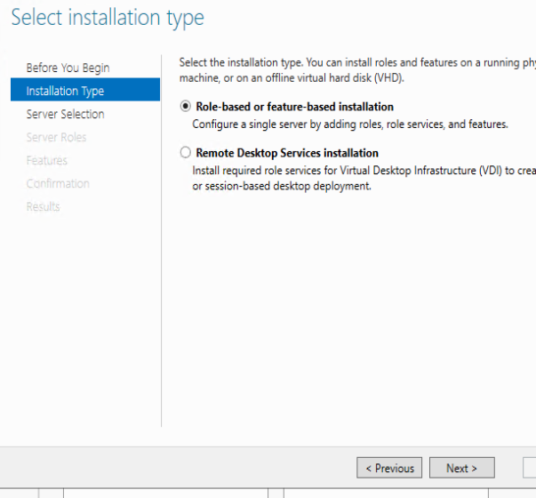
Figure 7 -Installation type left at default

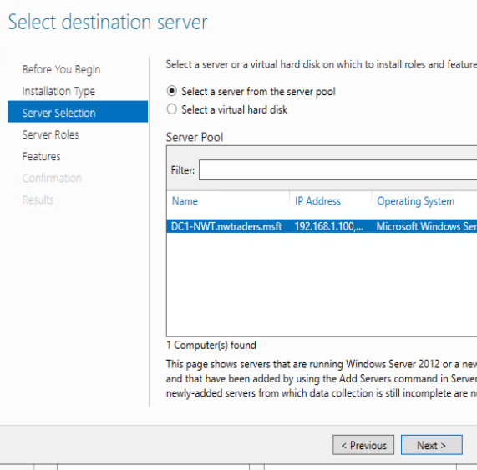
Figure 8- Select destination server where roles are to be installed
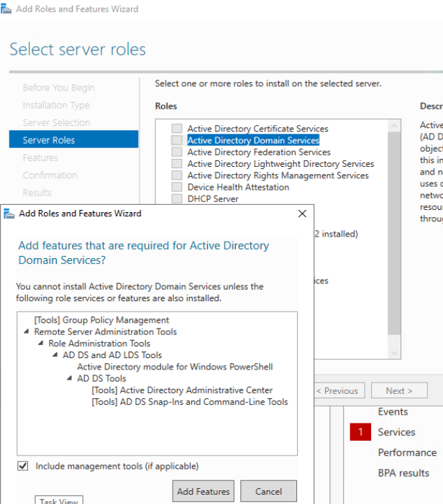
Figure 9- Select desired roles and features
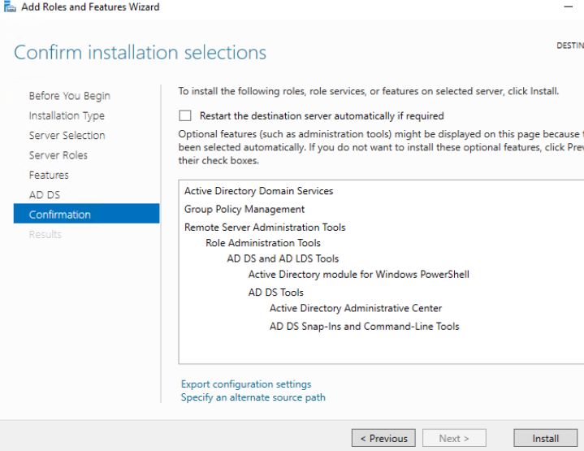
Figure 10- Summary of services being installed

Configuring the Domain Controller role

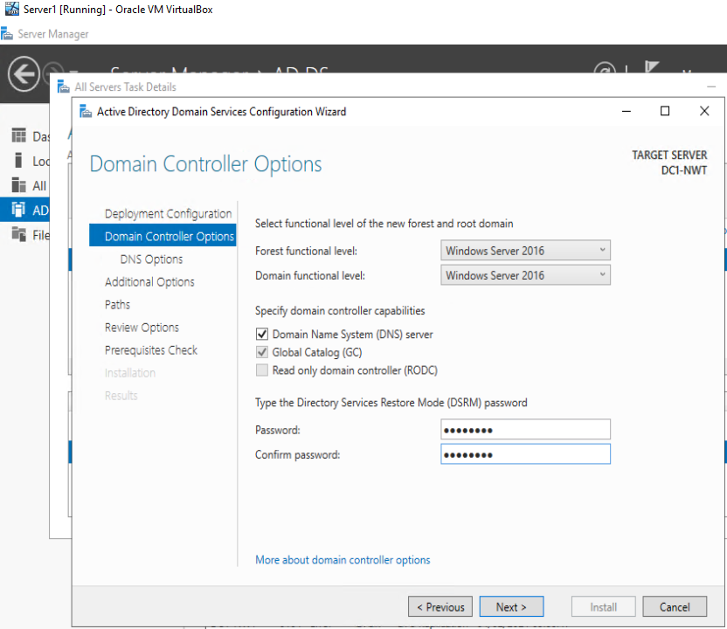
Figure 11-Functioanl levels, Roles and Recovery passwords

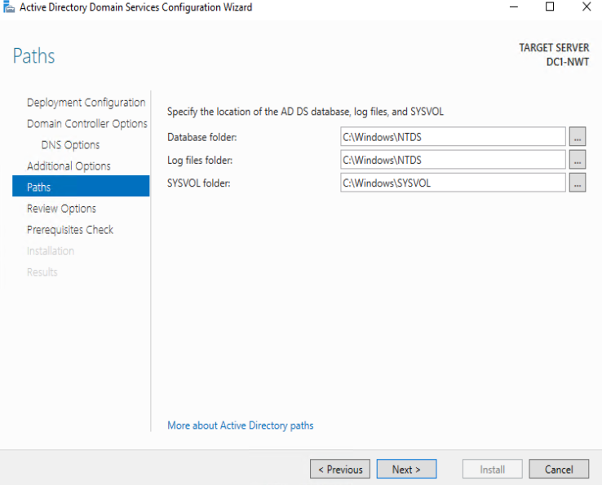
Figure 12- Data paths for Directory service components

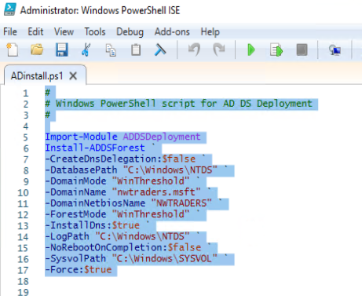

Figure 13- PowerShell script of the above process

Additional service installed as part of the DCPromo task
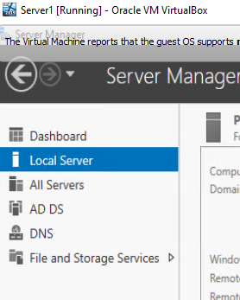
Figure 14- Additional installed roles / services that are available to manage

Active directory Users and computers

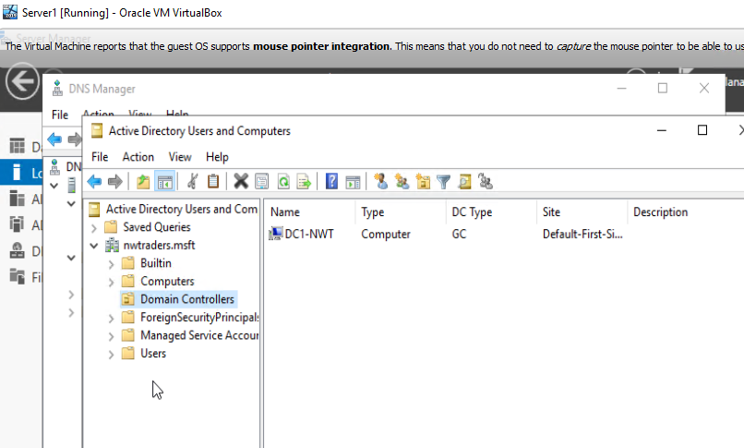
Figure 15- Active directory management console

Add additional user to Domain admins group

An additional administrative account was created. Typically, this is used to enable more effective auditing of who is making administrative changes to an estate as this account is normally assigned to a named individual.
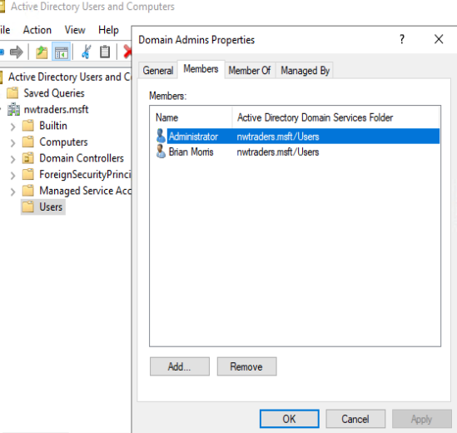
Figure 16 -Additional user in Domain Admin group

Standard user account

A non-administrative user without extended or elevated rights was created
Username: User1
Password: P@ssw0rd
The user was automatically added into the Global Domain Users group which itself nested into the local Users group
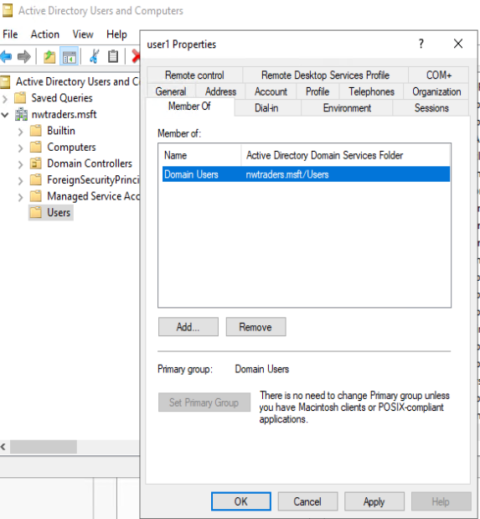
Figure 17-Non administrative user in Domain Users Group

Permitted hours logon restriction

Organizations where there is a defined working pattern for users can enforce login restrictions to prevent un-authorized access to systems outside of the defined hours.

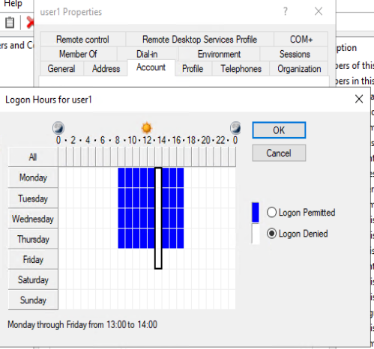
Figure 18- Applied Login hours restrictions

Time restrictions in effect
Note the warning on the user login screen when login on outside of the permitted hours.
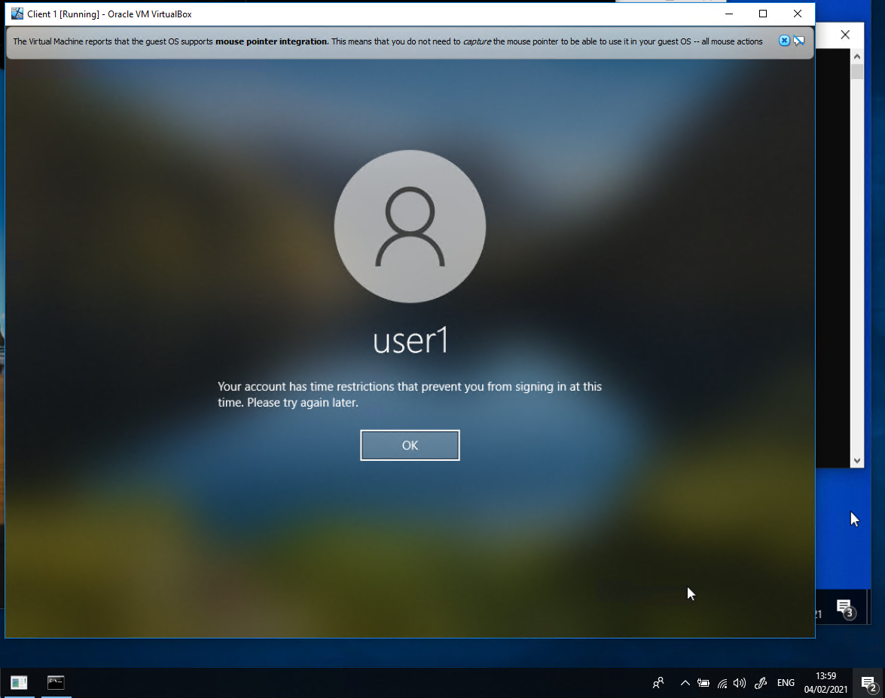
Figure 19- Waring dialogue of user login in outside of permitted hours

Per account user password restictions

Password settings across the domain can be specified in group policy object however some settings can be overwritten on a per account basis.

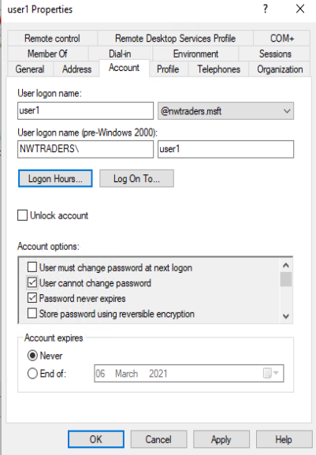
Figure 20-User account options to prevent password changes

Machine account creation

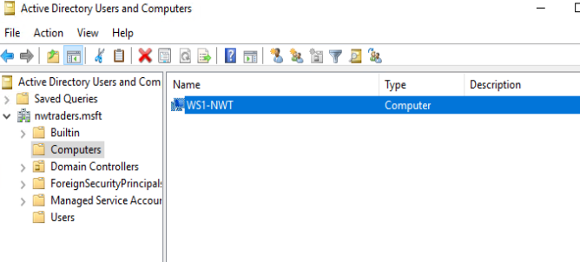
Figure 21 Domain Computer Container not an Organizational Unit

Adding the workstation to the domain

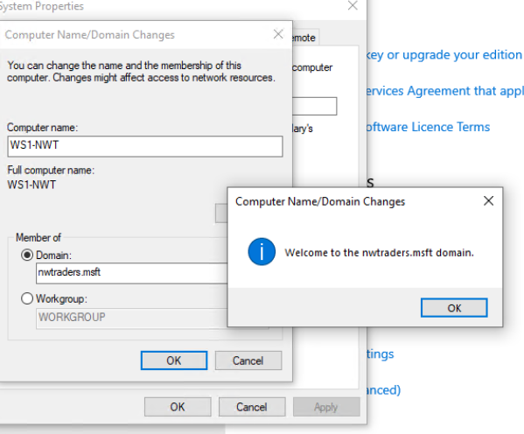
Figure 22- Successfully adding workstation to the domain

Sign in with domain account not local system.

Using the non admin account to sign into a workstation that is a member of the domain. Note the “Sign into” shows the domain NWTRADERS name not the workstation name. This indicates that the users account credentials would be validated against those on the domain controller not the account database of the local workstation.

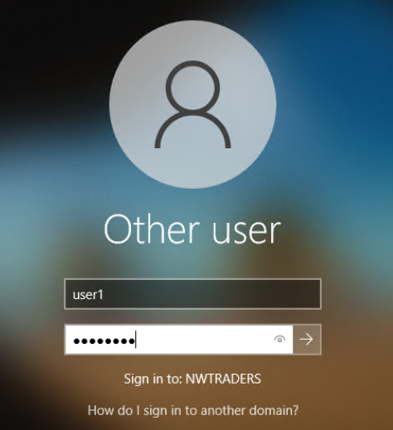
Figure 23- Login into domain with domain credentials

New user profile creation from the OOBE

As the local workstation does not have a user profile for this user a new profile will be created. As there has been no modification of the Out of Box Experience a new profile will created using the default settings.

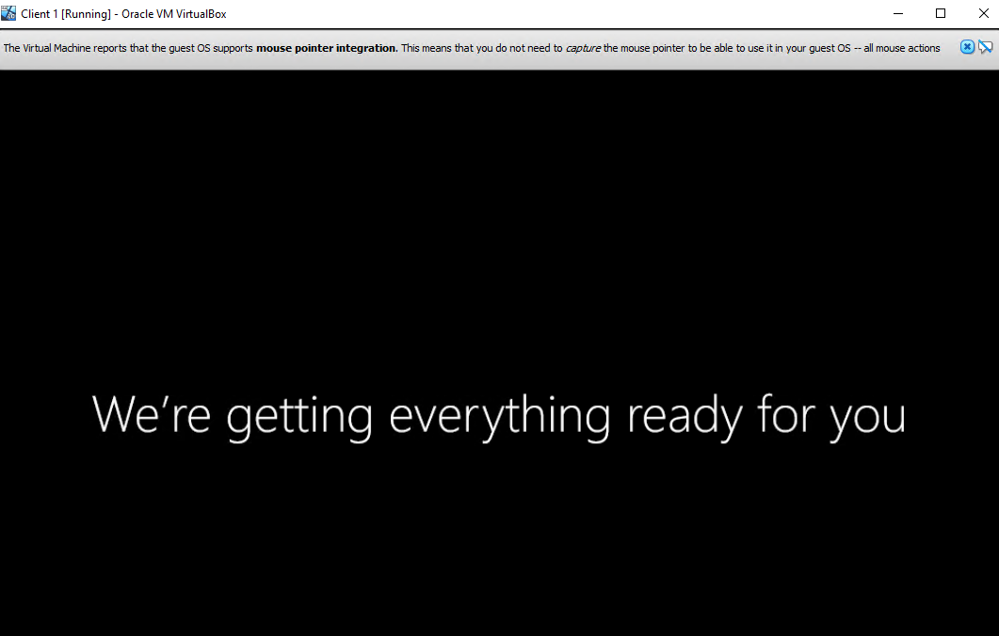
Figure 24 - new local user profile creation OOBE

Local profile storage

Note the new profile for the NWTRADERS User1 account has a separate profile that is stored in a newly created folder distinct from the user1 account that was local to the host machine.

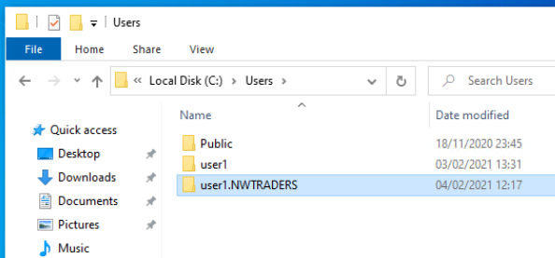
Figure 25- Illustration of local user profile storage creation

Non Administrative user trying to login locally to server

The following screen shot highlight the warning a non administrator would receive if they attempt an interactive logon to a server management console. Either at a physical server or remotely via a Remote Desktop session.

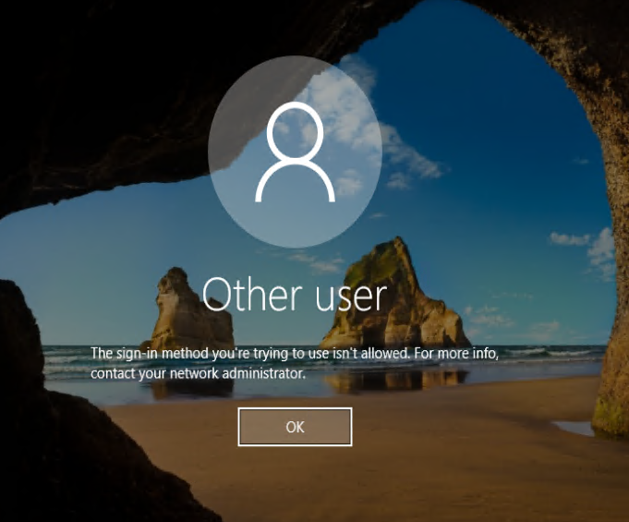
Figure 26- Unsuccessful logon attempt to local interactive console

Domain Name System
DNS primarily maps IP addresses to names or services. Prior to DNS there were several name resolution services used Host files being the prime example.
Host files are still in valid today and their operation has not changed. Manually edited text files that maintain the relationship between IP and Name typically used by one computer.
# Copyright (c) 1993-2009 Microsoft Corp.
#
# This is a sample HOSTS file used by Microsoft TCP/IP for Windows.
#
# This file contains the mappings of IP addresses to host names. Each
# entry should be kept on an individual line. The IP address should
# be placed in the first column followed by the corresponding host name.
# The IP address and the host name should be separated by at least one
# space.
#
# Additionally, comments (such as these) may be inserted on individual
# lines or following the machine name denoted by a '#' symbol.
#
# For example:
#
# 102.54.94.97 rhino.acme.com # source server
# 38.25.63.10 x.acme.com # x client host

# localhost name resolution is handled within DNS itself.
# 127.0.0.1 localhost
# ::1 localhost
Figure 27- Example of the default host file that ships with Windows clients
The above example has both ipv4 and ipv6 host file entries however none of these are in effect and are provided for illustration purposes only.
In the formative years of the internet the manual task of maintaining and distributing these records become more difficult to manage. Paul Mockapetris is credited with the creation of DNS in 1983 [1] [2]. This allowed organizations to manage their own local resources name mapping more effectively whilst still being able to query for resources outside of their own organization.
Whilst DNS maps name to IP address it is also used to map services to a resource. By examining the forward lookup zone of the sever DC1-NWT it details the information that are relevant for the running of the overall service.

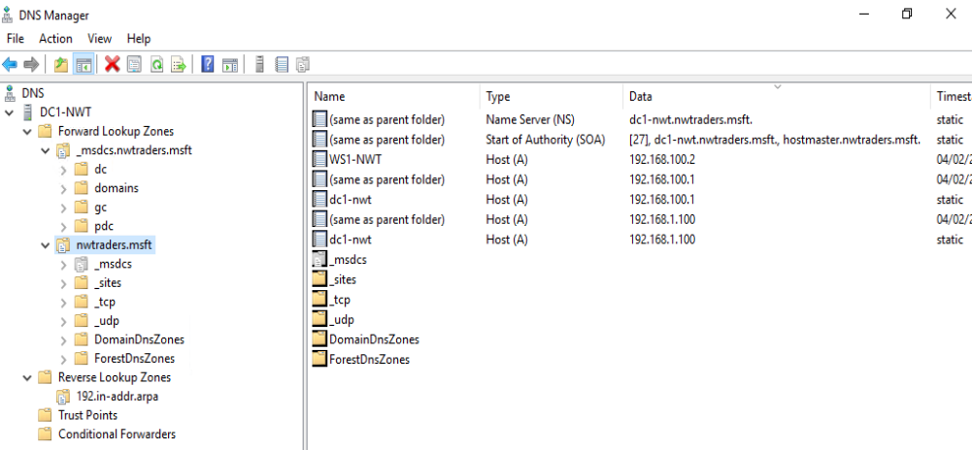
Figure 28- DNS console showing location of servers and services

In the screen shot above we can see the forward lookup zone with the list of mappings of servers and workstations to IP addresses. Also listed are Types of records that point to names of servers on the domain.
Name Server (NS) points to the Domain Name Servers in the estate in the example there is only one server that is currently authoritative for this domain.
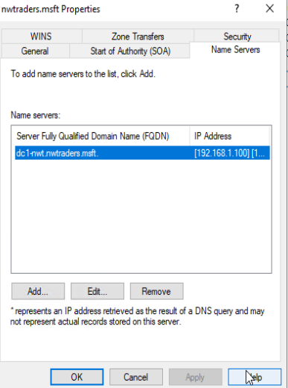
Figure 29- Name server record from DC1-nwt
Start of Authority (SOA) [2] has information relating to who is responsible for the domain how long before the server should wait before refreshes etc.
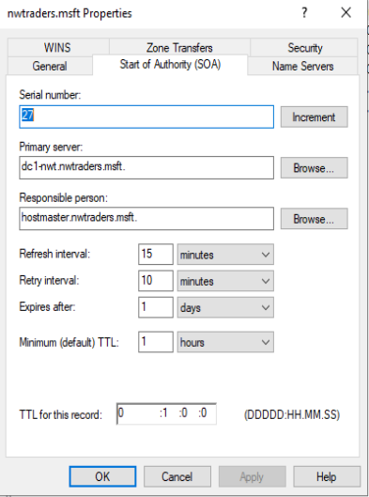
Figure 30- SOA record from DC1-nwt
Service Location (SRV) Contain the type of service and where that server resides, they also list the network port that service operates on.
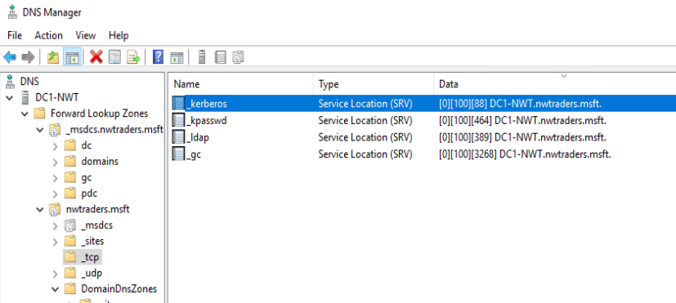
Figure 31- SRV records from test server
From the above illustration we can see that the following services reside on the following ports: -

Service | Port number | Role
Kerberos | 88 | Used for user authentication
Kpasswd | 464 | Used for password management
LDAP | 389 | Lightweight Directory Access Protocol
GC | 3268 | Global Catalog
Figure 32- details of service ports
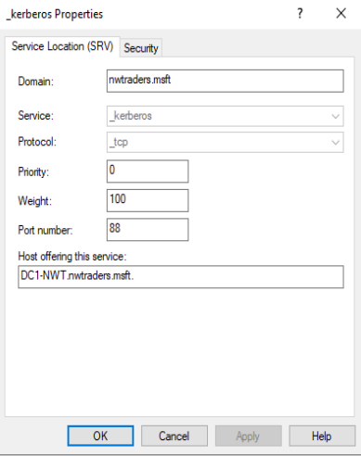
Figure 33- Detail of Kerberos SRV record
By identifying the available services within DNS. Directory service clients can operate in a far more autonomous way with less need for manual administrative intervention. For example, by placing SRV records into DNS such as the PDC or Primary Domain Controller client devices can locate services managed by the PDC Password resets, Time Synchronization etc more effectively. Where as the LDAP and GC SRV point clients in the direction of their nearest authentication service.
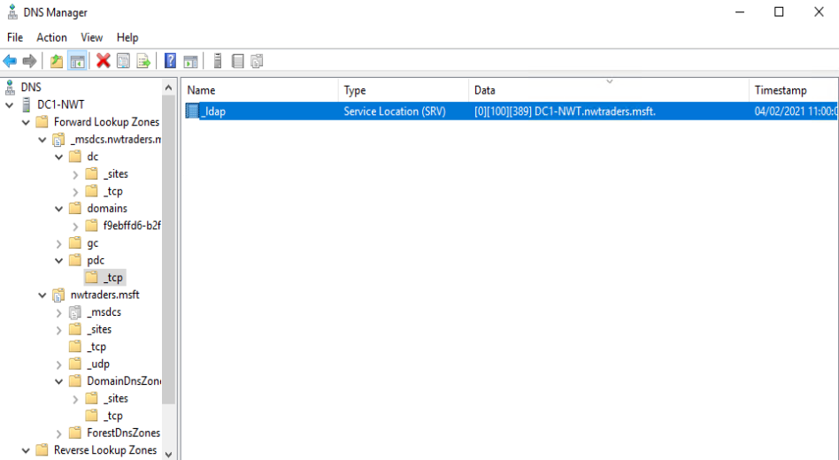
Figure 34- PDC SRV record

Active Directory
Microsoft Active Directory introduced with Windows 2000 as the successor to Windows NT. It improved on several limitations of the older product one being removing the 40000-account limit that hampered larger deployments.
Utilizing X.500 database protocols to provide a single directory information tree of an organization. Integrating DNS within Active Directory permitted services to be advertised within DNS without the need to manually configure settings on clients. Although it should be noted that running DNS and Active Directory separately is still a valid configuration and organizations can run DNS services on Operating systems other than Windows.
Using a hierarchical database that contained not just user and computer accounts but multiple types of network objects with the ability to extend the schema of the database and amend attributes to suit the needs of the business. Where NT4 had domains and trusts to manage resources. Active Directory added Organizational Units, Sites, Forests, and Trees this greatly expanded the capabilities of the system to match an organizational structure and demands as required. [3]

Multi Master and FSMO
Multi-master replication permits multiple servers to hold roles that replicate information across other domain controllers using a change control process of last writer wins [4]. Where the latest entry of an attribute becomes the referenced value and is replicated across the other DCs as required. This reduces the top-down approach typical with NT4’s Primary Domain controller and Backup Domain Controller model. For example, during an account password change any DC is able to update the account password. In NT4 a password change would need to authorise only by the Primary Domain Controller as this contained the only writeable copy of the account management database.
There are times where multi-master replication with last write wins can result in conflicts so Flexible Single Master Operation roles are configured [4]. A DC can hold either none of the roles or one or more of the five roles that exist within the domain.
These roles include the Schema Master, Domain Naming Master, RID Master, PDC Emulator, and Infrastructure Master.
The Schema Master is responsible for replicating changes to the databases schema. Schema can changes occur when domain wide active directory features or service need to be updated. For example when upgrading a domain from Windows 2012 to 2016 or 2019 new classes are added or additional attributes are added to existing objects.
The Domain Naming master is responsible to making forest -wide changes to the domain name space. This DC is the only one capable of adding or removing domains to the directory. The RID master creates pools of unique IDs that are distributed to other DCs that are attached to Security IDs within the domain.
The PDC Emulator used to as the name implies emulate the role of a Primary Domain Controller in legacy installations that still used NT4 based DC or older client devices that could not authenticate within an Active Directory. The PDC emulator still has a vital role as it is identified as the primary time source within a domain. Whilst clients that utilize the W32time service within a domain will use their nearest DC as their authoritative time source the DCs themselves will refer to the PDC as their authoritative time source. Password changes performed on one DC are preferentially replicated to the PDC before being replicated to other DCs in the estate. [4]
Object in the domain are referenced by a Globally Unique ID , A Security ID (SID) or Distinguished Name (DN). The Infrastructure master is responsible for updating an objects SID and DN in a cross-domain object reference.

File and Storage Services
The centralization of file storage has been a key role for work place in server for many years. The capability to access a central repository of files, coupled with the ability to collaboratively work on documents securely, has led to new ways of working for organizations.
The Server Messaging Block protocol or SMB is constantly evolving and has capabilities far greater than simply sharing office productivity documents. SMB protocols are part of the foundations of a Windows Software defined data centre [3] [4].
By default the file serving services are installed on a domain controller as this server will need to share data from its Sysvol share. The Sysvol contains group policy objects and logon scripts if configured. The Sysvol also contains the legacy Netlogon share used for pre-windows 2000 clients. The Sysvol is also a distributed file share as more domain controllers are added to the domain the Sysvol data is automatically replicated across the domain controller ensuring there is a resilient path to the data.
Linux and Unix systems would typically use SAMBA to share data to windows clients however these operating systems can also utilise NFS (Network File System) for sharing data amounts other UNIX/Linux devices. Microsoft now offers the ability to install NFS services on its windows hosts for improved interoperability with UNIX and Linux clients

DHCP
Dynamic Host Configuration Protocol is not exclusive to Microsoft Windows. Many other server operating systems can serve this role as well has network infrastructure from multiple vendors including Cisco and HP. This network role of DHCP eases the administrative overhead of assigning IP addresses to client devices in defined subnets. This permits client devices (for example laptops) to move from network to network without the need to manually reconfigure the client IP address configuration details. As a client connects to a subnet the DHCP process can assign the client a valid IP. If that client moves subnet a new address can be assigned to the device and the redundant IP address will be returned to the pool of available IP addresses to be reused for later requests without any manual configuration on the client.
Not only can the client receive a new IP address they would also typically also receive other options [5] a full list of DHCP options can be found here within RFC2132 .

Essential options for clients in a windows domain can include
Option Number | Option Name | Description
1 | Subnet Mask | The subnet mask to be applied to the address from the address pool
3 | Gateway | The IP address of the default gateway for that particular scope
4 | Domain Name Server | The IP address of the Domain Name Servers the client devices can contact on that subnet
Figure 35- small selection of DHCP options

The process for a new client being assigned an IP address is as follows [6] [7] :-
1 DHCP DISCOVER - Client device broadcasts on the subnet for a DHCP server to provide a valid configuration.
2 DHCP OFFER - A DHCP server or multiple DHCP servers responds to the client by sending an IP configuration to the client for the specific subnet
3 DHCP REQUEST – The client device selects the which DHCP it wishes to communicate with and broadcasts a request directly to the DHCP server. Whilst the client now possesses a valid IP address it has not applied it to the IP stack at this point.
4 DHCP ACK – The server sends confirmation, acknowledging the client can now start using the provisioned IP address and commits the details into its DHCP server database.

DHCP Lease time
DHCP lease times refer to length of time a client may continue to use the provisioned address before it needs to initiate a full DHCPDISCOVER process. By default, Windows servers offer a lease time of 8 days. To avoid overloading a service a client device should contact the DHCP server halfway through its lease time to renew its existing lease there by extending it for another 8 days. The longer the lease time the less traffic the DHCP server must manage however there is a possibility that IP scopes could become full as stale information has not been removed in a timely manner for the subnet being serviced. Conversely a short lease can generate more traffic for a DHCP server and the network. A short lease time is useful in networks where there is a limited range of IP addresses available and a high turn over of clients. For example a 100 seat conference room with wireless access for attendees may only have enough IP address for 50 clients however the clients may not be in the area for more than 2 hours. Limiting the lease time to minutes or a few hours allows for a higher turnover of clients.

DHCP Reservation
DHCP reservation are useful if a device needs to always be available via a specific IP address. The DHCP server is configured to ensure that a client using a specific MAC address is given a consistent IP address. This can be useful for ensuring certain pieces of infrastructure have a constant configuration when performing remote administration on the specific device could be problematic.

DHCP Exclusions
DHCP exclusions are applied within a range of address already being provisioned via DHCP. The scope of address may overlap with addresses that have been utilized elsewhere or the administrator requires to reduce the scope of available address as they deploy statically assigned address to specific clients in that subnet.

DHCP Policies
Windows 2012 [10] introduced Policy based assignment into DHCP scopes. Client devices can be assigned specific attributes based on the initial request. A scope can be split to allow devices access to a specific range within the subnet. Policies applied can review DHCP requests and identify Printers, IP phones, or Computers typically via the vendor class and MAC address prefix present by the DHCP client. For example IP phones can be limited to the to a defined IP range within the overall scope of address and additional configuration details such as the details of the TFTP server the phone needs to contact to retrieve is configuration details can be sent as a scope option that other clients in the overall scope will not need. Mobile devices can be assigned lease times that are different from the overall scopes lease time default.
Policies are useful in overriding scope defaults and allowing scopes to be used more effectively therefore freeing up address spaces. Prior to this feature devices that needed different settings would typically be assigned to different subnets and be managed with different scopes.
Within the Policies themselves there is also a processing order so multiple polices can be applied the processing order can be configured and weighting applied to which policy takes effect i.e. a policy processing order of 1 will be higher than a 2 . Conflicting or different settings in policy 2 will be ignored and policy 1 settings applied as it has the higher precedence.
Scope policies follow a priority when applying scope options as indicated below.
Highest |  |  |  | Lowest
Reservation > | Scope Policy > | Server Policy > | Scope -level > | Server-level
Figure 36 - Scope Level Policy Priority

Delegation of Administration
Many large enterprises have support teams who specialize in specific roles. The delegation of roles to the individuals would be irrelevant if every individual had the same rights on the network. By delegating rights for example to a DHCP Admin it is possible to provide just enough administrative rights to perform the role they are responsible for without weakening the overall security posture of the estate.
An admin in the DHCP Admin group would be permitted to set up new DHCP scopes and modify options within the scope as would be relevant for that role. However, they would not have permissions to create or delete users, change passwords, modify group membership. An Account Operator [7] for example can perform the above user account administration functions on domain users apart from users who are members of the domain admin group. This prevents account operators from elevating their own rights.

AGDLP and AGUDLP
To efficiently manage resources across an estate standardizing on the process of who or what can have access to perform certain task or access certain data, administrators using Microsoft solutions can follow AGDLP or AGUDLP
AGDLP Account Global Domain Local Permission
AGUDLP Account Global Universal Domain Local Permissions
Account refers to a user, computer or service account.
Global/Global Universal would be used to contain a selection of accounts that typically share the same roles eg Domain Admin, Sales Team, Year 3 students
Domain Local Would typically contain one Group or multiple Groups
Permissions refers to the access that a specific resource has been allowed or denied i.e Full control, Modify, Read & Execute, List content, Read, Write and Special Permission.
Least restrictive permissions take effect for example a user could be in two groups one for Read only and with Write access. The Write access is the least restrictive so the effective permissions would be Write. The exception to this is when Deny permissions is applied. If the user was in a third group that was set to explicitly deny access then this would take precedence regardless of the less restrictive access control list.
Take the following scenario for example a file large folder containing hundreds of thousands of files has been shared to lecturers and students. Lecturers can update the content, but students are only permitted to read the data. Whilst its possible to directly assign permissions for an individual account, the process of directly applying permission across a file system to an individual account can take a long time and consume system resources. Extend this example to multiple file shares and this process becomes even less efficient and consumes even more system resources. If a Student becomes a Lecturer not only does the process of reapplying permissions for this one user become highly inefficient the process of identifying the resources this individual account has access to also becomes problematic.
Securing [8]the resource with a Domain local group reduces the need to apply individual account permissions . Using the above example two Domain Local security groups could be utilised to secure the resource one group for Read Only and one for Write access. The process of applying the permissions only need to occur once, regardless of account additions and removals.
Nested within the Domain Local groups are either Universal or Global Groups. These groups contain the user accounts of users who perform a similar role Lecturer or Student. Therefore if a student joins the organization and is added in to the ‘student’ group , that group is already nested within Domain Local resource group and permissions are already present. The student now has access to all the required resources with the appropriate level of access. Take this a step further and the student becomes a lecturer their account is removed from the student group and added into the lecturer group. The revised group membership now grants the user write access to the resource they previously only had read access to. Conversely, if the lecturer becomes a student and is removed from the lecturer group and added into the student group, the users right to the resources will be that of a student without having to reapply or revoking permissions on individual resources across the estate.
Usernames and groups all need uniquely identifying names, ideally making the labels human readable is also advisable as descriptive names make the labels less ambiguous. For example, calling a group ‘Students’ doesn’t inform the administrator the type of group what type of student or what year it refers to. Like wise ‘Sales’ teams are often regionalized so adding this into the group name can also help when assigning the appropriate account in the correct security group.
The standardization of prefixes, suffixes and overall structure can ensure the system is easier to maintain. Eliminating the use of special characters and spaces also makes the process of handling security groups with scripts easier.

Type | Format | Example
User  Computer | Firstname.Lastname<index> | Jane.Doe  Jane.Doe47
Domain  Global Group | Grouptype_CollectionName  AdditionalSubcollection<_AdditonalSubcollection> | GG_Students_2018Intake  GG_SalesTeam_WalesandWest  GG_SocialWorker_AdultServices_Carers  GG_Enginering_Computers_Autocad
Domain Universal Group | Grouptype_CollectionName  _AdditionalSubcollection | UG_Students_2018Intake  UG_SalesTeam_WalesandWest  UG_SocialWorker_AdultServices_Carers
Domain Local Group | Grouptype_ResourceHost_  ResourceName_ResourceAccessPermissions | DLG_Server1_StudentResources_Read  DLG_Server1_StudentResources_Write  DLG_Appserv1_Application1_ReadExecute  DLG_HRServer_Wages_DenyRead  DLG_GPO_Office356_Apply
Figure 37- Domain user and groups naming convention
All the above security principles exist within a domain however member servers (servers that are not domain controllers but are members of the security domain) and workstations still maintain their local Security Access Management database or SAM. This database can have its own users and local groups. The local groups on servers can have nested within domain-based security groups as well as their own local server accounts

References

[1] | P. Mockapetris, “DOMAIN NAMES - IMPLEMENTATION and SPECIFICATION,” November 1983. [Online]. Available: https://tools.ietf.org/html/rfc883. [Accessed 4 Feb 2021].
[2] | P. Mockapetris, “DOMAIN NAMES - CONCEPTS and FACILITIES,” November 1983. [Online]. Available: https://tools.ietf.org/html/rfc882. [Accessed 4 Feb 2021].
[3] | Microsoft, “Active Directory Architecture,” Microsoft, 12 9 2009. [Online]. Available: https://web.archive.org/web/20170723214323/https://technet.microsoft.com/en-us/library/bb727030.aspx. [Accessed 24 2 2021].
[4] | “Active Directory FSMO roles in Windows,” Microsoft, 9 8 20. [Online]. Available: https://docs.microsoft.com/en-us/troubleshoot/windows-server/identity/fsmo-roles. [Accessed 25 2 21].
[5] | “Overview of file sharing using the SMB 3 protocol in Windows Server,” Micros0ft, 1 10 2020. [Online]. Available: https://docs.microsoft.com/en-us/windows-server/storage/file-server/file-server-smb-overview. [Accessed 4 Feb 2021].
[6] | “Windows Software Defined Datacentre,” Microsoft, 04 06 2019. [Online]. Available: https://docs.microsoft.com/en-us/windows-server/sddc. [Accessed 4 Feb 21].
[7] | S.Alexander, “ DHCP Options and BOOTP Vendor Extensions,” Silicon Graphics Inc, March 97. [Online]. Available: https://tools.ietf.org/html/rfc2132. [Accessed 6 Feb 21].
[8] | R.Droms, “ Dynamic Host Configuration Protocol,” Bucknell Univeristy, March 97. [Online]. Available: https://tools.ietf.org/html/rfc2131. [Accessed 06 Feb 2021].
[9] | “DHCP (Dynamic Host Configuration Protocol) Basics,” Microsoft, 26 5 20. [Online]. Available: https://docs.microsoft.com/en-us/windows-server/troubleshoot/dynamic-host-configuration-protocol-basics. [Accessed 18 2 21].
[10] | “Introduction to DHCP Policies,” Microsoft, 31 8 2016. [Online]. Available: https://docs.microsoft.com/en-us/previous-versions/windows/it-pro/windows-server-2012-r2-and-2012/dn425039(v=ws.11). [Accessed 25 2 21].
[11] | Microsoft, “Default groups,” Microsoft, 6 6 2011. [Online]. Available: https://docs.microsoft.com/en-us/previous-versions/windows/it-pro/windows-server-2003/cc756898(v=ws.10)?redirectedfrom=MSDN. [Accessed 6 2 21].
[12] | A. Fekay, “Using Group Nesting Strategy – AD Best Practices for Group Strategy,” 1 6 2012. [Online]. Available: https://blogs.msmvps.com/acefekay/2012/01/06/using-group-nesting-strategy-ad-best-practices-for-group-strategy/. [Accessed 7 Feb 2021].
[13] | Oracle, “Welcome to VirtualBox.org,” [Online]. Available: https://www.virtualbox.org/. [Accessed 31 Jan 2021].
[14] | IBM, “POWER Hypervisor,” IBM, 4 October 2012. [Online]. Available: https://www.ibm.com/support/knowledgecenter/POWER6/iphb2/iphb2hypervisor.htm. [Accessed 2 Feb 2021].
[15] | “The Future of Virtualization,” Oracle, 2 October 213. [Online]. Available: https://blogs.oracle.com/ravello/the-future-of-virtualization. [Accessed 2 Feb 2021].

