Title Page
University of Wales Trinity Saint David
School of Engineering
Title of the coursework: Heat exchanger laboratory analysis
Your Name: Loaghan Slade
Your Student Number: P151151
Date: 27/03/2019
Module Name and Code: Thermo-fluid mechanics, M5X00406
Lecturer’s name: Rob Goodson

Contents
1 Introduction 1
1.1 Aims 1
1.2 Objectives 1
2 Experimental procedure 2
2.1 External measurements 2
2.2 Experiment 1 2
2.3 Experiment 2 2
2.4 Experiment 3 3
3 Results 4
3.1 External information 4
3.2 Experiment 1 1
3.3 Experiment 2 1
3.4 Experiment 3 2
4 Analysis 1
4.1 Experiment 1 1
4.2 Experiment 2 2
4.3 Experiment 3 4
5 Conclusion 6
5.1 Experiment 1 6
5.2 Experiment 2 6
5.3 Experiment 3 6
5.4 Overall 6
6 Critical analysis 7
7 Further Work 8
8 References 9
8.1 Bibliography 9

Introduction

Aims
To demonstrate how varying conditions affect the efficiency of a parallel-flow heat exchanger.

Objectives
To conduct three experiments using the TD1007 water-to-air heat exchanger apparatus, changing a different aspect of the experiment each time to observe how these changes will affect the efficiency of the heat exchanger. These results will then be put in tables and presented using a series of graphs.

Experimental procedure

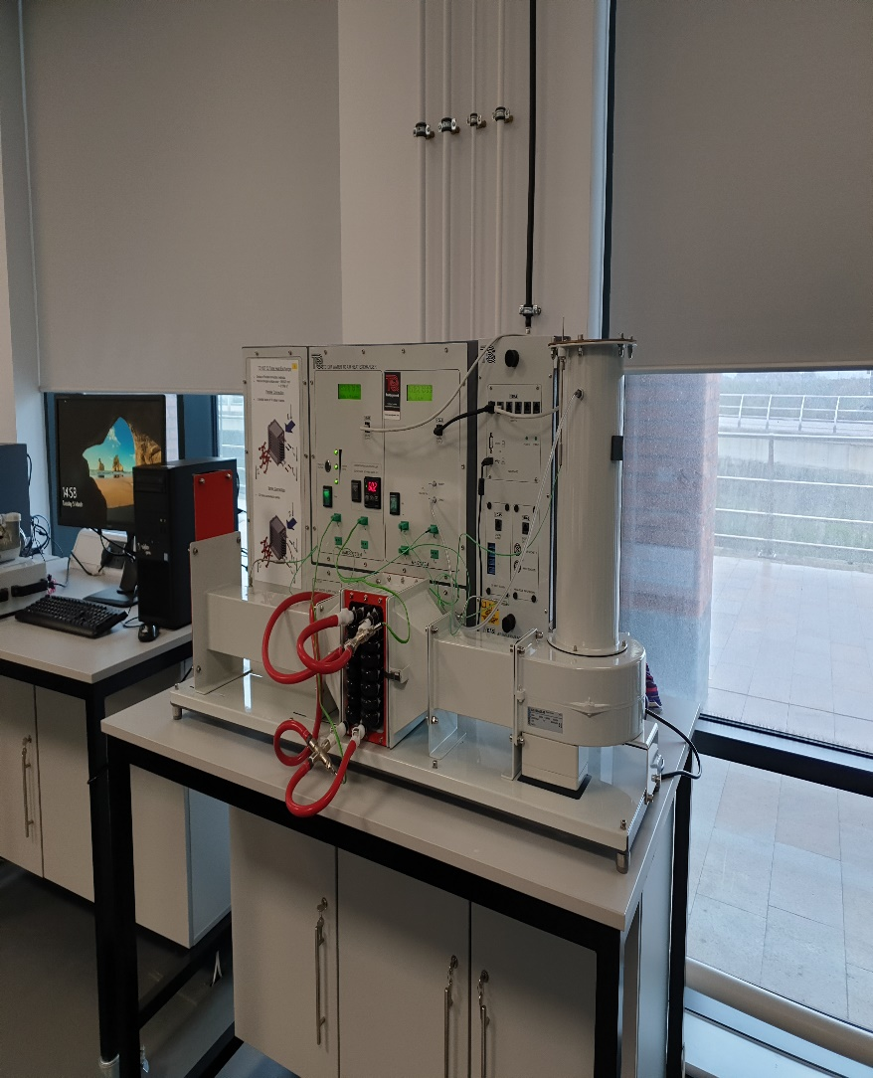
External measurements
Figure 1 Water to air heat exchanger apparatus TD1007
Before the experiments can proceed measurements of external conditions must be made; these consist of the ambient air pressure, the diameter of the intake orifice, the coefficient of drag for the orifice plate, and the heat exchanger surface area. These measurements can be found on a plate on the apparatus.

Experiment 1
Experiment 1 sets out to test the effect of a varying flow rate of water on the efficiency of the heat exchanger; the heat exchanger is set up in a standard 32 tube parallel configuration where water at a set 60 degrees Celsius is used. The pressure drop across the apparatus is set within a 5Pa tolerance at a fixed 250Pa. The experiment begins with the water flowing at a rate of 2.25 litres per minute with a tolerance of 0.01 litres per minute. A period of 5 minutes should be allowed for the all readings on the apparatus to equalise before the experiment is conducted. Readings from the experiment should be taken every 4 minutes, decreasing the flow of the water by 0.5 litres per minute at each step until 0.25 litres per minute is reached, this should yield 5 results.

Experiment 2
The goal of experiment 2 is to demonstrate how a difference in air flow rates will affect how the heat exchanger will perform; as such the water flow rate and temperatures will remain constant throughout the experiment. As with experiment 1, the temperature is at a constant 60 Celsius within the same tolerance, the water flow is set to a constant 0.25 litres per minute, and the initial pressure drop across the exchanger is set to 250Pa. After the initial 5-minute period to allow the experiment to stabilize, the pressure drop in the air flow rate is decreased by 50Pa until it reaches 50Pa. As with experiment 1, this experiment will also yield 5 results.

Experiment 3
The purpose of experiment 3 is to show how changes in the temperature of the water supplied to the exchanger will affect its efficiency with a static water flow rate. The procedure for this experiment is identical to experiment 2 however, as opposed to the water entering the exchanger being set at 60 Celsius it is instead set at 45 Celsius, all other experimental parameters are the same and will yield the same number of results.

Results

External information
Environmental information
Ambient pressure | 100000 | Pa
Orifice Diameter | 0.10011 | M
Orifice area | 0.007871 | M^2
Cd for orifice plate | 0.6
Heat exchanger surface area | 0.1558 | m^2
Specific gas constant for dry air | 287.05 | j/Kg.K
Specific heat capacity of air | 1005 | j/Kg.K
Specific heat capacity of water (@15c) | 4185.5 | j/Kg.K
Table 1 External information for experiment

Experiment 1
Table 2 Experient 1 results table

Experiment 2
Table 3 Experiment 2 results table

Experiment 3
Table 4 Experiment 3 results table

Analysis

Experiment 1

Graph 1 Experiment 1 Water mass flow vs energy flow

Graph 2 Experiment 1 Water mass flow vs Heat transfer efficiency

Graph 3 Experiment 1 Water mass flow vs Heat transfer coefficient

Experiment 2

Graph 4 Experiment 2 Air mass flow vs Energy flow

Graph 5 Experiment 2 Air mass flow vs Mean efficiency

Graph 6 Experiment 2 Air mass flow vs Heat transfer coefficient

Experiment 3

Graph 7 Experiment 3 Air mass flow vs Energy flow

Graph 8 Experiment 3 Air mass flow vs Mean efficiency

Graph 9 Experiment 3 Air mass flow vs Heat transfer coefficient

Conclusion

Experiment 1
The aim of experiment 1 was to show the effect a varying water flow rate while maintaining a steady pressure difference and temperature will have on the efficiency of the heat exchanger; from the results gathered it is shown that as the flow rate of the water decreases the efficiency of the exchanger will also decrease, as will the energy flow and heat transfer coefficient. This could be due to a decrease in the availability of a medium from which the heat apparatus is able to use conduction and convection to transfer the heat within the system to the atmosphere surrounding it; as such it shows the importance of a steady flow rate of water to maintain the maximum efficiency possible from the heat exchanger.

Experiment 2
The aim of experiment 2 was to show the effect a varying air flow rate while maintaining a steady water flow rate and temperature will have on the efficiency of the heat exchanger. As with experiment 1, the results gathered show that as the pressure difference is decreased across the heat exchanger, the efficiency will also decrease; this is due to there being less pressure forcing the air across the tubes in the heat exchanger, causing less air to pass over it. In turn, the air will be less able to transfer the heat emitted to the surrounding atmosphere. This further re-enforces the need for a steady flow of both water and air to maintain the maximum efficiency of the apparatus.

Experiment 3
The aim of experiment 3 was to show the effect a varying air flow rate while maintaining a steady water flow rate but at a decreased water temperature will have on the efficiency of the heat exchanger. The results for experiment 3 were almost identical to experiment 2, backing up the results gathered from performing the experiment. The results gathered over the course of all 3 experiments show that a heat exchanger has a very sensitive set of parameters and changing one of them even slightly will have drastic knock-on effects on the efficiency at which it will operate.

Overall
From the completion of all 3 experiments, the results gathered show that changing any one of the conditions under which a heat exchanger is operating by a small amount will have much larger implications in terms of the efficiency at which it is able to complete the task that it was designed for.

Critical analysis

Experimental equipment and procedure
While the experiment is set up to be completed multiple times with the aims of demonstrating how a heat exchanger works, the procedure is inherently flawed due to very fine adjustments needing to be made by humans. This allows for a large margin of error. This issue is easily remedied by implementing a computerised system to complete the fine adjustments of the pressure, temperature and water flow. A computerised system would also allow for more accurate results to be gathered. However, the experiment does give an excellent insight into how a heat exchanger functions and, as such, fulfils its purpose of being a piece of educational equipment very well.

Results
The results shown by the analysis tables and graphs in this report have a questionable accuracy level as they differ drastically from the results shown in the equipment handbook. This could be due to a misunderstanding of the equations needed to calculate some of the results, such as the specific heat capacity of water, or the LMTD (log mean temperature difference), as such, any results shown should be regarded with a level of scepticism. The results could be made more accurate by comparing them to see where the calculations used in this report differ from those used by others completing the same tasks. This would provide validation for both sets of results thus making them more accurate.
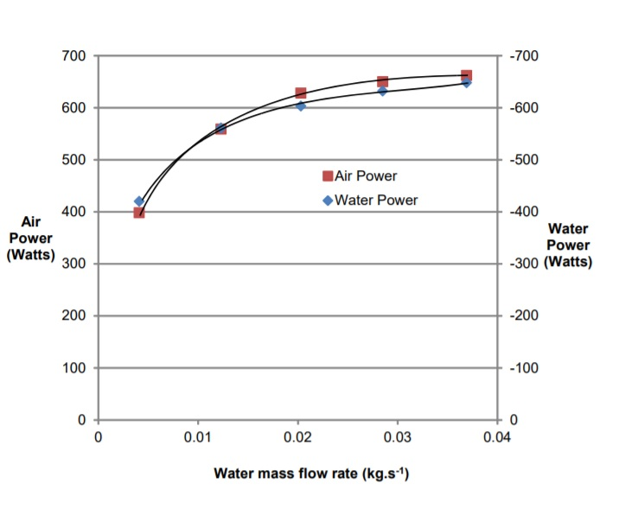
Graph 10 Experiment 1 Water mass flow rate vs Air and water power example graph (Ltd, 2014)

Graph 11 Experiment 1 Water mass flow vs Energy flow
The above graphs show a comparison between the example results provided by the equipment manufacturer and the results calculated by using the equations also provided by the equipment manufacturer.

Further Work
The experiment could be repeated using computerised mechanisms to complete any fine adjustments to the apparatus; this will remove the prospect of human error. The experiment could also be repeated using finer variations in the water flow, air flow, and temperature to generate more accurate results.
Improvements to the efficiency of the heat exchanger could be made by cleaning all the tubes used in the experiment in between each experiment; this is part of a good maintenance schedule which allows for the exchanger to operate at peak efficiency as there is no build up of foreign matter on the conductive interfaces. The efficiency of the heat exchanger could also be increased by increasing the flow in the tubes or plates used in the equipment; this increase in flow causes the flow within the mechanism to become turbulent, this in turn will help to slow the build up of any foreign contaminants that may negatively affect the efficiency of the heat exchanger. (Patel, 2018)

References
Figure 1 Water to air heat exchanger apparatus TD1007 2

Table 1 External information for experiment 4
Table 2 Experient 1 results table 1
Table 3 Experiment 2 results table 2
Table 4 Experiment 3 results table 2

Graph 1 Experiment 1 Water mass flow vs energy flow 1
Graph 2 Experiment 1 Water mass flow vs Heat transfer efficiency 1
Graph 3 Experiment 1 Water mass flow vs Heat transfer coefficient 2
Graph 4 Experiment 2 Air mass flow vs Energy flow 2
Graph 5 Experiment 2 Air mass flow vs Mean efficiency 3
Graph 6 Experiment 2 Air mass flow vs Heat transfer coefficient 3
Graph 7 Experiment 3 Air mass flow vs Energy flow 4
Graph 8 Experiment 3 Air mass flow vs Mean efficiency 4
Graph 9 Experiment 3 Air mass flow vs Heat transfer coefficient 5
Graph 10 Experiment 1 Water mass flow rate vs Air and water power example graph (Ltd, 2014) 7
Graph 11 Experiment 1 Water mass flow vs Energy flow 8

Bibliography
Ltd, T. (2014). TD1007 Water to air heat exchanger user guide. Swansea: TecQuipment.
Patel, J. (2018, December 06). 5 Tips for improving and maintaing heat exchanger efficiency . Retrieved from Manufacturingtomorrow: https://www.manufacturingtomorrow.com/article/2018/06/5-tips-for-improving-and-maintaining-heat-exchanger-efficiency/11698

