Student Name | Mazhar Abbas
Student Id | 2542523
Portfolio submission part 1 | DS1- My Digital Skills
 | University of Wales Trinity David
Deadlines | week 4-6 July 2026

Using a Laptop & Basic Computer Skills

This shows how to use a laptop properly has been one of the most important digital skills I have developed. Skills like managing files, creating folders, and switching between windows are quite tricky.
I now use my laptop every single day for studying, writing assignments, and staying connected with people. I want to improve some areas. I want to get faster at typing and learn more about how storage and memory work.
Communicating online-Email & Messaging
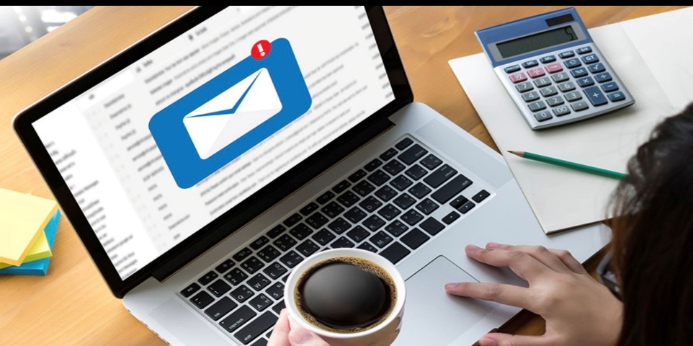
Before I came to university, I primarily used messaging apps like WhatsApp to communicate with friends and family. I had never thought about the difference between casual messaging and professional communication. Digital communication is something I expect to use throughout my career, so developing these skills early feels good.

Online Safety & Staying Secure
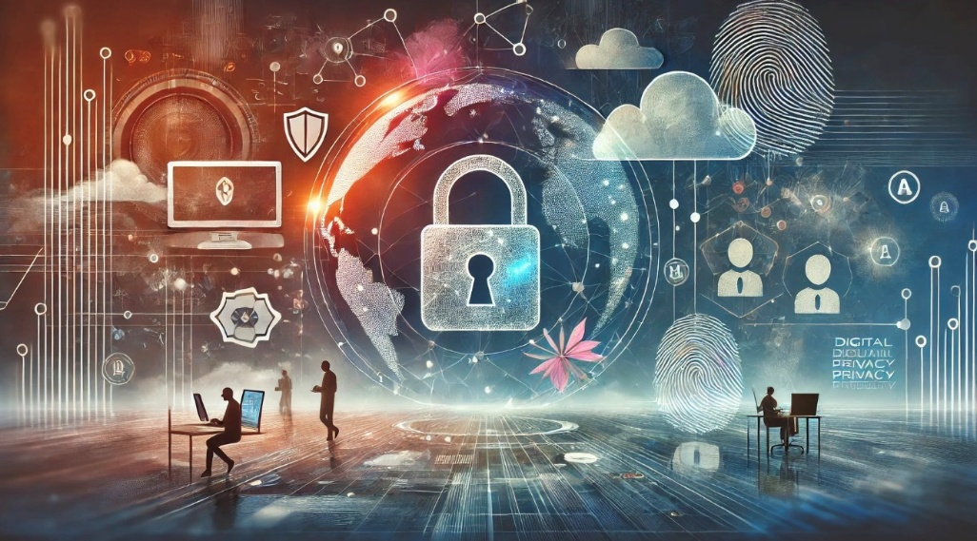
I used to think that cybersecurity was something only businesses or tech people needed to worry about. It was not until one of my friends targeted by phishing emails and password matters. One of the first practical changes I made was creating stronger, unique passwords and setting up pass keys for Gmail accounts for my most important accounts and setting up Face ID.

Using Microsoft Word & Office Tools
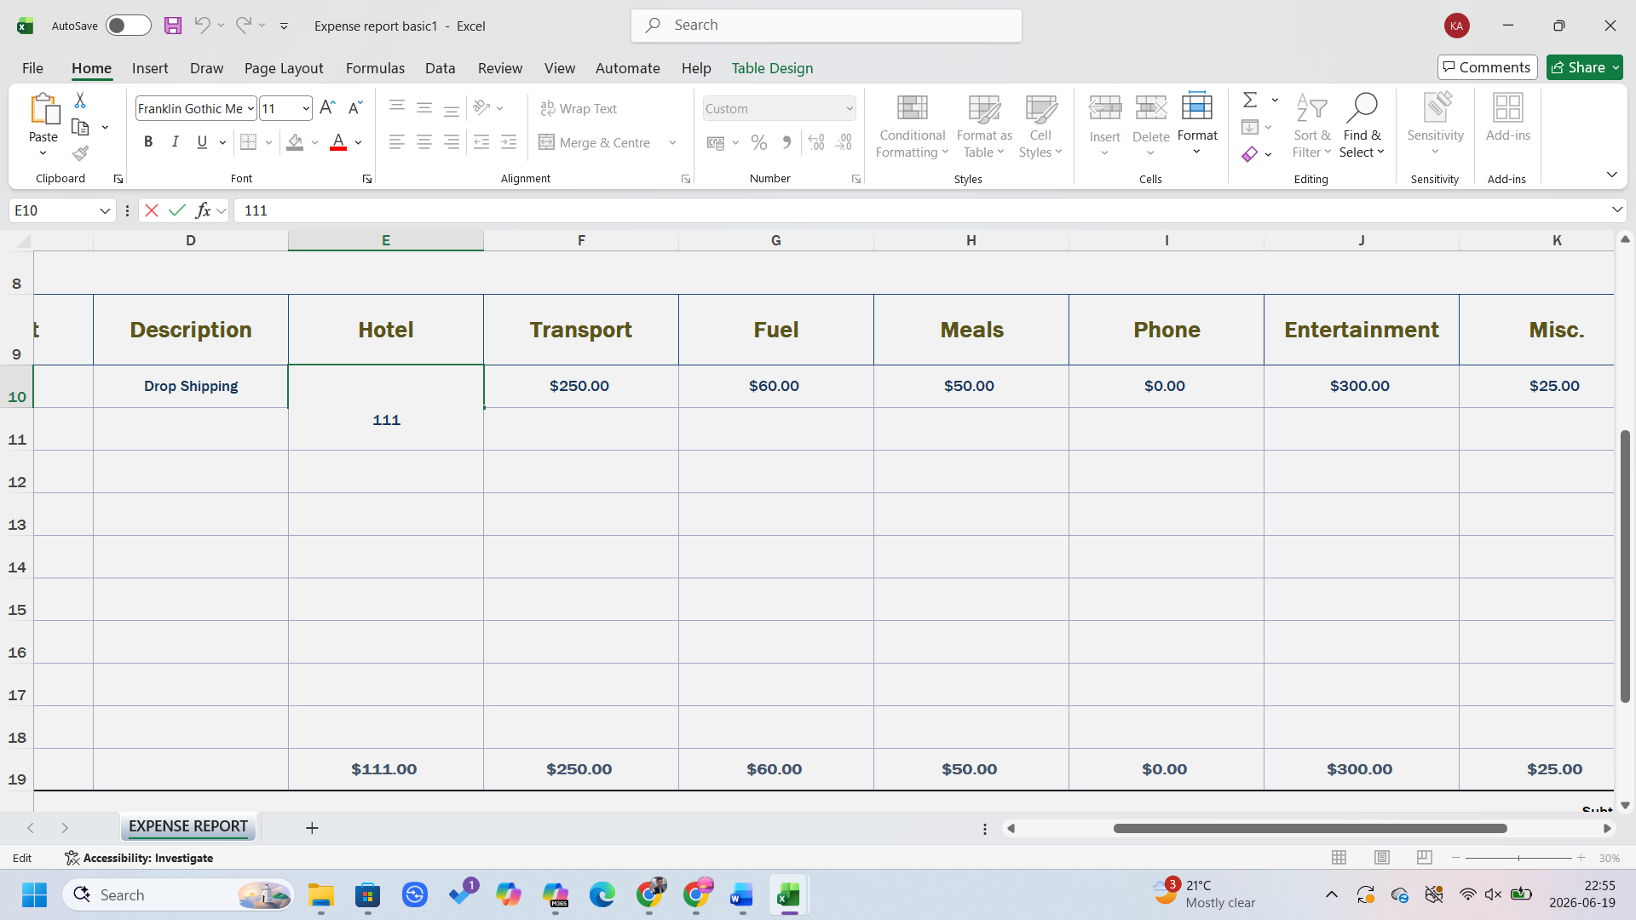
I have started using Microsoft Excel for my daily tasks like organising data in tables and doing simple calculations. I have started using Microsoft Word as well for my assignments and taking notes during class. I have downloaded Microsoft Word on my phone as well, so I can easily access my documents. Microsoft Office suite is used everywhere in the universe, in offices, and in small businesses. So building confidence with these tools is something I see as a long-term investment.

Learning Online & Using Digital Resources
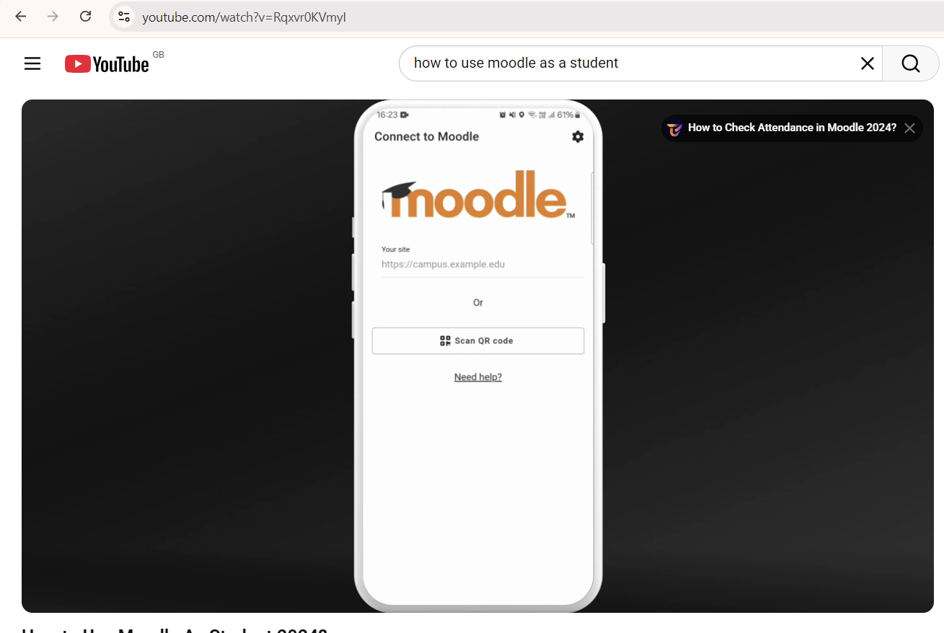
I have started using YouTube tutorials and free online guides when I want to learn something new. For example, I was struggling to upload a picture to the university student portal. I could not do it every time, and the error was showing. So, I watched a video on YouTube, and then I uploaded it successfully. I have started using Moodle for lecture notes Assignment, templates and sending my work and keeping an eye on deadlines.

Social Media & My Digital Footprint
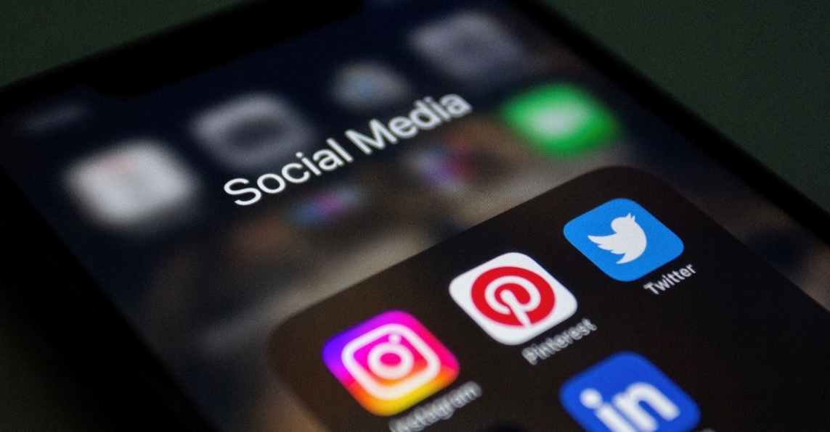
HI started to realise that everything I post on social media or comment on leaves a trace. What people can find about you on the internet is effectively your digital footprint. I have made a few changes, making my old posts and personal details private and being more intentional about what I share going forward. These skills are one of those I think a lot of people overlook because social media feels so casual and everyday. But managing your presence is genuinely important in the modern world, and I am glad I started thinking about it seriously now rather than later.

My Short Reflection
I used to think that young people like me could just teach we how to use technology. Now I realise that truly being part of the digital world takes a lot more than just playing with gadgets. We need more access to the right devices, people to guide and support us and a real reason to learn.
Looking back over these six areas, I can see how much my understanding of digital skills has grown. At the start, I thought of digital skills as just being able to use a computer or phone. This portfolio has made me more aware of my digital habits and motivated me to keep improving. Digital skills are not something you learn once and forget. They evolve as technology changes, and I want to make sure I keep up.

