Leo Smith (2217998)
Produced for Module: ACDB5007
Computer Aided Engineering for Terminal Ballistics

Abstract
This report delves into the field of ballistics where the science of high velocity projectile impact is used to provide insight into criminal, military, and civilian scenarios. The report focuses in on terminal ballistic which explored the final effect of a ballistic impact and on target behaviour. The study of this behaviour is challenging however, so the emerging field of Computer Aided Engineering (CAE) is introduced. The report explores what CAE is before discussing the methods advantages. The challenges are also discussed leading onto a case study. Here the work of Gupta et al [10] is replicated to practically show how CAE tools can be used to explore terminal ballistic scenarios. All elements of setting up a CAE simulation are discussed ranging from the software that can be used to the individual setting within this software which influences model results. Using the explored CAE tool Ansys Workbench a set of tests are performed exploring how differing model settings and parameters can affect the accuracy of the models. By comparing these results to the work of Gupta et al [10] conclusions are then drawn about the usefulness of CAE tools for the study of terminal ballistics.

Table of Contents
Abstract 1
Table of Figures 2
Table of Tables 4
1.0 Introduction 5
2.0 Methodology 8
2.1 Software 8
2.2 Materials 8
2.3 Geometries 9
2.3 Meshing 12
2.5 Simulation Conditions 13
2.6 Analysis 14
3.0 Discussion and Results 14
3.1 Test 1 14
3.2 Test 2 16
3.3 Test 3 and 4 17
3.4 Test 5 18
4.0 Conclusion 19
References 20

Table of Figures
Figure 1 - The differences in investment and understanding during the traditional and CAE led design processes [2]. 4
Figure 2 - Projectile Geometry 7
Figure 3 - 255mm by 1mm Solid Target Plate 8
Figure 4 - 50mm by 1mm Segmented Target Plate 9
Figure 5 - 255mm by 1mm Target Plate With 50mm Segmented Plate Embedded 9
Figure 6 - Meshing set up used by Gupta et al [10] 10
Figure 7 - Example model assembly made within SolidWorks. 11
Figure 8 - Test 1 Velocity Plot 12
Figure 9 - Equivalent Stress of Test 1 Explicit Dynamics 13
Figure 10 - Equivalent Stress of Test 1 LS-Dyna 13
Figure 11- Residual Velocity Plot For Test 2. 14
Figure 12 - Stress plot for Test 2. 14
Figure 13 - Residual Velocity Plots for Test 3 and 4. 15
Figure 14 - Residual Velocity Plots for Test 5. 16
Figure 15 - Equivalent Von-Mises Stress during initial perforation in Test 5. 16

Table of Tables
Table 1 - Material properties for 1100-H12 Aluminium Alloy target plate. [10] 8
Table 2 - Test 1 Residual Velocity Comparison 14
Table 3 - Comparison of residual Velocities for Test 2 15
Table 4 - Comparison of residual velocities from Test 3 and Test 4 16
Table 5 - Comparison of residual velocities for Test 5 17

Introduction
The field of ballistics studies the motion of projectiles throughout the lifespan of their operational function. The fields can be sub-divided however, into four distinct stages where the projectile experiences unique forces and hence different behaviours. These stages are internal, intermediate, external, and terminal ballistics [1]. This report focuses specifically on terminal ballistics. Terminal ballistics as the final stage of the ballistic process and explores the behaviour of the projectile as it impacts a target and delivers its desired effect. This may also be referred to as a ballistic impact scenario. The study of ballistic impact explores several factors, including, the deformation of materials, the efficiency of the projectile to penetrate materials and the damage caused by the projectile, be that into organic or inorganic matter.
The study of terminal ballistic impact is crucial for both civilian, law enforcement and military environments. In civil scenarios, such as aerospace, an understanding of ballistic impact can help engineers better understand and implement the safety measures. Although easily overlooked, ballistic impact analysis is crucial in ensuring aircraft are protected from collisions with unexpected bodies. In both law enforcement and military applications however the study of terminal ballistics fulfils a more obvious role helping to provide technological advantage in both offensive and defensive scenarios. By understanding the impact of projectiles engineers can work to improve both sides of the collision equation, improving the efficacy of projectiles, increasing the damage delt, and improving the resistance of armour systems to protect from impact. A clear example of where ballistic impact analysis has led to design improvement is in small arms ammunition. Here by analysing how rounds deliver their terminal effect specialist designs have been developed. One example of this is expanding bullets made with soft or hollow points. By exploring how these behave upon impact they have been specially designed to expand and fragment upon impact rapidly transferring energy to the target and increasing tissue disruption. This optimised design, supported by terminal ballistics exploration, then allows the round to optimally perform its role of incapacitating targets [1].
Practically studying terminal ballistic however, is a challenging process. This is due to the complex mechanical processes associated with the interactions [1]. These interactions occur over extremely small time periods and involve high energy transfers meaning they do not obey standard plastic and elastic deformation rules. As a result, to properly observe and understand the mechanisms in actions complex experimental set ups must be used in which high speed instrumentation logs large amounts of data relating to the interactions. This can then be processed to extract understanding of the interactions. Despite this difficulty common factors influence all ballistic impact problems in the same general way. These dictate that the mechanical processes mainly depend on the thicknesses, densities, geometries, velocities and material properties of the projectiles and the targets [3], [1], [4]. Unfortunately, however due to the range of these factors and the cost of experimental methods it is often impractical to experimentally explore all these factors when designing a projectile or armour system.
Fortunately for the modern engineer advanced in numerical and computational technologies now mean that a large portion of the design, testing and evaluation of terminal ballistic scenarios can now be completed computationally rather than experimental. This computational workflow is also known as Computer Aided Engineering (CAE).

Fortunately for the modern engineer advanced in numerical and computational technologies now mean that a large portion of the design, testing and evaluation of terminal ballistic scenarios can now be completed computationally rather than experimental. This computational workflow is also known as Computer Aided Engineering (CAE). CAE uses software and computational approaches to aid all stages of the design process from idea generation and drafting through to simulation, analysis, testing and manufacture [1], [2]. This is achieved through the application of mathematics-based analysis and simulation techniques [2]. During these techniques the CAE software uses deduction-based inference to take a user’s input and a known set of Multiphysics rules to infer the effect the scenario will have on a component [1]. Computers are well suited for this task as they have a large amount of analytical power enabling them to rapidly perform complex calculations and draw insight about problems [2]. For CAE tools to be useful they must have a computationally complete back end capable of performing the required mathematics calculations. This must however also be coupled with a user interface that allows the engineer to effectively communicate with the software allowing the system to act as desired [2]. To use a CAE tool the designer must first pre-process a problem defining the geometries, conditions, and parameters of the model [1]. This design can then simulate to provide the performance of the part in real-world scenarios [2], [1]. Post-processing then uses the results of the simulation to inform decision making and allow for further design refinement [1]. These capabilities have made CAE commonplace within industry [1].
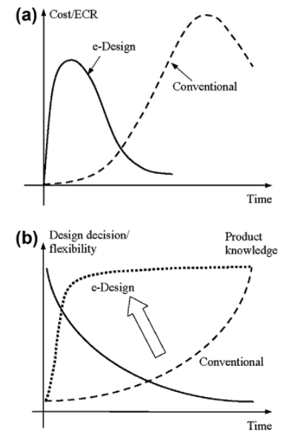
CAE is a fundamental shift from traditional design where products are designed, built, and then tested before iterating back to make amendments [2]. This is because with CAE designs can be analysed computationally before they are made. In the traditional design scenario, the designers understanding of the product tends to grow as the flexibility of the design decreases. This means major decisions are often made early on when designers are uninformed making mistakes and costly redesigns common [2]. With CAE however, design failings can be identified early in the process and quickly rectified this provides an iterative improvement process where the product can be quickly improved [2]. This gives the ability gain design information early in the process allowing better informed decisions early in the process [1]. A visual representation of this shift in focus can be seen in Figure 1 beside. By gaining this knowledge early on iteration of design can be accelerated meaning issues can be resolved quickly speeding up the process and reducing cost [1]. Finaly by enabling analysis before expensive prototypes are made CAE reduces the need for practical prototyping which reduced the cost and increases the efficiency [2]. All these advantages together lead to the largest benefit which is that the finished design better meet the design specification [2].
Figure 1 - The differences in investment and understanding during the traditional and CAE led design processes [2].
Despite these advantages CAE still has many challenges. A major challenge for the effective use of CAE is second order ignorance of the designer where they do not know the capabilities of the tool. This combined with first order ignorance, where the designer doesn’t know how to use the tool means, CAE software is often used ineffectively [1]. This often results in the incorrect selection of CAE tools for a given task leading to poor return on investment [1]. Another difficulty is the computational complexity of models. Hyper realistic models are often extremely large and as such take a large amount of computational resource to run. For the smaller design house this requirement may be too great meaning they cannot produce results to the desired level of realism [1]. Finally, CAE modelling can be cognitively very complex with the designer having to translate real world conditions into a virtual space [1]. This is most prevalent in areas such as geometry and material creation. If these are non-representative the model will not provide usable results [2]. Furthermore, the models have many tuneable parameters which if used incorrectly can cause the results to poorly represent the real-world scenario [2].
To explore how explicit dynamic modelling can be used and validated for the study of terminal ballistics this paper looks to directly replicate, and then compare results against, the computational and experimental work of Gupta et al [10]. In this work they looked to explore the deformation performance of multi-layered target plates when compared to homogenous plates of identical mass and composition. To do this they used a pneumatic gun to impact the plates with flat, ogive and hemispherical nosed steel projectiles at a range of sub-sonic velocities. These experimental results then enabled researchers to find the ballistic limit velocities (The minimum velocity at which penetration occurs) and the residual projectile velocities for each testing configuration. Gupta et al [10] then bolstered this experimental evidence by using a computational approach to numerically model the results. This numerical modelling was performed using the finite element code ABAQUS from Dassault Systems. They found when compared, the numerical results agreed strongly with the experimental outputs.
This work was chosen specifically for validation due to this mixture of experimental and computational results. By having both results for a singular test increases the number of reference points available, allowing the nuances of validation to be explored in more detail. Furthermore, as Gupta et al [10]
themselves replicated the experimental results computationally the paper also included the required geometry, materials and experimental information required to make the work conducted in this report truly representative of their work. This subsequently means the results can also be read across with high confidence aiding the formulation of conclusions.
The remaining sections of this report are organised as follows. First the fundamental set up of the modelling is discussed outlining the software, geometries and materials used within the validation. Then a series of tests are reported. These explore and experiment with varying elements of the model set up, aiming to optimise the agreement of the model with the reported literature. Finally, the results of these experiments have been analysed to draw conclusions about the optimal modelling configuration and the validation of explicit dynamics more generally.

2.0 Methodology

2.1 Software
As discussed when introducing CAE, the first stage of the process is the translation of a design from the engineers mind into a 3D computer geometry. This geometry is then fed forward and worked upon during the subsequent simulation and analysis steps. For all the geometries created in this work the SolidWorks software package from Dassault Systems was used [11]. SolidWorks is a 3D computer aided design software which allows the user to create geometries quickly and efficiently, building up from 2D drawings. SolidWorks also allows groups of geometries to be assembled into large systems simplifying the creation of the simulation landscape downstream. As a well-established software package this software was chosen specifically for its ease of use, the range of its capability and its ability to export geometries in .STEP file format. This file format was important as it was compatible with the CAE software used for software and analysis.
This CAE software was Ansys Workbench 2021 R1. Workbench is a tool that brings together all the software required to complete the design, simulation, and analysis of a product [12]. As such it could have been used instead of SolidWorks for geometry creation but was discounted due to poorer capability. Where Workbench thrives is in the running of numerous simulations with shared geometries, materials ect. as the software has a feature enabling simulations to be directly linked and share data. Another advantage of the workbench software is the fact it contains many different models and solvers. The models use different mathematics on the back end to solve scenarios specific to each model. This means within on software package different solver types can be experimented with, aiding exploration. During this research both these features were exploited with several models sharing data ran and two different solver types explored.

2.2 Materials
The work being replicated in this report from Gupta et al [10] as previously discussed looked to evaluate the impact of projectiles onto thin multi-layer target plates. For these experiments Gupta et al [10] chose aluminium for the target plate material, specifically a 1100-H12 grade alloy, and an EN-24 steel oiled quenched to a Rockwell Hardness of 47-52 for the projectile. To use the experimental data of Gupta et al [10] for validation these materials also had to be used within the Ansys modelling.
Interesting within the experimental work of Gupta et al [10] it was found that after impact all projectiles showed no sign of damage or deformation. This is useful information for completing computational modelling as it means the projectile can be modelled as a ridged body. Modeling as a ridged body means the simulation does not model the projectiles deformation and as such does not need the corresponding material properties to describe this. Instead, the only property needed was density to ensure the projectile has correct momentum. This density was determined to be 7.81 g/cm³.
For the aluminium target plates in all test’s deformation and usually failure of the plate occurred. This mean they needed a full set of material properties to be realistically modelled. There properties included Johnson-Cook parameters for both inelastic deformation and damage. This was important as the JC model performs well in the high strain rate interaction common with ballistic impact. The property data has been taken from the work of Gupta et al [10] to allow direct comparison with their work and can be seen in table 1.
Table 1 - Material properties for 1100-H12 Aluminium Alloy target plate. [10]
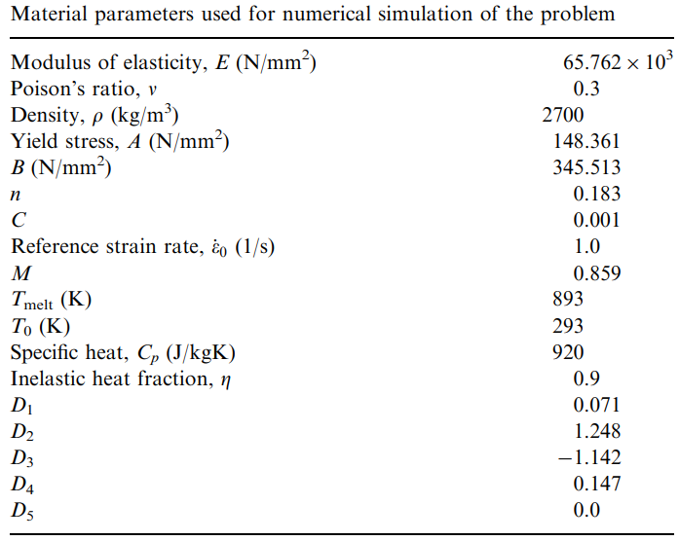

2.3 Geometries
Throughout all the testing completed within this work the geometry of the projectile was maintained as a control variable. This allowed a singular experiment from the work of Gupta et al [10] to be explored in detail. The scenario chosen was a flat nosed steel projectile into a one-millimetre aluminium plate. As such, the geometry of the projectile was taken directly from the paper [10]. The paper provided a simplistic drawing of the projectiles exterior dimensions and listed the wall thickness of the shell as 2.44mm. This thickness was provided separately as each projectile shape had a varied wall thickness to maintain a constant mass of 52.5g. The original drawing and the representative geometry created in SolidWorks can be seen in figure 2.

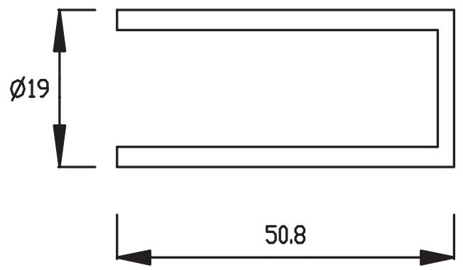 | 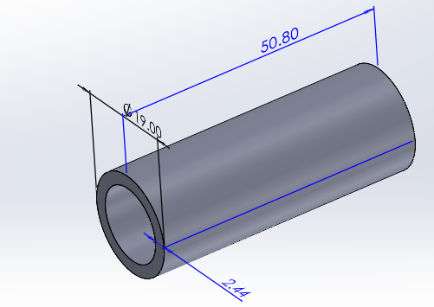
Drawings from Gupta et al [10] | Geometry created in SolidWorks

Figure 2 - Projectile Geometry
The geometry of the target plate unlike the projectile was varied throughout testing to explore several parameters that influence the model performance. In the work of Gupta et al [10] the target plates where all circular plates of 255mm diameter held in place by 16 bolts on a 230mm diameter circle. They varied the thickness of these target plates between 0.5 and 1.5mm but for the purpose of this work a singular thickness of 1mm was chosen to help control the testing.
Based on the plate used by Gupta et al [10] three plate geometries were created using SolidWorks in this report. The first was a 1mm solid plate with a diameter of 255mm and no segmentation, this was designed to best replicate the plate used by Gupta et al [10]. The second plate was a plate of 50mm diameter, segmented at 10, 20 and 35mm diameters. The third and final plate was the second plate, embedded within the larger plate to be 255mm in diameter segmented at 10, 20, 35, 50mm diameters. These three geometries can be seen in figure 3 , 4, 5.

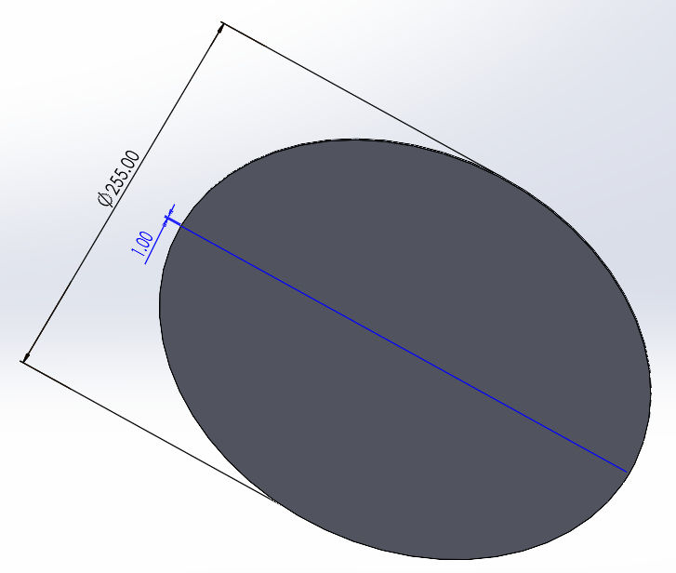
Figure 3 - 255mm by 1mm Solid Target Plate
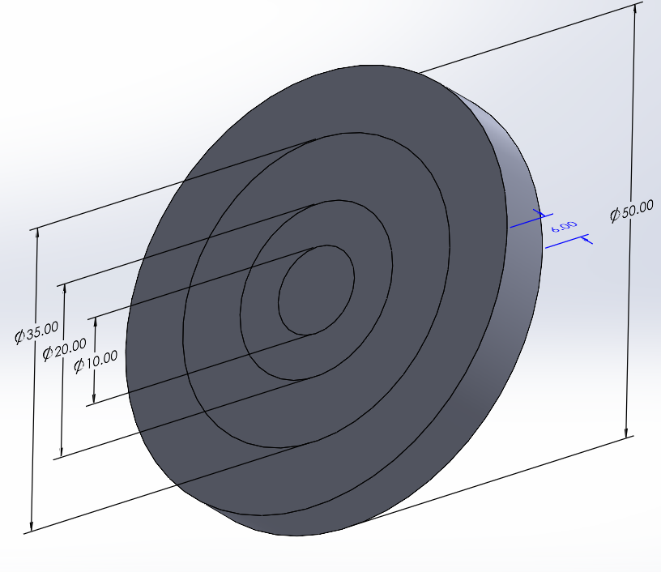
Figure 4 - 50mm by 1mm Segmented Target Plate
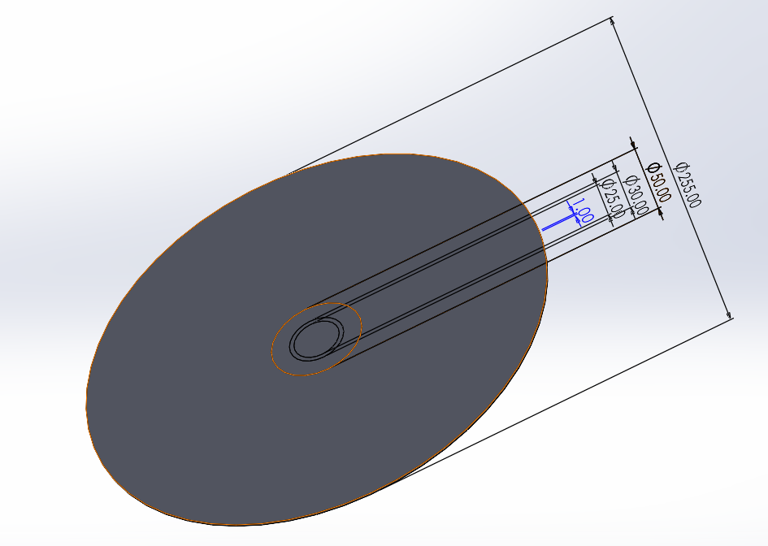
Figure 5 - 255mm by 1mm Target Plate With 50mm Segmented Plate Embedded

2.3 Meshing
The meshing of geometries is the first area of the model set up where the outcomes of the model are directly affected by the simulation technique used. As a rule of thumb, a course mesh with large element sizes will perform poorly. This is because the elements poorly represent the original geometry and provide little detail about the intricacies of the parts performance. Course meshes however, do result in far faster simulation times. This means the ideal model should have a mesh fine enough to be accurate and extract the necessary detail whilst also being as course as possible to ensure the model runs quickly.
In the work of Gupta et al [10] a variable mesh density was used with the size of elements being consistent smaller in the region of impact. This allows for fine detail in the area of interest whilst reducing model size and decreasing solve times. In the impact area 18 nodes were used per mm giving a size of 0.056mm and the overall model used 9108 elements in the plate. Figure 6 shows this set up.
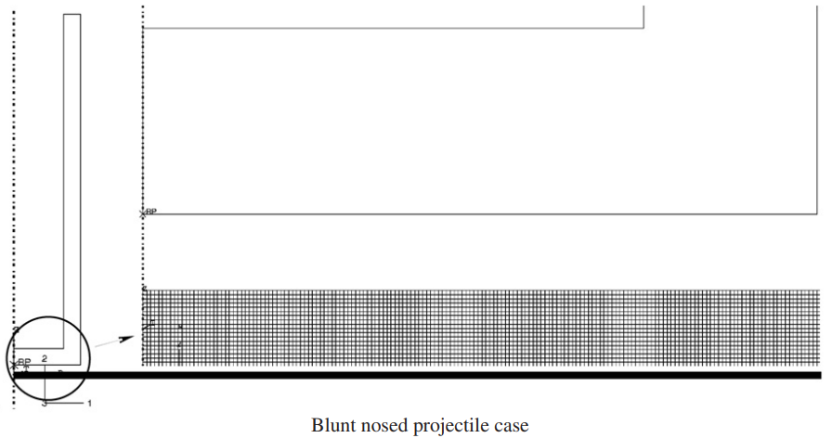
Figure 6 - Meshing set up used by Gupta et al [10]
In this report five different meshing scenarios were used for the five test cases. These were as follows:
- A standard mesh auto generated by Workbench based on the geometries.
- A variable mesh for the 50mm plate varying element size from 0.5mm to 1mm
- A variable mesh for the 50mm plate embedded in the 255mm plate with element sizes from 0.5mm to 10mm.
- A variable mesh for the 50mm plate embedded in the 255mm plate with element sizes from 0.5mm to 5mm.
- A variable mesh for the 50mm plate embedded in the 255mm plate with element sizes from 0.1mm to 1mm.

2.5 Simulation Conditions
When setting up the simulation the position of the components was first established using the SolidWorks Assembly tool. This was chosen as it provided an easy user interface and the relations tools within SolidWorks enabled the positions to be precisely set. Using this tool the projectile was first set to be concentric to the target plate. This ensured that the projectile struck centrally. This was important for both replicating the experimental work where impacts occurred at the centre and ensuring the shock waves travelled symmetrically through the plate. The projectile was then set to be oriented perpendicularly to the plate. This ensures a square impact as used in the experimental work. Finally, the projectile was set to be around 5mm from the front of the plate. This was because in a simulation velocities and forces are applied instantaneously and as a result it is not important how far the projectile is from the plate. By placing the projectile close it also reduces the run time of the model as less timesteps must be simulated. This set up can be seen in figure 7.
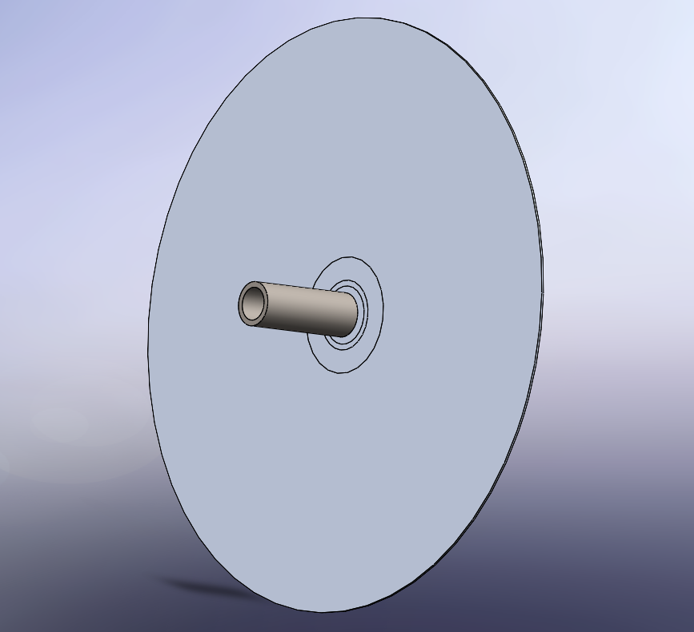
Figure 7 - Example model assembly made within SolidWorks.
With the positions established in SolidWorks the boundary and initialisation conditions could then be set within workbench. For the target plate the outer faces of the plate where set to be fixed in position. This does not exactly replicate the way the experimental plate was bolted but made the model more simplistic to run. Then, with the plate fixed an initial velocity was assigned to the projectile. This was varied based on the test but in all cases was set along the negative Z axis perpendicular to the plate.

2.6 Analysis
In order to draw insight from the simulation the results must be analysed in a quantitative way which allows either comparison to previous results of the formulation of benchmark results. Within the work of Gupta et al [10] they looked specifically to record two results. The first was the residual velocity of the projectile post impact. This was chosen as it gives an indication of the energy removed by the impact and the ballistic efficiency of the plate. The second result was a qualitative analysis of how the plate deformed in order to better understand the mechanics of a multi-plate system when compared to a singular homogenous plate of equal thickness.
Within this work a focus was placed on replicating and validating models using the residual velocity of the projectile. As such in the results section of Workbench a results query was set which recorded the velocity of the projectile body in the Z axis at every timestep. This allowed the velocity to be plotted against time and the residual velocity to be found and compared. For the qualitative analysis of the failure mechanism less importance was placed as only one plate configuration was to be used. As such for this result the Equivalent (von-Mises) stress for each element was shown at each time step allowing visual comparison.
Both the velocity and stress results for each test are shown and discussed within section 3.0 where their importance in regards to model validation is also explored.

3.0 Discussion and Results

3.1 Test 1
Test one aimed to be the foundation for all further testing and as part of this role was used to determine which Ansys Workbench Solver would be most suitable for the application. Due to the high strain rate interactions of a ballistic impact and explicit dynamic solver had to be used but Workbench provides two, “Explicit Dynamics” and “LS-Dyna”. In order to select between the two, two models where run with the same set-up but differing solvers.
For both models the plain 255mm non-segmented plate was used with meshing being autogenerated by workbench. An initial projectile velocity of 115.6m/s was selected co-inciding with the maximum velocity from the tests of Gupta et al [10]. The projectile velocities of the two models are shown in Figure 8 and the results compared to Gupta et al [10] in Table 2.

Figure 8 - Test 1 Velocity Plot
Table 2 - Test 1 Residual Velocity Comparison
Source | Residual Velocity (m/s)
Gupta (Experimental) | 93.0
Gupta (ABAQUS) | 98.7
Smith (Explicit Dynamic) | -34.5
Smith (LS-Dyna) | -31.6

From these results it is clear both models are extremely inaccurate showing very poor replication of the experimental or ABAQUS derived results. As such the Equivalent Stress images were analysed to provide explanation. These can be seen in Figures 9 and 10.
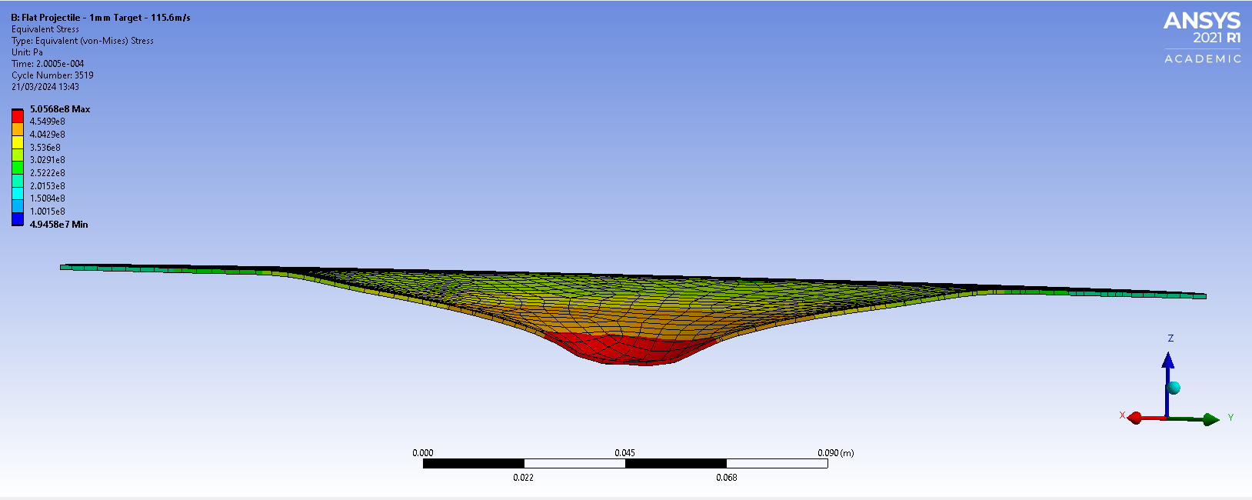
Figure 9 - Equivalent Stress of Test 1 Explicit Dynamics
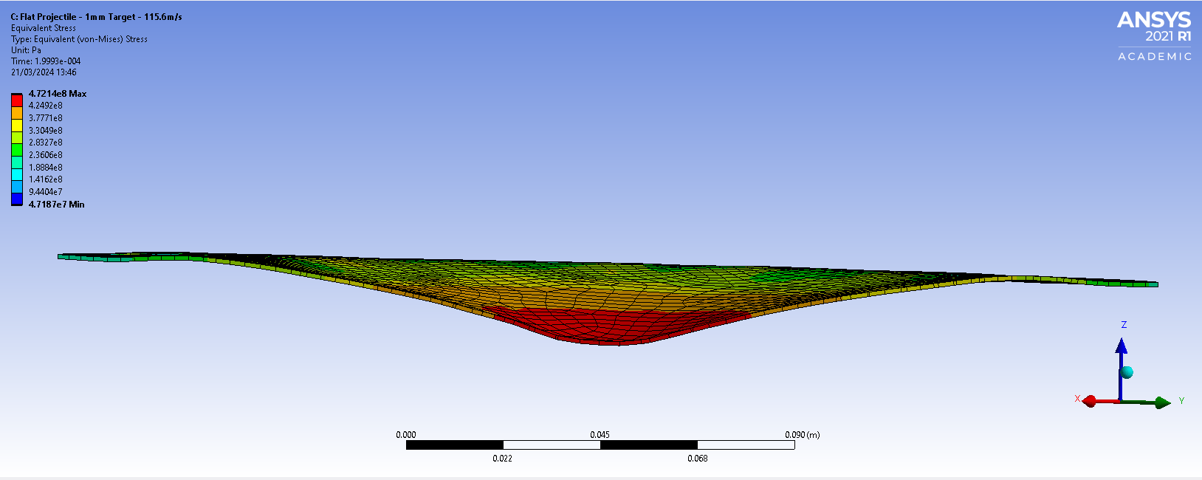
Figure 10 - Equivalent Stress of Test 1 LS-Dyna
In both cases the plate deformed by a large amount but in a parabolic fashion across the whole face. This was not how the plate should behave and suggests energy is being transferred too smoothly through the plate rather than being focused on the impact area and causing fracture. From the two results however, the Explicit dynamic model showed the most localised deformation and a flat-bottomed indent suggesting this better represented the scenario. As such explicit dynamics was favoured going forward.

3.2 Test 2
To test is it was the size of the mesh that was causing the smooth energy transfer and poor model performance Test 2 looked to drastically increase the mesh density. This was performed by moving to the 50mm segmented plate using the variable mesh from 0.5mm to 1mm. This model took far longer to run but yielded positive results. This prompted the model to be tested at the full suite of initial velocities with these results shown in Figure 11 and Table 3.

Figure 11- Residual Velocity Plot For Test 2.
Table 3 - Comparison of residual Velocities for Test 2
 | Residual Velocity (m/s)
Initial Velocity (m/s) | 115.6 | 102.5 | 87.455 | 61.3
Gupta (Experimental) | 93.0 | 79.167 | 58.264 | 0
Gupta (ABAQUS) | 98.7 | 82.512 | 53.15 | 0
Smith (Explicit Dynamic) | 93.47 | 78.098 | 58.897 | 0

The results from this model are better at replicating the experimental work than the ABAQUS model suggesting that by increasing the mesh density the results can be made closer to experimental results. During analysis of the stress plots however, an anomaly was found. This can be seen in Figure 12.
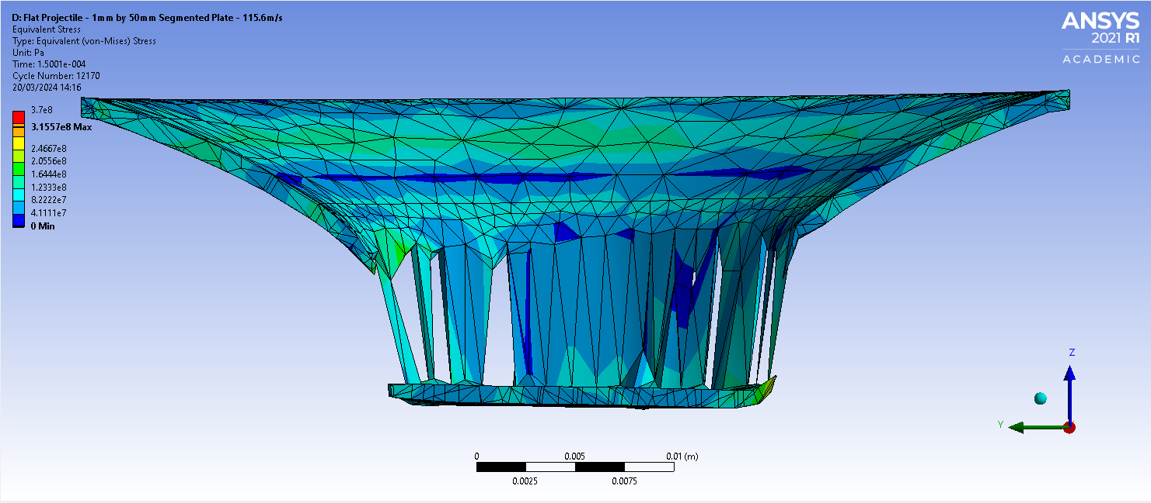
Figure 12 - Stress plot for Test 2.
In this plot although perforation of the plate has occurred the piece of material punched out by the projectile is still connected to the target plate by extremely deformed nodes. Fortunately, this did not affect the accuracy of the results but shows the model is not performing optimally. One theory for why this occurs is that fact that the material would have broken at some point within the stretched nodes but as these elements where large they could absorb this force and instead of breaking, stretch. This issue may be resolved in future by increasing mesh density.

3.3 Test 3 and 4
During Test 2 it was identified that the deformation of the 50mm target plate occurred all the way up to the boundary of the plate which was fixed. This suggests that energy was maintained within the impact area where, if the plate was the full 255mm wide, it would have instead been dissipated. To test this the segmented 50mm plate was inserted within the full size 255mm plate before being meshed with two differing densities.
Test 3 used a larger mesh size of 10mm for the outer region whereas Test 3 used a 5mm mesh size. The residual velocities can be seen in Figure 14 and Table 4.

Figure 13 - Residual Velocity Plots for Test 3 and 4.
Table 4 - Comparison of residual velocities from Test 3 and Test 4
Source | Residual Velocity (m/s)
Gupta (Experimental) | 93.0
Gupta (ABAQUS) | 98.7
Smith (Test 3) | -86.041
Smith (Test 4) | -56.23

From Table 4 is clear to see adding this extra plate width does negatively impact the model performance. This is likely because it brings the model closer to the failed Test 1 where energy is dissipated through the plate rather than staying in the impact zone. Interestingly the reduced mesh size in Test 4 yielded worse results which is a counter intuitive result. One theory to explain this is that the 1mm to 10mm mesh transition in Test 3 makes the transfer of energy more challenging than the 1mm to 5mm in Test 4 and as such traps more energy in the impact zone yielding more realistic results.

3.4 Test 5
Due to the inconclusive nature of Test 3 and 4 a final test was completed using the same test set up as 3 and 4 but the finest mesh density yet ranging from 0.1mm to 1mm. This aimed to clarify is a model using the full-size plate set up could be as accurate at predicting the experimental results as the 50mm segmented plate. The results of this test can be seen in Figure 14 and Table 5.

Figure 14 - Residual Velocity Plots for Test 5.
Table 5 - Comparison of residual velocities for Test 5
Source | Residual Velocity (m/s)
Gupta (Experimental) | 93.0
Gupta (ABAQUS) | 98.7
Smith (Test 5) | -90.15

These results show that even with the full 255mm diameter plate the Ansys Explicit Dynamics solver can be used to accurately predict the outcomes of an experimental ballistics scenario so long as the mesh density is sufficient. Despite the positive results found here the stress analysis shown in Figure 15 shows there is still room for improvement.
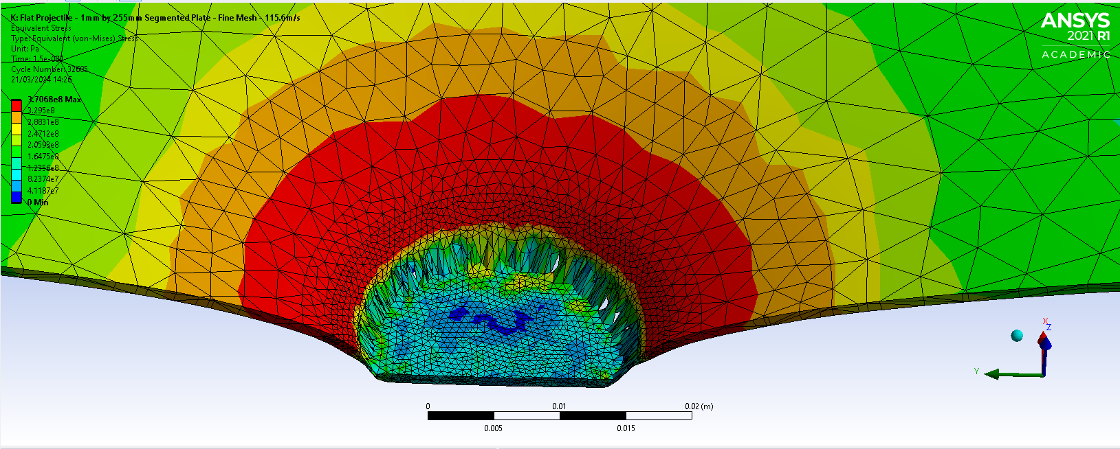
Figure 15 - Equivalent Von-Mises Stress during initial perforation in Test 5.
In this figure the highest stress region bleeds out of the high-density mesh region into the areas of lower density. This suggests that the high-density region is not large enough and should be increased. This would mean all the high stress region is modelled accurately increasing the accuracy of the material performance in this region, and likely leading to results even closer to the experimental. Unfortunately, however due to limitations in computation time this could not be performed.

4.0 Conclusion
This report has shown that in the field of terminal ballistics the utilisation of Computer Aided Engineering (CAE) tools holds great promise for accelerating the engineers understanding of projectile design and the complex interactions these projectiles experience during a ballistic impact. The practical testing and comparison to published literature consolidated this and through the series of tests and simulation conducted using Ansys workbench allowed many practical conclusions to be drawn.
The results of Test 1 showed that differing solvers, although capable of performing the same simulations, yield different results and as such must be carefully selected. This work showed in this regard that for the replication of the ballistic scenario in question the “Explicit Dynamic” solver within Workbench provided a superior capability for representing the local deformation and impact dynamics.
Test 1 also showed however, that the modelling of these ballistic scenarios is not a simple process with many aspects of a model requiring optimisation to yield high quality results. Test 2 using these findings demonstrated a great improvement is the model performance. From this it can be concluded that abstracting a problem and making sensible modelling assumptions which then allow more detail to be added into the model is extremely beneficial for optimising the quality of modelling outcomes.
It was also concluded however, that the abstraction of a problem to a smaller more focused model must be carefully managed to ensure that fundamental mechanics of how the system work are not lost. This was clearly shown in Test 3 and 4 where the reintroduction of the larger plate negated the mesh density increase of Test 2. This behaviour again stresses the complexity of CAE modelling and the importance of meticulously checking the models results to spot areas where undesirable behaviour may encroach.
The final test supported the widely known conclusion that and increased mesh density better represents real world scenarios when compared to course meshes. The lengthened run time of this model however, ale reinforced the trade-off between model performance and computational resource. It is sensible to conclude that more accurate models will always take more resource, but it is also important to not that although the mechanism within Test 2 where not the most representative of experimental conditions the results where the closest aligned. This suggests a designer must also consider the importance of realism as a trade of against accuracy when applying CAE tools.
When considered together however all the above conclusions paint a positive picture for the use of CAE within the field of terminal ballistics. By using one computer and two software packages a full experimental trail which likely cost thousands of pounds could be replicated in a few weeks. This success when combined with the continuing advancement of CAE tools suggests going forward into the future CAE tools will continue to be of increasing importance enabling engineers to strive towards a better understanding of the systems they explore and aid in the delivery of ever improving products.

References

[1] | N. K. Gupta, M. A. Iqbal and G. S. Sekhon, “Effect of projectile nose shape, impact velocity and target thickness on the deformation behavior of layered plates,” International Journal of Impact Engineering, vol. 35, pp. 37-60, 2008.
[2] | C. Humphrey and J. Kumaratilake, “Ballistics and anatomical modelling – A review,” Legal Medicine, no. 23, pp. 21-29, 2016.
[3] | The Royal Society, “Understanding Ballistics A Primer For Courts,” Royal Society of Edinburgh, Edinburgh, 2021.
[4] | M. A. Abtew, F. Boussu, P. Bruniaux, C. Loghin and I. Cristian, “Ballistic impact mechanisms – A review on textiles and fibre-reinforced composites impact responses,” Composite Structures, no. 223, 2019.
[5] | V. Pranay and S. K. Panigrahi, “Design and development of new spiral head projectiles undergoing ballistics impact,” International Journal of Structural Integrity, vol. 13, no. 3, pp. 490-510, 2022.
[6] | S. Cinemre, “What is Computer Aided Engineering (CAE)?,” Autodesk, 1 Febuary 2024. [Online]. Available: https://www.autodesk.com/products/fusion-360/blog/what-is-computer-aided-engineering-cae/. [Accessed 2 May 2024].
[7] | PTC, “Computer-Aided Engineering (CAE),” [Online]. Available: https://www.ptc.com/en/technologies/cad/computer-aided-engineering. [Accessed 2 May 2024].
[8] | B. Raphael and I. F. Smith, Fundimentals of Computer-Aided Engineering, Chichester: Wiley, 2003.
[9] | A. Saxena and B. Sahay, Computer Aided Engineering Design, New York: Springer, 2005.
[10] | K.-H. Chang, e-Design Computer-Aided Engineeering Design, London : Academic Press, Elsevier, 2016.
[11] | SolidWorks, “SOLIDWORKS 3D CAD,” [Online]. Available: https://www.solidworks.com/product/solidworks-3d-cad. [Accessed 2 May 2024].
[12] | ANSYS, “Ansys Workbench,” [Online]. Available: https://www.ansys.com/products/ansys-workbench#tab1-1. [Accessed 2 May 2024].

