University of Wales Trinity Saint David
BA (Hons) Business Management Level 4 - Weekend

Introducing the Modern Workplace (LCBB4003)
Lecturer: Dr Molly Jack

Student name: Raluca-Elena Bretea
Student ID 1917325
Structure and culture of Samsung Organization

Samsung built its corporate culture focusing on achieving a high degree of technological innovation involving human resource development strategies. A company’s organizational culture involves the customs, core values, and traditions applied to and expected in the behaviors of employees, in the case of this report we will refer to employees in the corporation’s main divisions and regional offices for consumer electronics, device solutions, and IT and mobile communications markets. Samsung’s organizational culture fusions with all areas of the conglomerate. This fusion indicates how important are the corporate cultural characteristics in achieving long-term business success.
Being a historical player in the global consumer electronics, device solutions, and IT and mobile communications markets, Samsung’s organizational structure is designed to promote technological innovation throughout the enterprise. Technological innovation is the core of the company’s strategies and this translates into rapid innovation involving smartphones and other consumer electronics thus ensuring their strong top position on the market. The corporate structure is also a result of the evolution of the business: from a small trading firm founded in March 1938, in Taegu, Korea by is Lee Byung-Chull, to a complex diversified multinational enterprise offering advanced adapting technologies. However, Samsung’s organizational structure was not primarily influenced by market conditions or political connections but they also incorporated the general social factors at the time of organizational founding i.e. family conglomerates (called chaebol in Korea) with a central manager having an emperor-like power over the group-wide management. (Sug-In, 2012)
Samsung structure is also determined by their competitive and intensive strategy and it is a product-type divisional organizational structure.
The corporate structure is replicated throughout its operations: e.g. the organizational structural characteristics of Samsung Electronics are the same as the structural characteristics of the conglomerate. Because of this consistency in how the corporate structure operates, the company’s operations are streamlined. This gives Samsung a competitive advantage against other companies operating in the same business such as Apple, Google, Sony, Intel, Dell, Acer, and Lenovo.
Samsung’s corporate structure has the following main characteristics:
- product-type divisions
- centralized corporate hierarchy
- geographical groupings
Product-Type Divisions. For Samsung, their strongest structure remains the product-type divisions. Each division is organized as a group of resources and operations that represent a product category, such as resources and operations for the production, distribution, and sale of consumer electronics. The main emphasis of these division’s is on technological innovation and product development thus achieving Samsung’s corporate vision and mission statements. The main conglomerate may add, merge, or disband divisions, depending on current business needs and the development of the organization, taking into account that further business diversification is necessary. However, these divisions need to follow strategic directives from the company’s headquarters in Seoul, as this structural hierarchy is necessary to keep Samsung’s entire organization unified toward its mission and vision. The product-type divisions in Samsung organizational structure are:
- Consumer Electronics
- Device Solutions
- IT & Mobile Communications
Centralized Corporate Hierarchy. Samsung’s corporate structure involves a hierarchical model. We can see the demonstration of this structure in the way the corporate headquarters are organized - the conglomerate’s operations are merged and directed towards growth and operational effectiveness. This characteristic of the organizational structure involves centralization of overall strategic planning, as well as vertical lines of command and authority that disseminate strategic directions from the headquarters to the daily operations in the Consumer Electronics, Device Solutions, and IT & Mobile Communications divisions. This separation in divisions determines lower labor costs as the employees are only specialized in one area or functional department. The cost of employing lower and middle managers is also reduced due to centralized decision-making process.
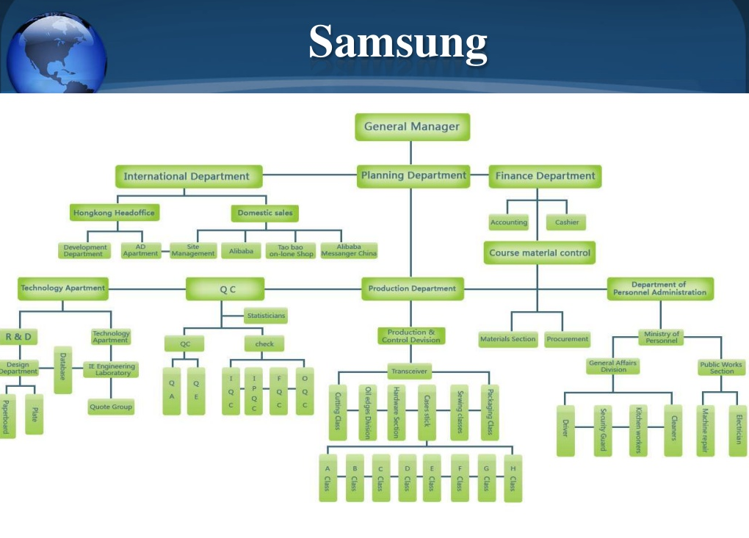

Source: pinterest.com
Fig 1: Samsung’s hierarchical tall organizational structure

Geographical Groupings. Using geographical groupings or divisions Samsung demonstrates its corporate structure. In the company’s organizational chart, these geographical divisions are generally under the product-type divisions. For exemplification, Samsung Electronics UK ltd is a geographical division within Samsung Electronics, which is a product-type division. Through this characteristic of the organizational structure, the company implements region-specific strategies, such as strategies intended for the UK market for Device Solutions (Samsung, 2020). Nonetheless there are challenges in expanding the business in regional markets, considering the low priority given to the geographical grouping but this is an area where Samsung’s corporate culture helps in minimizing the negative effects of this structural disadvantage.
Samsung’s corporate structure offers the advantage of substantial support for product development, especially in the technology and innovation areas. Also, the company’s structure and strategy support the ability to calibrate its strategies and operations based on market characteristics. These structural advantages are helping the business against fierce competition against major competitors like Apple Inc.
Comparing Samsung with another Asian company - Sony, we can observe that the important decisions that led to their success during the past decade did not came from differences in these firms' strategic content but actually came from their deeply rooted organizational processes and from their executives' political behavior. All these having as background their strong national cultures. Samsung's rise also shows that diversity may not always be a necessity for success, although this might not be politically correct. However, in the next period diversity in approach, thinking and organizational culture may well play a more important role for Samsung than for Sony. That is because Sony already shows diversity by having a non-Japanese CEO and international executives. (Hammerich and Lewis, 2013)
Considering the numerous divisions of Samsung’s organizational structure’s there is the need to employ various operations management strategies for different markets and industries. The organizational design and structural system are designed to cover various markets and industries related to the development and utilization of technologies, such as computing technologies. The most important factors that define Samsung’s management system's strong corporate performance are flexibility and team-orientation, the in-house training of the workforce, strong owner–manager leadership style, an excellent compensation system, and cooperative and participative management. Managers have observed that flexibility and team-orientation approaches determine changes in the right direction, fluid, fast human resources changes. Team-based job designs, a flexible workforce, quality improvement practices, and employee empowerment has led to better corporate performance. A specific importance was given to the distribution of limited resources into the areas that did not necessarily needed them; this was possible through a management process of fast decisions adapted to the continuous environment changes (Sug-In, 2012). Another important management performance factor is the consistent and strategic training of workforce that Samsung offers to their new and old employees. Training is done from inception as an important pillar, investing in its employees in order to turn them into international businessman who are, in turn returning this investment though strengthening the international competitiveness of the company. The owner–manager leadership style directly influences the corporate owner performance especially through its main manager. The owner–manager leadership style of Samsung CEO Lee has impacted profoundly the management of the company, entrepreneurship, and the management's overall ideology that has directly contributed to corporate performance. To exemplify, this leadership style tends to exert full discretion in strategic decisions and their values are reflected on strategic decision making. However, for company to adapt to the new challenges the company’s president worked collaboratively with the CEO, also involving the elaborate analysis and forecasting of his staff. The high rewarding compensation system of Samsung is high above the market average enhancing a high performance and loyalty to the company. The managements’ cooperative style enhances great collaboration among employees not only on the top management but also the workers have been able to agree on common goals and assume responsibility for achieving these goals. They have been observed that in the process, they have been able to find solutions to various problems in the workplace, enhance workers' commitment and morals, and eventually improve the organization's performance.
Through its evolution, Samsung chaebol conglomerate become large and diversified as a consequence of continued internalization and organically growth of business. There has to be a fit between structure and strategy that will impact the company’s performance. In Samsung’s case, the authoritarian and paternalistic leadership reinforced by a clear hierarchical order and vertical communication has led to a growing global leading business. Researches showed that servant leadership is related to critical employee and organizational criteria, although only a limited amount of studies link servant leaders to both internal and external stakeholder outcomes (Neubert, et. al, 2016). In Samsung’s case, despite being weighted with controversy, scandals and setbacks along the years, is now the 15th largest company in the world, taking $225 billion (£176bn) in sales, $41 billion (£32bn) in profit, $293 billion (£230bn) in assets and a market cap of $326 billion (£255bn) in 2018.

References

About us (2020) Available at: https://www.samsung.com/uk/aboutsamsung/home/, Accessed 8/08/20
Ashkenas, R., Ulrich, D., Jick, T., & Kerr, S. (2015). The boundaryless organization: Breaking the chains of organizational structure. John Wiley & Sons.
Hammerich, K., and Lewis, R., (2013) Fish Can't See Water : How National Culture Can Make or Break Your Corporate Strategy, Chichester, England.
Neubert, M. J., et al (2016) A servant leader and their stakeholders: When does organizational structure enhance a leader’s influence? The Leadership Quarterly, 27(6), 896-910, DOI: 10.1016/j.leaqua.2016.05.005
Sug-In, C., (2012) Study on Human Resource Management in Korea's Chaebol Enterprise: A Case Study of Samsung Electronics, International Journal of Human Resource Management 23.7, p.1436-462, DOI: 10.1080/09585192.2011.579922.

